Procedure Cover Sheet

Princeton Plasma Physics Laboratory
Procedure
Procedure Title:
PREOPERATIONAL TEST PROCEDURE FOR NCSX VACUUM VESSEL THERMOCOUPLES AND HEATERS

Number D-NCSX-PTP-TOK-015 |  | Revision: 0 |  |  | Effective Date: 5/15/08  Expiration Date: 5/15/10  (2 yr. unless otherwise stipulated)
Procedure Approvals
Author G. Tchilinguirian |  |  |  |  |  | Date
ATI G. W. Labik |  |  |  |  |  | Date
RLM B. Stratton |  |  |  |  |  | Date
Responsible Division:

Procedure Requirements
designated by RLM
Labwide:
X | Work Planning Form #_1187_(ENG-032) |  |  | Lockout/Tagout (ESH-016)
 | Confined Space Permit (5008, Sc. 8, Ch 5) |  |  | Lift Procedure (ENG-021)
 | Master Equip. List Mod (GEN-005) |  |  | ES&H Review (NEPA, IH, etc.)
 | RWP (HP-OP-20) |  |  | Independent Review
 | ATI Walkdown |  |  | Pre-job Brief
 | Post-job Brief |  | X | Hazard Analysis
D-Site Specific:
X | D-Site Work Permit (OP-AD-09) |  |  | Door Permit (OP-G-93)
 | Tritium Work Permit (OP-AD-49) |  |  | USQD (OP-AD-63)
 | Pre-job brief (OP-AD-79) |  |  | T-MOD (OP-AD-03)
 | ** DCA/DCN (OP-AD-104) #____________
REVIEWERS (designated by RLM)
Accountable Technical Individual G. Labik
Test Director G. Tchilinguirian
Independent Reviewer
D-Site Shift Supervisor:
NSTX/NCSX M. Viola
D-Site Caretaking
Vacuum
Computer: P. Sichta
Tritium
Quality Assurance/Quality Control
AC Power
Maintenance and Operations Division
Energy Conversion Systems
Engineering: P. Goranson
Environmental Restoration & Waste Management Division
Water Systems
Neutral Beam (Heating Systems Branch of Electrical Engineering)
Radiofrequency (Heating Systems Branch of Electrical Engineering)
Diagnostics:
Environmental, Safety, & Health
TRAINING (designated by RLM)
No training required ______________ Instructor _____________________

Personnel (group, job title or individual name) |  |  |  |  | Read Only* |  | Instruction | Hands-On
Test team participants |  |  |  |  | X
Training Rep. _______________________________
RLM ______________________________________

Scope

This procedure will demonstrate basic operation of the vacuum vessel’s instrumentation including thermocouples and heater strips. The flux loops, Rogowski coils, and voltage loops will be tested under a separate PTP. Testing includes electrical isolation tests of the signal leads to both to the vacuum vessel and to the plug body, short circuits between leads, and basic functional testing. A separate RUN COPY will be used for each of the three VV segments.

The procedure will initially be performed prior to installation of the NCSX coils over the vacuum vessel. Some of the tests can be repeated after final machine assembly, but others cannot due to impossible access to the sensors.

References

Documents

Drawings
dwg # | title (or portion of)
SE123-124 SH1 | Port 12 Interfaces Vacuum Vessel 1 (Bottom)
SE123-124 SH2 | Port 12 Interfaces Vacuum Vessel 1 (Top)
SE123-124 SH3 | Port 12 Interfaces Vacuum Vessel 2 (Bottom)
SE123-124 SH4 | Port 12 Interfaces Vacuum Vessel 2 (Top)
SE123-124 SH5 | Port 12 Interfaces Vacuum Vessel 3 (Bottom)
SE123-124 SH6 | Port 12 Interfaces Vacuum Vessel 3 (Top)
SE123-128 SH1 | Port 12, Vacuum Vessel 1 (Bottom). Thermocouple Flange 7
SE123-128 SH2 | Port 12, Vacuum Vessel 1 (Top). Thermocouple Flange 12
SE123-128 SH3 | Port 12, Vacuum Vessel 2 (Bottom). Thermocouple Flange 16
SE123-128 SH4 | Port 12, Vacuum Vessel 2 (Top). Thermocouple Flange 7
SE123-128 SH5 | Port 12, Vacuum Vessel 3 (Bottom). Thermocouple flange 12
SE123-128 SH6 | Port 12, Vacuum Vessel 3 (Top). Thermocouple Flange 16
SE123-129 SH1 | Port 12, Vacuum Vessel 1 (Bottom). Heater Field J-Box Wiring Detail
SE123-129 SH2 | Port 12, Vacuum Vessel 1 (Top). Heater Field J-Box Wiring Detail
SE123-129 SH3 | Port 12, Vacuum Vessel 2 (Bottom). Heater Field J-Box Wiring Detail
SE123-129 SH4 | Port 12, Vacuum Vessel 2 (Top). Heater Field J-Box Wiring Detail
SE123-129 SH5 | Port 12, Vacuum Vessel 3 (Bottom). Heater Field J-Box Wiring Detail
SE123-129 SH6 | Port 12, Vacuum Vessel 3 (Top). Heater Field J-Box Wiring Detail

Special Tools, Equipment and Materials
Thermocouple Testing
- Volt-Ohm Meter
  - Mfgr/Model/SN/Calib: ___________________________
- ‘Biddle’ thermocouple meter.
  - Mfgr/Model/SN/Calib: ___________________________
- Hand-held temperature (contact) meter.
  - Mfgr/Model/SN/Calib: ___________________________
- Breakout box with pin pairs selectable via a rotary switch (appendix B)
- Thermocouple adapter cable (appendix C).
- Heat gun with ‘distance’ fixture on nose (appendix E).
- Mating connector for Type E cryostat feed-through connector.

Heater Testing
- Volt-Ohm Meter
  - Mfgr/Model/SN/Calib: ___________________________
- Hand-held temperature (contact) meter.
  - Mfgr/Model/SN/Calib: ___________________________
- Oscilliscope
  - Mfgr/Model/SN/Calib: ___________________________
- Breakout box with pin pairs selectable via a rotary switch (appendix B)
- Heater adapter cable for isolation tests (appendix D).
- Heater adapter cable for heating tests (appendix F)
- Mating connector for MS-type cryostat feed-through connector.
- Heater limited-power power supply (Appendix A).

Pre-Requisites
The procedure must follow the completion of installation, wire routing and termination for thermocouples and heaters for NCSX vacuum Vessels assemblies 1, 2 and 3. At least two people are required for this. A small ladder is required to reach certain areas of the VV segment’s sensors.

At the discretion of the ATI, sections of the test may be omitted provided this is recorded and approved on the RUN COPY. In addition, the subsections of this procedure are self-contained; therefore the order in which the subsections are executed is not important.

- Obtain a D-Site Work Permit prior to performing this work.

_____________________________.
Work Permit No.

- Gather the test team at the job site and fill out a Job Hazard Analysis form and have the participants sign the JHA. Attach the JHA to the RUN COPY.

Test Procedure

- Record the Vacuum Vessel Segment Number :

Thermocouples
Each thermocouple (TC) will be tested for the following:
- Electrical isolation from VV, connector body, adjacent pins.
- Thermoelectric voltage (and shorted leads).
- Thermocouple response to heat.
- Verification of physical location of thermocouple on VV.
- Ruggedness of ‘fusion splice’ on signal wires.

The primary objective of this test is to verify the wiring and physical location of the thermocouples. This test will not verify the calibration of the thermocouple over the expected operating range. In this test the temperature of each thermocouple will be ‘bumped’ using a heat gun.

The measurements in this section should be recorded on Data Sheet Set #1, unless noted. Each data sheet should note the VV#, cryostat feed through connector ID, and the thermocouple ID’s.

Feed-Through Connector Pin-Pin shorts
The pin-pin test results should be recorded on Data Sheet Set #2.
    - Using the appropriate sheet of Data Sheet Set #2 for the VV segment and connector under test, attach a mating connector with solder cups on rear of mating connector exposed.
    - Attach one ohm meter lead to first pin (A). Pins are in alphabetical order, see Appendix C for diagram.
    - Using the ohm meter on low range, verify that there is not a short circuit to any other pins . Note that the ‘other’ pin of a thermocouple should not be included in this criterion.
    - Record any pin-pin failures (short) with an “F” and any pin passes (no short) with a “P”.
    - Move to the next pin (letter) and repeat steps 2 – 4 until pin ‘V’ is reached (there are 20 pins). . Use the “Pin to Pin” testing section of the test sheet as a guide to select the correct combinations and test them only once.

Thermocouple electrical isolation
  - Verify the cryostat feed through connector is properly labeled.
  - Attach 25 pin D-type to Type-E adapter to cryostat feed-through connector.
  - Attach 25 pin D-type connector from breakout box to adaptor from previous step.
  - Securely attach one lead of the ohm meter (low-resistance range) to the Vacuum Vessel at a well-grounded point.
  - Select the first pin pair (1,14) on breakout box
  - Measure and record the resistance from each of the two terminals on the box to the VV.

  - While observing the ohm meter, gently ‘wiggle’ each wire individually where it emerges from inconel braided sheath behind the pass-through connector. Record the presence of any erratic readings.
  - Inspect the signal leads along the VV. If a fusion splice was installed:
- Note that on the data sheet.
- Gently ‘wiggle’ each wire at any fusion welded junctions. Record the presence of any erratic readings.

  - For each subsequent TC, turn the rotary knob clockwise to the next pin position and repeat steps 6 - 8 until the (10,23) position is reached on the breakout box.

  - Measure the resistance between the cryostat feed through connector’s shell and the VV. If the resistance is more than one ohm:
- Note the resistance on the data sheet.
- Repeat steps 4 - 6 with the reference lead on the connector body instead of the VV.
- For each subsequent TC, turn the rotary knob clockwise to the next pin position and repeat.

Thermoelectric voltage and shorted leads
All thermocouples should remain at room temperature throughout this section.

- Attach 25 pin D-type to Type-E adapter cryostat feed-through connector on Vacuum Vessel.
- Attach 25-pin D-type connector from breakout box to adaptor from step 1.
- Select first pin pair (1,14) on breakout box.
- With the DVM in DC millivolt mode, record the thermoelectric voltage of the thermocouple under test. Record the polarity of the signal. If this is ‘zero’ volts it indicates a short, open, or mis-wiring.
- If the millivolts reading is ‘normal’, connect a thermocouple meter (“Biddle”) to the breakout box, with the thermocouple type set to ‘E’.
- Record the thermocouple’s temperature reading.
- While observing the ohm meter, gently ‘wiggle’ each wire individually where it emerges from inconel braided sheath behind the pass-through connector. Record the presence of any erratic readings.
- Inspect the signal leads along the VV. If a fusion splice was installed:
- Note that on the data sheet.
- Gently ‘wiggle’ each wire at any fusion welded junctions. Record the presence of any erratic readings.
- For each subsequent TC, turn the rotary knob clockwise to the next pin position and repeat steps 4 - 8 until the (10,23) position is reached on the breakout box.

Test for Temperature response
This section will test the TC’s to heat response. The TC are mounted in pairs, so no distinction will be made between them, but the location of the pair on the VV will be confirmed.
- Attach 25 pin D-type to Type-E adapter cryostat feed-through connector on Vacuum Vessel.
- Attach 25-pin D-type connector from breakout box to adaptor from step 1.
- Connect a thermocouple meter (“Biddle”) to the breakout box, thermocouple type set to ‘E’.
- Attach apparatus to nose of gun that will maintain consistent distance from TC, about one inch.
- Select pin pair on breakout box for the TC under test. Observe a normal temperature reading.
- Place the heat gun over the TC pair under test. Use the VV assembly drawing to verify the physical location of the thermocouples.
- Turn on the heat gun for about 15 seconds (if heating time needs to be different, note this on Data Sheet) while observing the temperature reading.
- Turn off gun and place in a secure location where it can cool and is not in danger of being inadvertently touched.
- Record the (approximate) peak temperature on the appropriate sheet of Data Sheet Set #1. Use the breakout box’s switch to obtain readings for both TC in the pair; they should be similar. Observe the temperature drop as the TC junction cools.

Repeat for all TC Connectors
Proceed to the next cryostat feed-through connector for TC and repeat the previous sections.

Heaters
Each heater will be tested for the following:
- Electrical isolation from VV, connector body, adjacent pins.
- Continuity (resistance).
- Thermal response to power (10% of rated load).
- Verification of physical location of heater on VV.

The primary objective of this test is to verify the wiring and physical location of the heaters. This test will not verify the heating performance or thermal coupling over the expected operating range. In this test the temperature of each heater will be ‘bumped’ using a special, power limited power supply.

The measurements in this section should be recorded on Data Sheet Set #3, unless noted. Each data sheet should note the VV#, cryostat feed through connector ID, and the heater ID’s.

Feed-Through Connector Pin-Pin shorts
The pin-pin test results should be recorded on Data Sheet Set #4.
- Using the appropriate sheet of Data Sheet Set #4 for the VV segment and connector under test, attach a mating connector, with solder cups on rear of mating connector exposed.
- Securely attach one ohm meter lead to first pin (A). Pins are in alphabetical order, see Appendix D for diagram.
- Using the ohm meter on low range, verify that there is not a short circuit to any other pins. Note that the ‘other’ pin of a heater should not be included in this criterion.
- Record any pin-pin failures (short) with an “F” and any pin passes (no short) with a “P”.
- Move to the next pin (letter) and repeat steps 2 – 4 until pin ‘S’ is reached (there are 16 pins). Use the “Pin to Pin” testing section of the test sheet as a guide to select the correct combinations and test them only once.

Heater electrical isolation
  - Verify the cryostat feed through connector is properly labeled.
  - Attach the heater adapter cable for isolation tests (appendix C) to the heater’s cryostat feed-through connector.
  - Attach 25 pin D-type connector from breakout box to adaptor from previous step.
  - Securely attach one lead of the ohm meter (low-resistance range) to the Vacuum Vessel at a well-grounded point.
  - Select the first pin pair (1,14) on breakout box.
  - Using an ohm meter on low resistance range, measure and record the resistance from each of the two terminals on the box to the VV.

  - While observing the ohm meter, gently ‘wiggle’ each wire individually where it emerges from inconel braided sheath behind the pass-through connector. Record the presence of any erratic readings.

  - For each subsequent heater wired to the MS connector, turn the rotary knob clockwise to the next pin position and repeat steps 4 - 6 until the (10,23) position is reached on the breakout box.

  - Measure the resistance between the cryostat feed through connector’s shell and the VV. If the resistance is more than one ohm:
- Note the resistance on the data sheet.
- Repeat steps 4 and 5 with the reference lead on the connector body instead of the VV.
- For each subsequent TC, turn the rotary knob clockwise to the next pin position and repeat.

Heater element resistance
The heater elements should be at room temperature for these tests.
- Attach mating D-type to MS adapter to MS heater pass-through connector on Vacuum Vessel
- Attach 25 pin D-type connector from breakout box to adaptor from step 1.
- Attach an ohm meter to the two terminals on the box.
- Select first pin pair (1,14) on breakout box
- Record the measured resistance on the data sheet.

- While observing the ohm meter, gently ‘wiggle’ each wire individually where it emerges from braided sheath behind the pass-through connector. Record the presence of any erratic readings.

- For each subsequent heater, turn the rotary knob clockwise to the next pin position and repeat steps 5 - 6 until the (8,21) position is reached on the breakout box

Test heater’s response to electrical power
CAUTION: The heater’s are not the self-regulating type. They will reach extremely high temperatures and will be damaged if full power is applied for too long. The test jig uses 48 vAC instead of the nominal 120 vAC. The heater temperature will be continuously monitored by the tester, and power removed when the area surrounding the heater element reaches 50 degC, well below the heater’s limit of 480 degC.

- Remove breakout box adapter cable that was used in the previous sections. The breakout box used for ohmic measurements will not be used in this section.
- Attach the Heater power supply test jig (Appendix A) to the heater MS connector on the VV.
- Attach an RMS amp meter to the power supply’s output.
- Using a hand-held digital thermometer, observe the ambient temperature of VV area near the heater element under test.
- Start a timer and turn on the heater power (48 volts AC, ~10% of heaters rated current), and monitor the temperature of the area adjacent to the heater.
- For the first heater element (only) record the power supply’s output:
  - Attach an oscilloscope to the power supply’s output.
  - Record the duty cycle of the TPO (Timed Pulsed Output) for the power supply:

____________________ .
TPO [%]
  - Record output voltage of the power supply:

____________________ .
Vout (pk-pk) [V]

- When the temperature reaches approximately 50 degC turn off the power to the heater.
- Record the duration of power-on.
- Record the peak temperature.
- Record the avg (RMS) current.
- Check for temperature uniformity around the heater element.

- For each subsequent heater, turn the rotary knob clockwise to the next pin position and repeat steps 4 - 6 until position 8 is reached on the test jig.

Repeat for all Heater Connectors
Proceed to the next cryostat feed-through connector for heater elements and repeat the previous section.

Conclusion
The ATI should review all test data, and indicate Pass/Fail at the appropriate section of the Data Sheets, and initiate corrective actions and re-test if necessary.

_________________________________.
ATI ( Reviewed all Data Sheets)

- Attach the JHA to the RUN COPY.
- The RUN COPY should be filed in the Operations Center.

Data Sheets
Data Sheet Set #1 – Thermocouple Test Data
Data Sheet Set #2 – Thermocouple Pin to Pin Test Sheet
Data Sheet Set #3 – Heater Test Data
Data Sheet Set #4 – Heater Pin to Pin Test Sheet

Appendices
Appendix A –Heater Power Supply
Appendix B – Sensor Testing Breakout Box
Appendix C – Adapter Cables for Thermocouple Tests
Appendix D – Adapter Cables for Heater Tests
Appendix E – Heat Gun Surface Standoff

Data Sheet Set 1: Thermocouple Test Data

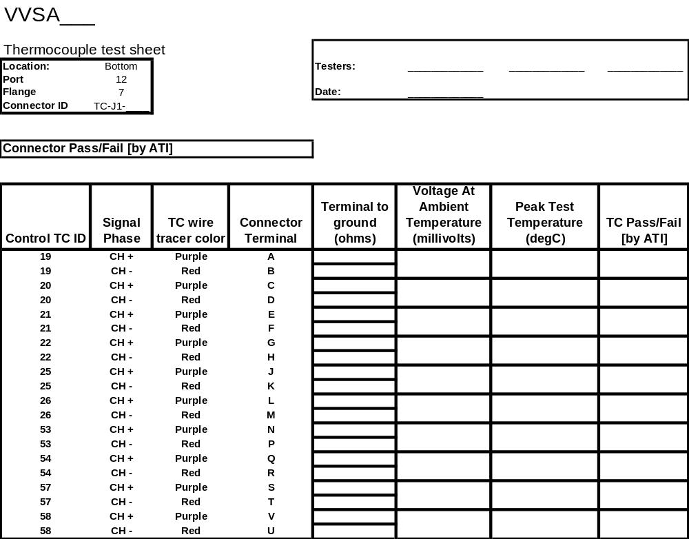
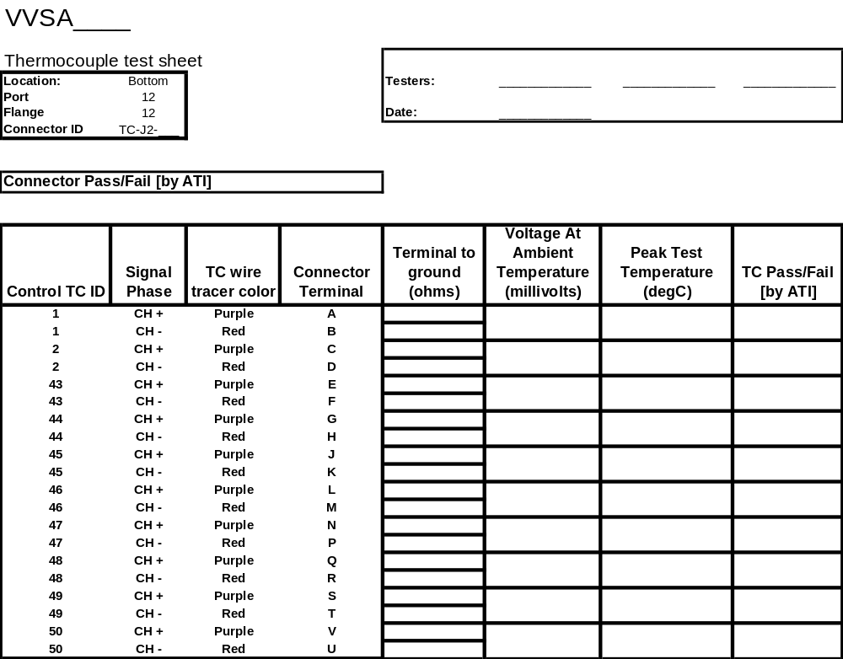
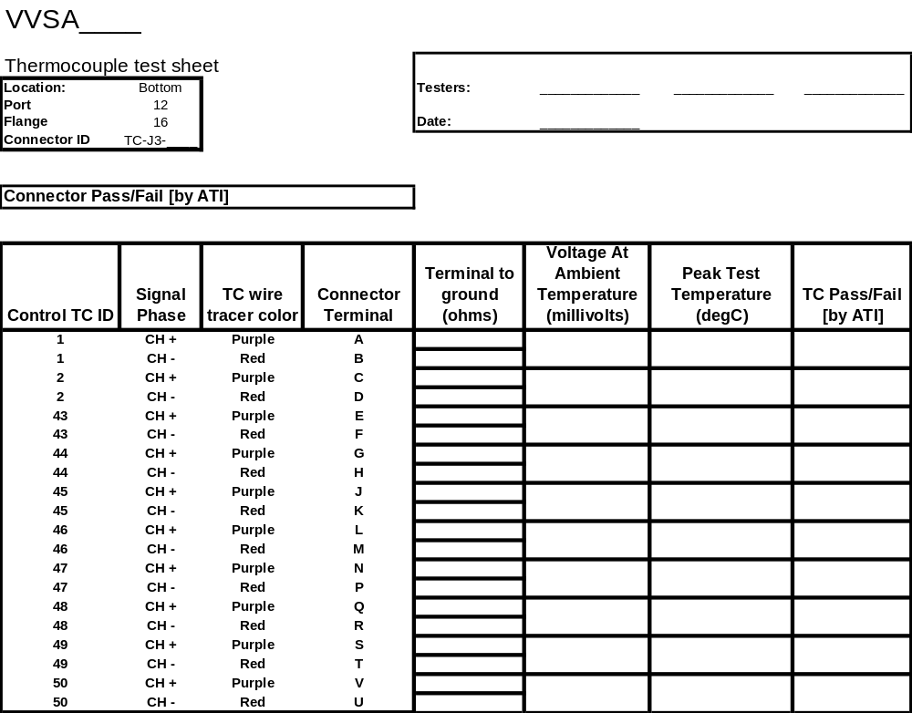
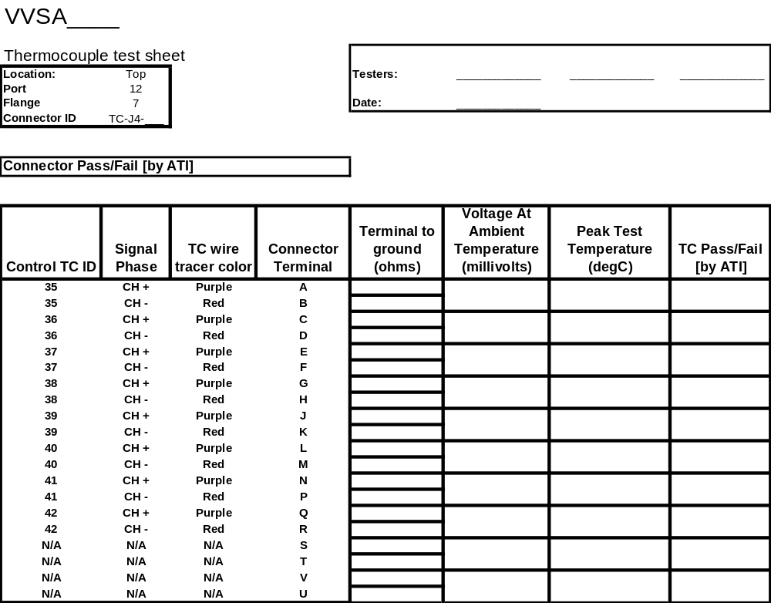

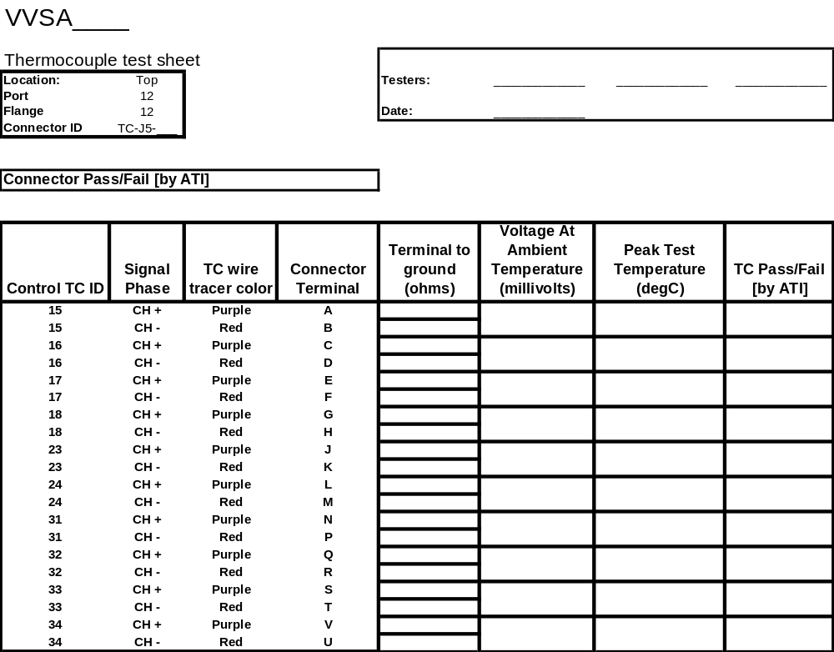

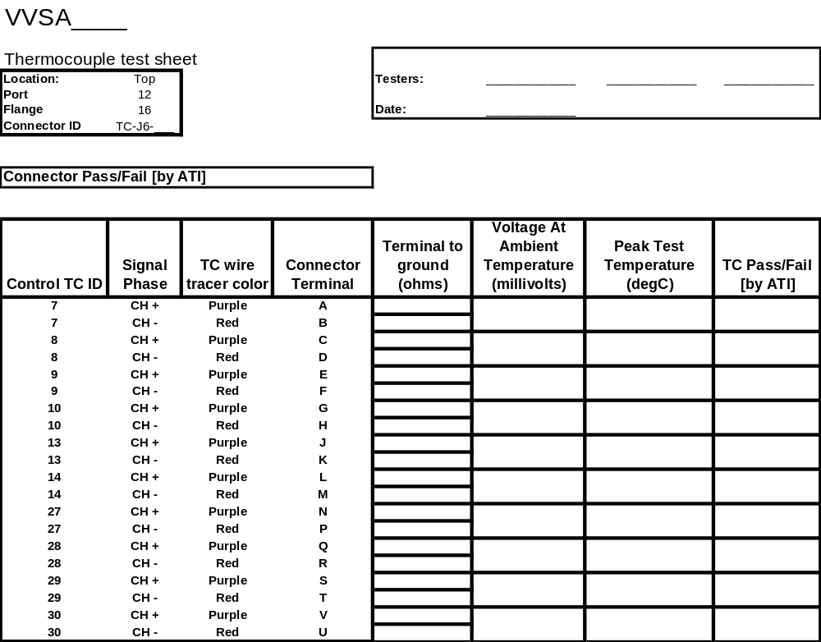

Data Sheet Set #2: Thermocouple connector pin-to-pin tests

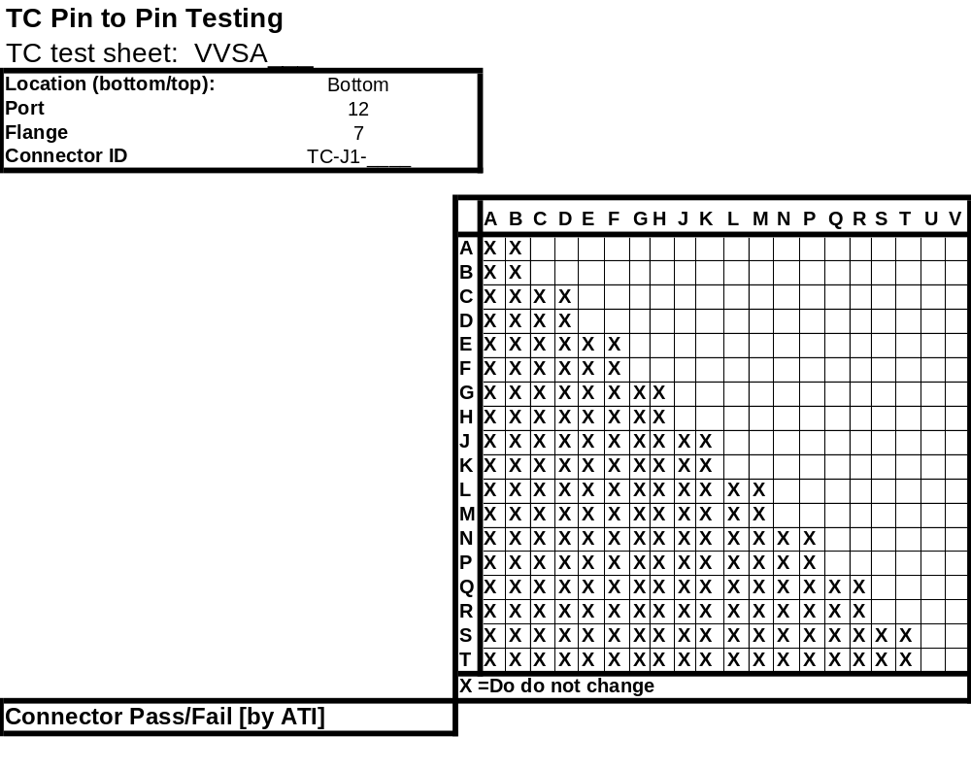
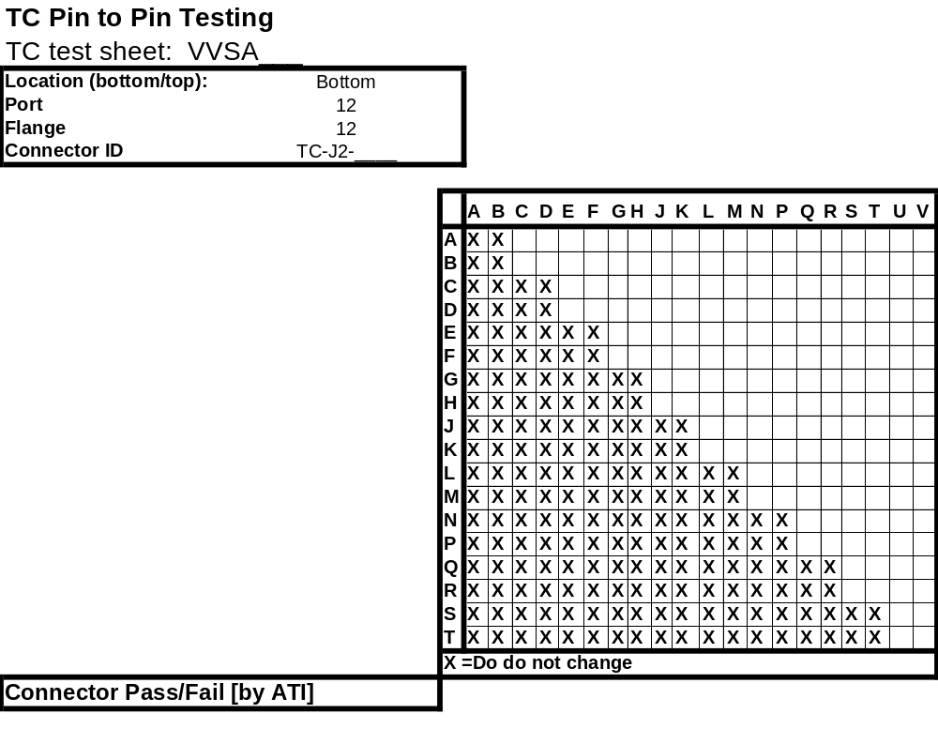
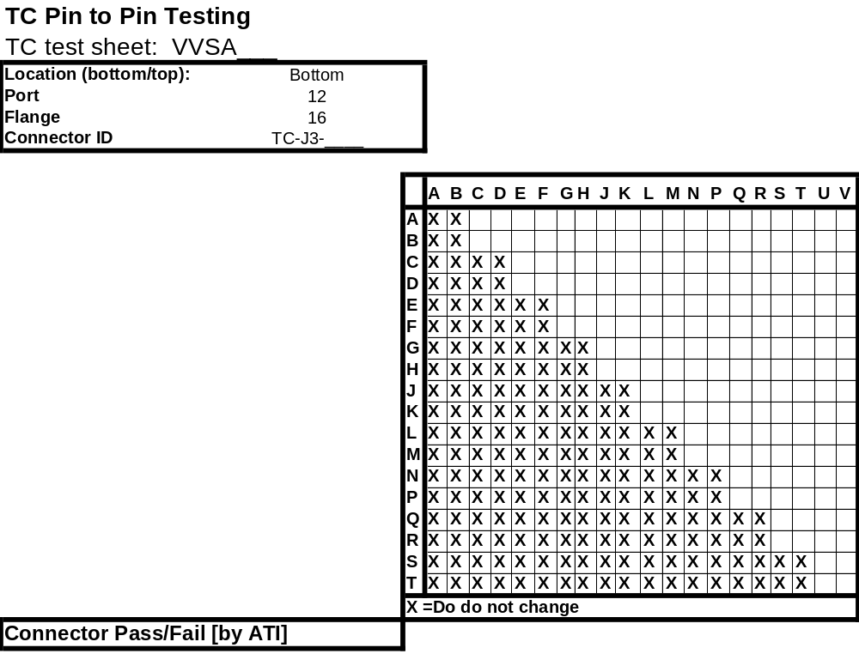
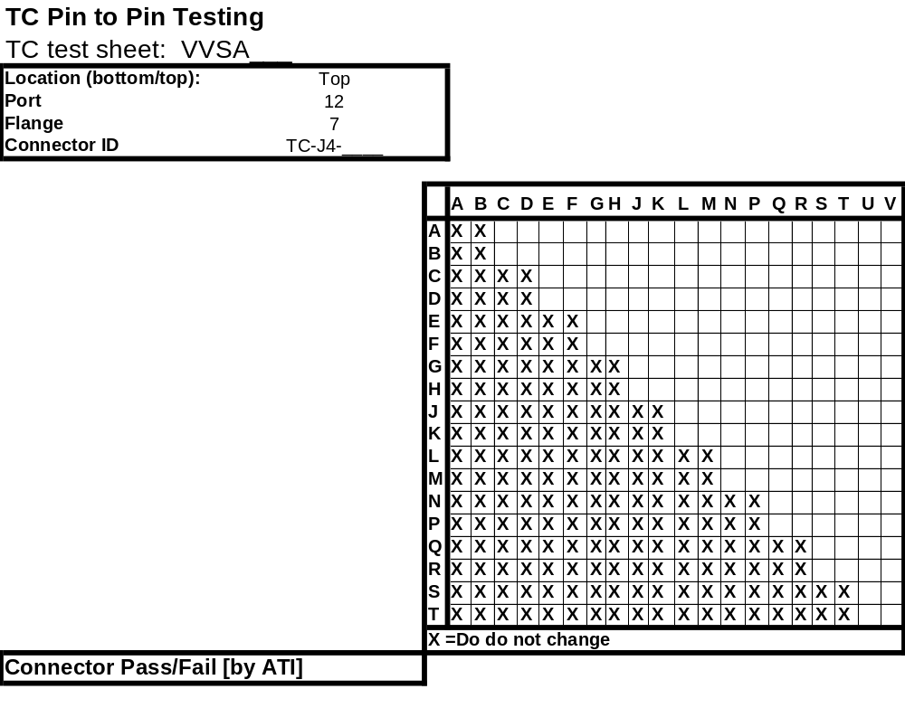
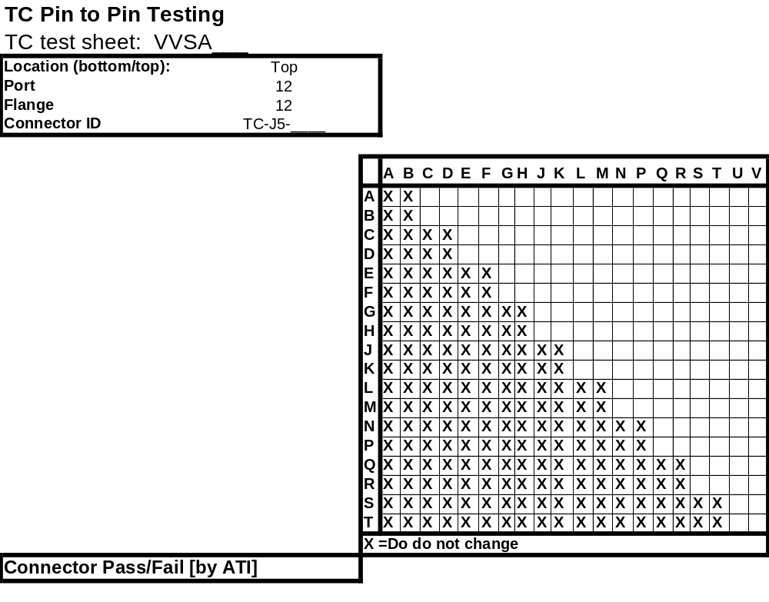
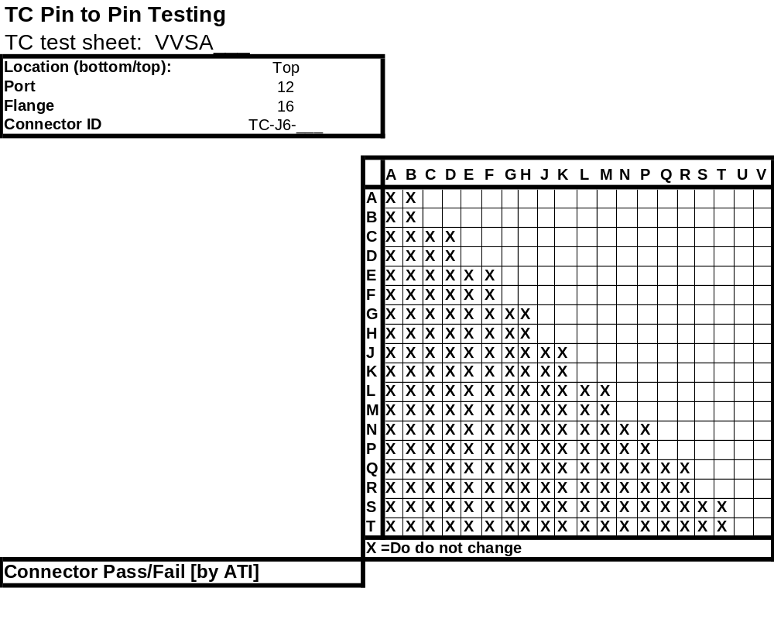

Data Sheet Set #3: Heater Test Data

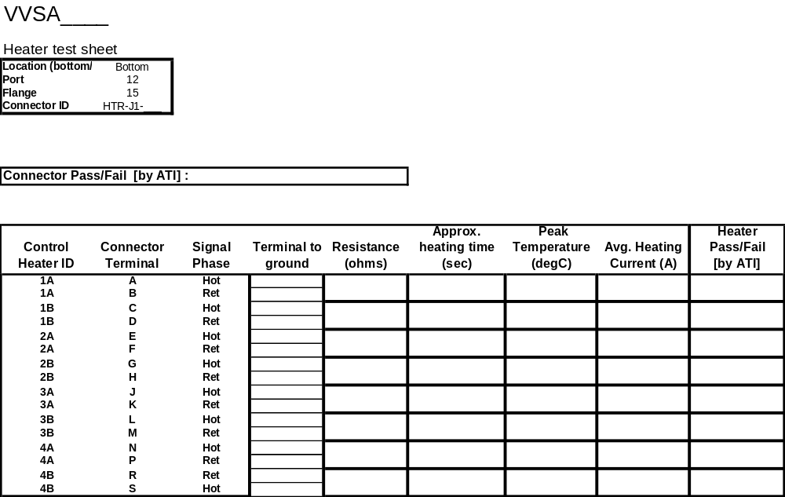
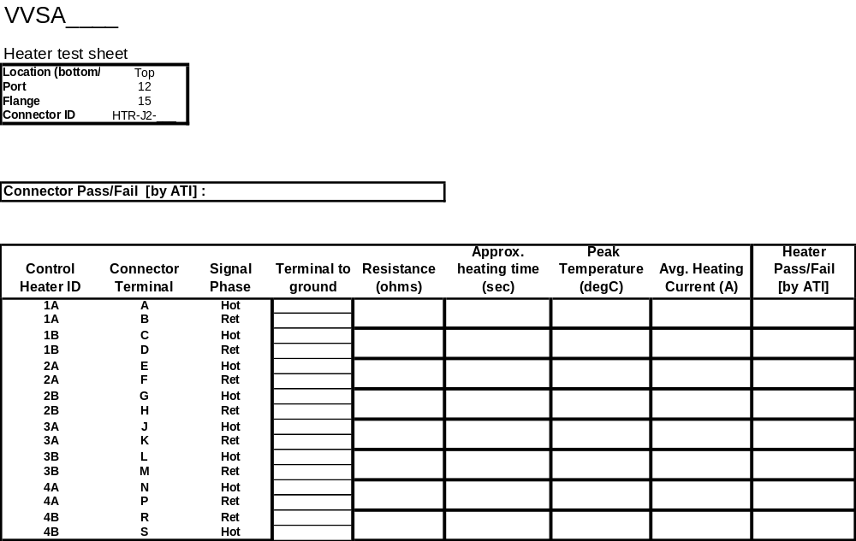
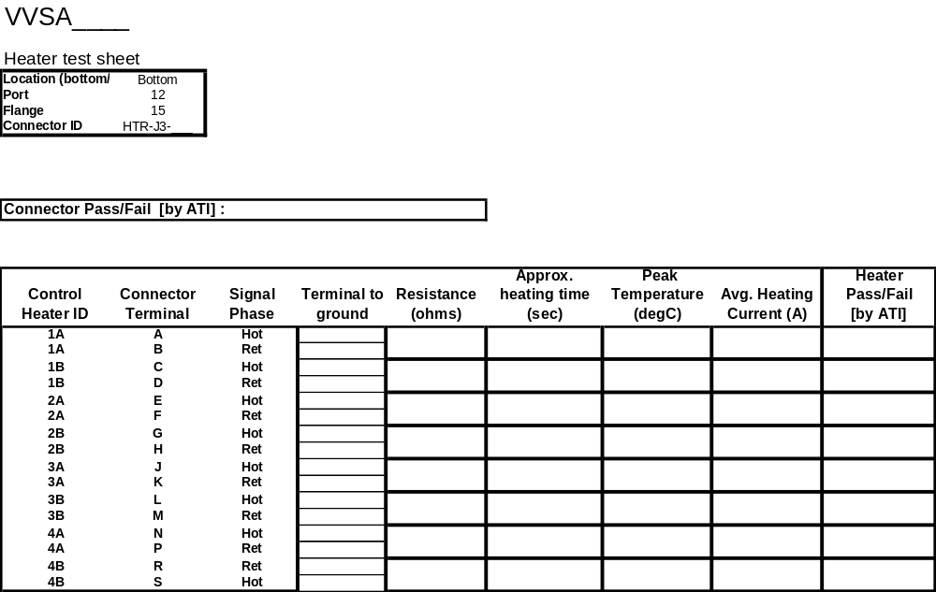
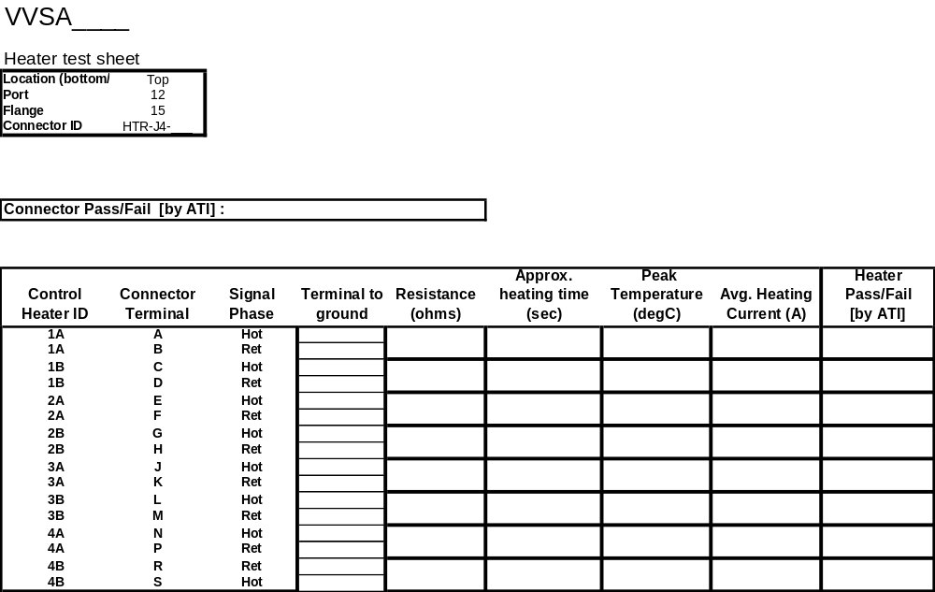
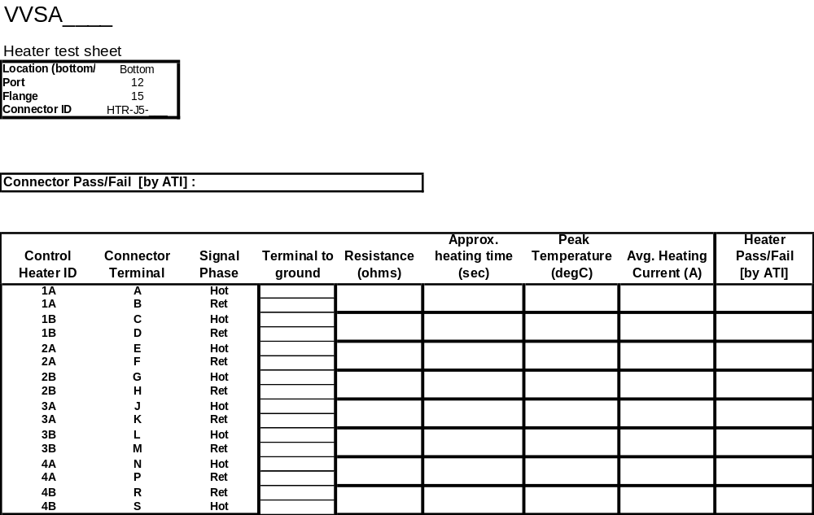
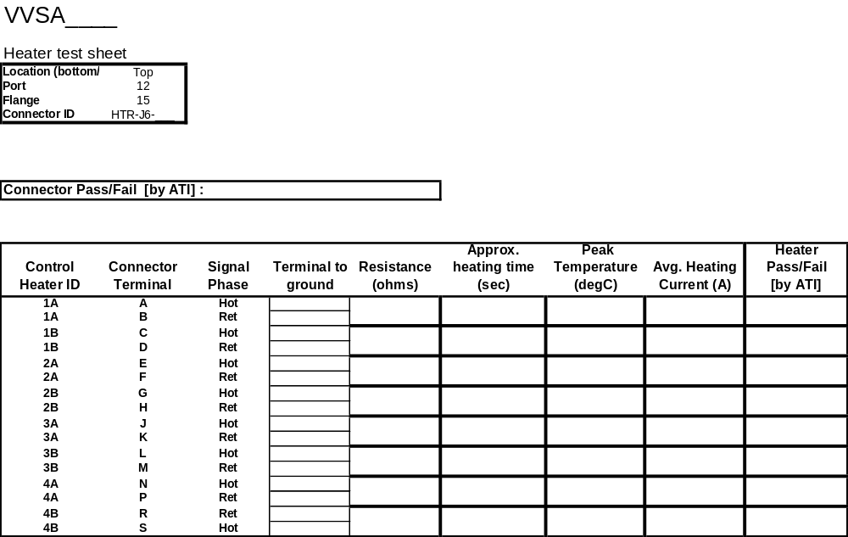

Data Sheet 4: Heater connector pin-to-pin tests

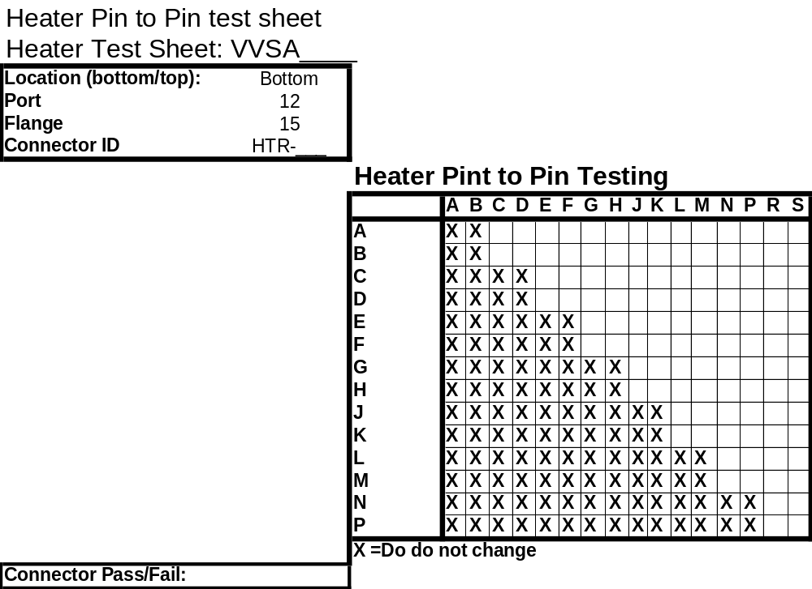
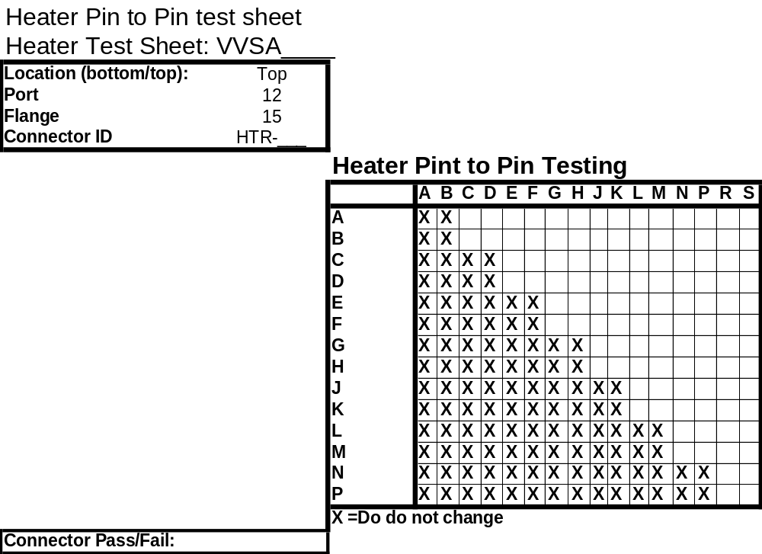

Appendix A: Heater Power tests power supply

DRAFT ONLY 15MAY2008 PS

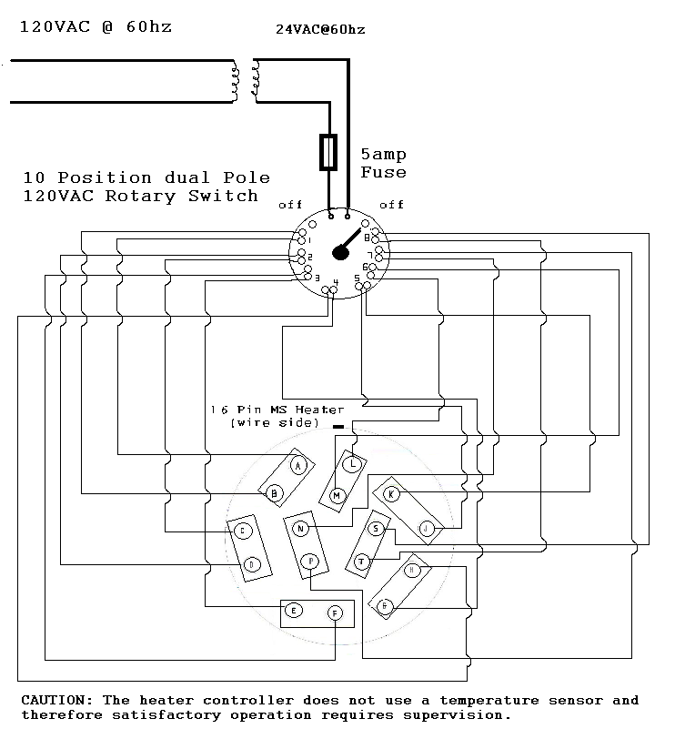
Power-Limiting
Power Supply
48VAC@60 Hz
TPO Current Limiting

Appendix A(cont’d)

Block Diagram of Power-Limiting Power Supply

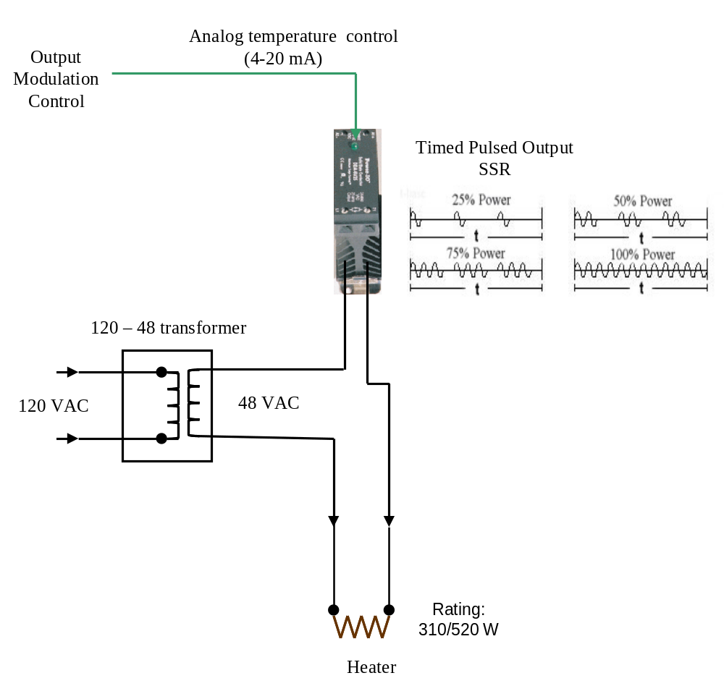

Appendix B: Sensor Testing Breakout Box
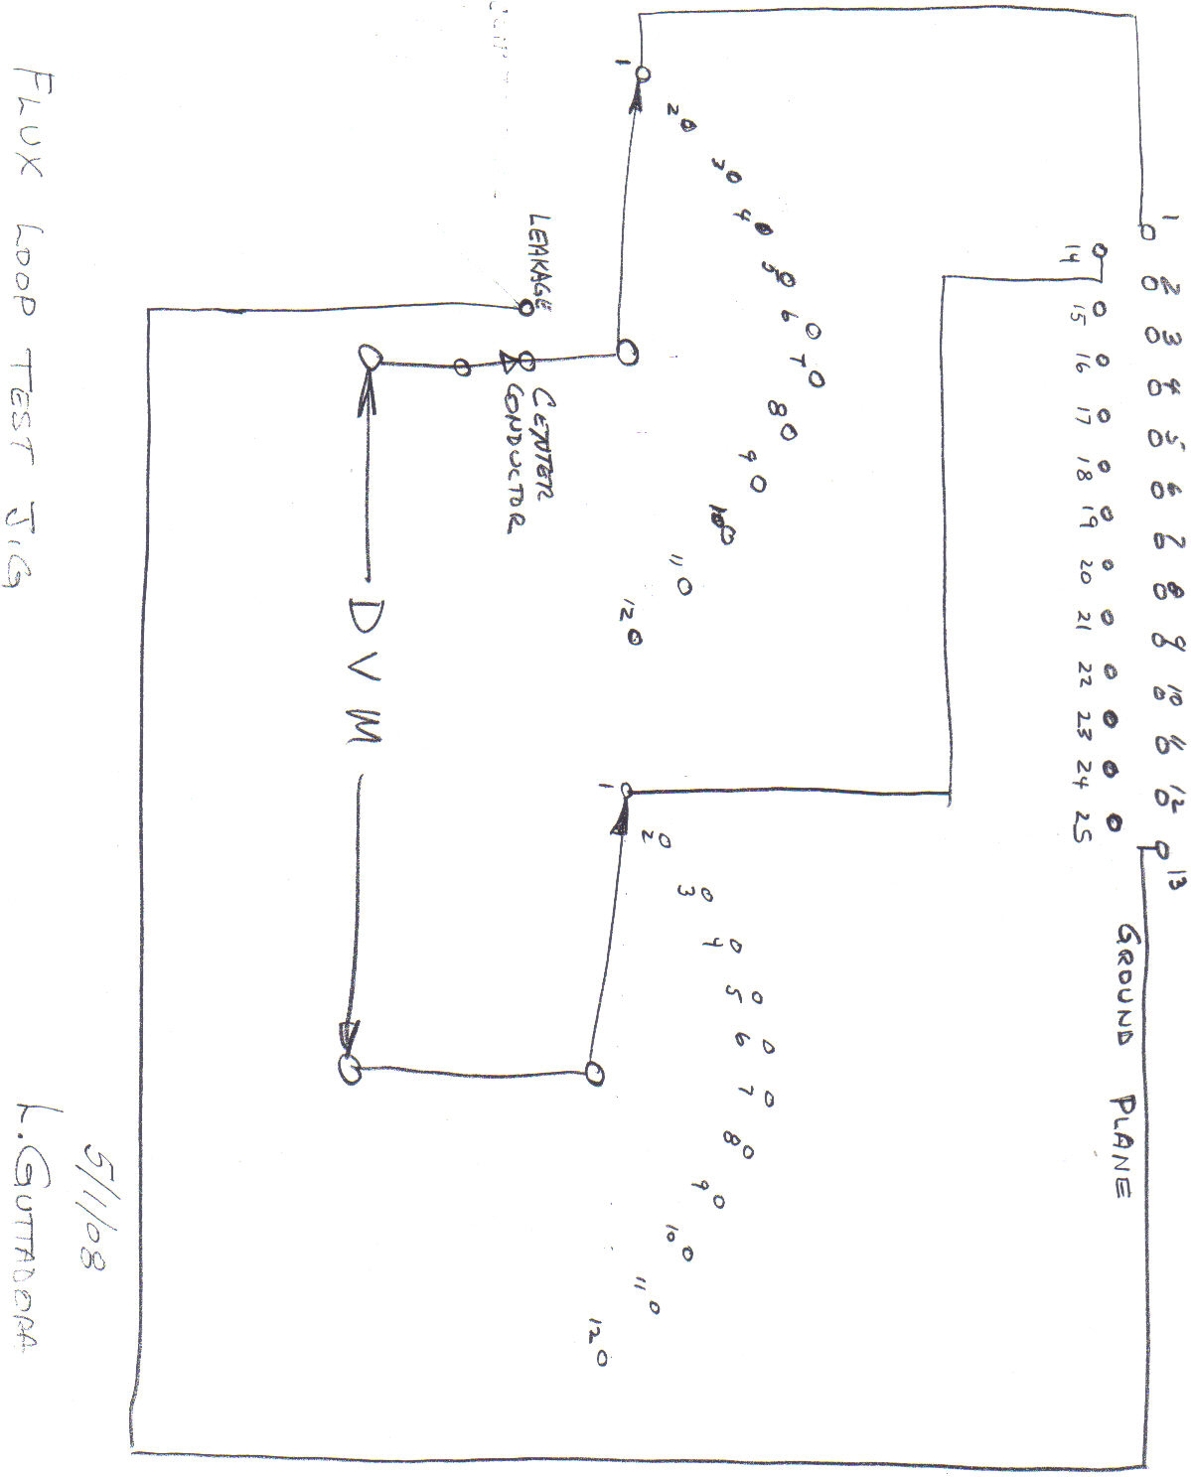
Appendix B (cont’d)

FLUX LOOP TESTER JIG PHOTO 1
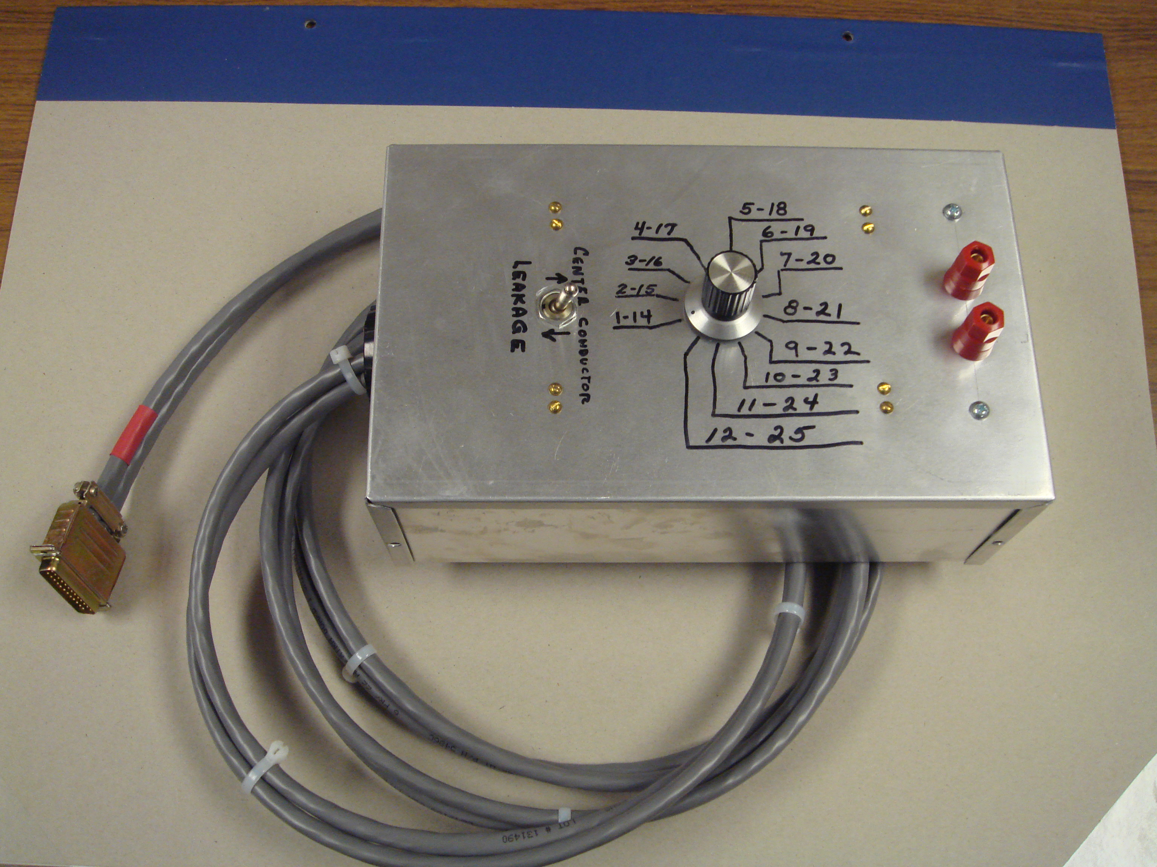
FLUX LOOP TESTER JIG PHOTO 2

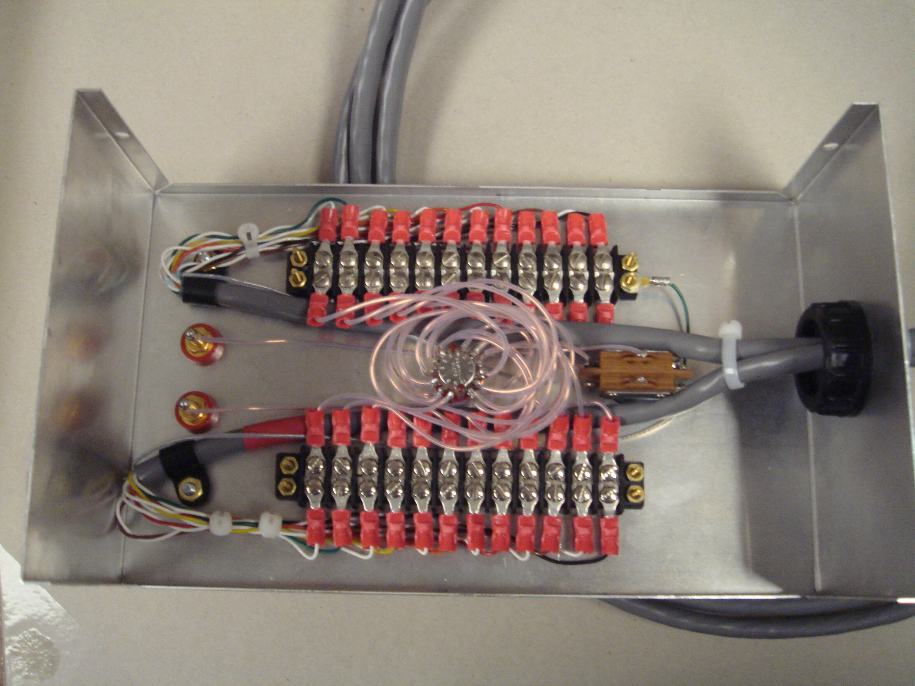

Appendix C: Adapter Cable for Thermocouple Tests
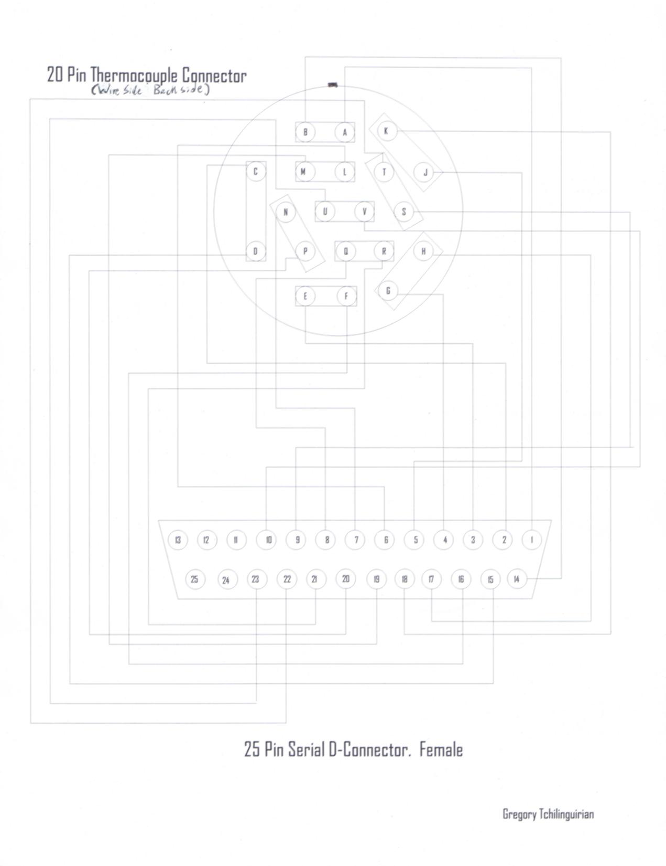
Appendix D: Adapter Cables for Heater Tests.
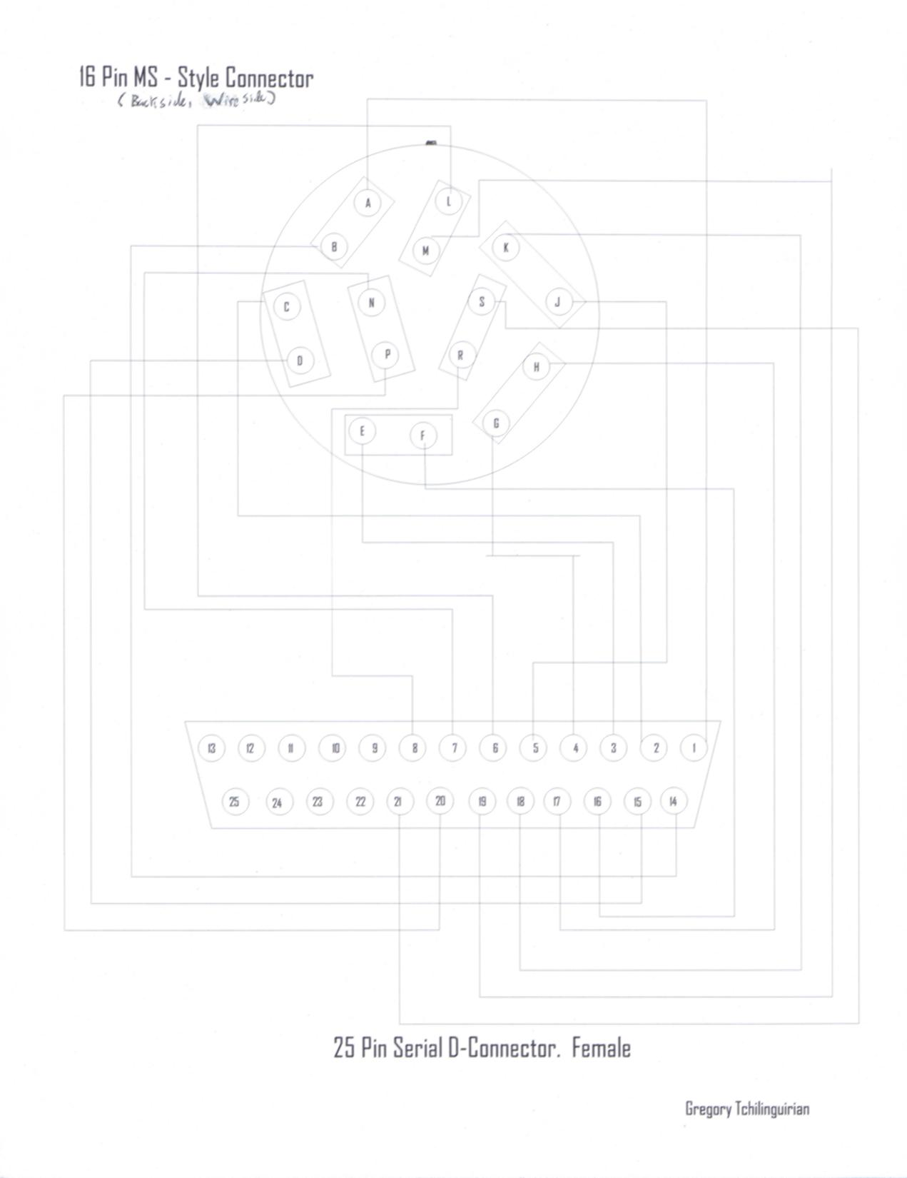

Appendix E: Heat Gun Surface Standoff

photo showing the heat gun with spacer

