A1-A2 Fitup Metrology 4/3/07

Lift the A1 coil off of the A2 coil.

Place the three shims in place, at the locations designated by Tom Brown.
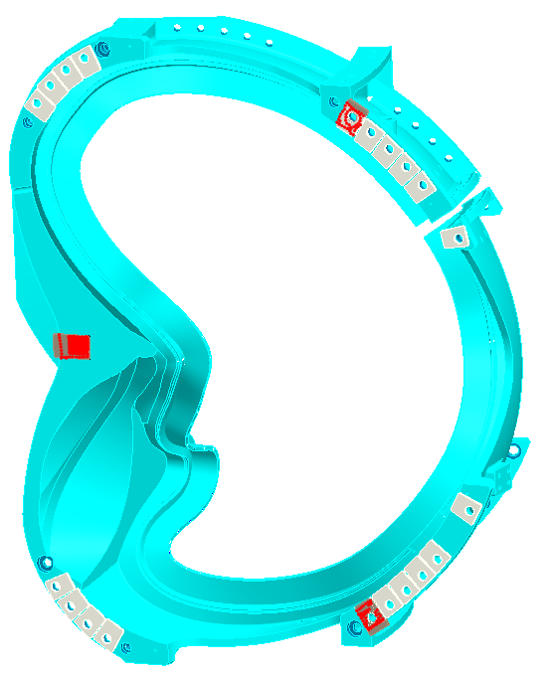
Lower the A1 back onto the A2 coil, in approximately its correct location.

Use a feeler gauge to see if the perimeters of the shims are in complete contact with the flanges. Proceed with the test regardless of the result; we have just about decided that, when fully tensioned, the actual bolts will provide compression over the entire shims because of the ductility of the flanges.

Align the laser tracker to A2 modular coil. Use the “realigned” nominals from Art Brooks. Pick a vantage point for the laser from which about 8 fiducials are visible. We should align to better than .005”, and I’d like to see more like .003”.

Assuming we can align, do the “leapfrog” measurements around the perimeter of the setup, measuring only the monuments on A2 and on the fixture.

Measure a few tooling balls on A1. A minimum of two locations must be measured. We will compute the amount of movement required of A1 to match up properly with A2. After A1 has been pushed into position, repeat the measurement of tooling balls on A1. If the tooling balls are not aligned properly, repeat the adjustment and measurement. If they are in the required location, measure the whole assembly [monuments on A1, A2, and the fixture], moving the laser tracker around the perimeter. Verify that the monuments on A1 and A2 are in the correct positions to better than .010”. If this is not the case, A1 will need to be repositioned.

[Optional step] Measure the flange to flange gap, inside and outside edge, with vernier calipers at each bolt location. This will provide a check on thickness calculations for the rest of the shims on the part. It will also help us to decide if this direct approach is more efficient for defining the remainder of the shim thicknesses than the computational approach.

Bob

