Princeton Plasma Physics Laboratory
Procedure
‘
Procedure Title: Modular Coil Fabrication-Winding Station Activities

Number:  D-NCSX-MCF-002 |  | Revision:  01 |  |  | Effective Date:  Expiration Date:  (2 yrs. unless otherwise stipulated)
Procedure Approvals
Author: James H. Chrzanowski |  |  |  |  |  | Date:
ATI: James H. Chrzanowski |  |  |  |  |  | Date:
RLM: Larry Dudek |  |  |  |  |  | Date:
Responsible Division: NCSX Project
Procedure Requirements
Designated by RLM
LABWIDE:
X | Work Planning Form # WP-1188 & 1138 (ENG-032) |  |  | Lockout/Tagout (ESH-016)
 | Confined Space Permit (5008,SEC.8 Chap 5) |  |  | Lift Procedure (ENG-021)
 | Master Equip. List Mod (GEN-005) |  | X | ES&H Review (NEPA, IH, etc.) NEPA 1283
 | RWP (HP-OP-20) |  |  | Independent Review
 | ATI Walkdown |  | X | Pre-Job Brief
X | Post-job Brief *
D-SITE SPECIFIC:
X | D-Site Work Permit (OP-AD-09) |  |  | Door Permit (OP-G-93)
 | Tritium Work Permit (OP-AD-49) |  |  | USQD (OP-AD-63)
X | Pre-Job Brief (OP-AD-79) |  |  | T-Mod (OP-AD-03)
 | ** DCA/DCN (OP-AD-104) #

* Required for installations involving internal vacuum installations, critical lifts, and for the initial installation of repetitive work.
** OP-AD-104 was voided by procedure ENG-032. However, DCA’s that were open at the time of adoption of ENG-032 are still considered valid for work approval purposes.

REVIEWERS (designated by RLM) Rec’d/
Incorp.
Comments
Accountable Technical Individual. …………J. Chrzanowski
Test Director
Independent Reviewer Hutch Neilson , Mike Anderson, Buddy Kearns XXX
D-Site Shift Supervisor
Independent
NCSX Dimensional Control Coordinator ……………………….Brent Stratton X
Vacuum
NCSX Field Supervisors… Steve Raftopoulos, Tom Meighan
Project Engineer for Stellerator Systems (WBS 1) Manager……Brad Nelson (ORNL) X
WBS Manager for Modular Coils (WBS14).. …………………Dave Williamson (ORNL)
Quality Assurance/Quality Control. ……Judy Malsbury, J. Boscoe, Colin Phelps XX
Maintenance and Operations Division
Energy Conversion System/Motor Control Division
Engineering ……………………………………..
Environmental Restoration & Waste Management Division
Environmental, Safety & Health……………………………………Jerry Levine X
Industrial Hygiene………………………………………………... Bill Slavin X
Health Physics…………………
RLM ………………………………………………………………..Larry Dudek X

TRAINING (designated by RLM)
No training required ______________ | Instructor Jim Chrzanowski
Personnel (group, job title or individual name) |  | Read Only | Instruction  Pre-job  Briefing | Hands On
Lead Tech. |  |  | X
Technicians performing task |  |  | X
Field Supervisors |  |  | X
Quality Control Representative |  |  | X
Training Rep.
RLM Larry Dudek

RECORD OF CHANGE

Revision | Date | Description of Change
00 | 11/19/04 | Initial release
01 | 8/1/05 | General description of changes:  Includes new concept for chill plates and epoxy shell for bag mold. Additional changes as result of winding the Twisted Racetrack Coil and new lead block design [changes identified with side bar]

TABLE OF CONTENTS

1 Scope 1
1.1 Introduction 1
1.2 Scope 1
1.3 Identification of Coil being manufactured: 1
2 Applicable Documents 1
2.1 NCSX-MIT/QA-142-01: 1
2.2 NCSX-PLAN-CMFOP-00: 1
2.3 D-L-NCSX-983 Lifting Modular Coil Winding Forms 1
2.4 D-L-NCSX-984 Lifting Modular Coil/ Ring Assemblies 1
2.5 D-NCSX-MCF-005 Dimensional Control & Metrology for the NCSX MC 1
2.6 D-NCSX-PLAN-MCWDC Modular Coil Dimensional Control Plan 2
3 Safety Requirements: 2
3.1 Job Hazard Analysis: 2
4 Prerequisites & Conditions: 2
4.1 Pre-Job Briefing: 2
4.2 Daily Operations Startup and Shutdown: 2
4.3 Reference Torque Values: 2
5 Materials and Parts for this station 2
6 Fabrication Process 3
6.1 Daily Startup Activities: 3
6.2 Daily Shutdown Activities: 3
6.3 Transporting MCWF from Casting Prep Station to Winding Station: 4
6.4 Install MCWF in Winding Station Turning Fixture: 4
6.5 Inspect Cladding: 6
6.6 Conductor Payout Spool: 6
6.7 Installation of Inner Groundwrap Insulation 7
6.8 Install Lower G-11CR Winding Blocks 9
6.9 Installation of Winding Clamp Side Bars 9
6.10 Dimensional Inspection 10
6.11 Positioning Lacing bands onto Winding Form 10
6.12 Position Leads for Side “A” Winding 11
6.13 Brazing Side “A” Lower Lead Connectors: 11
6.14 Fitup of Leads- Side “A” 15
6.15 Insulate Lower Leads- Side “A” 16
6.16 General Winding Notes: 16
6.17 Metrology Measurements/Tolerance Control: 18
6.18 Winding Operation- Side “A” 18
6.19 Upper Side “A” Leads 22
6.20 Preparation for Winding Side “B” 22
6.21 Inspect Cladding: 23
6.22 Positioning of lower leads for side “B” winding 24
6.23 Brazing Side “B” Lower Lead Connectors: 24
6.24 Fitup of Leads- Side “B” 27
6.25 Insulating Side “B” Lower Leads 27
6.26 General Winding Notes: 27
6.27 Winding Operation Side “B” 27
6.28 Upper Side “B” Leads 31
6.29 Winding Pack Adjustments 31
6.30 Completion of Groundwrap Installation 32
6.31 Installation of Diagnostic Loops 34
6.32 General Procedure- Outer Chill Plate/Cooling Tube Assembly: 35
6.33 Chill Plate Installation: 39
6.34 Final Positioning of Upper Leads sides “A” and “B” 40
6.35 Brazing Side “A” and “B” Upper Leads: 41
6.36 Fitup of Leads- Sides “A” and “B” 45
6.37 Insulate Upper Leads- Side “A” and “B” 45
6.38 Lead Area-Upper Chill Plates 46
6.39 Hydrostatic Tests: 47
6.40 Flow Check: 48
6.41 Winding Block Filler Strips 49
6.42 Outer Lead Chill Plate and Side Plates 49
6.43 Install Top Plate 50
6.44 Completion of Sides “A” and “B”: 50
6.45 Pre-VPI Electrical Insulation Tests: 51
6.46 Installation of Bag Mold: 53
7 Completion of Activities at Winding Station: 58
7.1 Document Verification: 58
7.2 Field Package: 58
7.3 Approval: 59

Index of Figures

Figure 1- Turning Fixture 5
Figure 2- Upper Support Plates 5
Figure 3- Orientation of Copper spools 6
Figure 4- Groundwrap scheme 7
Figure 5- Winding Clamp-Groundwrap Storage 8
Figure 6- Re-installation of Lower Winding Blocks 8
Figure 7-Location of Side Bar Shims 9
Figure 8- Position of Lacing Straps 10
Figure 9-Cross-section of Lacing straps position 11
Figure 10- Conductor w/Phenolic Blocks 12
Figure 11- Conductor in Forming Blocks 12
Figure 12- Removing Nylon Serve from conductor 12
Figure 13- Conductor in Connector 12
Figure 14- Cable Connector 13
Figure 15- Front Face-“Nibco” Braze Unit Control 13
Figure 16-Feeding the Lead Connector w/Sil-Fos 14
Figure 17- Positioning leads 16
Figure 18-Schematic of Turn Insulation Tester 17
Figure 19- Groundwrap Overlap Scheme 33
Figure 20-Diagnostic Loops 34
Figure 21- Outer Chill Plates 36
Figure 22- Staking Chill Plates 36
Figure 23- Setting Chill Plate and Tubing 37
Figure 24- Front Face- "Nibco Soldering Unit Control 38
Figure 25- Soldering Cooling Tube (photos a & b) 38
Figure 26- Cleaning of Soldered Chill Plates 39
Figure 27- Chill Plates in Lead Area 39
Figure 28- Outer Chill Plates 39
Figure 29- Upper Lead Winding Block 40
Figure 30- Upper Lead Blocks and Leads 45
Figure 31- Final Terminal Connections 45
Figure 32-Upper Lead Area Chill Plates 46
Figure 33- Winding Block Filler Strips 49
Figure 34- Outer Lead Area Chill Plate 50
Figure 35- Lead Area Side Plates 50
Figure 36-Top Plate Bushing 51
Figure 37- Lead Area Top Plate 51
Figure 38- Glass Roving Between Cooling Tubes 53
Figure 39- Installation of Bag Mold 54
Figure 40- Silicone Bag Mold 54
Figure 41- Sprue washers and extensions 55
Figure 42-Epoxy/Glass Mixture- "Cotton Candy" 57
Figure 43-Application Epoxy Glass Shell 57
Figure 44- Epoxy/Glass shell 58

Index of Tables

Table 1-Cooling Tube Hydrostat Results 46
Table 2-Cooling Tube Flow Results 47
Table 3- Pre-VPI Megger Test Results 57
Table 4- Type "C" Coil Drawings 59

Scope

Introduction
The Modular Coil Manufacturing Facility is divided into 5 workstations. Each workstation has a specific set of tasks that will be performed as part of the overall fabrication process. This procedure addresses the manufacturing, inspection, test and QC inspection points for a specific workstation.
- Station No. 1… Winding Form Preparation & Post VPI Activities
- Station No. 2… Winding Station -Molding and VPI Preparation
- Deleted Reference to Station 3
- Station No. 4… Winding Station -Molding and VPI Preparation
- Station No. 5… VPI and Autoclave Activities
- Station No. 7… Coil Testing Facility [Reference only]

Scope
This procedure is used to wind the compacted copper rope conductor onto the modular coil winding forms. It includes:
- Installing the WF in the turning fixture
- Installation of Groundwrap insulation
- Winding of coils
- Lacing of turns
- Termination of coil leads
- Metrology measurements
- Installation of Diagnostic probes
- Application of outer chill plates and cooling tubes
- Application of Bag Mold

Identification of Coil being manufactured:

Station Number: ________________________

Winding Form Type: _______________ (A, B, C or Twisted Racetrack Coil [TRC])

MC Winding Form ID No: _______________ Modular ID Coil Number: __________________

Applicable Documents

NCSX-MIT/QA-142-01:
All applicable documents associated with this procedure, are identified in the MIT/QA Plan, document number NCSX-MIT/QA-142-01.

NCSX-PLAN-CMFOP-00:
All Modular Coil work processes are governed by the “NCSX Coil Manufacturing Facility Operations Plan”, document number NCSX-PLAN-CMFOP-00.

D-L-NCSX-983 Lifting Modular Coil Winding Forms

D-L-NCSX-984 Lifting Modular Coil/ Ring Assemblies

D-NCSX-MCF-005 Dimensional Control & Metrology for the NCSX MC

D-NCSX-PLAN-MCWDC Modular Coil Dimensional Control Plan

Safety Requirements:
All work will be performed in a safe manner in accordance with PPPL Environmental Safety & Health Directives ES&H 5008 and the “Integrated Safety Management” (ISM) policy.

Job Hazard Analysis:
A JHA will be generated for each winding station, identifying existing or potential workplace hazards and to evaluate the risk of worker injury or illness associated with job tasks. (Reference document ESH-004 “Job Hazard Analysis”) The IH representative will review the JHAs for accuracy as well as completeness. It will be reviewed with all activity participants at the Pre-Job briefings.

Prerequisites & Conditions:

Pre-Job Briefing:
A pre-job briefing will be held, describing the processes and safety issues prior to starting any part of this procedure. Attendance shall be documented via training sign-in sheet.

Pre job Briefing complete: _______________________________ _________________
MC Field Supervisor Date

Daily Operations Startup and Shutdown:
Each working day, it is required to complete and initial the daily operations startup log to ensure that the station is ready to commence work activities for the day. The signoff log is located in the Daily Station Log. See section 6.1 and 6.2 for details.

Reference Torque Values:
Unless a torque value is specified, the following values shall be used whenever the procedure requires a torquing operation: (Low carbon steel hardware)

3/8-16UNC …… 18 ft-lbs 3/8-24UNF …… 19 ft-lbs ½-13 UNC …… 38 ft-lbs ½ -20 UNF …… 40 ft-lbs 5/8-11 UNC…. 83 ft-lbs 5/8-18 UNF… 95 ft-lbs
¾-10 UNC..…… 105 ft-lbs ¾-16 UNF ……. 102 ft-lbs 1-8 UNC … 236 ft-lbs 1-14 UNF …….. 212 ft-lbs 1 1/4 UNC …… 432 ft-lbs 1 ½-6 UNC …...732 ft-lbs

Materials and Parts for this station
The following materials and/or equipment will be used with this procedure.

General Description | Material | Reference Document/Product No.
Conductor | CDA 101 compacted copper rope | NCSX-CSPEC-142-03-01
Turn Insulation- glass tape | S-2 Dry glass 0.004 in. thick
Ground insulation-glass tape | S-2 Dry glass 0.007 in. thick
Ground insulation | Kapton- 5mil Type HN
Ground insulation | Kapton- 2mil Type HN
Diagnostic Flux loops | 316 SS Mineral cable insulated with Teflon heat shrink tubing | A.R.i. Incorp.  [0.032 dia. w/ 0.006 in. thk. sleeve]
Solvent | Chlor-Free Degreaser | CRC Product No. 03185 [MSDS #05032]
Solvent | Acetone | MSDS# 00561
Lead winding and enclosure fillers | G-11CR | Drawing list to be added as addendum for each coil type as approved
Chill Plates | C10100 Copper | Drawing list to be added as addendum for each coil type as approved
Cooling tubes | Copper
Lead support structures  (winding blocks) | G-11CR | Drawing list to be added as addendum for each coil type as approved
Lead terminal Assembly | Copper and G-11CR | SE142C-050
Cable connector | OFS Copper | SE142C-059
Braze material | Sil-Fos | MSDS # 03437
Turning Fixture | Equipment | Drawing no. SE144-008
Conductor payout spool | Equipment | Drawing no. SE144-120
Winding clamps | Equipment | Drawing SE144-080
Bag sealing agent | 2-part RTV 11 (white) | MSDS #02214
Bag mold material | Self-fusing Tape | Product no.7643A24 2 in. wide gray silicone tape
Bag mold shell material | chopped glass tape w/ epoxy*
Epoxy system for shell mold | *Resin/hardener 3561/2039 | MSDS # 03516 & 03515
Bag sealing | RTV 108 (caulking) | MSDS #01525
Braze inhibitor | Nicrobraz Green Stop-Off | MSDS #4748
Adhesive Tape for Lacing | 3M High Performance tape | Product no. 3M9485PC
Solder for chill plate tubes | Stay-Brite Rosin Core solder | MSDS# 05160 [J.W. Harris]

Fabrication Process
This fabrication procedure is to be used as guide to complete the station no. 2 & 4 activities. Deviation from this procedure for processes that DO NOT affect the design of the coil can be made during the winding process with the concurrence of the MC Field Supervisor. All deviations shall be documented in the procedure and initialed by the MC Field Supervisor prior to implementing the deviations. Deviations that may effect the design of the coil requires a Request for Deviation “RFD” approval. The RFD must be approved prior to proceeding. Procedure changes need to be incorporated into the document via “Minor Procedure Changes” or “Revisions”.

Daily Startup Activities:

Check all daily supplies needed:

Verify operation of all equipment needed that day.

Check station for cleanliness

Check that safety guards are intact

Check that safety equipment needed for day’s activities are available

Check that the day’s travelers and procedures are in their document holder.

Once completed, date and initial daily log at the back of the Station Log Book.

Daily Shutdown Activities:

Turn off power to equipment not in use.

Clean entire workstation area.

Verify that all Traveler and data sheet information is complete.

The Lead Technician shall verify that the Station’s Log Book has been completed and signed for the day.

Once completed, date and initial daily log at the back of the Station Log Book.

Transporting MCWF from Casting Prep Station to Winding Station:

Install the upper support plates that secure the support ring to the support/lift beam. This operation must be verified prior to proceeding. See Figure 2- Upper Support Plates

Verified by: _________________________ Date: __________________
Lead Technician

Using lift procedure D-L-NCSX-984 rig the upper support/lift beam to the overhead crane.

Once a slight load has been taken, remove the hardware that secures the upper support/lift beam to the turning fixture frame.

Compress the springs under the gear box (drive system) until they are bottomed.

Disengage and remove the upper guide rollers. NOTE: Sling the rollers and raise them into position with rope. Do not climb up ladder with roller assembly in hand.

Carefully raise the winding form/ring assembly from station 1b and transport to either modular coil winding stations no. 2 or 4. Install the MCWF into the turning fixture via the ceiling hatch.

Note: During the installation of the MCWF into the turning fixture, to minimize risk of potential dirt contamination, the rooms must be isolated from each other. This only applies if a coil is already in the adjacent winding station.

Verified by: _________________________ Date: __________________
Field Supervisor

Install MCWF in Winding Station Turning Fixture:

Compress the springs under the gear box (drive system) until they are bottomed.

Lower the MCWF and ring assembly into the turning fixture using the corner brackets for alignment. Bolt up one end loosely (use spud wrenches to align holes).

Install the upper guide rollers and align all of the guide rollers to the support ring. NOTE: Sling the rollers and raise them into position with rope. Do not climb up ladder with roller assembly in hand.

Decompress springs under the gear box (drive unit) until gear is fully engaged with ring gear rack. This must be verified prior to proceeding.

Verified by: _________________________ Date: __________________
Lead Technician

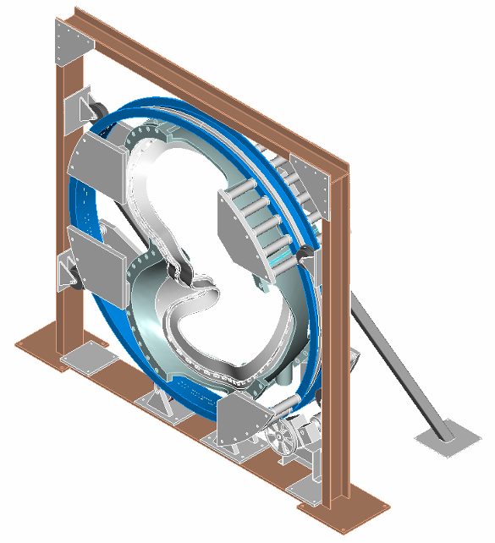
Turning Fixture Support Ring
Turning Fixture Support Plates
Turning Fixture-Upper Support/Lifting Beam
Turning Fixture Drive System
Turning Fixture Support Roller Guide Rollers
Turning Fixture Support Frame

Figure 1- Turning Fixture

Verify that the upper support/lift beam is in proper position and secured with appropriate hardware that is torqued to the proper value. [See section 4.3]

Verified by: _________________________ Date: __________________
Lead Technician

Remove the upper support plates between the support ring and lift beam. This operation must be verified prior to operating turning fixture. [See Figure 2- Upper Support Plates]

Verified by: _________________________ Date: __________________
Lead Technician
Remove Upper Support Plates
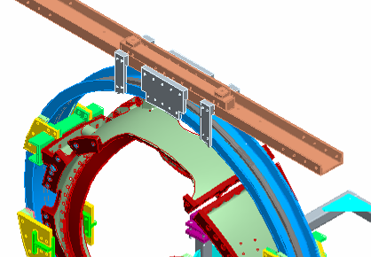
Figure 2- Upper Support Plates

To ensure proper alignment and operation of the turning fixture, rotate the MCWF a full revolution in the direction that is needed for winding, using the foot-pedal control. Re-adjust the alignment rollers as required. Alignment of MCWF to the turning fixture is complete.

Verified by: _________________________ Date: __________________
Lead Technician

Inspect Cladding:

Inspect cladding for any damage, movement or contamination that may have occurred during installation of MCWF into the turning fixture. Repair and/or clean as required.

Verified by: _________________________ Date: __________________
Lead Technician

Conductor Payout Spool:
Load (4) spools of copper conductor into the conductor payout spool fixture. Position the spools in the fixture with the upper spools (1 and 2) being fed from the bottom side and lower spools (3 & 4) being fed from the topside [See Figure 3- Orientation of Copper spools] [Note: the cable lead connectors may be brazed onto the conductors prior to installing the copper spools per section 6.13]

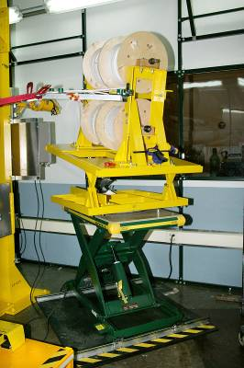
Conductor Spools 1 and 2
Conductor Spools 3 and 4
Figure 3- Orientation of Copper spools

The height, angle and pitch of the conductor payout spool relative to the winding station shall be modified during the winding operation. This will help to minimize any twisting or excessive keystoning of the conductor prior to being laid in position.

Measure the conductor cross-sectional dimensions with Vernier calipers using light pressure. Record the measured data in space below.
Measured conductor cross-section:
Height
(Inches)
Width (Inches)

Height (Inches):

Width (Inches):

Installation of Inner Groundwrap Insulation
Position the inner layers of ground wrap insulation onto the MCWF [Sides “A” and “B”] winding surfaces directly over the copper cladding. Since the Ground wrap insulation is being installed as individual lengths, it is necessary to roll the excess insulation on the top side of the winding form and store in place until the final GW operations begin. Ensure that the position of the rolled groundwrap insulation is high enough above the coil tee so that it does not get trapped by the upper layers of the coil during winding. Hold in position with non-conductive fasteners. On the lower side, a minimum of 4 inches should extend beyond the winding surface. This end cannot be rolled, but should remain loose. (See Error: Reference source not found)

Note: Ensure that personnel handling the insulation are wearing either cotton and/ or latex surgical gloves

Apply pre-cut layers (approximately 18 inches long) of ground wrap insulation Figure 4- Groundwrap scheme

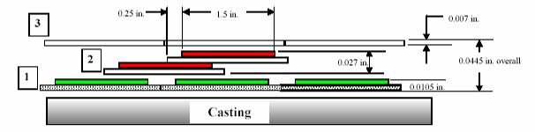
Figure 4- Groundwrap scheme
Layer 1 (Inner):
Apply (1) Butt lapped layer of composite insulation
- 0.007 inch thick S-2 glass [nominal 2 inch wide]
- 0.0035 (HN) Kapton tape [nominal 1.5 inch wide] with adhesive back
Layer 2 (Mid):
Apply (1) half-lapped layer of composite insulation:
  - 0.007 in. thick glass [2 inch nom. wide]
  - 0.0065(HN) Kapton [1.5 nom. wide] with adhesive
Layer 3 (Outer):
Apply (1) Butt lapped layer of S-2 glass tape
- 0.007 in. thick S-2 glass [2 inch nom. wide]

Application of the inner ground wrap has been satisfactorily completed.

Verified Side “A” complete:

Lead Technician: ____________________________ Date: ____________________

Field Supervisor: ____________________________ Date: ____________________

Verified Side “B” complete:

Lead Technician: ____________________________ Date: ____________________

Field Supervisor: ____________________________ Date: ____________________

Notes:

Winding clamp Base
Sidebars
Upper excess ground wrap shall be rolled for storage, but shall remain beyond winding surface. Hold in place with non-conductive fasteners.
Lower excess ground wrap shall extend a minimum of 4 inches beyond winding surface.

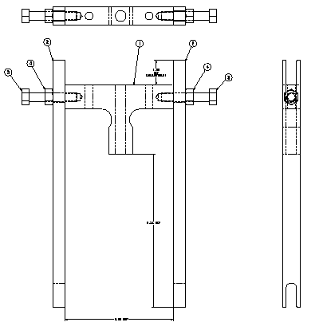
Figure 5- Winding Clamp-Groundwrap Storage

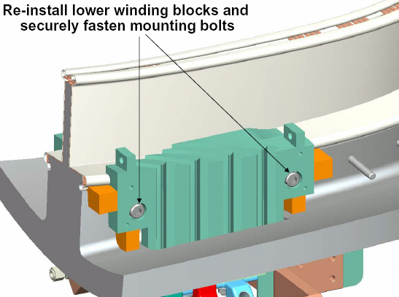

Figure 6- Re-installation of Lower Winding Blocks

Install Lower G-11CR Winding Blocks

Reinstall the lower positioning bushings and G-11CR winding blocks on sides “A” and “B”. Secure hardware. [Figure 6- Re-installation of Lower Winding Blocks

Installation of Winding Clamp Side Bars

The winding clamp side bars need to be positioned onto the winding form for sides “A” and “B”. Each side bar position shall be shimmed to pre-determined dimensions to set the maximum width of the coil bundle. Gauge blocks will be used to set the positions of side clamps and to ensure that they are parallel to the septum.

The shim dimensions shall be provided by the Metrology engineer.

Shim dimensions received and verified by:

Metrology Engineer: ____________________________ Date: ____________________

Dimensional Control Coordinator: __________________________Date: _____________

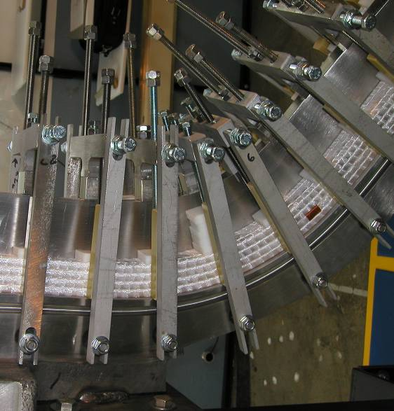
Location of washer shim packs (behind side bars)
Figure 7-Location of Side Bar Shims

The winding team shall install the correct shim washers on the weld studs between the casting and the side bar nuts. [See Figure 7-Location of Side Bar Shims

A record of the shim washer thicknesses used for each side bar shall be kept and approved by the Metrology Engineer.

Shim installation complete:
Verified by: _________________________ Date: _____________
Metrology Engineer

Dimensional Inspection

Using metrology equipment (Romer arm) thoroughly measure the surface of the ground wrap insulation on side “A” and “B” using procedure D-NCSX-MCF-005. This measurement will include the MCWF machined winding surfaces plus the cladding and groundwrap insulation thicknesses.

Measurements taken by: _________________________ Date: _______________

Measurements completed and verified by:

Metrology Engineer: ____________________________ Date: ____________________

QC Representative: ____________________________ Date: ____________________

Summary table of data collected shall be added to section 9 of the Coil Field Package.

Positioning Lacing bands onto Winding Form

Place single bands of 0.004 inch thick x 0.5 inch wide x 18 inch long glass tape onto the groundwrap (sides “A” and “B”) in positions located either side of the winding clamps. [See Figure 8- Position of Lacing Straps and Figure 9-Cross-section of Lacing straps position]

The bands of lacing can be temporarily held in place with strips of Kapton adhesive back tape on the vertical surface only. Note: The Kapton strips must be removed prior to being trapped by layers of conductor during winding operations.

The upper bands of lacing shall be rolled and stored with the Groundwrap insulation. Hold in position with non-conductive fasteners. On the lower side, a minimum of 6 inches should extend beyond the winding surface. This end cannot be rolled, but should remain loose. [See Figure 9-Cross-section of Lacing straps position]

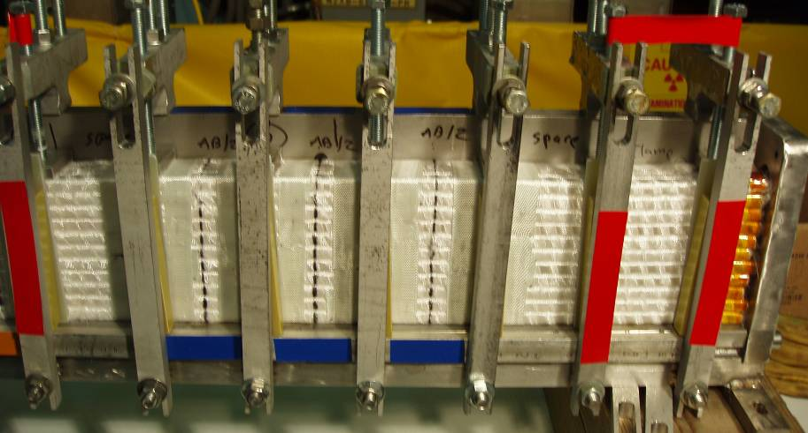
Glass lacing bands will be positioned on either side of winding clamp as shown. View shows bands after winding.
Winding clamp Base
Upper excess ground wrap shall be rolled for storage, but shall remain beyond winding surface.
Figure 8- Position of Lacing Straps

Position of lacing bands on winding form
Location of Kapton strips used to hold the lacing in position.
Figure 9-Cross-section of Lacing straps position

Installation of Lacing Bands Sides “A” and “B” is complete.

Verified:

Lead Technician: ____________________________ Date: ____________________

Field Supervisor: ____________________________ Date: ____________________

Position Leads for Side “A” Winding

Feed sufficient copper from each of the (4) conductor spools located on the payout spool fixture until they reach the MCWF. Note: the conductor shall be fully supported between the payout spool and the winding form.

Determine the length of each conductor that is required to reach the terminal connections.

Brazing Side “A” Lower Lead Connectors:
The cable lead connectors will be brazed to the cable conductor using flameless “Nibco” resistive heating carbon tongs and Sil-Fos braze material. Only braze qualified individuals [per BPS-008] can perform the lead brazes and requirements of ES&HD 5008, Section 9, Chapter 15 for safe brazing must be followed.

Notify the ESU and obtain a flame permit prior to starting brazing operation.

Verified by: _________________________ Date: __________________
Lead Technician

Area preparation: Protect the surrounding coil area from any dirt or carbon that may occur as a result of the brazing operation. The area between clean rooms MUST be isolated if a coil is in the adjacent room. The ceiling hatch should be open during the brazing operations.

Copper Cable Connector: Clean the copper cable connector [Figure 14- Cable Connector] using acetone-degreasing agent Scotchbrite, and clean lint free wipes. Use a wire bottlebrush on the inner bore along with the acetone. Once cleaned, do not touch the components with bare hands. Coat the threads and outside surface of the cable connector with “Nicrobraz”. This coating will minimize the braze material from adhering to the external surfaces. Do not get any of the “Nicrobraz” inside of the connector since this will effect the quality of the braze joint.

Conductor Preparation Step 1: Reshape the copper rope conductor using phenolic form blocks to provide a proper fit between the cable and cable connector. The nylon serve shall remain in place during the rounding operation. See Figure 10- Conductor w/Phenolic Blocks and Figure 11- Conductor in Forming Blocks.

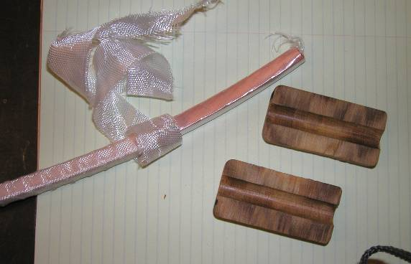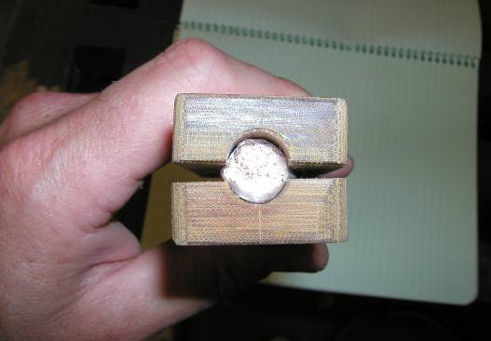
Figure 10- Conductor w/Phenolic Blocks
Figure 11- Conductor in Forming Blocks

Conductor Preparation Step 2: Once formed, carefully remove the Nylon serve (covering) from the very end of the (approx. ¼ inch) conductor. (Figure 12- Removing Nylon Serve from conductor) Measure the depth of the cable connector and transfer that measurement to the outside of the conductor serve.

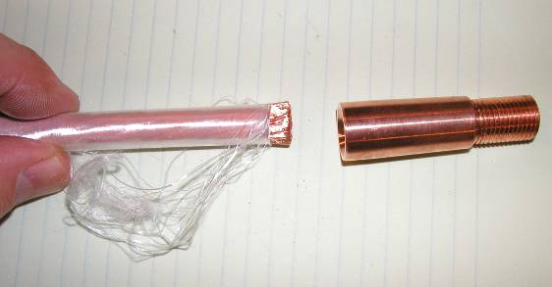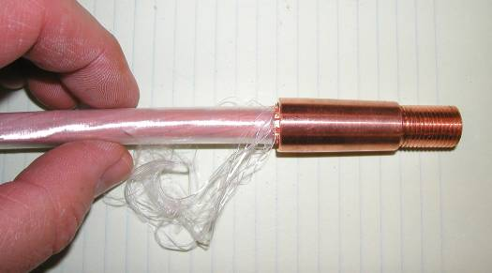
Figure 12- Removing Nylon Serve from conductor
Figure 13- Conductor in Connector

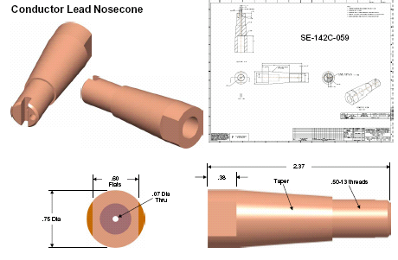
Figure 14- Cable Connector

Conductor Preparation Step 3: Carefully slide the end of the conductor into the connector. Once the conductor is engaged with the connector, carefully remove additional Nylon serve (covering) so that the bare conductor can be fully inserted into the inner connector bore. Use the measurement marking that is on the nylon serve from the step 6.13.5. Continue sliding the conductor into the connector, until it bottoms out. See Figure 13- Conductor in Connector

Conductor Preparation Step 4: Strip back approximately 5.5 inches of the nylon serve starting at the copper cable connector.

Position the bare copper rope conductor into the water chill blocks and position the Argon gas head directly over the copper terminal. [Figure 16-Feeding the Lead Connector w/Sil-Fos]

Place the carbon tongs onto the solid portion of the copper connector close to the threads

Set the toggle switches on the control unit to “B” and “C”. [Figure 15- Front Face-“Nibco” Braze Unit Control]

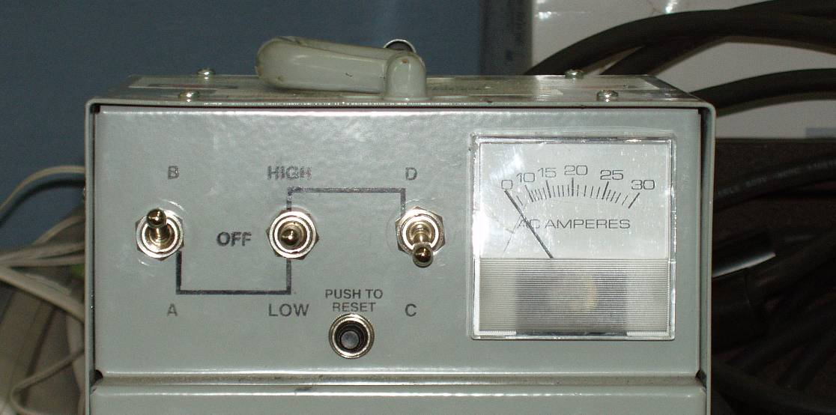
Figure 15- Front Face-“Nibco” Braze Unit Control

Place the center toggle switch to “HIGH”, and using the carbon tongs heat the copper connector. Once at temperature, feed the Sil-Fos rod through the feedhole at the threaded end of the connector until liquid braze material is visible at the conductor side of the connector. Reposition the tongs to the conductor side and feed the Sil-Fos rod through the backside of the connector until liquid braze material is visible at the threaded end of the connector. [See Figure 16-Feeding the Lead Connector w/Sil-Fos]

Clean the braze area, removing any excess Sil-Fos. Remove the remaining Nicrobraz from the surfaces. If required, use a special honing block for cleaning the tapered cable connector.

Repeat the process with each of the four inner copper cable connectors.

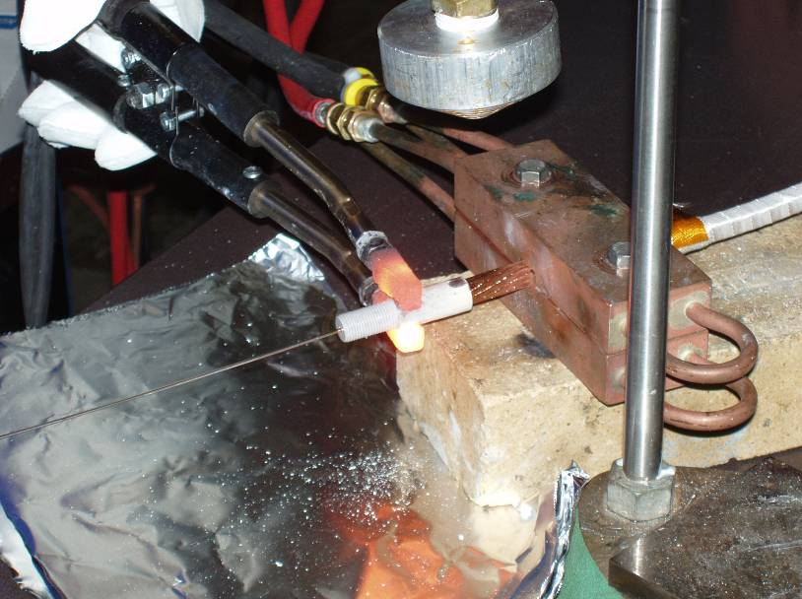
Argon Gas Head
Water Chill Block
Sil-Fos Rod being fed
Carbon Tongs
Figure 16-Feeding the Lead Connector w/Sil-Fos

Inspect each brazed lead connector following cleanup. If a lead connector braze is rejected, the connector must be removed and the connector braze remade.

LOWer CABLE CONNECTOR #1 Pancake “A”:

Date Brazed: ______________________ Braze performed by: _____________

QC Inspected by: ______________________ Date: ___________________

Notes:

LOWer CABLE CONNECTOR #2 Pancake “A”:

Date Brazed: ______________________ Braze performed by: _____________

QC Inspected by: ______________________ Date: ___________________

Notes:

LOWer CABLE CONNECTOR #3 Pancake “A”:

Date Brazed: ______________________ Braze performed by: _____________

QC Inspected by: ______________________ Date: ___________________

Notes:

LOWer CABLE CONNECTOR #4 Pancake “A”:

Date Brazed: ______________________ Braze performed by: _____________

QC Inspected by: ______________________ Date: ___________________

Notes:

Fitup of Leads- Side “A”

Carefully route the connector end of the conductors into the lower lead block. Pre-form the conductors during the fitup to conform to the lead block. Remove the formed conductors.

Insulate Lower Leads- Side “A”
Once the connectors have been brazed and leads prefit, the leads need to be insulated.

Apply by hand (1) half-lapped layer of composite insulation [0.007 in. thick glass tape/ 0.0065(HN) Kapton tape w/ adhesive back] over each of the individual conductors starting from the point that the conductors separate to the conductor connector.

Position the first layer of (4) conductors into the conductor slots in the lower lead guide block. The conductors shall be placed in alternating slots. Care must be taken during this operation, to minimize any damage to the over wrap insulation. Secure connectors in-place but do not torque at this time. [Figure 17- Positioning leads]

Verified:

Lead Technician: ____________________________ Date: ____________________

Field Supervisor: ____________________________ Date: ____________________

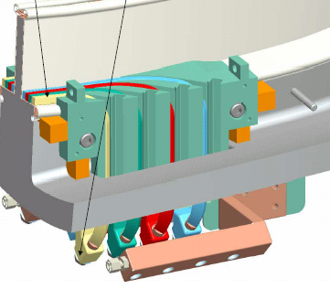
Position leads in lower lead guide block and into copper terminals
Figure 17- Positioning leads

General Winding Notes:
Once the first set of coil leads have been positioned and secured, the winding operation can begin.

Using the foot control start the rotation of the turning fixture in the direction that the coil is to be wound. [Determined by coil drawings and guidance of field supervisor] The speed of the turning fixture shall be decided by the Field Supervisor and lead technician as required to suit the coil manufacturing operation.

During the winding process, the pre-insulated copper rope conductors will be scanned with an electrical short indicator [“Whisker Detector”] that will identify any copper fibers that may protrude from the insulation causing turn to turn or turn to ground shorts. [Figure 18-Schematic of Turn Insulation Tester] If a whisker is detected, the whisker will be removed, prior to proceeding.

Copper plate
Grounded copper plates or rollers
4- Insulated conductors
Figure 18-Schematic of Turn Insulation Tester

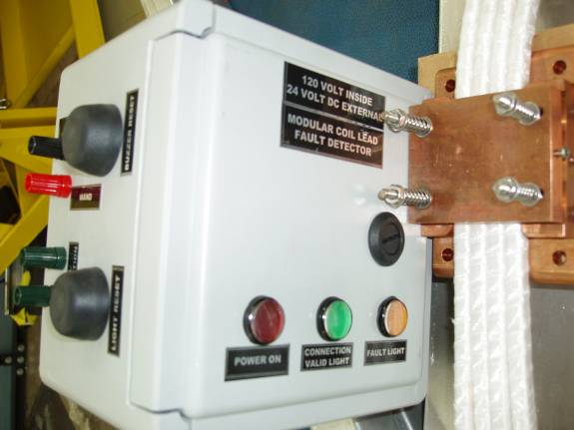
Conductor “Whisker” detector copper shell
“Whisker” detector control unit
Figure 18b- “Whisker” Detector

Wind the 4-in-hand conductors onto the MCWF until the first several coil clamps have been cleared. Stop the winder at that point.

During the winding process, as a general rule, remove the minimal number of winding clamps necessary to allow sufficient space for the conductors to be wound onto the winding form.

Tightening the upper coil clamps to 30 in-lbs and tightening the side bars until snug against the shim washers shall be repeated whenever clamps are replaced after adding another layer of conductor in a given area.

During the winding operations as the turns are laid onto the winding form, gently tap the turns with a G-10 setting tool and soft face hammer. This operation will set the turns in place and help minimize keystoning of the conductor.

Ensure that the Kapton strips that were installed in step 6.11 to hold the lacing strips in position are removed prior to being trapped by layers of conductor during winding.

Metrology Measurements/Tolerance Control:

During the winding operations, additional measurements may be required to verify the precise vertical and radial builds of the turns. The location and frequency of measurements will be determined by the NCSX Metrology Engineering and the Dimensional Control Coordinator.

Procedure D-NCSX-MCF-005 describes the use of the “Romer” measuring arm and the steps required to perform measurements. All data collected [in summary form] will be added to Section 9 of the Coil Field Package titled “Metrology Data”.).

To maintain tolerance control the use of “Lacing” bands and predetermined criteria described in 6.16.5 for tightening the winding clamps will be used.

Winding Operation- Side “A”

Wind layer number 1
Note all observations, abnormalities or measurements that were taken. All measurement data shall be added to Section 9 of the Coil Field Package titled “Metrology Data”.

Notes:

Completion of Layer 1

Verified by: _________________________ Date: __________________
Lead Technician

Wind layer number 2
Note all observations, abnormalities or measurements that were taken. All measurement data shall be added to Section 9 of the Coil Field Package titled “Metrology Data”.

Notes:

Completion of Layer 2

Verified by: _________________________ Date: __________________
Lead Technician

Wind layer number 3
Note all observations, abnormalities or measurements that were taken. All measurement data shall be added to Section 9 of the Coil Field Package titled “Metrology Data”.

Notes:

Completion of Layer 3

Verified by: _________________________ Date: __________________
Lead Technician

Wind layer number 4
Note all observations, abnormalities or measurements that were taken. All measurement data shall be added to Section 9 of the Coil Field Package titled “Metrology Data”.

Notes:

Completion of Layer 4

Verified by: _________________________ Date: __________________
Lead Technician

Wind layer number 5
Note all observations, abnormalities or measurements that were taken. All measurement data shall be added to Section 9 of the Coil Field Package titled “Metrology Data”.

Notes:

Completion of Layer 5

Verified by: _________________________ Date: __________________
Lead Technician

Wind layer number 6
Note all observations, abnormalities or measurements that were taken. All measurement data shall be added to Section 9 of the Coil Field Package titled “Metrology Data”.

Notes:

Completion of Layer 6

Verified by: _________________________ Date: __________________
Lead Technician

Wind layer number 7
Note all observations, abnormalities or measurements that were taken. All measurement data shall be added to Section 9 of the Coil Field Package titled “Metrology Data”.

Notes:

Completion of Layer 7

Verified by: _________________________ Date: __________________
Lead Technician

Wind layer number 8
Note all observations, abnormalities or measurements that were taken. All measurement data shall be added to Section 9 of the Coil Field Package titled “Metrology Data”.

Notes:

Completion of Layer 8

Verified by: _________________________ Date: __________________
Lead Technician

Wind layer number 9
Note all observations, abnormalities or measurements that were taken. All measurement data shall be added to Section 9 of the Coil Field Package titled “Metrology Data”.

Notes:

Completion of Layer 9

Verified by: _________________________ Date: __________________
Lead Technician

Wind layer number 10 [Note: Maximum turns in Type C and TRC coils]
Note all observations, abnormalities or measurements that were taken. All measurement data shall be added to Section 9 of the Coil Field Package titled “Metrology Data”.

Notes:

Completion of Layer 10

Verified by: _________________________ Date: __________________
Lead Technician

Wind layer number 11 [Note: Maximum turns in Type A and B coils]
Note all observations, abnormalities or measurements that were taken. All measurement data shall be added to Section 9 of the Coil Field Package titled “Metrology Data”.

Notes:

Completion of Layer 11

Verified by: _________________________ Date: __________________
Lead Technician

Upper Side “A” Leads

The upper side “A” leads cannot be finalized at this time.

Measure and determine the length of conductor that is required to complete the final coil leads. Add several additional inches to the required length.

Tape the end of the conductor at cut line so that the conductor rope does not unravel. Cut the four conductors.

Secure the four conductors to the side “A” bundle. These leads will be finalized once the side “B” bundle has been completed.

Side “A” is now secured, and work can begin on the side “B” bundle.

Verified:

Lead Technician: ____________________________ Date: ____________________

Field Supervisor: ____________________________ Date: ____________________

Preparation for Winding Side “B”

Reposition modular coil in turning fixture
Once the side “A” turns of the Modular Coil have been wound, the coil needs to be repositioned to enable the side “B” turns to be wound.

Note: To minimize potential dirt or contaminant risk, during the MCWF installation operation, if a coil is being wound in the adjacent station, the rooms must be isolated from each other.

Re-install the support plates between the lift beam and turning ring assembly. [Figure 2- Upper Support Plates]

Rig the support/lift beam assembly to the overhead crane per lift procedure D-L-NCSX-984.

Compress the springs under the gear box (drive system) until they are bottomed.

Remove the support/lift beam hardware that locks the lift beam to turning fixture frame. Loosen the alignment rollers from engagement with the turning fixture ring. NOTE: Sling the rollers and lower them into position with rope. Do not climb down ladder with roller assembly in hand.

Verify that all steps 6.20.1.1 thru 6.20.1.4 have been completed and the coil is ready for lift.

Verified by: _________________________ Date: __________________
Lead Technician

Using Lift Procedure D-L-NCSX-984 lift and reposition the modular coil in the turning fixture to allow winding of pancake “B”.

Lower the MCWF and ring assembly into the turning fixture using the corner brackets for alignment. Bolt up one end loosely (use spud wrenches to align holes).

Install the upper guide rollers and align all of the guide rollers to the support ring. NOTE: Sling the rollers and raise them into position with rope. Do not climb up ladder with roller assembly in hand.

Decompress springs under the gear box (drive unit) until gear is fully engaged with ring gear rack. This must be verified prior to proceeding.

Verified by: _________________________ Date: __________________
Lead Technician

Verify that the upper support/lift beam is in proper position and secured with appropriate hardware that is torqued to the proper value [see section 4.3].

Verified by: _________________________ Date: __________________
Lead Technician

Remove the upper support plates between the support ring and lift beam. This operation must be verified prior to operating turning fixture. [See Figure 2- Upper Support Plates]

Verified by: _________________________ Date: __________________
Lead Technician

To ensure proper alignment and operation of the turning fixture rotate the MCWF a full revolution in the direction needed for winding, using the foot-pedal control. Re-adjust the alignment rollers as required. Alignment of MCWF to the turning fixture is complete.

Verified by: _________________________ Date: __________________
Lead Technician

Inspect Cladding:

Inspect cladding for any damage, movement or contamination that may have occurred during installation of MCWF into the turning fixture. Repair and/or clean as required.

Verified by: _________________________ Date: __________________
Lead Technician

Conductor Payout Spool:
Load (4) spools of copper conductor into the conductor payout spool fixture. Position the spools in the fixture with the upper spools (1 and 2) being fed from the bottom side and lower spools (3 & 4) being fed from the topside (See Figure 3- Orientation of Copper spools) [Note: the cable lead connectors may be brazed onto the conductors prior to installing the copper spools per section 6.23]

Positioning of lower leads for side “B” winding

Feed sufficient copper from each of the (4) conductor spools located on the payout spool fixture until they reach the MCWF. Note: the conductor shall be fully supported between the payout spool and the winding form.

Measure the conductor cross-sectional dimensions with Vernier calipers using light pressure. Record the measured data in space below.

Measured conductor cross-section:
Height
(Inches)
Width (Inches)

Height (Inches):

Width (Inches):

Brazing Side “B” Lower Lead Connectors:
The cable lead connectors will be brazed to the cable conductor using flameless “Nibco” resistive heating carbon tongs and Sil-Fos braze material. Only braze qualified individuals [per BPS-008] can perform the lead brazes and requirements of ES&HD 5008, Section 9, Chapter 15 for safe brazing must be followed.

Notify the ESU and obtain a flame permit prior to starting brazing operation.

Verified by: _________________________ Date: __________________
Lead Technician

Area preparation: Protect the surrounding coil area from any dirt or carbon that may occur as a result of the brazing operation. The area between clean rooms MUST be isolated if a coil is in the adjacent room. The ceiling hatch should be open during the brazing operations.

Copper Cable Connectors: Clean the copper cable connectors [Figure 14- Cable Connector] using acetone-degreasing agent Scotchbrite, and clean lint free wipes.. Use a wire bottlebrush on the inner bore along with the acetone. Once cleaned, do not touch the components with bare hands. Coat the threads and outside surface of the cable connector with “Nicrobraz”. This coating will minimize the braze material from adhering to the external surfaces. Do not get any of the “Nicrobraz” inside of the connector since this will effect the quality of the braze joint.

Conductor Preparation Step 1: Reshape the copper rope conductor using phenolic form blocks to provide a proper fit between the cable and cable connector. The nylon serve shall remain in place during the rounding operation. See Figure 10- Conductor w/Phenolic Blocks and Figure 11- Conductor in Forming Blocks.

Conductor Preparation Step 2: Once formed, carefully remove the Nylon serve (covering) from the very end of the (approx. ¼ inch) conductor. (Figure 12- Removing Nylon Serve from conductor) Measure the depth of the cable connector and transfer that measurement to the outside of the conductor serve.

Conductor Preparation Step 3: Carefully slide the end of the conductor into the connector. Once the conductor is engaged with the connector, carefully remove additional Nylon serve (covering) so that the bare conductor can be fully inserted into the inner connector bore. Use the measurement marking that is on the nylon serve from the step 6.23.5. Continue sliding the conductor into the connector, until it bottoms out. See Figure 13- Conductor in Connector

Conductor Preparation Step 4: Strip back approximately 5.5 inches of the nylon serve starting at the copper cable connector.

Position the bare copper rope conductor into the water chill blocks and position the Argon gas head directly over the copper terminal. [Figure 16-Feeding the Lead Connector w/Sil-Fos]

Place the carbon tongs onto the solid portion of the copper connector.

Set the toggle switches on the control unit to “B” and “C”. [Figure 15- Front Face-“Nibco” Braze Unit Control]

Place the center toggle switch to “HIGH”, and using the carbon tongs heat the copper connector. Once at temperature, feed the Sil-Fos rod through the feedhole at the threaded end of the connector until liquid braze material is visible at the conductor side of the connector. Reposition the tongs to the conductor side and feed the Sil-Fos rod through the backside of the connector until liquid braze material is visible at the threaded end of the connector. [See Figure 16-Feeding the Lead Connector w/Sil-Fos

Clean the braze area, removing any excess Sil-Fos. Remove the remaining Nicrobraz from the surfaces. If required, use a special honing block for cleaning the tapered cable connector.

Repeat the process with each of the four inner copper cable connectors.

Inspect each brazed lead connector following cleanup. If a lead connector braze is rejected, the connector must be removed and the connector braze remade.

Lower CABLE CONNECTOR #1 Pancake “B”:

Date Brazed: ______________________ Braze performed by: _____________

QC Inspected by: ______________________ Date: ___________________

Notes:

Lower CABLE CONNECTOR #2 Pancake “B”:

Date Brazed: ______________________ Braze performed by: _____________

QC Inspected by: ______________________ Date: ___________________

Notes:

Lower CABLE CONNECTOR #3 Pancake “B”:

Date Brazed: ______________________ Braze performed by: _____________

QC Inspected by: ______________________ Date: ___________________

Notes:

Lower CABLE CONNECTOR #4 Pancake “B”:

Date Brazed: ______________________ Braze performed by: _____________

QC Inspected by: ______________________ Date: ___________________

Notes:

Fitup of Leads- Side “B”

Carefully route the connector end of the conductors into the lower side “B” lead block. Pre-form the conductors during the fitup to conform to the lead block. Remove the formed conductors.

Insulating Side “B” Lower Leads
Once the connectors have been brazed and leads pre-fit, the leads need to be insulated.

Apply by hand (1) half-lapped layer of composite insulation [0.007 in. thick glass tape/ 0.0065(HN) Kapton tape w/ adhesive back] over each of the individual conductors starting from the point that the conductors separate to the conductor connectors.

Position the first layer of (4) conductors into the conductor slots in the lower lead guide block. The conductors shall be placed in alternating slots. Care must be taken during this operation, to minimize any damage to the over wrap insulation. Secure connectors in-place but do not torque at this time. [Figure 17- Positioning leads]

Verified:

Lead Technician: ____________________________ Date: ____________________

Field Supervisor: ____________________________ Date: ____________________

General Winding Notes:
See section 6.16 for “General Winding Notes”.

Winding Operation Side “B”

Wind layer number 1
Note all observations, abnormalities or measurements that were taken. All measurement data shall be added to Section 9 of the Coil Field Package titled “Metrology Data”.

Notes:

Completion of Layer 1

Verified by: _________________________ Date: __________________
Lead Technician

Wind layer number 2
Note all observations, abnormalities or measurements that were taken. All measurement data shall be added to Section 9 of the Coil Field Package titled “Metrology Data”.

Notes:

Completion of Layer 2

Verified by: _________________________ Date: __________________
Lead Technician

Wind layer number 3
Note all observations, abnormalities or measurements that were taken. All measurement data shall be added to Section 9 of the Coil Field Package titled “Metrology Data”.

Notes:

Completion of Layer 3

Verified by: _________________________ Date: __________________
Lead Technician

Wind layer number 4
Note all observations, abnormalities or measurements that were taken. All measurement data shall be added to Section 9 of the Coil Field Package titled “Metrology Data”.

Notes:

Completion of Layer 4

Verified by: _________________________ Date: __________________
Lead Technician

Wind layer number 5
Note all observations, abnormalities or measurements that were taken. All measurement data shall be added to Section 9 of the Coil Field Package titled “Metrology Data”.

Notes:

Completion of Layer 5

Verified by: _________________________ Date: __________________
Lead Technician

Wind layer number 6
Note all observations, abnormalities or measurements that were taken. All measurement data shall be added to Section 9 of the Coil Field Package titled “Metrology Data”.

Notes:

Completion of Layer 6

Verified by: _________________________ Date: __________________
Lead Technician

Wind layer number 7
Note all observations, abnormalities or measurements that were taken. All measurement data shall be added to Section 9 of the Coil Field Package titled “Metrology Data”.

Notes:

Completion of Layer 7

Verified by: _________________________ Date: __________________
Lead Technician

Wind layer number 8
Note all observations, abnormalities or measurements that were taken. All measurement data shall be added to Section 9 of the Coil Field Package titled “Metrology Data”.

Notes:

Completion of Layer 8

Verified by: _________________________ Date: __________________
Lead Technician

Wind layer number 9
Note all observations, abnormalities or measurements that were taken. All measurement data shall be added to Section 9 of the Coil Field Package titled “Metrology Data”.

Notes:

Completion of Layer 9

Verified by: _________________________ Date: __________________
Lead Technician

Wind layer number 10 [Note: Maximum turns in Type C and TRC coils]
Note all observations, abnormalities or measurements that were taken. All measurement data shall be added to Section 9 of the Coil Field Package titled “Metrology Data”.

Notes:

Completion of Layer 10

Verified by: _________________________ Date: __________________
Lead Technician

Wind layer number 11 [Note: Maximum turns in Type A and B coils]
Note all observations, abnormalities or measurements that were taken. All measurement data shall be added to Section 9 of the Coil Field Package titled “Metrology Data”.

Notes:

Completion of Layer 11

Verified by: _________________________ Date: __________________
Lead Technician

Upper Side “B” Leads

The upper side “B” leads cannot be finalized at this time.

Measure and determine the length of conductor that is required to complete the final coil leads and add several additional inches.

Tape the end of the conductor at cut line so that the conductor rope does not unravel. Cut the four conductors.

Secure the four conductors to the side “B” bundle. These leads will be finalized once the bundles have been dimensional set, lacing locked in position, groundwrap completed and chill plates installed.

Side “B” is now secured, and work can begin on dimensionally positioning bundles.

Verified:

Lead Technician: ____________________________ Date: ____________________

Field Supervisor: ____________________________ Date: ____________________

Winding Pack Adjustments

Using procedure D-NCSX-MCF-005, measure and adjust the winding packs to adjust coil current centers. Oversight of these activities is the responsibility of the Metrology Engineer and Dimensional Control Coordinator.

Once winding packs have been adjusted [tensioning tool may be used], lock them into position by securing lacing bands using 3M High Performance Adhesive Transfer Tape [Product no. 3M9485PC]. Only apply the adhesive tape along upper half of the overlapping bands.

Using the Romer arm, measure the height and width of side “A” and “B” winding packs as a final check that winding pack dimensions are correct after lacing bands are tightened and secured.

Using Hysol 3561/2039, carefully paint the outside lower surface of the overlapping lacing bands in the area that is not secured with the adhesive tape. Special attention shall be made not to get any Hysol epoxy on the adjacent turn insulation. [Note: The use of this option is at the discretion of the Metrology Engineer]

Adjustment of the winding packs is complete and ready for Groundwrap insulation.

Side “A” complete and verified by:

Metrology Engineer: ____________________________ Date: ____________________

Dimensional Control Coordinator: __________________________Date: _____________

Side “B” complete and verified by:

Metrology Engineer: ____________________________ Date: ____________________

Dimensional Control Coordinator: __________________________Date: _____________

Completion of Groundwrap Installation

Complete the outer groundwrap insulation on both coil bundles A & B. Overlap the individual layers of Groundwrap and secure in position with adhesive back Kapton tape. Remove the minimum number of clamps needed to complete a section of the ground wrap. [Figure 19- Groundwrap Overlap Scheme]

Layer 3
Layer 2
1 inch overlap typ. every layer
3.5 in.
1.5 in.
2.5 in.
Layer 1
Figure 19- Groundwrap Overlap Scheme

The ground wrapping of the “A” and “B” pancakes has been satisfactorily completed.

Side “A” Complete and Verified:

Lead Technician: ____________________________ Date: ____________________

Field Supervisor: ____________________________ Date: ____________________

Side “B” Complete and Verified:

Lead Technician: ____________________________ Date: ____________________

Field Supervisor: ____________________________ Date: ____________________

Notes:

Installation of Diagnostic Loops

Diagnostic flux loops are to be positioned on the inner edges of each coil pancake closest to the tee as identified in Figure 20-Diagnostic Loops. Actual position will be determined by NCSX drawings and the Diagnostic representative.

Notify the Diagnostic representative that the installation of the flux loops is ready to begin. Diagnostic group shall provide flux loops.

Verified by: _________________________ Date: __________________
Lead Technician

Carefully position the flux loop per direction of Diagnostic representative and secure in place with adhesive back Kapton.

Route the Flux loop leads through the area where the coil leads exit the winding form. The flux loops need to be twisted starting at the point where they join and continue as they run though the lead area (2 inch pitch). In the area where the flux loop leads come in proximity of the coil leads, insulate the leads with (1) ½-lapped layer of Kapton. Leads shall extend beyond the winding form by minimum of 36 inches. Coil and secure the flux loop leads in place with Kapton tape.

Once the Flux loops are positioned, measure their position using the “Romer” measuring arm and attach data to procedure. Provide data to the Diagnostic representative.

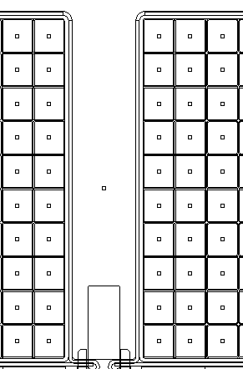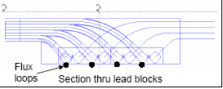
Location of Flux Loops- On top of Groundwrap and under Chill plates
Pair of twisted flux loops

Figure 20-Diagnostic Loops

Notes:

Installation complete-Verified:

Lead Technician: ____________________________ Date: ____________________

Diagnostic Representative: ____________________________ Date: ____________________

General Procedure- Outer Chill Plate/Cooling Tube Assembly:

Chill Plate Preparation:

Select the outer chill plates that are being used for the coil type being manufactured. The outer chill plates shall be de-burred prior to use. Clean the copper plates with ethanol and clean lint free cotton cloths. EXTREME CARE must be taken during handling of the cladding because of the sharp edges. It is recommended that Kevlar gloves be worn while handling the chill plates during the deburring operations.

General Chill Plate Installation Notes:

During the fitup and installation of the chill plates, remove the minimum number of winding clamps to perform the installation activities.

Fitup each copper chill plate to the outer ground wrap wall of the modular coil using the chill plate mapping drawings for guidance. Customizing of each copper chill plate may be required. Chill plates must be formed in place for proper fitup. Ensure that there are no sharp edges or burrs as a result of the customizing activities. Reclean if necessary.

Identify the location where the epoxy feed sprues will be positioned on the coil bundle. The chill plates in those positions will need to be pre-punched with a ¾ inch diameter hole prior to installation on the coil bundle.

The chill plates typically interface with the inner copper cladding at points A and B identified on Figure 21- Outer Chill Plates.

Once a chill plate is in position, CAREFULLY peen over the cladding tabs at points A and B using a ball peen hammer and G-10 block. Then stake the cladding and chill plate together using a staking tool. [This tool controls the depth of the stake, so that it does not break through the insulation on the back side of the cladding.] (Figure 22- Staking Chill Plates) Extreme care must be taken to ensure that during the staking process that the coil bundle is not damaged and that the Kapton on the back side of the cladding is not punctured.

During the installation of the chill plates, continue to verify that the chill plates are electrically isolated and are not forming a loop using a multi-meter.

Equipment Name & ID Number: _____________________ Calibration Date: ___________

Point B- Stake cladding to chill plate
Point A- Stake cladding to chill plate
Solder cooling tubes to chill plates
A
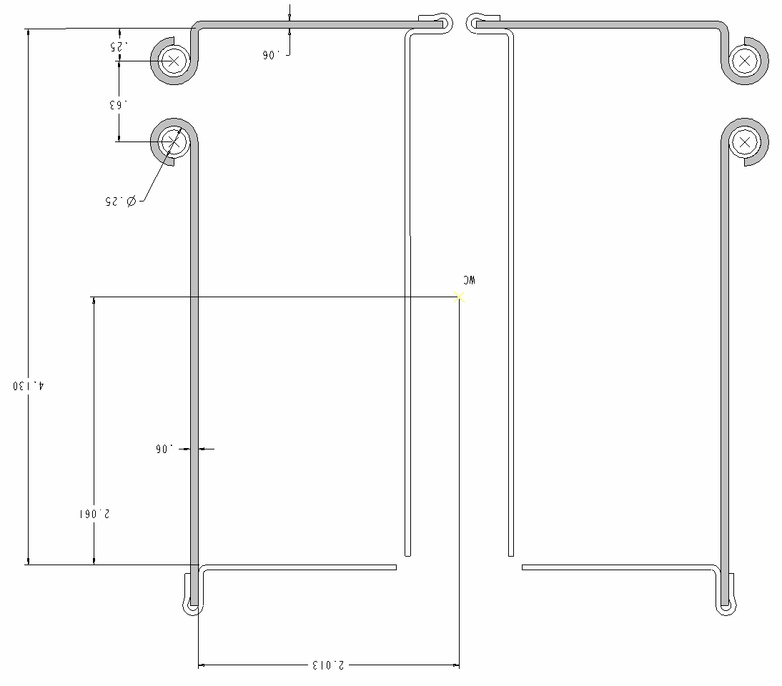
Figure 21- Outer Chill Plates

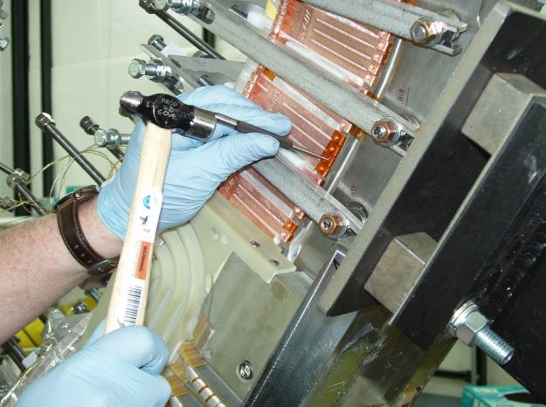
Figure 22- Staking Chill Plates

General Cooling Tube to Chill Plate Assembly Steps:

The copper cooling tubes needs to be installed after the chill plates have been secured to the cladding.

Using the appropriate cooling tube routing drawing, identify the locations where the cooling tubes will exit the coil bundle.

Using acetone-degreasing agent Scotchbrite and clean lint free cotton cloths clean the entire cooling tube. Once cleaned, do not touch the cooling tube with bare hands.

Position the tubing, and carefully begin mating the cooling tube with the chill plates, loosely hand forming the chill plate fingers over the tube.

Once the tube has been positioned, secure the chill plate fingers around the cooling tube with the G-10 tube setting block and light weight hammer. Position the setting block tool over the formed chill plate finger/cooling tube and gently tap until the copper fingers are secure around the cooling tube. Repeat process for every interfacing finger. [Figure 23- Setting Chill Plate and Tubing]

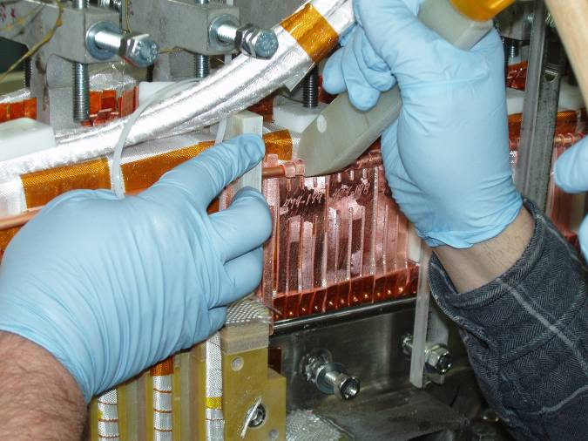
Figure 23- Setting Chill Plate and Tubing

General Cooling Tube to Chill Plate Soldering Steps:
The cooling tubes will be soldered to the chill plates using flameless “Nibco” resistive heating carbon tongs and Rosin core solder (Stay-Brite) material. Requirements of ES&HD 5008, Section 9, Chapter 15 for safe brazing/soldering must be followed.

Notify the ESU and obtain a flame permit prior to starting soldering operation.

Area preparation: Protect the surrounding coil area from any dirt or carbon that may occur as a result of the soldering operation. The area between clean rooms MUST be isolated if a coil is in the adjacent room. The ceiling hatch should be open during the soldering operations.

Position a metal sheet protector between the chill plate and ground wall insulation. This will protect the insulation from heat damage during soldering.

Place the carbon tongs onto the formed chill plate fingers. [Figure 25- Soldering Cooling Tube (photos a & b)

Set the toggle switches on the control unit to “A” and “C”. [Figure 24- Front Face- "Nibco Soldering Unit Control

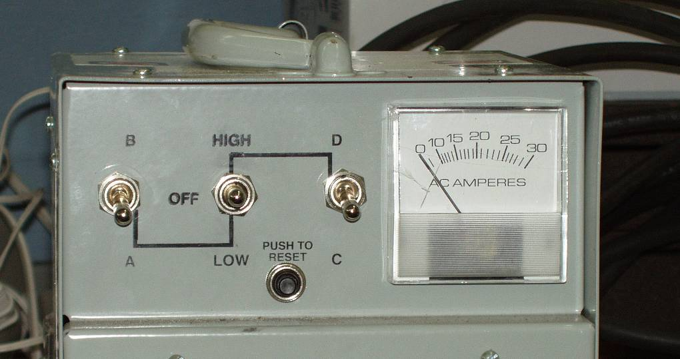
Figure 24- Front Face- "Nibco Soldering Unit Control

Place the center toggle switch to “LOW”, and using the carbon tongs heat the chill plate/cooling tube assembly. Once at temperature, feed the rosin core solder between the tube and copper fingers. [See Figure 25- Soldering Cooling Tube (photos a & b)]

Clean the solder area, removing any excess solder and flux. Use a stainless steel wire brush, and vacuum cleaner, then wipe with ethanol dampened lint free clean cloth. [Figure 26- Cleaning of Soldered Chill Plates

Repeat the process with each of the chill plate interfaces.

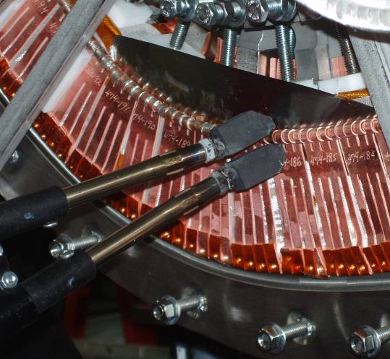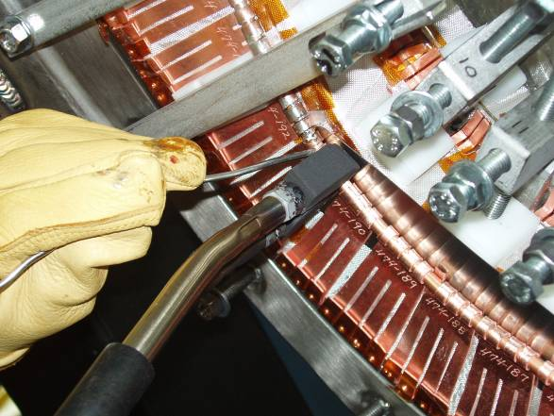
Figure 25- Soldering Cooling Tube (photos a & b)

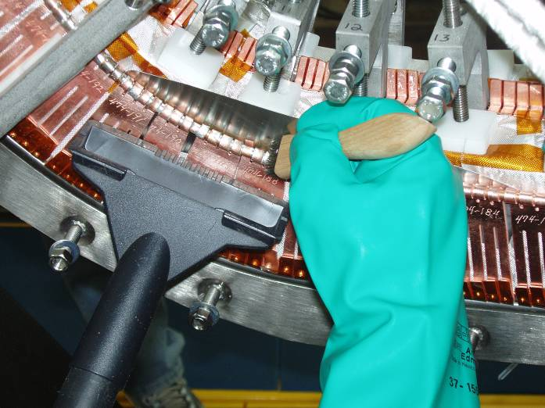
Figure 26- Cleaning of Soldered Chill Plates

Chill Plate Installation:

Install the modified upper and lower chill plates and cooling tubes in the lead area on both sides “A” and “B”. Use approved NCSX assembly drawings. See Figure 27- Chill Plates in Lead Area

Continue installing the balance of the chill plates and cooling tubes per section 6.32.2 and 6.32.3. [Figure 28- Outer Chill Plates]

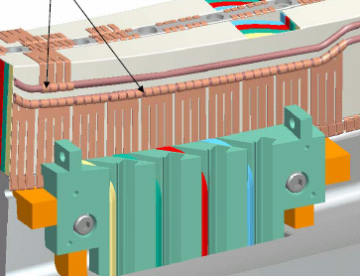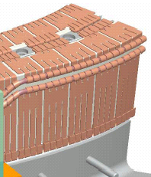
Outer Chill Plates
Lead Area Chill plates
Figure 27- Chill Plates in Lead Area
Figure 28- Outer Chill Plates

Once all of the chill plates have been fitup and secured in position. Solder the cooling tubes to the chill plates per section 6.32.4.

Date Soldered: ________ Obtain Flame Permit: _______ Solder performed by: _____________

Date Soldered: ________ Obtain Flame Permit: _______ Solder performed by: _____________

Date Soldered: ________ Obtain Flame Permit: _______ Solder performed by: _____________

Date Soldered: ________ Obtain Flame Permit: _______ Solder performed by: _____________

Date Soldered: ________ Obtain Flame Permit: _______ Solder performed by: _____________

Date Soldered: ________ Obtain Flame Permit: _______ Solder performed by: _____________

Notes:

Final Positioning of Upper Leads sides “A” and “B”

Mount the upper lead winding blocks to the MCWF for both sides “A” and “B” and secure in position with appropriate hardware. [Figure 29- Upper Lead Winding Block] Install glass cloth between G-11 fillers and fill all voids with glass tape or roving.

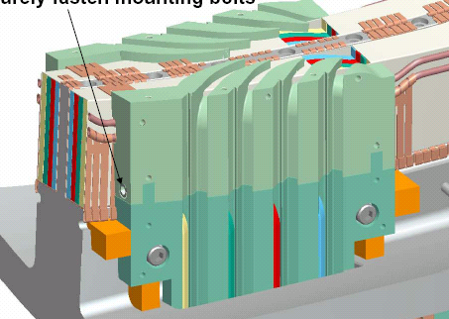
Upper Lead Winding Block
Figure 29- Upper Lead Winding Block

Upper Lead Winding Blocks are installed on sides “A” and “B”.

Complete:
Verified by: _________________________ Date: __________________
Lead Technician

Pre-determine the length of conductor that will become the coil leads for both sides “A” and “B” and make final cut.

Brazing Side “A” and “B” Upper Leads:
The lead cable connectors will be attached using a flameless “Nibco” resistive heating carbon tongs and Sil-Fos braze material. Only braze qualified individuals [Per BPS-008] can perform the lead brazes and requirements of ES&HD 5008, Section 9, Chapter 15 for safe brazing must be followed.

Notify the ESU and obtain a flame permit prior to starting brazing operation.

Verified by: _________________________ Date: __________________
Lead Technician

Area preparation: Protect the surrounding coil area from any dirt or carbon that may occur as a result of the brazing operation. The area between clean rooms MUST be isolated if a coil is in the adjacent room.

Copper Cable Connector: Clean the copper cable connector [Figure 14- Cable Connector] using acetone-degreasing agent Scotchbrite, and clean lint free wipes. Use a wire bottlebrush on the inner bore along with the acetone. Once cleaned, do not touch the components with bare hands. Coat the threads and outside surface of the cable connector with “Nicrobraz”. This coating will minimize the braze material from adhering to the external surfaces. Do not get any of the “Nicrobraz” inside of the connector since this will effect the quality of the braze joint.

Conductor Preparation Step 1: Reshape the copper conductor using phenolic form blocks to provide a proper fit between the cable and connector. The nylon serve shall remain in place during the rounding operation. See Figure 10- Conductor w/Phenolic Blocks and Figure 11- Conductor in Forming Blocks.

Conductor Preparation Step 2: Once formed, carefully remove the Nylon serve (covering) from the very end of the (approx. ¼ inch) conductor. (Figure 12- Removing Nylon Serve from conductor) Measure the depth of the cable connector and transfer that measurement to the outside of the conductor serve.

Conductor Preparation Step 3: Carefully slide the end of the conductor into the connector. Once the conductor is engaged with the connector, carefully remove additional Nylon serve (covering) so that the bare conductor can be fully inserted into the inner connector bore. Use the measurement marking that is on the nylon serve from the step 6.35.5. Continue sliding the conductor into the connector, until it bottoms out. See Figure 13- Conductor in Connector

Conductor Preparation Step 4: Strip back approximately 5.5 inches of the nylon serve starting at the copper cable connector.

Position the bare copper rope conductor into the water chill blocks and position the Argon gas head directly over the copper terminal. [Figure 16-Feeding the Lead Connector w/Sil-Fos]

Place the carbon tongs onto the solid portion of the copper connector.

Set the toggle switches on the control unit to “B” and “C”. [Figure 15- Front Face-“Nibco” Braze Unit Control]

Place the center toggle switch to “HIGH”, and using the carbon tongs heat the copper connector. Once at temperature, feed the Sil-Fos rod through the feedhole at the threaded end of the connector until liquid braze material is visible at the conductor side of the connector. Reposition the tongs to the conductor side and feed the Sil-Fos rod through the backside of the connector until liquid braze material is visible at the threaded end of the connector. (See Figure 16-Feeding the Lead Connector w/Sil-Fos)

Clean the braze area, removing any excess Sil-Fos. Remove the remaining Nicrobraz from the surfaces. Use a special honing block for cleaning the tapered terminal block.

Repeat the process with each of the four inner copper cable connectors on sides “A” and “B”.

Inspect each brazed lead connector following cleanup. If a lead connector braze is rejected, the connector must be removed and the connector braze remade.

Upper CABLE CONNECTOR #1 Pancake “A”:

Date Brazed: ______________________ Braze performed by: _____________

QC Inspected by: ______________________ Date: ___________________

Notes:

Upper CABLE CONNECTOR #2 Pancake “A”:

Date Brazed: ______________________ Braze performed by: _____________

QC Inspected by: ______________________ Date: ___________________

Notes:

Upper CABLE CONNECTOR #3 Pancake “A”:

Date Brazed: ______________________ Braze performed by: _____________

QC Inspected by: ______________________ Date: ___________________

Notes:

Upper CABLE CONNECTOR #4 Pancake “A”:

Date Brazed: ______________________ Braze performed by: _____________

QC Inspected by: ______________________ Date: ___________________

Notes:

Upper CABLE CONNECTOR #1 Pancake “B”:

Date Brazed: ______________________ Braze performed by: _____________

QC Inspected by: ______________________ Date: ___________________

Notes:

Upper CABLE CONNECTOR #2 Pancake “B”:

Date Brazed: ______________________ Braze performed by: _____________

QC Inspected by: ______________________ Date: ___________________

Notes:

Upper CABLE CONNECTOR #3 Pancake “B”:

Date Brazed: ______________________ Braze performed by: _____________

QC Inspected by: ______________________ Date: ___________________

Notes:

Upper CABLE CONNECTOR #4 Pancake “B”:

Date Brazed: ______________________ Braze performed by: _____________

QC Inspected by: ______________________ Date: ___________________

Notes:

Fitup of Leads- Sides “A” and “B”

Carefully route the connector end of the conductors into the upper lead blocks. Pre-form the conductors during the fitup to conform to the lead block. Remove the formed conductors.

Insulate Upper Leads- Side “A” and “B”
Once the connectors have been brazed and leads prefit, the leads need to be insulated.

Apply by hand (1) half-lapped layer of composite insulation [0.004 in. thick glass tape/ 0.0065(HN) Kapton tape w/ adhesive back] over each of the individual conductors starting from the point that the conductors separate to 6 inches from the conductor end.

Position the last layer of conductors [4 each side] on sides “A” and “B” into the conductor slots in the upper lead guide block. Care must be taken during this operation, to minimize any damage to the over wrap insulation. Figure 30- Upper Lead Blocks and Leads

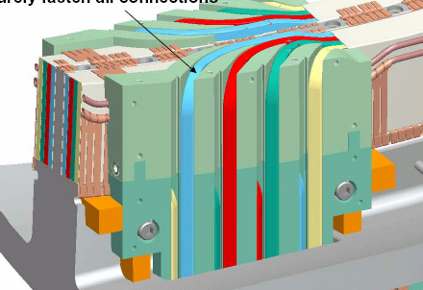
Upper conductor leads
Figure 30- Upper Lead Blocks and Leads

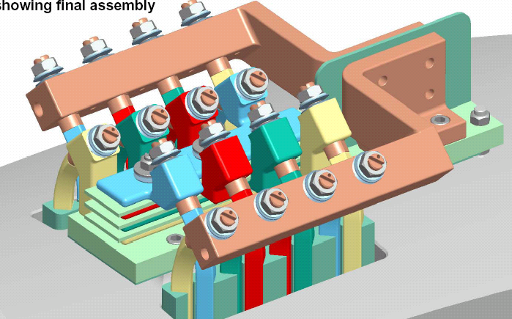
Final lead termination
Figure 31- Final Terminal Connections

Secure all of the cable connectors to the terminal blocks. Torque all of the connectors and lock hardware in position. [Figure 31- Final Terminal Connections]

The lead installation activities have been completed.

Verified by:
Lead Technician: ____________________________ Date: ____________________

Field Supervisor: ____________________________ Date: ____________________

Quality Control: _____________________________ Date: ____________________

Notes:

Lead Area-Upper Chill Plates
Install the remaining upper chill plates on the top side of the lead area. Fitup and solder in place per section 6.32.2. [Figure 32-Upper Lead Area Chill Plates]
Upper Lead Chill Plates
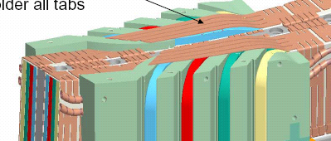
Figure 32-Upper Lead Area Chill Plates

Installation of the Outer Chill Plates is complete and plates are electrically isolated:

Lead Technician: ____________________________ Date: ____________________

Field Supervisor: ____________________________ Date: ____________________

Quality Control: _____________________________ Date: ____________________

Hydrostatic Tests:
The chill plate cooling tubes will be hydrostat tested to verify the integrity of the cooling tubes. [Note: HP shall first survey the water in the hydrostat unit prior to bringing it into the NCSX Coil Winding Facility (Test Cell)]

Place compression fittings on each end of the coolant tubes.

Using engineering procedure ENG-014 (Guidelines for Hydrostatic and Pneumatic Testing) test the individual cooling tubes.

Fill the coolant tubes in the conductors with water, then pressurize to 200 psi with nitrogen or house air and isolate from the pressure source.

All safety precautions including the use of PPE’s shall be followed as outlined in the Job Hazard Analysis sheet and recommendations made by the PPPL Industrial Hygienist.

Gauges shall have a minimum 5-psi graduation.

Verified by: _________________________________ Date: __________________
Quality Control Representative

Acceptance criteria: The test pressure shall be maintained without any detectable drop within the resolution of the gauge for at least ten minutes from the time the system was isolated from the pressure source, during which time there shall be no change in the pressure reading on the calibrated pressure gauge.

Record test data in the table below [Table 1-Cooling Tube Hydrostat Results]

Table 1-Cooling Tube Hydrostat Results
Cooling Tube No. | Start/Final Pressure Reading (psi) | Test Duration (Minutes) | Inspection (pass/fail) | Cooling Tube No. | Start/Final Pressure Reading (psi) | Test Duration (Minutes) | Inspection (pass/fail)

Flow Check:
Flow nitrogen or air through each flow package to verify that there are no blockages.

Place compression fittings on one end of the coolant tubes.

Connect cooling tube to either a nitrogen bottle or air supply. Ensure that there is good ventilation in clean room.

Flow nitrogen or air through the cooling tube. If you have through flow with no apparent restriction, shut off regulator and proceed to next cooling tube. Repeat process for each tube.

Record test data in the table below [Error: Reference source not found.

Table 2-Cooling Tube Flow Results
Cooling Tube No. | (pass/fail)  Lead Tech. | Cooling Tube No. | (pass/fail)  Lead Tech.

Installation of the Outer Cooling Tube Sub-assemblies is complete:

Lead Technician: ____________________________ Date: ____________________

Field Supervisor: ____________________________ Date: ____________________

Quality Control: _____________________________ Date: ____________________

Winding Block Filler Strips

Install the pre-insulated (w/Kapton tape) copper filler strips into the conductor slots in the upper G-11CR winding block fillers. Complete sides “A” and “B”. [Figure 33- Winding Block Filler Strips]

Place adhesive backed Kapton tape over the lower winding block mounting hardware. [Figure 33- Winding Block Filler Strips

Installations are complete Sides “A” and “B”:

Verified by: _________________________ Date: __________________
Lead Technician

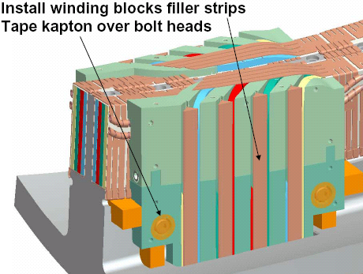
Figure 33- Winding Block Filler Strips

Outer Lead Chill Plate and Side Plates

Pre-fit the outer lead chill plate to the lead area to ensure that there are no interferences. [Figure 34- Outer Lead Area Chill Plate]

Remove the outer chill plate from the lead area. Assemble the chill plate to the G-11CR side plates. Place (1) layer of 0.010 dry glass sheet between the chill plate and G-11CR side plates.

Re-install the chill plate/side plate assembly and secure in place with the appropriate hardware. Repeat the assembly process for both sides “A” and “B”. [Figure 35- Lead Area Side Plates] Seal all seams with RTV-108.

Assembly of the outer lead area chill plate and side plates is complete.

Installations complete Sides “A” and “B”:

Verified by: _________________________ Date: __________________
Lead Technician

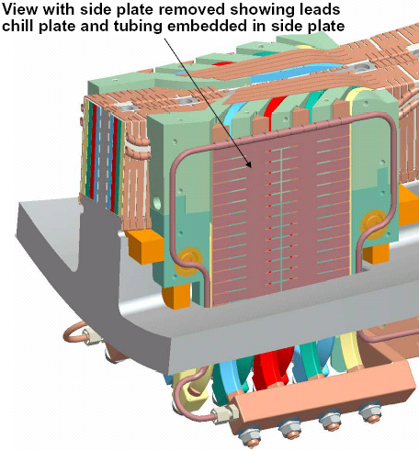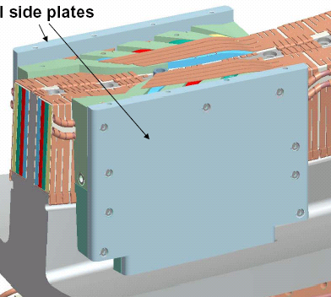
Lead G-11CR Side Plates
Outer Lead Chill Plates
Figure 34- Outer Lead Area Chill Plate
Figure 35- Lead Area Side Plates

Install Top Plate

Install the top plate bushing and mount the G-11CR top plate to the side plates. Secure top plate to side plates and center tee with the appropriate hardware. [Figure 36-Top Plate Bushing & Figure 37- Lead Area Top Plate]

Installations complete Top Plate:

Verified by: _________________________ Date: __________________
Lead Technician

Completion of Sides “A” and “B”:
The “A” and “B” sides are complete and ready for the installation of the bag mold.

Pancakes “A” and “B” have been completed and are ready for bag mold installation.

Lead Technician: ____________________________ Date: ____________________

Field Supervisor: ____________________________ Date: ____________________

QC shall verify completion of documentation:

Quality Control: _____________________________ Date: ____________________

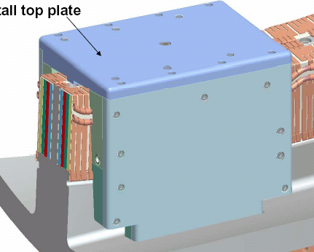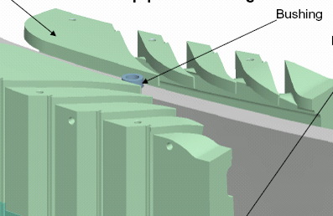
Top Plate Bushing
Lead G-11CR Top Plate
Figure 36-Top Plate Bushing
Figure 37- Lead Area Top Plate

Pre-VPI Electrical Insulation Tests:
Prior to applying the “Bag Mold” perform a low voltage Megger test to verify the integrity of the coil insulation.

Perform a preliminary Megger test of the completed coil prior to transporting to the autoclave.

Coil Voltage level: 500 volts

Coil Insulation Resistance: 1K Meg ohms

The Test Director for this test is: _____________________________

Safety Requirements and Conditions:

The following safety and prerequisites shall be used for performing test of the Modular Coil.

All personnel involved with these tests shall be familiar with the hazards and work procedure to minimize accidents that may occur.

A “Safety Watch” shall be appointed by the Test Director. The Test Director shall clearly describe to the Safety Watch his/her responsibilities.

Name of Safety Watch: ______________________

Responsibilities have been clearly discussed with Safety Watch:

Verified: ________________________________ Date: ________________
Test Director

Responsibilities of a Safety Watch include as a minimum:

a) Monitoring the operations in an attempt to prevent careless or unsafe activities.

b) Shutting down the power in case of an accident.

c) Contacting ESU in case of accident

d) Additional responsibilities of a Safety Watch can be found in the ES&H Manual Section 2, Chapter 2.2.6.

During the test, the “Test Area” shall be roped-off and suitable “danger high voltage” signs and flashing lights displayed.

Test Area has been safed:

Verified by: _________________________ Date: __________________
Test Director

The test operator shall stand on an electrical safety mat during the test operation.

Approved rubber electrical safety gloves shall be worn by test members during grounding operations which occur once the test has been completed, and the test equipment turned off.

Upon completion of test and before the components are declared safe to touch, the coil being tested shall be properly discharged using a “Ground Hook”. After a minimum period of 10 seconds, while the ground hook is still in place, attach a ground cable to the coil. The ground hook may be removed once the ground cable is in place.

Electrically ground the winding form, and chill plate cooling tubes.

Measure the insulation resistance of pancakes “A” and “B”. The test results shall be in compliance with the requirements noted in Section 6.45.1. Pancakes “A” and “B” are connected together at the terminal block. If the test results are questionable, project will be contacted, and the terminal block may be disassembled to allow testing of each separate pancake.

Table 3- Pre-VPI Bag Mold Megger Test Results
Test Coil | Test Voltage Level Volts | Measured Resistance  Ohms | Remarks
Pancake “A”

Pancake “B”

Coil Temperature: __________________ Degrees C

Equipment ID Number: _____________________________ Calibration Date: _____________

Megger Results: Acceptable: _______________ Unacceptable: ____________

Test Director Signoff: _____________________________ Date: ______________

Quality Control Verify: __________________________ Date: ______________

Field Supervisor: __________________________ Date: ______________

Installation of Bag Mold:

Once the chill plates and cooling tubes have been installed, the installation of the “bag mold” can commence.

During this procedure, to maintain dimensional control the number of adjacent winding clamps that can be removed should be no more than three. [Some areas may require removal of more clamps due to available working space]

Mount the G-11 sprue washers to the chill plates in the areas that were pre-cut to accommodate the epoxy feed sprues. Secure in place using 3M adhesive cement #CA40H. Pre-apply by brushing, 3M Accelerator “Pronto Surface Activator” to the chill plate that will mate with the washer. Apply the cement to the sprue washer and place on to the chill plate. Repeat for all sprue locations. [Figure 41- Sprue washers and extensions]

Install the final G-10 pressure pads in the areas where the final coil clamps will be placed. These pads shall be held in position with small amount of silicone RTV 108. All void areas behind the pads will be filled with glass insulation or roving.

Install glass roving (rope) in the areas between the cooling tubes. [Figure 38- Glass Roving Between Cooling Tubes

Apply (1) layer of dry glass tape (0.010 inch thick) over the chill plates and cooling tubes in all areas not covered by the G-10 push pads. Secure glass in place with adhesive backed Kapton tape.
Glass roving
Figure 38- Glass Roving Between Cooling Tubes

Apply (2) half-lapped layers of the silicone rubber tape over the modular coil bundle chill plate and cooling tube assembly. The silicone tape extends from the Side “A” seal groove across the top to the Side “B” seal groove. Apply bead of adhesive RTV caulking in the seal groove prior to positioning the silicone tape. (Figure 39- Installation of Bag Mold & Figure 40- Silicone Bag Mold)

Apply bead of Silicone adhesive at base of seal groove
(2) ½ lapped layers of Silicone rubber tape from groove A to B
Winding clamps with spacers are used to secure tubing in seal groove (Typ.)

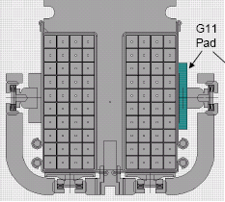
A
B
Figure 39- Installation of Bag Mold

Hold the silicone rubber bag mold in the groove using 5/16” (or 3/8 inch) refrigeration tubing. Use the special VPI winding clamps with spacers to hold the tube in place. (Figure 39- Installation of Bag Mold & Figure 40- Silicone Bag Mold)

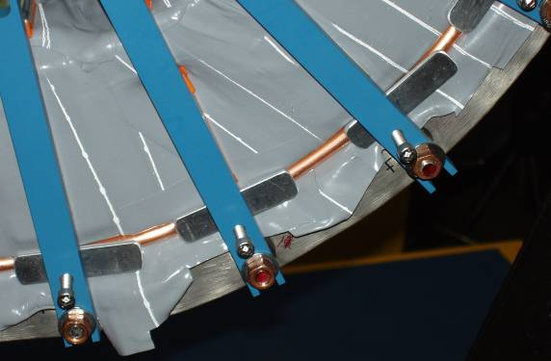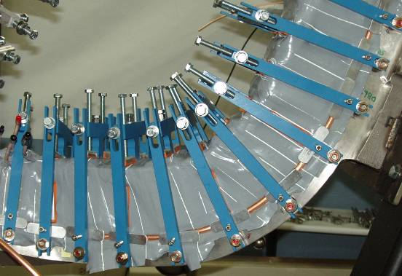
Figure 40- Silicone Bag Mold

It is important to note that the bag mold should only be installed in small sections. Removal of too many clamps will result in possible loosening of turns. Do not remove any more than three adjacent clamps at one time if possible. [Some areas may require removal of more clamps due to available working space] Once a section of coil is complete, immediately reinstall the winding clamps to the bundle. Tighten the upper and side clamps until they are hand snug against the silicone bag. Modified mold released side bars will be used during VPI cycle. These side bars have additional tapped holes for holding the edges of the cotton candy in position.

Install a VPI seal box around the lead connections located outside of the winding form.

Seal all external joints of the G-11 CR lead cover plates with RTV108.

Once the entire bag has been installed, apply a vacuum to the bag mold. This will help the silicone bag to conform to the bundle.

Check for any gross vacuum leaks. Repair leaks with adhesive RTV108. Continue to pump on bag to achieve lowest possible vacuum. (Maximum 5 Torr)

Vacuum pressure (achieved):

Notes:

Once a reasonable vacuum has been reached, shut off vacuum and vent the bag mold.

Install the long and short sprue extension to the sprue washers. This requires cutting the bag where the washers are located. The sprue locations can be easily identified after the initial vacuum pump-down. The lead technician shall decide whether a long or short extension will be used. [Figure 41- Sprue washers and extensions]

Cement the sprue extensions to the sprue washers. Secure in place using 3M adhesive cement #CA40H. Pre-apply by brushing, 3M Accelerator “Pronto Surface Activator” to the washer that will mate with the sprue extension. Apply the cement to the sprue extension and place on to the washer. Press the silicone skirt that is around the sprue extension directly to the silicone bag. Repeat for all sprue locations.

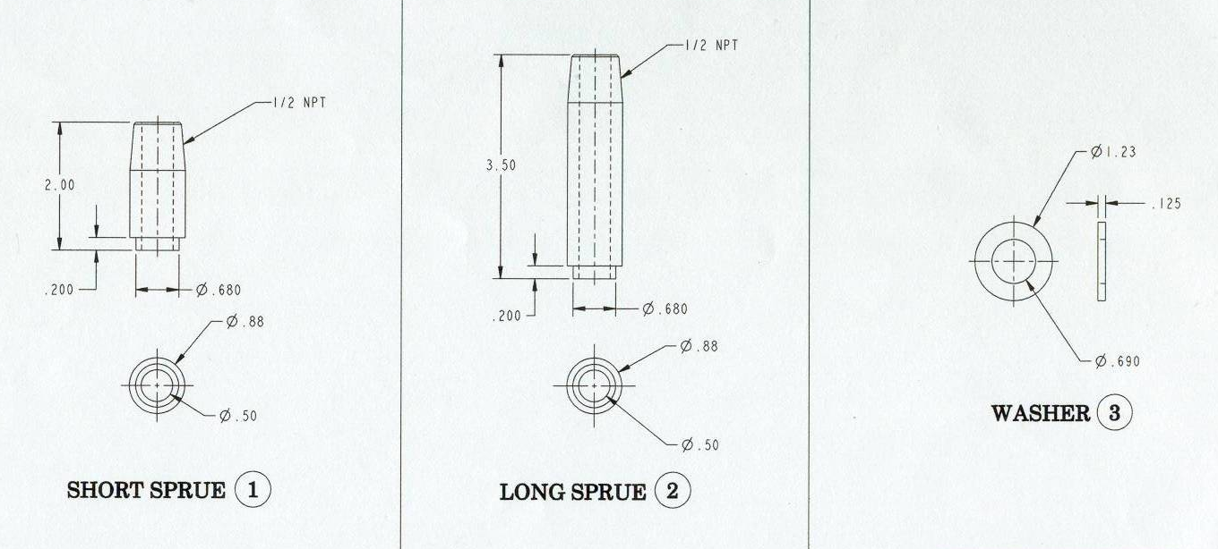
Figure 41- Sprue washers and extensions

All sprues have been installed and bag is ready for RTV coating:
Verified:

Lead Technician: ____________________________ Date: ____________________

Field Supervisor: ____________________________ Date: ____________________

Cap the sprues and re-apply the vacuum to the “bag Mold”. Check for any gross vacuum leaks around the newly installed sprue assemblies. Repair leaks with adhesive RTV108. Continue to pump on bag to achieve lowest possible vacuum. (Maximum 5 Torr)

Paint the outer surface of the silicone bag with 2- part RTV 11 (white) to seal any small leaks in the bag. Allow the RTV to dry for minimum 12 hours.

Vacuum pressure (achieved):

Notes:

After 12 hour cure the bag mold has been sealed and is ready for installation of outer shell.
Verified:

Lead Technician: ____________________________ Date: ____________________

Field Supervisor: ____________________________ Date: ____________________

Install epoxy shell:
An epoxy shell will now be installed over the silicone bag to provide structural support during the epoxy filling process.

Mix sufficient glass epoxy “cotton candy” using 2-part Hysol -epoxy system with mix ratio recommended by the epoxy supplier. (Resin 3561 /Hardener 2039). Document all epoxy mixing data.

Epoxy mix ratio used:
100 pbw of Resin………. Hysol RE2039
30 pbw of Hardener……. Hysol HD3561

Quantity of epoxy mixed:
2 gallon mixture [working batch]

“Cotton Candy” mix data:
100 grams of part “A”
30 grams of part “B”
30 grams of chopped glass

Thoroughly mix epoxy and glass components until it begins to take on the appearance of “Cotton Candy”. [Figure 42-Epoxy/Glass Mixture- "Cotton Candy"]

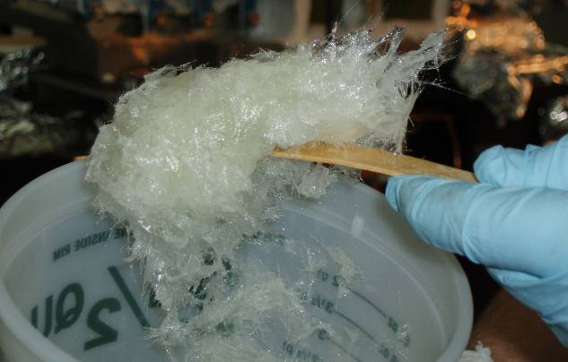
Figure 42-Epoxy/Glass Mixture- "Cotton Candy"

Begin applying the “Cotton Candy” over all areas of the exposed silicone bag mold between side bars to a thickness of at least ¼ inch. Build up the areas around the sprues to provide additional support. [Figure 43-Application Epoxy Glass Shell]

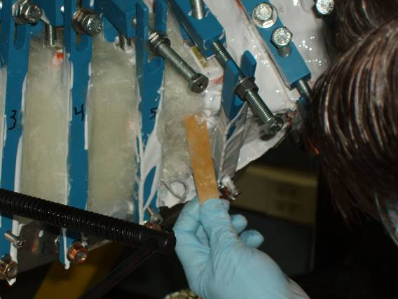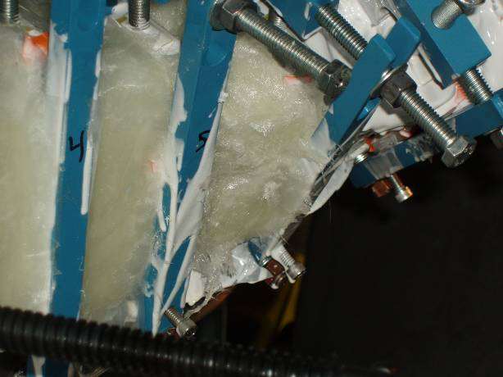
Figure 43-Application Epoxy Glass Shell

Once an area has been completed, apply a layer of non-adhesive Mylar tape over the “Cotton Candy” and begin smoothing the under layer of epoxy/glass. Continue the application of the “Cotton Candy” until the silicone “Bag Mold” has been fully covered. [Figure 44- Epoxy/Glass shell]

Once the epoxy shell has been installed, install clamps to secure the ends of the epoxy shell.

Allow 24 hours for the Hysol to totally cure before proceeding with the next activity.

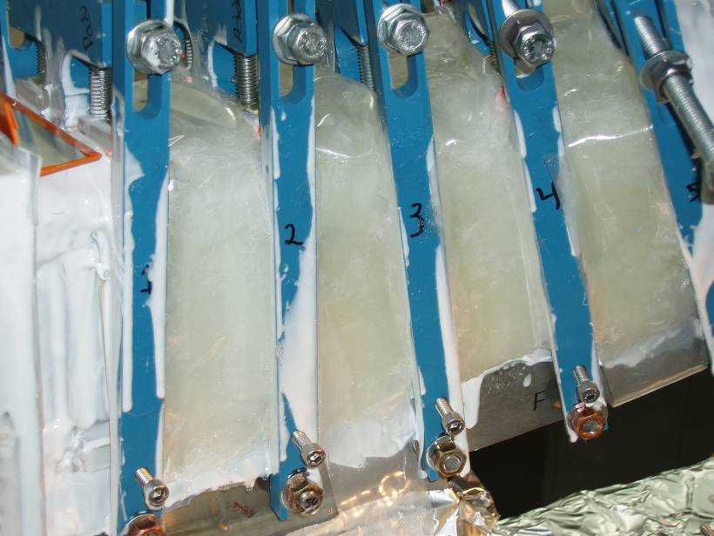
Figure 44- Epoxy/Glass shell

Installation of the “Bag Mold” is complete:

Lead Technician: ____________________________ Date: ____________________

Field Supervisor: ____________________________ Date: ____________________

Quality Control: _____________________________ Date: ____________________

Comments:

Completion of Activities at Winding Station:

Document Verification:
Verify that all pertinent data in the procedure and data sheets have been completed.

Field Package:
Ensure that all data sheets, photographs, QC inspection sheets, etc are included in the Field Package.

Approval:
Prior to releasing a modular coil to the Vacuum-Pressure-Impregnation station (VPI), it is required that the all-responsible individuals sign the release indicating that all processes at the winding station have been satisfactorily completed. The release will include signatures from the Station Lead Technician, Field Supervisor and the QC representative.

All winding form preparation activities have been satisfactorily completed.

Lead Technician: ____________________________ Date: ____________________

Field Supervisor: ____________________________ Date: ____________________

QC shall verify completion of documentation:

Quality Control Representative: _________________________ Date: ________

The modular coil with “Bag Mold” is ready for transfer to the VPI station no. 5:

Comments:

DELETED START-UP AND SHUTDOWN LOGS

Table 4- Type "C" Coil Drawings

Drawing Numbers | Drawing Description
Top level assembly and layouts
se140-103.drw | MODULAR COIL ASSEMBLY TYPE-C
se142c-019.drw | TYPE-C WINDING PACK DIMENSIONS
se142c-016.drw | TYPE-C ELECTRICAL SCHEMATIC
se142c-015.drw | TYPE-C COOLING SCHEMATIC
SE141-103 | Winding form assembly,
ds141-036.drw | STUD, 1.375-6UNC-2A X 9 LG
ds141-038.drw | INSULATING WASHER
ds141-060.drw | NUT, 12PT HEX 1.375-6UNC-2B
ds141-079.drw | FLAT WASHER
se141-078.drw | POL BREAK SHIM ASSEMBLY TYPE-C
se141-103.drw | MOD COIL WINDING FORM ASSEMBLY TYPE-C
se141-116.drw | PRODUCTION WINDING FORM TYPE-C
se141-123.drw | MCWF TYPE-C STUD WELDMENT
SE142C-018 | Side-A winding pack assembly,
se142c-018.drw | TYPE-C SIDE-A WINDING PACK ASSEMBLY
se142c-134.drw | TYPE-C SIDE-A LOWER LEAD BLOCK COMBINED
se142c-136.drw | TYPE-C SIDE-A UPPER LEAD BLOCK COMBINED
se142c-382-101_105.drw | TYPE-C SIDE-A UPPER CLADDING FLAT PATTERN
se142c-382-106_110.drw | TYPE-C SIDE-A UPPER CLADDING FLAT PATTERN
se142c-382-111_115.drw | TYPE-C SIDE-A UPPER CLADDING FLAT PATTERN
se142c-382-116_120.drw | TYPE-C SIDE-A UPPER CLADDING FLAT PATTERN
se142c-382-121_125.drw | TYPE-C SIDE-A UPPER CLADDING FLAT PATTERN
se142c-382-126_130.drw | TYPE-C SIDE-A UPPER CLADDING FLAT PATTERN
se142c-382-131_135.drw | TYPE-C SIDE-A UPPER CLADDING FLAT PATTERN
se142c-382-136_140.drw | TYPE-C SIDE-A UPPER CLADDING FLAT PATTERN
se142c-382-141_145.drw | TYPE-C SIDE-A UPPER CLADDING FLAT PATTERN
se142c-382-146_150.drw | TYPE-C SIDE-A UPPER CLADDING FLAT PATTERN
se142c-382-151_155.drw | TYPE-C SIDE-A UPPER CLADDING FLAT PATTERN
se142c-382-156_160.drw | TYPE-C SIDE-A UPPER CLADDING FLAT PATTERN
se142c-382-161_165.drw | TYPE-C SIDE-A UPPER CLADDING FLAT PATTERN
se142c-382-166_170.drw | TYPE-C SIDE-A UPPER CLADDING FLAT PATTERN
se142c-382-171_175.drw | TYPE-C SIDE-A UPPER CLADDING FLAT PATTERN
se142c-382-176_180.drw | TYPE-C SIDE-A UPPER CLADDING FLAT PATTERN
se142c-382-181_185.drw | TYPE-C SIDE-A UPPER CLADDING FLAT PATTERN
se142c-382-186_190.drw | TYPE-C SIDE-A UPPER CLADDING FLAT PATTERN
se142c-382-191_195.drw | TYPE-C SIDE-A UPPER CLADDING FLAT PATTERN
se142c-382-196_200.drw | TYPE-C SIDE-A UPPER CLADDING FLAT PATTERN
se142c-382-201_205.drw | TYPE-C SIDE-A UPPER CLADDING FLAT PATTERN
se142c-382-206_210.drw | TYPE-C SIDE-A UPPER CLADDING FLAT PATTERN
se142c-382-211_215.drw | TYPE-C SIDE-A UPPER CLADDING FLAT PATTERN
se142c-382-216_220.drw | TYPE-C SIDE-A UPPER CLADDING FLAT PATTERN
se142c-382-221_225.drw | TYPE-C SIDE-A UPPER CLADDING FLAT PATTERN
se142c-382-226_230.drw | TYPE-C SIDE-A UPPER CLADDING FLAT PATTERN
se142c-382-231_235.drw | TYPE-C SIDE-A UPPER CLADDING FLAT PATTERN
se142c-382-236_240.drw | TYPE-C SIDE-A UPPER CLADDING FLAT PATTERN
se142c-382-241_245.drw | TYPE-C SIDE-A UPPER CLADDING FLAT PATTERN
se142c-382-246_250.drw | TYPE-C SIDE-A UPPER CLADDING FLAT PATTERN
se142c-382-251_255.drw | TYPE-C SIDE-A UPPER CLADDING FLAT PATTERN
se142c-382-256_260.drw | TYPE-C SIDE-A UPPER CLADDING FLAT PATTERN
se142c-382-261_265.drw | TYPE-C SIDE-A UPPER CLADDING FLAT PATTERN
se142c-382-266_270.drw | TYPE-C SIDE-A UPPER CLADDING FLAT PATTERN
se142c-382-271_275.drw | TYPE-C SIDE-A UPPER CLADDING FLAT PATTERN
se142c-382-276_280.drw | TYPE-C SIDE-A UPPER CLADDING FLAT PATTERN
se142c-382-281_285.drw | TYPE-C SIDE-A UPPER CLADDING FLAT PATTERN
se142c-382-286_290.drw | TYPE-C SIDE-A UPPER CLADDING FLAT PATTERN
se142c-382-291_295.drw | TYPE-C SIDE-A UPPER CLADDING FLAT PATTERN
se142c-384-101_105.drw | TYPE-C SIDE-A LOWER CLADDING FLAT PATTERN
se142c-384-106_110.drw | TYPE-C SIDE-A LOWER CLADDING FLAT PATTERN
se142c-384-111_115.drw | TYPE-C SIDE-A LOWER CLADDING FLAT PATTERN
se142c-384-116_120.drw | TYPE-C SIDE-A LOWER CLADDING FLAT PATTERN
se142c-384-121_125.drw | TYPE-C SIDE-A LOWER CLADDING FLAT PATTERN
se142c-384-126_130.drw | TYPE-C SIDE-A LOWER CLADDING FLAT PATTERN
se142c-384-131_135.drw | TYPE-C SIDE-A LOWER CLADDING FLAT PATTERN
se142c-384-136_140.drw | TYPE-C SIDE-A LOWER CLADDING FLAT PATTERN
se142c-384-141_145.drw | TYPE-C SIDE-A LOWER CLADDING FLAT PATTERN
se142c-384-146_150.drw | TYPE-C SIDE-A LOWER CLADDING FLAT PATTERN
se142c-384-151_155.drw | TYPE-C SIDE-A LOWER CLADDING FLAT PATTERN
se142c-384-156_160.drw | TYPE-C SIDE-A LOWER CLADDING FLAT PATTERN
se142c-384-161_165.drw | TYPE-C SIDE-A LOWER CLADDING FLAT PATTERN
se142c-386-166_170.drw | TYPE-C SIDE-A UPPER CHILL PLATE FLAT PATTERN
se142c-386-171_175.drw | TYPE-C SIDE-A UPPER CHILL PLATE FLAT PATTERN
se142c-386-176_180.drw | TYPE-C SIDE-A UPPER CHILL PLATE FLAT PATTERN
se142c-386-181_185.drw | TYPE-C SIDE-A UPPER CHILL PLATE FLAT PATTERN
se142c-386-186_190.drw | TYPE-C SIDE-A UPPER CHILL PLATE FLAT PATTERN
se142c-386-191_195.drw | TYPE-C SIDE-A UPPER CHILL PLATE FLAT PATTERN
se142c-386-201_205.drw | TYPE-C SIDE-A UPPER CHILL PLATE FLAT PATTERN
se142c-386-206_210.drw | TYPE-C SIDE-A UPPER CHILL PLATE FLAT PATTERN
se142c-386-211_215.drw | TYPE-C SIDE-A UPPER CHILL PLATE FLAT PATTERN
se142c-386-216_220.drw | TYPE-C SIDE-A UPPER CHILL PLATE FLAT PATTERN
se142c-386-221_225.drw | TYPE-C SIDE-A UPPER CHILL PLATE FLAT PATTERN
se142c-386-226_230.drw | TYPE-C SIDE-A UPPER CHILL PLATE FLAT PATTERN
se142c-386-231_235.drw | TYPE-C SIDE-A UPPER CHILL PLATE FLAT PATTERN
se142c-386-236_240.drw | TYPE-C SIDE-A UPPER CHILL PLATE FLAT PATTERN
se142c-386-241_245.drw | TYPE-C SIDE-A UPPER CHILL PLATE FLAT PATTERN
se142c-386-246_250.drw | TYPE-C SIDE-A UPPER CHILL PLATE FLAT PATTERN
se142c-386-251_255.drw | TYPE-C SIDE-A UPPER CHILL PLATE FLAT PATTERN
se142c-386-256_260.drw | TYPE-C SIDE-A UPPER CHILL PLATE FLAT PATTERN
se142c-386-261_265.drw | TYPE-C SIDE-A UPPER CHILL PLATE FLAT PATTERN
se142c-386-266_270.drw | TYPE-C SIDE-A UPPER CHILL PLATE FLAT PATTERN
se142c-386-271_275.drw | TYPE-C SIDE-A UPPER CHILL PLATE FLAT PATTERN
se142c-386-276_280.drw | TYPE-C SIDE-A UPPER CHILL PLATE FLAT PATTERN
se142c-386-281_285.drw | TYPE-C SIDE-A UPPER CHILL PLATE FLAT PATTERN
se142c-386-286_290.drw | TYPE-C SIDE-A UPPER CHILL PLATE FLAT PATTERN
se142c-386-291_292.drw | TYPE-C SIDE-A UPPER CHILL PLATE FLAT PATTERN
se142c-388-101_105.drw | TYPE-C SIDE-A LOWER CHILL PLATE FLAT PATTERN
se142c-388-106_110.drw | TYPE-C SIDE-A LOWER CHILL PLATE FLAT PATTERN
se142c-388-111_115.drw | TYPE-C SIDE-A LOWER CHILL PLATE FLAT PATTERN
se142c-388-121_125.drw | TYPE-C SIDE-A LOWER CHILL PLATE FLAT PATTERN
se142c-388-126_130.drw | TYPE-C SIDE-A LOWER CHILL PLATE FLAT PATTERN
se142c-388-131_135.drw | TYPE-C SIDE-A LOWER CHILL PLATE FLAT PATTERN
se142c-388-136_140.drw | TYPE-C SIDE-A LOWER CHILL PLATE FLAT PATTERN
se142c-388-141_145.drw | TYPE-C SIDE-A LOWER CHILL PLATE FLAT PATTERN
se142c-388-146-150.drw | TYPE-C SIDE-A LOWER CHILL PLATE FLAT PATTERN
se142c-388-151-155.drw | TYPE-C SIDE-A LOWER CHILL PLATE FLAT PATTERN
se142c-388-156_160.drw | TYPE-C SIDE-A LOWER CHILL PLATE FLAT PATTERN
se142c-388-161_165.drw | TYPE-C SIDE-A LOWER CHILL PLATE FLAT PATTERN
se142c-388-166_170.drw | TYPE-C SIDE-A LOWER CHILL PLATE FLAT PATTERN
se142c-388-171_175.drw | TYPE-C SIDE-A LOWER CHILL PLATE FLAT PATTERN
se142c-388-176_180.drw | TYPE-C SIDE-A LOWER CHILL PLATE FLAT PATTERN
se142c-388-181_185.drw | TYPE-C SIDE-A LOWER CHILL PLATE FLAT PATTERN
se142c-388-186_190.drw | TYPE-C SIDE-A LOWER CHILL PLATE FLAT PATTERN
se142c-388-191_195.drw | TYPE-C SIDE-A LOWER CHILL PLATE FLAT PATTERN
se142c-388-201_205.drw | TYPE-C SIDE-A LOWER CHILL PLATE FLAT PATTERN
se142c-388-206_210.drw | TYPE-C SIDE-A LOWER CHILL PLATE FLAT PATTERN
se142c-388-211_215.drw | TYPE-C SIDE-A LOWER CHILL PLATE FLAT PATTERN
se142c-388-216_220.drw | TYPE-C SIDE-A LOWER CHILL PLATE FLAT PATTERN
se142c-388-221_225.drw | TYPE-C SIDE-A LOWER CHILL PLATE FLAT PATTERN
se142c-388-226_230.drw | TYPE-C SIDE-A LOWER CHILL PLATE FLAT PATTERN
se142c-388-231_235.drw | TYPE-C SIDE-A LOWER CHILL PLATE FLAT PATTERN
se142c-388-236_240.drw | TYPE-C SIDE-A LOWER CHILL PLATE FLAT PATTERN
se142c-388-241_245.drw | TYPE-C SIDE-A LOWER CHILL PLATE FLAT PATTERN
se142c-388-246_250.drw | TYPE-C SIDE-A LOWER CHILL PLATE FLAT PATTERN
se142c-388-251_255.drw | TYPE-C SIDE-A LOWER CHILL PLATE FLAT PATTERN
se142c-388-256_260.drw | TYPE-C SIDE-A LOWER CHILL PLATE FLAT PATTERN
se142c-388-261_265.drw | TYPE-C SIDE-A LOWER CHILL PLATE FLAT PATTERN
se142c-388-266_270.drw | TYPE-C SIDE-A LOWER CHILL PLATE FLAT PATTERN
se142c-388-271_275.drw | TYPE-C SIDE-A LOWER CHILL PLATE FLAT PATTERN
se142c-388-276_280.drw | TYPE-C SIDE-A LOWER CHILL PLATE FLAT PATTERN
se142c-388-281_285.drw | TYPE-C SIDE-A LOWER CHILL PLATE FLAT PATTERN
se142c-388-286_290.drw | TYPE-C SIDE-A LOWER CHILL PLATE FLAT PATTERN
se142c-388-291_292.drw | TYPE-C SIDE-A LOWER CHILL PLATE FLAT PATTERN
SE142C-017 | Side-B winding pack assembly,
se142c-017.drw | TYPE-C SIDE-B WINDING PACK ASSEMBLY
se142c-135.drw | TYPE-C SIDE-B LOWER LEAD BLOCK COMBINED
se142c-137.drw | TYPE-C SIDE-B UPPER LEAD BLOCK COMBINED
se142c-482-101_105.drw | TYPE-C SIDE-B UPPER CLADDING FLAT PATTERN
se142c-482-106_110.drw | TYPE-C SIDE-B UPPER CLADDING FLAT PATTERN
se142c-482-111_115.drw | TYPE-C SIDE-B UPPER CLADDING FLAT PATTERN
se142c-482-116_120.drw | TYPE-C SIDE-B UPPER CLADDING FLAT PATTERN
se142c-482-121_125.drw | TYPE-C SIDE-B UPPER CLADDING FLAT PATTERN
se142c-482-126_130.drw | TYPE-C SIDE-B UPPER CLADDING FLAT PATTERN
se142c-482-131_135.drw | TYPE-C SIDE-B UPPER CLADDING FLAT PATTERN
se142c-482-136_140.drw | TYPE-C SIDE-B UPPER CLADDING FLAT PATTERN
se142c-482-141_145.drw | TYPE-C SIDE-B UPPER CLADDING FLAT PATTERN
se142c-482-146_150.drw | TYPE-C SIDE-B UPPER CLADDING FLAT PATTERN
se142c-482-151_155.drw | TYPE-C SIDE-B UPPER CLADDING FLAT PATTERN
se142c-482-156_160.drw | TYPE-C SIDE-B UPPER CLADDING FLAT PATTERN
se142c-482-161_165.drw | TYPE-C SIDE-B UPPER CLADDING FLAT PATTERN
se142c-482-166_170.drw | TYPE-C SIDE-B UPPER CLADDING FLAT PATTERN
se142c-482-171_175.drw | TYPE-C SIDE-B UPPER CLADDING FLAT PATTERN
se142c-482-176_180.drw | TYPE-C SIDE-B UPPER CLADDING FLAT PATTERN
se142c-482-181_185.drw | TYPE-C SIDE-B UPPER CLADDING FLAT PATTERN
se142c-482-186_190.drw | TYPE-C SIDE-B UPPER CLADDING FLAT PATTERN
se142c-482-191_195.drw | TYPE-C SIDE-B UPPER CLADDING FLAT PATTERN
se142c-482-196_200.drw | TYPE-C SIDE-B UPPER CLADDING FLAT PATTERN
se142c-482-201_205.drw | TYPE-C SIDE-B UPPER CLADDING FLAT PATTERN
se142c-482-206_210.drw | TYPE-C SIDE-B UPPER CLADDING FLAT PATTERN
se142c-482-211_215.drw | TYPE-C SIDE-B UPPER CLADDING FLAT PATTERN
se142c-482-216_220.drw | TYPE-C SIDE-B UPPER CLADDING FLAT PATTERN
se142c-482-221_225.drw | TYPE-C SIDE-B UPPER CLADDING FLAT PATTERN
se142c-482-226_230.drw | TYPE-C SIDE-B UPPER CLADDING FLAT PATTERN
se142c-482-231_235.drw | TYPE-C SIDE-B UPPER CLADDING FLAT PATTERN
se142c-482-236_240.drw | TYPE-C SIDE-B UPPER CLADDING FLAT PATTERN
se142c-482-241_245.drw | TYPE-C SIDE-B UPPER CLADDING FLAT PATTERN
se142c-482-246_250.drw | TYPE-C SIDE-B UPPER CLADDING FLAT PATTERN
se142c-482-251_255.drw | TYPE-C SIDE-B UPPER CLADDING FLAT PATTERN
se142c-482-256_260.drw | TYPE-C SIDE-B UPPER CLADDING FLAT PATTERN
se142c-482-261_265.drw | TYPE-C SIDE-B UPPER CLADDING FLAT PATTERN
se142c-482-266_270.drw | TYPE-C SIDE-B UPPER CLADDING FLAT PATTERN
se142c-482-271_275.drw | TYPE-C SIDE-B UPPER CLADDING FLAT PATTERN
se142c-482-276_280.drw | TYPE-C SIDE-B UPPER CLADDING FLAT PATTERN
se142c-482-281_285.drw | TYPE-C SIDE-B UPPER CLADDING FLAT PATTERN
se142c-482-286_290.drw | TYPE-C SIDE-B UPPER CLADDING FLAT PATTERN
se142c-482-291_295.drw | TYPE-C SIDE-B UPPER CLADDING FLAT PATTERN
se142c-484-101_105.drw | TYPE-C SIDE-B LOWER CLADDING FLAT PATTERN
se142c-484-106_110.drw | TYPE-C SIDE-B LOWER CLADDING FLAT PATTERN
se142c-484-111_115.drw | TYPE-C SIDE-B LOWER CLADDING FLAT PATTERN
se142c-484-116_120.drw | TYPE-C SIDE-B LOWER CLADDING FLAT PATTERN
se142c-484-121_125.drw | TYPE-C SIDE-B LOWER CLADDING FLAT PATTERN
se142c-484-126_130.drw | TYPE-C SIDE-B LOWER CLADDING FLAT PATTERN
se142c-484-131_135.drw | TYPE-C SIDE-B LOWER CLADDING FLAT PATTERN
se142c-484-136_140.drw | TYPE-C SIDE-B LOWER CLADDING FLAT PATTERN
se142c-484-141_145.drw | TYPE-C SIDE-B LOWER CLADDING FLAT PATTERN
se142c-484-146_150.drw | TYPE-C SIDE-B LOWER CLADDING FLAT PATTERN
se142c-484-151_155.drw | TYPE-C SIDE-B LOWER CLADDING FLAT PATTERN
se142c-484-156_160.drw | TYPE-C SIDE-B LOWER CLADDING FLAT PATTERN
se142c-484-161_165.drw | TYPE-C SIDE-B LOWER CLADDING FLAT PATTERN
se142c-484-166_170.drw | TYPE-C SIDE-B LOWER CLADDING FLAT PATTERN
se142c-484-171_175.drw | TYPE-C SIDE-B LOWER CLADDING FLAT PATTERN
se142c-484-176_180.drw | TYPE-C SIDE-B LOWER CLADDING FLAT PATTERN
se142c-484-181_185.drw | TYPE-C SIDE-B LOWER CLADDING FLAT PATTERN
se142c-484-186_190.drw | TYPE-C SIDE-B LOWER CLADDING FLAT PATTERN
se142c-484-191_195.drw | TYPE-C SIDE-B LOWER CLADDING FLAT PATTERN
se142c-484-196_200.drw | TYPE-C SIDE-B LOWER CLADDING FLAT PATTERN
se142c-484-201_205.drw | TYPE-C SIDE-B LOWER CLADDING FLAT PATTERN
se142c-484-206_210.drw | TYPE-C SIDE-B LOWER CLADDING FLAT PATTERN
se142c-484-211_215.drw | TYPE-C SIDE-B LOWER CLADDING FLAT PATTERN
se142c-484-216_220.drw | TYPE-C SIDE-B LOWER CLADDING FLAT PATTERN
se142c-484-221_225.drw | TYPE-C SIDE-B LOWER CLADDING FLAT PATTERN
se142c-484-226_230.drw | TYPE-C SIDE-B LOWER CLADDING FLAT PATTERN
se142c-484-231_235.drw | TYPE-C SIDE-B LOWER CLADDING FLAT PATTERN
se142c-484-236_240.drw | TYPE-C SIDE-B LOWER CLADDING FLAT PATTERN
se142c-484-241_245.drw | TYPE-C SIDE-B LOWER CLADDING FLAT PATTERN
se142c-484-246_250.drw | TYPE-C SIDE-B LOWER CLADDING FLAT PATTERN
se142c-484-251_255.drw | TYPE-C SIDE-B LOWER CLADDING FLAT PATTERN
se142c-484-256_260.drw | TYPE-C SIDE-B LOWER CLADDING FLAT PATTERN
se142c-484-261_265.drw | TYPE-C SIDE-B LOWER CLADDING FLAT PATTERN
se142c-484-266_270.drw | TYPE-C SIDE-B LOWER CLADDING FLAT PATTERN
se142c-484-271_275.drw | TYPE-C SIDE-B LOWER CLADDING FLAT PATTERN
se142c-484-276_280.drw | TYPE-C SIDE-B LOWER CLADDING FLAT PATTERN
se142c-484-281_285.drw | TYPE-C SIDE-B LOWER CLADDING FLAT PATTERN
se142c-484-286_290.drw | TYPE-C SIDE-B LOWER CLADDING FLAT PATTERN
se142c-484-291_295.drw | TYPE-C SIDE-B LOWER CLADDING FLAT PATTERN
se142c-486-101_105.drw | TYPE-C SIDE-B UPPER CHILL PLATE FLAT PATTERN
se142c-486-106_110.drw | TYPE-C SIDE-B UPPER CHILL PLATE FLAT PATTERN
se142c-486-111_115.drw | TYPE-C SIDE-B UPPER CHILL PLATE FLAT PATTERN
se142c-486-121_125.drw | TYPE-C SIDE-B UPPER CHILL PLATE FLAT PATTERN
se142c-486-126_130.drw | TYPE-C SIDE-B UPPER CHILL PLATE FLAT PATTERN
se142c-486-131_135.drw | TYPE-C SIDE-B UPPER CHILL PLATE FLAT PATTERN
se142c-486-136_140.drw | TYPE-C SIDE-B UPPER CHILL PLATE FLAT PATTERN
se142c-486-141_145.drw | TYPE-C SIDE-B UPPER CHILL PLATE FLAT PATTERN
se142c-486-146-150.drw | TYPE-C SIDE-B UPPER CHILL PLATE FLAT PATTERN
se142c-486-151-155.drw | TYPE-C SIDE-B UPPER CHILL PLATE FLAT PATTERN
se142c-486-156_160.drw | TYPE-C SIDE-B UPPER CHILL PLATE FLAT PATTERN
se142c-486-161_165.drw | TYPE-C SIDE-B UPPER CHILL PLATE FLAT PATTERN
se142c-486-166_170.drw | TYPE-C SIDE-B UPPER CHILL PLATE FLAT PATTERN
se142c-486-171_175.drw | TYPE-C SIDE-B UPPER CHILL PLATE FLAT PATTERN
se142c-486-176_180.drw | TYPE-C SIDE-B UPPER CHILL PLATE FLAT PATTERN
se142c-486-181_185.drw | TYPE-C SIDE-B UPPER CHILL PLATE FLAT PATTERN
se142c-486-186_190.drw | TYPE-C SIDE-B UPPER CHILL PLATE FLAT PATTERN
se142c-486-191_195.drw | TYPE-C SIDE-B UPPER CHILL PLATE FLAT PATTERN
se142c-486-201_205.drw | TYPE-C SIDE-B UPPER CHILL PLATE FLAT PATTERN
se142c-486-206_210.drw | TYPE-C SIDE-B UPPER CHILL PLATE FLAT PATTERN
se142c-486-211_215.drw | TYPE-C SIDE-B UPPER CHILL PLATE FLAT PATTERN
se142c-486-216_220.drw | TYPE-C SIDE-B UPPER CHILL PLATE FLAT PATTERN
se142c-486-221_225.drw | TYPE-C SIDE-B UPPER CHILL PLATE FLAT PATTERN
se142c-486-226_230.drw | TYPE-C SIDE-B UPPER CHILL PLATE FLAT PATTERN
se142c-486-231_235.drw | TYPE-C SIDE-B UPPER CHILL PLATE FLAT PATTERN
se142c-486-236_240.drw | TYPE-C SIDE-B UPPER CHILL PLATE FLAT PATTERN
se142c-486-241_245.drw | TYPE-C SIDE-B UPPER CHILL PLATE FLAT PATTERN
se142c-486-246_250.drw | TYPE-C SIDE-B UPPER CHILL PLATE FLAT PATTERN
se142c-486-251_255.drw | TYPE-C SIDE-B UPPER CHILL PLATE FLAT PATTERN
se142c-486-256_260.drw | TYPE-C SIDE-B UPPER CHILL PLATE FLAT PATTERN
se142c-486-261_265.drw | TYPE-C SIDE-B UPPER CHILL PLATE FLAT PATTERN
se142c-486-266_270.drw | TYPE-C SIDE-B UPPER CHILL PLATE FLAT PATTERN
se142c-486-271_275.drw | TYPE-C SIDE-B UPPER CHILL PLATE FLAT PATTERN
se142c-486-276_280.drw | TYPE-C SIDE-B UPPER CHILL PLATE FLAT PATTERN
se142c-486-281_285.drw | TYPE-C SIDE-B UPPER CHILL PLATE FLAT PATTERN
se142c-486-286_290.drw | TYPE-C SIDE-B UPPER CHILL PLATE FLAT PATTERN
se142c-486-291_292.drw | TYPE-C SIDE-B UPPER CHILL PLATE FLAT PATTERN
se142c-488-101_105.drw | TYPE-C SIDE-B LOWER CHILL PLATE FLAT PATTERN
se142c-488-106_110.drw | TYPE-C SIDE-B LOWER CHILL PLATE FLAT PATTERN
se142c-488-111_115.drw | TYPE-C SIDE-B LOWER CHILL PLATE FLAT PATTERN
se142c-488-121_125.drw | TYPE-C SIDE-B LOWER CHILL PLATE FLAT PATTERN
se142c-488-126_130.drw | TYPE-C SIDE-B LOWER CHILL PLATE FLAT PATTERN
se142c-488-131_135.drw | TYPE-C SIDE-B LOWER CHILL PLATE FLAT PATTERN
se142c-488-136_140.drw | TYPE-C SIDE-B LOWER CHILL PLATE FLAT PATTERN
se142c-488-141_145.drw | TYPE-C SIDE-B LOWER CHILL PLATE FLAT PATTERN
se142c-488-146-150.drw | TYPE-C SIDE-B LOWER CHILL PLATE FLAT PATTERN
se142c-488-151-155.drw | TYPE-C SIDE-B LOWER CHILL PLATE FLAT PATTERN
se142c-488-156_160.drw | TYPE-C SIDE-B LOWER CHILL PLATE FLAT PATTERN
se142c-488-161_165.drw | TYPE-C SIDE-B LOWER CHILL PLATE FLAT PATTERN
se142c-488-166_170.drw | TYPE-C SIDE-B LOWER CHILL PLATE FLAT PATTERN
se142c-488-171_175.drw | TYPE-C SIDE-B LOWER CHILL PLATE FLAT PATTERN
se142c-488-176_180.drw | TYPE-C SIDE-B LOWER CHILL PLATE FLAT PATTERN
se142c-488-181_185.drw | TYPE-C SIDE-B LOWER CHILL PLATE FLAT PATTERN
se142c-488-186_190.drw | TYPE-C SIDE-B LOWER CHILL PLATE FLAT PATTERN
se142c-488-191_195.drw | TYPE-C SIDE-B LOWER CHILL PLATE FLAT PATTERN
se142c-488-201_205.drw | TYPE-C SIDE-B LOWER CHILL PLATE FLAT PATTERN
se142c-488-206_210.drw | TYPE-C SIDE-B LOWER CHILL PLATE FLAT PATTERN
se142c-488-211_215.drw | TYPE-C SIDE-B LOWER CHILL PLATE FLAT PATTERN
se142c-488-216_220.drw | TYPE-C SIDE-B LOWER CHILL PLATE FLAT PATTERN
se142c-488-221_225.drw | TYPE-C SIDE-B LOWER CHILL PLATE FLAT PATTERN
se142c-488-226_230.drw | TYPE-C SIDE-B LOWER CHILL PLATE FLAT PATTERN
se142c-488-231_235.drw | TYPE-C SIDE-B LOWER CHILL PLATE FLAT PATTERN
se142c-488-236_240.drw | TYPE-C SIDE-B LOWER CHILL PLATE FLAT PATTERN
se142c-488-241_245.drw | TYPE-C SIDE-B LOWER CHILL PLATE FLAT PATTERN
se142c-488-246_250.drw | TYPE-C SIDE-B LOWER CHILL PLATE FLAT PATTERN
se142c-488-251_255.drw | TYPE-C SIDE-B LOWER CHILL PLATE FLAT PATTERN
se142c-488-256_260.drw | TYPE-C SIDE-B LOWER CHILL PLATE FLAT PATTERN
se142c-488-261_265.drw | TYPE-C SIDE-B LOWER CHILL PLATE FLAT PATTERN
se142c-488-266_270.drw | TYPE-C SIDE-B LOWER CHILL PLATE FLAT PATTERN
se142c-488-271_275.drw | TYPE-C SIDE-B LOWER CHILL PLATE FLAT PATTERN
se142c-488-276_280.drw | TYPE-C SIDE-B LOWER CHILL PLATE FLAT PATTERN
se142c-488-281_285.drw | TYPE-C SIDE-B LOWER CHILL PLATE FLAT PATTERN
se142c-488-286_290.drw | TYPE-C SIDE-B LOWER CHILL PLATE FLAT PATTERN
se142c-488-291_292.drw | TYPE-C SIDE-B LOWER CHILL PLATE FLAT PATTERN
SE142C-050 | Leads terminal assembly,
se142c-047.drw | TYPE-C JUMPERS BASE BLOCK
se142c-049.drw | TYPE-C JUMPERS INSULATOR
se142c-050.drw | TYPE-C LEADS TERMINAL ASSEMBLY
se142c-051.drw | TYPE-C TERMINAL JUMPER #1
se142c-052.drw | TYPE-C TERMINAL JUMPER #2
se142c-053.drw | TYPE-C TERMINAL JUMPER #3
se142c-054.drw | TYPE-C TERMINAL JUMPER #4
se142c-055.drw | TYPE-C SHORT TERMINAL LUG
se142c-056.drw | TYPE-C LONG TERMINAL LUG
se142c-057.drw | TYPE-C TERMINAL LUG CONNECTOR
se142c-058.drw | TYPE-C TERMINAL LUG CONNECTOR
se142c-059.drw | TYPE-C CABLE CONNECTOR
se142c-062.drw | WASHER .53 ID 1.25 OD X .06 THK
se142c-063.drw | FLAT WASHER
se142c-064.drw | 1/2-13unc SCREW
se142c-065.drw | .53 ID .875 OD .06 THK FLAT WASHER
se142c-068.drw | INSULATING WASHER
se142c-069.drw | INSULATING SLEEVE
SE142C-233 | Lead blocks enclosure,
se142c-226.drw | LEAD BLOCKS WEDGE, SIDE-B
se142c-227.drw | LEAD BLOCKS WEDGE, SIDE-A
se142c-183.drw | LEAD BLOCKS CHILL PLATE, SIDE-A
se142c-241.drw | LEAD BLOCKS CHILL PLATE, SIDE-B
se142c-201.drw | LEAD BLOCKS SUPP COOLING TUBE, SIDE-A
se142c-202.drw | LEAD BLOCKS SUPP COOLING TUBE, SIDE-A
se142c-220.drw | LEAD BLOCKS SIDE PLATE, SIDE-A
se142c-221.drw | LEAD BLOCKS SIDE PLATE, SIDE-B
se142c-184.drw | LEAD BLOCKS TOP PLATE
SE1405-275P | Clamp assembly,
se1405-258p.drw | WASHER, BELLEVILLE
se1405-261p.drw | SCREW, SET, 15/16-20 UNEF-2A X 3/8
se1405-263p.drw | WASHER, SPERICAL, CONVEX
se1405-267.drw | TRC CLAMP PAD
se1405-272.drw | CLAMP SWIVEL STUD
se1405-273.drw | CLAMP SWIVEL PAD
se1405-274.drw | TRC FLAT WASHER 3/4 OD
se1405-275p.drw | CLAMP ASSEMBLY, SHORT
se1405-276.drw | BAR, CLAMP, HORIZONTAL
se1405-277.drw | PISTON, SPHERICAL, CONCAVE
se1405-278.drw | CLAMP BUSHING

