Princeton Plasma Physics Laboratory
Procedure
‘
Procedure Title: Field Period Assembly Station One

Number:  D-NCSX-FPA-001 |  | Revision:  0 |  |  | Effective Date:  Expiration Date:  (2 yrs. unless otherwise stipulated)
Procedure Approvals
Author: John W. Edwards |  |  |  |  |  | Date:
ATI: |  |  |  |  |  | Date:
RLM: Larry Dudek |  |  |  |  |  | Date:
Responsible Division: NCSX Project
Procedure Requirements
Designated by RLM
LABWIDE:
X | Work Planning Form (ENG-032) |  |  | Lockout/Tagout (ESH-016)
 | Confined Space Permit (5008,SEC.8 Chap 5) |  |  | Lift Procedure (ENG-021)
 | Master Equip. List Mod (GEN-005) |  | X | ES&H Review (NEPA, IH, etc.) NEPA 1283
 | RWP (HP-OP-20) |  |  | Independent Review
 | ATI Walkdown |  | X | Pre-Job Brief
X | Post-job Brief *
D-SITE SPECIFIC:
X | D-Site Work Permit (OP-AD-09) |  |  | Door Permit (OP-G-93)
 | Tritium Work Permit (OP-AD-49) |  |  | USQD (OP-AD-63)
X | Pre-Job Brief (OP-AD-79) |  |  | T-Mod (OP-AD-03)
 | ** DCA/DCN (OP-AD-104) #

* Required for installations involving internal vacuum installations, critical lifts, and for the initial installation of repetitive work.
** OP-AD-104 was voided by procedure ENG-032. However, DCA’s that were open at the time of adoption of ENG-032 are still considered valid for work approval purposes.

REVIEWERS (designated by RLM) Rec’d/
Incorp.
Comments
Accountable Technical Individual. …………John W Edwards
Test Director
Independent Reviewer Hutch Neilson
D-Site Shift Supervisor
Independent
NCSX Dimensional Control Coordinator ……………………….Brent Stratton
Vacuum
NCSX Field Supervisors… Steve Raftopoulos, Mike Viola
Project Engineer for Stellerator Systems (WBS 1) Manager……Brad Nelson (ORNL)
WBS Manager for Modular Coils (WBS14).. …………………Dave Williamson (ORNL)
Quality Assurance/Quality Control. ……Judy Malsbury, J. Boscoe, Colin Phelps
Maintenance and Operations Division
Energy Conversion System/Motor Control Division
Engineering ……………………………………..
Environmental Restoration & Waste Management Division
Environmental, Safety & Health……………………………………Jerry Levine
Industrial Hygiene………………………………………………... Bill Slavin
Health Physics…………………
RLM ………………………………………………………………..Larry Dudek

TRAINING (designated by RLM)
No training required ______________ | Instructor John Edwards
Personnel (group, job title or individual name) |  | Read Only | Instruction  Pre-job  Briefing | Hands On
Lead Tech. |  |  | X
Technicians performing task |  |  | X
Field Supervisors |  |  | X
Quality Control Representative |  |  | X
Training Rep.
RLM Larry Dudek

RECORD OF CHANGE

Revision | Date | Description of Change
00 | XXXX | Initial release

TABLE OF CONTENTS

1. Scope 1
1.1. Introduction 1
1.2. Scope 1
1.3. Identification of Vacuum Vessel Segment: 1
2. Applicable Documents 1
2.1. NCSX-MIT/QA-XXXXX: 1
2.2. NCSX-PLAN-CMFOP-00: 1
2.3. D-L-NCSX-XXX Lifting Vacuum Vessel Segment 1
2.4. D-NCSX-XXXX Dimensional Control & Metrology for the NCSX VV 1
2.5 D-NCSX-PLAN-FPA1DC-XX VV Dimensional Control Plan 1
3. Safety Requirements: 1
3.1. Job Hazard Analysis: 1
4. Prerequisites & Conditions: 2
4.1. Pre-Job Briefing: 2
4.2. Daily Operations Startup and Shutdown: 2
5. Materials and Parts for this station 2
6. Asembly Process 2
6.1. Daily Startup Activities: 3
6.2. Daily Shutdown Activities: 3
6.3. Vacuum Vessel Receipt Inspection 3
6.4. Replace Port Flanges with Station 1 Assembly Flanges: 3
6.5. Cg verification and Install VV in Station One Rotating Fixture 4
6.6. Metrology Set-Up and Initial Vewssel Measurements: 6
6.7. Marking Flux Loop Template and Heating Coolant Stud Locations: 7
6.8. Vertical Port Componet Installation: 9
6.9. Installation of Magnetic Flux Loop Templates: 10
6.10. Installation of Magnetic Flux Loops: 11
6.11. H/C Stud and Loop Wires Installation: 12
6.12. Final Loop Routing and Measurement: 13
6.13. H/C line Installation: 13
6.14. Loop Termination and Verification Check: 14
6.15.
6.16.
6.17.
6.18.
6.19.
6.20.
6.21.
6.22.
6.23.
7. Completion of Activities at Station One: 13
7.1. Document Verification: 13
7.2. Field Package: 13
7.3. Approval: 13
7.4. Preparing and Transfering Completed VV to Station 3: 13
8. Appendix A Doccument Sign Off Record: 14

Index of Figures

Figure 1-Horizontal Flange
Figure 2- Heating and Cooling Cryostat Interface Flanges
Figure 3- Vacuum Vessel in Horizontal Position
Figure 4- Worm Drive Installation Details
Figure 5-Toroidal Field Direction
Figure 6-60º Off Vertical Position
Figure 7- Vacuum Vessel in Rotated Position
Figure 8- Templates Locating and Numbering
Figure 9- Overlay of the Coolant Lines Over the Diagnostic Loops
Figure 10- Overlay of the Coolant Lines Over the Diagnostic Loops
Figure 11- Cryostat Interface
Figure 12- Heating strip
Figure 13- Installing Loop Templates
Figure 14- H/C Support Brackets
Figure 15- Hard Tube Installation
Figure 16- Angle Support Bracket and Base Support Plate
Figure 17- Stage 3 Support Stand
Figure 18-
Figure 19-
Figure 20-

Index of Tables

Table 1-Loop Installation Data For Field Period #1:
Table 2-Loop Installation Data For Field Period #2:
Table 3-Loop Installation Data For Field Period #3:
Table 4-Stud Installation Data:
Table 5-H/C/ Lines Installation and Leak Check Data:

1. Scope

Introduction
The Field Period Assembly is divided into 5 workstations. Each workstation has a specific set of tasks that will be performed as part of the overall assembly process. This procedure addresses the manufacturing, inspection, test and QC inspection points for a specific workstation.
- Station No. 1… Vacuum Vessel Subassembly (VVSA) Activities

Scope
This procedure is used to describe the assembly sequence required for Station 1 Field Period Assembly.
- Installing the Vacuum Vessel in the turning fixture
- Metrology measurements
- Flux Loop Locations
- Heating Cooling Tube Stud Location
- Installation of Flux Loops
- Installation of Heating –Cooling Tubes

Identification of Vacuum Vessel Segment being assembled:

Segment Number: ________________________

Applicable Documents:

NCSX-MIT/QA-XXXXX:
All applicable documents associated with this procedure, are identified in the MIT/QA Plan, document number NCSX-MIT/QA-XXXXX.

NCSX-PLAN-CMFOP-00:
All work processes are governed by the “NCSX Coil Manufacturing Facility Operations Plan”, document number NCSX-PLAN-CMFOP-00.

D-L-NCSX-XXX Lifting Vacuum Vessel Segment

D-NCSX-XXXX Dimensional Control & Metrology for the NCSX VV

D-NCSX-PLAN-FPA1DC-XX VV Dimensional Control Plan

Safety Requirements:
All work will be performed in a safe manner in accordance with PPPL Environmental Safety & Health Directives ES&H 5008 and the “Integrated Safety Management” (ISM) policy.

Job Hazard Analysis:
A JHA will be generated for each Vacuum Vessel Sub Assembly station, identifying existing or potential workplace hazards and to evaluate the risk of worker injury or illness associated with job tasks. (Reference document ESH-004 “Job Hazard Analysis”) The IH representative will review the JHAs for accuracy as well as completeness. It will be reviewed with all activity participants at the Pre-Job briefings.

Prerequisites & Conditions:

Pre-Job Briefing:
A pre-job briefing will be held, describing the processes and safety issues prior to starting any part of this procedure. Attendance shall be documented via training sign-in sheet.

See Appendix A – Document Sigh-off-Record

Daily Operations Startup and Shutdown:

Each working day, it is required to complete and initial the daily operations startup log to ensure that the station is ready to commence work activities for the day. The signoff log is located in the Daily Station Log. See section 6.1 and 6.2 for details.

Materials and Parts for this station
The following materials and/or equipment will be used with this procedure.

General Description | Material | Reference Document/Product No.

Assembly Process
This assembly procedure is to be used as guide to complete the station no. 1 activities. Deviation from this procedure for processes that DO NOT affect the design of the assembly can be made during the assembly process with the concurrence of the VVSA Field Supervisor. All deviations shall be documented in the procedure and initialed by the VVSA Field Supervisor prior to implementing the deviations. Deviations that may effect the design of the coil requires a Request for Deviation “RFD” approval. The RFD must be approved prior to proceeding. Procedure changes need to be incorporated into the document via “Minor Procedure Changes” or “Revisions”.

Daily Startup Activities:

Check all daily supplies needed:

Verify operation of all equipment needed that day.

Check station for cleanliness

Check that safety equipment needed for day’s activities are available

Check that the day’s travelers and procedures are in their document holder.

Once completed, date and initial daily log at the back of the Station Log Book.

Daily Shutdown Activities:

Turn off power to equipment not in use.

Clean entire workstation area.

Verify that all Traveler and data sheet information is complete.

The Lead Technician shall verify that the Station’s Log Book has been completed and signed for the day.

Once completed, date and initial daily log at the back of the Station Log Book.

Vacuum vessel Receipt and Inspection:

Perform visual Inspections

Perform metrology measurements with emphasis made to resolve impact of out of tolerance conditions.

Verify all tooling ball locations with respect to MTM data package.

Measure end flanges and compare with theoretical position.

See Appendix A – Document Sigh-off-Record

Replace Port Flanges with Station 1 Assembly Flanges:

If attached remove the two horizontal port flanges covers and bag bolt assemblies for future use. See Figure 1.

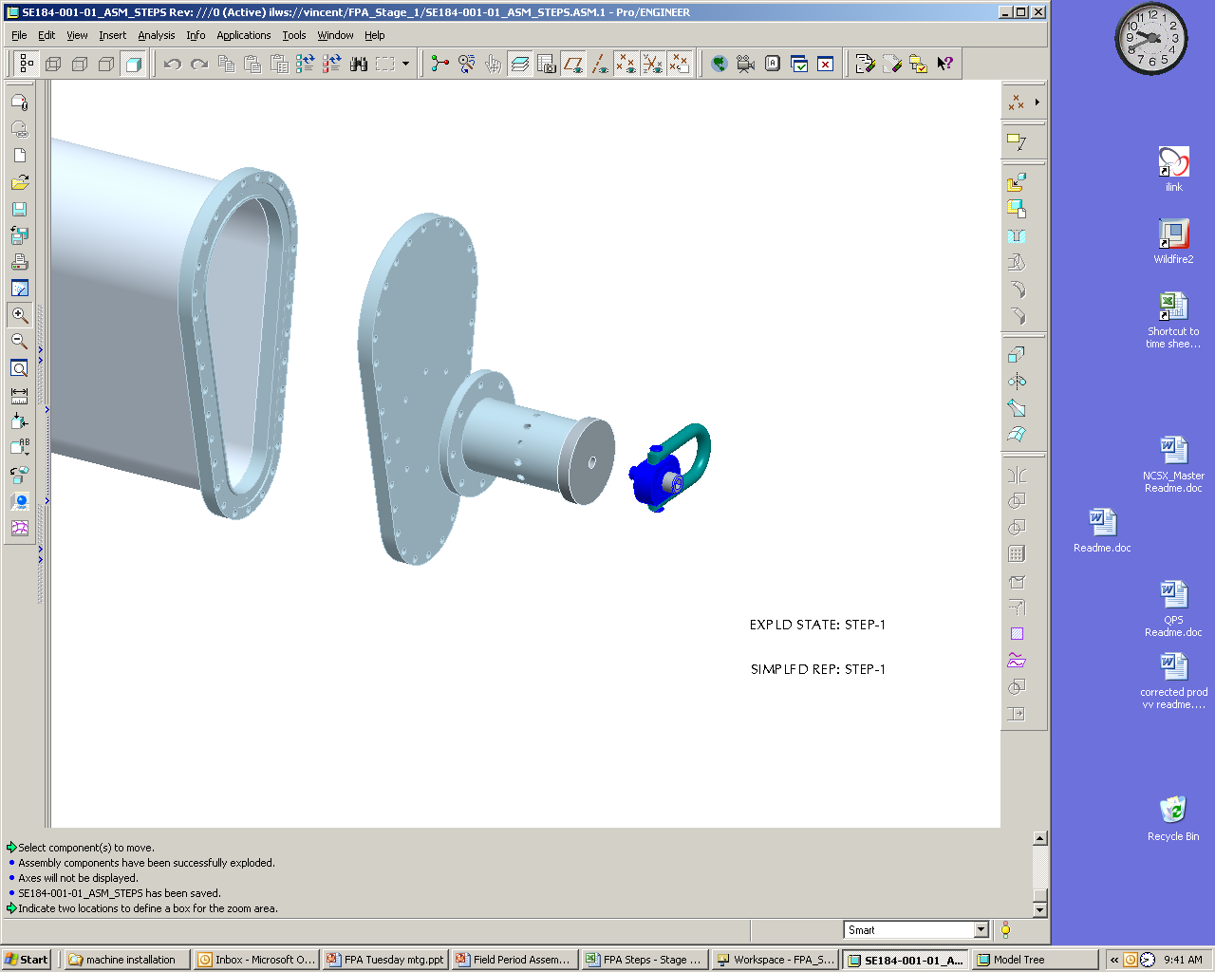
Support Axle Weldment
Hoist Ring
Stage 1 Port Horizontal Flange

Figure 1. Horizontal Flange

If attached remove NB port flange and bag bolt assemblies for future use. See Figure 2

Install VV heating/cooling cryostat interface flanges by slipping each over each vertical port. The interface flanges need to be temporarily supported on the flanges. Reference drawing: se123-164. See Figure 2

Install VV heating/cooling cryostat interface flanges by slipping each over each vertical port. The interface flanges need to be temporarily supported on the flanges. Reference drawing: se123-164. See Figure 2

If attached remove NB port flange and bag bolt assemblies for future use. See Figure 2.

Install VV heating/cooling cryostat interface flanges by slipping each over each vertical port. The interface flanges need to be temporarily supported on the flanges. Reference drawing: se123-164. See Figure 2
Heating/cooling cryostat interface flange (se123-164)
N.B. port flange
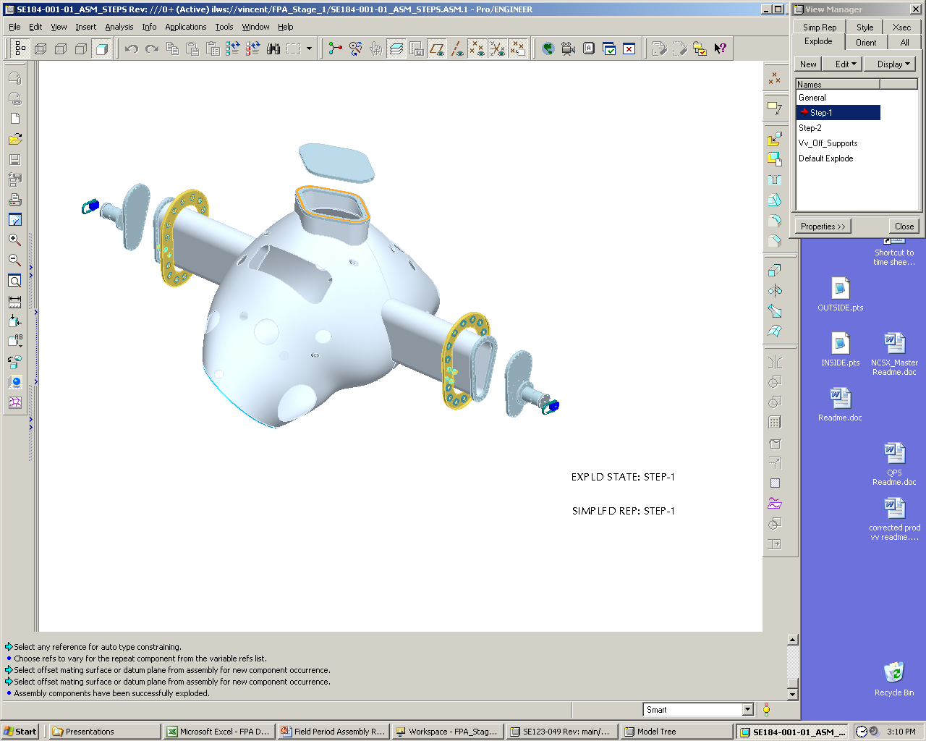
Stage one port
Assembly flange
Support Axle
Weldment

Hoist Ring
Figure 2 Heating and Cooling Cryostat Interface Flanges

Using rubber gasket material or gortex gasket material on the flanges for flange protection install stage one port assembly flange covers, support axle weldments, and hoist rings.

6.4.4 Using shim stock as needed to keep support axle weldments coaxial install support axle weldments to stage one port assembly flanges.

Install VVSA in Station One Rotating Fixture:

Using lift procedure (D-L-NCSX-XXXX) and test cell crane attached to Weldment hoist rings. Lift VV from a horizontal position and rotate to a vertical position. Check to see if VV is in a near vertical position. Mark CG location.

Note: If VV Cg is found to be off by a value greater than 2.0” return VV to its original position. Remove and relocate support axle Weldments to proper location and retest.
See Appendix A – Document Sigh-off-Record

Lubricate support axle and axle support cradle. Add lubricate to support axle weldment and support axle cradle components (cradle top and cradle base) to reduce VV rotation friction.

Mount VV on Station one rotating fixture in the horizontal position. See Figure 3.

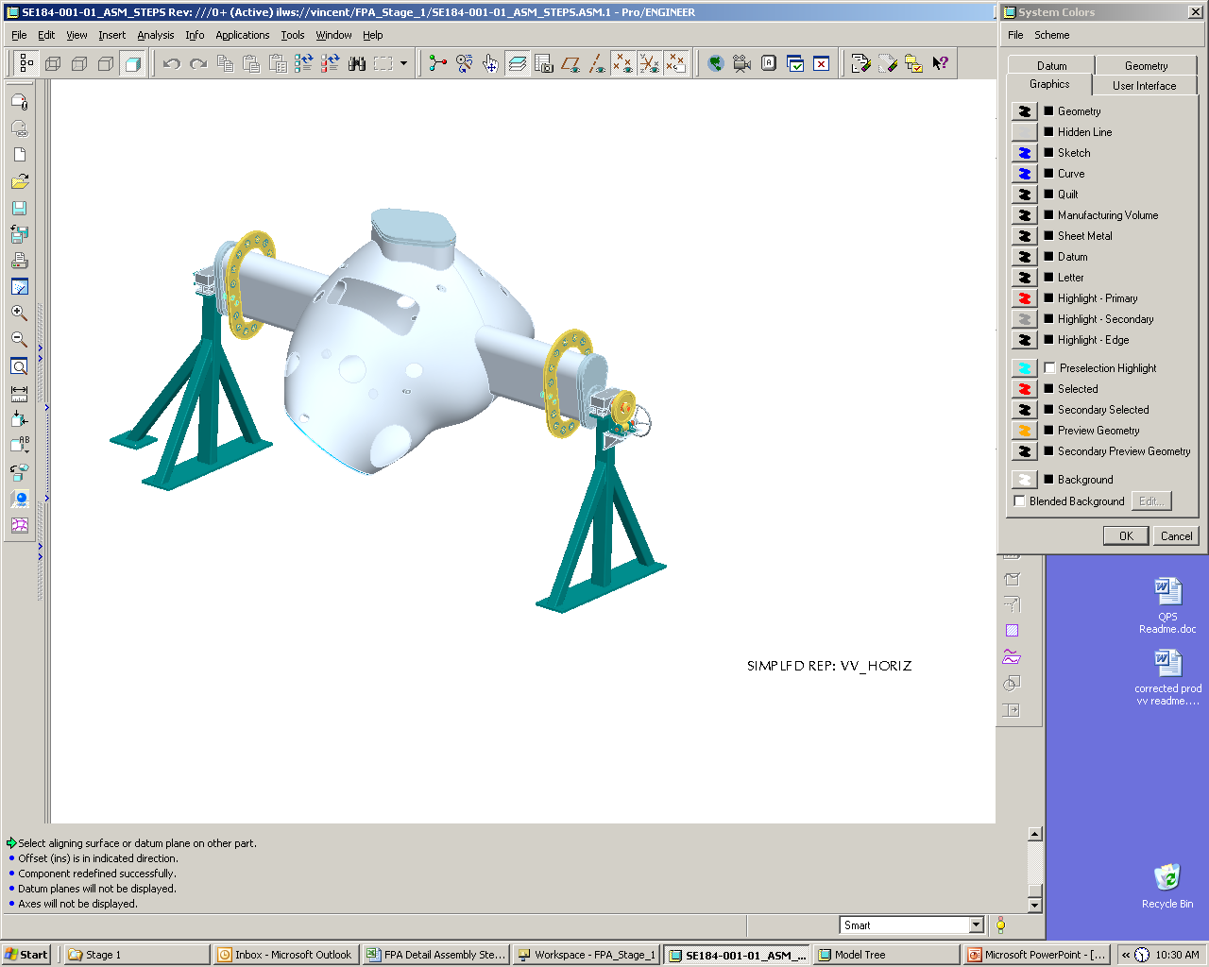

Figure 3 Vacuum Vessel in Horizontal Position

Secure in place by bolting down support axle cradle to support blocks. See Figure 6-4.

Install quick release pin. See Figure 6-4.

Remove the hoist ring from worm gear side of VV support axle weldment. Install worm gear axle and worm gear. See Figure 6-4.
Quick release pin
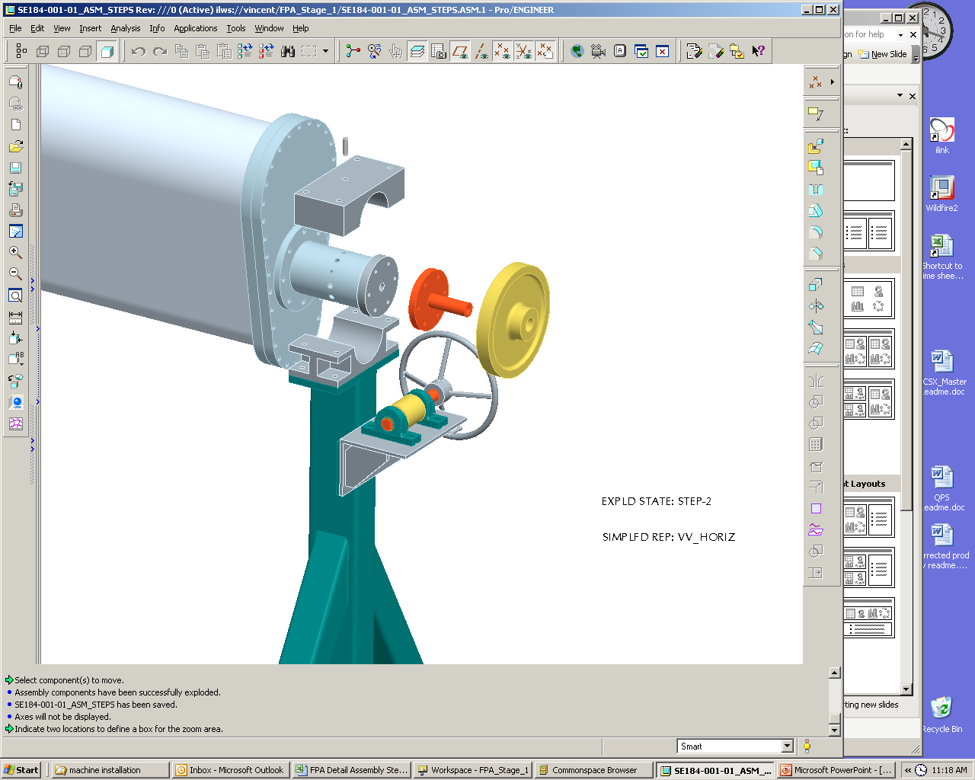

Worm gear axle Weldment

Support axle cradle top

Figure 4 Worm Drive Installation Details

Metrology Set-up and Initial Vessel Measurements

Using a marker mark the positive toroidal field direction on the front and back surface of the vacuum vessel.
Note: The worm gear system is identified as the VV down direction. See Figure 5.

See Appendix A – Document Sigh-off-Record
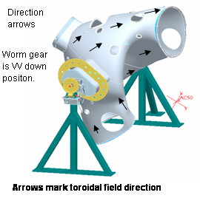
Figure 5

Using one or both of the metrology systems set up and measure monument fiducials provided by MTM plus add additional monuments as specified in FP Dimensional Control Plan for Station 1 (NCSXPLAFPA1DC-00). Rotate vessel to convenient access positions.
Note: Some monuments will be located on the body of the VVSA

Perform a best fit to the fiducial measurements using the monuments on the VV body. Settings will be made with the vessel NBI port at a +/-60º off vertical position as indicated in Figure 6 and Figure 7. Secure vessel position by inserting release pin and tighten support axle cradle bolts. Verify that the mounting system is rigid enough to meet FP Dimensional Control Plan metrology requirements.

See Appendix A – Document Sigh-off-Record

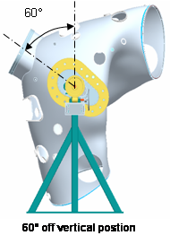
Figure 6

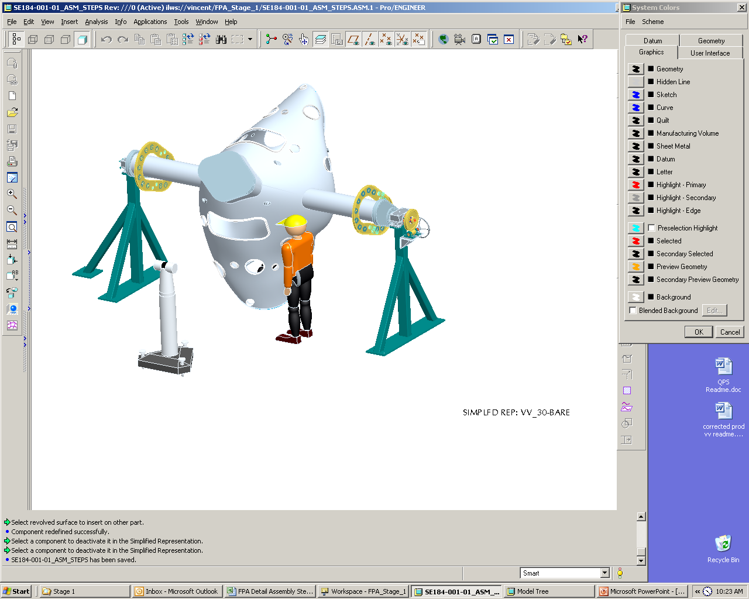
Figure 7 Vacuum Vessel in Rotated Position

Marking Flux Loop Template and Heating Coolant Stud Locations:

Each loop template has four locating notches which shall be used to install loops within ± 0.160” of marked locations, except for the loops at the symmetry points which shall be positioned within ± 0.020”. Transfer the locator points for all copper templates to the measurement arm software. These points are the centers of the 0.020 inch radius semicircles machined on each side of a template. These are the ideal locations as defined in the CAD model. There will be some variation of the vessel surface from the CAD model and therefore the locator points. Installation will therefore be on a best fit basis to be approved by the physics and engineering cognizant and recommended by the personnel responsible for the installation including metrology.

In general the templates are to be located within 1mm of the ideal, understanding that the vessel may vary radially to plus or minus 0.187 inch. One can define the tolerance as a point within a cylinder of 1 mm radius and a radial extent of 0.375 inch.

The exceptions are the templates which define the Stellarator symmetry points. They’re 15 such loops. These are to be located to a tolerance as a point within a cylinder of 0.25mm radius with a radial extent of 0.35 inches. The symmetry loops are located at theta 0 and 180 degrees, with poloidal centers on the NB ports and the period spacers. These loops are to be identically constructed and positioned on each of the 3 periods. These loops are templates 2-Th180-1 thru 2-180-5. See Figure 8.
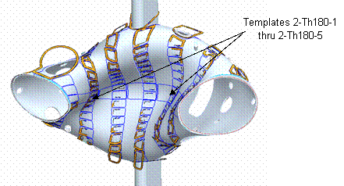
Figure 8 Locating of Templates
6.7.1 Secure vessel position with the 60º NBI port at a +/– 60º off vertical position by inserting release pin and tighten support axle cradle bolts.

    - Mark surface for XXX loop placements with the vessel NBI port at a +/–60º off vertical position. It is expected that three metrology positions will be required on each side to accurately mark the vessel. The metrology system will be used to accurately define four marks (within +/–0.040”) for each of the XXX loops except for the loops at the symmetry points which shall be positioned within +/–0.010”. The magnetic loop locating points are to be permanently marked on the vessel surface. One method is to use a center punch. As each set of locator points are marked, outline the rough geometry of the template, and circle the locator points. For ease of locating templates mark template number at center of four points. See figure 9 below and Reference drawing XXXXX and ProE model XXXXX for loop designation, point marking details and model geometry data.

NOTE:
All Loop installation data to be logged on Table 1 at end of procedure.

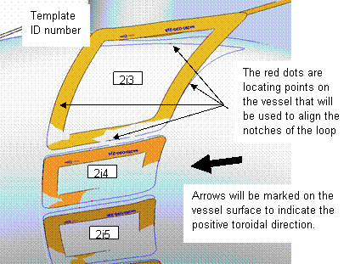

Figure 9 Template Locating and Numbering

6.7.4 The Leica or Roma Arm metrology system will be used to locate XXXX studs per half period at X” spacing. Fine accuracy is not important position within +/– .50”. The stud location shall be marked with a circle with a name designation added ( A1, A2, A3….) to define the series. An outline of the coolant line and hold-down bracket shall also be marked. See Figure 10 and reference drawing se121-128 sheet 4 for loop designation, point marking details.

Note: The cooling lines overlay the diagnostic loops.
All stud installation data to be logged on Table 2 at end of procedure.

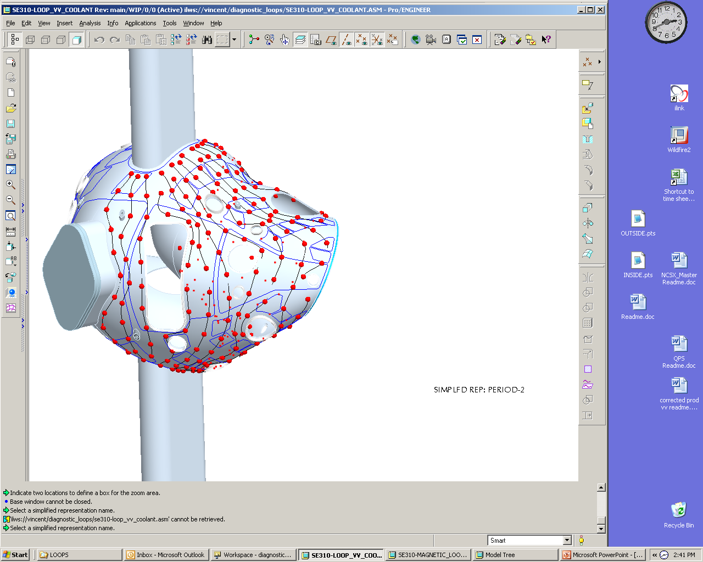

Figure 10 Overlay of the Coolant Lines Over the Diagnostic Loops

Vertical Port Component Installation

Mark heating/cooling support bracket A and B attachment studs and mark bracket clip outline.

Install cryostat interface mounting flange on vertical ports. Before welding the interface flange on the vertical ports the cryostat interface flange must be moved into the proper assembly position. ( See Figure 11).

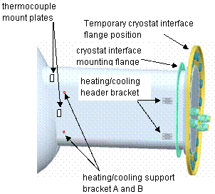

Figure 11 Cryostat Interface

Install cryostat interface flange on vertical ports.

Install heating/cooling header bracket.

Install thermocouple mounting plates and thermocouples to VV vertical ports.

Reference drawing se 121-004.

    - Install heating strips on vessel vertical ports. See Figure 11.

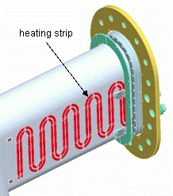
HBase Support Plate

Figure 12 Heating strip

6.9 Installing of Magnetic Flux Loop Templates

    - Rotate VVSA to convenient installation position for locating loop templates. Each loop template has four locating notches which shall be used to install loops. Locate the template and fix it to the vessel using flat 316 SS shim stock clips (0.010 recommended, strong enough to hold the template yet developing a weak enough spot weld that can be easily removed with a chisel). Initially use only enough clips to support the template but allow it to be moved if need be. Using the metrology system verify the position of template and add additional clips securing the template at this position. If the tolerance deviation of the vessel does not allow the tolerance achievement of the loops then the cognizant physicist will determine the acceptable position. Installation will therefore be on a best fit basis to be approved by the physics and engineering cognizant and recommended by the personnel responsible for the installation including metrology. Symmetry Templates 2-Th180-1 thru 2-180-5 need to be placed and the flux loop wires run before adjacent loops are placed because of local template interferences. See Figure 8. After symmetry loop Templates 2-Th180-1 thru 2-180-5 are secured and positions verified, mark the path of the voltage loops on the vessel period surface. Proceed to step 6.10 and install flux loop wires for the five symmetry Loops.

    - Install all of the templates on the field period and log all information for each template on table 1 at end of procedure.

Note:
The locating direction arrow should be aligned in the general direction of the positive toroidal field direction arrows marked on the vessel surface. See Figure 13.
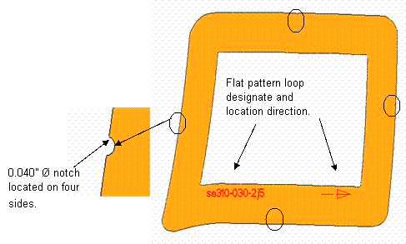
Figure 13 Installing Loop Templates
6.10 Installing of Magnetic Flux Loop

Each saddle Loop consists of a two turn coil of an inconel sheath and conductor, coaxial cable and twisted leads which run along the vessel surface and exit the cryostat region thru a 2.75 inch CF in the horse collar of a vertical port. The cables will be terminated in a junction box at a later time. Up to 20 twisted pairs will enter a JB.

Determine the unique length of co axial cable required for a complete loop including the twisted pair. One method is to use a pliable yet non stretching material ( stranded wire) to determine the circumference of the template and the developed length needed for the twisted pair along the marked path and along the vertical port and to the JB. If the circumference is designed as ( C ) and the twisted pair length as ( L ) then the total length (TL) required can be calculated as TL=( 2C+1 ) + 2( L+20 ) + ( .667xL ). This should result in about 20 inches of excess length at the JB box if the pitch is >^@% inches and somewhat more if the pitch is closer to 0.75 inches. To determine L the starting point of the twisted pair must be determined.

At a few locations where the twisted pair cross a Voltage Loop the pitch will be interrupted and the pair will be run straight and parallel and touching for up to 2 inches. The voltage loop ( single coaxial cable ) will cross over the twisted pair at this location. This straight length pair will have a hold down clip on each side of the Voltage Loop and the Voltage Loop will have a hold down clip on either side of the twisted pair.

6.10.2 After the Loop length is determined cut the length from the large roll and remove all kinks and twists.

Seal both ends and the end on the large roll with the moisture barrier material provided. The MGO insulator is hygroscopic and must be sealed from moist air immediately after being cut.

½ inch wide by 3/8 inch deep indents have been provided along the edge of each template to accommodate the use of shim stock as hold downs. The hold downs are preformed and are 0.005 inch thick 316 SS. The clips are to have a magnetic permeability of less than 1.02. QA is to check a random sampling of 50 clips. High magnetic permeability can be mitigated by heat treating. There is sufficient space in an indent to accommodate 2 hold down clips. The partial clips are to be used to secure the inner turn and the full clips secure the outer turn. The copper templates are 0.043 inch thick and have the central portion removed to facilitate conforming to the vessel surface and allow for the placement of the template holding clips. Use at least 4 spot welds to weld the clip to the vessel surface. Check each clip and ensure that the spot welds have punched through and the clip is secure.

6.10.3 The best point on the template to start the twisted pair was determined before the loop length was calculated therefore keeping this in mind start the wrap of the inner turn around the template and install a pre formed 0.005 inch thick SS partial clamp at each indent by spot welding, leaving sufficient space for the full clamp to be installed adjacent to it. In general the lower limit for the bend radius is ¼ inch. Minimize the dead space or excess area formed at the point where the inner and outer turns meet to start the twisted pair. Determine a method to form the same dead or excess area for all loops. This area will be added to the loop measurement area.

    - A simple plastic tool with two parallel holes drilled through has been developed to assist in the task of forming the twisted pairs. The twisted leads are to be identified with a 2 digit color band. There are less than 100 loops on the highest density field period. The twisted pair are to be identified in more than one location along its path and in the cryostat region, at least in the location under the horse collar and at the end of the cable inside the JB. The color bands must be retained at all times and when the excess length is cut and the termination made. All loop installation information and identifiers will be logged in Appendix 3 at end of procedure which will include loop tag nomenclature and color code number. The standard electrical wiring identifying convention will be used. Two different width bands will be used. The first number is the series will be the wider band with.
The color identifiers are:
0=Black 5=Green
1=Brown 6=Blue
2=Red 7=Violet
3=Orange 8=Gray
4=Yellow 9=White

    - After each twisted pair is installed it must be tested for continuity of the conductor and integrity of the MGO insulation. Log the test results for all pairs on Appendix 3. A dielectric fixture will be provided to facilitate the testing.

6.10.6 Install all remaining flux loop templates. Except for the mentioned wire runs in the previous step, all remaining templates shall be installed before any loop wires are run.

6.10.7 Mark vessel surface showing twisted pair leads path.

6.11 H/C stud and Loop wires installation.

NOTE:
- Use Reference drawing: XXXXX , ProE model: XXXXXX, and Dimensional Control Plan: NCSX-PLAN-FPA1DC-00 .
- Location of H/C tube mounting hardware in reference to Flux Loops must be considered before studs are welded on VVSA.
- All H/C installation data to be logged on Table 2 at end of procedure

6.11.1 Install H/C studs on the VV being careful not to damage Flux Loops and Flux Loop Templates.

6.11.2 Install H/C tube hardware used for mounting H/C lines.

6.11.3 Install loop wires and then remove templates. Refer to drawing XXXXXXX and ProE model XXXXX for guide in running voltage loops.

6.11.4 Use electrical color identifying code to mark wires as twisted wires leave template, along its path and after it passes through the horse collar.

6.11.5 Lay leads loosely to accommodate the installation of the H/C tube heat transfer bases.

6.11.6 Route excess lead length through the 2 ¾ Cryostat Flange and protect the excess length from damage.

6.12 Final Loop routing and Measurement

    - Perform final routing of flux leads and hold down with spot-welded shims stock straps spaced approximately 4” apart.]\

NOTE: The radial build of the twisted leads should not exceed 1/8’, except in a few places (not under H/C tube paths) where it may be necessary for one set of leads to cross another.

    - Measure as-built paths of flux loops within ±0.025 mm (0.010”). This shall be done by tracing the groove between the two turns of each loop using a Laser Tracker probe with a small tip.

See Appendix A – Document Sigh-off-Record

6.12.3 Using Reference drawing: se121-004 install thermocouple mount plates and thermocouples to VV shell.

6.13 Installation of H/C lines

6.13.1 Install H/C support bracket Weldment A and B and tube mount strap. See figure 14. and Reference Drawing: se121-00.

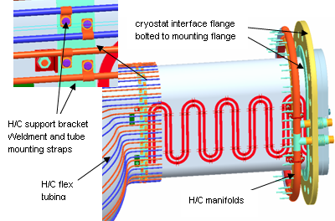:
Figure 14 H/C Support Brackets

6.13.2 Using reference Drawings: sse121-008, se123-049 Install H/C cryostat flange and H/C manifolds. See Figure 14.

6.13.3 Using reference Drawings: sse121-008, se123-049 Install H/C flex tubing. See Figure 14.

6.13.4 Using reference Drawings: sse121-008, se123-049 Install H/C hard tubing. See Figure 15.

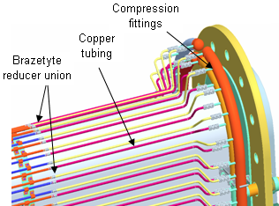

Figure 15 Hard Tube Installation

    - Leak check coolant lines.

Note: Log leak check on table 3.

See Appendix A – Document Sigh-off-Record

6.14 Loop termination and verification check.

6.14.1 Perform final installation of twisted leads by checking continuity and resistance to ground of each pair. After H/C line bases are completed dress in cables and install hold down supports.

6.14.2 Verify tagging and conductors by physical check or use oscillator.
Note: Log continuity check and tagging on table 1.

See Appendix A – Document Sigh-off-Record

6.14.3 Trim cable length – cut excess length to 1ft. using diamond wheel to cut end flat. This is accomplished by installing gas seal and partial junction box (JB); inserting CF gasket: routing cables thru predrilled holes in CF blank; routing cables thru pre-punched holes of silicon rubber gaskets; routing cables thru predrilled holes in JB base; installing CF threaded fasteners thru the JB base and torque to get metal contact between JB base and CF ring; and checking the cable configuration and condition in cryostat region.

6.14.5 Terminate the cables by determining the length to terminal box (TB0; flat cut the cable with diamond wheel; strip back the sheath with tool provide leaving (TBD) of conductor exposed; cleaning the MGO from the conductor; apply a moisture barrier to MGO; and installing Teflon heat shrink tubing (4.1).

6.14.6 Strain relieve cables inside JB using spot welded SS shim stock.

6.14.7 Install TB circuit boards into front panel of JB and install conductors into TB.

6.14.8 Protect D sub connector by placing a protective cover over the D subminiature connector.

6.14.9 After the installation is complete, the as installed geometry and location of each saddle loop is to be measured and the data transferred to physics possibly through as intermediary since the data may be generated and stored as IGES files.

7. Completion of Activities at Station One:

Document Verification:
Verify that all pertinent data in the procedure tables 1,2,3, and Appendix 1 have been completed.

Field Package:
Ensure that all data sheets, photographs, QC inspection sheets, etc are included in the Field Package.

Approval:
Prior to releasing a VV from Station One it is required that the all-responsible individuals sign the release indicating that all processes at the station one have been satisfactorily completed. The release will include signatures from the Station Lead Technician, Field Supervisor and the QC representative.

All station one preparation activities including completion of appendix one and table 1,2,3, have been satisfactorily completed.

Lead Technician: ____________________________ Date: ____________________

Field Supervisor: ____________________________ Date: ____________________

QC shall verify completion of documentation:

Quality Control Representative: _________________________ Date: ________

The VV is ready for transfer to the VV station no. 3:

Comments:

Preparing and Transferring Completed VV to Holding Area

    - Install the NB port temporary cover and NB angle support bracket. See Figure 16

    - Rotate VV to horizontal position. Secure in place by bolting down support axle cradle top support blocks and installing quick release pin.
    - Remove worn gear and install hoist rings.

    - Using lift procedure D-L-NCSX-XXX remove completed VV from support stand and reposition to the vertical position with worm gear side of vessel in the down position.

    - While on the crane install base support plate. See Figure 16.

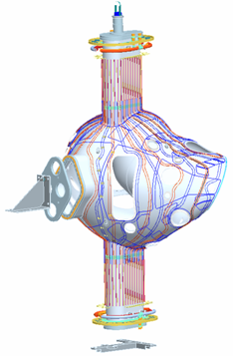
NB Port
Temporary
Cover

NB Angle
Support
Stage 1 Port Horizontal Flange

Figure 16 NB Angle Support Bracket and Base Support Plate

    - Position completed VV on Station 3 stand. See Figure 17.
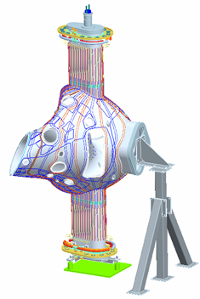
Stage 3 Support Stand
Worm gear
Figure 17 Stage 3 Support Stand

8. Appendix A. Document Sign Off

Vacuum Vessel Segment Identification.

Segment Identification.

Verified by: _________________________ Date: __________________
Lead Technician

  - Pre Job Briefing:

Pre Job Briefing Complete:
VV Field Supervisor Date

  - Vacuum Vessel Receipt and Inspection:

Measurements taken by: _________________________ Date: _______________

Measurements completed and verified by:
Metrology Engineer: ____________________________ Date: ____________________

QC Representative: ____________________________ Date: ____________________

  - Cg verification:

Verified by: _________________________ Date: __________________
Lead Technician

  - Arrows marked for toroidal field direction:

Verified by: _________________________ Date: __________________
Lead Technician

6.6.3 Best fit to Fiducials :

Measurements taken by: _________________________ Date: _______________

Measurements verified and /or approved by:

Metrology Engineer: ____________________________ Date: ____________________

QC Representative: ____________________________ Date: ____________________

6.9 Loop Templates Best fit to Model:

Measurements taken by: _________________________ Date: _______________

Measurements verified and/or approved by:

Metrology Engineer: ____________________________ Date: ____________________

Physics Representative: ____________________________ Date: ____________________

QC Representative: ____________________________ Date: ____________________

6.12 Final Loop Measurements:

Measurements taken by: _________________________ Date: _______________

Measurements verified and/or approved by:

Metrology Engineer: ____________________________ Date: ____________________

Physics Representative: ____________________________ Date: ____________________

QC Representative: ____________________________ Date: ____________________

6.13 Leak Check Coolant Lines:

Verified by: _________________________ Date: __________________
Lead Technician

QC Representative: ____________________________ Date:

6.12 Loop Termination Continuity Check:

Verified by: _________________________ Date: __________________
Lead Technician

QC Representative: ____________________________ Date:

Verified by: _________________________ Date: __________________
Lead Technician

Table 1-Loop Installation Data For Field Period 1

Table 2-Loop Installation Data For Field Period 2

Table 3-Loop Installation Data For Field Period 3

Table 4-Stud Installation Data:

Table 5-H/C/ Lines Installation and Leak Check Data:

