Princeton Plasma Physics Laboratory
Procedure
‘
Procedure Title: Field Period Assembly Station One

Number:  D-NCSX-FPA-001 |  | Revision:  1 |  |  | Effective Date: 12/04/06  Expiration Date:  (2 yrs. unless otherwise stipulated)
Procedure Approvals
Author: John W. Edwards |  |  |  |  |  | Date:
ATI: Mike Viola |  |  |  |  |  | Date:
RLM: Larry Dudek |  |  |  |  |  | Date:
Responsible Division: NCSX Project
Procedure Requirements
Designated by RLM
LAB-WIDE:
X | Work Planning Form (ENG-032) #1224 |  |  | Lockout/Tagout (ESH-016)
 | Confined Space Permit (5008,SEC.8 Chap 5) |  |  | Lift Procedure (ENG-021)
 | Master Equipment List Mod (GEN-005) |  | X | ES&H Review (NEPA, IH, etc.) NEPA 1283
 | RWP (HP-OP-20) |  |  | Independent Review
 | ATI Walkdown |  | X | Pre-Job Brief
X | Post-job Brief * |  | X | Hydrostatic and Pneumatic Testing. (ENG-014)
D-SITE SPECIFIC:
X | D-Site Work Permit (OP-AD-09) |  |  | Door Permit (OP-G-93)
 | Tritium Work Permit (OP-AD-49) |  |  | USQD (OP-AD-63)
X | Pre-Job Brief (OP-AD-79) |  |  | T-Mod (OP-AD-03)
 | **DCA/DCN (OP-AD-104) #

* Required for installations involving internal vacuum installations, critical lifts, and for the initial installation of repetitive work.
** OP-AD-104 was voided by procedure ENG-032. However, DCA’s that were open at the time of adoption of ENG-032 are still considered valid for work approval purposes.

REVIEWERS (designated by RLM)

Incorporated
Comments
Accountable Technical Individual…………………………………….John W. Edwards
Test Director
Independent Reviewer
D-Site Shift Supervisor
Independent
NCSX Dimensional Control Coordinator………………………..…Art Brooks
Vacuum Vessel Cognizant Engineer……………………………….Paul Goranson
NCSX Field Supervisors………………………………..Steve Raftopoulos, Mike Viola |  |  |  | X
Project Engineer for Stellarator Systems (WBS 1) Manager………..Brad Nelson (ORNL)
FPA Tooling and Constructability …………………………………….Tom Brown |  |  |  | X
Quality Assurance/Quality Control…………………………….….Frank Malinowski |  |  |  | X
Maintenance and Operations Division
Energy Conversion System/Motor Control Division
Engineering ……………………………………………………………Wayne Reiersen
Environmental Restoration & Waste Management Division
Environmental, Safety & Health……………………………………….Jerry Levine |  |  |  | X
Industrial Hygiene………………………………………………………...Bill Slavin
Health Physics……………………………………………………..……George Ascione
RLM………………………………………………………………….….Larry Dudek |  |  |  | X
TRAINING (designated by RLM)

No training required ______________ | Instructor John Edwards
Personnel (group, job title or individual name) |  | Read Only | Instruction  Pre-job  Briefing |  | Hands On
Lead Tech. |  |  | X
Technicians performing task |  |  | X
Field Supervisors |  |  | X
Quality Control Representative |  |  | X
Training Rep.
RLM Larry Dudek

RECORD OF CHANGE

Revision | Date | Description of Change
00 | XXXX | Initial release

TABLE OF CONTENTS

1. Scope 1
1.1 Introduction 1
1.2 Scope 1
1.3 Identification of Vacuum Vessel Segment being assembled: 1
2. Applicable Documents: 1
2.1 NCSX-MIT/QA-185-00: 1
2.2 NCSX-PLAN-CMFOP-00: 1
2.3 D-L-NCSX-007 Lifting Vacuum Vessel Segment 1
2.4 D-NCSX-PLAN-FPA1DC-00 VV Dimensional Control Plan 1
2.5 NCSX-CSPEC-185-01-00 Product Specification Station 1 Field Period Assembly 1
2.6 NCSX-CSPEC-31-01-01 Diagnostic Specification External
Saddle Loops……………………………………………………………………….1
3. Safety Requirements: 1
3.1 Job Hazard Analysis: 1
4. Prerequisites & Conditions: 2
4.1 Pre-Job Briefing: 2
4.2 Daily Operations Startup and Shutdown: 2
5. Materials and Parts for this station 2
6. Assembly Process 2
6.1 Daily Startup Activities: 3
6.2 Daily Shutdown Activities: 3
6.3 Replace Port Flanges with Station 1 Assembly Flanges: 3
6.4 Install VVSA in Station One Rotating Fixture: 4
6.5 Metrology Set-up and Initial Vessel Measurements 5
6.6 Marking Flux Loop Template: 7
6.7 Marking Heating Coolant Stud Locations: 9
6.8 Vertical Port Component Installation 10
6.10 Installing of Magnetic Flux Loop 11
6.11 Final Loop routing and Measurement 12
6.12 Thermocouple installation 14
6.13 Installation of H/C lines 15
7. Completion of Activities at Station One: 18
7.1 Document Verification: 18
7.2 Field Package: 18
7.3 Approval: 18
7.4 Preparing and Transferring Completed VV to Holding Area 18
8. Appendix A. Document Sign Off 19
1.3 Vacuum Vessel Segment Identification 19
4.1 Pre Job Briefing: 19
6.4.7 Rotating fixture secure: 19
6.4.8 Cg verification: 19
6.5.1 Arrows marked for toroidal field direction: 19
6.5.4 Best fit to Fiducials: 19
6.7.2 Heating/cooling studs: 20
6.8.3 Cryostat Interface Flange: 20
6.8.4 Heating/cooling header bracket 20
6.8.5 Thermocouple mounting plates: 20
6.8.6 Heating/cooling support brackets 20
6.8.7 Heating strips 21
6.8.7.1 Heating strips continuity and isolation test. 21
6.10.6 Loop Templates best fit to Model: 21
6.10.8 Loop Continuity and resistance check: 21
6.11.4 Final Loop Measurements: 22
6.13.3 Heating/cooling manifold 22
6.13.4 Heating/cooling tube stud torque: 22
6.13.5 Heating cooling hard tubing: 22
6.13.7 Heating/cooling tube stud re-torque: 23
8.21 Approval: 23

Index of Figures

Figure 1 Horizontal Flange 3
Figure 3 Vacuum Vessel in Horizontal Position 4
Figure 4 Worm Drive Installation Details 5
Figure 5 Arrow Mark Toroidal Field Direction 6
Figure 6 60 degree off Vertical Position 7
Figure 7 Vacuum Vessel in Rotated Position 7
Figure 8 Template Locating and Numbering 8
Figure 9 Overlays of the Coolant Lines over the Diagnostic Loops 9
Figure 10 Cryostat Interface 10
Figure 11 Heating strip 11
Figure 12 Installing Loop Templates 12
Figure 13 H/C Support Brackets 15
Figure 14 Hard Tube Installations 16
Figure 15 NB Angle Support Bracket and Base Support Plate 18
Figure 16 Stage 3 Support Stand 18

Index of Tables

Table 1-Loop Installation Data For Field Period 1 24
Table 2 Loop Installation Data For Field Period 2 27
Table 3 Loop Installation Data For Field Period 3 30
Table 4-Stud Installation Data 33
Table 5 H/C/ Lines Installation and Leak Check Data 53

1. Scope

1.1 Introduction
The Field Period Assembly is divided into 5 workstations. Each workstation has a specific set of tasks that will be performed as part of the overall assembly process. This procedure addresses the manufacturing, inspection, test and QC inspection points for a specific workstation.
Station No. 1 Vacuum Vessel Subassembly (VVSA) Activities

1.2 Scope
This procedure is used to describe the assembly sequence required for Station 1 Field Period Assembly.
Installing the Vacuum Vessel in the turning fixture
Metrology measurements
Flux Loop Locations
Heating Cooling Tube Stud Location
Installation of Flux Loops
Installation of Heating –Cooling Tubes

1.3 Identification of Vacuum Vessel Segment being assembled:

Lead Technician See Appendix A – Document Sigh-off-Record

2. Applicable Documents:

NCSX-MIT/QA-185-00:
All applicable documents associated with this procedure, are identified in the MIT/QA Plan, document number NCSX-MIT/QA-185-00.

NCSX-PLAN-CMFOP-00:
All work processes are governed by the “NCSX Coil Manufacturing Facility Operations Plan”, document number NCSX-PLAN-CMFOP-00.

2.3 D-L-NCSX-007 Lifting Vacuum Vessel Segment

2.4 D-NCSX-PLAN-FPA1DC-00 VV Dimensional Control Plan

2.5 NCSX-CSPEC-185-01-00 Product Specification Station 1 Field Period Assembly

2.6 NCSX-CSPEC-31-01-01 Diagnostic Specification External Saddle Loops

3. Safety Requirements:
All work will be performed in a safe manner in accordance with PPPL Environmental Safety &
Health Directives ES&H 5008 and the “Integrated Safety Management” (ISM) policy.

3.1 Job Hazard Analysis:
A JHA will be generated for each Vacuum Vessel Sub Assembly station, identifying existing or potential workplace hazards and to evaluate the risk of worker injury or illness associated with job tasks. (Reference document ESH-004 “Job Hazard Analysis”) The IH representative will review the JHAs for accuracy as well as completeness. It will be reviewed with all activity participants at the Pre-Job briefings.

4. Prerequisites & Conditions:

4.1 Pre-Job Briefing:
A pre-job briefing will be held, describing the processes and safety issues prior to starting any part of this procedure. Attendance shall be documented via training sign-in sheet.

VV Field Supervisor See Appendix A – Document Sign-off Record

4.2 Daily Operations Startup and Shutdown:

Each working day the Lead Technician it is required to complete and initial the daily operations startup log to ensure that the station is ready to commence work activities for the day. The signoff log is located in the Daily Station Log. See section 6.1 and 6.2 for details.

5. Materials and Parts for this station
The following materials and/or equipment will be used with this procedure.

General Description | Material | Reference Document/Product No.
Vacuum Vessel Sub Assembly | See Drawing | SE120-002
VVSA Support Stand Assembly | See Drawing | SE184-001
Magnetic Diagnostic Templates | Copper | SE310-030-A-Q,Se310-030-THO  SE310-030-THO-TH180
Vacuum Vessel Heating/Cooling Assembly | See Drawing | SE123-049, SE121-008,SE121-009
Thermocouple Mounting | See Drawing | SE121-004
Heating Tapes | See Drawing | SE121-005
Header Standoff | See Drawing | SE121-009

6. Assembly Process
This assembly procedure is to be used as guide to complete the station no. 1 activities. Deviation from this procedure for processes that DO NOT affect the design of the assembly can be made during the assembly process with the concurrence of the VVSA Field Supervisor. All deviations shall be documented in the procedure and initialed by the VVSA Field Supervisor prior to implementing the deviations. Deviations that may affect the design of the assembly requires a Request for Deviation “RFD” approval. The RFD must be approved prior to proceeding. Procedure changes need to be incorporated into the document via “Minor Procedure Changes” or “Revisions”.

6.1 Daily Startup Activities:

6.1.1 Verify operation of all equipment needed that day.

6.1.3 Check that safety equipment needed for day’s activities are available

6.1.5 Check that the day’s travelers (I.E. Appendix A) and procedures are in their document holder.

6.1.6 Once completed Lead Technician shall, date and initial the Station Log Book.

6.2 Daily Shutdown Activities:

6.2.1 Turn off power to equipment not in use.

6.2.2 Lock Cabinets.

6.2.3 Verify that all Traveler (I.E. Appendix A) and data sheet information is complete.

6.2.4 Verify that all deviation from the procedure have been documented in the procedure and initialed by the VVSA Field Supervisor.

6.2.5 The Lead Technician shall verify that the Station’s Log Book has been completed and signed for the day.

6.3 Replace Port Flanges with Station 1 Assembly Flanges:

6.3.1 If attached remove the two horizontal port flanges covers and bag bolt assemblies for future use. See Figure 1.

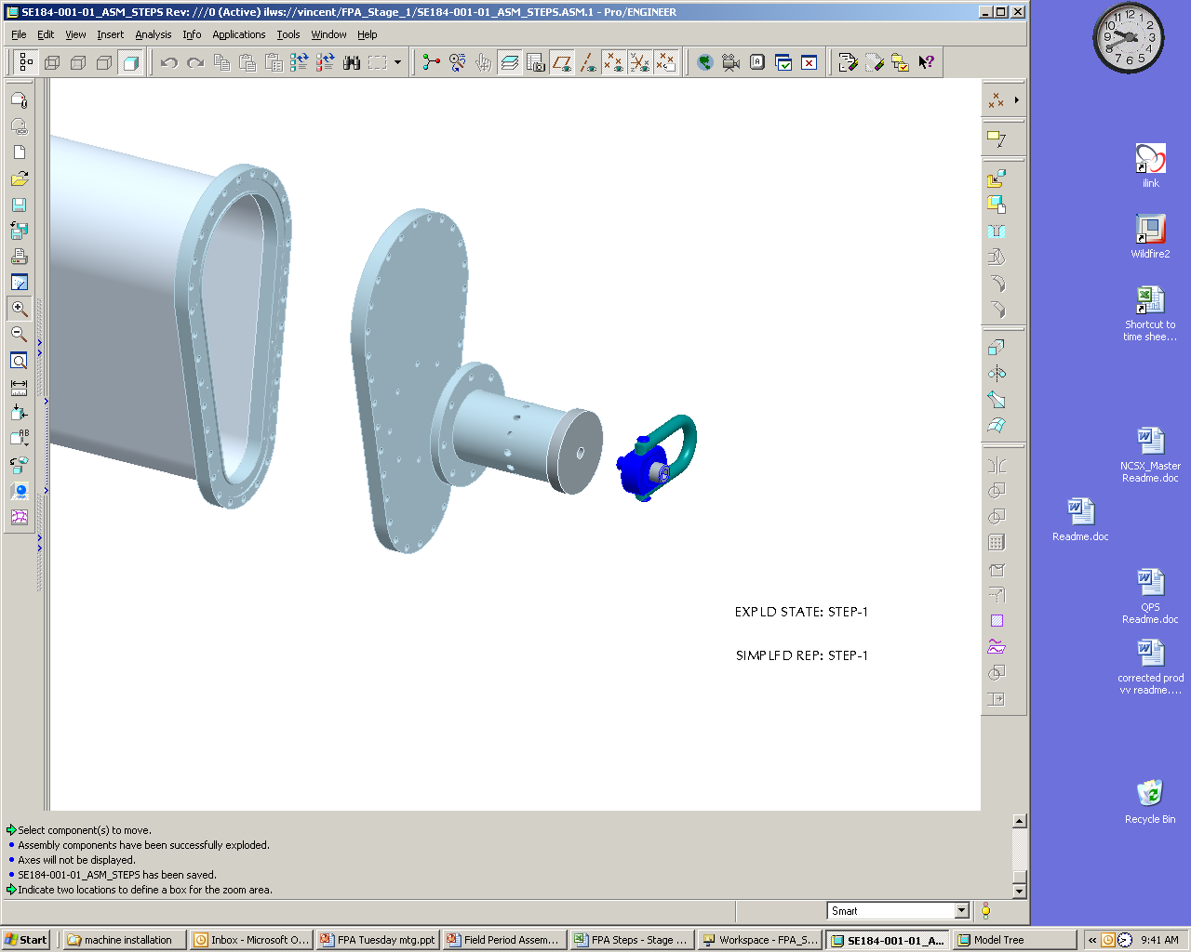
Support Axle Weldment
Hoist Ring
Stage 1 Port Horizontal Flange

Figure 1 Horizontal Flange

6.3.2 If attached remove NB port flange cover and bag bolt assemblies for future use. Install temporary port cover se 184-054 and seal spacer se 184-055. See Figure 2.

6.3.3 Install VV heating/cooling cryostat interface flanges by slipping each over each vertical port. The interface flanges need to be temporarily supported on the flanges. Reference drawing: se123-164. See Figure 2
Heating/cooling cryostat interface flange (se123-164)
N.B. port flange
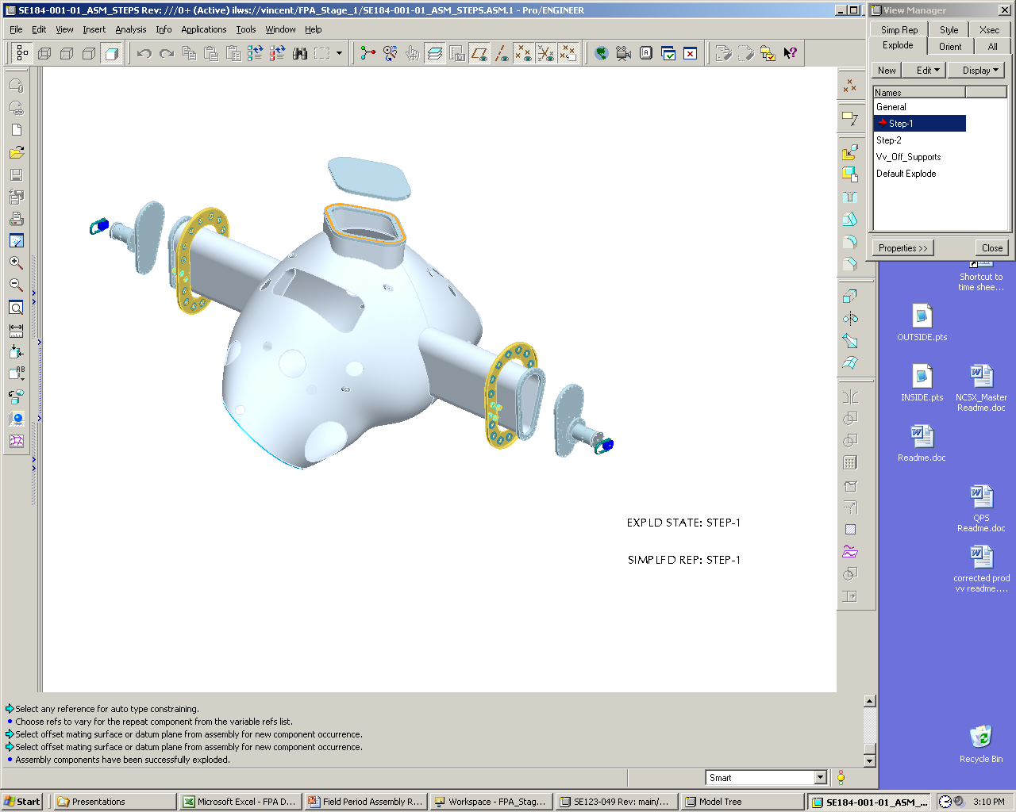
Stage one port
Assembly flange
Support Axle
Weldment

Hoist Ring
Figure 2 Heating and Cooling Cryostat Interface Flanges

6.3.6 Using rubber gasket material or gortex gasket material on the flanges for flange protection install stage one port assembly flange covers. Torque flange bolts to 50 foot lbs.

6.3.7 Using shim stock as needed to keep support axle weldment coaxial. Install support axle weldment to stage one port assembly flanges.

6.4 Install VVSA in Station One Rotating Fixture:

6.4.1 Using lift procedure (D-L-NCSX-997) and test cell crane, basket around the two VVSA port 12’s. Lift VVSA enough to remove load from a base support then remove support base by grinding the welds off the support base to VVSA. Lifts VVSA high enough too allow the VVSA base support to be removed from under the VVSA.

6.4.2 Lubricate support axle and axle support cradle. Add lubricant to support axle weldment and support axle cradle components (cradle top and cradle base) to reduce VV rotation friction.

6.4.3 Mount VV on Station one rotating fixture in the horizontal position. See Figure 3.

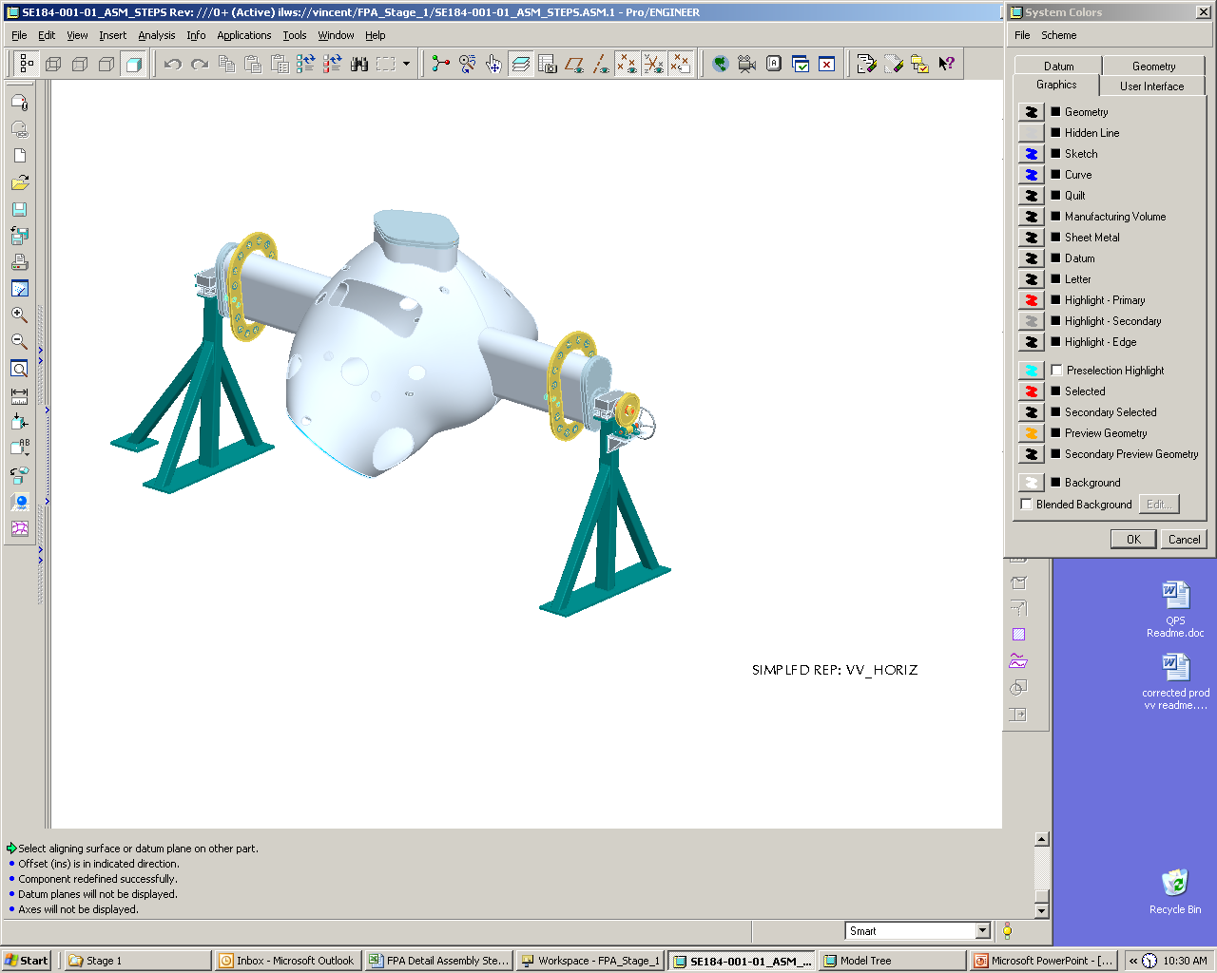

Figure 3 Vacuum Vessel in Horizontal Position

6.4.4 Secure in place by bolting down support axle cradle to support blocks. See Figure 4.

6.4.5 Install quick release pin. See Figure 4.

6.4.6 Install worm gear axle and worm gear. See Figure 4.
Quick release pin
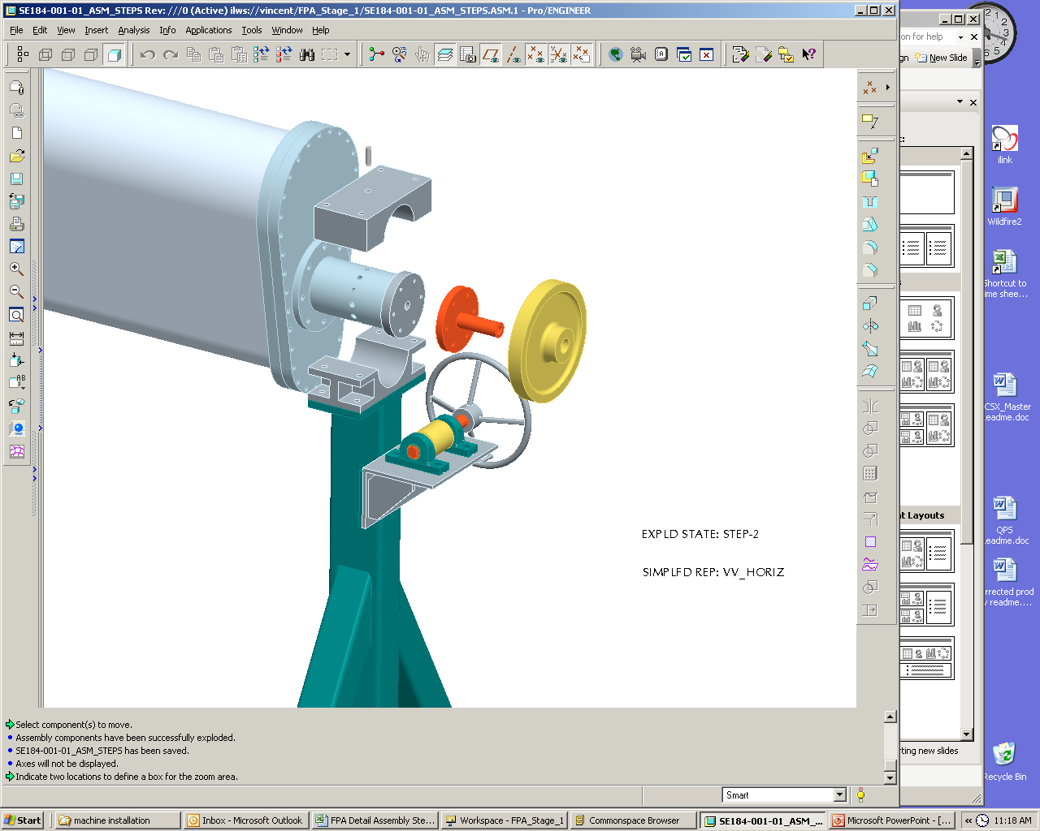

Worm gear axle Weldment

Support axle cradle top

Figure 4 Worm Drive Installation Details

Verify all components of rotating fixture are secure and that VV is ready to rotate.

Lead Technician See Appendix A – Document Sign-off Record

6.4.8 Using rotating crank handle and ratchet mechanism slowly rotate VV on its horizontal axis checking to see that the center of gravity (CG) is correct and not putting undue strain on the rotating mechanism.

Note: If VV CG is found to be off enough to cause rotating problem the support axle weldments will have to be moved or weight added to VV to shift the CG.

Lead Technician See Appendix A – Document Sign-off Record

6.5 Metrology Set-up and Initial Vessel Measurements

6.5.1 Using a marker mark the positive toroidal field direction (SF-110-030-1 sheet 3) on the front and back surface of the vacuum vessel.

Note: The worm gear system is identified as the VV down direction. See Figure 5.

Lead Technician See Appendix A – Document Sign-off Record

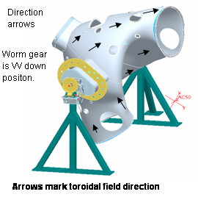
Figure 5 Arrow Mark Toroidal Field Direction

6.5.2 Rotate the VVSA through one full revolution and take note of the MTM supplied fiducial points. Determine whether the MTM supplied fiducials are adequate in number and location to allow alignment to the VVSA from any desired rotation on the turning fixture. Add additional fiducial points if required.

Note: Some monuments will be located on the body of the VVSA

6.5.3 Perform a best fit to the fiducial measurements using the monuments on the VV body. Settings will be made with the vessel NBI port at a +/-60º off vertical position as indicated in Figure 6 and Figure 7. Secure vessel position by inserting release pin and tighten support axle cradle bolts. Verify that the mounting system is rigid enough to meet FP Dimensional Control Plan metrology requirements.

If additional fiducial points were added in step 6.5.2, measure their location.

Metrology Technician and Engineer See Appendix A – Document Sign-off Record

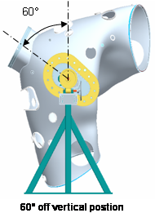
Figure 6 60 degree off Vertical Position
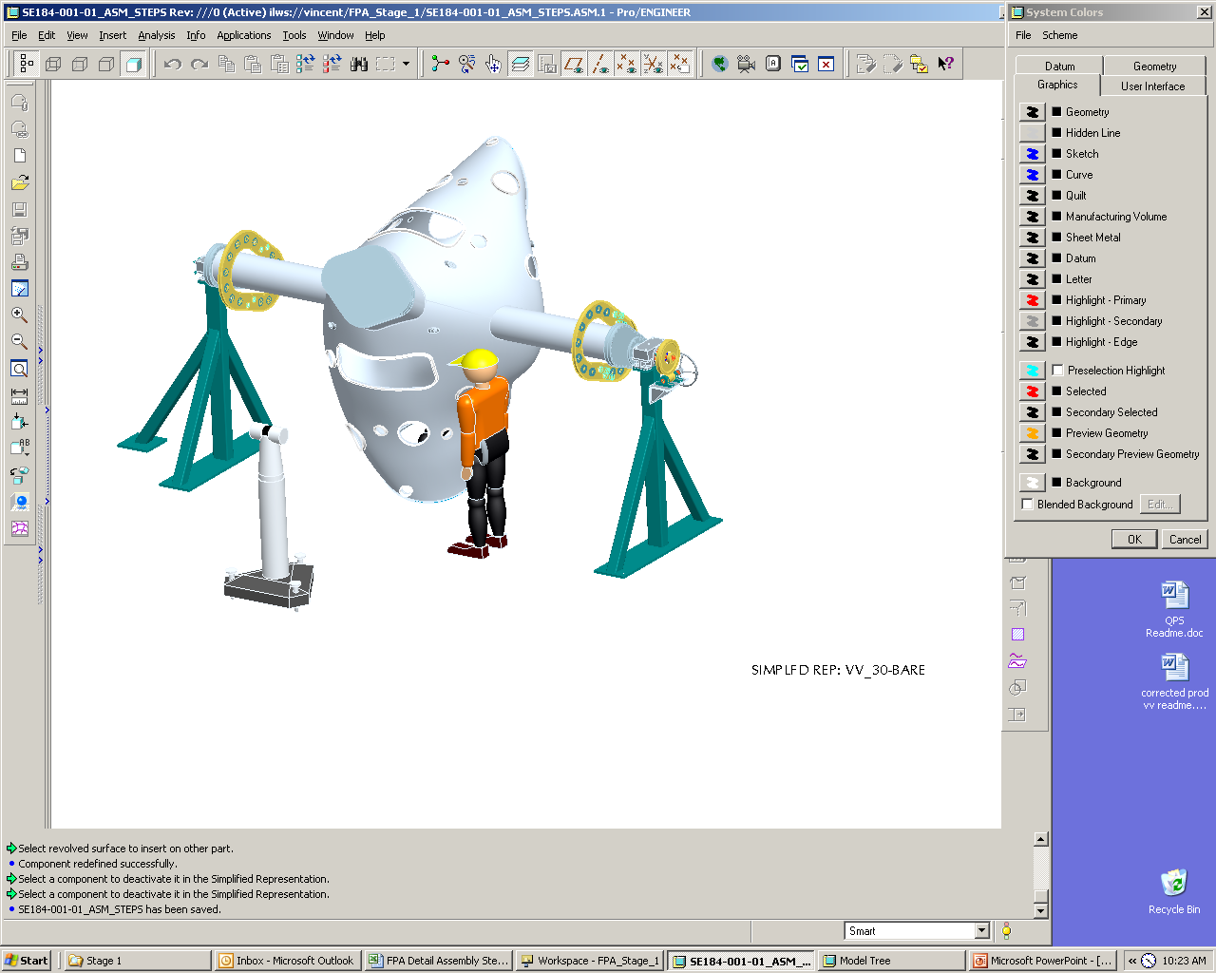
Figure 7 Vacuum Vessel in Rotated Position

6.6 Marking Flux Loop Template:
Each loop template has four locating notches which shall be used to install loops within ± 0.160” of marked locations, except for the loops at the symmetry points which shall be positioned within ± 0.020”. Each template position is defined by its multiple locator points (ideal) listed in the table of drawings #se310-030-1 to 3). Using a sharpie permanent marker transfer the locator points for all copper templates to the measurement Veri Surf software. These points are the centers of the 0.020 inch radius semicircles machined on each side of a template. These are the ideal locations as defined in the CAD model. There will be some variation of the vessel surface from the CAD model and therefore the locator points. Installation will therefore be on a best fit basis recommended by the personnel responsible for the installation including metrology. Document relocated template location points.

Minimize the distance between an ideal point and a final selected surface point, while keeping the difference in the local x-y coordinates to less than 0.160 inch for the general loops and 0.020 inch for the symmetry loops. A secondary requirement for a Field Period symmetry loop is that it be equidistant from the center of the NB port (theta = 0) and the corresponding point at the inner center ( theta = 180) with a local x-y coordinate difference of less than 0.020 inch, if the as built dimensions of the vacuum vessel do not permit the first requirement to be met.
*Note: That there are 2 similar symmetry loops on each filed period spacer with similar requirements. The total number of symmetry loops is 12. Six on the FP’s and size on the FP spacers.

When locating the templates, some of the fiducials points may be located such that they interfere
with the template positioning. Individual fiducial points may be removed (and relocated if necessary), as long as there are sufficient additional fiducial points in the vicinity to allow for alignment and measurement of the relocated point

6.6.1 Secure vessel position with the 60º NBI port at a +/– 60º off vertical position by inserting release pin and tighten support axle cradle bolts.

6.6.2 Mark surface with permanent marker for all loop placements with the vessel NBI port at a +/–60º off vertical position. It is expected that three metrology positions will be required on each side to accurately mark the vessel. The metrology system will be used to accurately define four marks (within +/–0.160”) for each of the 55 loops except for the loops at the symmetry points which shall be positioned within +/–0..020”. The magnetic loop locating points are to be permanently marked on the vessel in a way that does not distort the surface. As each set of locator points are marked, outline the rough geometry of the template, and circle the locator points. For ease of locating templates mark template number at center of four points. See figure 8 below and Reference drawing se 310-030-1 to 3 for loop designation, point marking details and model geometry data.

NOTE: All Loop installation data to be logged on Table 1, 2 or 3 at end of procedure.

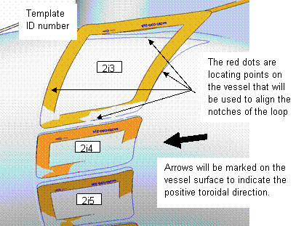
Figure 8 Template Locating and Numbering

Marking Heating Coolant Stud Locations:

6.71. The Leica or Roma Arm metrology system will be used to locate 730 studs per half period at 5” spacing. Fine accuracy is not important spacing may be varied along the length of the theoretical hose location +/ 1 inch and lateral +/- ½ inch if necessary to avoid interference with flux loop installation. The stud location shall be marked with a circle with a name designation added ( A1, A2, A3.) to define the series. An outline of the coolant line and hold-down bracket shall also be marked. See Figure 9 and reference drawing se121-008 sheet 4 for cooling loop designation and locator point details.

6.7.2 Install all heating / cooling tube weld studs that do not interfere with flux loop templates. Use heating cooling tube saddle foot print as a guide to maintain a minimum distance of ¼ inch from the flux loops. Remaining heating / cooling tube weld studs will be installed after flux loops are installed. Caution: Use heat blanket, taps on foil to protect flux loops from weld slag during installation of remaining studs.

Lead Technician and QC Representative See Appendix A – Document Sign-off Record

NOTE:
The cooling lines overlay the diagnostic loops.
- Use Reference drawing: se 123 008 and Dimensional Control Plan: NCSX-PLAN-FPA1DC-00.
- Location of H/C tube mounting hardware in reference to Flux Loops must be considered before studs are welded on VVSA.
- All H/C installation data to be logged on Table 7, 8, or 9 at end of procedure

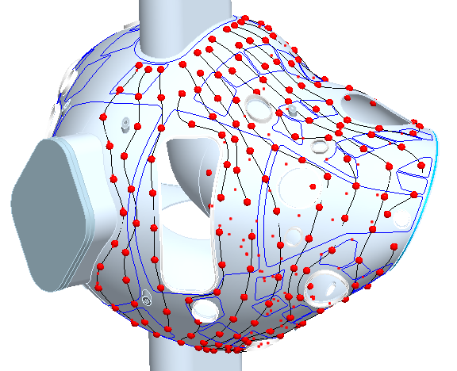

Figure 9 Overlays of the Coolant Lines over the Diagnostic Loops

6.8 Vertical Port Component Installation

6.8.1 Mark heating/cooling support bracket A and B attachment studs and mark bracket clip outline. See Figure 10 and SE121-008.

6.8.2 Install cryostat interface mounting flange on vertical ports. Before welding the interface flange on the vertical ports the cryostat interface flange must be moved into the proper assembly position. See Figure 10 and SE121-049.

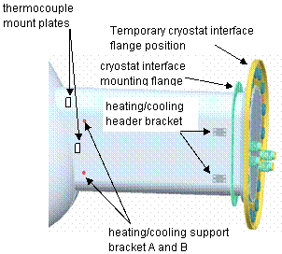

Figure 10 Cryostat Interface

Install cryostat interface flange on vertical ports. See Figure 10 and SE121-049

Lead Technician and QC Representative See Appendix A – Document Sign-off Record

6.8.4 Install heating/cooling header bracket. See Figure 10 and SE121-008

Lead Technician and QC Representative See Appendix A – Document Sign-off Record

6.8.5 Install 29 thermocouple mounting plates on port 12’s and vacuum vessel. See Figure 10 and SE121-004

Lead Technician and QC Representative See Appendix A – Document Sign-off Record

6.8.6 Install heating/cooling support bracket studs. See Figure 10 and SE121-004

Lead Technician and QC Representative See Appendix A – Document Sign-off Record

Install heating strips on vessel vertical ports. See Figure 11 and SE121-004

Lead Technician and QC Representative See Appendix A – Document Sign-off Record

6.8.7.1 Perform electrical continuity shock and an electrical isolation test (10 Mohms at 5 kV) on the heater strips. See: (NCSX-CSPEC-185-01-00)

Lead Technician and QC Representative See Appendix A – Document Sign-off Record

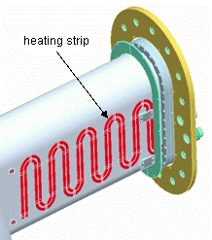
HBase Support Plate

Figure 11 Heating strip

6.8.8 Mark vessel surface showing voltage loop paths.

6.8.9 Mark vessel surface showing flux loop twisted pair leads path.

6.9 Installing of Magnetic Flux Loop Templates

6.9.1 Rotate VVSA to convenient installation position for locating loop templates. Each loop template has four locating notches which shall be used to install loops. Locate the template, contour the template to the vessel surface by hand, and fix it to the vessel using flat 316 SS shim stock clips (0.010 recommended, strong enough to hold the template yet developing a weak enough spot weld that can be easily removed with a chisel). Initially use only enough clips to support the template but allow it to be moved if need be. Using the metrology system verify the position of template and add additional clips securing the template at this position. If the tolerance deviation of the vessel does not allow the tolerance achievement of the loops then the cognizant physicist will determine the acceptable position. Installation will therefore be on a best fit basis to be approved by the physics and engineering cognizant and recommended by the personnel responsible for the installation including metrology. Templates Th180-1 thru Th180-5 need to be placed and the flux loop wires run before adjacent loops are placed because of local template interferences. See Figure 8. After symmetry loop Templates Th180-1 thru T h180-5 are secured and positions verified use a sharpie permanent marker to mark the path of the voltage loops on the vessel period surface. Proceed to step 6.10 and install flux loop wires for the five symmetry Loops.

6.9.2 Install Templates Th180-1 thru Th180-5 on the field period and log all information for each template on table 1 at end of procedure. After loop Templates Th180-1 thru T h180-5 are secured and positions verified, mark the path of the loops on the vessel period surface. Precede to step 6.11 and install flux loop wires for the five Loops.

Note: The locating direction arrow should be aligned in the general direction of the positive toroidal field direction arrows marked on the vessel surface. See Figure 12.

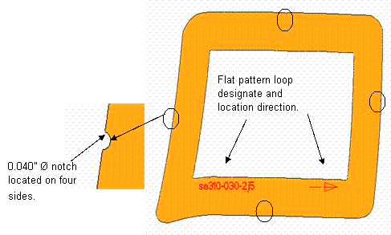
Figure 12 Installing Loop Templates

6.10 Installing of Magnetic Flux Loop

6.10.1 Each saddle Loop consists of a two turn coil of an Inconel sheath and conductor, coaxial cable and twisted leads which run along the vessel surface and exit the cryostat region thru a 2.75 inch CF in the horse collar of a vertical port. The cables will be terminated in a junction box at a later time. Up to 20 twisted pairs will enter a JB.

Determine the unique length of co axial cable required for a complete loop including the twisted pair. Use a pliable yet non stretching material (stranded wire) to determine the circumference of the template and the developed length needed for the twisted pair along the marked path and along the vertical port and to the JB. The circumferential length is determined by measuring the template perimeter (P) and multiplying by 2 (two turn coil).The twisted pair length (lg) is determined by measuring the path marked on the vessel surface up to and into the JB, adding 18 inches and multiplying by 2.8. The total minimum length of coaxial cable needed to form a two turn loop and a twisted pair into the JB, with sufficient length to strain relive the cable and terminate them into the terminal blocks is L = 2(P) + 2.8 (lg+18).

At a few locations where the twisted pair crosses a Voltage Loop the pitch will be interrupted and the pair will be run straight and parallel and touching for up to 2 inches. The voltage loop (single coaxial cable) will cross over the twisted pair at this location. This straight length pair will have a hold down clip on each side of the Voltage Loop and the flux Loop will have a hold down clip on either side of the twisted pair.
Note: An acceptable after note is in the voltage loop to cross over the twisted pair if these is no local interference with H/C tubes.

6.10.2 After the Loop length is determined cut the length from the large roll and remove all kinks and twists.

Seal both ends and the end on the large roll with the moisture barrier material provided. The MGO insulator is hygroscopic and must be sealed from moist air immediately after being cut.

½ inch wide by 3/8 inch deep indents have been provided along the edge of each template to accommodate the use of shim stock as hold downs. The hold downs are preformed and are 0.005 inch thick 316 SS. The clips are to have a magnetic permeability of less than 1.02. QA is to check a random sampling of 50 clips. High magnetic permeability can be mitigated by heat treating. There is sufficient space in an indent to accommodate 2 hold down clips. The partial clips are to be used to secure the inner turn and the full clips secure the outer turn. The copper templates are 0.043 inch thick and have the central portion removed to facilitate conforming to the vessel surface and allow for the placement of the template holding clips. Use at least 4 spot welds to weld the clip to the vessel surface. Check each clip and ensure that the spot welds have punched through and the clip is secure.

The best point on the template to start the twisted pair was determined before the loop length was calculated therefore keeping this in mind start the wrap of the inner turn around the template and install a pre formed 0.005 inch thick SS partial clamp at each indent by spot welding, leaving sufficient space for the full clamp to be installed adjacent to it. In general the lower limit for the bend radius is ¼ inch. Minimize the dead space or excess area formed at the point where the inner and outer turns meet to start the twisted pair. Determine a method to form the same dead or excess area for all loops. This area will be added to the loop measurement area.

A simple plastic tool with two parallel holes drilled through has been developed to assist in the task of forming the twisted pairs. The polarity sense is to be maintained (clockwise looking at the template) if practical. If a counter clockwise polarity loop must be installed, document the loop tag number under comments in table 3. Twist the leads up to but not into or beyond, the entrance of the JB. The cable is to be smooth and leads parallel through the JB rubber seal. The twisted leads are to be identified with a 2 digit color band using the color code of drawing se310-0301 to 3. There are less than 100 loops on the highest density field period. The twisted pair is to be identified in more than one location along its path and in the cryostat region, at least in the location under the horse collar and at the end of the cable inside the JB. The color bands must be retained at all times and when the excess length is cut and the termination made. All loop installation information and identifiers will be logged in Table 3 at end of procedure which will include loop tag nomenclature and color code number. The standard electrical wiring identifying convention will be used. Two different width bands will be used. The first number is the series will be the wider band with.

The color identifiers are:
0=Black 5=Green
1=Brown 6=Blue
2=Red 7=Violet
3=Orange 8=Gray
4=Yellow 9=White

6.10.5 Perform final routing of flux leads, holding down twisted flux leads with spot-welded shims stock straps spaced approximately 4” apart.

6.10.6 Install all remaining flux loop templates. Except for the mentioned wire runs in the previous step, all remaining templates shall be installed before any loop wires are run. Verify all templates are best fit to model.

Metrology Technician and Engineer and Physics Representative See Appendix A – Document Sign-off Record

6.10.7 Install and perform final routing of remaining flux leads.

NOTE: The radial build of the twisted leads should not exceed 1/8”, except in a few places (not under H/C tube paths) where it may be necessary for one set of leads to cross another.

6.10.8 After each twisted pair is installed it must be tested for continuity and resistance of the conductor and integrity of the MGO insulation See: (NCSX CSPEC-31-A-01-01). Log the test results for all pairs on Table 1. A dielectric fixture will be provided to facilitate the testing.

Lead Technician and QC Representative See Appendix A – Document Sign-off Record

6.11 Final Loop routing and Measurement

6.11.1 Refer to drawing #____TBD___to determine which holes through the CF flange and Jb are to be used for cables. The cables are not to be pulled through the CF flange at this time. Assemble the silicone rubber seal between the CF flange and JB lightly tightening the ¼ inch hardware. The predrilled holes for the ¼ inch fasteners will allow orienting the JB properly. Note that most of the JB to CF bolt circle pattern orientation is unique. The JB must be oriented properly on the horse collar. Using a small hypodermic needle (0.014 inches OD) puncture the rubber seal for one hole at first to clock the predrilled holes in the CF flange with the predrilled holes in the JB. Only the predrilled holes to be populated with cable are to have the rubber seal punctured. The non populated holes must have an intact rubber seal to prevent nitrogen boil off. Loosen the ¼ inch hardware and insert the smooth non twisted leads through the drilled holes in the 2.75 CF flange drilled blank, then silicone rubber, and then the JB. Verify that the pattern is as shown on drawing___TB___. Pull in the cable with the last twist up against the CF flange. Continue the twisting of the leads inside the JB boundary for approximately 3 turns. Do not twist the leads beyond the 3 turns at this time so as not to interfere with the terminations phase of work after machine operations start. After all cables are pulled into a JB square cut the ends to a length of 15 inches and seal the ends with Aero Seal. The color code should be applied and visible inside the JB and below the hoarse collar

6.11.2 Remove the winding templates after the loops are formed and twisted leads run to the JB.

6.11.3 Using an exciter coil verifies that the proper coil leads are in the proper holes.

Measure as-built paths of flux loops within ±.25 mm (0.01”) in the lateral dimension. Each flux loop position and geometry is to be measured by using a Romer Arm with a small tip or the Laser Tracker and tracing the interface (groove) between the two turns. The measurement should be made a minimum of every one inch. In addition the triangular open area, formed at the point where the twisting of leads start and end, is to be measured and documented as a continuous geometry. The measurement should be logged into a table of xyz coordinates which can be read by the Physics Group.

Note: Log continuity check and tagging on table 1, 2, or 3.

Metrology Technician and Engineer and Physics Representative See Appendix A – Document Sign-off Record

6.12 Thermocouple installation

6.12.1 Using Reference drawing: se121-004 install thermocouples to port 12 and VV shell.

Perform electrical isolation check (10 Mohms @ 5kV) and an operation check on the thermocouples. See (NCSX CSPEC-185-01-00).

Lead Technician and QC Representative See Appendix A – Document Sign-off Record

6.13 Installation of H/C lines

6.13.1 Install remaining H/C studs on the VV being careful not to damage Flux Loops.

6.13.2 Install H/C support bracket Weldment A and B and tube mount strap. See figure 13. and Reference Drawing: se123-049.

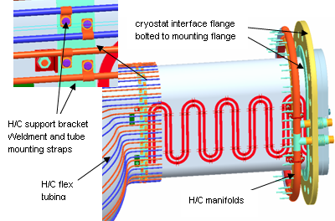:
Figure 13 H/C Support Brackets

6.13.3 Using reference Drawings: sse121-008, se123-049 Install H/C cryostat flange and H/C manifolds. See Figure 13

Lead Technician and QC Representative See Appendix A – Document Sign-off Record

6.13.4 Using reference Drawings: sse121-008, se123-049 Install H/C flex tubing.
Torque stud nuts to___TBD___ ft. lbs. Log torque data on Table 4 at end of procedure. See Figure 13.

Lead Technician and QC Representative See Appendix A – Document Sign-off Record

Using reference Drawings: sse121-008, se123-049 Install H/C hard tubing. Log data on Table 5 at end of procedure. See Figure 14.

Lead Technician and QC Representative See Appendix A – Document Sign-off Record

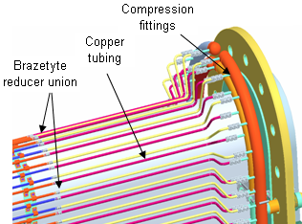

Figure 14 Hard Tube Installations

6.13.6 Leak check and flow check coolant lines. Using NCSX-CSPEC-185-01-00 and engineering procedure ENG-014 (guidelines for Hydrostatic testing) test the individual cooling lines.

Note: Log leak check flow on table 5.

Lead Technician and QC Representative See Appendix A – Document Sign-off Record

Re-torque heating/coolant stud clamps to___TBD___ft. lbs.

Lead Technician and QC Representative See Appendix A – Document Sign-off Record

7. Completion of Activities at Station One:

Document Verification:
Verify that all pertinent data in the procedure tables 1, 2, 3, and Appendix A have been completed.

7.2 Field Package:
Ensure that all data sheets, photographs, QC inspection sheets, etc are included in the Field Package.

Approval:
Prior to releasing a VV from Station One it is required that the all-responsible individuals sign the release indicating that all processes at the station one have been satisfactorily completed. The release will include signatures from the Station Lead Technician, Field Supervisor and the QC representative.

All station one preparation activities including completion of appendix one and table 1, 2, 3, have been satisfactorily completed.

QC shall verify completion of documentation:
Quality Control Representative See Appendix A – Document Sign-off Record

The VV is ready for transfer to the VV station no. 3:
Lead Technician, Field Supervisor, and QC Representative See Appendix A – Document Sign-off Record

7.4 Preparing and Transferring Completed VV to Holding Area

7.4.1 Install the NB port temporary cover and NB angle support bracket. See Figure 16

7.4.2 Rotate VV to horizontal position. Secure in place by bolting down support axle cradle top support blocks and installing quick release pin.

7.4.3 Remove worm gear and install hoist rings.

7.4.4 Using lift procedure D-L-NCSX-997 remove completed VV from support stand and reposition to the vertical position with worm gear side of vessel in the down position.

7.4.5 While on the crane install base support plate. See Figure 15.

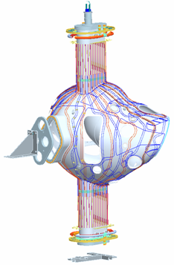
NB Port
Temporary
Cover

NB Angle
Support
Stage 1 Port Horizontal Flange

Figure 15 NB Angle Support Bracket and Base Support Plate

7.4.6 Position completed VV on Station 3 stand. See Figure 16.
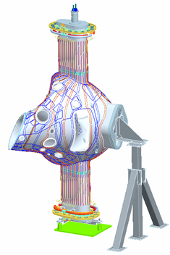
Stage 3 Support Stand
Worm gear

Figure 16 Stage 3 Support Stand

Appendix A. Document Sign Off

Vacuum Vessel Segment Identification

Segment Identification

Verified by: _________________________ Date: __________________
Lead Technician

4.1 Pre Job Briefing:

Pre Job Briefing Complete:
VV Field Supervisor Date

6.4.7 Rotating fixture secure:

Verified by: _________________________ Date: __________________
Lead Technician

6.4.8 Cg verification:

Verified by: _________________________ Date: __________________
Lead Technician

6.5.1 Arrows marked for toroidal field direction:

Verified by: _________________________ Date: __________________
Lead Technician

6.5.4 Best fit to Fiducials:

Measurements taken by: _________________________ Date:_______________

Measurements verified and /or approved by: __________________________________________Date:__________________

Metrology Engineer: ________________________ Date: ___________________

6.7.2 Heating/cooling studs:

Verified by: _________________________ Date: __________________
Lead Technician

QC Representative: ____________________________ Date:__________

6.8.3 Cryostat Interface Flange:

Verified by: _________________________ Date: __________________
Lead Technician

QC Representative: ____________________________ Date:__________

6.8.4 Heating/cooling header bracket

Verified by: _________________________ Date: __________________
Lead Technician

QC Representative: ____________________________ Date:__________

6.8.5 Thermocouple mounting plates:

Verified by: _________________________ Date: __________________
Lead Technician

QC Representative: ____________________________ Date:__________

6.8.6 Heating/cooling support brackets

Verified by: _________________________ Date: __________________
Lead Technician

QC Representative: ____________________________ Date:__________

6.8.7 Heating strips

Verified by: _________________________ Date: __________________
Lead Technician

QC Representative: ____________________________ Date:__________

6.8.7.1 Heating strips continuity and isolation test.

Verified by: _________________________ Date: __________________
Lead Technician

QC Representative: ____________________________ Date:__________

6.10.6 Loop Templates best fit to Model:

Measurements taken by: ________________________ Date: _______________

Measurements verified and/or approved by:

Metrology Engineer: ____________________________ Date: _______________

Physics Representative: ________________________ Date: ________________

6.10.8 Loop Continuity and resistance check:

Verified by: _________________________ Date: __________________
Lead Technician

QC Representative: ____________________________ Date:__________

6.11.4 Final Loop Measurements:

Measurements taken by: _______________________Date: _______________

Measurements verified and/or approved by:

Metrology Engineer: ___________________________Date: ________________

Physics Representative: _______________________ Date: ________________

    - Thermocouple electrical isolation and operation check.

Verified by: _________________________ Date: __________________
Lead Technician

QC Representative: ____________________________ Date:__________

6.13.3 Heating/cooling manifold

Verified by: _________________________ Date: __________________
Lead Technician

QC Representative: ____________________________ Date:__________

6.13.4 Heating/cooling tube stud torque:

Verified by: _________________________ Date: __________________
Lead Technician

QC Representative: ____________________________ Date:__________

6.13.5 Heating cooling hard tubing:

Verified by: _________________________ Date: __________________
Lead Technician

QC Representative: ____________________________ Date:__________

6.13.6 Leak Check Coolant Linen:

Verified by: _________________________ Date: __________________
Lead Technician

QC Representative: ____________________________ Date:__________

6.13.7 Heating/cooling tube stud re-torque:

Verified by: _________________________ Date: __________________
Lead Technician

QC Representative: ____________________________ Date:__________

7.3 Approval:

QC shall verify completion of documentation:

Quality Control Representative: _________________________ Date: ________

The VV is ready for transfer to the VV station no. 3:

Lead Technician: ___________________________Date:_________________

Field Supervisor: ___________________________ Date:_________________

Quality Control Representative: _________________Date:_________________
Table 1-Loop Installation Data For Field Period 1
Loop | Metrology | Initial | Template | Template | Loops | Loop | Loop | Continuity | Tagging | Comments
I.D. | Position | Points Located | Placed | Verified | Placed | Measured Length | Length Verified | Checked | Verified
AA1
CC3
CC5
D1
D3
D7
DD7
E1
E4
EE4
F2
F4
F6
F10
FF2
FF4
FF5
G7
GG1
GG3
GG5
GG9
GG11
H4
H8
Table 1-Loop Installation Data For Field Period 1
Loop | Metrology | Initial | Template | Template | Loops | Loop | Loop | Continuity | Tagging | Comments
I.D. | Position | Points Located | Placed | Verified | Placed | Measured Length | Length Verified | Checked | Verified
HH6
HH9
I7
JJ5
K2
K4
K7
K11
KK3
KK9
L6
L9
LL5
M2
M9
MM1
MM10
N3
N5
N6
N8
N9
NN4
NN8
NN11
Table 1-Loop Installation Data For Field Period 1
Loop | Metrology | Initial | Template | Template | Loops | Loop | Loop | Continuity | Tagging | Comments
I.D. | Position | Points Located | Placed | Verified | Placed | Measured Length | Length Verified | Checked | Verified
O6
OO5
OO8
P2
PP3
THO-1
THO-2
THO-3
THO-4
THO-5
TH180-1
TH180-2
TH180-3
TH180-4
TH180-5

Table 2 Loop Installation Data For Field Period 2
Loop | Metrology | Initial | Template | Template | Loops | Loop | Loop | Continuity | Tagging | Comments
I.D. | Position | Points Located | Placed | Verified | Placed | Measured Length | Length Verified | Checked | Verified
AA2
B2
C1
C4
CC4
D4
D5
DD2
DD5
E2
EE7
F8
F11
FF3
FF7
G1
G4
G9
GG10
H5
HH2
HH5
HH8
Table 2-Loop Installation Data For Field Period 2
Loop | Metrology | Initial | Template | Template | Loops | Loop | Loop | Continuity | Tagging | Comments
I.D. | Position | Points Located | Placed | Verified | Placed | Measured Length | Length Verified | Checked | Verified
HH10
I4
II1
II2
II3
II4
II5
II6
II7
II8
II9
J1
J2
J3
J4
J5
J6
J7
J8
J9
J10
JJ2
K5
KK11

Table 2-Loop Installation Data For Field Period 2
Loop | Metrology | Initial | Template | Template | Loops | Loop | Loop | Continuity | Tagging | Comments
I.D. | Position | Points Located | Placed | Verified | Placed | Measured Length | Length Verified | Checked | Verified
L1
L3
LL2
LL4
LL7
M4
MM5
N2
N7
NN1
NN3
O7
O10
OO8
PP4
THO-1
THO-2
THO-3
THO-4
THO-5
THO180-1
THO180-2

Table 3 Loop Installation Data For Field Period 3
Loop | Metrology | Initial | Template | Template | Loops | Loop | Loop | Continuity | Tagging | Comments
I.D. | Position | Points Located | Placed | Verified | Placed | Measured Length | Length Verified | Checked | Verified
B1
B4
BB3
CC2
D6
DD3
DD4
E3
E4
E5
F5
EE6
F9
FF1
FF9
G2
G8
GG6
H1
H3
HH4
H11
HH7
Table 3-Loop Installation Data For Field Period 3
Loop | Metrology | Initial | Template | Template | Loops | Loop | Loop | Continuity | Tagging | Comments
I.D. | Position | Points Located | Placed | Verified | Placed | Measured Length | Length Verified | Checked | Verified
I2
I8
JJ4
JJ8
K6
KK1
KK4
KK7
KK8
KK10
L2
L4
L8
LL8
LL10
M3
M7
M8
MM6
MM8
MM11
N10
O1
O4
O9
Table 3-Loop Installation Data For Field Period 3
Loop | Metrology | Initial | Template | Template | Loops | Loop | Loop | Continuity | Tagging | Comments
I.D. | Position | Points Located | Placed | Verified | Placed | Measured Length | Length Verified | Checked | Verified
O11
OO2
OO3
OO4
OO7
OO10
PP1
Q2
QQ1
THO-1
THO-2
THO-3
THO-4
THO-5
TH180-1
TH180-2
TH180-3
TH180-4
TH180-5

Table 4-Stud Installation Data
STUD | STUD | STUD | STUD | STUD RE- | STUD | INSPECTION | COMMENTS
# | LOCATED | PLACED | TORQUED | TORQUED | MEASURED
AA-1
AA-2
AA-3
AA-4
AA-5
AA-6
AA-7
AA-8
AA-9
AA-10
AA-11
AA-12
AA-13
AA-14
AA-15
AA-16
AA-17
AA-18
AB-1
AB-2
AB-3
AB-4
AB-5
AB-6
AB-7
AB-8
AB-9
AB-10
AB-11
AB-12
AB-13
AB-14
AB-15
AB-16
AB-17
STUD | STUD | STUD | STUD | STUD RE- | STUD | INSPECTION | COMMENTS
# | LOCATED | PLACED | TORQUED | TORQUED | MEASURED
AC-1
AC-2
AC-3
AC-4
AC-5
AC-6
AC-7
AC-8
AC-9
AC-10
AC-11
AC-12
AC-13
AC-14
AC-15
AC-16
AD-1
AD-2
AD-3
AD-4
AD-5
AD-6
AD-7
AD-8
AD-9
AD-10
AD-11
AD-12
AD-13
AD-14
AD-15
AD-16
AD-17
AD-18
AD-19
AD-20

STUD | STUD | STUD | STUD | STUD RE- | STUD | INSPECTION | COMMENTS
# | LOCATED | PLACED | TORQUED | TORQUED | MEASURED
AE-1
AE-2
AE-3
AE-4
AE-5
AE-6
AE-7
AE-8
AE-9
AE-10
AE-11
AE-12
AE-13
AE-14
AE-15
AE-16
AE-17
AE-18
AE-19
AF-20
AF-1
AF-2
AF-3
AF-4
AF-5
AF-6
AF-7
AF-8
AF-9
AF-10
AF-11
AF-12
AF-13
AF-14
AF-15
AF-16
AF-17
STUD | STUD | STUD | STUD | STUD RE- | STUD | INSPECTION | COMMENTS
# | LOCATED | PLACED | TORQUED | TORQUED | MEASURED
AF-18
AF-19
AF_20
AG-1
AG-2
AG-3
AG-4
AG-5
AG-6
AG-7
AG-8
AG-9
AG-10
AG-11
AG-12
AG-13
AG-14
AG-15
AG-16
AG-17
AG-18
AG-19
AG-20
AG-21
AG-22
AG-23
AG-24
AH-1
AH-2
AH-3
AH-4
AH-5
AH-6
AH-7
AH-8
AH-9
STUD | STUD | STUD | STUD | STUD RE- | STUD | INSPECTION | COMMENTS
# | LOCATED | PLACED | TORQUED | TORQUED | MEASURED
AH-10
AH-11
AH-12
AH-13
AH-14
AH-15
AH-16
AH-17
AH-18
AH-19
AH-20
AH-21
AH-22
AH-23
AH-24
AH-25
AH-26
AH-27
AH-28
AJ-1
AJ-2
AJ-3
AJ-4
AJ-5
AJ-6
AJ-7
AJ-8
AJ-9
AJ-10
AJ-11
AJ-12
AJ-13
AJ-14
AJ-15
AJ-16
AJ-17
AJ-18
STUD | STUD | STUD | STUD | STUD RE- | STUD | INSPECTION | COMMENTS
# | LOCATED | PLACED | TORQUED | TORQUED | MEASURED
AJ-19
AJ-20
AJ-21
AJ-22
AJ-23
AJ-24
AJ-25
AJ-26
AJ-27
AJ-28
AJ-29
AK-1
AK-2
AK-3
AK-4
AK-5
AK-6
AK-7
AK-8
AK-9
AK-10
AK-11
AK-12
AK-13
AK-14
AK-15
AK-16
AK-17
AK-18
AK-19
AK-20
AK-21
AK-22
AK-23
AK-24
AK-25
AK-26
STUD | STUD | STUD | STUD | STUD RE- | STUD | INSPECTION | COMMENTS
# | LOCATED | PLACED | TORQUED | TORQUED | MEASURED
AK-27
AK-28
AK-29
AK-30
AK-31
AK-32
AK-33
AL-1
AL-2
AL-3
AL-4
AL-5
AL-6
AL-7
AL-8
AL-9
AL-10
AL-11
AL-12
AL-13
AL-14
AL-15
AL-16
AL-17
AL-18
AL-19
AL-20
AL-21
AL-22
AL-23
AL-24
AL-25
AL-26
AL-27
AL-28
AL-29
AL-30
STUD | STUD | STUD | STUD | STUD RE- | STUD | INSPECTION | COMMENTS
# | LOCATED | PLACED | TORQUED | TORQUED | MEASURED
AL-31
AL-32
AL-33
AL-34
AM-1
AM-2
AM-3
AM-4
AM-5
AM-6
AM-7
AM-8
AM-9
AM-10
AM-11
AM-12
AM-13
AM-14
AM-15
AM-16
AM-17
AM-18
AM-19
AM-20
AM-21
AM-22
AM-23
AM-24
AN-1
AN-2
AN-3
AN-4
AN-5
AN-6
AN-7
AN-8
STUD | STUD | STUD | STUD | STUD RE- | STUD | INSPECTION | COMMENTS
# | LOCATED | PLACED | TORQUED | TORQUED | MEASURED
AN-9
AN-10
AN-11
AN-12
AN-13
AN-14
AN-15
AN-16
AN-17
AN-18
AN-19
AN-20
AN-21
AN-22
AP-1
AP-2
AP-3
AP-4
AP-5
AP-6
AP-7
AP-8
AP-9
AP-10
AP-11
AP-12
AP-13
AP-14
AP-15
AP-16
AP-17
AP-18
AP-19
AP-20
AP-21
STUD | STUD | STUD | STUD | STUD RE- | STUD | INSPECTION | COMMENTS
# | LOCATED | PLACED | TORQUED | TORQUED | MEASURED
AQ-1
AQ-2
AQ-3
AQ-4
AQ-5
AQ-6
AQ-7
AQ-8
AQ-9
AQ-10
AQ-11
AQ-12
AQ-13
AQ-14
AQ-15
AQ-16
AQ-17
AQ-18
AQ-19
AQ-20
AR-1
AR-2
AR-3
AR-4
AR-5
AR-6
AR-7
AR-8
AR-9
AR-10
AR-11
AR-12
AR-13
AR-14
AR-15
AR-16
AR-17
STUD | STUD | STUD | STUD | STUD RE- | STUD | INSPECTION | COMMENTS
# | LOCATED | PLACED | TORQUED | TORQUED | MEASURED
AR-18
AR-19
BA-1
BA-2
BA-3
BA-4
BA-5
BA-6
BA-7
BA-8
BA-9
BA-10
BA-11
BA-12
BA-13
BA-14
BA-15
BA-16
BA-17
BA-18
BB-1
BB-2
BB-3
BB-4
BB-5
BB-6
BB-7
BB-8
BB-9
BB-10
BB-11
BB-12
BB-13
BB-14
BB-15
BB-16
BB-17
STUD | STUD | STUD | STUD | STUD RE- | STUD | INSPECTION | COMMENTS
# | LOCATED | PLACED | TORQUED | TORQUED | MEASURED
BC-1
BC-2
BC-3
BC-4
BC-5
BC-6
BC-7
BC-8
BC-9
BC-10
BC-11
BC-12
BC-13
BC-14
BC-15
BC-16
BD-1
BD-2
BD-3
BD-4
BD-5
BD-6
BD-7
BD-8
BD-9
BD-10
BD-11
BD-12
BD-13
BD-14
BD-15
BD-16
BD-17
BD-18
BD-19
BD-20

STUD | STUD | STUD | STUD | STUD RE- | STUD | INSPECTION | COMMENTS
# | LOCATED | PLACED | TORQUED | TORQUED | MEASURED
BE-1
BE-2
BE-3
BE-4
BE-5
BE-6
BE-7
BE-8
BE-9
BE-10
BE-11
BE-12
BE-13
BE-14
BE-15
BE-16
BE-17
BE-18
BE-19
BF-1
BF-2
BF-3
BF-4
BF-5
BF-6
BF-7
BF-8
BF-9
BF-10
BF-11
BF-12
BF-13
BF-14
BF-15
BF-16
BF-17
STUD | STUD | STUD | STUD | STUD RE- | STUD | INSPECTION | COMMENTS
# | LOCATED | PLACED | TORQUED | TORQUED | MEASURED
BF-18
BF-19
BF-20
BF-21
BG-1
BG-2
BG-3
BG-4
BG-5
BG-6
BG-7
BG-8
BG-9
BG-10
BG-11
BG-12
BG-13
BG-14
BG-15
BG-16
BG-17
BG-18
BG-19
BG-20
BG-21
BG-22
BG-23
BG-24
BH-1
BH-2
BH-3
BH-4
BH-5
BH-6
BH-7
BH-8
STUD | STUD | STUD | STUD | STUD RE- | STUD | INSPECTION | COMMENTS
# | LOCATED | PLACED | TORQUED | TORQUED | MEASURED
BH-9
BH-10
BH-11
BH-12
BH-13
BH-14
BH-15
BH-16
BH-17
BH-18
BH-19
BH-20
BH-21
BH-22
BH-23
BH-24
BH-25
BH-26
BH-27
BH-28
BJ-1
BJ-2
BJ-3
BJ-4
BJ-5
BJ-6
BJ-7
BJ-8
BJ-9
BJ-10
BJ-11
BJ-12
BJ-13
BJ-14
BJ-15
BJ-16
BJ-17
STUD | STUD | STUD | STUD | STUD RE- | STUD | INSPECTION | COMMENTS
# | LOCATED | PLACED | TORQUED | TORQUED | MEASURED
BJ-18
BJ-19
BJ-20
BJ-21
BJ-22
BJ-23
BJ-24
BJ-25
BJ-26
BJ-27
BJ-28
BJ-29
BK-1
BK-2
BK-3
BK-4
BK-5
BK-6
BK-7
BK-8
BK-9
BK-10
BK-11
BK-12
BK-13
BK-14
BK-15
BK-16
BK-17
BK-18
BK-19
BK-20
BK-21
BK-22
BK-23
BK-24
BK-25
STUD | STUD | STUD | STUD | STUD RE- | STUD | INSPECTION | COMMENTS
# | LOCATED | PLACED | TORQUED | TORQUED | MEASURED
BJ-26
BJ-27
BK-28
Bk-29
BK-30
BK-31
BK-32
BK-33
BL-1
BL-2
BL-3
BL-4
BL-5
BL-6
BL-7
BL-8
BL-9
BL-10
BL-11
BL-12
BL-13
BL-14
BL-15
BL-16
BL-17
BL-18
BL-19
BL-20
BL-21
BL-22
BL-23
BL-24
BL-25
BL-26
BL-27
BL-28
BL-29
STUD | STUD | STUD | STUD | STUD RE- | STUD | INSPECTION | COMMENTS
# | LOCATED | PLACED | TORQUED | TORQUED | MEASURED
BL-30
BL-31
BL-32
BL-33
BL-34
BM-1
BM-2
BM-3
BM-4
BM-5
BM-6
BM-7
BM-8
BM-9
BM-10
BM-11
BM-12
BM-13
BM-14
BM-15
BM-16
BM-17
BM-18
BM-19
BM-20
BM-21
BM-22
BM-23
BM-24
BN-1
BN-2
BN-3
BN-4
BN-5
BN-6
BN-7
BN-8
BN-9
STUD | STUD | STUD | STUD | STUD RE- | STUD | INSPECTION | COMMENTS
# | LOCATED | PLACED | TORQUED | TORQUED | MEASURED
BN-10
BN-11
BN-12
BN-13
BN-14
BN-15
BN-16
BN-17
BN-18
BN-19
BN-20
BN-21
BN-22
BP-1
BP-2
BP-3
BP-4
BP-5
BP-6
BP-7
BP-8
BP-9
BP-10
BP-11
BP-12
BP-13
BP-14
BP-15
BP-16
BP-17
BP-18
BP-19
BP-20
BP-21
BQ-1
BQ-2
BQ-3
STUD | STUD | STUD | STUD | STUD RE- | STUD | INSPECTION | COMMENTS
# | LOCATED | PLACED | TORQUED | TORQUED | MEASURED
BQ-4
BQ-5
BQ-6
BQ-7
BQ-8
BQ-9
BQ-10
BQ-11
BQ-12
BQ-13
BQ-14
BQ-15
BQ-16
BQ-17
BQ-18
BQ-19
BQ-20
BR-1
BR-2
BR-3
BR-4
BR-5
BR-6
BR-7
BR-8
BR-9
BR-10
BR-11
BR-12
BR-13
BR-14
BR-15
BR-16
BR-17
BR-18
BR-19

Table 5 H/C/ Lines Installation and Leak Check Data

H/CLINE | FLEX LINE | HARD LINE | JOINT | LEAK | FLOW | COMMENTS
# | INSTALLED | INSTALLED | BRAZED | CHECKED | CHECKED
AA-1
AA-2
AB-1
AB-2
AC-1
AC-2
AD-1
AD-2
AE-1
AE-2
AF-1
AF-2
AG-1
AG-2
AH-1
AH-2
AJ-1
AJ-2
AK-1
AK-2
AL-1
AL-2
AM-1
AM-2
AN-1
AN-2
AP-1
AP-2
AQ-1
AQ-2
AR-1
AR-2

Table 5-H/C/ Lines Installation and Leak Check Data

H/CLINE | FLEX LINE | HARD LINE | JOINT | LEAK | FLOW | COMMENTS
# | INSTALLED | INSTALLED | BRAZED | CHECKED | CHECKED
BA-1
BA-2
BB-1
BB-2
BC-1
BC-2
BD-1
BD-2
BE-1
BE-2
BF-1
BF-2
BG-1
BG-2
BH-1
BH-2
BJ-1
BJ-2
BK-1
BK-2
BL-1
BL-2
BM-1
BM-2
BN-1
BN-2
BP-1
BP-2
BQ-1
BQ-2
BR-1
BR-2

