Princeton Plasma Physics Laboratory
Procedure
‘
Procedure Title: Field Period Assembly Station Two

Number: D-NCSX-FPA-002 |  | Revision:  0-dA |  |  | Effective Date: December 7, 2007  Expiration Date:  (2 yrs. unless otherwise stipulated)
Procedure Approvals
Author: Bill Sands
ATI: Mike Viola
RLM: Larry Dudek
Responsible Division: NCSX Project
Procedure Requirements
Designated by RLM
LAB-WIDE:
X | Work Planning Form (ENG-032) #1224 |  |  | Lockout/Tagout (ESH-016)
 | Confined Space Permit (5008,SEC.8 Chap 5) |  |  | Lift Procedure (ENG-021)
 | Master Equipment List Mod (GEN-005) |  | X | ES&H Review (NEPA, IH, etc.) NEPA 1283
 | RWP (HP-OP-20) |  |  | Independent Review
 | ATI Walkdown |  | X | Pre-Job Brief
X | Post-job Brief * |  | X | Hydrostatic and Pneumatic Testing. (ENG-014)
D-SITE SPECIFIC:
X | D-Site Work Permit (OP-AD-09) |  |  | Door Permit (OP-G-93)
 | Tritium Work Permit (OP-AD-49) |  |  | USQD (OP-AD-63)
X | Pre-Job Brief (OP-AD-79) |  |  | T-Mod (OP-AD-03)
 | **DCA/DCN (OP-AD-104) #

* Required for installations involving internal vacuum installations, critical lifts, and for the initial installation of repetitive work.
** OP-AD-104 was voided by procedure ENG-032. However, DCA’s that were open at the time of adoption of ENG-032 are still considered valid for work approval purposes.

REVIEWERS (designated by RLM)

Incorporated
Comments
Accountable Technical Individual……………………………………
Test Director
Independent Reviewer
D-Site Shift Supervisor
Independent
NCSX Dimensional Control Coordinator………………………..…Art Brooks
Vacuum Vessel Cognizant Engineer……………………………….Paul Goranson
NCSX Field Period Assembly Supervisors………………………John Edwards, Mike Viola
Project Engineer for Stellarator Systems (WBS 1) Manager………..Brad Nelson (ORNL)
FPA Tooling and Constructability …………………………………….Tom Brown
Quality Assurance/Quality Control…………………………….….Frank Malinowski
Maintenance and Operations Division
Energy Conversion System/Motor Control Division
Engineering ……………………………………………………………Phil Heitzenroeder
Environmental Restoration & Waste Management Division
Environmental, Safety & Health……………………………………….Jerry Levine
Industrial Hygiene………………………………………………………...Bill Slavin
Health Physics……………………………………………………..……George Ascione
RLM………………………………………………………………….….Larry Dudek
TRAINING (designated by RLM)

No training required ______________ | Instructor John Edwards
Personnel (group, job title or individual name) |  | Read Only | Instruction  Pre-job  Briefing |  | Hands On
Lead Tech. |  |  | X
Technicians performing task |  |  | X
Field Supervisors |  |  | X
Quality Control Representative |  |  | X
Training Rep.
RLM Larry Dudek

RECORD OF CHANGE

Revision | Date | Description of Change
00 | XXXX | Initial release

TABLE OF CONTENTS

Table of Figure ii
Index of Tables ii
1. Scope 1
1.1 Introduction 1
1.2 Scope 1
1.3 Identification of Modular Coil Segments being assembled: 1
2. Applicable Documents: 1
2.1 NCSX-MIT/QA-185-00: 1
2.2 NCSX-PLAN-CMFOP-00: 1
2.3 D-L-NCSX-999 Wound Modular Coil Lift Procedure 1
2.4 D-NCSX-PLAN-FPA1DC-00 VV Dimensional Control Plan 1
3. Safety Requirements: 1
3.1 Job Hazard Analysis: 1
4. Prerequisites & Conditions: 2
4.1 Pre-Job Briefing: 2
4.2 Daily Operations Startup and Shutdown: 2
5. Materials and Parts for this station 2
6. Assembly Process 2
6.1 Daily Startup Activities: 3
6.2 Daily Shutdown Activities: 3
6.4 Racking of the Modular Coils 4
6.5 Pre-Measurement of Modular Coils 6
7. Pre-installation Station 2 Setup 7
8. A-B Modular Coil Assembly 7
9. (A-B) to C modular coil assembly 12
10. Inflate all Wing Shim Bags 14
11. Complete local service and interface details 14
12. Final measurements / transfer completed MCHP to holding area 14

Table of Figure

Figure 1. MC arrangement for the full machine assembly 4
Figure 2. Datum's 5
Figure 3. MCHP base supports 15
Figure 4. Type “A” to Type “B” Setup 8
Figure 5. Mating “B” coil into position 9

Index of Tables

Table 1. Period Assembly Make-up 3

1. Scope

1.1 Introduction
The Field Period Assembly is divided into 5 workstations. Each workstation has a specific set of tasks that will be performed as part of the overall assembly process. This procedure addresses the manufacturing, inspection, test and QC inspection points for a specific workstation.
Station No. 2 Half Period Assembly (HPA) Activities.

1.2 Scope
This procedure is used to describe the assembly sequence required for Station 2 Half Period Assembly.
Installing Modular Coil on Stands
Metrology measurements (all racking and interim measurements)
Coil A-B assembly
Coil (A-B) to C assembly

1.3 Identification of Modular Coil Segments being assembled:

Lead Technician See Appendix A – Document Sigh-off-Record

2. Applicable Documents:

NCSX-MIT/QA-185-00:
All applicable documents associated with this procedure, are identified in the MIT/QA Plan, document number NCSX-MIT/QA-185-00.

NCSX-PLAN-CMFOP-00:
All work processes are governed by the “NCSX Coil Manufacturing Facility Operations Plan”, document number NCSX-PLAN-CMFOP-00.

2.3 D-L-NCSX-999 Wound Modular Coil Lift Procedure

2.4 D-NCSX-PLAN-FPA1DC-00 VV Dimensional Control Plan

3. Safety Requirements:
All work will be performed in a safe manner in accordance with PPPL Environmental Safety &
Health Directives ES&H 5008 and the “Integrated Safety Management” (ISM) policy.

3.1 Job Hazard Analysis:
A JHA will be generated for each Vacuum Vessel Sub Assembly station, identifying existing or potential workplace hazards and to evaluate the risk of worker injury or illness associated with job tasks. (Reference document ESH-004 “Job Hazard Analysis”) The IH representative will review the JHAs for accuracy as well as completeness. It will be reviewed with all activity participants at the Pre-Job briefings.

4. Prerequisites & Conditions:

4.1 Pre-Job Briefing:
A pre-job briefing will be held, describing the processes and safety issues prior to starting any part of this procedure. Attendance shall be documented via training sign-in sheet.

VV Field Supervisor See Appendix A – Document Sign-off Record

4.2 Daily Operations Startup and Shutdown:

Each working day the Lead Technician it is required to at the beginning of shift and at end of shift to record any significant changes. See section 6.1 and 6.2 for details.

5. Materials and Parts for this station
The following materials and/or equipment will be used with this procedure.

General Description | Material | Reference Document/Product No.

6. Assembly Process
This assembly procedure is to be used as guide to complete the station no. 2 activities. Deviation from this procedure for processes that DO NOT affect the design of the assembly can be made during the assembly process with the concurrence of the HPA Field Supervisor. All deviations shall be documented in the procedure and initialed by the HPA Field Supervisor prior to implementing the deviations. Deviations that may affect the design of the assembly requires a Request for Deviation “RFD” approval. The RFD must be approved prior to proceeding. Procedure changes need to be incorporated into the document via “Minor Procedure Changes” or “Revisions”.

6.1 Daily Startup Activities:

6.1.1 Verify operation of all equipment needed that day.

6.1.3 Check that safety equipment needed for day’s activities are available

6.1.5 Check that the day’s travelers (I.E. Appendix A) and procedures are in their document holder.

6.1.6 Lead Technician shall record, date, and initial any significant changes or events in Station 2 logbook

6.2 Daily Shutdown Activities:

6.2.1 Turn off power to equipment not in use.

6.2.2 Lock Cabinets.

6.2.3 Verify that all Traveler (I.E. Appendix A) and data sheet information is complete.

6.2.4 Verify that all deviation from the procedure have been documented in the procedure and initialed by the HPA Field Supervisor.

6.2.5 The Lead Technician shall verify any significant changes during the days activities and record ,date and initial in Station’s Log Book .

6.3 MC fit-up pre-check and surface insulation

6.3.1 Verify that mating MC's of a MCHP will come together without interferences by pre-fitting mating coils. This will include the Type-C coil with its interfacing Period Type-C coil. The full assembly layout of the mating MC's can be found in Table 1 and Figure 3 next page. Some of this effort may be done before the half period assembly activity begins.

Table 1. Period Assembly Make-up

Period 1: MCHP – Left Side MCHP – Right Side
C1 / B1 / A1 A2 / B2 / C2
Period 2: MCHP – Left Side MCHP – Right Side
C3 / B3 / A3 A4 / B4 / C4
Period 3: MCHP – Left Side MCHP – Right Side
C6 / B5 / A5 A6 / B6 /C5

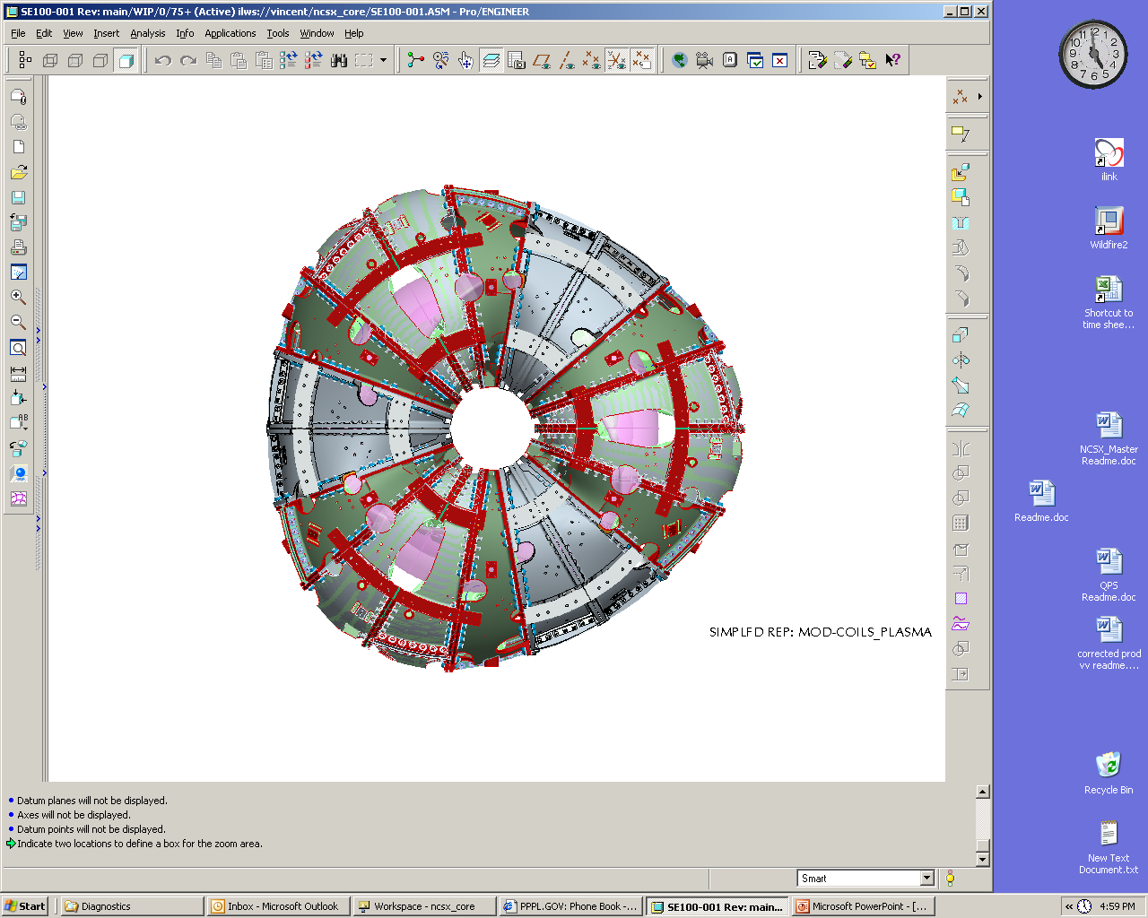
1st Period
2nd Period
3rd Period
C2
C1
B1
A1
A2
B2
C3
B3
A3
B4
A4
C4
C6
B5
A5
A6
B6
C5
Y
X
X
Y
Z
CS0
MCHP – Right Side

Figure 1. MC arrangement for the full machine assembly

6.4 Racking of the Modular Coils
The following general steps are provided to rack the modular coils:
6.4.1
Set up a wedge fixture, with the top surface approximately level, with the appropriate top plate for the type of coil to be measured. Support the narrow edge at its corners and approximately midway along its length. The top plate shall have precisely drilled holes for monuments at its corners, or pucks to receive the 1.5” diameter reflecting ball shall be glued to the corners.
6.4.2 Place a set of wedge jacks, one roughly under the position where each conical seat will be, on the top surface.
6.4.3 Place the laser tracker in a position relative to the wedge, and at a height, where it will be able to measure at least 75% of the conical seats on the coil, and three of the corner monuments on the wedge. Note: this position, for each type of coil, is to be determined during pre-measurement of the first coil of each type.
6.4.4 Measure a plane [“measure plane” in Verisurf©] by measuring three arbitrary points on the top surface of the fixture. One point should be near each corner at the thick end of the wedge, and the third point should be approximately midway along the narrow edge. This plane will be referred to as plane “G”.
6.4.5 Measure the four corner monuments on the wedge, and a set of five or more global monuments attached to the building. These will be the global monuments used for subsequent global alignments. The set of monuments must be approved by the Dimensional Control Coordinator.
6.4.6 Using the laser tracker and the “Build to Surface” feature of Verisurf©, set the jacks to a constant height relative to plane “G”.
6.4.7 Lower the coil onto the jacks. For type “B” and type “C” coils datum “E” shall face down. For type “A” coils, datum “D” shall face down. See figure 2 below for datum reference.
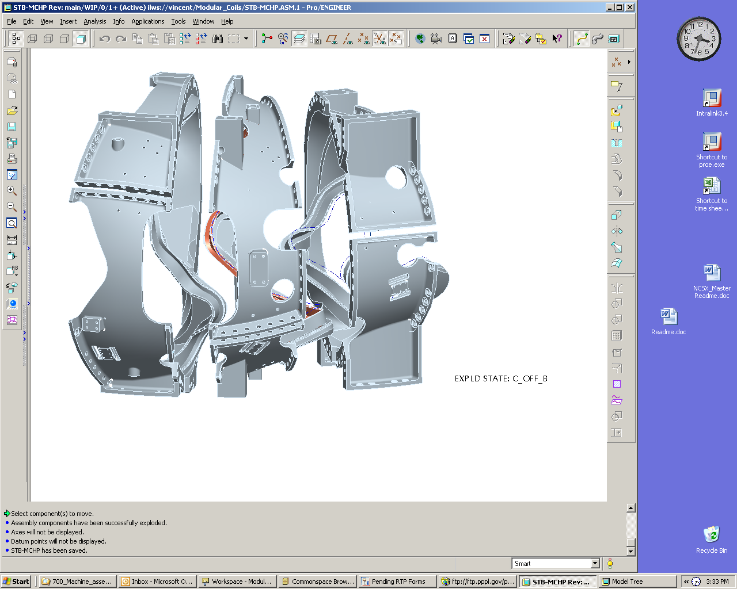
Type-A
Type-B
Type-C
Side-A (datum D)
Side-B (datum E)
Side-B (datum E)
Side-A (datum D)
Type-A
Type-B
Type-C
Side-A (datum D)
Side-B (datum E)
Side-B (datum E)
Side-A (datum D)
Figure 2. Datum's
6.4.8 Re-check the measurements of global monuments on the fixture. If they have moved more than .002”, re-measure the full set of global monuments.
6.4.9 Measure the locations of all of the conical seats that are accessible, in sequence from lowest to highest number.
6.4.10 In Microsoft Excel, open the racking spreadsheet for the particular coil that has been prepared by Dimensional Control. In Verisurf©, select only the level in which plane “G” has been defined, do a point report on the three points, and transfer the results to the spreadsheet in the cells assigned to those points. This enables the spreadsheet to compute the unit normal vector and the scalar that define the plane in 3dimensional Cartesian space.
6.4.11 In Verisurf©, select only the level on which the conical seats are defined. Do a point report, transfer the results to the racking spreadsheet in the cells that are assigned to the conical seats. The “nominal”, or as-wound, positions of the conical seats, will have already been entered into the spreadsheet by Dimensional Control. The coordinates of each conical seat are pasted into sheet 2 of the spreadsheet, in the assigned location, to calculate the offsets of the conical seats from plane “G”. These offsets are entered in the assigned cells on sheet 1, and after this has been done for each conical seat, the spreadsheet will display the amount that each conical seat must be raised in order to twist the coil as close as possible to its as-wound condition.
6.4.12 Clamp a dial indicator to the fixture surface near each jack location so that it reads the vertical motion of the flange closest to the fixture surface. Take care that each indicator reads of an adequately smooth surface. Check each indicator to verify its proper operation.
6.4.13 Watching the dial indicators, jack at each location by the amount specified on the racking spreadsheet. Jack alternately at points roughly across the diameter, rather than working around circumferentially.
6.4.14 Save the racking spreadsheet, and save it as a new copy.
6.4.15 Repeat steps 6.4.9 through . When the racking spreadsheet indicates that the required jacking at each location is 0.002” or less, the coil has been adjusted to the best of our ability. It is now permissible to do an alignment.
6.4.16 Align to the set of conical seats that are accessible. The acceptance criterion is .005” rms deviation. If this is not met, consult the Dimensional Control office before proceeding further.
6.4.17 After alignment and resolution of any nonconformance’s, the alignment report is saved, and the alignment is accepted.
6.4.18 Measure the global monuments. Note that, because of the presence of the coil, one or two of the monuments on the fixture will no longer be accessible. This set of global monuments will be used for subsequent alignments of the laser tracker. All alignments to the global monuments will include the full set of building monuments, and at least two of the monuments on the fixture. The acceptance criterion for global alignments is .002” rms deviation. A failure to meet this criterion must be resolved by the Dimensional Control office.

6.5 Pre-Measurement of Modular Coils

The following general steps are provided to pre-measure the modular coils:

6.5.1 Check the location of two monuments on the fixture. If they are less than .003” from their original position, proceed to 2.3.2. If they are more than .003” from their original position, it may indicate that the laser has been bumped, or the fixture moved slightly. Re-align to the global monuments. If the acceptance criterion is not met, it may mean that the fixture and the building have moved relative to each other. Do not accept the alignment, but re-align to the conical seats. If this alignment is not acceptable, contact the Dimensional Control Office and work out a resolution to the problem before proceeding.

6.5.2 Scan the top flange of the coil. This information will be used in the pre-calculation of shim thicknesses.

6.5.3 Measure the positions of all of the tooling balls accessible to the laser. Accuracy criteria are laid out in Section 2 of Assembly Dimensional Control Plan (ADCP) NCSX-PLAN-HPADC-00-dE.

6.5.4 Move the laser tracker to a new vantage point from which the remaining monuments on the part are visible. [note – a third and fourth position may be required]

6.5.5 Align to the global monuments, using the full set of building monuments and at least two monuments on the fixture. If the alignment does not meet the acceptance criterion, consult Dimensional Control before proceeding.

6.5.6 Measure the positions of all of the tooling balls accessible to the laser. Accuracy criteria are laid out in Section 2.1 of ADCP NCSX-PLAN-HPADC-00-dE.

6.5.7 Repeat steps 6.5.4 through until all of the monuments have been measured.

6.5.8 Save the data file and back it up. At this point, the pre-measurement of the modular coil is complete. The external tooling balls are now related to the position of the coil current center in the as-sound condition of the coil. The external tooling balls, with the appropriate rigid body realignments as needed, will be the reference points for positioning and tracking the modular coil during subsequent assembly steps. The conical seats that interfere with coil-to-coil fitup can be removed at this point, but should not be removed unless it is necessary. This will ensure that we retain redundant dimensional information as far as possible into the assembly sequence. It is anticipated that, prior to full period assembly, all remaining conical seats will be removed.

7. Pre-installation Station 2 Setup

    - Using flange measurement of the coils, define the A/B shim thickness. This is a back office calculation where shim thickness is predetermined based on the scanned flange surface data.

7.1.2 Compress alumina coated shims and sort by thickness the shim set that will be installed on the MCHP. Care must be taken when handling alumina shims to mitigate any possible surface contamination conditions.

8. A-B Modular Coil Assembly

8.1.1 Follow the steps defined in Section 6.4 of this document for racking coils, lower the Type-A modular coil onto the jacks, “A” flange (datum "D") down and rack the "A" coil into its proper shape. See figure 4 next page. The acceptance criterion is .003" RMS deviation in alignment to the set of tooling balls. With a successful alignment a set of global fiducial monuments will have been established. Subsequent alignments of the laser tracker will be to the global monument, and the criterion of .002” RMS deviation will apply

8.1.2 Using the Type-A (B-flange) inboard shim template mark the nose shim locations and puck locations. Remove the template. A simple template of similar device to be developed to represent puck area for proper measurement of puck thickness.

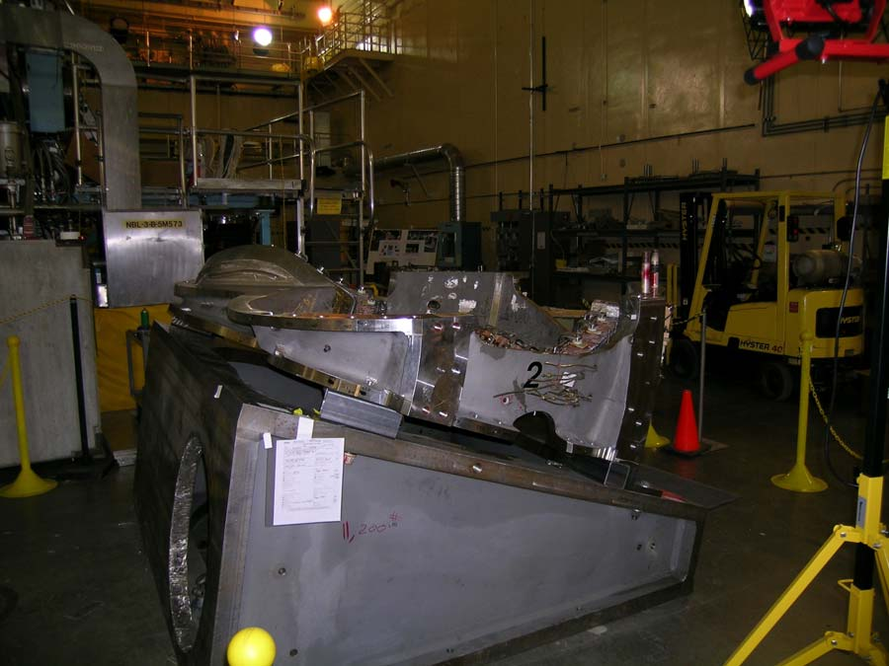

Figure 4 Type “A” to Type “B” Setup

8.1.3 Place an initial set of alumina shims (4-8) on the Type-A coil in designated locations for the initial alignment of the mating coil. See document XXXX for shim size and location.

8.1.4 Place unfilled shim bags in the wing areas

8.1.5 Lower the mating “B” coil into position. As shown below in figure 5.

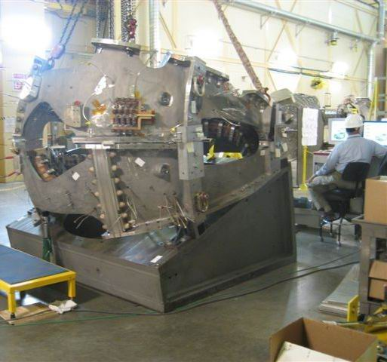

Figure 5 Mating “B” coil into position

8.1.6 Perform an alignment to the “B” coil tooling balls to verify that it has not changed shape. Do not accept the alignment. If the alignment fails to meet the .003”RMS criterion, add additional shims to the initial set, or adjust shim thicknesses as necessary, until the “B” coil meets the alignment criterion.

8.1.7 Install the jack screws and dial indicators for horizontal positioning

8.1.8 Using three selected monuments on the “B” coil, position the coil within ±.002" normal to the mating flanges and within ±.060" horizontally

8.1.9 Install the remaining alumina coated shims; install studs, supernuts, and torque to 50% of final value.

8.1.10 Make a hand "wiggle" test (rotate on bolt) on all shims to make sure that they are tight. If a loose shim is found back off on sufficient adjacent bolts to allow a replacement shim to be inserted. Tighten bolt and recheck.

8.1.11 After tightening, measure the position of all monuments as per section 6.5, following steps 6.5.3 through 6.5.7.All monuments shall be within .007" (true distance) of their desired position. Adjust shims until this criterion is met.

8.1.12 Measure the shim puck height (at a number of points around the puck surface) at each of the nose shim puck locations. Use the data to define each puck height.

8.1.13 Unfasten bolts and raise the "B" coil in height to remove the puck locating rings and install all nose shims with the properly sized pucks. Use temporary shims to support the Type-B flex shims.

8.1.14 “Lightly” tack weld the nose flexes shims to the perspective "A" and "B" coils

8.1.15 Unfasten all bolts and remove the "B" coil and place it on a separate fixture, with the Type-B coil side "A" flange (datum "D") facing up.

8.1.16 Recheck the part alignment of the "A" coil to make sure it is still within alignment. Verify that it still meets the .003” RMS criterion. Do not accept alignment. If the .003” criterion is not met, re-rack the “A” coil.

8.1.17 Weld all Type-A flex shims to the plasma side, following the weld sequence plan

8.1.18 After welding the "A" coil nose shims recheck alignment to determine if the part still meets the metrology acceptance criterion. The acceptance criterion is .003" RMS deviation in alignment to the set of tooling balls.

8.1.19 Time needs to be allocated for a back office assessment of the part after welding. If Control Plan acceptance criterion is not met project input is needed to determine how to proceed.

8.1.20 On the separate fixture measure the "B" fiducials to establish a reference coordinate system prior to welding the "B" coil nose shims.

8.1.21 With the successful "A" coil weld operation, weld all Type-B (A-flange) flex shims to the plasma side, following the weld sequence plan.

8.1.22 After welding the "B" coil nose shims recheck the part to determine if it still meets the metrology acceptance criterion. Align to measurements of 8.1.20. Acceptance criterion is RMS .le. .004". Project input is required in the event of failure.

8.1.23 Time needs to be allocated for a back office assessment of the part after welding. If Control Plan acceptance criterion is not met project input is needed to determine how to proceed.

8.1.24 Remove alumina shims as necessary except for the (4-8) initial locating shims on the Type-A coil in designated locations for the initial alignment of the mating coil.

8.1.25 Lower the mating “B” coil into position

8.1.26 Perform an alignment to the “B” coil tooling balls to verify that it has not changed shape. Do not accept the alignment if the alignment fails to meet the .003”RMS criterion, add additional shims to the initial set, or adjust shim thicknesses as necessary, until the “B” coil meets the alignment criterion.

8.1.27 Using three selected monuments on the “B” coil, position the coil accurately in the x, y, and z directions. An accuracy of ±.002” or better in each direction is expected and required for this step.

8.1.28 Raise the "B" coil slightly and install the remaining alumina coated shims; install Fuji paper on all outboard shims, install studs, supernuts, and torque to 50% of final value.

8.1.29 Make a hand "wiggle" test (rotate on bolt) on all shims to make sure that they are tight. If a loose shim is found back off on sufficient adjacent bolts to allow a replacement shim to be inserted. Tighten bolt and recheck.

8.1.30 After tightening, measure the position of all monuments following steps 6.5.3 through 6.5.7.All monuments should be within .007" (true distance) of their desired position.

8.1.31 Unfasten the bolts, lift the “B” coil enough to remove the Fuji paper, and examine the load sharing. At the same time, the “back office” will analyze the measurements of the monument positions. A revised set of shim thicknesses, to provide adequate loads.

8.1.32 If a revised set of shims is required, install the new shims and Fuji paper. Lower and reposition the “B” coil. Repeat steps 8.1.29 thru 8.1.31.

8.1.33 With a successful Fuji load pattern, unfasten the bolts, lift the “B” coil enough to remove the Fuji paper and initial shims. Install an equivalent set of alumina coated shims without Fuji paper, install studs, supernuts, and torque to 50% of final value. Recheck alignment. Send the Fuji paper test shims out to be cleaned.

8.1.34 If the above step does not fall within .007" or less then loosen all studs, adjust shims locally. Re-torque all studs to 50%.All monuments shall be within .007" (true distance) of their desired position. Adjust shims until this criterion is met.

8.1.35 Remove supernuts one at a time or as many in an area that can be removed without chance of coil shift. Using the eccentric gage slid onto the stud define the hole eccentricity. Select bushings and machine to match required eccentricity. Install bushings. Replace nuts and tighten back to 50% and measure the position of all monuments following steps 6.5.3 through 6.5.7.This operation can be done concurrently at different locations if in so doing the part does not move.

8.1.36 After super bolt tightening, measure the position of all monuments following steps 6.5.3 through 6.5.7.All monuments shall be within .007" (true distance) of their desired position.

8.1.37 Tighten all bolts to their final torque.

8.1.38 After tightening hardware, measure the position of all monuments following steps 6.5.3 through 6.5.7.All monuments shall be within .009" (true distance) of their desired position.

8.1.39 Weld the A / B nose region solenoid side following the weld procedure.

8.1.40 Measure the positions of all monuments per the process defined in Section 6, steps 6.5.3 through 6.5.7.All monuments shall be within .012" (true distance) of their desired position.

8.1.41 Review the above results with Back Office. Adjust wing supports if needed to meet alignment requirements

8.1.42 Identify, if possible, a set of monuments that have moved less than .005” from their original positions. The alignment that will be necessary for mating to the “C” coil will use monuments from among this set.

8.1.43 Fill all lose bushings with Stycast 2850FT

8.1.44 Scan the "B" flange (datum “E”) of the “B” coil, for the purpose of defining the shim thickness for the mating to the “C” coil. Save the measurement file and back it up.

8.1.45 Using the "B" flange (datum "E") measurement of the Type-B coil and the earlier "A" flange (datum "E") measurement of the Type-C coil, define all B/C flange shim thickness. This is a back office calculation where shim thickness is predetermined based on the scanned flange surface data.

9. (A-B) to C modular coil assembly

9.1.1 Bolt the "A" coil to its fixture and lift the (A-B) coil, along with the fixture, onto another wedge with its top surface tilted at 20 degrees from horizontal. Bolt the fixtures together.

9.1.2 Select a subset of monuments identified in step 8.1.42 that will be used for the initial alignment in this next phase of half period assembly.

9.1.3 Align to the set of monuments selected in 9.1.2. The acceptance criterion is .005" RMS deviation in alignment to the set of tooling balls.

9.1.4 Establish a set of global monuments, on the fixture and on the building. Subsequent alignments to these monuments must meet the .002"RMS criterion.

9.1.5 Using the Type-B (B-flange) inboard shim template mark the nose shim locations and puck locations. Remove the template. Use a thin equivalent washer of the puck diameter (or some other method) to provide a positional "feel" to allow measuring puck height in the A -B installed position.

9.1.6 Place an initial set of alumina shims (4-8) on the Type-B coil in designated locations for the initial alignment of the mating coil. See document XXXX for shim size and location.

9.1.7 Place unfilled shim bags in the wing areas

9.1.8 Lower the mating “C” coil into position.

9.1.9 Perform an alignment to the “C” coil tooling balls to verify that it has not changed shape. Do not accept the alignment. If the alignment fails to meet the .003”RMS criterion, add additional shims to the initial set, or adjust shim thicknesses as necessary, until the “C” coil meets the alignment criterion.

9.1.10 Install the jack screws and dial indicators for horizontal positioning.

9.1.11 Using three selected monuments on the “C” coil, position the coil within ±.002" normal to the plane of the mating flanges and within ±.060" in the plane of the mating flanges.

9.1.12 Install the remaining alumina coated shims; install studs, supernuts, and torque to 50% of final value.

9.1.13 Make a hand "wiggle" test (rotate on bolt) on all shims to make sure that they are tight. If a loose shim is found back off on sufficient adjacent bolts to allow a replacement shim to be inserted. Tighten bolt and recheck.

9.1.14 After tightening, measure the position of all monument following steps 6.5.3 through 6.5.7. All monuments shall be within .015" (true distance) of their desired position. The component of the deviations of monuments on the “C” coil that is normal to the flange faces shall be less than .010”. Adjust shims until this criterion is met.

9.1.15 Measure the shim puck height (at a number of points around the puck surface) at each of the nose shim puck locations. Use the data to define each puck height.

9.1.16 Unfasten bolts and raise the "C" coil in height to remove the puck locating rings and install all nose shims with the properly sized pucks. Use temporary shims to support the Type-C flex shims.

9.1.17 “Lightly” tack weld the nose flexes shims to the respective "B" and "C" coils.

9.1.18 Unfasten all bolts and remove the "C" coil and place it on a separate fixture, with the Type-C coil side "A" flange (datum "D") facing up.

9.1.19 Recheck the part alignment of the "A / B" coil to make sure it is still within alignment and then weld all Type-B flex shims to the plasma side, following the weld sequence plan. RMS deviation .005" or less is the acceptance criterion. Consult Dimensional Control if this criterion is not met.

9.1.20 After welding the "B" coil nose shims recheck alignment to determine if the part still meets the metrology acceptance criterion. RMS deviation .005" or less is the acceptance criterion. Consult Dimensional Control if this criterion is not met.

9.1.21 Time needs to be allocated for a back office assessment of the part after welding.If Control Plan acceptance criterion is not met project input is needed to determine how to proceed.

9.1.22 On the separate fixture measure the "C" fiducials to establish a reference coordinate system prior to welding the "C" coil nose shims.

9.1.23 With the successful "A / B" coil weld operation, weld all Type-C (A-flange) flex shims to the plasma side, following the weld sequence plan.

9.1.24 After welding the "C" coil nose shims recheck the part to determine if it still meets the metrology acceptance criterion. RMS deviation .004" or less is the acceptance criterion. Consult Dimensional Control if this criterion is not met.

9.1.25 Time needs to be allocated for a back office assessment of the part after welding.If Control Plan acceptance criterion is not met project input is needed to determine how to proceed.

9.1.26 Remove alumina shims as necessary except for the (4-8) initial locating shims on the Type-B coil in designated locations for the initial alignment of the mating coil.

9.1.27 Lower the mating “C” coil into position.

9.1.28 Perform an alignment to the “C” coil tooling balls to verify that it has not changed shape. Do not accept the alignment. If the alignment fails to meet the .003”RMS criterion, add additional shims to the initial set, or adjust shim thicknesses as necessary, until the “C” coil meets the alignment criterion.

9.1.29 Using three selected monuments on the “C” coil, position the coil accurately in the x, y, and z directions. An accuracy of .002” or better is expected and required for this step.

9.1.30 Raise the "C" coil slightly and install the remaining alumina coated shims; install Fuji paper on all outboard shims, install studs, supernuts, and torque to 50% of final value.

9.1.31 Make a hand "wiggle" test (rotate on bolt) on all shims to make sure that they are tight. If a loose shim is found back off on sufficient adjacent bolts to allow a replacement shim to be inserted. Tighten bolt and recheck.

9.1.32 After tightening, measure the position of all monuments following steps 6.5.3 through 6.5.7.All monuments shall be within .015" (true distance) of their desired position.

9.1.33 Unfasten the bolts, lift the “C” coil enough to remove the Fuji paper, and examine the load sharing. At the same time, the “back office” will analyze the measurements of the monument positions. A revised set of shim thicknesses, to provide adequate load sharing and dimensional accuracy, will be generated if required.

9.1.34 If a revised set of shims is required, install the new shims and Fuji paper. Lower and reposition the “C” coil. Repeat steps 9.1.31 thru 9.1.33.

9.1.35 With a successful Fuji load pattern, unfasten the bolts, lift the “C” coil enough to remove the Fuji paper and initial shims. Install an equivalent set of alumina coated shims without Fuji paper, install studs, supernuts, and torque to 50% of final value. Recheck alignment. Send the Fuji paper test shims out to be cleaned.

9.1.36 If the above step does not fall within .015" or less then loosen all studs, adjust shims locally. Re-torque all studs to 50%.Repeat until the desired tolerance is met.

9.1.37 One hole at a time, remove the supernut. Using the eccentric gage slid onto the stud define the hole eccentricity. Select bushing and machine to match required eccentricity. Install bushing. Replace nut and tighten back to 50% and recheck alignment. This operation can be done concurrently at different locations if in so doing the part does not move.

9.1.38 After super bolt tightening (50 % value), measure the position following steps 6.5.3 through 6.5.7.All monuments shall be within .015" (true distance) of their desired position.

9.1.39 Tighten all bolts to their final torque.

9.1.40 After tightening hardware, measure the position of all monuments following steps 6.5.3 through 6.5.7.All monuments shall be within .017" (true distance) of their desired position.

9.1.41 Weld the B / C nose region solenoid side following the weld procedure.

9.1.42 Measure the positions of all monuments per the process defined in the Section 6, steps 6.5.3 through 6.5.7.All monuments shall be within .020" (true distance) of their desired position.

9.1.43 Back office of above results and adjust wing supports if needed to meet alignment requirements

9.1.44 Fill all lose bushings with Stycast 2850FT

10. Inflate all Wing Shim Bags

11. Complete local service and interface details

11.1.1 Inject sealant compound to fill in all shim spaces in order to prevent VV/MC insulation from falling out.

12. Final measurements / transfer completed MCHP to holding area

12.1.1 Using tension tester measure bolt length on all tension fasteners and record the results. Bolts have been supplied measured from vendor for initial reference.

12.1.2 Mark part for identification Part identification should indicate the period and subparts (ex. MCHP - Left Side C1/B1/A!)

12.1.3 Install base supports. See figure 3 page 14 for base supports.

12.1.4 Remove from stand and measure weight of completed assembly

12.1.5 Move to holding area.

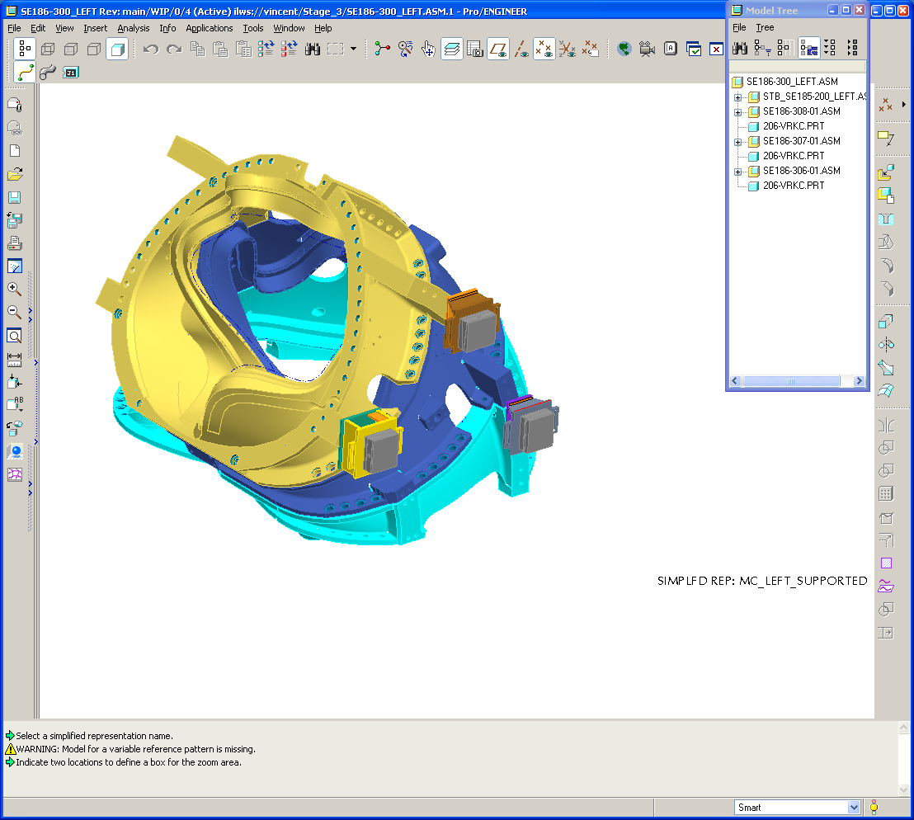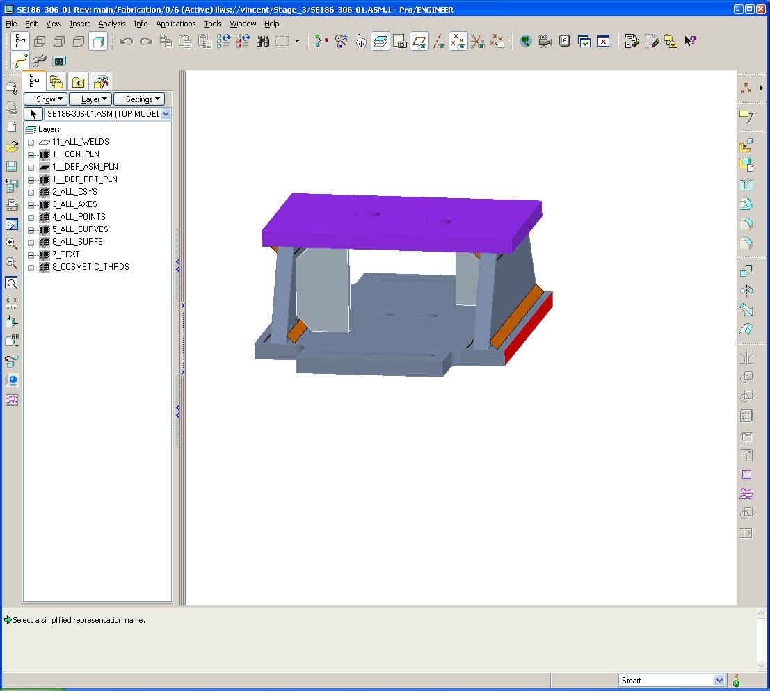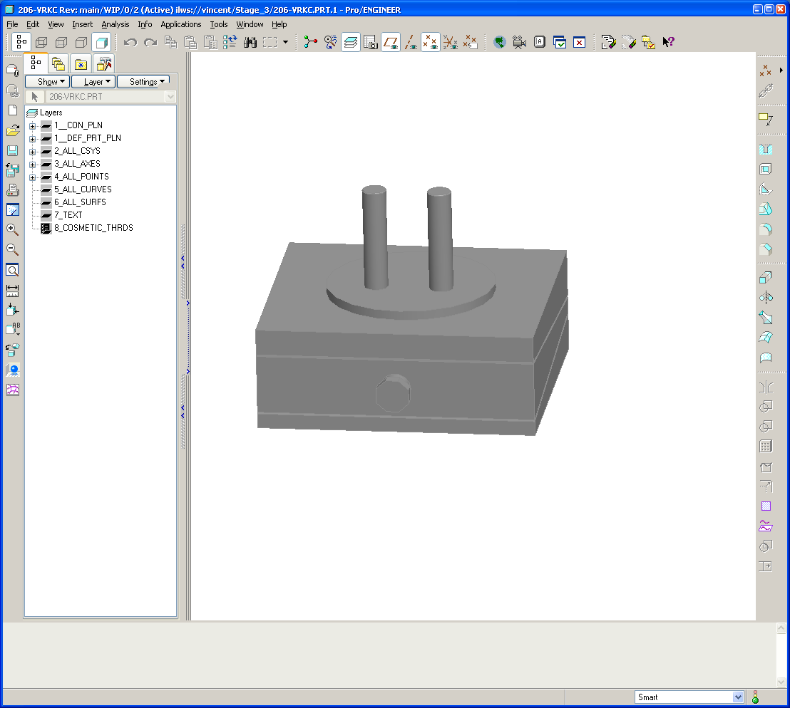
Precision Leveler
Precision Leveler support structure
Precision Leveler support mounted at three locations at the base of the MCHP.
Figure 3. MCHP base supports

Reference Drawings:

SE140-003 MC Half Period Assembly
SE140-046 MC Shim Plate Layout
SE140-050 Wing Support Bladder
SE140-052 AB Inboard Shim
SE140-054 BC Inboard Shim
SE140-056 Shim Puck
SE 140-060 Wing Support

