Princeton Plasma Physics Laboratory
Procedure
‘
Procedure Title: Field Period Assembly Station Two

Number: D-NCSX-FPA-002 |  | Revision: 0-dD |  |  | Effective Date: January 4, 2008  Expiration Date:  (2 yrs. unless otherwise stipulated)
Procedure Approvals
Author: Bill Sands / Mike Viola
ATI: Mike Viola
RLM: Larry Dudek
Responsible Division: NCSX Project
Procedure Requirements Designated by RLM - LAB-WIDE:
X | Work Planning Form (ENG-032) #1224 |  |  | Lockout/Tagout (ESH-016)
 | Confined Space Permit (5008,SEC.8 Chap 5) |  | X | Lift Procedure (ENG-021)
 | Master Equipment List Mod (GEN-005) |  | X | ES&H Review (NEPA, IH, etc.) NEPA 1261
 | RWP (HP-OP-20) |  |  | Independent Review
 | ATI Walkdown |  | X | Pre-Job Brief
X | Post-job Brief * |  | X | Hydrostatic and Pneumatic Testing. (ENG-014)
D-SITE SPECIFIC:
X | D-Site Work Permit (OP-AD-09) |  |  | Door Permit (OP-G-93)
 | Tritium Work Permit (OP-AD-49) |  |  | USQD (OP-AD-63)
X | Pre-Job Brief (OP-AD-79) |  |  | T-Mod (OP-AD-03)
 | **DCA/DCN (OP-AD-104) #

* Required for installations involving internal vacuum installations, critical lifts, and for the initial installation of repetitive work.
** OP-AD-104 was voided by procedure ENG-032. However, DCA’s that were open at the time of adoption of ENG-032 are still considered valid for work approval purposes.

REVIEWERS (designated by RLM)
Incorporated Comments
Accountable Technical Individual……………………………………
Test Director
Independent Reviewer
D-Site Shift Supervisor
Independent
NCSX Dimensional Control Coordinator…………………………… Bob Ellis
Vacuum Vessel Cognizant Engineer
PPPL Metrology Manager…………………………………………… Steve Raftopoulos
NCSX Field Period Assembly Manager…………………………… Mike Viola |  |  |  | 12/26/07
NCSX Field Supervisor……………………………………………… John Edwards |  |  |  | 12/26/07
Project Engineer for Stellarator Systems (WBS 1) Manager…… Brad Nelson (ORNL)
FPA Tooling and Constructability ………………………………… Tom Brown |  |  |  | 12/26/07
Quality Assurance/Quality Control…………………………….…… J. Malsbury/C. Colin |  |  |  | 12/26/07
Maintenance and Operations Division
Energy Conversion System/Motor Control Division
Engineering ………………………………………………………… Phil Heitzenroeder
Environmental Restoration & Waste Management Division
Environmental, Safety & Health…………………………………… Jerry Levine |  |  |  | 12/26/07
Industrial Hygiene…………………………………………………… Bill Slavin
Health Physics……………………………………………………..… George Ascione
RLM………………………………………………………………….…. Larry Dudek
TRAINING (designated by RLM)
No training required ______________ | Instructor John Edwards
Personnel (group, job title or individual name) |  | Read Only | Instruction  Pre-Job Briefing |  | Hands On
Lead Tech. |  |  | X
Technicians performing task |  |  | X
Field Supervisors |  |  | X
Quality Control Representative |  |  | X
Training Rep.
RLM Larry Dudek

RECORD OF CHANGE

Revision | Date | Description of Change
00 | January 4, 2008 | Initial release

TABLE OF CONTENTS

1 Introduction and Scope 1
1.1 Introduction 1
1.2 Scope 1
1.3 Identification of Modular Coil Segments Being Assembled 1
2 Applicable Documents 1
2.1 Manufacturing Facility Operations Plan (NCSX-PLAN-MFOP) 1
2.2 Manufacturing, Test, and Quality Assurance Plan (NCSX-MIT/QA-185) 1
2.3 Modular Coil Lift Procedures (D-L-NCSX-999 Wound Modular Coil Lift Procedure) 1
2.4 Field Period Assembly Station 2 Dimensional Control Plan ( D-NCSX-PLAN-FPA2DC) 2
2.5 Metrology data plan and area is in place 2
2.6 Weld qualifications and weld procedure 2
3 Safety Requirements 2
3.1 Job Hazard Analysis (JHA) 2
4 Prerequisites & Condition 3
4.1 Pre-Job Briefing 3
4.2 Training 3
5 Drawings Required for Station 2 3
6 Assembly Process 4
6.1 Daily Startup Activities 4
6.2 Daily Shutdown Activities 4
6.3 MC fit-up pre-check and surface insulation 4
6.4 Racking of the Modular Coils 5
6.5 Pre-Measurement of Modular Coils 8
7 Pre-installation Station 2 Setup 9
8 A-B Modular Coil Assembly 10
9 (A-B) to C Modular Coil Assembly 16
10 Inflate all Wing Shim Bags and Inject Bushings 21
11 Complete Local Service and Interface Details 21
12 Final Measurements/Transfer Completed MCHP to Holding Area 21
13 “A-A” Shear Plate Weldment 23
14 Procedure Complete 23
15 Appendix A. Document Sign Off 24
16 Appendix B. Shim Thickness and Puck Height Record 33
17 Appendix C. Stud Tension Record 35
18 Appendix D. Coil Megger Test 36
19 Appendix E. Log Book Record 42

LIST of TABLES

Table 1 Reference Drawings 3
Table 2 Figure Modular Coil Half Period (MCHP) Assembly Makeup 4

LIST OF FIGURES

Figure 1 MC Arrangement for the Full Machine Assembly 5
Figure 2 Modular Coil Datum's 7
Figure 3 Type “A” to Type “B” Setup 10
Figure 4 Mating “B” Coil into Position 11
Figure 5 MCHP base supports 22

Introduction and Scope

Introduction
The Field Period and Machine Assembly are divided into 5 workstations. Stations 1, 2, 3, and 5 deal with Field Period Assembly and Station 6 deals with final machine assembly. Each workstation has a specific set of tasks that will be performed as part of the overall assembly process. This procedure addresses the manufacturing, inspection, test and QC inspection points for the Station No. 2 Half Period Assembly (HPA) Activities.

Scope
This procedure is used to describe the assembly sequence required for Station 2 Half Period Assembly and includes:
- Installing Modular Coil on Stands;
- Metrology measurements (all racking and interim measurements);
- Coil A -B assembly; and
- Coil (A-B) to C assembly

Identification of Modular Coil Segments Being Assembled
Field Supervisor lists the Modular Coil Segments being assembled on Appendix A.
Field Supervisor See Appendix A – Document Sign-off Record

Applicable Documents

Manufacturing Facility Operations Plan (NCSX-PLAN-MFOP)
The purpose of this operations plan is to describe how the activities within the NCSX Manufacturing Facility will meet PPPL Integrated Safety Management (ISM) requirements specified in laboratory policies, programs, and procedures. It will also provide an overview of the general processes that occur in the facility. More detailed descriptions and processes for each process will be described in specific Manufacturing, Inspection and Test/Qualify Assurance (MIT/QA) plans and detailed manufacturing/assembly procedures.

Manufacturing, Test, and Quality Assurance Plan (NCSX-MIT/QA-185)
This plan addresses the manufacturing, inspection, test and Quality Assurance (QA) plan to complete and deliver three (3) Field Period Assemblies for the NCSX Project to the NCSX test cell.

Modular Coil Lift Procedures (D-L-NCSX-999 Wound Modular Coil Lift Procedure)
D-L-NCSX-999 describes the necessary equipment and methods to follow in lifting and transporting each wound modular coil assembly. A separate procedure will be developed to lift the wedge with the joined A-B coil as well as a procedure to lift the completed 3 coil Modular Coil Half Period (MCHP).

Field Period Assembly Station 2 Dimensional Control Plan ( D-NCSX-PLAN-FPA2DC)
This plan describes the dimensional control steps that will be taken to ensure adequate dimensional control of the Modular Coil Half Period (MCHP) that will occur at Station 2. Each half period assembly consists of three modular coils, one each of type A, B, and C. The three coils are joined together with studs and shims. Two half periods are joined, in stellarator symmetry, to form a full period. Adequate dimensional control will ensure that the coil current centers are within the specified tolerance.

Metrology data plan and area is in place

All metrology record copy files shall be saved electronically per PPPL Metrology Procedure D-NCSX-FPA-010. The metrology Supervisor and Quality control shall assure that the file area is set up, accessible by the field measurement technicians and back office engineers.
Metrology Supervisor and Quality Control
See Appendix A – Document Sign-off Record

Weld qualifications and weld procedure

All welding of the NCSX modular Coils shall be performed with an approved welding procedure and with qualified welders per PPPL ENG-037. The welding engineer shall record the weld procedure and list those individuals qualified to perform welding per this procedure.
Welding Engineer Supervisor and Quality Control
See Appendix A – Document Sign-off Record

Safety Requirements
All work will be performed in a safe manner in accordance with PPPL Environmental Safety & Health Directives ES&H 5008 and the “Integrated Safety Management” (ISM) policy.

Job Hazard Analysis (JHA)
A JHA will be generated for each Vacuum Vessel Sub Assembly station, identifying existing or potential workplace hazards and to evaluate the risk of worker injury or illness associated with job tasks. (Reference document ESH-004 “Job Hazard Analysis”) The IH representative will review the JHA’s for accuracy as well as completeness. It will be reviewed with all activity participants at the Pre-Job briefings. These JHA’s will be regularly reviewed and updated as needed. Any changes to the JHA’s must be reviewed by all active participants
 Refer to JHA for All Hazardous Activities!

Prerequisites & Condition

Pre-Job Briefing
A pre-job briefing will be held, describing the processes and safety issues prior to starting any part of this procedure. Attendance shall be documented via training sign-in sheet. A copy of the sign-in sheet will be maintained with the run copy of the procedure. The original will be delivered in person to Human Resources, as required by ENG-030
Field Supervisor See Appendix A – Document Sign-off Record

Training
Assure all individuals working on FPA 2 have been trained as per requirements of the Field Period Assembly Training Matrix located at:

http://ncsx.pppl.gov/SystemsEngineering/Training/Training_Matrices/FPA_Training_MatrixR0.pdf
Field Supervisor to verify all training has been performed
See Appendix A – Document Sign-off Record

Drawings Required for Station 2
Materials are listed in drawing bill of materials on the respective drawings in

Title | Drawing Number
MC Half Period Assembly | SE140-003
MC Shim Plate Layout | SE140-046
Wing Support Bladder | SE140-050
AB Inboard Shim | SE140-052
BC Inboard Shim | SE140-053
AA Inboard Shim | SE140-054
Shim Puck | SE140-056
Wing Support | SE140-060

Table 1 Reference Drawings

Assembly Process
This assembly procedure is to be used as guide to complete the station no. 2 activities. Deviation from this procedure for processes that DO NOT affect the design of the assembly can be made during the assembly process with the concurrence of the Field Supervisor. All deviations shall be documented in the procedure and initialed by the Field Supervisor prior to implementing the deviations. Deviations that may affect the design of the assembly requires a Request for Deviation “RFD” approval. The RFD must be approved prior to proceeding. Procedure changes need to be incorporated into the document via “Minor Procedure Changes” or “Revisions”. A station log book may be used to record information useful to pass on between work crews and work days. The log book shall become part of the final documentation for this MCHP and be called the “Station 2 Coil ____; ____; ____; logbook Appendix E” where the blanks will be filled in with the name of the three coils being assembled. Log book records shall be dated, and initialed.

Daily Startup Activities
- Verify operation of all equipment needed that day.
- Check that safety equipment needed for day’s activities are available.
- Check that the day’s travelers (I.E. Appendix A) and procedures are in their document holder.
- Check the log book for useful information

Daily Shutdown Activities
- Turn off power to equipment not in use.
- Lock Cabinets.
- Verify that all Traveler (I.E. Appendix A) and data sheet information is complete.
- Verify that all deviation from the procedure have been documented in the procedure and initialed by the FPA Field Supervisor. Design changes require either an approved Request for Deviation, Minor Procedure Change or formal revision of procedure.
- Record any useful information in the log book. Remember, log book records shall be dated and initialed.

MC fit-up pre-check and surface insulation
Verify that mating MC's of a MCHP will come together without interferences by pre-fitting mating coils. This will include the Type-C coil with its interfacing Period Type-C coil. The full assembly layout of the mating MC's can be found in Table 2 below and Figure 1 on the next page. Some of this effort may be done before the half period assembly activity begins.
Field Supervisor See Appendix A – Document Sign-off Record

Period | Left Side | Right Side
1 | C1 / B1 / A1 | A2 / B2 / C2
2 | C3 / B3 / A3 | A4 / B4 / C4
3 | C5 / B5 / A5 | A6 / B6 /C6

Table 2 Figure Modular Coil Half Period (MCHP) Assembly Makeup

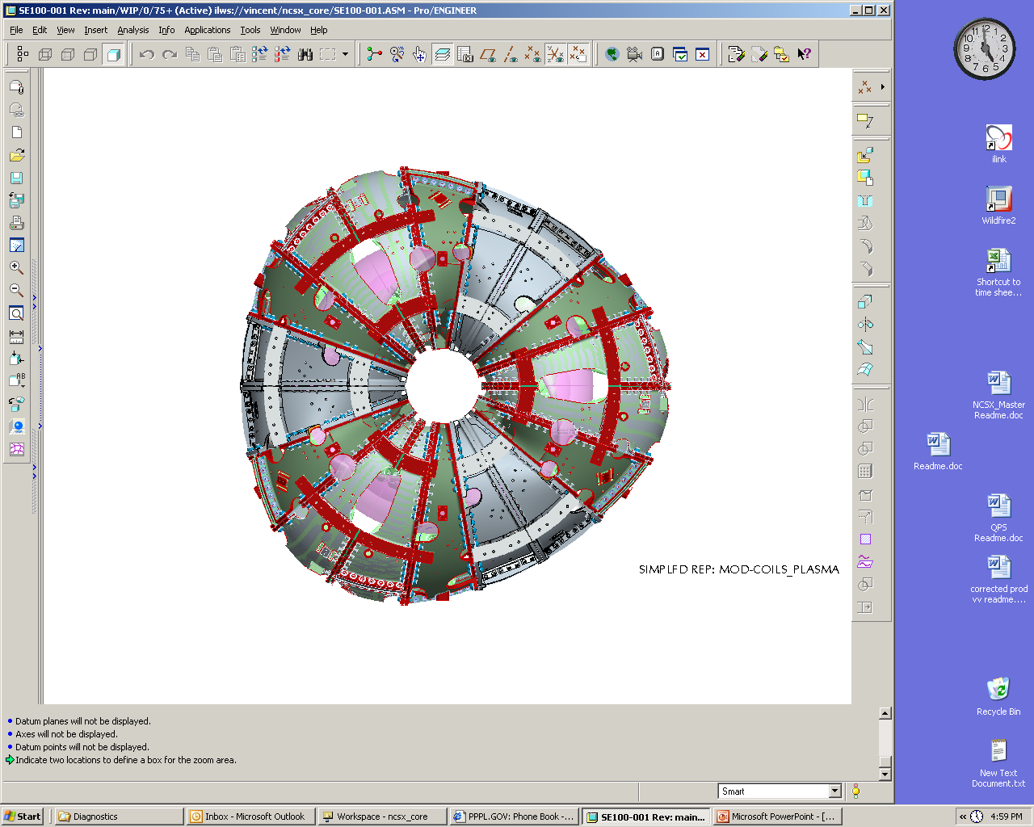
FPA 1
FPA 2
FPA 3
C2
C1
B1
A1
A2
B2
C3
B3
A3
B4
A4
C4
C5
B5
A5
A6
B6
C6
Y
X
X
Y
Z
CS0
MCHP 2
(Right Side)
MCHP 1
(Left Side)
MCHP 3
(Left Side)
MCHP 4
(Right Side)
MCHP 5
(Left Side)
MCHP 6
(Right Side)

Figure 1 MC Arrangement for the Full Machine Assembly

Racking of the Modular Coils
The following steps are provided to rack the modular coils:
Refer to JHA for All Hazardous Activities!

Set up a wedge fixture, with the top surface approximately level, with the appropriate top plate for the type of coil to be measured. Support the narrow edge at its corners and approximately midway along its length. The top plate shall have precisely drilled holes for monuments at its corners, or pucks to receive the 1.5” diameter reflecting ball shall be glued to the corners.

Place the wedge jacks, roughly under each conical seat located on the inside casting surface.
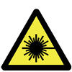 | Caution Laser Light -  Refer to JHA for All Hazardous Activities!

Place the laser tracker in a position relative to the wedge, and at a height, where it will be able to measure at least 75% of the conical seats on the coil, and three of the corner monuments on the wedge. Note: this position, for each type of coil, is to be determined during pre-measurement of the first coil of each type.

Measure a plane [“measure plane” in Verisurf©] by measuring three arbitrary points on the top surface of the fixture. One point should be near each corner at the thick end of the wedge, and the third point should be approximately midway along the narrow edge. This plane will be referred to as plane “G”.

Measure the four corner monuments on the wedge, and a set of five or more global monuments attached to the building. These will be the global monuments used for subsequent global alignments. The set of monuments must be approved by the Dimensional Control Coordinator.
Dimensional Control Coordinator Appendix A – Document Sign-off Record

Using the laser tracker and the “Build to Surface” feature of Verisurf©, set the jacks to a constant height relative to plane “G”.
 | Caution Crush hazard -  Refer to JHA for All Hazardous Activities!

Lower the coil onto the jacks. For type “B” and type “C” coils datum “E” shall face down. For type “A” coils, datum “D” shall face down. See Figure 2 below for datum reference

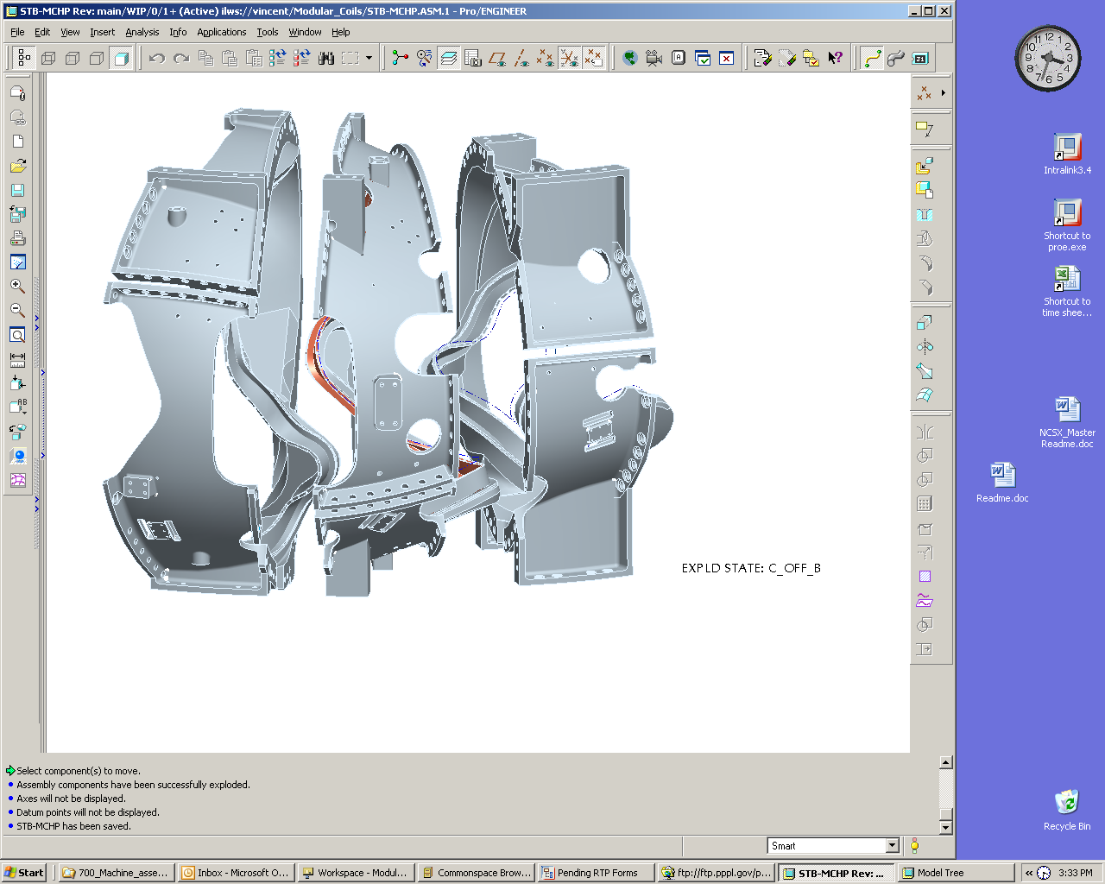
Type-A
Type-B
Type-C
Side-A (datum D)
Side-B (datum E)
Side-B (datum E)
Side-A (datum D)
Type-A
Type-B
Type-C
Side-A (datum D)
Side-B (datum E)
Side-B (datum E)
Side-A (datum D)

Figure 2 Modular Coil Datum's

Re-check the measurements of global monuments on the fixture. If they have moved more than .002”, re-measure the full set of global monuments.

Measure the locations of all of the conical seats that are accessible, in sequence from lowest to highest number.

In Microsoft Excel, open the racking spreadsheet for the particular coil that has been prepared by Dimensional Control. In Verisurf©, select only the level in which plane “G” has been defined, do a point report on the three points, and transfer the results to the spreadsheet in the cells assigned to those points. This enables the spreadsheet to compute the unit normal vector and the scalar that define the plane in 3 dimensional Cartesian space.

In Verisurf©, select only the level on which the conical seats are defined. Do a point report, transfer the results to the racking spreadsheet in the cells that are assigned to the conical seats. The “nominal”, or as-wound, positions of the conical seats, will have already been entered into the spreadsheet by Dimensional Control. The coordinates of each conical seat are pasted into sheet 2 of the spreadsheet, in the assigned location, to calculate the offsets of the conical seats from plane “G”. These offsets are entered in the assigned cells on sheet 1, and after this has been done for each conical seat, the spreadsheet will display the amount that each conical seat must be raised in order to twist the coil as close as possible to its as-wound condition.

Clamp a dial indicator to the fixture surface near each jack location so that it reads the vertical motion of the flange closest to the fixture surface. Take care that each indicator reads of an adequately smooth surface. Check each indicator to verify its proper operation.

Watching the dial indicators, jack at each location by the amount specified on the racking spreadsheet. Jack alternately at points roughly across the diameter, rather than working around circumferentially.

Save the racking spreadsheet as a new copy per the naming convention listed in D-NCSX-FPA-010.

Repeat steps 6.4.9 through 6.4.14. When the racking spreadsheet indicates that the required jacking at each location is 0.002” or less, the coil has been adjusted to the best of our ability. It is now permissible to do an alignment to conical seats.

6.4.16 Align to the set of conical seats that are accessible. The acceptance criterion is .005” RMS deviation. The Dimensional Control Coordinator shall record the achieved RMS value.
Dimensional Control Coordinator Appendix A – Document Sign-off Record

After alignment and resolution of any nonconformance’s, the alignment report is saved, and the alignment is accepted.

6.4.18 Measure the global monuments. Note that, because of the presence of the coil, one or two of the monuments on the fixture will no longer be accessible. This set of global monuments will be used for subsequent alignments of the laser tracker. All alignments to the global monuments will include the full set of building monuments, and at least two of the monuments on the fixture. The acceptance criterion for global alignments is .002” RMS deviation. Continue until the Dimensional Control Office approves the alignment. The Dimensional Control Office shall record the achieved alignment RMS value.
Dimensional Control Coordinator Appendix A – Document Sign-off Record

Pre-Measurement of Modular Coils
The following steps are provided to pre-measure the modular coils:

    - Check the location of two monuments on the fixture. If they are less than .003” from their original position, proceed to 6.5.2. If they are more than .003” from their original position, it may indicate that the laser has been bumped, or the fixture moved slightly. Re-align to the global monuments. If the acceptance criterion is not met, it may mean that the fixture and the building have moved relative to each other. Do not accept the alignment, but re-align to the conical seats. Continue until the Dimensional Control Office approves the alignment. The Dimensional Control Office shall record the achieved alignment RMS value.
Dimensional Control Coordinator Appendix A – Document Sign-off Record

Scan the top flange of the coil. This information will be used in the pre-calculation of shim thicknesses.

Measure the positions of all of the tooling balls accessible to the laser. Accuracy criteria are laid out in Section 2 of the Station 2 Dimensional Control Plan (NCSX-PLAN-FPA2DC)

Move the laser tracker to a new vantage point from which the remaining monuments on the part are visible. [Note – a third and fourth position may be required]

Align to the global monuments, using the full set of building monuments and at least two monuments on the fixture. If the alignment does not meet the acceptance criterion, consult Dimensional Control before proceeding.

Measure the positions of all of the tooling balls accessible to the laser. Accuracy criteria are laid out in Section 2.1 of the Station 2 Dimensional Control Plan (NCSX-PLAN-FPA2DC).

Repeat steps 6.5.4 through 6.5.6 until all of the monuments have been measured.

Save the data file and back it up per the naming convention listed in D-NCSX-FPA-010. At this point, the pre-measurement of the modular coil is complete. The external tooling balls are now related to the position of the coil current center in the as-wound condition of the coil. The external tooling balls, with the appropriate rigid body realignments as needed, will be the reference points for positioning and tracking the modular coil during subsequent assembly steps. The conical seats that interfere with coil-to-coil fit-up can be removed at this point, but should not be removed unless it is necessary. This will ensure that we retain redundant dimensional information as far as possible into the assembly sequence. It is anticipated that, prior to full period assembly, all remaining conical seats will be removed.
Field Supervisor and Metrology Supervisor
See Appendix A – Document Sign-off Record

Pre-installation Station 2 Setup

Back office calculations have predetermined shim thicknesses base on the scanned flanges. Using the back office data acquire the proper A/B shims. Back office shall provide the shim thicknesses using Appendix B for each mating coil.

Compress alumina coated shims for thickness measurements and sort by resulting measurements to determine the shim set that will be installed on the MCHP. Care must be taken when handling alumina shims to mitigate any possible surface contamination conditions. Use cotton gloves and oil free surfaces for measuring and storage.

A-B Modular Coil Assembly
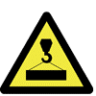 | Caution Lifting hazard -  Refer to JHA for All Hazardous Activities!

Follow the steps defined in Section 6.4 of this document for racking coils, lower the Type-A modular coil onto the jacks, “A” flange (datum "D") down and rack the "A" coil into its proper shape. See Figure 3. The acceptance criterion is .003" RMS deviation in alignment to the set of tooling balls. Clamp the "A" coil to its fixture and verify that the alignment remained the same. With a successful alignment a set of global fiducial monuments will have been established. Subsequent alignments of the laser tracker will be to the global fiducial monuments, with the criterion of .002” RMS deviation.

Dimensional Control Coordinator Appendix A – Document Sign-off Record
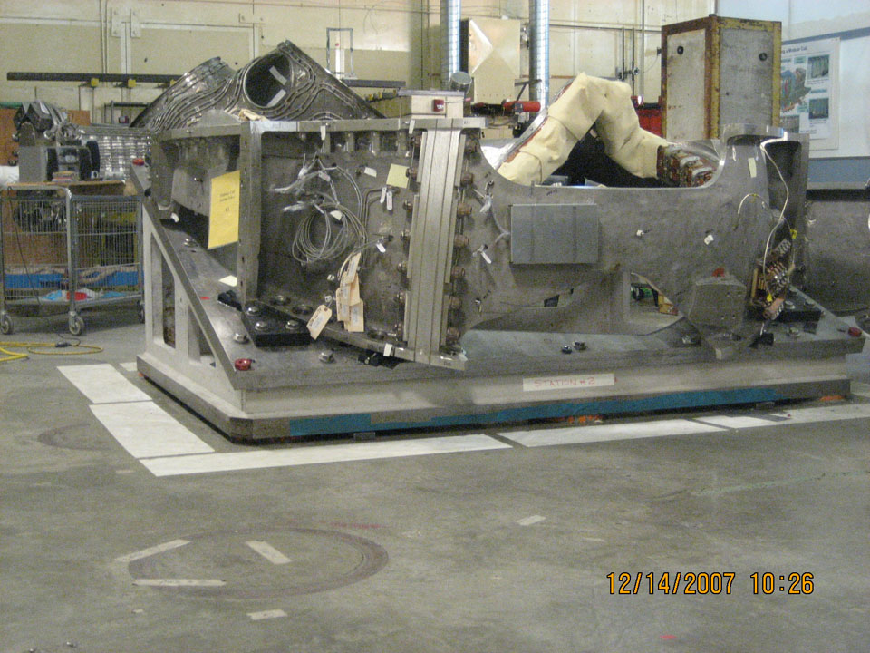
Figure 3 Type “A” to Type “B” Setup

Using the Type-A (B-flange) inboard shim template mark the nose shim locations and puck locations. Remove the template. A simple template of similar device to be developed to represent puck area for proper measurement of puck thickness.

Place an initial set of alumina shims (4-8) on the Type-A coil in designated locations for the initial alignment of the mating coil. Back office calculations have predetermined shim thicknesses base on the scanned flanges. Using the back office data acquire the proper A/B shims. Back office shall provide the shim thicknesses using Appendix B for each mating coil.

Caution Lifting hazard -
Refer to JHA for All Hazardous Activities!

Lower the mating “B” coil into position. As shown below in figure 4

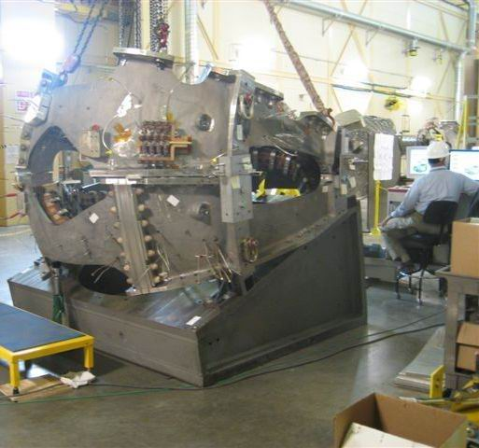

Figure 4 Mating “B” Coil into Position

Perform an alignment to the “B” coil tooling balls to verify that it has not changed shape. Do not accept the alignment if the alignment fails to meet the .003” RMS criterion; add additional shims to the initial set, or adjust shim thicknesses as necessary, until the “B” coil meets the alignment criterion.

nstall the jack screws and dial indicators for horizontal positioning

Using three selected monuments on the “B” coil, position the coil within ±.002" normal to the mating flanges and within ±.060" horizontally

Install the remaining alumina coated shims; install studs and supernuts, proceed with a “hand wiggle test” (rotate on stud) on all shims to make sure that they are tight. Replace any loose shims with the proper thickness shim.

Torque supernuts to approximately 18 ft-lbs. ± 3 ft-lbs. Use stud tension meter to verify a few (4) tension values. Note: Full tension is 72,000 lbs. or approximately 38 ft-lbs. 18 ft-lbs. should result in approximately 35,000 lbs. of tension

After tightening, measure the position of all monuments as per section 6.5, following steps 6.5.3 through 6.5.7. All monuments shall be within .007" (true distance) of their desired position. Adjust shims until this criterion is met.

Measure the shim puck height (at a number of points around the puck surface) at each of the nose shim puck locations. Record puck heights in Appendix “B”. Use the data to define each puck height.
Field Supervisor and Quality Control
See Appendix A – Document Sign-off Record and Appendix B

Unfasten studs and raise the "B" coil in height to remove the puck locating rings and install all nose shims with the properly sized pucks. Use temporary shims to support the Type-B flex shims.

Caution Lifting hazard -
Refer to JHA for All Hazardous Activities!

“Lightly” tack weld the nose flexes shims to the perspective "A" and "B" coils. Unfasten all studs and lift the "B" coil and place it on a separate fixture, with the Type-B coil side "A" flange (datum "D") facing up. All welding shall be performed per paragraph 2.6.

Recheck the part alignment of the "A" coil to make sure it is still within alignment. Verify that it still meets the .003” RMS criterion. Do not accept alignment. If the .003” criterion is not met, re-rack the “A” coil.
Dimensional Control Coordinator See Appendix A – Document Sign-off Record

Weld all Type-A flex shims to the plasma side, following the weld procedure noted in paragraph 2.6.

After welding the "A" coil nose shims recheck alignment to determine if the part still meets the metrology acceptance criterion. The acceptance criterion is .003" RMS deviation in alignment to the set of tooling balls.
Dimensional Control Coordinator, Quality Control, Field Manager
See Appendix A – Document Sign-off Record

On the separate fixture measure the "B" fiducials to establish a reference coordinate system prior to welding the "B" coil nose shims.

With the successful "A" coil weld operation, weld all Type-B (A-flange) flex shims to the plasma side, following the weld procedure noted in paragraph 2.6.

After welding the "B" coil nose shims recheck the part to determine if it still meets the metrology acceptance criterion. Align to previous measurements. Acceptance criterion is RMS 0.004"
Dimensional Control Coordinator, Quality Control, Field Manager
See Appendix A – Document Sign-off Record

Remove alumina shims as necessary except for the (4-8) initial locating shims on the Type-A coil in designated locations for the initial alignment of the mating coil.

Place unfilled shim bags in the wing areas

Caution Lifting hazard -
Refer to JHA for All Hazardous Activities!

Lower the mating “B” coil into position

Perform an alignment to the “B” coil tooling balls to verify that it has not changed shape. Do not accept the alignment if the alignment fails to meet the .003” RMS criterion, add additional shims to the initial set, or adjust shim thicknesses as necessary, until the “B” coil meets the alignment criterion.

Using three selected monuments on the “B” coil, position the coil accurately in the x, y, and z directions. An accuracy of ±.002” or better in each direction is expected and required for this step.
Dimensional Control Coordinator See Appendix A – Document Sign-off Record

Raise the "B" coil slightly and install the remaining alumina coated shims; install Fuji paper on all outboard shims, install studs, supernuts, and make a hand "wiggle" test (rotate on stud) on all shims to make sure that they are tight.

Torque to approximately 18 ft-lbs. ± 3 ft-lbs.

After tightening, recheck the wiggle test and then measure the position of all monuments following steps 6.5.3 through 6.5.7. All monuments should be within .007" (true distance) of their desired position.

Unfasten the studs, lift the “B” coil enough to remove the Fuji paper, and examine the load sharing. At the same time, the “back office” will analyze the measurements of the monument positions. A revised set of shim thicknesses shall be provided by the back office per Appendix B, to provide adequate loads.

If a revised set of shims is required, install the new shims and Fuji paper. Lower and reposition the “B” coil. Repeat steps 8.1.25 thru 8.1.28.

With a successful Fuji load pattern, unfasten the studs, lift the “B” coil enough to remove the Fuji paper and initial shims. Install an equivalent set of alumina coated shims without Fuji paper, install studs, supernuts, and torque to approximately 18 ft-lbs. ± 3 ft-lbs. Recheck alignment. Send the Fuji paper test shims out to be cleaned.

If the above step does not fall within .007" or less then loosen all studs, adjust shims locally. Re-torque all supernuts to approximately 18 ft-lbs. ± 3 ft-lbs. All monuments shall be within .007" (true distance) of their desired position. Adjust shims until this criterion is met.

Remove supernuts one at a time or as many in an area that can be removed without chance of coil shift. Using the eccentric gage slid onto the stud define the hole eccentricity. Select bushings and machine to match required eccentricity. Install bushings. Replace nuts and tighten back to approximately 18 ft-lbs. ± 3 ft-lbs. and measure the position of all monuments following steps 6.5.3 through 6.5.7. This operation can be done concurrently at different locations if in so doing the part does not move.

After superbolt tightening, measure the position of all monuments following steps 6.5.3 through 6.5.7.All monuments shall be within .007" (true distance) of their desired position.

Tighten all supernuts to their final torque of approximately 38 ft-lbs. using the tension meter to assure that the final tension of 72,000 lbs. is achieved. Record stud tension in Appendix “C”.
Field Supervisor and Quality Control
See Appendix A – Document Sign-off Record

After tightening hardware, measure the position of all monuments following steps 6.5.3 through 6.5.7. All monuments shall be within .009" (true distance) of their desired position.

Weld the A / B nose region solenoid side following the weld procedure noted in paragraph 2.6.

Measure the positions of all monuments per the process defined in Section 6, steps 6.5.3 through 6.5.7. All monuments shall be within .012" (true distance) of their desired position.

Review the above results with Back Office. Adjust wing supports if needed to meet alignment requirements
Dimensional Control Coordinator, Quality Control, Field Manager
See Appendix A – Document Sign-off Record

Select the monuments that have moved less than .005” from their original positions. The alignment that will be necessary for mating to the “C” coil will use monuments from among this set. Consult the Dimension Control Coordinator if monuments exceed this criterion. Edit the Mastercam file, making one or more layers with only the monuments that we will continue to use.

Scan the "B" flange (datum “E”) of the “B” coil, for the purpose of defining the shim thickness for the mating to the “C” coil. Save the measurement file and back it up per the naming convention listed in D-NCSX-FPA-010.

Using the "B" flange (datum "E") measurement of the Type-B coil and the earlier "A" flange (datum "E") measurement of the Type-C coil, define all B/C flange shim thickness and provide table per Appendix B. This is a back office calculation where shim thickness is predetermined based on the scanned flange surface data.
Field Supervisor and Dimensional Control Coordinator
See Appendix A – Document Sign-off Record

(A-B) to C Modular Coil Assembly
Caution Lifting hazard -
Refer to JHA for All Hazardous Activities!

Verify that the "A" coil remained clamped to its fixture and lift the (A-B) coil, along with the fixture, onto another wedge with its top surface tilted at 20 degrees from horizontal. Bolt the fixtures together.

Select the monuments identified in step 8.1.39 that will be used for the initial alignment in this next phase of half period assembly.

Align to the set of monuments selected in 9.1.2. The acceptance criterion is .005" RMS deviation in alignment to the set of tooling balls.

Establish a set of global monuments, on the fixture and on the building. Subsequent alignments to these monuments must meet the .002" RMS criterion.
Dimensional Control Coordinator Appendix A – Document Sign-off Record

Using the Type-B (B-flange) inboard shim template mark the nose shim locations and puck locations. Remove the template. Use a thin equivalent washer of the puck diameter (or some other method) to provide a positional "feel" to allow measuring puck height in the A -B installed position. Record puck heights in Appendix “B”.

Place an initial set of alumina shims (4-8) on the Type-B coil in designated locations for the initial alignment of the mating coil. Back office calculations have predetermined shim thicknesses base on the scanned flanges. Using the back office data acquire the proper A/B shims. Back office shall provide the shim thicknesses using Appendix B for each mating coil.
Caution Lifting hazard -
Refer to JHA for All Hazardous Activities!

Lower the mating “C” coil into position.

Perform an alignment to the “C” coil tooling balls to verify that it has not changed shape. Do not accept the alignment. If the alignment fails to meet the .003” RMS criterion, add additional shims to the initial set, or adjust shim thicknesses as necessary, until the “C” coil meets the alignment criterion.

Install the jack screws and dial indicators for horizontal positioning.

Using three selected monuments on the “C” coil, position the coil within ±.002" normal to the plane of the mating flanges and within ±.060" in the plane of the mating flanges.

Install the remaining alumina coated shims; install studs and supernuts, proceed with a “hand wiggle test” (rotate on stud) on all shims to make sure that they are tight. Replace any loose shims with the proper thickness shim.

Torque supernuts to approximately 18 ft-lbs. ± 3 ft-lbs.

After tightening, measure the position of all monument following steps 6.5.3 through 6.5.7. All monuments on the “A” and “B” coils shall be within .015" (true distance) of their desired position. The component of the deviations of monuments on the “C” coil that is normal to the flange faces shall be less than .010”. Adjust shims until this criterion is met.
Dimensional Control Coordinator Appendix A – Document Sign-off Record

Measure the shim puck height (at a number of points around the puck surface) at each of the nose shim puck locations. Record puck heights in Appendix “B”. Use the data to define each puck height.

Unfasten studs and raise the "C" coil in height to remove the puck locating rings and install all nose shims with the properly sized pucks. Use temporary shims to support the Type-C flex shims.

“Lightly” tack weld the nose flexes shims to the respective "B" and "C" coils.
Caution Lifting hazard -
Refer to JHA for All Hazardous Activities!

Unfasten all studs and lift the "C" coil and place it on a separate fixture, with the Type-C coil side "A" flange (datum "D") facing up.

Recheck the part alignment of the "A / B" coil to make sure it is still within alignment and then weld all Type-B flex shims to the plasma side, following the weld procedure noted in paragraph 2.6. RMS deviation .005" or less is the acceptance criterion.

After welding the "B" coil nose shims recheck alignment to determine if the part still meets the metrology acceptance criterion. RMS deviation .005" or less is the acceptance criterion.
Dimensional Control Coordinator, Quality Control, Field Manager
See Appendix A – Document Sign-off Record

On the separate fixture measure the "C" fiducials to establish a reference coordinate system prior to welding the "C" coil nose shims.

With the successful "A / B" coil weld operation, weld all Type-C (A-flange) flex shims to the plasma side, following the weld procedure noted in paragraph 2.6.

After welding the "C" coil nose shims recheck the part to determine if it still meets the metrology acceptance criterion. RMS deviation .004" or less is the acceptance criterion.
Dimensional Control Coordinator, Quality Control, Field Manager
See Appendix A – Document Sign-off Record

Remove alumina shims as necessary except for the (4-8) initial locating shims on the Type-B coil in designated locations for the initial alignment of the mating coil.

Place unfilled shim bags in the wing areas

Caution Lifting hazard -
Refer to JHA for All Hazardous Activities!

Lower the mating “C” coil into position.

Perform an alignment to the “C” coil tooling balls to verify that it has not changed shape. Do not accept the alignment. If the alignment fails to meet the .003” RMS criterion, add additional shims to the initial set, or adjust shim thicknesses as necessary, until the “C” coil meets the alignment criterion.
Dimensional Control Coordinator Appendix A – Document Sign-off Record

Using three selected monuments on the “C” coil, position the coil accurately in the x, y, and z directions. An accuracy of .002” or better is expected and required for this step.

Raise the "C" coil slightly and install the remaining alumina coated shims; install Fuji paper on all outboard shims, install studs, supernuts, and make a hand "wiggle" test (rotate on stud) on all shims to make sure that they are tight.

Torque to approximately 18 ft-lbs. ± 3 ft-lbs. and recheck.

After tightening, measure the position of all monuments following steps 6.5.3 through 6.5.7. All monuments shall be within .015" (true distance) of their desired position.

Unfasten the studs, lift the “C” coil enough to remove the Fuji paper, and examine the load sharing. At the same time, the “back office” will analyze the measurements of the monument positions. A revised set of shim thicknesses, to provide adequate load sharing and dimensional accuracy, will be generated if required.

If a revised set of shims is required, install the new shims and Fuji paper. Lower and reposition the “C” coil. Repeat steps 9.1.28 thru 9.1.31.

With a successful Fuji load pattern, unfasten the studs, lift the “C” coil enough to remove the Fuji paper and initial shims. Install an equivalent set of alumina coated shims without Fuji paper, install studs, supernuts, and torque to approximately 18 ft-lbs. ± 3 ft-lbs. Recheck alignment. Send the Fuji paper test shims out to be cleaned.

If the above step does not fall within .015" or less then loosen all studs, adjust shims locally. Re-torque all supernuts to approximately 18 ft-lbs. ± 3 ft-lbs. Repeat until the desired tolerance is met.
Field Supervisor See Appendix A – Document Sign-off Record

One hole at a time, remove the supernut. Using the eccentric gage slid onto the stud define the hole eccentricity. Select bushing and machine to match required eccentricity. Install bushing. Replace nut and tighten back to approximately 18 ft-lbs. ± 3 ft-lbs. and recheck alignment. This operation can be done concurrently at different locations if in so doing the part does not move.

After superbolt tightening back to approximately 18 ft-lbs. ± 3 ft-lbs., measure the position following steps 6.5.3 through 6.5.7. All monuments shall be within .015" (true distance) of their desired position.

Tighten all supernuts to their final torque of approximately 38 ft-lbs. using the tension meter to assure that the final tension of 72,000 lbs. is achieved. Record stud tension in Appendix “C”.

Field Supervisor and Quality Control See Appendix A – Document Sign-off Record

After tightening hardware, measure the position of all monuments following steps 6.5.3 through 6.5.7. All monuments shall be within .017" (true distance) of their desired position.

Weld the B / C nose region solenoid side following the weld procedure noted in paragraph 2.6.
Dimensional Control Coordinator, Quality Control, Field Manager
See Appendix A – Document Sign-off Record

Measure the positions of all monuments per the process defined in the Section 6, steps 6.5.3 through 6.5.7. All monuments shall be within .020" (true distance) of their desired position.

Back office of above results and adjust wing supports if needed to meet alignment requirements
Dimensional Control Coordinator Appendix A – Document Sign-off Record

After 30 days, recheck the stud tension using the tension meter to assure that the final tension of 72,000 lbs. is maintained on both joint (A-B; B-C), record any changes on Appendix C and retighten both joints supernuts to their final torque of approximately 38 ft-lbs. using the tension meter to assure that the final tension of 72,000 lbs. is achieved.
Field Supervisor and Quality Control See Appendix A – Document Sign-off Record

Inflate all Wing Shim Bags and Inject Bushings

Pull a weak partial vacuum on the shim bag and slowly inject shim bag with Stycast 2850FT. Do not exceed 2 PSIG while filling.
Field Supervisor See Appendix A – Document Sign-off Record

Inject bushings which cannot be premeasured and securely fit with Stycast 2850FT
Field Supervisor See Appendix A – Document Sign-off Record

Complete Local Service and Interface Details

Inject “Great Stuff” sealant compound to fill in all shim spaces in order to prevent VV/MC insulation from falling out.
Field Supervisor See Appendix A – Document Sign-off Record

Final Measurements/Transfer Completed MCHP to Holding Area

Using tension tester measure stud length on all tension fasteners and record the results in Appendix C. Studs have been supplied measured from vendor for initial reference. Record stud tension in Appendix “C”.
Field Supervisor See Appendix A – Document Sign-off Record
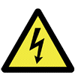 | Caution Shock hazard -  Refer to JHA for All Hazardous Activities!

Megger test of individual coils A, B and C and recorded per Appendix D.
Tom Meighan and Field Supervisor
See Appendix A – Document Sign-off Record

Mark part with sharpie pen for identification - Part identification should indicate the period and subparts (ex. MCHP - Left Side C1/B1/A1)

Install base supports. See Figure 5.

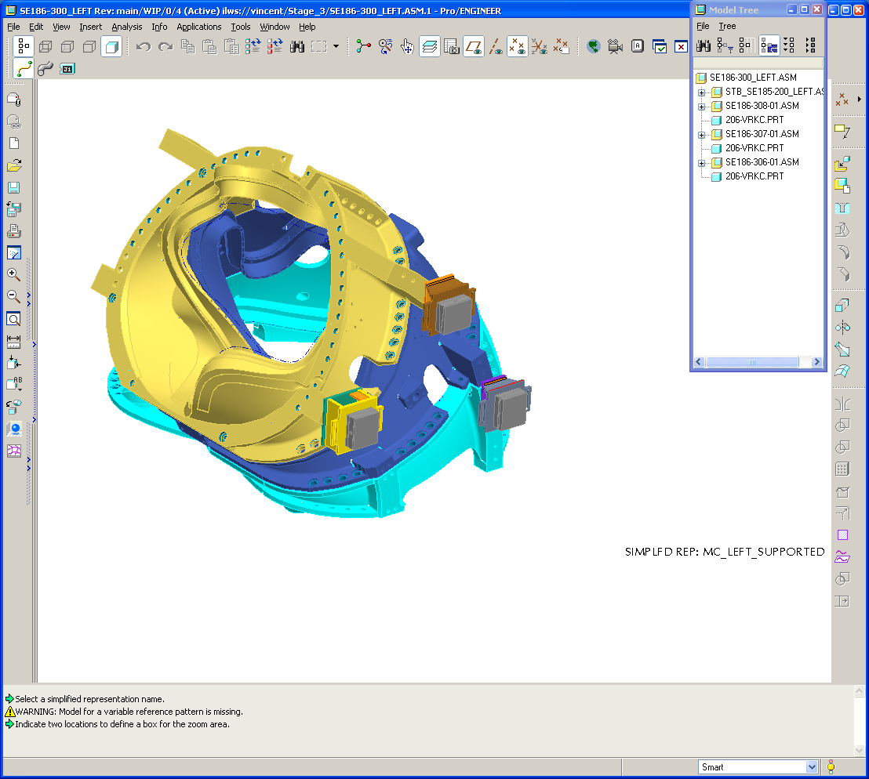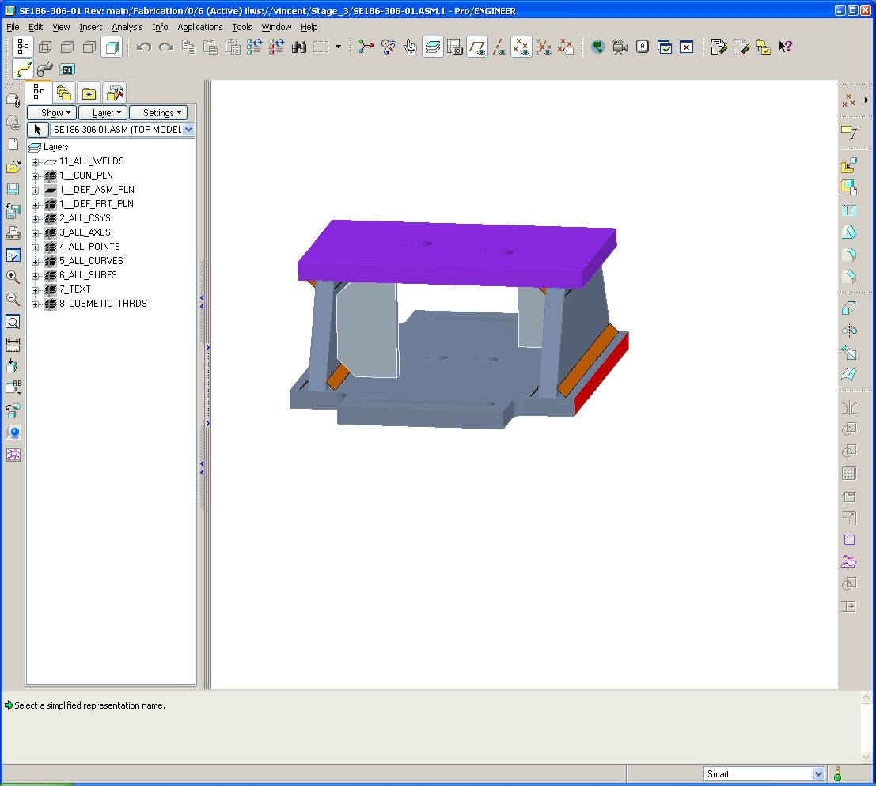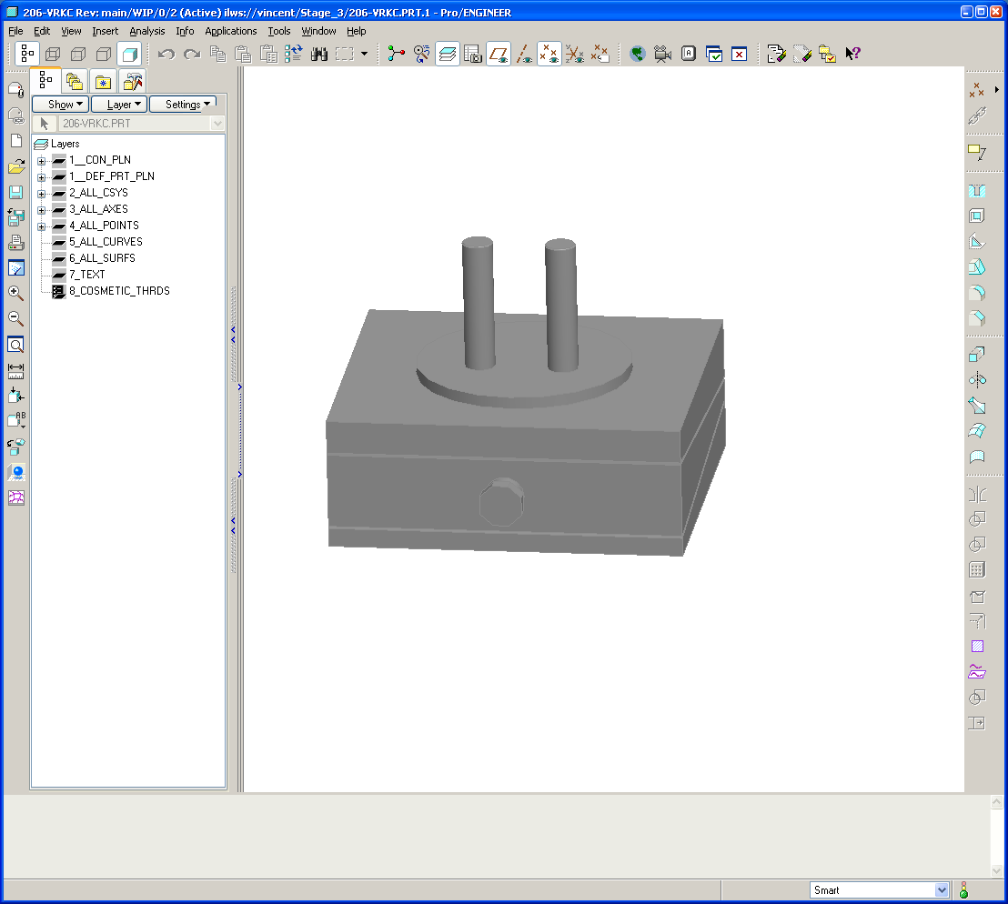
Precision Leveler
Precision Leveler support structure
Precision Leveler support mounted at three locations at the base of the MCHP.

Figure 5 MCHP base supports

Caution Lifting hazard -
Refer to JHA for All Hazardous Activities!

Remove from stand and measure weight of completed assembly; record in Appendix A.
Field Supervisor and Quality Assurance
See Appendix A – Document Sign-off Record

Move to holding area.

Remove upper wedge to original floor position, reset and grout for subsequent processes.

“A-A” Shear Plate Weldment
Note: this procedure section can be done in either Station 2 or Station 3
Caution Lifting hazard -
Refer to JHA for All Hazardous Activities!

Lift and orient the MCHP, position the “A” coil with the “A-A” flange up in a flat position for welding.

While monitoring distortion, weld “A-A” shear plates in the nose area as per approved drawings and weld procedure noted in paragraph 2.6.
Dimensional Control Coordinator, Quality Control, Field Manager
See Appendix A – Document Sign-off Record

Procedure Complete
Field Supervisor, Dimensional Control Coordinator, Quality Control, Field Manager
See Appendix A – Document Sign-off Record

Appendix A. Document Sign Off

1.3 Modular Coil Segments Identification

Assembly Coils Involved: ______________; ______________; ______________

Verified by: _________________________ Date: __________________
Field Supervisor

2.5 Metrology data area is in place

Verified by: _________________________ Date: __________________
Metrology Supervisor

Verified by: _________________________ Date: __________________
Quality Control

2.6 Welding procedure and qualified welders

Welding Procedure number: ____________________________

Qualified Welders: __________________________; _______________________

__________________________; _______________________

Verified by: _________________________ Date: __________________
Welding Engineer Supervisor

Verified by: _________________________ Date: __________________
Quality Control

4.1 Pre Job Briefing

Pre Job Briefing Complete:

Verified by: _________________________ Date: __________________
Field Supervisor

4.2 Training

Individuals trained per training matrix:
_____________________________________________________________________
_____________________________________________________________________
_____________________________________________________________________

Verified by: _________________________ Date: __________________
Field Supervisor

6.3 MC fit-up Pre-check and Surface Insulation

Log Book created for coils: _______; ________; _________

Record Date and any clearance notes in the log book

Fit check of A-A: _________________ Date: __________________

Fit check of A-B: _________________ Date: __________________

Fit check of B-C: _________________ Date: __________________

Fit check of C-C: _________________ Date: __________________

Verified by: _________________________ Date: __________________
Field Supervisor

6.4.5 Alignment Acceptance

Monuments Approved

Verified by: _________________________ Date: __________________
Dimensional Control Coordinator

6.4.16 Alignment Acceptance

Coil racked, and record achieved RMS: ___________

Verified by: _________________________ Date: __________________
Dimensional Control Coordinator

6.4.18 Monument Acceptance

Monuments Approved

Record achieved RMS: ___________

Verified by: _________________________ Date: __________________
Dimensional Control Coordinator

6.5.1 Premeasurement Alignment Acceptance

Record achieved RMS: ___________

Verified by: _________________________ Date: __________________
Dimensional Control Coordinator

6.5.8 Data Saved

Verified by: _________________________ Date: __________________
Field Supervisor

Verified by: _________________________ Date: __________________
Metrology Supervisor

8.1.1 Alignment Acceptance

Record achieved RMS: ___________

Verified by: _________________________ Date: __________________
Dimensional Control Coordinator

8.1.11 Shim Adjustment Criterion Met and puck height recorded in Appendix B

Verified by: _________________________ Date: __________________
Field Supervisor

Verified by: _________________________ Date: __________________
Quality Control

8.1.14 Alignment Acceptance

Record achieved RMS: ___________

Verified by: _________________________ Date: __________________
Dimensional Control Coordinator

8.1.16 Weld Quality and Distortion Acceptance

Distortion Acceptable. RMS alignment: ________________________

Verified by: _________________________ Date: __________________
Dimensional Control Coordinator

Weld Inspection acceptable and Permeability acceptable (<1.02 mu)

Verified by: _________________________ Date: __________________
Quality Control

Verified by: _________________________ Date: __________________
Field Manager

8.1.19 Weld Quality and Distortion Acceptance

Distortion Acceptable. RMS alignment: ________________________

Verified by: _________________________ Date: __________________
Dimensional Control Coordinator

Weld Inspection acceptable and Permeability acceptable (<1.02 mu)

Verified by: _________________________ Date: __________________
Quality Control

Verified by: _________________________ Date: __________________
Field Manager

8.1.24 Alignment Acceptance

Record achieved RMS: ___________

Verified by: _________________________ Date: __________________
Dimensional Control Coordinator

8.1.34 Record stud tension in Appendix “C”.

Verified by: _________________________ Date: __________________
Field Supervisor

Verified by: _________________________ Date: __________________
Quality Control

8.1.38 Alignment Acceptance and weld inspection

Distortion Acceptable. RMS alignment: ________________________

Verified by: _________________________ Date: __________________
Dimensional Control Coordinator

Weld Inspection acceptable and Permeability acceptable (<1.02 mu)

Verified by: _________________________ Date: __________________
Quality Control

Verified by: _________________________ Date: __________________
Field Manager

8.1.41 Shims defined for (A-B) to C joint

Thickness provided in Appendix B

Verified by: _________________________ Date: __________________
Field Supervisor

Verified by: _________________________ Date: __________________
Dimensional Control Coordinator

9.1.4 Alignment Acceptance

Verified by: _________________________ Date: __________________
Dimensional Control Coordinator

9.1.13 Alignment Acceptance

Verified by: _________________________ Date: __________________
Dimensional Control Coordinator

9.1.19 After Weld Alignment Acceptance

Distortion Acceptable. RMS alignment: ________________________

Verified by: _________________________ Date: __________________
Dimensional Control Coordinator

Weld Inspection acceptable and Permeability acceptable (<1.02 mu)

Verified by: _________________________ Date: __________________
Quality Control

Verified by: _________________________ Date: __________________
Field Manager

9.1.22 After Weld Alignment Acceptance

Distortion Acceptable. RMS alignment: ________________________

Verified by: _________________________ Date: __________________
Dimensional Control Coordinator

Weld Inspection acceptable and Permeability acceptable (<1.02 mu)

Verified by: _________________________ Date: __________________
Quality Control

Verified by: _________________________ Date: __________________
Field Manager

9.1.26 Dimensional Control Acceptance

Verified by: _________________________ Date: __________________
Dimensional Control Coordinator

9.1.34 Shim Adjustment

Verified by: _________________________ Date: __________________
Field Supervisor

9.1.37 Record stud tension in Appendix “C”.

Verified by: _________________________ Date: __________________
Field Supervisor

Verified by: _________________________ Date: __________________
Quality Control

9.1.39 After Weld Alignment Acceptance

Distortion Acceptable. RMS alignment: ________________________

Verified by: _________________________ Date: __________________
Dimensional Control Coordinator

Weld Inspection acceptable and Permeability acceptable (<1.02 mu)

Verified by: _________________________ Date: __________________
Quality Control

Verified by: _________________________ Date: __________________
Field Manager

9.1.41 Alignment Acceptance

Verified by: _________________________ Date: __________________
Dimensional Control Coordinator

9.1.42 Record stud tension in Appendix “C”.

Verified by: _________________________ Date: __________________
Field Supervisor

Verified by: _________________________ Date: __________________
Quality Control

10.1.1 Inflate all Wing Shim Bags with Stycast 2850FT

Verified by: _________________________ Date: __________________
Field Supervisor

10.1.2 Inject bushings with Stycast 2850FT

Verified by: _________________________ Date: __________________
Field Supervisor

11.1.1 Complete Local Service and Interface Details

Verified by: _________________________ Date: __________________
Field Supervisor

12.1.1 Final Stud tension record in Appendix C

Verified by: _________________________ Date: __________________
Field Supervisor

12.1.2 Coil Megger passed

Verified by: _________________________ Date: __________________
Tom Meighan

Verified by: _________________________ Date: __________________
Field Supervisor

12.1.5 Final Weight

Final Weight: ________________________

Verified by: _________________________ Date: __________________
Field Supervisor

Verified by: _________________________ Date: __________________
Quality Control

13.1.2 “A-A” Shear Plate Weldment and Alignment Acceptance

Distortion Acceptable. RMS alignment: ________________________

Verified by: _________________________ Date: __________________
Dimensional Control Coordinator

Weld Inspection acceptable and Permeability acceptable (<1.02 mu)

Verified by: _________________________ Date: __________________
Quality Control

Verified by: _________________________ Date: __________________
Field Manager

14.0 Procedure Complete

Verified by: _________________________ Date: __________________
Field Supervisor and Field Supervisor

MCHP Measurements acceptable

Verified by: _________________________ Date: __________________
Dimensional Control Coordinator

All documentation complete and metrology data filed

Verified by: _________________________ Date: __________________
Quality Control

Party scheduled

Verified by: _________________________ Date: __________________
Field Manager

Appendix B. Shim Thickness and Puck Height Record

Shim Thickness table - Coils Involved: _________; ___________

Hole No. | Initial | Wiggle | Readjust 1 | Readjust 2 | Final
1
2
3
4
5
6
7
8
9
10
11
12
13
14
15
16
17
18
19
20
21
22
23
24
25
26
27
28
29
30
31
32
33
34
Puck Thickness table - Coils Involved: _________; ___________

Hole No. | Initial | Readjust 1 | Readjust 2 | Final
1
2
3
4
5
6
7
8
9
10
11
12
13
14
15
16
17
18
19
20
21
22
23
24
25
26
27
28
29
30

Appendix C. Stud Tension Record

Coils Involved: _________; ___________

Hole No. | Initial 50% | Before Welding | After Welding | After 30 days | Final value
1
2
3
4
5
6
7
8
9
10
11
12
13
14
15
16
17
18
19
20
21
22
23
24
25
26
27
28
29
30
31
32
33
34

Appendix D. Coil Megger Test

Electrical Megger Testing of Modular Coil [Room Temperature]

This Megger electrical test will be performed at room temperature to verify the integrity of the insulation of each modular coil once a 3-pack [A-B-C] has been assembled and prior to installation over Vacuum vessel.

Test Director:
Test Director for this test series is: _______________________

Safety Requirements & Conditions

The following safety requirements and prerequisites shall be used for performing tests on the Modular Coils.

All personnel performing these tests shall be familiar with the hazards and work procedure to minimize accidents that may occur.

A “Safety Watch” shall be appointed by the Test Director. The Test Director shall clearly describe to the Safety Watch his/her responsibilities.

Name of Safety Watch: ______________________

Responsibilities have been clearly discussed with Safety Watch:

Verified: ________________________________ Date: ________________
Test Director

Responsibilities of a Safety Watch include as a minimum:

a) Monitoring the operations in an attempt to prevent careless or unsafe activities.

b) Shutting down the power in case of an accident.

c) Contacting ESU in case of accident

d) Additional responsibilities of a Safety Watch can be found in the ES&H Manual Section 2, Chapter 2.2.6.

During the test, the “Test Area” shall be roped-off and suitable “danger high voltage” signs and flashing lights displayed.

Test Area has been safed:

Verified by: _________________________ Date: __________________
Test Director

The test operator shall stand on an electrical safety mat during the test operation.

Approved rubber electrical safety gloves shall be worn by test members during grounding operations which occur once the test has been completed, and the test equipment turned off.

Upon completion of test and before the components are declared safe to touch, (dielectric joint) being tested shall be properly discharged using a “Ground Hook”. After a minimum period of 10 seconds, while the ground hook is still in place, attach a ground cable to the casting and poloidal mid-plane. The ground hook may be removed once the ground cable is in place.

Electrically ground the adjacent winding form, and chill plate cooling tubes. Care must be taken not to damage the tubes with the grounding clips.

Joint Cleanliness: The Test Director shall verify that the coil lead area has been thoroughly cleaned prior to starting any electrical tests. It is recommended that the area be wiped with ethanol as the last cleaning operation.

Joint Insulation: The Test Director shall verify that the Kapton insulation has been properly installed and that the coil is ready for testing.

Joint area has been cleaned and coil is ready for testing:

Verified by: _________________________ Date: __________________
Test Director

Insulation Resistance Measurement

Acceptance criteria:

Coil Voltage level: 5000 volts Coil Insulation Resistance: >1K Meg ohms

Complete the steps below and perform the insulation resistance test [Megger] of pancakes “A” and “B”. Pancakes “A” and “B” are connected together at the terminal block.

Test director shall verify that all safety requirements and prerequisites have been performed prior to starting the test.
  - Place the Megger test set on a firm, stable surface.
  - Securely connect a ground cable between building steel and the test unit.
  - Connect the megger ground lead to the coil casting.
  - Connect a ground cable to the chill plates.
  - Connect the megger power lead to the coil leads.
  - Measure the insulation resistance to ground. The test results shall be in compliance with the requirements noted in Section 1.1.5.

Upon completion of test and before the components are declared safe to touch, (dielectric joint) being tested shall be properly discharged using a “Ground Hook”. After a minimum period of 10 seconds, while the ground hook is still in place, attach a ground cable to the casting and Poloidal mid-plane. The ground hook may be removed once the ground cable is in place.

Electrically ground the adjacent winding forms, and chill plate cooling tubes. Care must be taken not to damage the tubes with the grounding clips.
  - Repeat process for each of the three modular coils

Coil No.: A-____ Test Location: __________________ Test Date: ______________

Table 1 - Final Megger Test Results [Type A Coil]
Test Voltage | Insulation Resistance Minimum 1KMΩ | Observations
1000
2000
3000
4000
5000

Calibration Date: _____________ Temperature: __________ Humidity: ___________

Equipment Name: ____________________________ Equipment S/N _____________________

Megger Results: Acceptable: _______________ Unacceptable: ____________

Test Director Signoff: _____________________________ Date: ______________

Quality Control verify: __________________________ Date: ______________

Comments:

Coil No.: B-____ Test Location: __________________ Test Date: ______________

Table 2 - Final Megger Test Results [Type B Coil]
Test Voltage | Insulation Resistance Minimum 1KMΩ | Observations
1000
2000
3000
4000
5000

Calibration Date: _____________ Temperature: __________ Humidity: _________

Equipment Name: __________________________ Equipment S/N _________________

Megger Results: Acceptable: _______________ Unacceptable: ____________

Test Director Signoff: _____________________________ Date: ______________

Quality Control verify: __________________________ Date: ______________

Comments:

Coil No.: C-____ Test Location: __________________ Test Date: ______________

Table 3 - Final Megger Test Results [Type C Coil]
Test Voltage | Insulation Resistance Minimum 1KMΩ | Observations
1000
2000
3000
4000
5000

Calibration Date: _____________ Temperature: __________ Humidity: ___________

Equipment Name: ____________________________ Equipment S/N _______________

Megger Results: Acceptable: _______________ Unacceptable: ____________

Test Director Signoff: _____________________________ Date: ______________

Quality Control verify: __________________________ Date: ______________

Comments:

Appendix E. Log Book Record

