Princeton Plasma Physics Laboratory
Procedure
‘
Procedure Title: Field Period Assembly Component Receipt Inspection

Number:  D-NCSX-FPA-QA1 |  | Revision:  0 |  |  | Effective Date:  Expiration Date:  (2 yrs. unless otherwise stipulated)
Procedure Approvals
Author: Mike Viola |  |  |  |  |  | Date:
ATI: Mike Viola |  |  |  |  |  | Date:
RLM: Larry Dudek |  |  |  |  |  | Date:
Responsible Division: NCSX Project
Procedure Requirements
Designated by RLM
LABWIDE:
X | Work Planning Form (ENG-032) |  |  | Lockout/Tagout (ESH-016)
 | Confined Space Permit (5008,SEC.8 Chap 5) |  |  | Lift Procedure (ENG-021)
 | Master Equip. List Mod (GEN-005) |  | X | ES&H Review (NEPA, IH, etc.) NEPA 1261
 | RWP (HP-OP-20) |  |  | Independent Review
 | ATI Walkdown |  | X | Pre-Job Brief
X | Post-job Brief *
D-SITE SPECIFIC:
X | D-Site Work Permit (OP-AD-09) |  |  | Door Permit (OP-G-93)
 | Tritium Work Permit (OP-AD-49) |  |  | USQD (OP-AD-63)
X | Pre-Job Brief (OP-AD-79) |  |  | T-Mod (OP-AD-03)
 | ** DCA/DCN (OP-AD-104) #

* Required for installations involving internal vacuum installations, critical lifts, and for the initial installation of repetitive work.
** OP-AD-104 was voided by procedure ENG-032. However, DCA’s that were open at the time of adoption of ENG-032 are still considered valid for work approval purposes.

REVIEWERS (designated by RLM) Rec’d/
Incorp.
Comments
Accountable Technical Individual John W Edwards
Test Director
Independent Reviewer Hutch Neilson
D-Site Shift Supervisor
Independent
NCSX Dimensional Control Coordinator Brent Stratton
Vacuum
NCSX Field Supervisors Steve Raftopoulos, Mike Viola
Project Engineer for Stellerator Systems (WBS 1) Manager Brad Nelson (ORNL)
WBS Manager for Field Period Assembly Coils (WBS18) Dave Williamson (ORNL)
Quality Assurance/Quality Control. Judy Malsbury, J. Boscoe, Colin Phelps
Maintenance and Operations Division
Energy Conversion System/Motor Control Division
Engineering
Environmental Restoration & Waste Management Division
Environmental, Safety & Health Jerry Levine
Industrial Hygiene Bill Slavin
Health Physics
RLM Larry Dudek

TRAINING (designated by RLM)
No training required ______________ | Instructor: John Edwards
Personnel (group, job title or individual name) |  | Read Only | Instruction  Pre-job  Briefing | Hands On
Lead Tech. |  |  | X
Technicians performing task |  |  | X
Field Supervisors |  |  | X
Quality Control Representative |  |  | X
Training Rep.
RLM: Larry Dudek

RECORD OF CHANGE

Revision | Date | Description of Change
00 | XXXX | Initial release

TABLE OF CONTENTS

1 Scope 1
1.1 Introduction 1
1.2 Scope 1
1.3 Identification of Vacuum Vessel Segment: 1
2 Applicable Documents 1
2.1 NCSX-MIT/QA-XXXXX: 1
2.2 NCSX-PLAN-CMFOP-00: 1
2.3 D-L-NCSX-XXX Lifting Vacuum Vessel Segment 1
2.4 D-NCSX-XXXX Dimensional Control & Metrology for the NCSX VV 1
2.5 D-NCSX-PLAN-FPA1DC-XX VV Dimensional Control Plan Error! Bookmark not defined.
3 Safety Requirements: 1
3.1 Job Hazard Analysis: 1
4 Prerequisites & Conditions: 2
4.1 Pre-Job Briefing: 2
4.2 Daily Operations Startup and Shutdown: 2
5 Materials and Parts for this station 2
6 Fabrication Process 3
6.1 Daily Startup Activities: 3
6.2 Daily Shutdown Activities: 3
6.3 Moving VVSA from Shipping Pallet: 3
6.4 Installation of VVSA on Turning Fixture: Error! Bookmark not defined.
6.5 Inspect VVSA: Error! Bookmark not defined.
6.6 Metrology Set-Up and Dimensional Inspection: 9
6.7 Marking Flux Loop Template and Heating Coolant Stud Locations: Error! Bookmark not defined.
6.8 Installation of Flux Loop Templates: Error! Bookmark not defined.
6.9 Installation of Heating Collant Studs: Error! Bookmark not defined.
6.10 Installation of Flux-Loops and Routing Leads: Error! Bookmark not defined.
6.11 As Built Dimensional Inspection of Flux Loops: Error! Bookmark not defined.
6.12 Flux Loop Termination and Template Removal: Error! Bookmark not defined.
6.13 Installation of Heating Coolant Tubes: Error! Bookmark not defined.
6.14 Dimensional Inspection: Error! Bookmark not defined.
6.15
6.16
6.17
6.18
6.19
6.20
6.21
6.22
6.23
6.24
6.25
7 Completion of Activities at Station One: Error! Bookmark not defined.
7.1 Document Verification: Error! Bookmark not defined.
7.2 Field Package: Error! Bookmark not defined.
7.3 Approval: Error! Bookmark not defined.

Index of Figures

Figure 1- Turning Fixture
Figure 2-
Figure 3-
Figure 4-
Figure 5-
Figure 6-
Figure 7-
Figure 8-
Figure 9-
Figure 10-
Figure 11-
Figure 12-
Figure 13-
Figure 14-
Figure 15- Error! Bookmark not defined.
Figure 16-
Figure 17-
Figure 18-
Figure 19-
Figure 20-

Index of Tables

Table 1-
Table 2-
Table 3-
Table 4-

Scope

Introduction
The Field Period Assembly is divided into 5 workstations. Each workstation has a specific set of tasks that will be performed as part of the overall assembly process. This procedure addresses the manufacturing, inspection, test and QC inspection points for a specific workstation.
- Station No. 1… Vacuum Vessel Subassembly (VVSA) Activities

Scope
This procedure is used to describe the assembly sequence required for Station 1 Field Period Assembly.
- Installing the Vacuum Vessel in the turning fixture
- Metrology measurements
- Flux Loop Locations
- Heating Cooling Tube Stud Locations
- Installation of Flux Loops
- Installation of Heating –Cooling Tubes

Identification of Vacuum Vessel Segment being Assembled:

Segment Number: ________________________

Applicable Documents

NCSX-MIT/QA-185-01:
All applicable documents associated with this procedure, are identified in the MIT/QA Plan, document number NCSX-MIT/QA-185-01.

NCSX-PLAN-MFOP-00:
All work processes are governed by the “NCSX Coil Manufacturing Facility Operations Plan”, document number NCSX-PLAN-MFOP-00.

D-L-NCSX-XXX Lifting Vacuum Vessel Segment

D-NCSX-XXXX Dimensional Control & Metrology for the NCSX VV

D-NCSX-PLAN-FPA1DC-01 VV Dimensional Control Plan

Safety Requirements:
All work will be performed in a safe manner in accordance with PPPL Environmental Safety & Health Directives ES&H 5008 and the “Integrated Safety Management” (ISM) policy.

Job Hazard Analysis:
A JHA will be generated for each Vacuum Vessel Sub Assembly station, identifying existing or potential workplace hazards and to evaluate the risk of worker injury or illness associated with job tasks. (Reference document ESH-004 “Job Hazard Analysis”) The IH representative will review the JHAs for accuracy as well as completeness. It will be reviewed with all activity participants at the Pre-Job briefings.

Prerequisites & Conditions:

Pre-Job Briefing:
A pre-job briefing will be held, describing the processes and safety issues prior to starting any part of this procedure. Attendance shall be documented via training sign-in sheet.

Pre job Briefing complete: _______________________________ _________________
VVSA Field Supervisor Date

Daily Operations Startup and Shutdown:
Each working day, it is required to complete and initial the daily operations startup log to ensure that the station is ready to commence work activities for the day. The signoff log is located in the Daily Station Log. See section 6.1 and 6.2 for details.

Materials and Parts for this activity
The following materials and/or equipment will be used with this procedure.

General Description | Material | Reference Document/Product No.
VVSA | Inconel | SE120-002

Assembly Process
This procedure is to be used as guide to receive and inspect and store NCSX components. Deviation from this procedure for processes that DO NOT affect the design of the assembly can be made during the assembly process with the concurrence of the VVSA Field Supervisor. All deviations shall be documented in the procedure and initialed by the VVSA Field Supervisor prior to implementing the deviations. Deviations that may effect the design of the coil requires a Request for Deviation “RFD” approval. The RFD must be approved prior to proceeding. Procedure changes need to be incorporated into the document via “Minor Procedure Changes” or “Revisions”.

Daily Startup Activities:

Check all daily supplies needed:

Verify operation of all equipment needed that day.

Check station for cleanliness

Check that safety equipment needed for day’s activities are available

Check that the day’s travelers and procedures are in their document holder.

Once completed, date and initial daily log at the back of the Station Log Book.

Daily Shutdown Activities:

Turn off power to equipment not in use.

Clean entire workstation area.

Verify that all Traveler and data sheet information is complete.

The Lead Technician shall verify that the Station’s Log Book has been completed and signed for the day.

Once completed, date and initial daily log at the back of the Station Log Book.

Vacuum vessel Receipt and Inspection:

The VVSA, SE120-002, consists of a vessel shell referred to as a Vacuum Vessel Period Assembly (Period
Assembly), SE120-003, a Spacer Assembly (Spacer), SE121-014, two (2) Vacuum Vessel Blank Off Covers, SE121-102, two (2) Vacuum Vessel Seals, SE121-095, and the port extension assemblies with their associated blank flanges, seals, and fasteners. Three VVSA units, including all hardware in the referenced drawings, are to be procured, fabricated, and delivered by the Seller. Bills of material are provided in drawings listed in Appendix A.

Verify item receipt
NCSX-CSPEC-121-02 Paragraph
5.1 Labeling
Subassemblies and components, except bolts and standard hardware, shall be marked with unique serial numbers to provide positive identification. When such markings would impair proper functioning of the equipment, a metal, non-corrosive, non-magnetic tag shall be used. Match markings shall be provided to uniquely identify the location and positioning of all port extensions relative to the Period Assembly.
5.2 Packing and Skidding
All components shall be sealed, packaged, and skidded to provide protection against contamination, deterioration and damage during shipment. Vacuum sealing surfaces shall be protected from damage during shipping and handling. A plan shall be provided to the Laboratory prior to shipment which includes a description of methods to be used to preserve, package, skid, and identify equipment. The Seller shall contact the Laboratory ten days prior to shipment of the machine to confirm shipping method and route.
5.3 Marking
Each shipping skid shall be marked with the name of the Seller, Laboratory Purchase Order Number, the component name, and gross weight. Boxes containing loose parts, attachments, and accessories shall be marked identifying the assembly to which they belong, and where possible, boxes are to be secured to the skid of the unit.
Identify each item and list the item in the Material log

Verified by: _________________________ Date: __________________
Lead Technician

Perform Material verification
NCSX-CSPEC-121-02 Paragraph
3.3.2.1 Sheet, Strip, and Plate
All as-supplied sheet, strip, and plate shall be annealed Alloy (UNS N06625) and meet the requirements of ASTM B 443.
3.3.2.2 Tubing and Piping
All Inconel tubing and pipe shall be seamless or welded Alloy (UNS N06625) and meet the requirements of ASTM B 444, or ASTM B 705. All austenitic stainless steel tubing shall be seamless or welded 316L alloy and meet the requirements of ASTM A 249/A 249 M-04A or ASTM A 213/A 213M-03.
3.3.2.3 Bar and Structural Shapes
All bar and structural shapes shall be annealed Alloy (UNS N06625) and meet the requirements of ASTM B 446.
3.3.2.4 Conflat Flanges
The conflat flanges shall meet the requirements of ASTM A 240.
3.3.2.5 Weld Filler Metal (Not Applicable)
Weld filler metal shall meet the requirements of the applicable AWS A series specifications or ASME SFA specifications. Certified material test reports shall be supplied for all materials (see section 4.2.7). Welding of stainless steel conflat flanges to Inconel 625 (UNS N06625) ports shall use ASME/AWS SFA/A 5.14 ERNiCr-3 or ERNiCrMo-3 filler metal
3.3.2.6 Bolts
Conflat flange bolts shall be ASTM A 193, Grade B8; silver-plated, 12-point bolt kits provided with flanges from the flange manufacturer. Non-circular o-ring flange bolts, with the exception of the neutral beam port, shall use ASTM A453 Grade 660 bolts (A286) The neutral beam port, whose flanges are Inconel 625, shall use Inco 718 bolts per ASTM A1014.
3.3.2.7 Seals
3.3.2.7.1 Metal Seals
Seals for Conflat flanges shall use standard copper seals provided from the flange manufacturer.
3.3.2.7.2 Custom Flanges
Custom non-circular flanges, with the exception of the neutral beam port, will be sealed with two Viton A seals.

Verified by: _________________________ Date: __________________
Lead Technician

Perform visual Inspections
NCSX-CSPEC-121-02 Paragraph
3.2.2.1 Interior (Vacuum) Surfaces
Interior of the Period Assembly wall, Spacer, and port extensions shall be polished to a 32 micro-inch finish. Interior weld beads, scratches, and tooling marks resulting from fabrication shall be polished to a 32 micro-inch finish. Interior wall surface weld beads shall be ground to within .032 inch of the surface prior to polishing. Scratches, pits, weld pin holes and other surface imperfections exceeding depth limits set forth in the Engineering Drawings shall be repaired by welding before finish polishing.
3.2.3 Exterior Surface Finish
Mill finish on the exterior surfaces is acceptable, but any imperfections greater than 0.04 inches deep shall be weld repaired and ground smooth.

Verified by: _________________________ Date: __________________
Lead Technician

Perform Permeability check of welds components and shell surface
NCSX-CSPEC-121-02 Paragraph
4.2.3 Verification of Magnetic Permeability
To verify conformance to Section 3.2.4, magnetic permeability shall be measured in accordance with the requirements of ASTM A 800, Supplementary Requirement S1, but with the measurements taken in relative permeability, rather than ferrite content. All surfaces and features shall be checked with a calibrated Severn Permeability Indicator3 for compliance with Section 3.2.4. The surfaces of the VVSA components shall be checked and documented in a 6" x 6" grid. The weld seams in the shell wall, at the conflat flanges, and at the junction between the port extension, reinforcement, and shell shall be checked every 1/2" (both inside and outside surfaces wherever possible). Actual values need be recorded only for any out-of-tolerance conditions.
3.2.4 Magnetic Permeability
Relative magnetic permeability of all components shall not exceed 1.02 except for welds (and heat affected zones) joining stainless steel to nickel chromium, which shall not exceed 1.2.

Verified by: _________________________ Date: __________________
Lead Technician

Perform metrology measurements with emphasis made to resolve impact of out of tolerance conditions.

Verify all tooling ball locations with respect to MTM data package

Measure end flanges and compare with theoretical position.

Verified by: _________________________ Date: __________________
Lead Technician

Replace Port Flanges with Station 1 Assembly Flanges:

If attached remove the two horizontal port flanges covers and bag bolt assemblies for future use. See Figure 6-1.

Figure 6-1.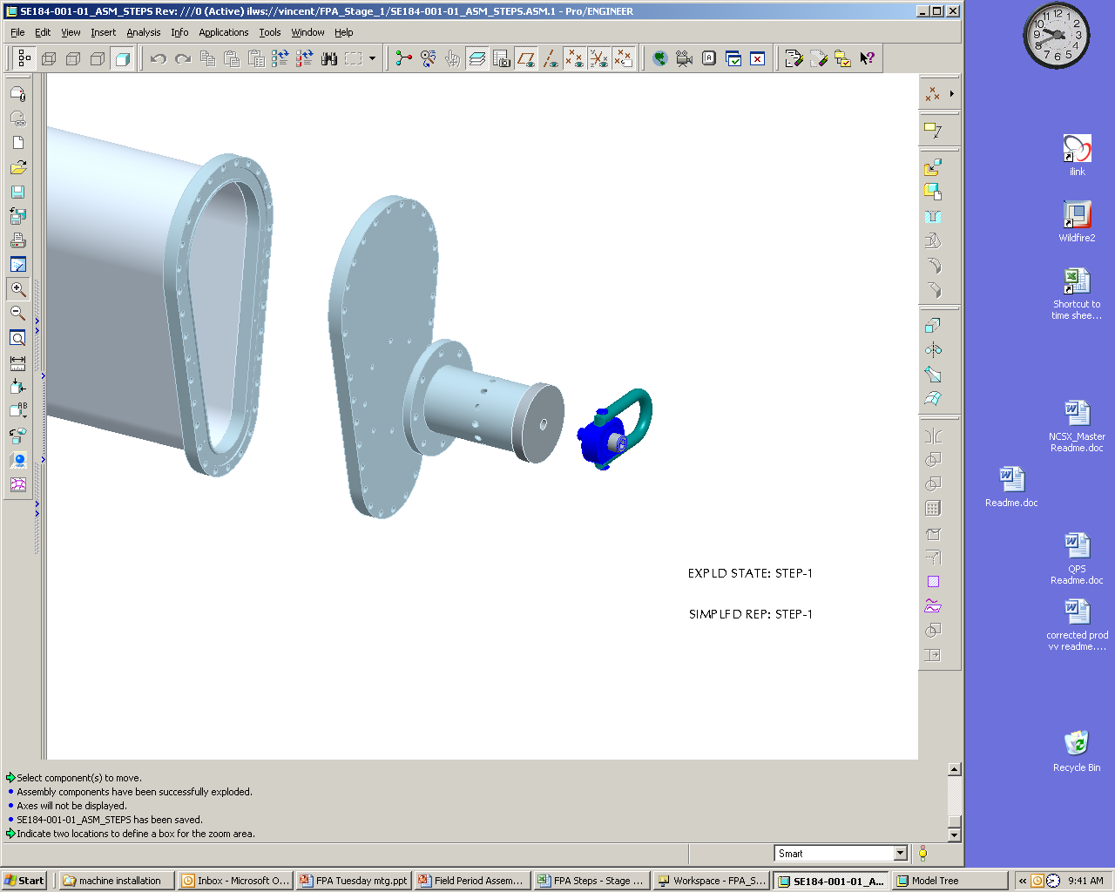
Support Axle Weldment
Hoist Ring
Stage 1 Horizontal port flange cover

If attached remove NB port flange and bag bolt assemblies for future use. See Figure 6-2.

Install VV heating/cooling cryostat interface flanges by slipping each over each vertical port. The interface flanges need to be temporarily supported on the flanges. Reference drawing: se123-164. See Figure 6-2
Heating/cooling cryostat interface flange (se123-164)
N.B. port flange
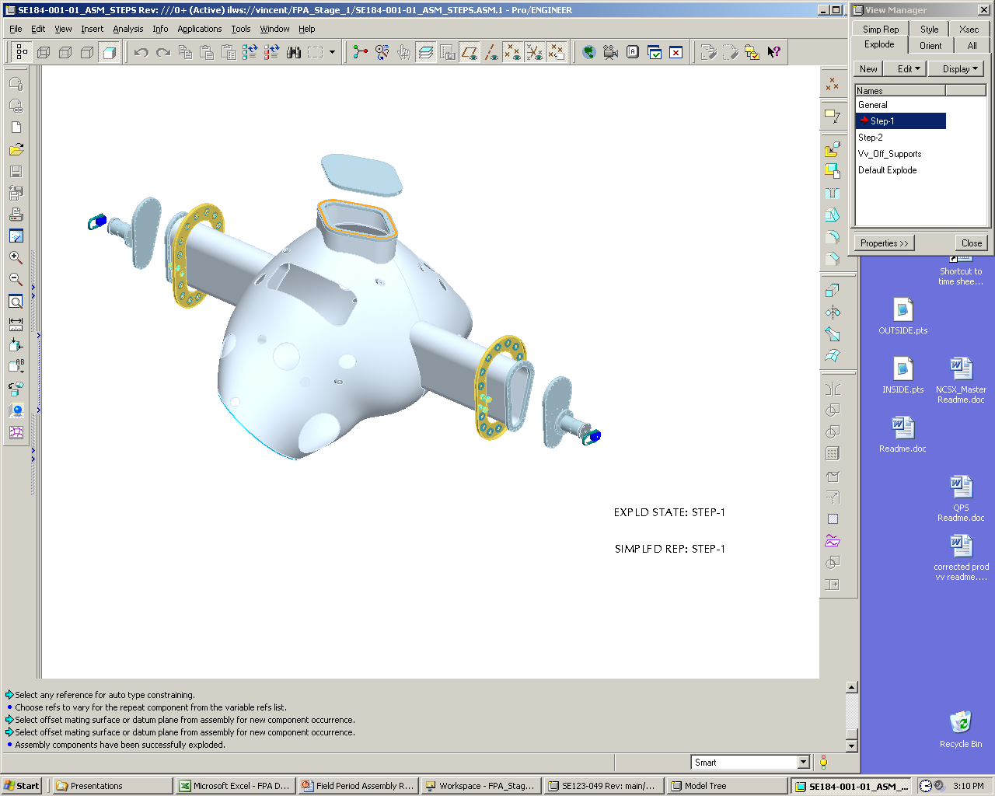
Stage one port
Assembly flange
Support Axle
Weldment

Hoist Ring
Figure 6.2 Heating and Cooling Cryostat Interface Flanges

Using rubber gasket material or gortex gasket material on the flanges for flange protection install stage one port assembly flange covers, support axle weldments, and hoist rings.

Install VVSA in Station One Rotating Fixture:

Using lift procedure (D-L-NCSX-XXXX) and test cell crane attached to Weldment hoist rings. Lift VV from a horizontal position and rotate to a vertical position. Check to see if VV is in a near vertical position. Mark CG location.

Note: If VV Cg is found to be off by a value greater than 2.0” return VV to its original position. Remove and relocate support axle Weldments to proper location and retest.

Verified by: _________________________ Date: __________________
Field Supervisor

Lubricate support axle and axle support cradle. Add lubricate to support axle weldment and support axle cradle components (cradle top and cradle base) to reduce VV rotation friction.

Mount VV on Station one rotating fixture in the horizontal position. See Figure 6-3.

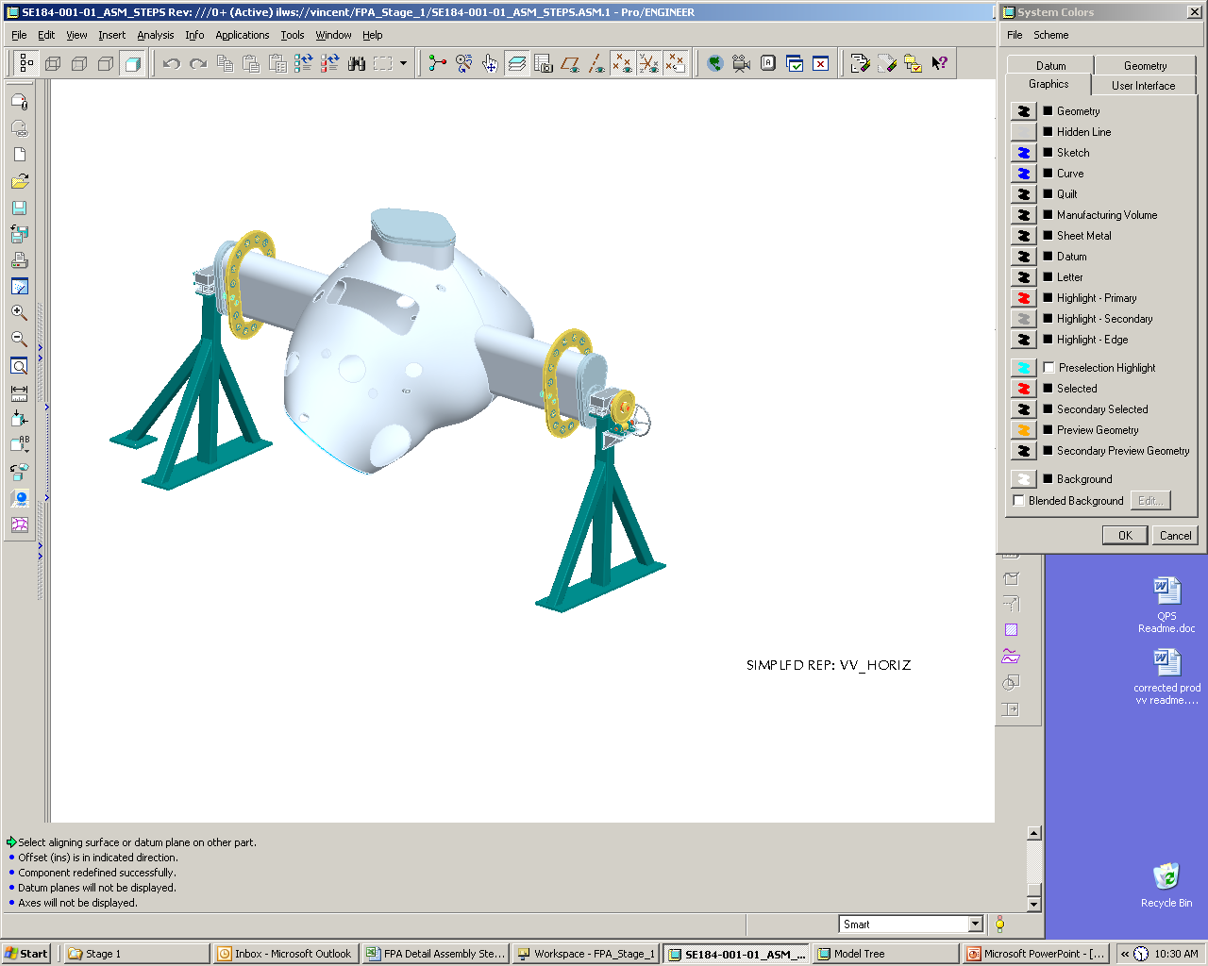

Figure 6.3 Vacuum Vessel in Horizontal Position

Secure in place by bolting down support axle cradle to support blocks. See Figure 6-4.

Install quick release pin. See Figure 6-4.

Remove the hoist ring from worm gear side of VV support axle weldment. Install worm gear axle and worm gear. See Figure 6-4.
Quick release pin
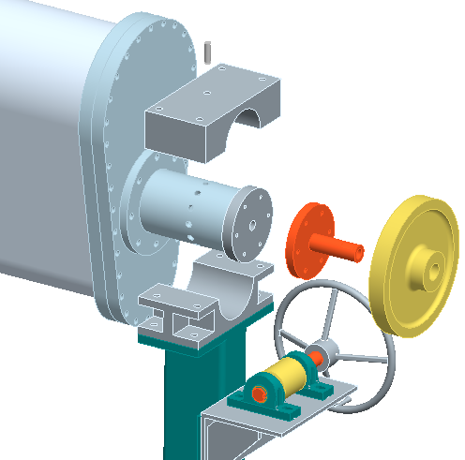

Worm gear axle Weldment
Support axle cradle base
Support axle cradle top
Worm gear

Figure 6.4 Installation Details

Metrology Set-up and Initial Vessel Measurements

Using a marker mark the positive toroidal field direction on the front and back surface of the vacuum vessel.
Note: The worm gear system is identified as the VV down direction. See Figure 6.5.

Verified by: _________________________ Date: __________________
Field Supervisor

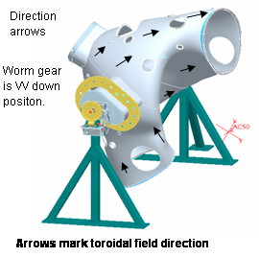
Figure 6.6

Set up measurement fiducials provided by MTM plus add additional monuments as specified in FP Dimensional Control Plan for Station 1 (NCSXPLAFPA1DC-00). Rotate vessel to convenient access positions.
Note: Some monuments will be located on the body of the VVSA

Perform a best fit to the fiducial measurements using the monuments on the VV body. Settings will be made with the vessel NBI port at a +/-60º off vertical position as indicated in Figure 6-4 and Figure 6-5. Secure vessel position by inserting release pin and tighten support axle cradle bolts. Verify that the mounting system is rigid enough to meet FP Dimensional Control Plan metrology requirements.

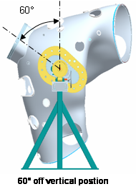
Figure 6-4

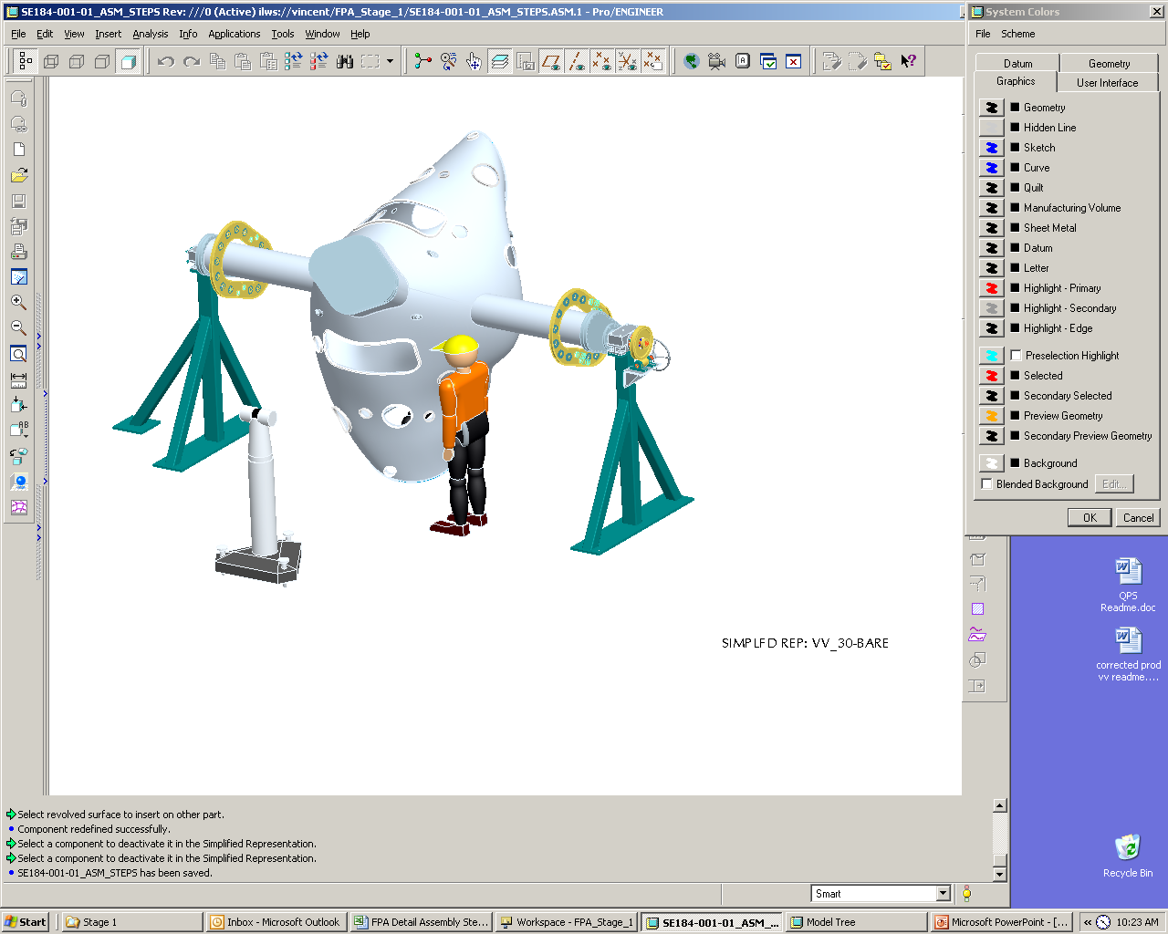

Figure 6.5 Vacuum Vessel in Rotated Position

Marking Flux Loop Template and Heating Coolant Stud Locations:

6.7.1 Secure vessel position with the 60º NBI port at a +/– 60º off vertical position by inserting release pin and tighten support axle cradle bolts.

6.7.2 Mark surface for XXX loop placements with the vessel NBI port at a +/–60º off vertical position. It is expected that three Leica positions will be required on each side to accurately mark the vessel. The Leica metrology system will be used to accurately define four marks (within +/–0.040”) for each of the XXX loops except for the loops at the symmetry points which shall be positioned within +/–0.010”. The magnetic loop points shall be marked using an X to indicate the locating point. For ease of locating templates mark template number at center of four points. See figure 6.6 below and Reference drawing XXXXX and ProE model XXXXX for loop designation, point marking details and model geometry data.

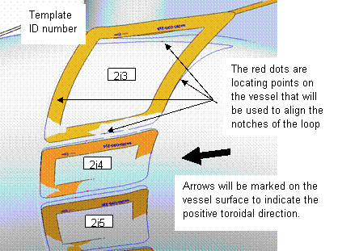

Figure 6.6 Template Locating and Numbering

6.7.3 If not previously positioned rotate VV so that vessel NBI port is at a +/–60º off vertical position. See Figure 6-4.

6.7.4 The Leica metrology system will be used to locate XXXX studs per half period at X” spacing. Fine accuracy is not important position within +/– .50”. The stud location shall be marked with a circle with a name designation added ( A1, A2, A3….) to define the series. An outline of the coolant line and hold-down bracket shall also be marked. See Figure 6.7 and reference drawing se121-128 sheet 4 for loop designation, point marking details.
Note: The cooling lines overlay the diagnostic loops.

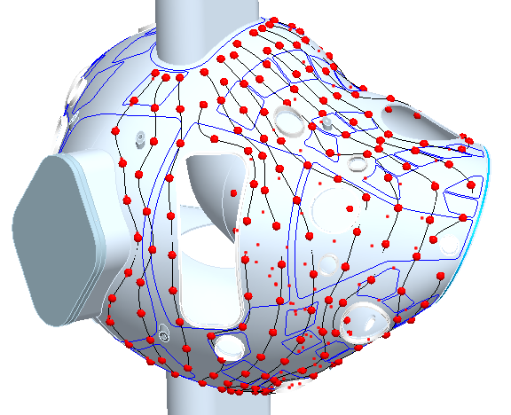

Figure 6-7 Overlay of the Coolant Lines Over the Diagnostic Loops

Vertical Port Component Installation

Mark heating/cooling support bracket A and B attachment studs and mark bracket clip outline.

Install cryostat interface mounting flange on vertical ports. Before welding the interface flange on the vertical ports the cryostat interface flange must be mover into the proper assembly position. ( See Figure 6-8).

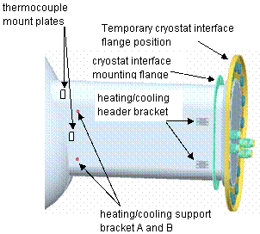
Figure 6-8 Cryostat Interface Flange

