NCSX

NCSX Coil Manufacturing Facility
Operations Plan

NCSX-PLAN-CMFOP-01-Rev 00

May 19, 2005

Author: _______________________________________
James H. Chrzanowski- Coil Facility Manager

Reviewed By: _________________________________
Steve Raftopoulos- Field Supervisor

Reviewed By: _________________________________
Tom Meighan- Field Supervisor

Reviewed By: _________________________________
Mike Kalish- Field Supervisor

Reviewed By: _________________________________
Judy Malsbury- NCSX QA Representative

Reviewed By: _________________________________
Brent Stratton- Dimensional Control Coordinator

Reviewed By: _________________________________
Jerry Levine- PPPL Safety Representative

Reviewed By: _________________________________
Bill Slavin- PPPL IH Representative

Approved By: _________________________________
Larry Dudek- RLM for Coil Facility

RECORD OF CHANGE

Revision | Date | Description of Change
00 | 5/19/05 | Supersedes NCSX-PLAN-MCFOP-01

TABLE OF CONTENTS

1 Introduction and Scope - 1 -
1.1 Introduction - 1 -
1.2 Scope - 1 -
2 Applicable Documents - 1 -
3 General Description NCSX Coils - 2 -
3.1 Modular Coils - 2 -
3.2 Twisted Racetrack Coil - 3 -
3.3 Toroidal Field Coil - 3 -
4 Facilities and Work Stations - 4 -
4.1 Facilities Description - 4 -
4.2 Work Station Descriptions - 5 -
5 Manufacturing Inspection & Test/Quality Assurance Plan - 6 -
6 Flow Plan of the Manufacturing Operations - 7 -
7 Responsibilities during Manufacturing - 9 -
7.1 Manufacturing Facility Manager - 9 -
7.2 Field Supervisors - 9 -
7.3 Lift Engineer - 9 -
7.4 Coil Test Director - 9 -
7.5 Lead Technicians - 9 -
7.6 Field Crews - 9 -
7.7 Health Physics Representative - 9 -
7.8 Industrial Hygiene Representative - 10 -
7.9 Dimensional Control/Metrology Representative(s) - 11 -
7.10 Construction Safety Representative - 11 -
7.11 Quality Control Representative - 11 -
8 General Facility Operating Guidelines - 11 -
8.1 Field Supervisors - 11 -
8.2 House-Keeping/Cleanliness Rules - 11 -
8.3 Hard hats - 12 -
8.4 Station Logbook - 13 -
8.5 Daily Summary Report - 13 -
9 Safety and Training Requirements - 13 -
9.1 Integrated Safety Management (ISM) - 13 -
9.2 Job Hazard Analysis Surveys and Safety Meetings - 13 -
9.3 Safety Walk-Through’s - 13 -
9.4 Training - 14 -
9.5 Personal Protective Equipment [PPE’s] - 14 -
9.6 Radiation Controlled Area: - 14 -
9.7 Emergency Response Procedure - 14 -
10 Meetings and Communication - 14 -
10.1 Daily Startup Meetings - 14 -
10.2 Safety Meetings - 15 -
10.3 Pre-Job Briefings - 15 -
10.4 Post-Job Briefings - 16 -
11 Documentation - 16 -
11.1 Document Control - 16 -
11.2 Coil Field Package - 16 -
11.3 Documents Retention and Storage - 16 -
12 Quality Assurance/Quality Control Requirements - 16 -
12.1 Quality Control during Manufacturing - 16 -
12.2 Measurements - 17 -
12.3 Other Quality Control Representative Responsibilities - 17 -

LIST OF FIGURES

Figure 1-Modular Coil Types - 2 -
Figure 2- Twisted Racetrack Coil - 3 -
Figure 3- Toroidal Field Coil - 4 -
Figure 4-NCSX Coil Manufacturing Facility - 6 -
Figure 5- Flow Plan for MC Fabrication - - 7 -
Figure 6- Flow Plan for TRC Fabrication - 8 -
Figure 7- Flow Plan for TF Coil Fabrication - 8 -
Figure 8-NCSX Coil Manufacturing Facility Organizational Chart - 10 -

Introduction and Scope

Introduction
The National Compact Stellerator Experiment (NCSX) Modular and Toroidal Field Coils will be manufactured at the Princeton Plasma Physics Laboratory (PPPL) for the NCSX Project. This document describes the general operating plan that will be used during the manufacturing of the Twisted Racetrack (TRC), Modular Coils (MC) and Toroidal Field (TF) coils.

Scope
This document will describe how the NCSX coil facility will function during the coil-manufacturing phase. This document includes the following sections:
2 Applicable Documents
3 General Description of the NCSX Coils
4 Facilities and Workstations
5 Manufacturing Inspection and Test Plan (MIT)
6 Flow Plan for Manufacturing Operations
7 Responsibilities during Manufacturing
8 General Facility Operating Guidelines
9 Safety Requirements
10 Meetings and Communication
11 Documentation
12 Quality Assurance/Quality Control

This “General Operating Plan” along with the Manufacturing, Inspection and Test/Quality Assurance (MIT/QA) plans will govern the processes by which the Twisted Racetrack, Modular and Toroidal Field coils will be fabricated.

Applicable Documents

Document Number | Title
ESH-004 | Job Hazard Analysis
ES&H 5008 | PPPL Environmental, Safety and Health Manual
NCSX-MIT/QA-131-01-00 | Mfg., Inspection, Test/QA Plan for Toroidal Field Coils
NCSX-MIT/QA-142-01-00 | Mfg., Inspection, Test/QA Plan for Modular Coils
NCSX-CSPEC-131-01 | Toroidal Field Coil Product Specification
NCSX-CSPEC-140-03 | Modular Coil Specification
NCSX-CSPEC-142-04 | Twisted Racetrack Coil Product Specification
WP-1038 | Work Planning Form for Winding Production Mod Coil
WP-1188 | Work Planning Form for Twisted Racetrack Coil
WP-1227 | Work Planning Form for Winding Production TF Coils
ESH-008 | Access to Radiological Areas (RCA’s)
NEPA 1283 | Modular/TF Coil Development and Production
D-NCSX-OP-EO-41 | NCSX Coil Manufacturing Facility Emergency Response

General Description NCSX Coils

Modular Coils
The Modular Coil Set consists of three field periods with 6 coils per period for a total of 18 coils. Due to symmetry, only three different coil shapes are required to make up the complete coil set. Each modular coil is constructed by winding pre-insulated rectangular compacted copper cable onto a stainless steel cast winding form. Each coil consists of two double pancake windings. Once wound, the entire coil is vacuum-pressure impregnated (VPI) with epoxy. The winding forms are bolted together to form a complete torus and are electrically insulated from each other at the bolted flange interfaces. The coil set will be pre-cooled to cryogenic temperatures before each experimental pulse by nitrogen gas. Error: Reference source not found shows the (3) different modular coil types.

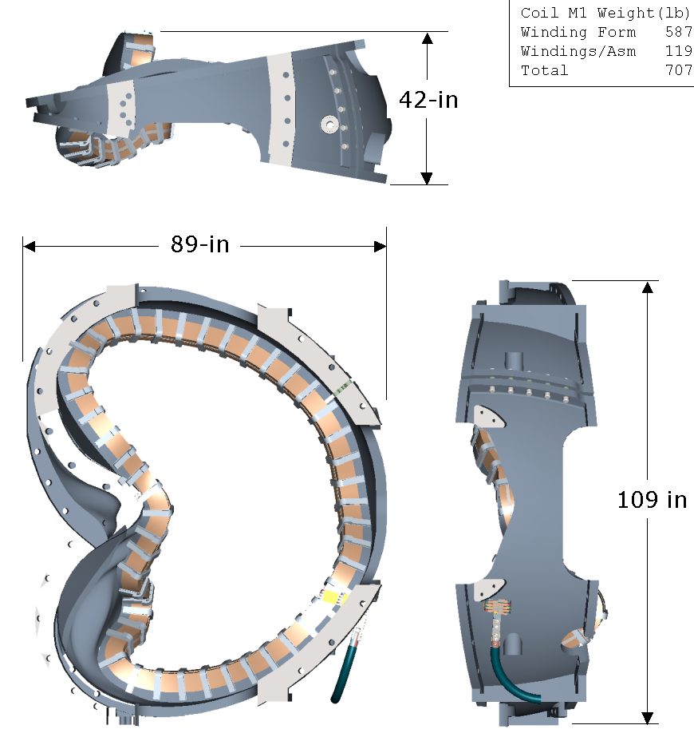
Type B Type A

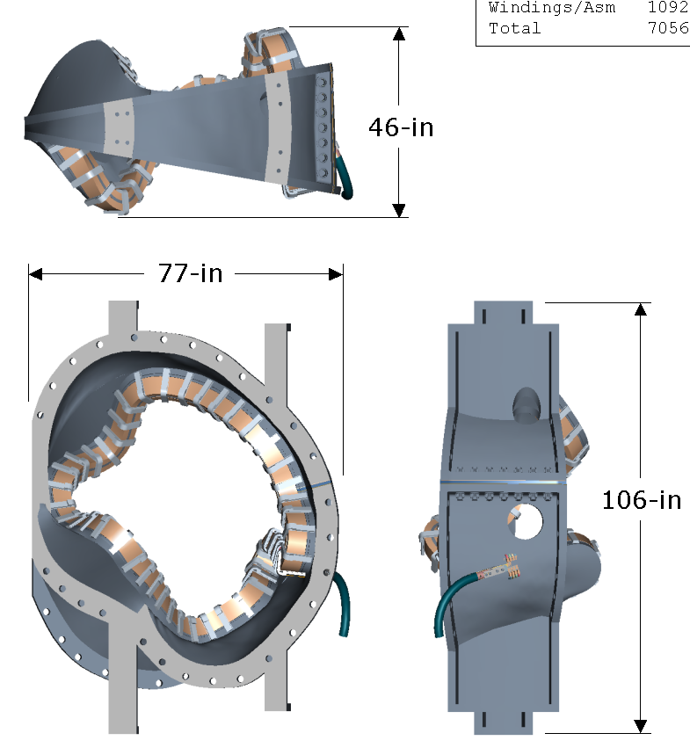 Type C
Figure 1-Modular Coil Types

Twisted Racetrack Coil
The Twisted Racetrack coil (TRC) was designed to replicate many of the design features that are in the modular coils. It includes the same cross-section; general construction (insulation, conductor, epoxy system); lead design; cooling system and typical complex geometry. This coil will be used to verify the design elements, manufacturing procedures, qualify tooling and equipment and train personnel. Figure 2- Twisted Racetrack Coil shows the Twisted Racetrack coil.

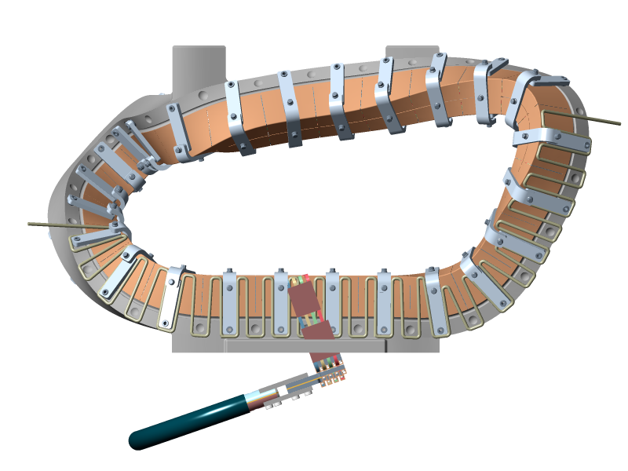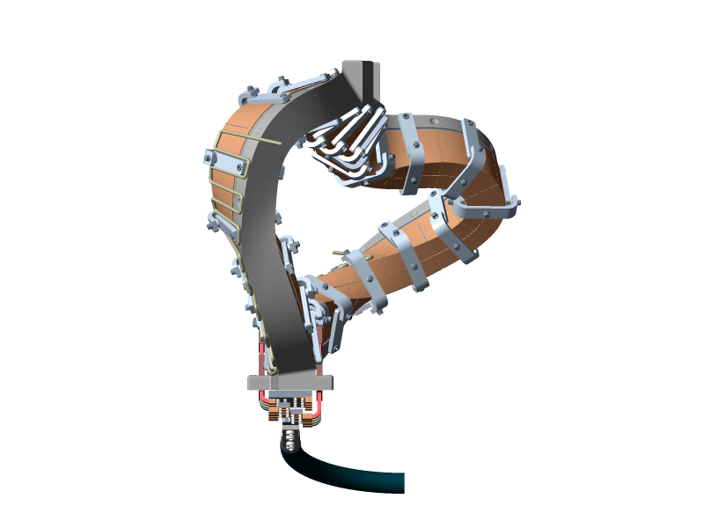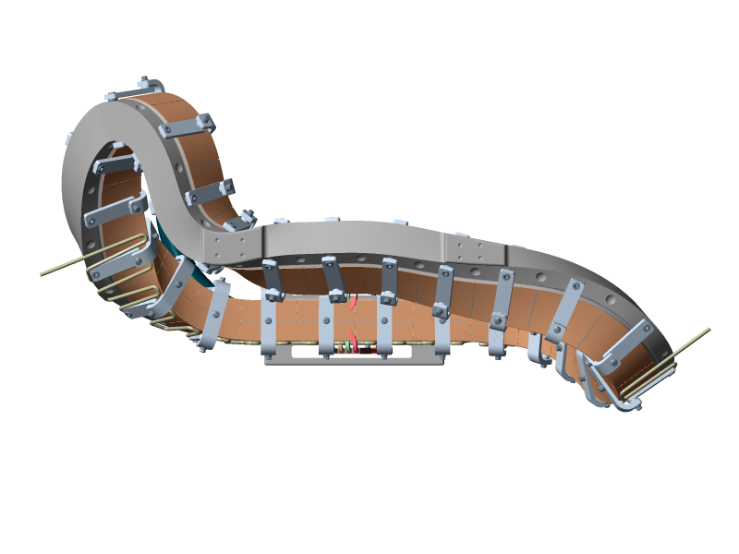
35-in
61-in
32-in
Figure 2- Twisted Racetrack Coil

Toroidal Field Coil
The Toroidal Field (TF) Coil Set consists of a total of 18 identical, equally spaced coils. Each TF coil has 12 turns and is constructed by winding pre-insulated rectangular hollow core copper conductors onto a winding mandrel. Once wound, the coils are ground wrapped with fiberglass tape, placed in a vacuum mold and epoxy impregnated (VPI) in the autoclave. A stainless steel nose casting will then be installed. During post VPI testing and operation, the coil set will be pre-cooled to cryogenic temperatures using nitrogen gas. Figure 3- Toroidal Field Coil shows a typical Toroidal Field Coil. [The present plan is to cold test only the first TF coil. However, the project may elect to test additional coils]
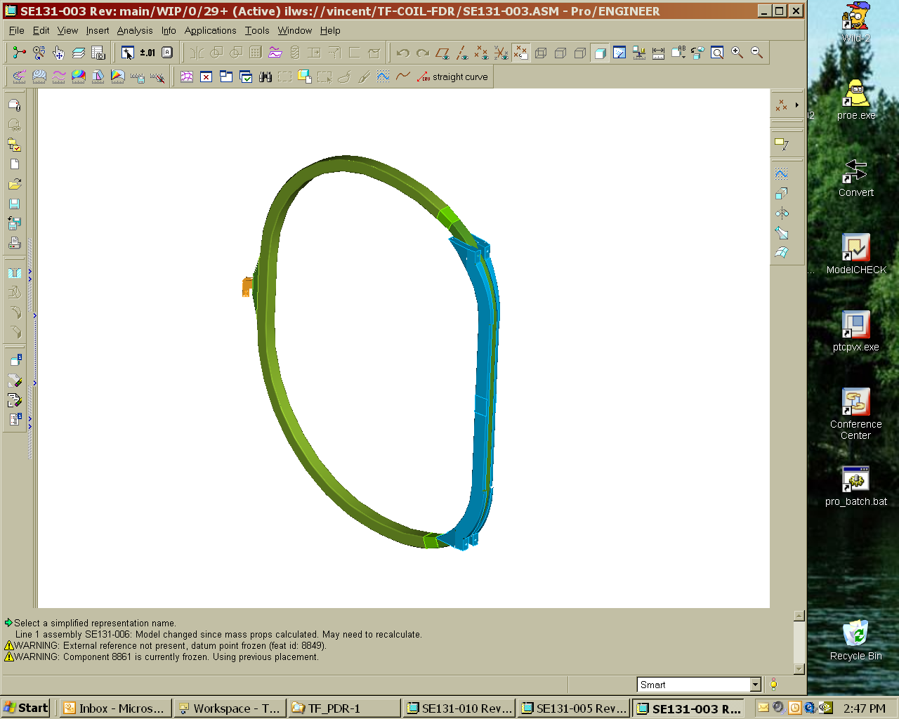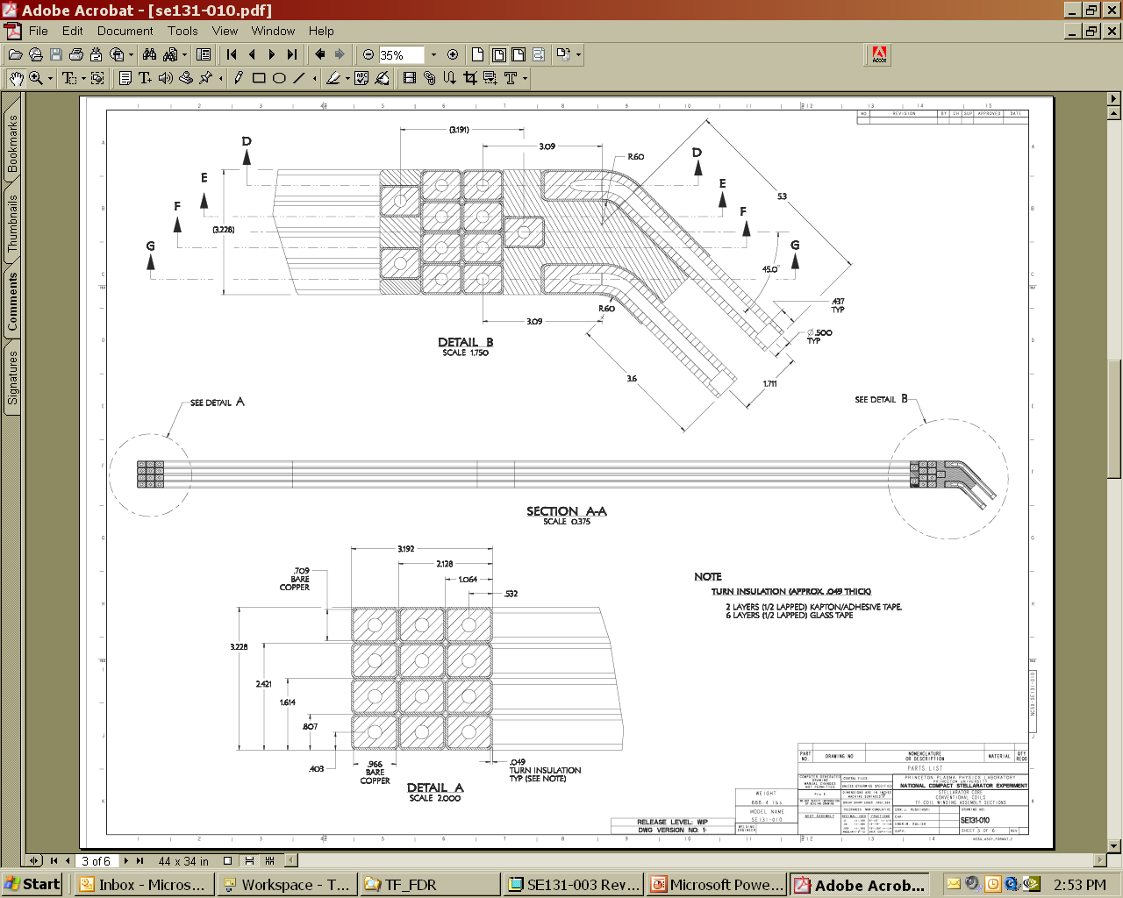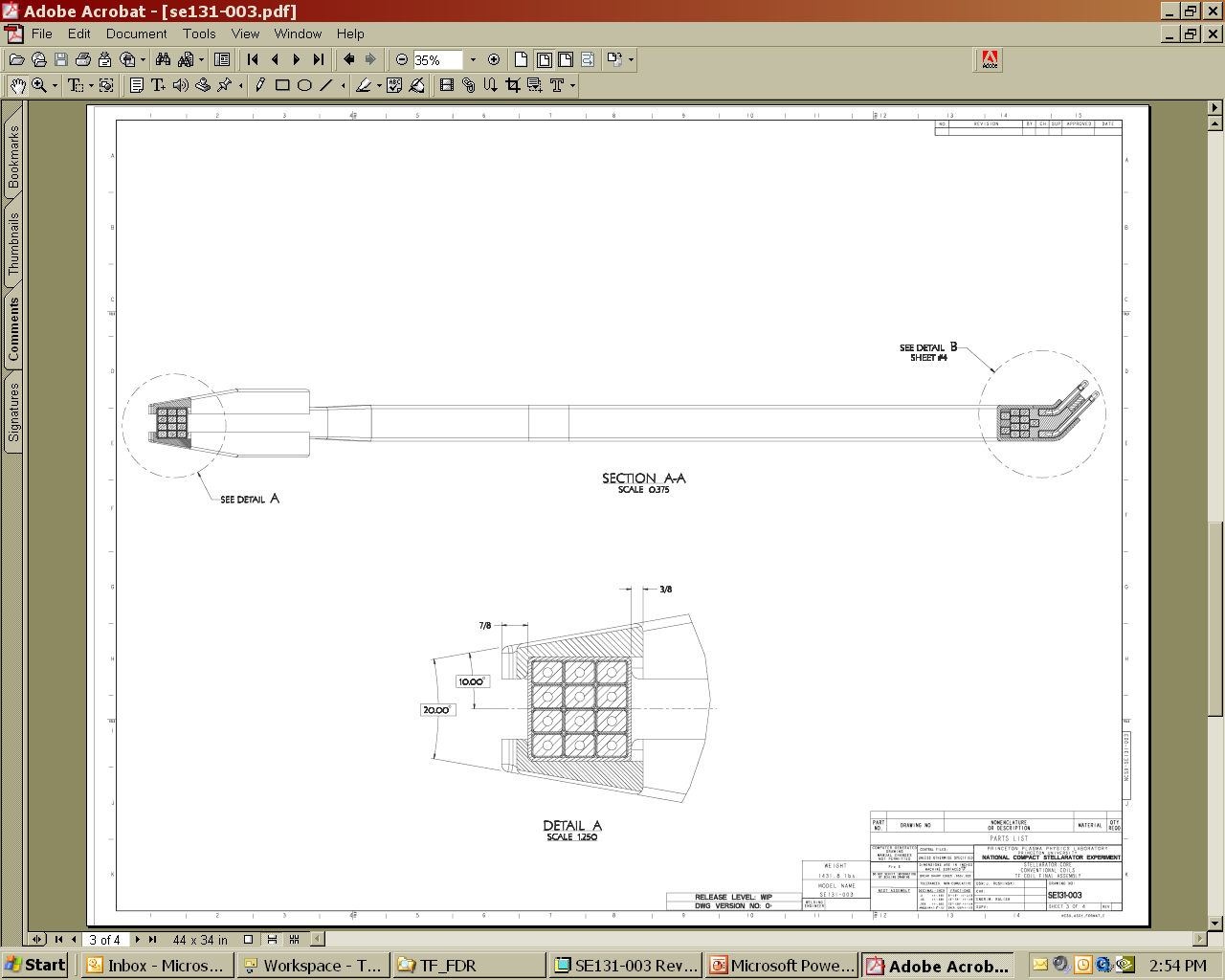
94”
124”
Figure 3- Toroidal Field Coil

Facilities and Work Stations
The Twisted Racetrack (TRC), Modular (MC) and Toroidal Field (TF) Coils are fabricated in the vacated TFTR Test Cell at D-site. The coil testing facility as well as the coil storage area is located in the Test Cell basement. The NCSX Coil Manufacturing Facility (CMF) has adequate climate control needed for comfort and tolerance control and crane capabilities. There are a total of six [7] workstations associated with the manufacturing of the MC, TRC and TF coils. The facility will from here on be identified as the “NCSX Coil Manufacturing Facility” (Figure 4-NCSX Coil Manufacturing Facility). The basement area will be identified as the NCSX Coil Test Facility and the NCSX Coil Storage Area.

Facilities Description

Crane Capacity
The manufacturing facility has an overhead trolley crane with (2) hooks.
Load capacity: Large hook- 110 Ton
Small hook/ 25 Ton

Climate Control
The coil manufacturing facility environment will be maintained at a constant 70 degrees F +/- 5 degrees with 50% relative humidity +/- 10%

Work Space
Test Cell has over 14,000 square feet of floor space that will be shared between the coil manufacturing facility, field period assembly activities plus the remaining neutral beams from TFTR. The coil winding facility will need a minimum of 3500 square feet of floor space.

Work Station Descriptions
Modular Coils: There are a total of [5] workstations associated with the production of the Modular Coils. Stations 1, 2, 4 and 5 are located in the Coil Manufacturing Facility (CMF). Station No. 7 is located in the basement.

Twisted Racetrack Coils: There are a total of [3] workstations associated with the production of the TRC. Stations 2 and 5 are located in the Coil Manufacturing Facility (CMF). Station No. 7 is located in the basement.

Toroidal Field Coils: There are [4] workstations associated with the production of the TF coils. Stations 3, 5 and 6 are located in the Coil Manufacturing Facility (CMF). Station No. 7 is located in the basement.

Station No. 1a & b- Winding Form Preparation and Post VPI
Modular Coils: [Winding Form Prep]: At this station [1a] the modular coil winding forms are mounted to the turning fixture support rings. The assembled MC form and support ring are then installed into the [1b] turning fixture. There the winding forms are inspected and cleaned. The poloidal break will be electrically tested and sealed, the coil clamp studs are welded in position, initial metrology and inspections performed and the inner copper cladding is installed.
[Post VPI]:Once the coil has been epoxy impregnated (VPI) at station 5, it will return to station 1b for cleanup, installation of final coil clamps and final room temperature electrical testing.

Stations 2 & 4- Coil Winding and Mold Preparation
Modular Coils: At these (2) stations the pre-insulated copper cable conductors are wound onto the stainless steel winding forms [castings]. Work at this station includes winding, adjusting the coil centroid using the Romer (CCM), the installation of the Groundwrap insulation as well as completion [brazing] of the coil leads. Once the Groundwrap has been completed, the outer chill plates, outer diagnostics, and “Bag Mold” are installed. These (2) stations are enclosed with a ceiling and walls to better control the cleanliness of the winding environment. The rooms are provided with positive pressure that may be utilized to reduce any outside contamination.

Twisted Racetrack Coil: At station 2 all winding form preparations as well as coil winding and post VPI activities will be performed on the TRC.

Station No. 3- Coil Winding and Mold Preparation
Toroidal Field Coils: At this station the TF coils are wound onto a winding mandrel using insulated extruded copper conductor. Work at this station includes application of turn insulation, conductor brazing, joint testing as well as completion of the coil leads. Once the coil has been wound, the coil is then moved to stands within the cleanroom, for application of the groundwrap insulation. The coil is then placed into a vacuum mold in preparation for VPI activities. This station is enclosed with a ceiling and walls to better control the cleanliness of the winding environment. The room is provided with positive pressure that may be used to reduce any outside contamination.

Station No. 5- Autoclave/VPI
This station is comprised of the autoclave [vacuum/pressure oven], epoxy mixing station and epoxy control/delivery manifold for performing the epoxy vacuum-pressure-impregnation of the TRC, MC and TF coils.

Station No. 6- TF Wedge Casting Assembly:
At this station a matching pair of stainless steel wedge castings is assembled to the TF Coil to make up the TF Coil Subassembly. This operation occurs after VPI is complete and the coil is cured therefore a clean room is not required. The wedge castings are adhered to the coil within a steel alignment fixture to precisely locate the mating surfaces of the castings with respect to the current center of the coils. Note: This will occur following any cold testing.

Station No. 7- NCSX Coil Test Facility
This station is located in the Test Cell basement. This facility will be used to electrically test the coils at liquid nitrogen temperatures to ensure their integrity.
Coil Exit
Station #6
TF Coil Casting Assy
Station #1a
MC Prep
Station #1b
MC Prep
Station #3
MfgTF Coils
Station #2
MC Mfg.
Station #4
MC Mfg.
Stat. #5
VPI

Future Field Period Assembly Area
Figure 4-NCSX Coil Manufacturing Facility

Manufacturing Inspection & Test/Quality Assurance Plan
The Manufacturing Inspection & Test/Quality Assurance Plans (MIT/QA) govern all manufacturing activities. These documents describe the steps required to successfully manufacture, inspect and test the NCSX coils. The (MIT/QA) plan document numbers NCSX-MIT/QA-142-01-01 (Modular Coils) and NCSX-MIT/QA-131-01-00 (TF Coils) identify procedures, test plans, Field Packages etc. necessary to complete the production of the NCSX coils.
Station No. 1 Winding Form Preparation station activities include:
-Mount WF to support ring-Clean & mold release WF
-Measure/inspect MC surfaces-Install winding clamps
-Install clamp studs-Install inner cladding

Manpower: 2 technicians per station

Station No.1
Casting Preparation

Two winding stations [2 & 4] will be used. Each station will include:
-Coil winding
-Ground wrapping
-Installation of chill plates
-Adjustment of coil centroid
-Installation bag mold
-Vacuum leak checking of bag
Manpower: 2. 5 technicians per station

Station #5 activities include:
-Install TRC Coil into autoclave
-VPI
-Cleanup
Manpower: 3 technicians per station

Station No.5
VPI/Autoclave
Station No.2
Winding/Molding
Station No.4
Winding/Molding
Station No.1
Post VPI
Cold test the Modular Coils [TC Basement]

Station No.7
Coil Testing
Station #1 [Post VPI] activities include:
-Transport VPI’d coil back to Station #2 turning fixture
-Install Final Coil Clamps
-Perform room temperature tests [Electrical]

Manpower: 2 technicians per station

Figure 5- Flow Plan for MC Fabrication -

Flow Plan of the Manufacturing Operations
Figure 5- Flow Plan for MC Fabrication -provides the general flow plan outlining the operation of this facility for the Modular Coils. Figure 6- Flow Plan for TRC Fabrication provides the general flow plan outlining the operation of this facility for the Twisted Racetrack Coil. provides the general flow plan outlining the operation of this facility for the Toroidal Field Coils.

Station #2 activities include:
-Mount WF to support ring-Coil winding/positioning
-Measure/inspect WF surfaces -Ground wrapping
-Install clamp studs-Final coil positioning
-Clean & mold release WF-Install chill plates
-Install winding clamps-Install bag mold
-Install inner cladding -Vacuum leak check bag

Manpower: 2 technicians per station

Station #5 activities include:
-Install TRC Coil into autoclave
-VPI
-Cleanup

Manpower: 3 technicians per station

Station No.5
VPI/Autoclave Station
Station No.2
-Winding Form Prep. -Coil Winding
- Install of Mold
Station No.2
Post VPI
Cold test the modular coil [TC Basement]

Station No.6
Coil Testing
Station #2 activities include:
-Transport VPI’d coil back to Station #2 Turning fixture
-Install Final Coil Clamps
-Perform room temperature tests [Electrical]

Manpower: 2 technicians per station

Figure 6- Flow Plan for TRC Fabrication

----------------------------------------------------------------------------------------------------------
Station #3 activities include:
-Coil winding
-Ground wrapping
-Installation of coil in mold
-Vacuum leak checking of mold

Station #5 activities include:
-Install TF Coil into autoclave
-VPI Coil
-Cleanup & Transport coil to next station

Station #7 activities include:
-Cold test the TF coil [TC Basement]
-Not every coil will be cold tested

Station No.5
VPI/Autoclave
Station No.6
TF Coil/ and Wedge Casting Assy
Station No.3
TF Coil Winding

Station No.7
Coil Testing
Station #6 activities include:
-Join wedge castings to the nose section of the TF coil
-Transport coil to storage

Figure 7- Flow Plan for TF Coil Fabrication

Responsibilities during Manufacturing
This section identifies by discipline, those individuals who staff the manufacturing facility. Figure 8-NCSX Coil Manufacturing Facility Organizational Chart is an overall organization chart for the Modular Coil Manufacturing Facility. The subsections, which follow, provide a brief description of each position on that organization chart.

Manufacturing Facility Manager
The Manufacturing Facility Manager is responsible for the overall operation of the NCSX Coil Manufacturing Facility and successful completion of the coils. Duties include managing the Field Supervisors, heading daily startup meetings and ensuring that both Integrated Safety Management (ISM) and risk management are incorporated in all aspects of the manufacturing activities.

Field Supervisors
The Field Supervisors (FS) report to the Manufacturing Facility Manager and are responsible for managing the lead technicians and field crews. FS may have a primary station responsibility as well as sharing the overall supervisory responsibilities. In addition they are responsible for ensuring that ISM and risk management are incorporated in all aspects of the manufacturing activities.

Lift Engineer
The Lift Engineer shall monitor and retain overall responsibility for the hoisting and rigging of Critical non-repetitive lifts.

Coil Test Director
This Coil Test Director is the engineer responsible for coordinating the testing of each coil in the Coil Test Station located in the Test Cell Basement.

Lead Technicians
The lead technicians are responsible for supervising the field crew activities at each workstation. They are also responsible for communicating all questions and/or concerns to the Field Supervisor filling the station log book on a daily basis and for ensuring that ISM and risk management are incorporated in all aspects of the manufacturing activities. The Lead Technician reports to the Field Supervisors.

Field Crews
The field crews report to the Lead Technicians and are responsible for performing the manufacturing activities as identified in the MIT/QA Plan and procedures to successfully complete the fabrication of the NCSX Coils. They are also responsible for ensuring that ISM is incorporated in all aspects of the manufacturing activities

Health Physics Representative
The Health Physics Representative is responsible for coordinating with the Field Supervisors all health physics issues associated with work being performed in the Coil Manufacturing Facility (Test Cell).

[Note: The Manufacturing Facility is located in a Radiation Controlled Area (RCA) requiring HP coverage to ensure that activities conform to PPPL HP policy.]

Industrial Hygiene Representative
The Industrial Hygiene (IH) Representative is responsible for reviewing and approving Job Hazard Analysis (JHA) surveys and issuing Confined Space Work Permits. He/she provides IH technical support to the field supervisors, lead technicians and field crews.

Construction Safety Representative
Coil Manufacturing Facility Manager
Jim Chrzanowski
Industrial Hygiene Representative
Health Physics (HP) Representative
PPPL Responsible Line Manager
Larry Dudek
NCSX WBS 14 Manager
Dave Williamson
NCSX WBS 13 Manager
Mike Kalish
Indicates a communication link, and not a management link between the participants
* Note: Designates primary station responsibility as well as sharing overall field management responsibilities.
Quality Control Representative
Dimensional Control/Metrology Representative (Stratton/Raftopoulos)
Field Supervisor *
Steve Raftopoulos

Field Supervisor *
Jim Chrzanowski

Station No. 1
Winding Form Preparation
(1) Lead Tech. + [1] crew
Station No. 2, 3 & 4
Winding stations
(3) Lead Techs + [4] crew
Station No. 5
VPI
(1) Lead Tech. + [2] crew
Field Supervisor*
Mike Kalish

Field Supervisor *
Tom Meighan

Station No. 6
TF coil/Wedge Cast.
(1) Lead Tech. + [1] crew

Figure 8-NCSX Coil Manufacturing Facility Organizational Chart

Dimensional Control/Metrology Representative(s)
The Dimensional Control and Metrology Representatives are responsible for defining ensuring that the centroid of the coil windings is located within the specified tolerance. These individuals define, guide participate and approve of the measurements performed during coil fabrication.

Construction Safety Representative
The Construction Safety Representative is responsible for reviewing and ensuring that all field activities are being performed safely and in accord with PPPL safety requirements. Responsibilities include working with field supervisors, lead technicians and field crews, making recommendations for types of safety equipment to be used and how to perform work more safely.

Quality Control Representative
QC shall work as an independent group, reviewing field activities to ensure that procedures are being followed and that necessary travelers and data sheets are completed in a timely fashion. The QC representative shall apprise the Field Supervisors and Manufacturing Facility Manager of any concerns.

General Facility Operating Guidelines
The following sections provide a brief overview of the operating guidelines for the NCSX Coil Manufacturing Facility.

Field Supervisors

Shall be appointed by the Manufacturing Facility Manager and will supervise all field operations. Additionally during the MC and TF Coil production, a Field Supervisor will be on duty in the NCSX Coil Manufacturing Facility during working hours.

House-Keeping/Cleanliness Rules
“Good House-Keeping” is an essential element to the success of the manufacturing of the modular coils. The following steps will be taken to enforce this practice.

No food, gum, smoking or beverage will be allowed in the NCSX Coil manufacturing facility. (Radiation Controlled Area “RCA”)

The coil winding and molding preparation stations [Work Stations #2-4] are housed in a clean environment with walls, ceiling and filtered airflow.

Only personnel associated with the coil manufacturing activities may enter Work Stations #2-4 unless approved by the Manufacturing Field Manager or Field Supervisors. Approved names will be posted outside each station.

Step-off pads will be used at the entrances of workstations 2-4, to minimize transport of foreign particulate and dirt into the work area. In addition, some sort of approved protection may be worn over street shoes such as booties or other approved foot coverage while in these areas.

It is recommended that lab coats or Tyvex suits be worn by the crew during the winding and molding operations.

Latex, rubber or cotton lint-free gloves will be required to be worn during the handling of insulated conductor, insulation, fillers or other components used in the construction of the modular coils.

The manufacturing stations will be cleaned daily by the coil work crew at the end of each shift.

Markers and Pencils:
The use of lead pencils or non-approved markers is prohibited in the fabrication stations. “Sharpie” permanent markers are the only markers that may be used without prior approval by the Field Supervisor.

Chips and Filings:
Extreme care must be taken when using files, grinders, etc. that could generate metal chips or filings. Surrounding areas must be protected from these activities. This type of work should be minimized near the coils whenever possible.

Hard hats
Hard hats are not required in the NCSX Coil Manufacturing Facility unless the facility crane is in use. The following rules shall be followed if the crane is in use:

NCSX Coil Winding Facility Hard Hat Rules
While the overhead crane is powered up (crane lights are on), all personnel under or within 5 feet of the BRIDGE of the crane MUST be wearing hard hats. This includes walking under the bridge to enter or exit the Facility.

If the crane is in a powered down mode (lights are off), but there is a load suspended from the crane, all personnel under the TROLLEY of the crane must be wearing hard hats.

Crane operators must sound horn when powering up the crane. The person responsible for the lift must perform a visual inspection to ensure that all personnel under the bridge of the crane don hard hats before the crane is operated. This includes checking ALL clean rooms if the bridge is over that area of the facility. If the crane bridge is moving through the facility, the person responsible for the lift must ensure that all personnel in the path are wearing hard hats before the crane travels.
The person in charge of the lift must also ensure that there are signs and/or barriers outside the facility indicating that the crane is in use, and that hard hats are required.

Station Logbook
Each workstation will have a “Station Logbook” that will be filled in on a daily basis by the Lead Technician. Entries will include technical data associated with that station, daily progress, as well as problems and solutions that may arise.

Daily Summary Report
A daily summary report, outlining the day’s activities, will be issued by the Field Supervisor on duty at the end of the shift. This report will briefly outline the day’s accomplishments as well as manufacturing issues he feels should be included. This report will be e-mailed to the NCSX project management. Note: These daily reports will begin once full production of the modular and TF coils starts.

Safety and Training Requirements

Integrated Safety Management (ISM)
ISM principles will be used throughout the coil manufacturing process. It is a “Common sense approach to Doing Work Safely”. There are seven guiding principles for safety management:

Line management responsibility for safety

Clear roles and responsibilities

Competence commensurate with responsibilities

Balanced priorities

Identification of safety standards and requirements

Hazard controls tailored to work being performed

Operations authorization

Job Hazard Analysis Surveys and Safety Meetings

JHA’s will be generated to identify existing or potential workplace hazards and to evaluate the risk of worker injury or illness associated with job tasks. (Reference document ESH-004 “Job Hazard Analysis”) The JHA’s will be reviewed by the IH representative for accuracy as well as completeness. It will be reviewed with all activity participants at the Pre-Job briefings.

Safety meetings will be conducted on a regular basis to ensure that the focus on safety is a foremost priority.

Safety Walk-Through’s
Daily safety walk-throughs will be performed by Industrial Hygiene, by Construction Safety and by field supervisors with the intention of identifying and correcting unsafe conditions or activities in the manufacturing area.

Training
Training of personnel is “Key” to completing the NCSX fieldwork safely. Courses will be required for all personnel, instructing them in the proper use of tools and equipment; personal protective equipment (PPE’s); and general laboratory policy and safety requirements. All personnel entering the Coil Manufacturing Facility must be Radiation Safety Qualified, must wear current radiation dosimetry, and must sign the Radiation Work Permit (RWP)/Access Log daily. Visitors may only enter if escorted by an individual RAD Safety qualified with a visitor’s radiation badge. A Coil Manufacturing training matrix identifies the training required for the individual working in the manufacturing facility.

Personal Protective Equipment [PPE’s]
The PPPL Industrial Hygiene and Construction Safety representatives will work together with the Manufacturing Facility Manager to identify the necessary and correct personal protective equipment needed to ensure a healthy and safe work environment for the work force.

Radiation Controlled Area:
The NCSX coil manufacturing facility is located in a Radiation Controlled Area (RCA). As a result, all personnel entering or working in the area must be radiation qualified, read and sign the RWP, or be escorted by a qualified escort.

Food and Beverage
No food, gum, or beverage is allowed in the Coil Manufacturing Facility because it is located in an RCA.

Emergency Response Procedure
In the event of abnormal conditions in the NCSX Coil Manufacturing Facility, procedure “D-NCSX-OP-EO-41” identifies what actions should be taken. Abnormal conditions are identified as conditions which, if not corrected, could result in injury to personnel or damage to equipment. All employees working in the coil manufacturing facility will be required to read the emergency response procedure.

Meetings and Communication
Communication between management and the field crews is essential to ensure a successful and cohesive working group. In addition to the meetings described below, other meetings may be held “as required” to keep the work crew informed of laboratory or safety related items.

Daily Startup Meetings
There will be a Daily Startup Meeting to review inter-actions, planning, scheduling, safety and commitments for all activities associated with the Coil Manufacturing Facility. Additional meetings will be held between shifts for the purpose of exchanging information.

Time: The meetings will be held in the AM Monday thru Friday prior to the start of field activities and will address the day’s scheduled activities.

Location: The meetings will normally be held in the WCC trailer conference room at D-site. Location of meeting may also be in the field.

Chairman: The Manufacturing Facility Manager (MFM) or his designee (Field Supervisor) will chair this meeting.

Attendees should include the MFM, Field Supervisors, Lead Technicians, Field Crews, Health Physics Representative, Industrial Hygiene Representative, Quality Control Representative and Construction Safety Representative. This list may change depending upon the tasks being performed that day.

Safety Meetings
There will be safety meetings typically every other week to discuss particular safety issues associated with the manufacturing of the modular coils and/or general safety related topics. (These meetings will commence once the production of the modular coils has begun)

Time: The meetings will be held at 11:00 AM every other Tuesday and will address safety issues.

Location: The meetings will generally be held in the WCC trailer conference room at D-site. However, they may be held in other areas as deemed appropriate for the topic being discussed.

Chairman: Either a safety representative or a field supervisor will chair the meetings, as required.

Attendees should include the Field Supervisors, Lead Technicians, Field Crews, Health Physics Representative, Industrial Hygiene Representative, Quality Control Representative and Construction Safety Representative. This list may change depending upon the topic of the meeting that day.

Pre-Job Briefings
Pre-job briefings are held prior to the start of any new work activity. The purpose of the briefing is to discuss specific work activities, responsibilities of the participants, a review of the JHA/safety issues, and to respond to all questions and concerns. In addition a review of post job briefings from previous, similar type operations may be appropriate. The participants at these briefings should include all individuals who will be involved with the activity including lead technician, field crews, and supervisors. Representatives from construction safety, Industrial Hygiene, Health Physics and Quality Control should be included as appropriate to the job.

Post-Job Briefings
A post-job briefing is held at the conclusion of a work activity. These briefings will be held at each station for every NCSX coil. The purpose of the briefing is to discuss the completed work activities. It should include lessons learned including technique problems, improvements and safety related issues. Minutes from the post job briefings will be kept and filed with the run copy of the procedure. This information will be shared as deemed appropriate at the pre-job briefing of the next similar type operation. The participants at these briefings should include all individuals involved with the completed activity or procedure. It should include the lead technician, field crews, and supervisors. Representatives from construction safety, Industrial Hygiene, Health Physics and Quality Control will be included as appropriate to the job.

Documentation

Document Control
All NCSX associated documents used for manufacturing the NCSX coils will be under NCSX Project document control. Any modifications to the procedures will be implemented using ENG-030.

Coil Field Package

Each coil will have a separate “Coil Field Package” that will follow the coil from station to station. It will include all of the process procedures, QC inspection reports, photographs, test results, and measurements used to document completion of major activities. The Field Package will be further discussed in the MIT/QA plan.

The Lead Technician, Field Supervisor and or Quality Control representative will document all critical completions in the procedure. This will be completed using the signer’s initials identifying the approver.

The signoffs in the procedures will be filled out in a timely fashion once a particular activity has been completed.

Documents Retention and Storage
If paper documents, they should be stored in the Ops Center. If electronic documents, they will be stored on the NCSX web site. Per the NCSX Docs and Records Plan, they need to be retained until the machine is dismantled and disposed.

Quality Assurance/Quality Control Requirements

Quality Control during Manufacturing
Quality control during the manufacturing process will be the responsibility of all parties involved in the manufacturing (Field supervisors, technicians, and Quality Control representative)

Measurements
Measurements and tests will typically be performed by the work crews and engineering. The QC representative should be made aware of planned tests and measurements, but unless required by the procedures, need not be present.

Other Quality Control Representative Responsibilities

The QC representative will review the field activities on a daily basis; checking for completion of documentation as well as compliance with the approved procedures.

The QC representative will be a required signature on the procedure verifying that the station activities have been completed and that the coil may move to the next station.

The QC representative will report to the laboratory appointed NCSX Quality Assurance representative. He/she will also inform the Coil Facility Manager of any issues or concerns that may be uncovered.

