6.3 Replace Port Flanges with Station 1 Assembly Flanges:

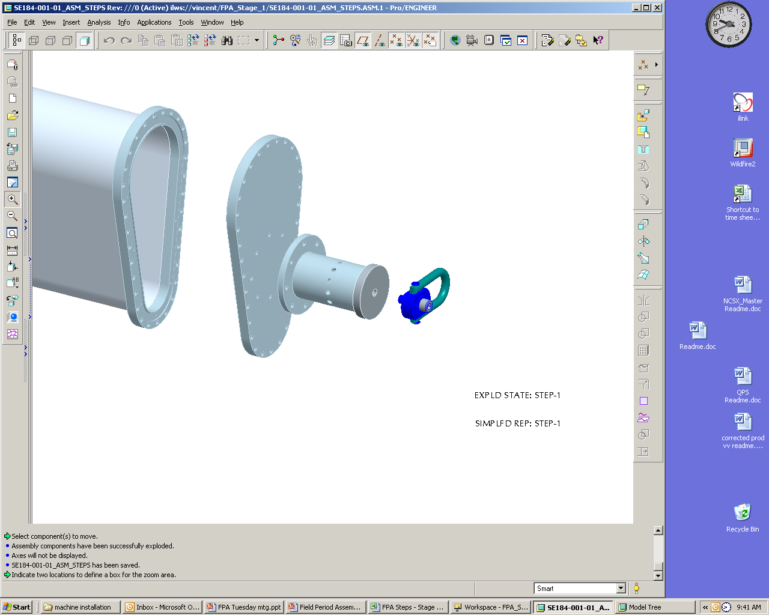
Support Axle Weldment
Hoist Ring
Stage 1 Port Horizontal Flange

Figure 1 Horizontal Flange

Heating/cooling cryostat interface flange (se123-164)
N.B. port flange
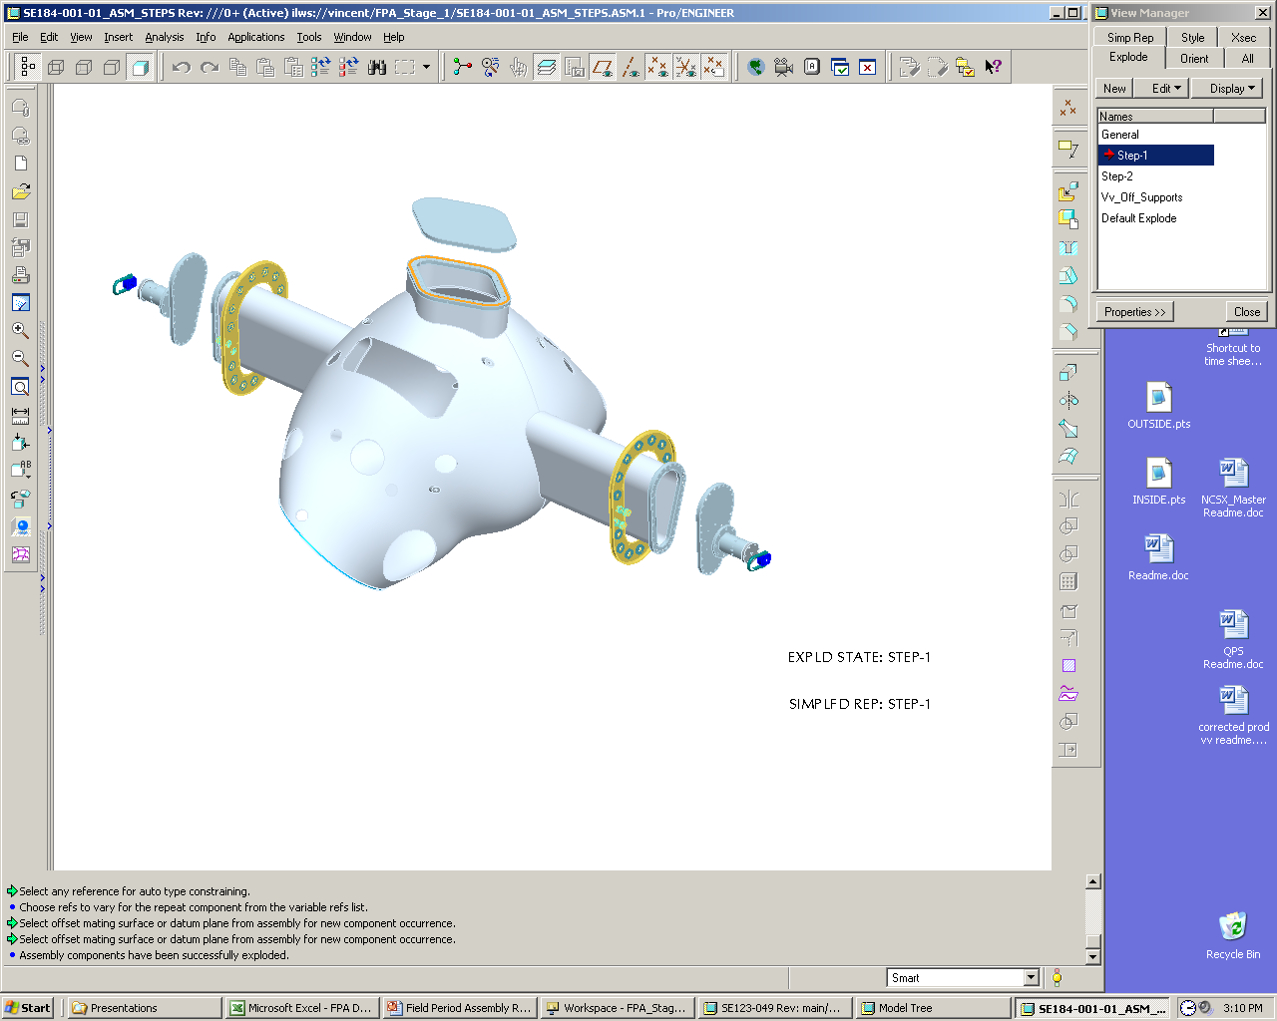
Stage one port
Assembly flange
Support Axle
Weldment

Hoist Ring
Figure 2 Heating and Cooling Cryostat Interface Flanges

6.4 Install VVSA in Station One Rotating Fixture:

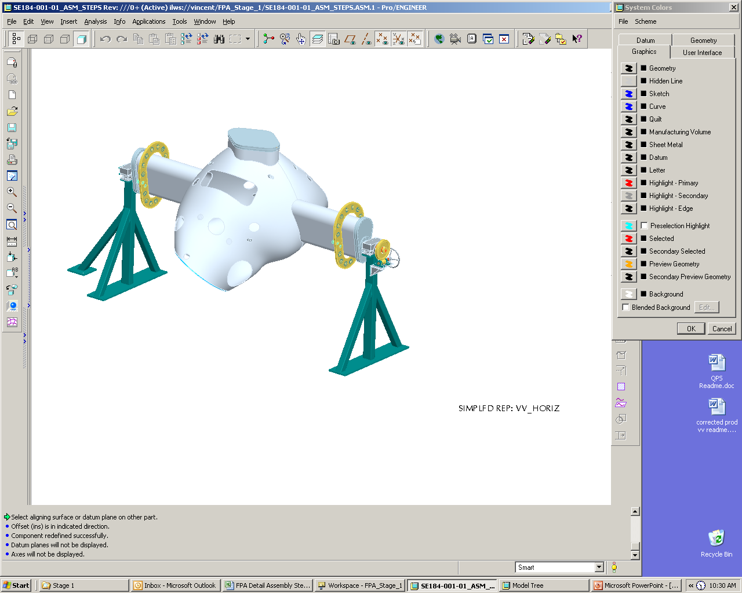

Figure 3 Vacuum Vessel in Horizontal Position

6.5 Metrology Set-up and Initial Vessel Measurements

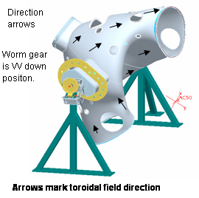
Figure 4 Arrow Mark Toroidal Field Direction
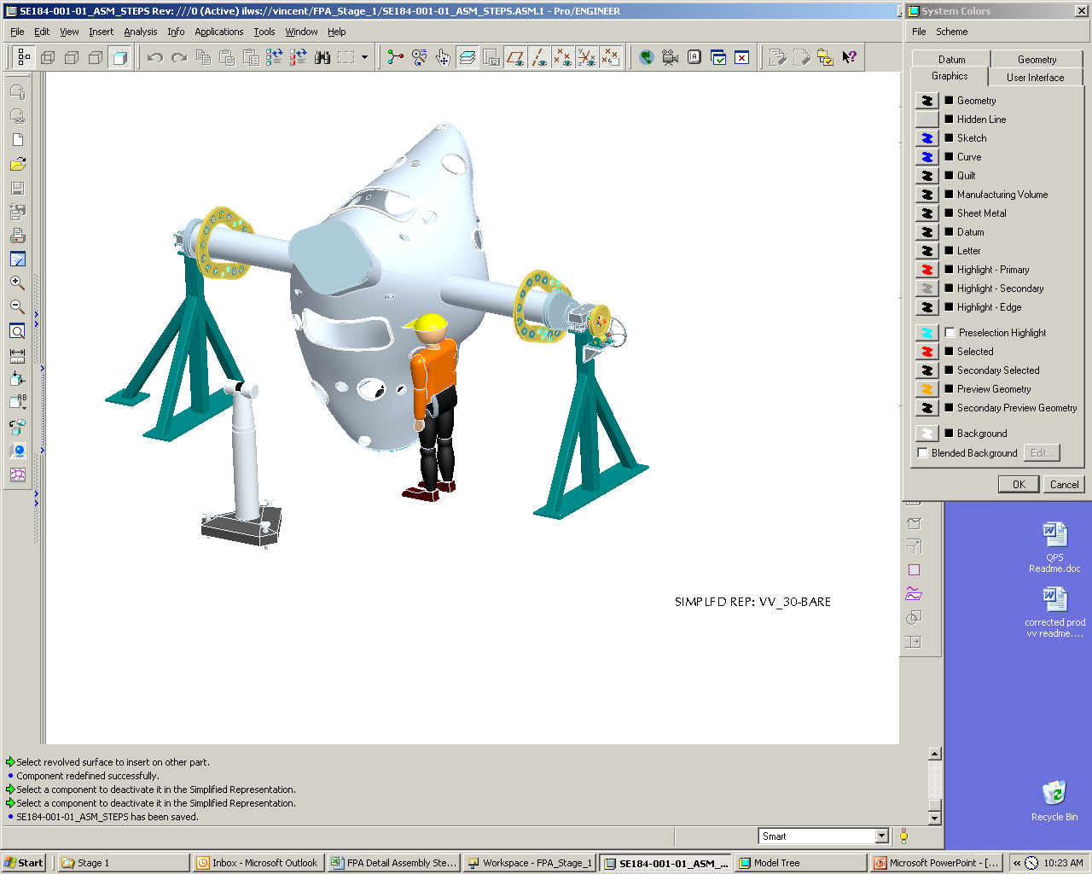

Figure 5 Vacuum Vessel in Rotated Position

6.6 Marking Flux Loop Template:

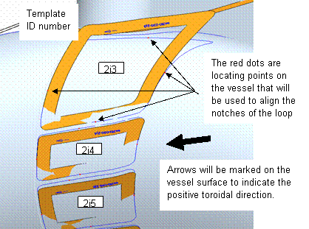
Figure 6 Template Locating and Numbering

Marking Heating Coolant Stud Locations:

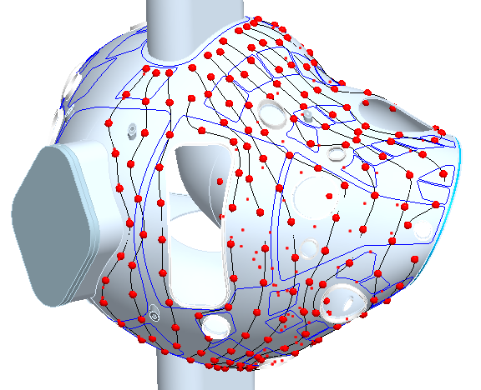

Figure 7 Overlays of the Coolant Lines over the Diagnostic Loops

6.8 Vertical Port Component Installation

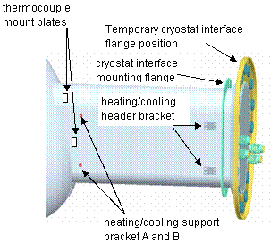

Figure 8 Cryostat Interface

6.8.5 Install 29 thermocouple mounting plates on port 12’s and vacuum vessel. See Figure 10 and SE121-004

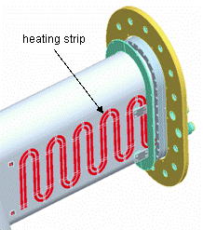
HBase Support Plate

Figure 9 Heating strip

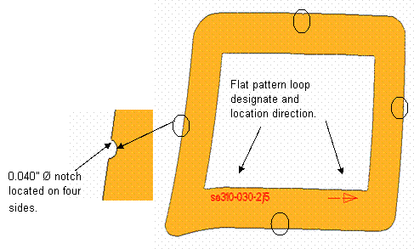
Figure 10 Installing Loop Templates

6.10 Installing of Magnetic Flux Loop

6.11 Final Loop routing and Measurement

6.12 Thermocouple installation

6.13 Installation of H/C lines

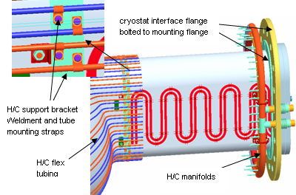:
Figure 11 H/C Support Brackets

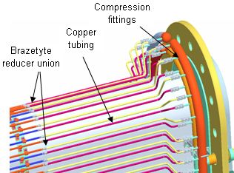

Figure 12 Hard Tube Installations

7. Completion of Activities at Station One:

Document Verification:
Verify that all pertinent data in the procedure tables 1, 2, 3, and Appendix A have been completed.

7.2 Field Package:
Ensure that all data sheets, photographs, QC inspection sheets, etc are included in the Field Package.

Approval:
Prior to releasing a VV from Station One it is required that the all-responsible individuals sign the release indicating that all processes at the station one have been satisfactorily completed. The release will include signatures from the Station Lead Technician, Field Supervisor and the QC representative.

All station one preparation activities including completion of appendix one and table 1, 2, 3, have been satisfactorily completed.

QC shall verify completion of documentation:
Quality Control Representative See Appendix A – Document Sign-off Record

The VV is ready for transfer to the VV station no. 3:
Lead Technician, Field Supervisor, and QC Representative See Appendix A – Document Sign-off Record

7.4 Preparing and Transferring Completed VV to Holding Area

7.4.1 Install the NB port temporary cover and NB angle support bracket. See Figure 16

7.4.2 Rotate VV to horizontal position. Secure in place by bolting down support axle cradle top support blocks and installing quick release pin.

7.4.3 Remove worm gear and install hoist rings.

7.4.4 Using lift procedure D-L-NCSX-997 remove completed VV from support stand and reposition to the vertical position with worm gear side of vessel in the down position.

7.4.5 While on the crane install base support plate. See Figure 15.

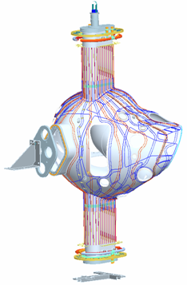
NB Port
Temporary
Cover

NB Angle
Support
Stage 1 Port Horizontal Flange

Figure 13 NB Angle Support Bracket and Base Support Plate

7.4.6 Position completed VV on Station 3 stand. See Figure 16.
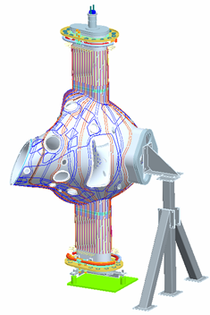
Stage 3 Support Stand
Worm gear

Figure 14 Stage 3 Support Stand

Appendix A. Document Sign Off

Vacuum Vessel Segment Identification

Segment Identification

Verified by: _________________________ Date: __________________
Lead Technician

4.1 Pre Job Briefing:

Pre Job Briefing Complete:
VV Field Supervisor Date

6.4.7 Rotating fixture secure:

Verified by: _________________________ Date: __________________
Lead Technician

6.4.8 Cg verification:

Verified by: _________________________ Date: __________________
Lead Technician

6.5.1 Arrows marked for toroidal field direction:

Verified by: _________________________ Date: __________________
Lead Technician

6.5.4 Best fit to Fiducials:

Measurements taken by: _________________________ Date:_______________

Measurements verified and /or approved by: __________________________________________Date:__________________

Metrology Engineer: ________________________ Date: ___________________

6.7.2 Heating/cooling studs:

Verified by: _________________________ Date: __________________
Lead Technician

QC Representative: ____________________________ Date:__________

6.8.3 Cryostat Interface Flange:

Verified by: _________________________ Date: __________________
Lead Technician

QC Representative: ____________________________ Date:__________

6.8.4 Heating/cooling header bracket

Verified by: _________________________ Date: __________________
Lead Technician

QC Representative: ____________________________ Date:__________

6.8.5 Thermocouple mounting plates:

Verified by: _________________________ Date: __________________
Lead Technician

QC Representative: ____________________________ Date:__________

6.8.6 Heating/cooling support brackets

Verified by: _________________________ Date: __________________
Lead Technician

QC Representative: ____________________________ Date:__________

6.8.7 Heating strips

Verified by: _________________________ Date: __________________
Lead Technician

QC Representative: ____________________________ Date:__________

6.8.7.1 Heating strips continuity and isolation test.

Verified by: _________________________ Date: __________________
Lead Technician

QC Representative: ____________________________ Date:__________

6.10.6 Loop Templates best fit to Model:

Measurements taken by: ________________________ Date: _______________

Measurements verified and/or approved by:

Metrology Engineer: ____________________________ Date: _______________

Physics Representative: ________________________ Date: ________________

6.10.8 Loop Continuity and resistance check:

Verified by: _________________________ Date: __________________
Lead Technician

QC Representative: ____________________________ Date:__________

6.11.4 Final Loop Measurements:

Measurements taken by: _______________________Date: _______________

Measurements verified and/or approved by:

Metrology Engineer: ___________________________Date: ________________

Physics Representative: _______________________ Date: ________________

    - Thermocouple electrical isolation and operation check.

Verified by: _________________________ Date: __________________
Lead Technician

QC Representative: ____________________________ Date:__________

6.13.3 Heating/cooling manifold

Verified by: _________________________ Date: __________________
Lead Technician

QC Representative: ____________________________ Date:__________

6.13.4 Heating/cooling tube stud torque:

Verified by: _________________________ Date: __________________
Lead Technician

QC Representative: ____________________________ Date:__________

6.13.5 Heating cooling hard tubing:

Verified by: _________________________ Date: __________________
Lead Technician

QC Representative: ____________________________ Date:__________

6.13.6 Leak Check Coolant Linen:

Verified by: _________________________ Date: __________________
Lead Technician

QC Representative: ____________________________ Date:__________

6.13.7 Heating/cooling tube stud re-torque:

Verified by: _________________________ Date: __________________
Lead Technician

QC Representative: ____________________________ Date:__________

7.3 Approval:

QC shall verify completion of documentation:

Quality Control Representative: _________________________ Date: ________

The VV is ready for transfer to the VV station no. 3:

Lead Technician: ___________________________Date:_________________

Field Supervisor: ___________________________ Date:_________________

Quality Control Representative: _________________Date:_________________
Table 1-Loop Installation Data For Field Period 1
Loop | Metrology | Initial | Template | Template | Loops | Loop | Loop | Continuity | Tagging | Comments
I.D. | Position | Points Located | Placed | Verified | Placed | Measured Length | Length Verified | Checked | Verified
AA1
CC3
CC5
D1
D3
D7
DD7
E1
E4
EE4
F2
F4
F6
F10
FF2
FF4
FF5
G7
GG1
GG3
GG5
GG9
GG11
H4
H8
Table 1-Loop Installation Data For Field Period 1
Loop | Metrology | Initial | Template | Template | Loops | Loop | Loop | Continuity | Tagging | Comments
I.D. | Position | Points Located | Placed | Verified | Placed | Measured Length | Length Verified | Checked | Verified
HH6
HH9
I7
JJ5
K2
K4
K7
K11
KK3
KK9
L6
L9
LL5
M2
M9
MM1
MM10
N3
N5
N6
N8
N9
NN4
NN8
NN11
Table 1-Loop Installation Data For Field Period 1
Loop | Metrology | Initial | Template | Template | Loops | Loop | Loop | Continuity | Tagging | Comments
I.D. | Position | Points Located | Placed | Verified | Placed | Measured Length | Length Verified | Checked | Verified
O6
OO5
OO8
P2
PP3
THO-1
THO-2
THO-3
THO-4
THO-5
TH180-1
TH180-2
TH180-3
TH180-4
TH180-5

Table 2 Loop Installation Data For Field Period 2
Loop | Metrology | Initial | Template | Template | Loops | Loop | Loop | Continuity | Tagging | Comments
I.D. | Position | Points Located | Placed | Verified | Placed | Measured Length | Length Verified | Checked | Verified
AA2
B2
C1
C4
CC4
D4
D5
DD2
DD5
E2
EE7
F8
F11
FF3
FF7
G1
G4
G9
GG10
H5
HH2
HH5
HH8
Table 2-Loop Installation Data For Field Period 2
Loop | Metrology | Initial | Template | Template | Loops | Loop | Loop | Continuity | Tagging | Comments
I.D. | Position | Points Located | Placed | Verified | Placed | Measured Length | Length Verified | Checked | Verified
HH10
I4
II1
II2
II3
II4
II5
II6
II7
II8
II9
J1
J2
J3
J4
J5
J6
J7
J8
J9
J10
JJ2
K5
KK11

Table 2-Loop Installation Data For Field Period 2
Loop | Metrology | Initial | Template | Template | Loops | Loop | Loop | Continuity | Tagging | Comments
I.D. | Position | Points Located | Placed | Verified | Placed | Measured Length | Length Verified | Checked | Verified
L1
L3
LL2
LL4
LL7
M4
MM5
N2
N7
NN1
NN3
O7
O10
OO8
PP4
THO-1
THO-2
THO-3
THO-4
THO-5
THO180-1
THO180-2

Table 3 Loop Installation Data For Field Period 3
Loop | Metrology | Initial | Template | Template | Loops | Loop | Loop | Continuity | Tagging | Comments
I.D. | Position | Points Located | Placed | Verified | Placed | Measured Length | Length Verified | Checked | Verified
B1
B4
BB3
CC2
D6
DD3
DD4
E3
E4
E5
F5
EE6
F9
FF1
FF9
G2
G8
GG6
H1
H3
HH4
H11
HH7
Table 3-Loop Installation Data For Field Period 3
Loop | Metrology | Initial | Template | Template | Loops | Loop | Loop | Continuity | Tagging | Comments
I.D. | Position | Points Located | Placed | Verified | Placed | Measured Length | Length Verified | Checked | Verified
I2
I8
JJ4
JJ8
K6
KK1
KK4
KK7
KK8
KK10
L2
L4
L8
LL8
LL10
M3
M7
M8
MM6
MM8
MM11
N10
O1
O4
O9
Table 3-Loop Installation Data For Field Period 3
Loop | Metrology | Initial | Template | Template | Loops | Loop | Loop | Continuity | Tagging | Comments
I.D. | Position | Points Located | Placed | Verified | Placed | Measured Length | Length Verified | Checked | Verified
O11
OO2
OO3
OO4
OO7
OO10
PP1
Q2
QQ1
THO-1
THO-2
THO-3
THO-4
THO-5
TH180-1
TH180-2
TH180-3
TH180-4
TH180-5

Table 4-Stud Installation Data
STUD | STUD | STUD | STUD | STUD RE- | STUD | INSPECTION | COMMENTS
# | LOCATED | PLACED | TORQUED | TORQUED | MEASURED
AA-1
AA-2
AA-3
AA-4
AA-5
AA-6
AA-7
AA-8
AA-9
AA-10
AA-11
AA-12
AA-13
AA-14
AA-15
AA-16
AA-17
AA-18
AB-1
AB-2
AB-3
AB-4
AB-5
AB-6
AB-7
AB-8
AB-9
AB-10
AB-11
AB-12
AB-13
AB-14
AB-15
AB-16
AB-17
STUD | STUD | STUD | STUD | STUD RE- | STUD | INSPECTION | COMMENTS
# | LOCATED | PLACED | TORQUED | TORQUED | MEASURED
AC-1
AC-2
AC-3
AC-4
AC-5
AC-6
AC-7
AC-8
AC-9
AC-10
AC-11
AC-12
AC-13
AC-14
AC-15
AC-16
AD-1
AD-2
AD-3
AD-4
AD-5
AD-6
AD-7
AD-8
AD-9
AD-10
AD-11
AD-12
AD-13
AD-14
AD-15
AD-16
AD-17
AD-18
AD-19
AD-20

STUD | STUD | STUD | STUD | STUD RE- | STUD | INSPECTION | COMMENTS
# | LOCATED | PLACED | TORQUED | TORQUED | MEASURED
AE-1
AE-2
AE-3
AE-4
AE-5
AE-6
AE-7
AE-8
AE-9
AE-10
AE-11
AE-12
AE-13
AE-14
AE-15
AE-16
AE-17
AE-18
AE-19
AF-20
AF-1
AF-2
AF-3
AF-4
AF-5
AF-6
AF-7
AF-8
AF-9
AF-10
AF-11
AF-12
AF-13
AF-14
AF-15
AF-16
AF-17
STUD | STUD | STUD | STUD | STUD RE- | STUD | INSPECTION | COMMENTS
# | LOCATED | PLACED | TORQUED | TORQUED | MEASURED
AF-18
AF-19
AF_20
AG-1
AG-2
AG-3
AG-4
AG-5
AG-6
AG-7
AG-8
AG-9
AG-10
AG-11
AG-12
AG-13
AG-14
AG-15
AG-16
AG-17
AG-18
AG-19
AG-20
AG-21
AG-22
AG-23
AG-24
AH-1
AH-2
AH-3
AH-4
AH-5
AH-6
AH-7
AH-8
AH-9
STUD | STUD | STUD | STUD | STUD RE- | STUD | INSPECTION | COMMENTS
# | LOCATED | PLACED | TORQUED | TORQUED | MEASURED
AH-10
AH-11
AH-12
AH-13
AH-14
AH-15
AH-16
AH-17
AH-18
AH-19
AH-20
AH-21
AH-22
AH-23
AH-24
AH-25
AH-26
AH-27
AH-28
AJ-1
AJ-2
AJ-3
AJ-4
AJ-5
AJ-6
AJ-7
AJ-8
AJ-9
AJ-10
AJ-11
AJ-12
AJ-13
AJ-14
AJ-15
AJ-16
AJ-17
AJ-18
STUD | STUD | STUD | STUD | STUD RE- | STUD | INSPECTION | COMMENTS
# | LOCATED | PLACED | TORQUED | TORQUED | MEASURED
AJ-19
AJ-20
AJ-21
AJ-22
AJ-23
AJ-24
AJ-25
AJ-26
AJ-27
AJ-28
AJ-29
AK-1
AK-2
AK-3
AK-4
AK-5
AK-6
AK-7
AK-8
AK-9
AK-10
AK-11
AK-12
AK-13
AK-14
AK-15
AK-16
AK-17
AK-18
AK-19
AK-20
AK-21
AK-22
AK-23
AK-24
AK-25
AK-26
STUD | STUD | STUD | STUD | STUD RE- | STUD | INSPECTION | COMMENTS
# | LOCATED | PLACED | TORQUED | TORQUED | MEASURED
AK-27
AK-28
AK-29
AK-30
AK-31
AK-32
AK-33
AL-1
AL-2
AL-3
AL-4
AL-5
AL-6
AL-7
AL-8
AL-9
AL-10
AL-11
AL-12
AL-13
AL-14
AL-15
AL-16
AL-17
AL-18
AL-19
AL-20
AL-21
AL-22
AL-23
AL-24
AL-25
AL-26
AL-27
AL-28
AL-29
AL-30
STUD | STUD | STUD | STUD | STUD RE- | STUD | INSPECTION | COMMENTS
# | LOCATED | PLACED | TORQUED | TORQUED | MEASURED
AL-31
AL-32
AL-33
AL-34
AM-1
AM-2
AM-3
AM-4
AM-5
AM-6
AM-7
AM-8
AM-9
AM-10
AM-11
AM-12
AM-13
AM-14
AM-15
AM-16
AM-17
AM-18
AM-19
AM-20
AM-21
AM-22
AM-23
AM-24
AN-1
AN-2
AN-3
AN-4
AN-5
AN-6
AN-7
AN-8
STUD | STUD | STUD | STUD | STUD RE- | STUD | INSPECTION | COMMENTS
# | LOCATED | PLACED | TORQUED | TORQUED | MEASURED
AN-9
AN-10
AN-11
AN-12
AN-13
AN-14
AN-15
AN-16
AN-17
AN-18
AN-19
AN-20
AN-21
AN-22
AP-1
AP-2
AP-3
AP-4
AP-5
AP-6
AP-7
AP-8
AP-9
AP-10
AP-11
AP-12
AP-13
AP-14
AP-15
AP-16
AP-17
AP-18
AP-19
AP-20
AP-21
STUD | STUD | STUD | STUD | STUD RE- | STUD | INSPECTION | COMMENTS
# | LOCATED | PLACED | TORQUED | TORQUED | MEASURED
AQ-1
AQ-2
AQ-3
AQ-4
AQ-5
AQ-6
AQ-7
AQ-8
AQ-9
AQ-10
AQ-11
AQ-12
AQ-13
AQ-14
AQ-15
AQ-16
AQ-17
AQ-18
AQ-19
AQ-20
AR-1
AR-2
AR-3
AR-4
AR-5
AR-6
AR-7
AR-8
AR-9
AR-10
AR-11
AR-12
AR-13
AR-14
AR-15
AR-16
AR-17
STUD | STUD | STUD | STUD | STUD RE- | STUD | INSPECTION | COMMENTS
# | LOCATED | PLACED | TORQUED | TORQUED | MEASURED
AR-18
AR-19
BA-1
BA-2
BA-3
BA-4
BA-5
BA-6
BA-7
BA-8
BA-9
BA-10
BA-11
BA-12
BA-13
BA-14
BA-15
BA-16
BA-17
BA-18
BB-1
BB-2
BB-3
BB-4
BB-5
BB-6
BB-7
BB-8
BB-9
BB-10
BB-11
BB-12
BB-13
BB-14
BB-15
BB-16
BB-17
STUD | STUD | STUD | STUD | STUD RE- | STUD | INSPECTION | COMMENTS
# | LOCATED | PLACED | TORQUED | TORQUED | MEASURED
BC-1
BC-2
BC-3
BC-4
BC-5
BC-6
BC-7
BC-8
BC-9
BC-10
BC-11
BC-12
BC-13
BC-14
BC-15
BC-16
BD-1
BD-2
BD-3
BD-4
BD-5
BD-6
BD-7
BD-8
BD-9
BD-10
BD-11
BD-12
BD-13
BD-14
BD-15
BD-16
BD-17
BD-18
BD-19
BD-20

STUD | STUD | STUD | STUD | STUD RE- | STUD | INSPECTION | COMMENTS
# | LOCATED | PLACED | TORQUED | TORQUED | MEASURED
BE-1
BE-2
BE-3
BE-4
BE-5
BE-6
BE-7
BE-8
BE-9
BE-10
BE-11
BE-12
BE-13
BE-14
BE-15
BE-16
BE-17
BE-18
BE-19
BF-1
BF-2
BF-3
BF-4
BF-5
BF-6
BF-7
BF-8
BF-9
BF-10
BF-11
BF-12
BF-13
BF-14
BF-15
BF-16
BF-17
STUD | STUD | STUD | STUD | STUD RE- | STUD | INSPECTION | COMMENTS
# | LOCATED | PLACED | TORQUED | TORQUED | MEASURED
BF-18
BF-19
BF-20
BF-21
BG-1
BG-2
BG-3
BG-4
BG-5
BG-6
BG-7
BG-8
BG-9
BG-10
BG-11
BG-12
BG-13
BG-14
BG-15
BG-16
BG-17
BG-18
BG-19
BG-20
BG-21
BG-22
BG-23
BG-24
BH-1
BH-2
BH-3
BH-4
BH-5
BH-6
BH-7
BH-8
STUD | STUD | STUD | STUD | STUD RE- | STUD | INSPECTION | COMMENTS
# | LOCATED | PLACED | TORQUED | TORQUED | MEASURED
BH-9
BH-10
BH-11
BH-12
BH-13
BH-14
BH-15
BH-16
BH-17
BH-18
BH-19
BH-20
BH-21
BH-22
BH-23
BH-24
BH-25
BH-26
BH-27
BH-28
BJ-1
BJ-2
BJ-3
BJ-4
BJ-5
BJ-6
BJ-7
BJ-8
BJ-9
BJ-10
BJ-11
BJ-12
BJ-13
BJ-14
BJ-15
BJ-16
BJ-17
STUD | STUD | STUD | STUD | STUD RE- | STUD | INSPECTION | COMMENTS
# | LOCATED | PLACED | TORQUED | TORQUED | MEASURED
BJ-18
BJ-19
BJ-20
BJ-21
BJ-22
BJ-23
BJ-24
BJ-25
BJ-26
BJ-27
BJ-28
BJ-29
BK-1
BK-2
BK-3
BK-4
BK-5
BK-6
BK-7
BK-8
BK-9
BK-10
BK-11
BK-12
BK-13
BK-14
BK-15
BK-16
BK-17
BK-18
BK-19
BK-20
BK-21
BK-22
BK-23
BK-24
BK-25
STUD | STUD | STUD | STUD | STUD RE- | STUD | INSPECTION | COMMENTS
# | LOCATED | PLACED | TORQUED | TORQUED | MEASURED
BJ-26
BJ-27
BK-28
Bk-29
BK-30
BK-31
BK-32
BK-33
BL-1
BL-2
BL-3
BL-4
BL-5
BL-6
BL-7
BL-8
BL-9
BL-10
BL-11
BL-12
BL-13
BL-14
BL-15
BL-16
BL-17
BL-18
BL-19
BL-20
BL-21
BL-22
BL-23
BL-24
BL-25
BL-26
BL-27
BL-28
BL-29
STUD | STUD | STUD | STUD | STUD RE- | STUD | INSPECTION | COMMENTS
# | LOCATED | PLACED | TORQUED | TORQUED | MEASURED
BL-30
BL-31
BL-32
BL-33
BL-34
BM-1
BM-2
BM-3
BM-4
BM-5
BM-6
BM-7
BM-8
BM-9
BM-10
BM-11
BM-12
BM-13
BM-14
BM-15
BM-16
BM-17
BM-18
BM-19
BM-20
BM-21
BM-22
BM-23
BM-24
BN-1
BN-2
BN-3
BN-4
BN-5
BN-6
BN-7
BN-8
BN-9
STUD | STUD | STUD | STUD | STUD RE- | STUD | INSPECTION | COMMENTS
# | LOCATED | PLACED | TORQUED | TORQUED | MEASURED
BN-10
BN-11
BN-12
BN-13
BN-14
BN-15
BN-16
BN-17
BN-18
BN-19
BN-20
BN-21
BN-22
BP-1
BP-2
BP-3
BP-4
BP-5
BP-6
BP-7
BP-8
BP-9
BP-10
BP-11
BP-12
BP-13
BP-14
BP-15
BP-16
BP-17
BP-18
BP-19
BP-20
BP-21
BQ-1
BQ-2
BQ-3
STUD | STUD | STUD | STUD | STUD RE- | STUD | INSPECTION | COMMENTS
# | LOCATED | PLACED | TORQUED | TORQUED | MEASURED
BQ-4
BQ-5
BQ-6
BQ-7
BQ-8
BQ-9
BQ-10
BQ-11
BQ-12
BQ-13
BQ-14
BQ-15
BQ-16
BQ-17
BQ-18
BQ-19
BQ-20
BR-1
BR-2
BR-3
BR-4
BR-5
BR-6
BR-7
BR-8
BR-9
BR-10
BR-11
BR-12
BR-13
BR-14
BR-15
BR-16
BR-17
BR-18
BR-19

Table 5 H/C/ Lines Installation and Leak Check Data

H/CLINE | FLEX LINE | HARD LINE | JOINT | LEAK | FLOW | COMMENTS
# | INSTALLED | INSTALLED | BRAZED | CHECKED | CHECKED
AA-1
AA-2
AB-1
AB-2
AC-1
AC-2
AD-1
AD-2
AE-1
AE-2
AF-1
AF-2
AG-1
AG-2
AH-1
AH-2
AJ-1
AJ-2
AK-1
AK-2
AL-1
AL-2
AM-1
AM-2
AN-1
AN-2
AP-1
AP-2
AQ-1
AQ-2
AR-1
AR-2

Table 5-H/C/ Lines Installation and Leak Check Data

H/CLINE | FLEX LINE | HARD LINE | JOINT | LEAK | FLOW | COMMENTS
# | INSTALLED | INSTALLED | BRAZED | CHECKED | CHECKED
BA-1
BA-2
BB-1
BB-2
BC-1
BC-2
BD-1
BD-2
BE-1
BE-2
BF-1
BF-2
BG-1
BG-2
BH-1
BH-2
BJ-1
BJ-2
BK-1
BK-2
BL-1
BL-2
BM-1
BM-2
BN-1
BN-2
BP-1
BP-2
BQ-1
BQ-2
BR-1
BR-2

