KRR-2005-002 July 12, 2005

To: L. Dudek, W. Reiersen, A. von Halle, M. Viola, R. Sheneman, T. Stevenson, J. Levine, G. Ascione, E. Perry, J. Graham, M. Awad, J. Anderson, M. Williams

From: Keith Rule

Subject: NSTX and NCSX Storage Issues

A meeting was held on June 28th to discuss the storage issues facing the NCSX and NSTX projects in the coming months and years. The results of this meeting were summarized in a previous memo which outlined the available options. Through subsequent discussions based upon the memo, e-mail responses, and a second meeting on July 8th, the following conclusions should provide for planned and organized storage of critical items.

We appreciate the cooperation and input provided by the addressees of this memo. We believe that continued dialogue and actions with regard to the OH rectifier room and D-site storage pad will add significant value to material handling and storage for the construction of NCSX. This will also provide for a reduced impact to the NSTX operations and any unforeseen repair or construction activities this project may encounter.

Attendees: Jerry Levine, Mike Viola, Wayne Reiersen, Larry Dudek, Spence Holcombe, and Keith Rule.

There are three main storage issues. They are the NB ion sources, NSTX center stack bakeout oven, and the NCSX coils (modular and TF).

- Storage of Ion Sources - There are four neutral beam ion sources that have not been opened and re-furbished since the conclusion of TFTR operations. These four sources will be stored on the NB mezzanine in the Mock-up building in preparation for future dismantling and re-build. All of the remaining 11 sources have been repaired, modified or used for parts in some manner. At any given time, there are 6-8 blue ion source enclosures that are not needed for research. These enclosures are empty. They do not contain the working parts of an ion source. They are mildly activated and may have very low-levels of tritium surface contamination. The enclosures have a flanged closure and are sealed. They will be stored in the Radioactive Waste Handling Facility. There is a need for storage of small ion source components that are highly contaminated. These will have to be packaged and stored in the TFTR test cell. Possible areas for storage may include the top of a neutral beam or on top of a labyrinth.

- Storage of the NSTX Center Stack Bakeout Oven – The best storage option for the oven is the C-site MG. This area can also be used for storage of a second smaller oven. Mounir Awad will be contacted for permission to store the ovens in this area.

ACTION: Keith Rule will contact Mounir Awad.

- Storage of NCSX Modular and TF Coils – Space along the north wall of the RWHF will be allocated for the storage of six modular coils and 18 TF coils. Approximately 500 square feet will be allocated. The bridge crane will be used to move the coils within the facility. Forklifts will be used to transport the coils to and from the facility.

OPEN ITEM

- OH Rectifier Room - This is an open item. We want to continue discussion for future use of this facility. This area contains a large number of orange electronics racks, old transformers and rectifiers, and various RF equipment from PLT/PBX. The potential storage area in this building exceeds 3,000 square feet of combined floor and mezzanine area. We are advocating the use of this facility as a satellite warehouse, for NCSX use, in preparation for construction in the test cell and other machine assembly items. The receiving #3 warehouse is at capacity and at present time, can only handle transitional receipt of materials.

- It is the general opinion of many, that most of the material in storage can be released for excess or stored in a better manner.
- The M&ES organization is willing to provide some labor resources to assist with these activities in conjunction with other project labor.
- M&ES is also willing to provide a rack system to improve the storage capability of this large room.

ACTION: Larry Dudek to contact Mike Williams about this suggestion.
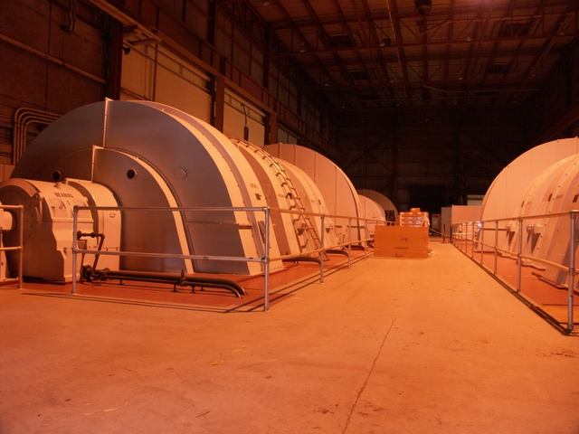
C- Site MG – Storage of oven
Need approval
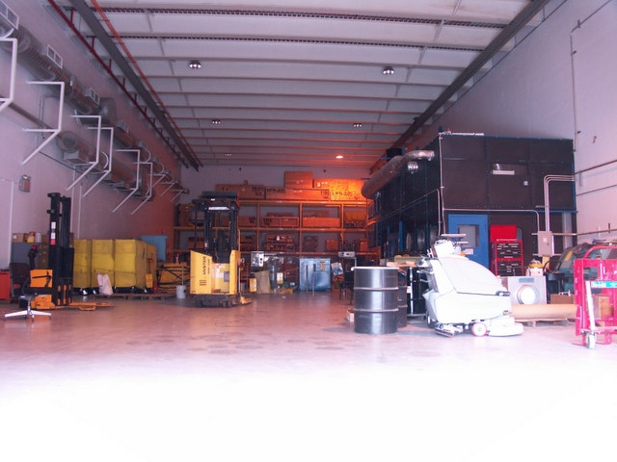
Area for NCSX coil storage
Radioactive Waste Handling Facility

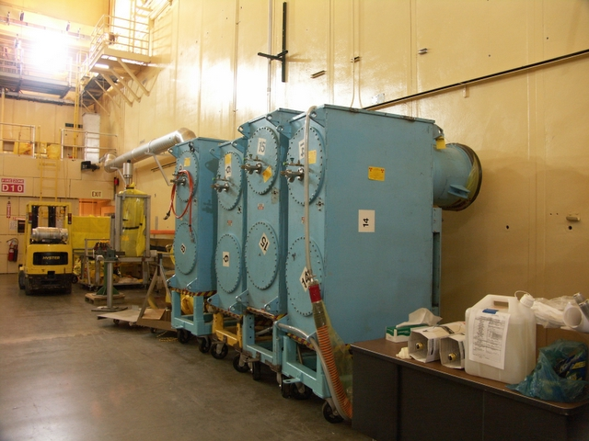
Current Ion Source storage along with other materials.
Sources will be moved to mezzanine.

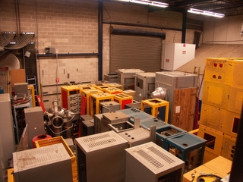
Floor area in front of mezzanine – OH Rectifier

Materials in storage in OH Rectifier Room


