September 21, 2001

Dr. Charles R. Finfgeld
Stellarator Program Manager
U.S. Department of Energy
Office of Fusion Energy Sciences, SC-55
19901 Germantown Road
Germantown, MD 20874-1290

Dear Dr. Finfgeld:

NCSX Milestone Report

This letter reports completion of the last FY-2001 milestone identified in the NCSX Program Execution Agreement. The milestone, “Update NCSX Machine Configuration,” was completed this month, on schedule. This letter also includes a progress report on the disposition of the PVR recommendations, one of which called for careful reconsideration of the size of NCSX. Because size is an important issue for the configuration design, this recommendation and the September milestone are tightly linked.

Updated Machine Configuration

This configuration update occurs at a point in time about midway between the March, 2001, Physics Validation Review and the Conceptual Design Review planned for April, 2002. Tool developments and design studies since the PVR have resulted in significant design improvements. Better access and more space have been provided for heating, diagnostics, in-vessel hardware, and maintenance, consistent with physics requirements for plasma properties and flexibility. The updated machine configuration consolidates the gains that have been made and will be the basis for the next phase of design development in preparation for the CDR.

The coil design developments since the PVR are summarized in the following table:

 | Current  Sept., 2001 | PVR  March, 2001 | Comment on current design
Number of modular coils / coil shapes | 18 / 3 | 21 / 4 | Lower cost, better access, more consistent with required physics properties and flexibility.
Symmetry planes containing coils | none | v = 0 | Allows tangential NBI access without extended coil.
Number / location of TF coils | 18 / centered on modulars | 21 / between modulars. | Better access.
Number of PF coil pairs | 5 | 4 | Provides required physics flexibility, Ohmic volt-seconds.

A modified vacuum vessel shape will enlarge the interior volume, including space specifically provided for an inboard radiofrequency wave launcher and a divertor. A modification to accommodate Thomson scattering on the v=1/2 symmetry cross section will be incorporated.

The size (1.4 m major radius) and baseline heating configuration (3 MW of NBI) will be kept the same, as explained in Attachment 1.

The configuration design will continue to evolve as understanding improves. Expected changes include: 1) the modular coil geometry will be perturbed by small displacements to eliminate islands once the design tools are fully tested, 2) coil-to-coil and coil-to vessel spacings will be increased locally to resolve interferences, 3) the vacuum vessel segmentation will be optimized for assembly, and 4) the PFC configuration will be optimized for compatibility with a range of plasma configurations. Nonetheless, the main architecture of NCSX is now established, providing a point of departure for conceptual design development.

Progress on PVR Recommendations

The Physics Validation Review panel report included 29 recommendations requiring follow-up by the project. The plan that the project and OFES developed for dispositioning these recommendations called for a progress report at this time. We provide this in the form of a series of attachments, including expanded progress summaries for certain items.

The attachments are:

Attachment 1. NCSX Size and Heating Requirements. Addresses recommendations II-2 (machine size) and IV-1 (baseline heating power).

Attachment 2. Stellarator Program Coordination Issues. Addresses recommendations II-1 (3D physics leadership), II-3 and V-2 (reactor studies), II-6 (stellarator interrelationships), V-1 (inclusive management), and V-3 (decision process).

Attachment 3. Diagnostic Integration. Addresses recommendations II-5 and IV-8 (physics program-diagnostics linkage) and generally integrating diagnostics with the machine.

Attachment 4. PIES Update. Addresses progress on recommendation III-5 (flux surfaces) and generally developing PIES as a design tool.

Attachment 5. NCSX PVR Recommendations Tracking Log. Briefly summarizes plans and current status of all 29 recommendations.

In summary, the project is making steady progress in resolving the issues raised by the PVR committee. The progress to date is commensurate with the overall project schedule and the schedule for closing out the individual PVR recommendations.

Sincerely,

G. H. Neilson
NCSX Project Manager

xc:
J. Lyon, B. Nelson, ORNL
R. Goldston, R. Hawryluk, P. Heitzenroeder, W. Reiersen, J. Schmidt, M. Zarnstorff, PPPL
G. Pitonak, DOE/PAO
W. Marton, J. Willis, DOE/OFES

Attachment 1. NCSX SIZE AND HEATING REQUIREMENTS
September, 2001

1. Introduction

The choice of the NCSX machine size (major radius) is an important decision that balances project cost with experimental performance. The Physics Validation Review committee expressed a concern that the size is too small, citing examples of parameters considered to be marginal. They also had a concern that critical parameters were being fit to a predefined budget envelope. The committee recommended that the project give continued attention to this issue and carefully justify its choices.

Since the PVR, the project has been working toward a goal of producing an updated machine configuration design that will be the basis for developing the design for the planned April, 2002, Conceptual Design Review (CDR). If a change in the overall size were to be made, now would be the most convenient time to make it. However, increasing the size would certainly raise the project cost above the $65M target (corresponding to $55M in FY-1999 dollars) that the project and PPPL management established. The more attractive course is, if at all possible, to resolve the committee’s concerns in ways that do not require enlarging the machine or increasing the project cost. The project is pursuing this course.

Concerns about neutrals penetration and small plasma-to-PFC spacing are being addressed by optimizing the vacuum vessel to increase plasma-facing component (PFC) space availability. A new design concept has been developed that will significantly increase the interior volume and permit a wider range of PFC options, such as divertor plates and baffles, for neutrals control. Encouraged also by recent successes in W7-AS divertor experiments, the project is now focussing on optimizing the PFC configuration design within the expanded vacuum vessel volume, including compatibility with needed plasma shape flexibility, as its neutral particle control strategy.

With regard to concerns about confinement assumptions, heating power, and neutral beam ion losses we have reviewed the analyses presented at the PVR for the R = 1.4-m design point. Performance can be measured in terms of the capability to access regimes of simultaneously low collisionality and high beta. In this regard we continue to believe that the 1.4-m design is adequate, though marginally so as the committee stated. Rather than enlarging the machine, we have instead pursued approaches that are more attractive from a cost-benefit point of view to boost confidence in the adequacy of the projected performance of the 1.4-m design. One, prospects for neutrals and plasma density control have improved because of W7-AS results and design improvements mentioned above. Two, coil design tools have improved, making it possible to maintain low ripple while improving other design metrics such as access and fabricability. Three, coil and vacuum vessel design improvements have produced better access for both neutral-beam and radiofrequency heating systems, expanding the possibilities for heating upgrades beyond the initial 3 MW of NBI, should they become necessary.

In summary, the new NCSX machine configuration that is being developed for the CDR is a significant improvement over the PVR design. It is likely that the size-related concerns raised at the PVR will be resolved without increasing the device size or baseline heating power. Given that, increasing the size and cost at this time is not justified.

2. Confinement and Heating Power

Confinement analysis is performed to establish requirements that give adequate assurance that the NCSX experiment can achieve the goal of testing the beta limits in a collisionality regime of interest. The calculated beam-orbit losses have been taken into account in the analysis. The main conclusions of this work, which was documented in Sect. 8.2 of the PVR document, are summarized here.

Figure 1b shows that with 3 MW injected and with H_{ITER-97P} = 1 and H_{ISS-95} ≈ 2.9, it is possible to reach ⟨β⟩ = 3.5% at relatively high collisionality, ν_{i}* = 1, or a lower beta ⟨β⟩ = 2.7% at low collisionality, ν_{I}* = 0.25 (the target value). Given the flexibility of the coils to move stability boundaries in beta (confirmed by post-PVR analysis with the latest coil design), the conditions accessible with 3 MW should be enough to complete some tests of beta-limit predictions. These same H factors produce the target ⟨β⟩ = 4.0% at low collisionality, ν_{i}* = 0.25 if the NBI heating power is increased to 6 MW. The design accommodates this possibility as an upgrade. In fact, NBI access has improved as a result of coil design changes that eliminate coils from the v = 0 symmetry plane. High-power (up to 6 MW) mode conversion radiofrequency heating can also be accommodated now due to a design modification to allow installation of a high-field-side launcher. The need and optimum configuration for heating upgrades will be determined by initial results with the baseline 3 MW NBI system.

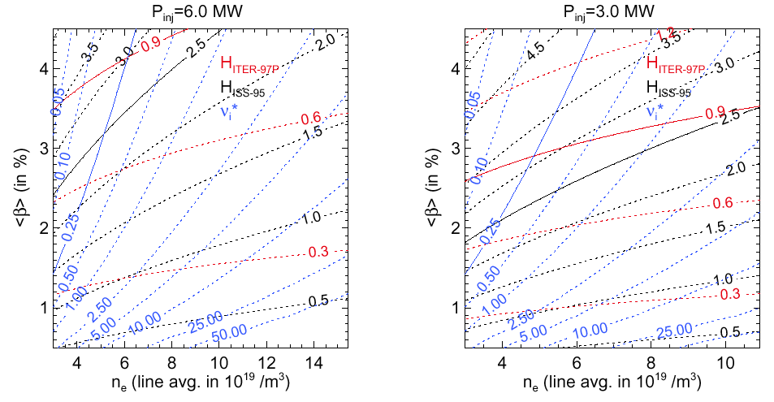
Figure 1. Contours of constant H_{ITER-97P}, H_{ISS-95} and collisionality ν*=0.25 for (a)Pinj = 6 MW and (b) Pinj = 3 MW.

It is important to note that machine size variations are a relatively weak factor in determining the achievable collisionality-beta range. Figure 2 shows the effects of machine size and magnetic field variations. The H-factors required to reach a given collisionality and beta are insensitive to size if B0×R0 is kept constant, which approximately corresponds to keeping the neutral-beam orbit loss fraction constant. Thus, a larger machine would not improve collisionality-beta performance, although it would reduce the minimum useful magnetic field to a lower value.

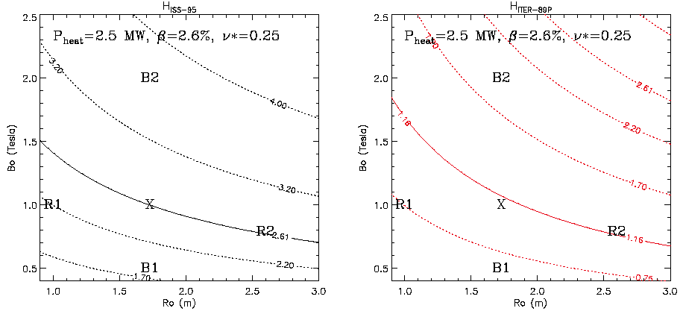
Figure 2. Contours of constant (a)H_{ISS-95} and (b)H_{ITER-97P} for constant Pheat, ν*, and β.

3. Neutral Penetration

An important requirement for the NCSX design is that the neutrals generated at the plasma boundary do not penetrate too far into the plasma discharge for a reasonable range of operating parameters. Deep penetration of the neutrals could lead to an unacceptable energy loss channel. To address this issue the DEGAS 2 code was used to model the neutral penetration, first with recycling occurring at an outboard limiter and then, with the recycling occurring at a divertor baffle. This modeling effort was documented in Sect. 11.8 of the PVR document. Figures 3 and 4 summarize the results. Figure 3 models a neutral source at the outboard mid-plane and in Figure 4 the source is at the banana tips. If the plasma is limited at the midplane, the scale lengths for both the neutral density and the ion source rate in front of the mid-plane limiter are about 0.8 cm. The neutral density at the magnetic axis is roughly 10-3 of the peak value for the midplane limiter configuration. For case with the neutral source at the banana tip the neutral density and ionization source at the magnetic axis are effectively equal to zero. Thus, it is very important to ensure that recycling occurs at the banana tips and not the mid-plane. This is the project’s design objective.

Neutrals control in NCSX looks promising when compared with the recent experimental results on W7-AS [P. Grigull, EPS 2001]. The W7-AS has only about ~18 cm diameter in the midplane of the bean-shape cross-section (vs ≥24 cm in NCSX) and has, nevertheless, achieved excellent plasma performance with the island divertor operation. In particular, density control and plasma collapse which used to be a problem in W7-AS before the installation of the divertor, has been solved due to a combination of recycling control and particle confinement. It appears that the divertor plates and baffles provide the needed neutrals control at the source so that the neutral penetration at the midplane should not be a machine size determinant but careful design of the PFC configuration and location are important for neutral control. We are taking this approach to developing the conceptual design. An initial assessment of the space available for implementing such a divertor on NCSX is encouraging.

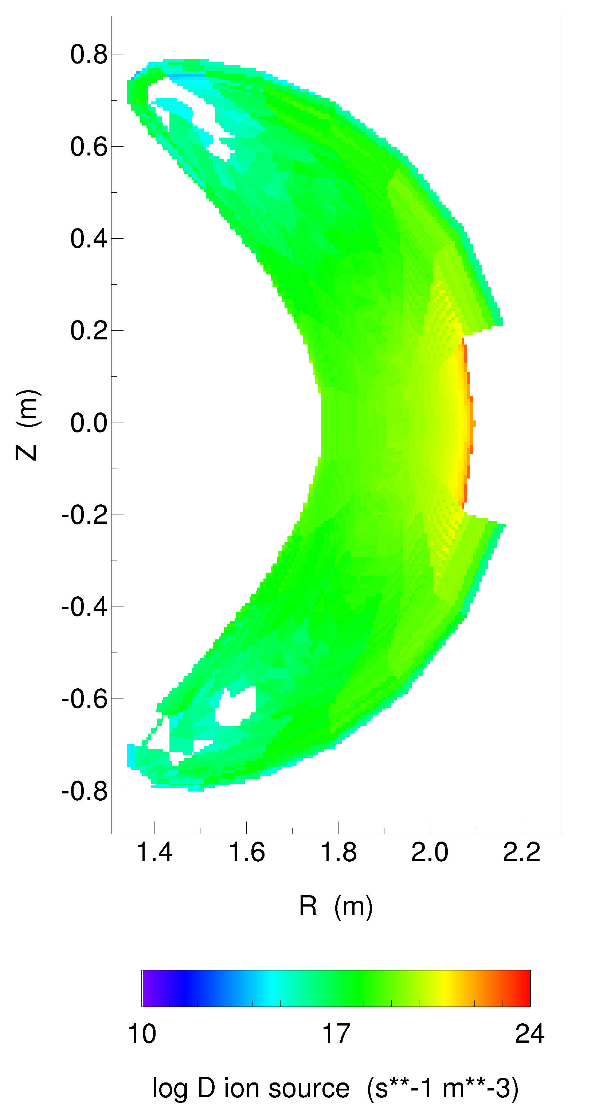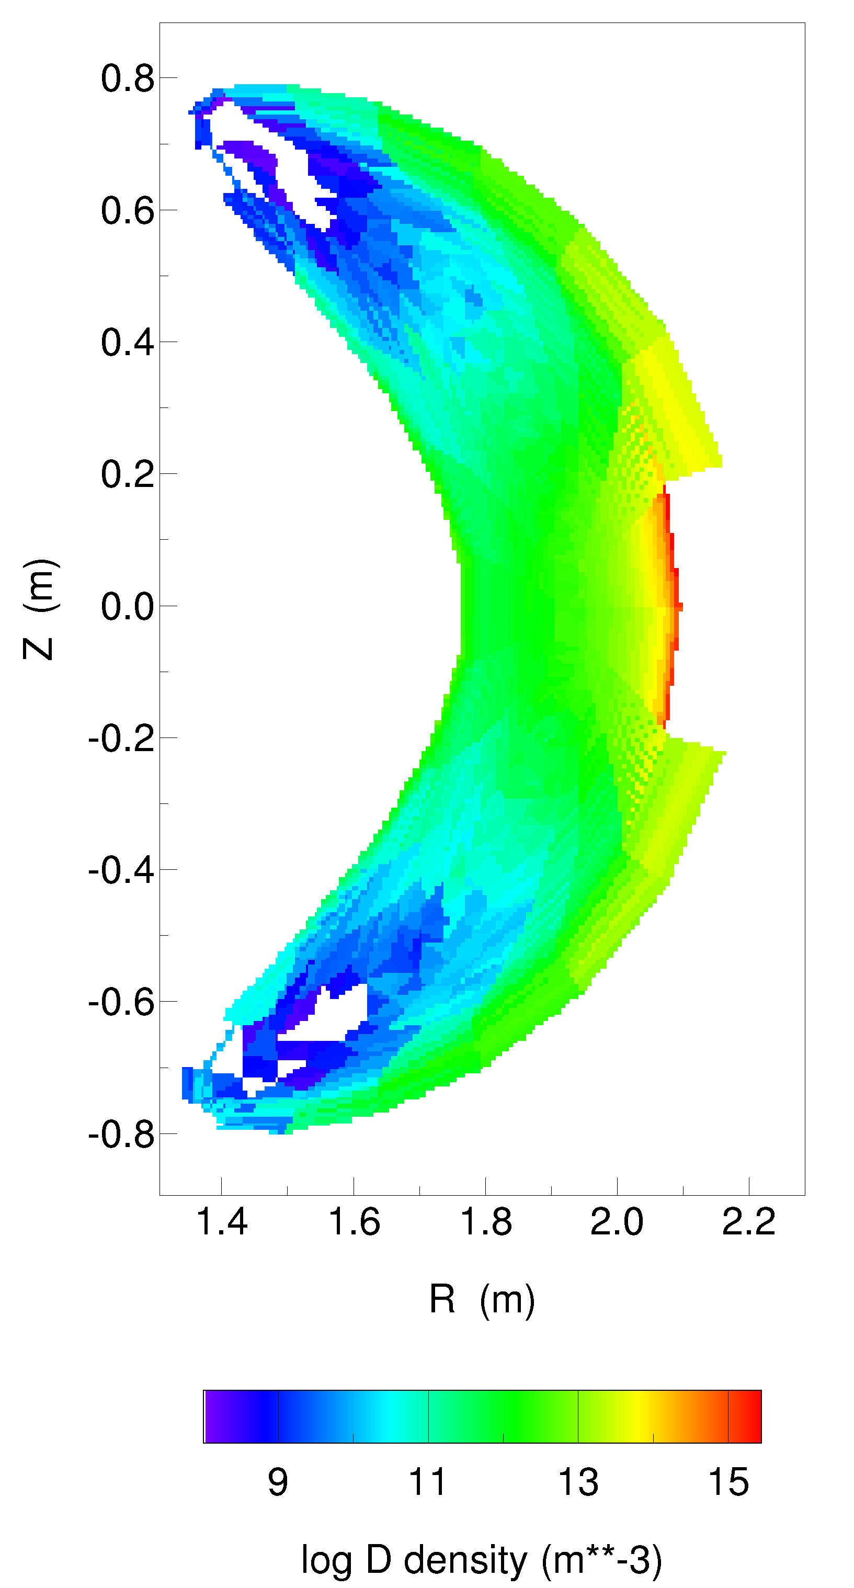
Figure 3. Two-dimensional plots of the log of the neutral atom density and the ion source rate obtained with recycling at an outboard limiter. To facilitate computation of the logarithm, factors of 10⁹ and 10¹⁰, respectively, were first added to the data
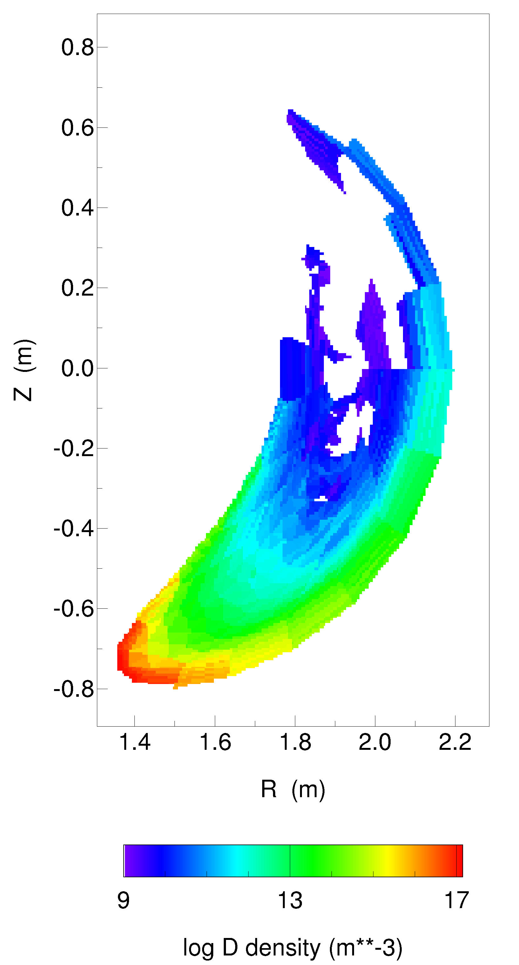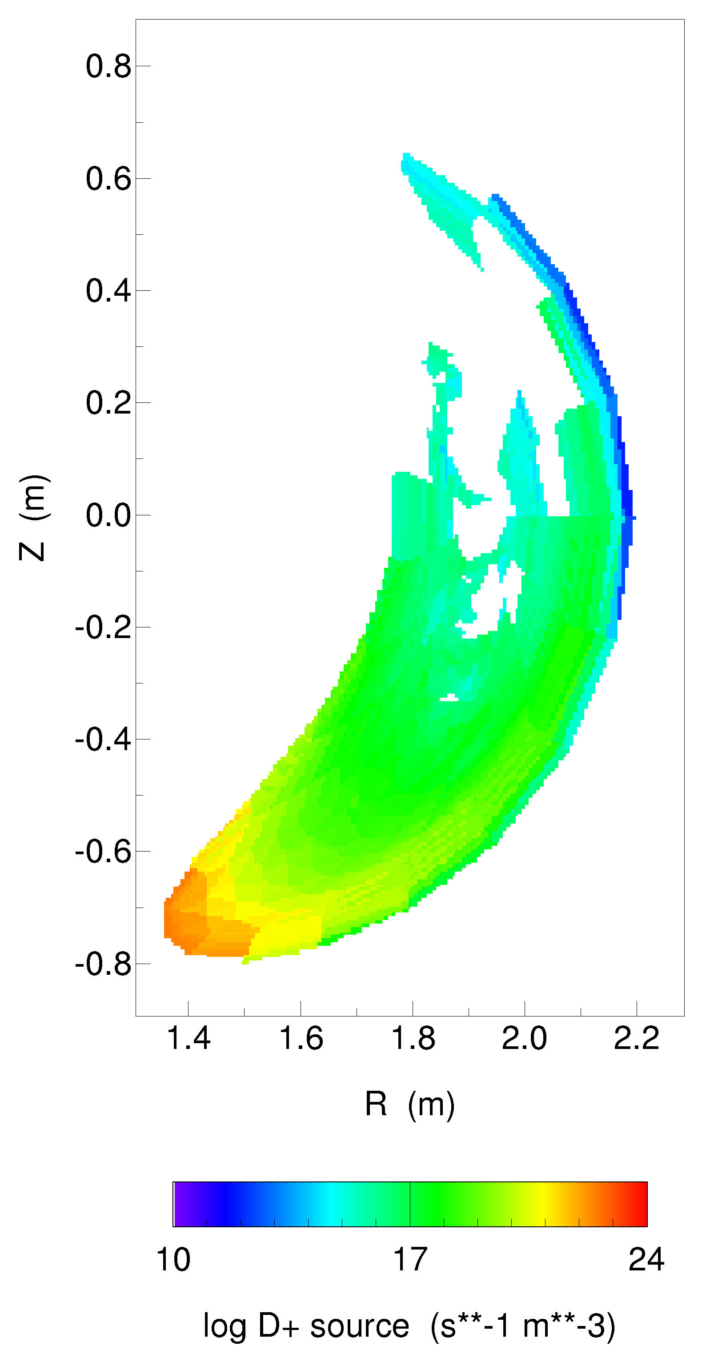
Figure 4. Two-dimensional plots of the log of the neutral atom density and the ion source rate obtained with recycling at lower divertor. To facilitate computation of the logarithm, factors of 10⁹ and 10¹⁰, respectively, were first added to the data

4. Beam Orbit Confinement

Beam injected ion orbit confinement is generally an issue for experiments the size of NCSX. In addition, the unique symmetry of NCSX may impact high energy ion orbit characteristics. For this reason orbit analysis has received special attention as part of the NCSX design process. This work is documented in Sect. 7.3 of the PVR documentation.

Figure 5 summarizes the beam ion loss studies. Beam deposition has been modeled using axisymmetric models with the plasma cross-section of the tangency cross-section in the actual geometry. Beam ion dynamics have been modeled using the actual 3D equilibrium. The loss of injected energy is significant but not prohibitive. The confinement studies have taken these losses into account in projecting operating points. Thus, while a larger machine would increase the operating range in magnetic field and in density (for limiting collisional orbit characteristics), the 1.4-m device is adequate.

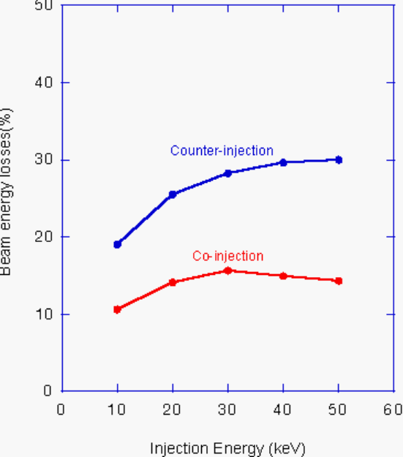 | 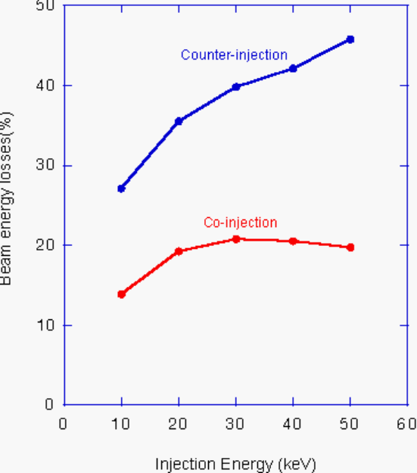
Figure 5. Variation of the beam energy losses with injection energy for a recent machine design point at R₀ = 1.4 m, <B> = 1.23 T, n(0) = 8.5 x 10¹⁹ m⁻³, T_{e}(0) = T_{I}(0) = 1.58 keV for (a) Hydrogen beams injected into a hydrogen plasma, and (b) Deuterium beams injected into a deuterium plasma

5. Access

The overall machine size affects the access for personnel, heating (particularly beam heating) and diagnostics. The status of the access for the NCSX configuration and size are summarized below for each of these areas.

A. Personnel
A discussion of the personnel access is documented in Sect. 3.2.3 of the PVR document. The conclusion outlined there is that the personnel access is not limited by the present size of the machine. The primary limitation for personnel access are the availability of ports not filled with diagnostics, neutral beams or trim coils. The solution of the problem of competition for port utilization will be an important design integration focus for the conceptual design.

Beam
The neutral beam optics has been modeled for the PBX neutral beams in the NCSX geometry. The modeling uses the measured PBX beam characteristics as input. Front-end cryopumping is provided to eliminate reionization losses in the duct. As a result, it is projected that the full 1.5 MW per beamline will be injected into the torus. The beam “footprint” size is not small compared to the plasma cross section, as shown in Figure 6, but does enclose more than 90% of the injected power from the most poorly focussed beam. These beam transmission levels are adequate and therefore should not be a size or configuration driver.

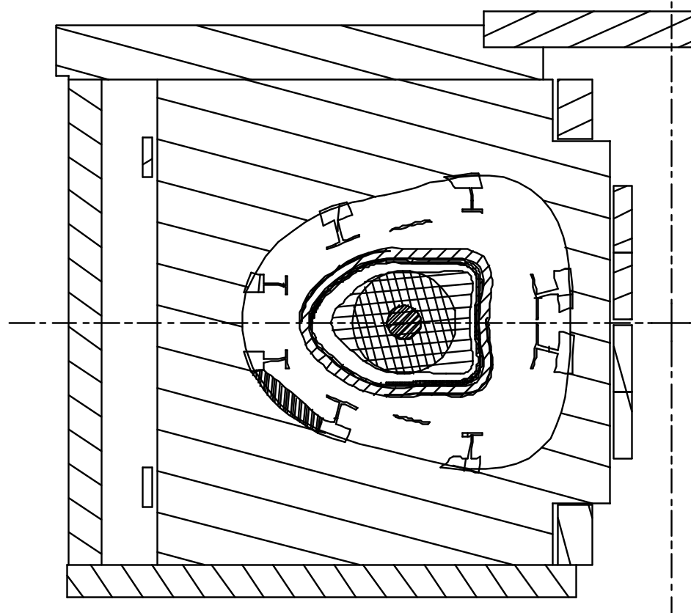
Figure 6. NBI footprint (circles) for the most poorly focussed beam superimposed on the oblate plasma cross section. The larger circle encloses ~96% of the injected power, the smaller circle encloses 47%.

Diagnostics
For fusion experimental facilities there is never enough access for diagnostics and NCSX will not be an exception. For the PVR configuration NCSX has 87 ports with 66 ports dedicated to diagnostics. The specifics of the diagnostics port utilization are provided in Sect. 12.3 of the PVR documentation. One limitation for diagnostics access on NCSX is the duct length required to penetrate through the PFC’s, vacuum vessel, modular coil shells and the cryostat. Increased machine size would increase both the duct area and the duct length. Because of these factors increasing the machine size does not obviously improve diagnostic access.

6. PFC Space

The space available for plasma facing components (PFC) is a weak function of the overall machine size (over the range of reasonable size changes), but strongly dependent on the magnetics design and the space available inside the vacuum vessel. With this in mind we have adopted the strategy of maximizing the space available for plasma scrape-off and PFC’s within the constraints of the plasma shape and the coils. For a given coil design, the vacuum vessel volume is limited by the requirement to be able to install the modular coils over the vacuum vessel. Since the PVR, a change from 21 to 18 modular coils and improvements in how the vacuum vessel geometry is generated have made it possible to significantly enlarge the vacuum vessel volume at fixed major radius. While the understanding of the magnetic topology of the plasma edge (over the range of plasma discharges needed for flexibility) and the design of the PFCs will continue to evolve for a period of time, the prospects for having adequate space have greatly improved by these changes to the major components. Based on tokamak and stellerator experience it is expected that the space allocated for the scrape-off and PFC’s will be large enough.

7. Summary

The overall machine size impacts the space available for internal hardware, the access for personnel, heating and diagnostics, the neutral penetration to the plasma core and the energy confinement. For those elements related to space availability (i.e. access and PFC space) the present machine size has been shown to be adequate; in fact these elements benefit relatively weakly from increases in the overall machine size. The neutral penetration is most strongly dependent on the location of the source of neutrals. If we avoid limiting surfaces near the narrow plasma cross sections the discharge should not be adversely impacted by neutral penetration. (W7AS) The performance element that is most sensitive to the overall machine size (at fixed heating power) is the useful operating range of magnetic field, which translates into a range of accessible collisionalities. The minimum magnetic field for adequate beam orbit confinement varies as ~1/R while the maximum magnetic field for a given coil configuration and temperature rise is proportional to R. The 1.4-m design provides a range of 1.2 to 1.7 T in the reference plasma configuration. A determination of whether the upper limit can be raised awaits further analysis that is planned as part of conceptual design preparation.

The studies that have been carried out and are summarized in this report show that the NCSX design point is adequate for heating powers somewhere in the range of three to six megawatts. This range of heating powers is dictated by the range of uncertainty in projecting the energy confinement. Based on this assessment it is prudent to begin the heating experiments with a baseline heating power of 3 MW and plan future upgrades of the heating system based on the results from the initial experiments.

Attachment 2. Stellarator Program Coordination Issues

Several of the PVR recommendations (II-1, II-3, II-6, and all of V) addressed the larger stellarator proof-of-principle program, emphasizing 3D plasma physics theory and diagnostics, international collaboration, and stellarator reactor studies in particular. Good coordination and mutual support among the various program elements were recommended, with NCSX seen as having a central role both scientifically and organizationally. In response, the NCSX leadership has been working with the leadership of the other stellarator program elements and involved institutions to move the program forward as a whole and to continuously improve coordination. Some examples of coordination actions taken or planned by the stellarator community since the PVR:

• 3D plasma physics theory. A workshop on “Future Directions in Theory of 3D Magnetic Confinement Systems” will be held to develop plans for 3D plasma theory research. It has been scheduled for Jan. 7-9, 2002, at ORNL.

• International Collaboration. Physicists who have been involved in the NCSX design work have begun to shift focus to collaborations with LHD and W7-AS. Topics in which collaborations have started or are being planned include neoclassical transport, anomalous transport, energetic ion physics, MHD equilibrium and stability, and divertors.

• Stellarator reactor studies. Discussions with the ARIES group have produced a preliminary understanding of the approximate cost and possible schedules for an ARIES CS reactor study, and the preparatory work that both the ARIES and stellarator teams would need to do. One constraint on the timing is that stellarator experts who would be needed for a reactor study are still involved in designing experiments.

• Broader management focus. The scope of the NCSX PAC has been broadened to advise on PPPL’s stellarator theory and collaboration activities in addition to NCSX. Stellarator groups outside of PPPL will have the opportunity to make presentations to the NCSX PAC if they wish. The next meeting has been scheduled for November 14-15 at PPPL.

• Support of FESAC / DOE Decision process. The stellarator community presentations to FESAC in May and August explained the program goals; the purpose of each element of the program and their interrelationships, the costs, and the program’s expected benefits to fusion science and energy.

One area that has received little attention in the brief period since the PVR is 3D plasma diagnostics. This will receive more emphasis in the next few months through the NCSX conceptual design effort. Coordination and advancement of the stellarator program will require the sustained efforts of the entire stellarator community leadership. While much remains to be done to follow up on the plans that have been put in place, good progress has been made since the PVR in responding to the recommendations for good stellarator program coordination.

