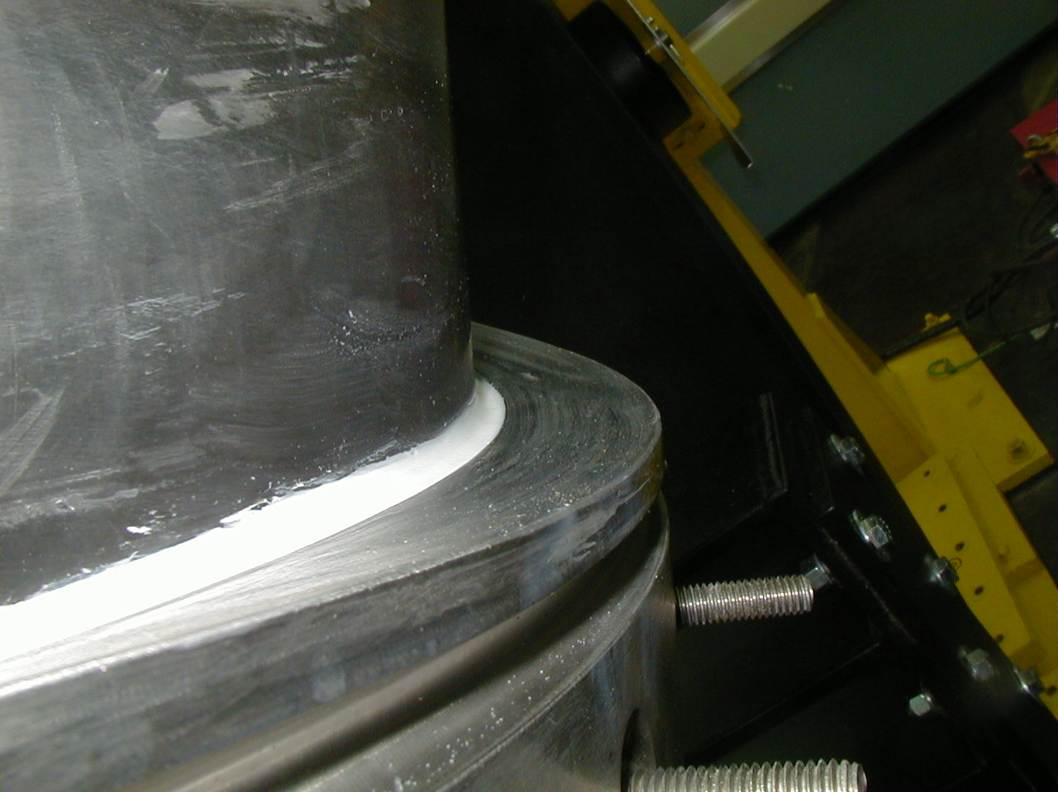

In this picture you can see that the isn’t completely filled in.
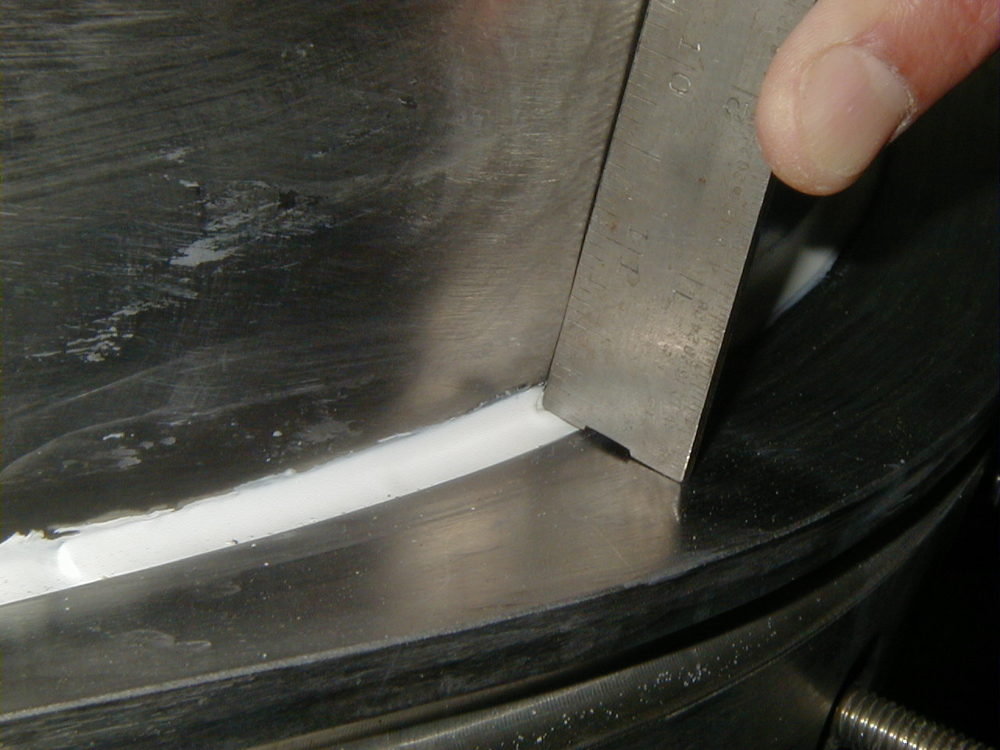

Here’s a photograph where there is too much putty in the groove and the corner of the ruler is digging into the putty. Also notice that the vertical wall of the Tee is pulling away from the ruler. We had the short edge of the ruler sitting flat on the base of the Tee
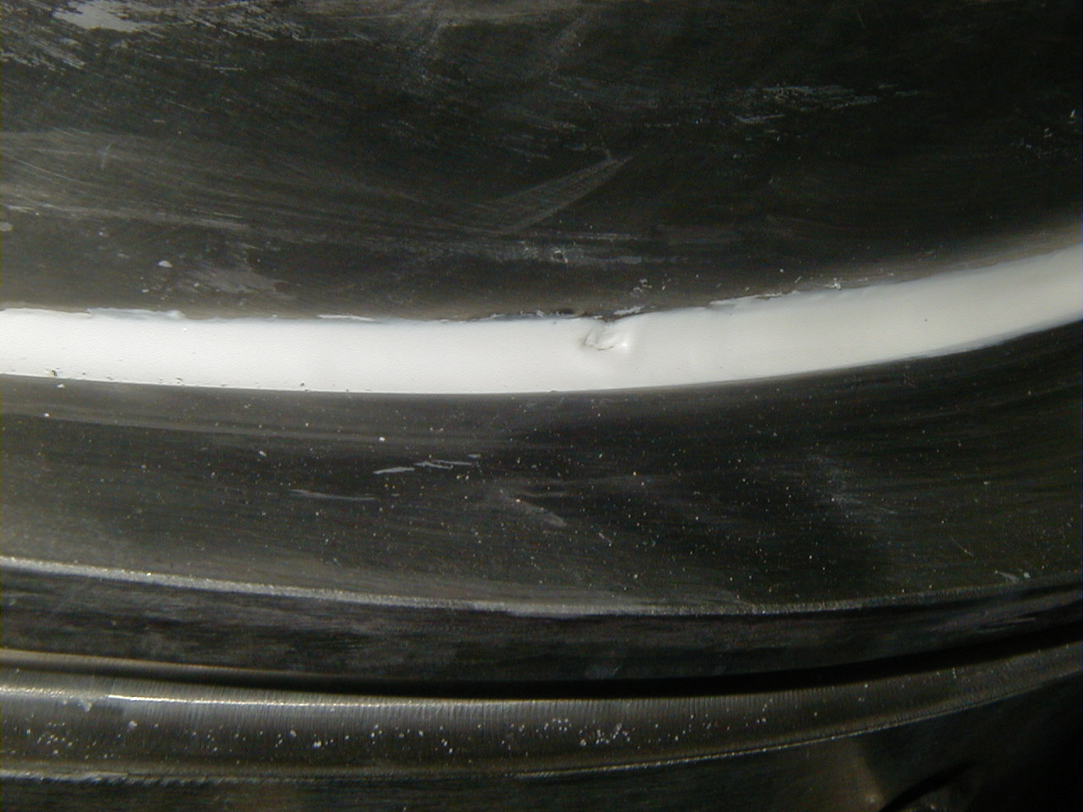

The indentation into the putty that the corner of the ruler made after it was removes. The indentation was on the order of .015” -.020” deep. The inner-most conductor will lay into this area. What kind of effect will this have on the position of the 4x10 bundle?
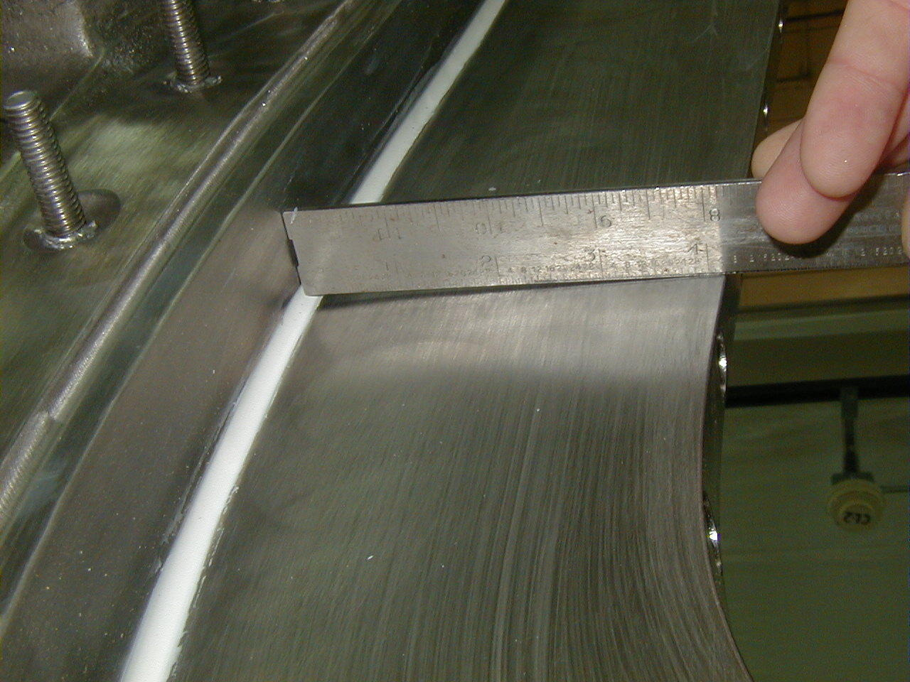

Here you see that the base and wall of the tee are not perpendicular.
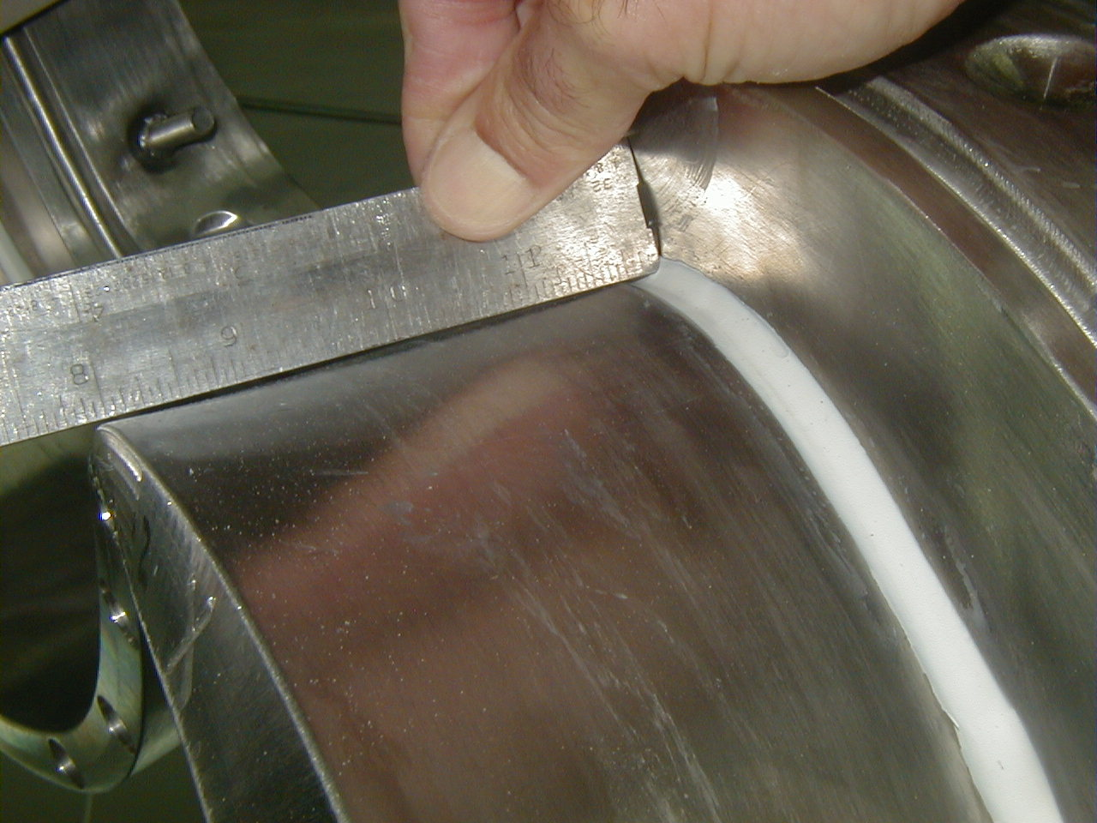

At this location it appears that the Tee is “bowed” approximately half way up the side.
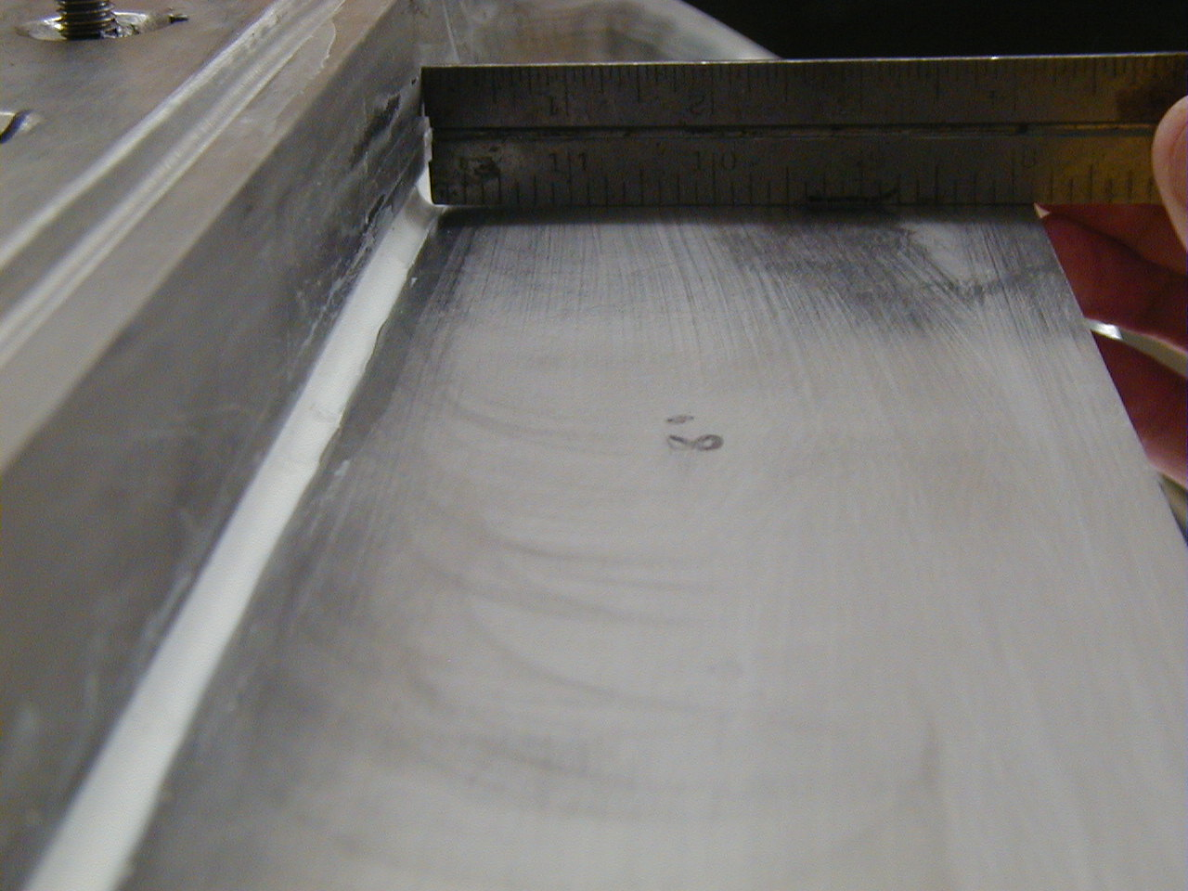

Groove is not compltely filles. The innermost conductor will “roll” into this void.
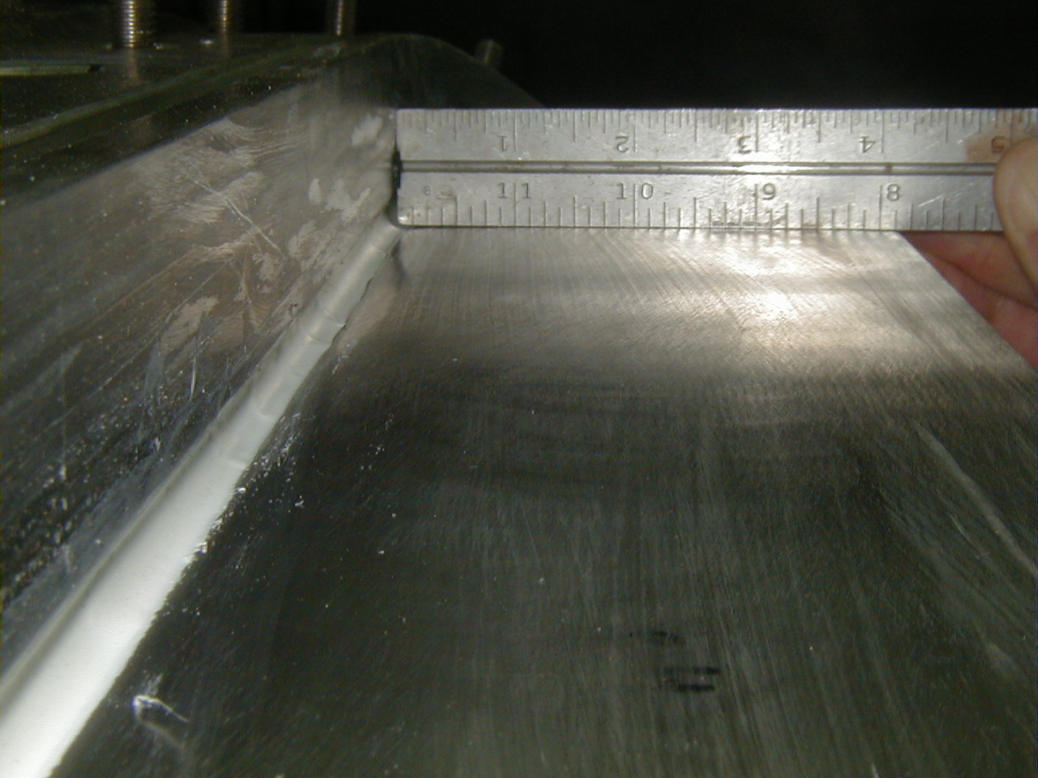

More of the same.

