Both welds ¼” on shim with 2 ¼” hole – shim stayed flat after clamp removed.

With 1 ½ hole, semi circular weld is 1/2'” – straight weld is 5/16”.

Both are easy to do –

Initial shim: lifted 0.5” – it took ~3500 lbs. to push it flat. (could be off by a factor of 2)
Kevin: gets 8.7 kips.

Standard shim clamped during welds – springs up 0.046” and takes 1180 lbs. to flatten. If we make the standard shim thickness 0.44 it should work everywhere.

Low friction coating (if needed)
0.44
Limiter puck
Plasma Side

Running load is about 3000 lbs./ in. compression.

If mu is 0..1 , the load on a shim would be 0.1 x 4” x10000 =4000 lbs. Needs to have adequately sized welds to restrain it.

Perform A6 weld test for longitudinal weld shrinkage on A/B flange. If it works out, the shims will stay on.

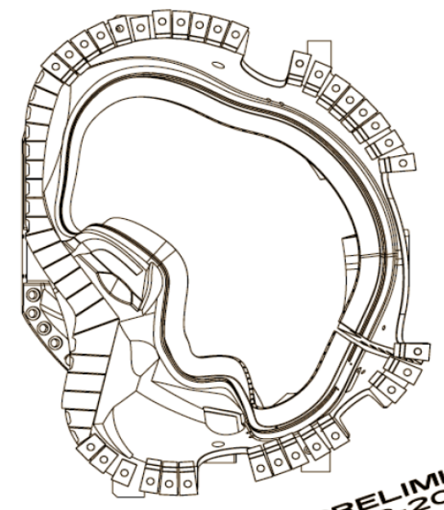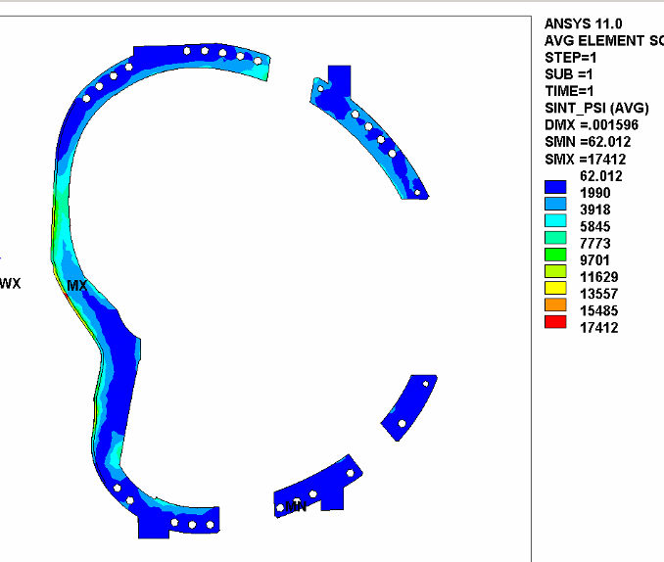

PLAN OVERVIEW

- Proceed with PDR and FDR based on flex shim and drop in limiter
  - Special shim designs are necessary in “narrow flange” areas.
  - Consider longer length shims with multiple limiter pucks where they may be useful (i.e., at the ends where there are strange shaped shims). Welds may still be discontinuous to avoid longitudinal shrinkage.
  - Requirements:
    - Must react shear of 4,200 lbs. / inch of flange.
    - Must generate a minimum of weld shrinkage forces which could result in wing motion and casting deformations.
    - Must react compressive centering force loads as high as 12,000 lbs. / inch of flange.
    - Stresses (in welds, shim, and casting) must be within the allowable Sm of 31.5 ksi.
    - Motion due to deformation of the shim should be <0.005? inches.
- Proceed ASAP with confirmatory longitudinal weld distortion tests on A6 (details below)
- High confidence that weld distortions due to lateral weld shrinkage is controlled; less confidence that distortions due to longitudinal weld shrinkage is controlled.
  - Based on data from the water jet cut leg mock up weld tests, the longitudinal weld shrinkage is expected to be < < 0.05”. ( i.e., ~5 x 10⁻⁴ x 100” =0.05”) NOTE: welds are now two ½” or smaller fillets compared to a single .5 x .5” butt weld.

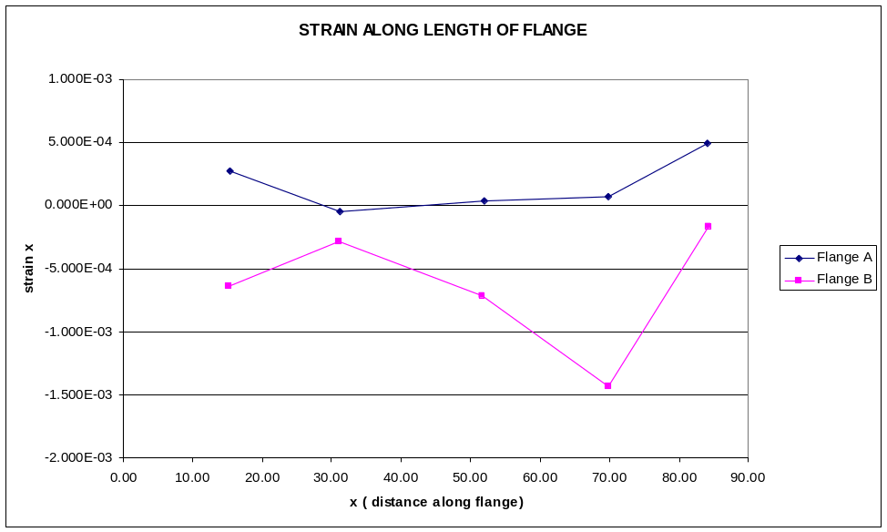
Probably an extraneous point due to “funny shape” of flange in this location.
- Cannot analytically accurately predict effect on coil metrology.
- Develop the pincushion without electrical insulation as a backup should weld distortion continues to be a problem.
- With relief provided by the relaxation of the need for electrical isolation, many of the former issues are significantly relaxed.
- Many bench tests have already been performed.

CONFIRMATORY LONGITUDINAL DISTORTION CONTROL TEST

- A6 will be used for longitudinal distortion weld tests. (NOTE: the shims will be left in place if successful )
  - Flex shim with undercut to reduce cantilever beam strength. (undercut detail tbd Kevin),
  - Basic shim thickness reduced to 0.375-0.400 to compensate for expected “spring up” based on results of weld tests.
  - Mike Cole will provide dxf files of the shims.
  - Minimum weld sizes to be specified by Kevin shim by shim.
  - Peer review of shim design before cutting them.
- Tests performed in Test Cell due to metrology requirements.
  - A6 Fixtured on a wedge fixture with complete metrology characterization.
  - Flex shims restrained flat by clamp during plasma side weld.
  - Weld shim sequence as specified by Mike V or EWI to minimize distortion.

0.44

1.5” dia. steel pucks (alumina is desirable)

Shim plates are ~18” long with “n” limiters per plate.
Need to determine how long a continuous length of weld should be made to reduce longitudinal shrinkage deformations.
  - Real time laser tracker monitoring of wing and one OD fiducial.
  - Backup monitoring of wing and one or more fiducials by dial indicators
  - If successful, the winding form will be sent for winding with these shims left in place and used as the “production” shims.

