NCSX
Product Specification

Twisted Racetrack Coil Assembly

NCSX-CSPEC-142-04-00_dB

December 7, 2004

Prepared by: _____________________________________________________________
D. Williamson, WBS14

Concurred by: ____________________________________________________________
J. Chrzanowski, Coil Windings and Assembly

Concurred by: ____________________________________________________________
B. Nelson, NCSX Stellarator Core

Concurred by: ____________________________________________________________
F. Malinowski, PPPL Procurement QA Representative

Approved by: ____________________________________________________________
W. Reiersen, Engineering Manager

-------------------------Controlled Document -----------------------
This is a controlled document. Check the NCSX Engineering web for latest revision.

Revision History

Revision No. | Affected Pages | Date
0 (Initial Issue) | All

TABLE OF CONTENTS

1 INTRODUCTION AND SCOPE 3
2 APPLICABLE DOCUMENTS 3
3 REQUIREMENTS 3
4 QUALITY ASSURANCE 3
5 DOCUMENTATION 3

INTRODUCTION AND SCOPE
  - Introduction
The National Compact Stellarator Experiment (NCSX) is a quasi-axisymmetric facility that combines the high beta and good confinement features of an advanced tokamak with the low current, disruption-free characteristics of a stellarator. The experiment is based on a three field period plasma configuration with an average major radius of 1.4 m, a minor radius of 0.3 m, and a toroidal magnetic field on axis of up to 2 T. The modular coils are one set in a complex assembly of four coil systems that surround the highly shaped plasma. There are six each of three coil types in the assembly for a total of 18 modular coils. The coils are constructed by winding copper cable onto a cast stainless steel winding form that has been machined to high accuracy, so that the current center of the winding pack is within ±1.5 mm of its theoretical position. The modular coils operate at a temperature of 80 K and are subjected to rapid heating and stress during a pulse.

The Twisted Racetrack Coil (TRC) is the third test article in the modular coil R&D program, and the first to demonstrate a prototypical coil winding. It will be fabricated in the production winding facility and tested under similar operating conditions as the modular coils. At the conclusion of testing, the TRC will be disassembled for inspection.

  - Scope
This specification defines the twisted racetrack coil assembly and requirements for its construction and operation.

APPLICABLE DOCUMENTS
  - Standards and Specifications

ASTM A703/M-01 Specification for Steel Castings
ASTM B152/M-00 Standard Specification for Copper Sheet
NCSX-CSPEC-141-02 TRC Winding Form Product Specification
NCSX-CSPEC-142-03 Modular Coil Conductor Specification
NCSX-MCWFOP-00 Winding Facility Operations Plan
NCSX-MITQA-142-01 Modular Coil MIT/QA Plan
NCSX-PLAN-QAP NCSX Quality Assurance Plan

  - Drawings

SE140-084 Twisted Racetrack Winding Form
SE140-283 TRC Web Side A Cladding Assembly
SE140-284 TRC Flange Side B Cladding Assembly
SE140-285 TRC Flange Side A Cladding Assembly
SE140-286 TRC Web Side B Cladding Assembly
SE140-287 Web Side A Cladding Flat Dev
SE140-288 Flange Side B Cladding Flat Dev
SE140-289 Flange Side A Cladding Flat Dev
SE140-290 Web Side B Cladding Flat Dev
SE1405-250P Prototype Clamp Assembly
SE1405-251P Clamp Vertical Bar
SE1405-254P Clamp Horizontal Bar
SE1405-255P Set Screw
SE1405-256P Special Rivet
SE1405-257P Spherical Washer
SE1405-259P Spherical Washer
SE1405-260P Nut, Pin Drive
SE1405-261P Set Screw
SE1405-262P Piston
SE1405-263P Spherical Washer
SE1405-264P Screw
SE1406-009 Twisted Racetrack Assembly Model Tree
SE1406-010 Twisted Racetrack Coil Assembly
SE1406-011 TRC Winding Form Modifications
SE1406-048 Terminal Block Insulating Base
SE1406-049 Terminal Jumper Insulator
SE1406-051 Terminal Jumper No. 1
SE1406-052 Terminal Jumper No. 2
SE1406-053 Terminal Jumper No. 3
SE1406-054 Terminal Jumper No. 4
SE1406-055 Cable Tapered Connector
SE1406-057 Terminal Lug Block
SE1406-058 Coaxial Power Cable
SE1406-059 Terminal Lug Splice Plate
SE1406-061 TRC Chill Plate Assembly Side A
SE1406-063 TRC Chill Plate Assembly Side B
SE1406-090 Winding Pack Dimensional Layout
SE1406-091 TRC Cladding / Chill Plate Layout
SE1406-108 Strain Gage and Thermocouple Layout
SE1406-118 Upper Winding Block Side A
SE1406-119 Upper Winding Block Side B
SE1406-122 Lower Winding Block Side A
SE1406-123 Lower Winding Block Side B
SE1406-134 Lower Guide Block Side A
SE1406-135 Lower Guide Block Side B
SE1406-136 Upper Guide Block Side A
SE1406-137 Upper Guide Block Side B
SE1406-161 Cooling Tube Fringe Assembly Side A
SE1406-163 Cooling Tube Fringe Assembly Side B
SE1406-171 Cooling Tube Assembly Side B
SE1406-172 Cooling Tube Assembly Side A
SE1406-175 VPI Bag Mold and Sprue Layout

REQUIREMENTS
  - Definition
The twisted racetrack coil assembly includes the winding form, conductor and insulation, leads and termination, cooling system, instrumentation, vacuum-pressure epoxy impregnation (VPI) features, and the coil clamps. Figure 1 shows the main subcomponents of the coil assembly:

Winding form – a cast, stainless steel structure with a machined “tee” profile

Cladding – inner layer of copper that cools the winding pack by conduction

Ground insulation – multiple layers of glass cloth surrounding the winding pack

Conductor – stranded copper wire with a compacted, rectangular cross-section

Turn insulation – pre-wrapped layers of glass around each conductor

Shims – additional layers of glass that adjust the center of the winding pack

Lead blocks – insulated supports for conductor entry/exit from winding pack

Terminal blocks – electrical connection to coax power feed

Chill Plates – outer layer of copper, “fringe” connectors, and tubes for cooling

Bag mold – silicone and fiberglass shell that surrounds winding pack

Clamps – support that provides clamping force, preload on winding pack

Instrumentation – strain gages, thermocouples, and voltage taps

Magnetic diagnostics – two co-wound wires on the ‘plasma side” of each winding pack

Figure 2 is an illustration of the subcomponent “model tree” for the coil assembly, as modeled in Pro/ENGINEER.

  - Characteristics
Each of the twisted racetrack assembly subcomponents has performance or physical characteristics that are necessary for proper function of the coil and should be verified prior to or during assembly.

    - Winding form
      - Material – The winding form material is a cast, stainless steel alloy.
      - Size and weight – The bounding dimensions of the winding form are aa x aa-in. and the weight is approximately aa-lbs.
      - Winding surface – The dimensions and tolerance of the “tee” section of the winding form are illustrated in Fig. 3.
      - Magnetic permeability – The relative magnetic permeability of the winding form shall not exceed 1.02.
      - Surface finish – All winding surfaces shall have a surface finish <125-u in.
      - Modifications – A terminal block and studs shall be attached to the winding form by welding, as specified in drawing SE1406-011.

    - Inner Copper Cladding
      - Material – The cladding material is 0.040-in thick OFHC copper sheet, with high thermal conductivity and a temper suitable for forming (dead soft is acceptable).
      - Quantity, size, and weight – There are aa pieces of cladding with average dimensions of aa x aa-in. and a total weight of aa-lbs.
      - Sliding fit – The cladding shall conform to the winding surface but not be permanently bonded or attached to it. Temporary bonding will be required during the coil winding process.
      - Electrical insulation – The cladding shall be electrically isolated from the winding form by a half-lapped layer of 0.0035-in Kapton tape.

    - Ground Insulation
      - Material – The ground insulation is composed of S2 glass and adhesive Kapton.
      - Quantity, size, and weight – The total thickness of 0.0445-in is composed of three layers: 1) a butt-lapped layer of 0.007-in S2 glass, 2) a half-lapped layer consisting of 2-in wide x 0.007-in S2 glass and 1.5-in wide x 0.0065-in adhesive Kapton tape, and 3) a butt-lapped layer of the same composite

    - Conductor and Turn Insulation
      - Material – The conductor material is 34-AWG CDA-101 copper wire, and the turn insulation is S-2 glass cloth with S920 Silane finish.
      - Size and Weight – The nominal size of the conductor with insulation is .374 x .415-in, and the weight is approximately 410-lbs per 1000-ft.
      - Conductor length – The total length of conductor is aa-ft.
      - Electrical properties – The resistance of the conductor shall be less than 0.089-Ω per 1000-ft when measured at room temperature.

    - Supplemental turn insulation near terminations
      - Material – S2 glass and interleaved Kapton with adhesive backing
      - Quantitiy, Size and Weight The total thickness of 0.041-in is composed of two half-lapped layers consisting of 1-in wide x 0.007-in S2 glass and 0.75-in wide x 0.0065-in adhesive Kapton tape

    - Winding Pack Shims
      - Material – The shim material is S2 glass cloth with adhesive backing
      - Size and Weight – shims are cut from xx inch wide x yy thick glass tape
      - Temporary attachment method – shims are attached via adhesive backing
      - Placement location – Shims shall be applied between layers as shown in Fig. 3.

    - Lead Blocks
      - Material – The lead blocks are constructed of a NEMA grade G11 CR epoxy laminate.
      - Quantity, Size and Weight – There are four blocks per side, the largest of which is aa x aa-in in size. The total weight of the lead blocks is aa-lbs.
      - Surface Finish – The lead blocks shall be free of burrs and sharp edges that can damage the conductor. All surfaces unless machined shall be sanded to remove any high gloss surface, to promote bonding of the epoxy to the lead blocks.

    - Terminal Blocks and insulators
      - Material – The terminal material is OFHC copper, and interleaved insulation is NEMA Grade G11-CR laminate.
      - Quantity, Size, and Weight –
      - Electrical Continuity –

    - Chill Plates
      - Material – The chill plate material is 0.040-in thick OFHC copper sheet, with high thermal conductivity and a temper suitable for forming
      - Quantity, size, and weight – There are aa pieces of cladding with average dimensions of aa x aa-in. and a total weight of aa-lbs

    - Tubing / Fringe
      - Material – The tubing/fringe material is OFHC Copper
      - Quantity, size, and weight –
      - Electrical continuity –

    - VPI Bag Mold
      - Material – The bag mold is comprised of Self fusing gray silicone tape; 2-part RTV-11 (white); Nomex felt Stk. No. NX08-6 ; Hysol Resin/hardener 3561/2039.
      - Quantity, size and weight – [2] layers of silicone tape/ painted with RTV 11/ over wrapped with [2] layers of Nomex felt filled with Hysol epoxy formulation.

    - Clamp Assembly
      - Material –
      - Quantity, size and weight –

    - Instrumentation –
      - Strain gages
        - Material – Fiber optic strain gage
        - Quantity, size, and weight – Minimum of 8 strain gages
        - Location – Three each at each end of the coil, located at the tip of the tee web and the inside/outside surface of the tee base. Two additional strain gages to be located near and opposite the coil leads.

      - Thermocouples
        - Material – Type E Chromel/Constantan, 0.010-in diameter.
        - Quantity, size, and weight – Minimum of six thermocouples.
        - Location – Within a coil plane, opposite the leads region, thermocouples shall be located in the middle of each winding pack and spaced vertically between the layers.

    - Flux loops
        - Material – Two different cables are planned. First is copper coax in a braided stainless steel jacket, second is mineral insulated wire.
        - Quantity, size, and weight – Diameter is 0.070-in, length is approx 12-ft.
        - Location – Wires shall be located at the outer corner, plasma side of each winding pack.
        - Termination – Wires shall be routed along the lead block to the base of the winding form.

QUALITY ASSURANCE
  - Inspections and tests shall be performed in accordance with written / approved procedures referencing criteria for acceptance for rejection. Adequate records shall be maintained and available for project review.

  - Inspections and tests shall be performed using properly calibrated measuring and test equipment. All critical calibration standards shall be traceable to the National Institute for Standards and Technology (NIST) and shall not be used for shop inspections, but instead be protected against damage or degradation.

  - Material and equipment identification shall be maintained throughout the program and be traceable to records.

DOCUMENTATION

  - During coil assembly, the team shall maintain a system of documentation whereby objective evidence of required operations, inspections, examinations, and tests is systematically compiled and stored. Such documentation shall include process travelers and any certification, inspection, examination, test, and discrepancy reports that are required.

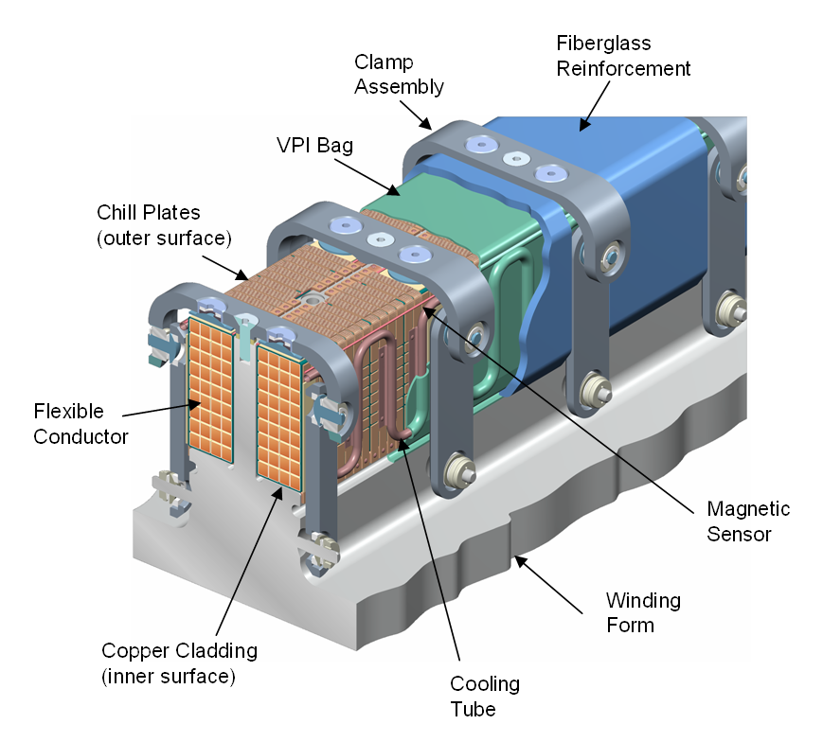
Fig. 1 – Coil Assembly

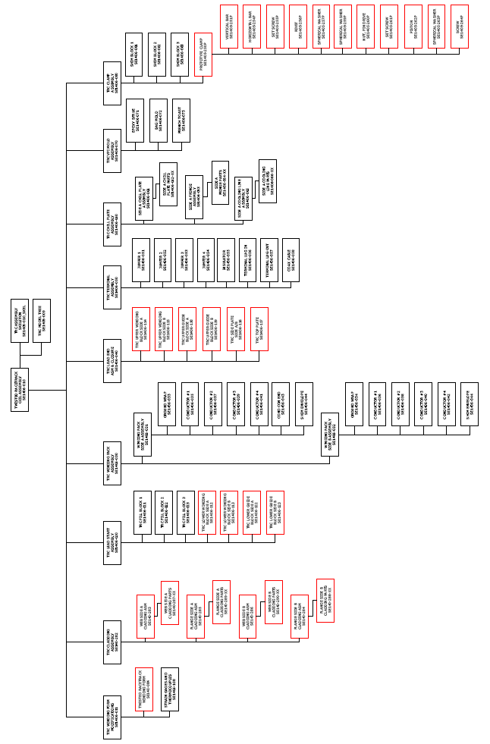
Fig. 2 – Coil Assembly Model Tree

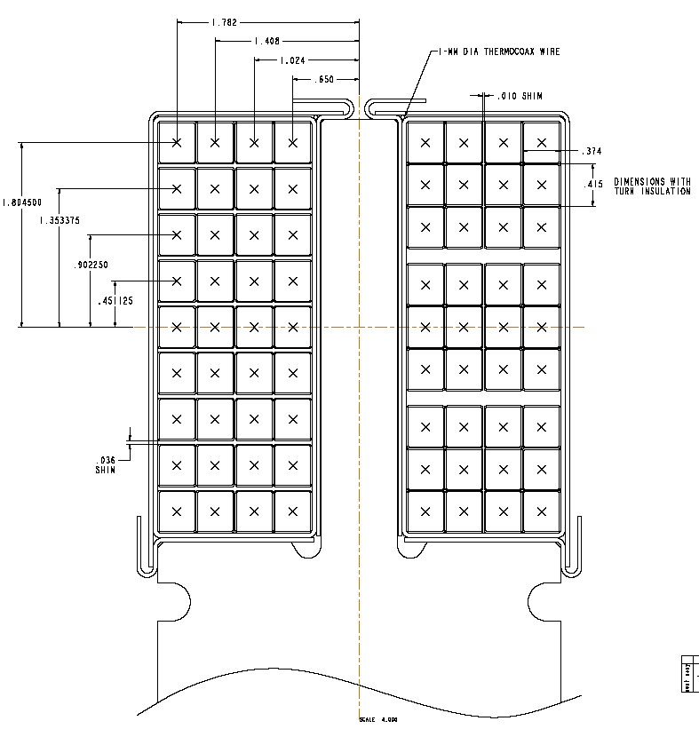

Fig. 3 – Winding Pack and Shim Dimensions

