NCSX
Product Specification

Twisted Racetrack Coil Assembly

NCSX-CSPEC-142-04-00_dD

January 3, 2005

Prepared by: _____________________________________________________________
D. Williamson, WBS14

Concurred by: ____________________________________________________________
J. Chrzanowski, Coil Windings and Assembly

Concurred by: ____________________________________________________________
B. Nelson, NCSX Stellarator Core

Concurred by: ____________________________________________________________
F. Malinowski, PPPL Procurement QA Representative

Approved by: ____________________________________________________________
W. Reiersen, Engineering Manager

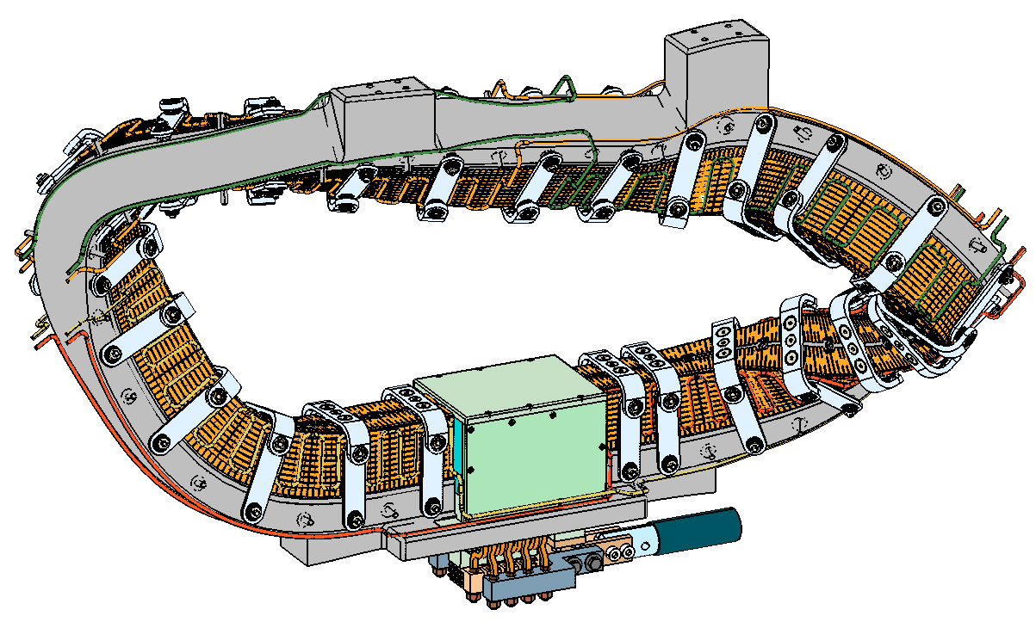

-------------------------Controlled Document -----------------------
This is a controlled document. Check the NCSX Engineering web for latest revision.

Revision History

Revision No. | Affected Pages | Date
0 (Initial Issue) | All | Dec 2004

TABLE OF CONTENTS

1 INTRODUCTION AND SCOPE 2
2 APPLICABLE DOCUMENTS 2
3 REQUIREMENTS 2
4 QUALITY ASSURANCE 2
5 DOCUMENTATION 2

INTRODUCTION AND SCOPE

  - Introduction
The National Compact Stellarator Experiment (NCSX) is a quasi-axisymmetric facility that combines the high beta and good confinement features of an advanced tokamak with the low current, disruption-free characteristics of a stellarator. The experiment is based on a three field period plasma configuration with an average major radius of 1.4 m, a minor radius of 0.3 m, and a toroidal magnetic field on axis of up to 2 T. The modular coils are one set in a complex assembly of four coil systems that surround the highly shaped plasma. There are six each of three coil types in the assembly for a total of 18 modular coils. The coils are constructed by winding copper cable onto a cast stainless steel winding form that has been machined to high accuracy, so that the current center of the winding pack is within ±1.5 mm of its theoretical position. The modular coils operate at a temperature of 80 K and are subjected to rapid heating and stress during a pulse.

The Twisted Racetrack Coil (TRC) is the third test article in the modular coil R&D program, and the first to demonstrate a prototypical coil winding. It will be fabricated in the production winding facility and tested under similar operating conditions as the modular coils. At the conclusion of testing, the TRC will be disassembled for inspection.

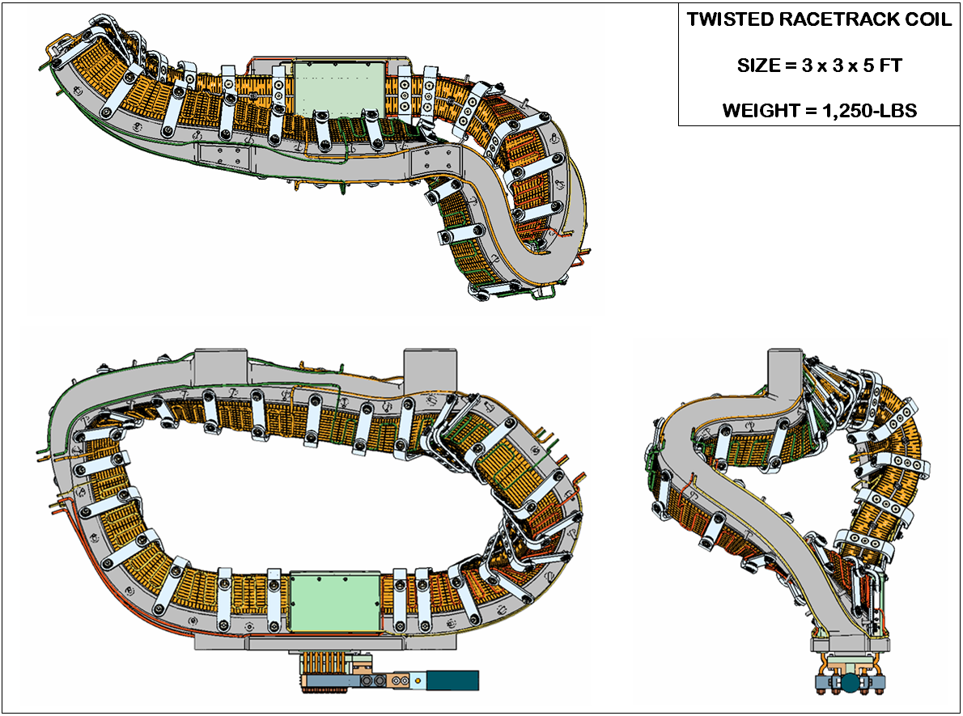
Figure 1 - Twisted Racetrack Coil Assembly

  - Scope
This specification defines the twisted racetrack coil assembly and requirements for its construction and operation.

APPLICABLE DOCUMENTS

  - Standards and Specifications

ASTM A703/M-01 Specification for Steel Castings
ASTM B152/M-00 Standard Specification for Copper Sheet
ASTM B280-03 Standard Specification for Seamless Copper Tube
NCSX-CSPEC-141-02 TRC Winding Form Product Specification
NCSX-CSPEC-142-03 Modular Coil Conductor Specification
NCSX-MCWFOP-00 Winding Facility Operations Plan
NCSX-MITQA-142-01 Modular Coil MIT/QA Plan
NCSX-PLAN-QAP NCSX Quality Assurance Plan

  - Drawings

SE1406-009.DRW TRC MODEL TREE
SE1406-090.DRW TRC WINDING PACK XSEC
SE1406-091.DRW TRC CLADDING / CHILL PLATE LAYOUT
SE1406-010.DRW TWISTED RACETRACK COIL ASSEMBLY
SE140-084.DRW TWISTED RACETRACK WINDING FORM
SE1406-011.DRW TRC WINDING FORM WELDMENT
SE1406-048.DRW TRC JUMPER BASE BLOCK
SE1406-049.DRW TRC JUMPER INSULATOR
SE1406-051.DRW TRC JUMPER 1
SE1406-052.DRW TRC JUMPER 2
SE1406-053.DRW TRC JUMPER 3
SE1406-054.DRW TRC JUMPER 4
SE1406-055.DRW TRC TERMINAL LUG OUT
SE1406-059.DRW TRC TERMINAL LUG IN
SE1406-022.DRW FILL BLOCK 2
SE1406-023.DRW FILL BLOCK 3
SE1406-024.DRW FILL BLOCK 1
SE1406-025.DRW TRC FILL BLOCK
SE1406-122.DRW LOWER WINDING BLOCK
SE1406-123.DRW LOWER WINDING BLOCK MIRROR
SE1406-134.DRW LOWER GUIDE BLOCK
SE1406-135.DRW LOWER GUIDE BLOCK MIRROR
SE140-283.DRW CLADDING SIDE A WEB
SE140-287.DXF CLADDING SIDE A WEB FLAT PATTERNS
SE140-284.DRW CLADDING SIDE B FLANGE
SE140-288.DXF CLADDING SIDE B FLANGE FLAT PATTERNS
SE140-285.DRW CLADDING SIDE A FLANGE
SE140-289.DXF CLADDING SIDE A FLANGE FLAT PATTERNS
SE140-286.DRW CLADDING SIDE B WEB
SE140-290.DXF CLADDING SIDE B WEB FLAT PATTERNS
SE1406-077.DRW CABLE CONNECTOR
SE1406-118.DRW UPPER WINDING BLOCK
SE1406-119.DRW UPPER WINDING BLOCK MIRROR
SE1406-136.DRW UPPER GUIDE BLOCK
SE1406-137.DRW UPPER GUIDE BLOCK MIRROR
SE1406-116.DRW LEADS SIDE PLATE
SE1406-121.DRW LEADS SIDE PLATE
SE1406-117.DRW LEADS TOP PLATE
SE1406-061.DRW CHILL PLATE SIDE A ASSEMBLY
SE1406-062.DXF CHILL PLATE SIDE A FLAT PATTERNS
SE1406-063.DRW CHILL PLATE SIDE B ASSEMBLY
SE1406-064.DXF CHILL PLATE SIDE B FLAT PATTERNS
SE1406-380.DRW TUBE/FRINGE SIDE A ASSEMBLY
SE1406-390.DRW TUBE/FRINGE SIDE B ASSEMBLY
SE1406-161.DRW FRINGE SIDE A ASSEMBLY
SE1406-162.DRW FRINGE SIDE B ASSEMBLY
SE1405-250P.DRW PROTOTYPE CLAMP ASSEMBLY
SE1405-251P.DRW CLAMP VERTICAL BAR
SE1405-254P.DRW CLAMP HORIZONTAL BAR
SE1405-255P.DRW SET SCREW
SE1405-256P.DRW SPECIAL RIVET
SE1405-257P.DRW SPHERICAL WASHER
SE1405-259P.DRW SPHERICAL WASHER
SE1405-260P.DRW NUT, PIN DRIVE
SE1405-261P.DRW SET SCREW
SE1405-262P.DRW PISTON
SE1405-263P.DRW SPHERICAL WASHER
SE1405-264P.DRW SCREW

REQUIREMENTS

  - Definition
The twisted racetrack coil assembly includes the winding form, conductor and insulation, leads and termination, cooling system, instrumentation, vacuum-pressure epoxy impregnation (VPI) features, and the coil clamps. Figure 2 shows the main subcomponents of the coil assembly:

Winding form – a cast, stainless steel structure with a machined “tee” profile

Cladding – inner layer of copper that cools the winding pack by conduction

Ground insulation – multiple layers of glass cloth surrounding the winding pack

Conductor – stranded copper wire with a compacted, rectangular cross-section

Turn insulation – pre-wrapped layers of glass around each conductor

Shims – additional layers of glass that adjust the center of the winding pack

Lead blocks – insulated supports for conductor entry/exit from winding pack

Terminal blocks – electrical connection to coax power feed

Chill Plates – outer layer of copper, “fringe” connectors, and tubes for cooling

Bag mold – silicone and fiberglass shell that surrounds winding pack

Clamps – support that provides clamping force, preload on winding pack

Instrumentation – strain gages, thermocouples, and voltage taps

Magnetic diagnostics – two wires co-wound on the plasma side of winding pack

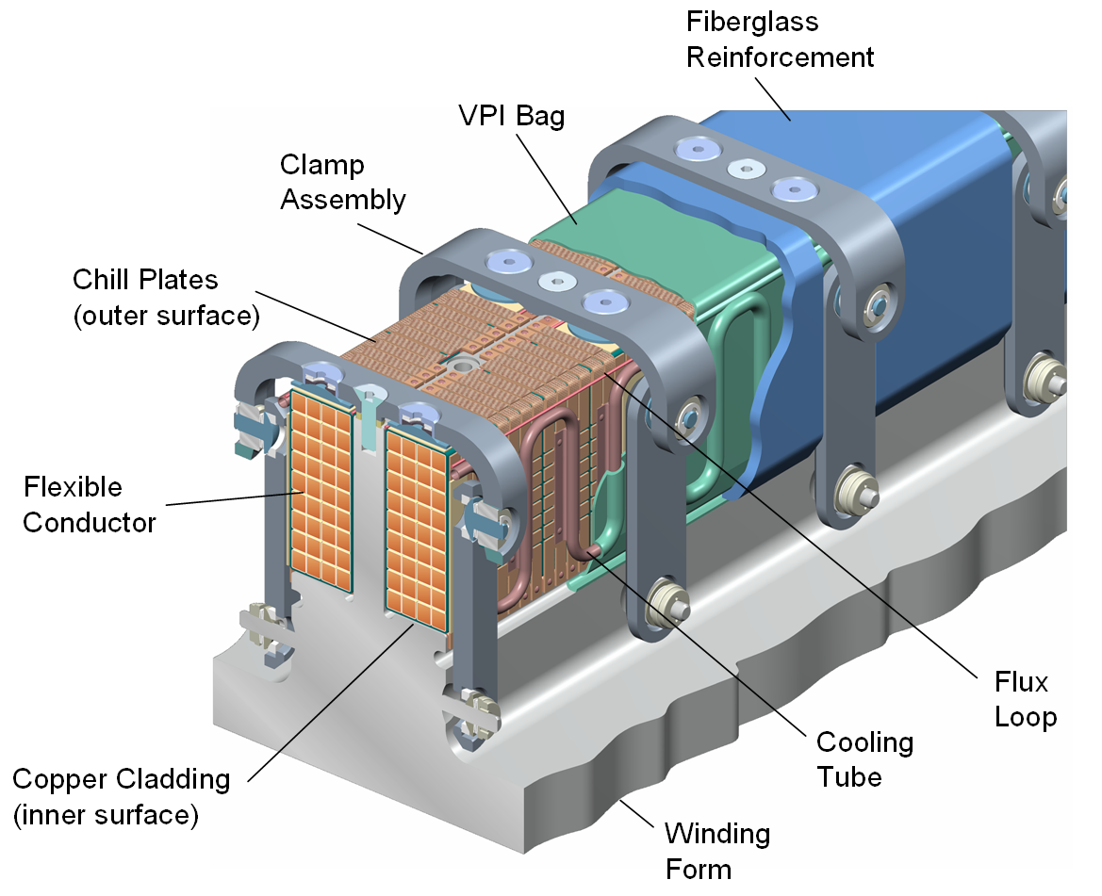
Figure 2 - TRC Winding Pack

  - Characteristics
Each of the twisted racetrack assembly subcomponents has performance or physical characteristics that are necessary for proper function of the coil and should be verified prior to or during assembly.

    - Winding form
      - Material – The winding form material is a cast, stainless steel alloy.
      - Size and weight – The bounding dimensions of the winding form are 3 x 3 x 5-ft and the weight is approximately 750-lbs.
      - Winding surface – The dimensions and tolerance of the “tee” section of the winding form are illustrated in Fig. 3.
      - Magnetic permeability – The relative magnetic permeability of the winding form shall not exceed 1.02.
      - Surface finish – All winding surfaces shall have a surface finish <125-u in.
      - Modifications – A terminal block and studs shall be attached to the winding form by welding, as specified in drawing SE1406-011.DRW.

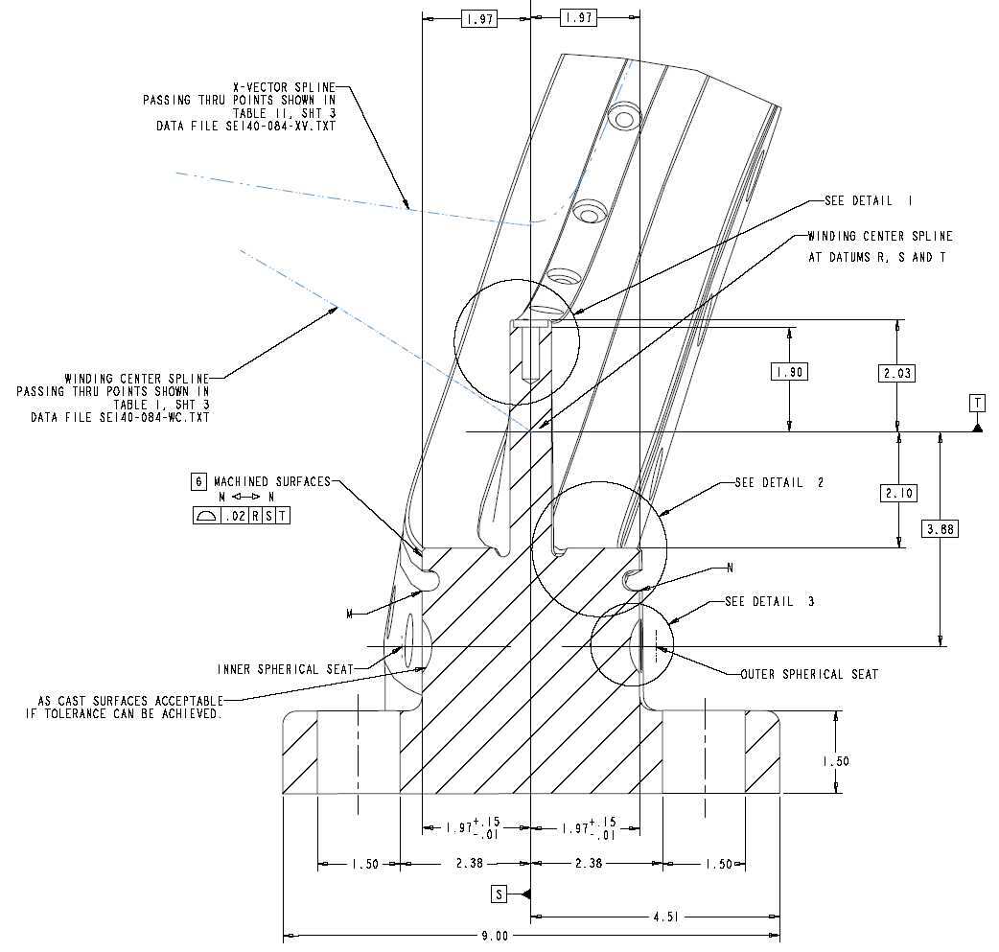
Figure 3 - Tee Dimensions and Tolerances (SE140-084.DRW)

    - Inner Copper Cladding
      - Material – The cladding material is 0.040-in thick copper sheet, UNS No. C10200, with high thermal conductivity and a temper suitable for forming. Annealed condition is acceptable.
      - Quantity, size, and weight – There are 400 pieces of cladding, with average dimensions of 1.5 x 4-in. and a total weight of ~30-lbs.
      - Sliding fit – The cladding shall conform to the winding surface but not be permanently bonded or attached to it. Temporary bonding will be required during the coil winding process.
      - Electrical insulation – The cladding shall be electrically isolated from the winding form by a half-lapped layer of 0.0035-in Kapton tape.

    - Ground Insulation
      - Material – The ground insulation is composed of S2 glass and adhesive Kapton.
      - Quantity, size, and weight – The total thickness of 0.0445-in is composed of three layers: 1) a butt-lapped layer of 0.007-in S2 glass, 2) a half-lapped layer consisting of 2-in wide x 0.007-in S2 glass and 1.5-in wide x 0.0065-in adhesive Kapton tape, and 3) a butt-lapped layer of the same composite

    - Conductor and Turn Insulation
      - Material – The conductor material is 34-AWG CDA-101 copper wire, and the turn insulation is S-2 glass cloth with S920 Silane finish.
      - Size and Weight – The nominal size of the conductor with insulation is .374 x .415-in, and the weight is approximately 410-lbs per 1000-ft.
      - Conductor length – The total length of conductor is ~900-ft.
      - Electrical properties – The resistance of the conductor shall be less than 0.089-Ω per 1000-ft when measured at room temperature.

    - Supplemental Turn Insulation at Leads
      - Material – S2 glass and interleaved Kapton with adhesive backing.
      - Quantity, size, and weight – The total thickness of 0.041-in is composed of two half-lapped layers consisting of 1-in wide x 0.007-in S2 glass and 0.75-in wide x 0.0065-in adhesive Kapton tape.

    - Winding Pack Shims
      - Material – The shim material is S2 glass cloth and or G-11 spacers with adhesive backing.
      - Size and Weight – Shims are cut from ~1-in wide x 0.035-in thick glass tape
      - Temporary attachment – Shims are attached via adhesive backing.
      - Placement location – Shims shall be applied between layers as shown in Fig. 4. Actual arrangement to be determined after conductor winding trials.
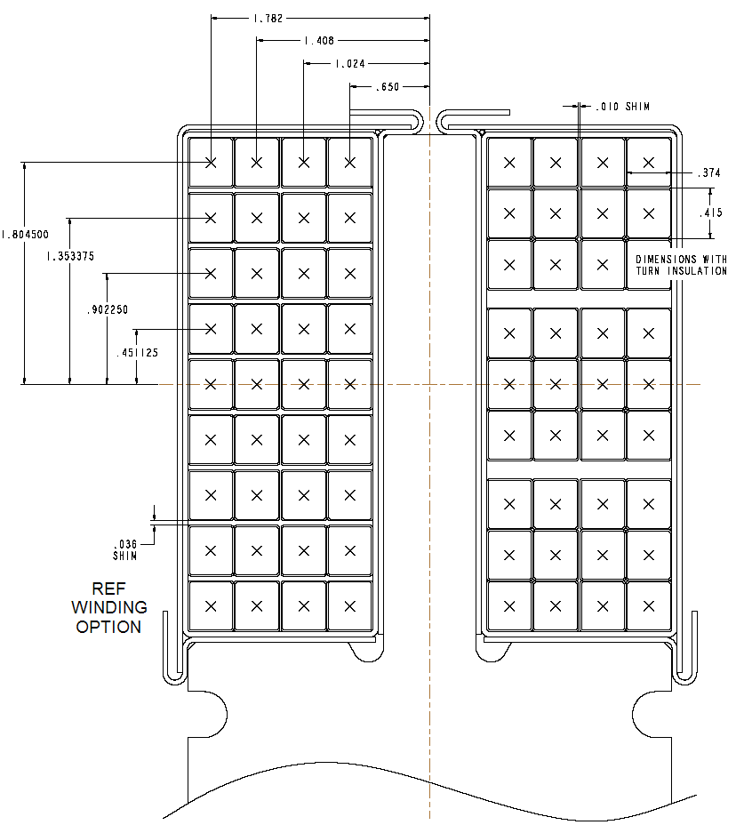
Figure 4 - Winding Pack Shim Options

    - Lead Blocks
      - Material – The lead blocks are constructed of an insulating material such as NEMA grade G11CR epoxy laminate.
      - Quantity, Size and Weight – There are four blocks per side, the largest of which is 1.5 x 5 x 10-in in size. The total weight of the lead blocks is ~10-lbs.
      - Surface Finish – The lead blocks shall be free of burrs and sharp edges that can damage the conductor. All surfaces unless machined shall be sanded to remove any high gloss surface, to promote bonding of the epoxy to the lead blocks.

    - Terminal Blocks and Insulators
      - Material – The terminal material is copper, UNS No. C10200, with interleaved insulation composed of NEMA Grade G11CR laminate.
      - Quantity, Size, and Weight – There are four jumpers per coil, with average dimensions of 1.5 x 4.5 x 5.5-in and a weight of ~0.5-lb each.
      - Surface Finish – The terminal blocks and insulators shall be free of burrs and sharp edges that can damage the conductor.

    - Chill Plates
      - Material – The cladding material is 0.040-in thick copper sheet, UNS No. C10200, with high thermal conductivity and a temper suitable for forming. Dead soft is acceptable.
      - Quantity, size, and weight – There are 200 chill plate parts, with average dimensions of 1.5 x 4 x 4-in. and a total weight of ~30-lbs.

    - Tubing / Fringe
      - Material – The tubing/fringe material is 0.040-in thick copper sheet, UNS No. C10200, and 0.25-in dia x 0.030-in wall tubing, with high thermal conductivity and a temper suitable for forming. Annealed condition is acceptable.
      - Quantity, size, and weight – There are 8 tube lengths and ~50 fringe parts total

    - VPI Bag Mold
      - Material – The bag mold is composed of self-fusing gray silicone tape, 2-part RTV-11 (white), Nomex felt (Stock No. NX08-6), and Hysol resin/hardener (Part 3561/2039).
      - Quantity, size and weight – [2] layers of silicone tape/ painted with RTV-11/ overwrapped with [2] layers of Nomex felt filled with Hysol epoxy formulation.

    - Clamp Assembly
      - Material – Stainless steel
      - Quantity, size and weight – There are 25 permanent clamps in the coil assembly.

    - Instrumentation –
      - Strain gages
        - Material – Fiber optic strain gage
        - Quantity, size, and weight – Minimum of 8 strain gages
        - Location – Three each at each end of the coil, located at the tip of the tee web and the inside/outside surface of the tee base. Two additional strain gages to be located near and opposite the coil leads.

      - Thermocouples
        - Material – Type E Chromel/Constantan, 0.010-in diameter.
        - Quantity, size, and weight – Minimum of six thermocouples.
        - Location – Within a coil plane, opposite the leads region, thermocouples shall be located in the middle of each winding pack and spaced vertically between the layers.

      - Flux loops
        - Material – Two different cables are planned. First is copper coax in a braided stainless steel jacket, second is mineral insulated wire.
        - Quantity, size, and weight – Diameter is 0.070-in, length is approx 12-ft.
        - Location – Wires shall be located at the outer corner, plasma side of each winding pack.
        - Termination – Wires shall be routed along the lead block to the base of the winding form.

QUALITY ASSURANCE
  - Inspections and tests shall be performed in accordance with written / approved procedures referencing criteria for acceptance for rejection. Critical measurements shall include 1) measuring the machined winding form prior to start of winding activities, and 2) measuring the conductor layers during and after winding activities.

  - Inspections and tests shall be performed using properly calibrated measuring and test equipment. All critical calibration standards shall be traceable to the National Institute for Standards and Technology (NIST) and shall not be used for shop inspections, but instead be protected against damage or degradation.

  - Material and equipment identification shall be maintained throughout the program and be traceable to records.

DOCUMENTATION

  - During coil assembly, the team shall maintain a system of documentation whereby objective evidence of materials used in construction and the functional compliance of the coil can be verified. Such documentation shall include process travelers and any certification, inspection, examination, test, and discrepancy reports that are required.

