To: Hutch Neilson Date: November 6, 2002

From: Jim Chrzanowski Subject: Evaluation of UT Coil in Preparation for VPI

Oak Ridge National Laboratory (ORNL) has requested that Princeton Plasma Physics Laboratory (PPPL) provide support in the fabrication of a canned test coil for the QPS device. The coil would be constructed of similar type conductor, insulation and epoxy system as is being considered for the NCSX project. The University of Tennessee was charged with fabricating the winding form and winding the coil. The coil was then to be shipped to PPPL to be vacuum-pressure-impregnated (VPI).

The UT coil arrived at PPPL on October 23, 2002. Jim Chrzanowski conducted an initial inspection and evaluation of the coil on October 29, 2002. Upon completion of the evaluation, the following observations were made:

Observation #1 (Photo #1)

Upon removal of the caps which were installed over coil leads and cooling tubes, it was noted that the cooling tubes were pressed hard against the openings in the cover plate. The same was true with the electrical leads. No electrical insulation was observed on the copper tubes, and the electrical leads in my opinion, were inadequately insulated or supported.

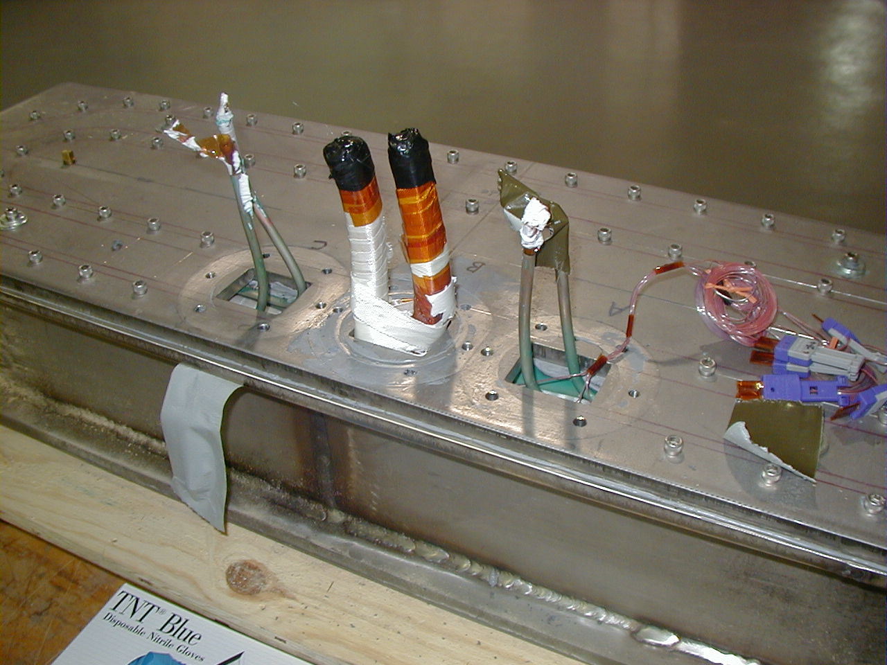
Photo #1 Leads and Cooling Tubes

Photo #2 shows more closely the copper cooling tubes exiting the coil.

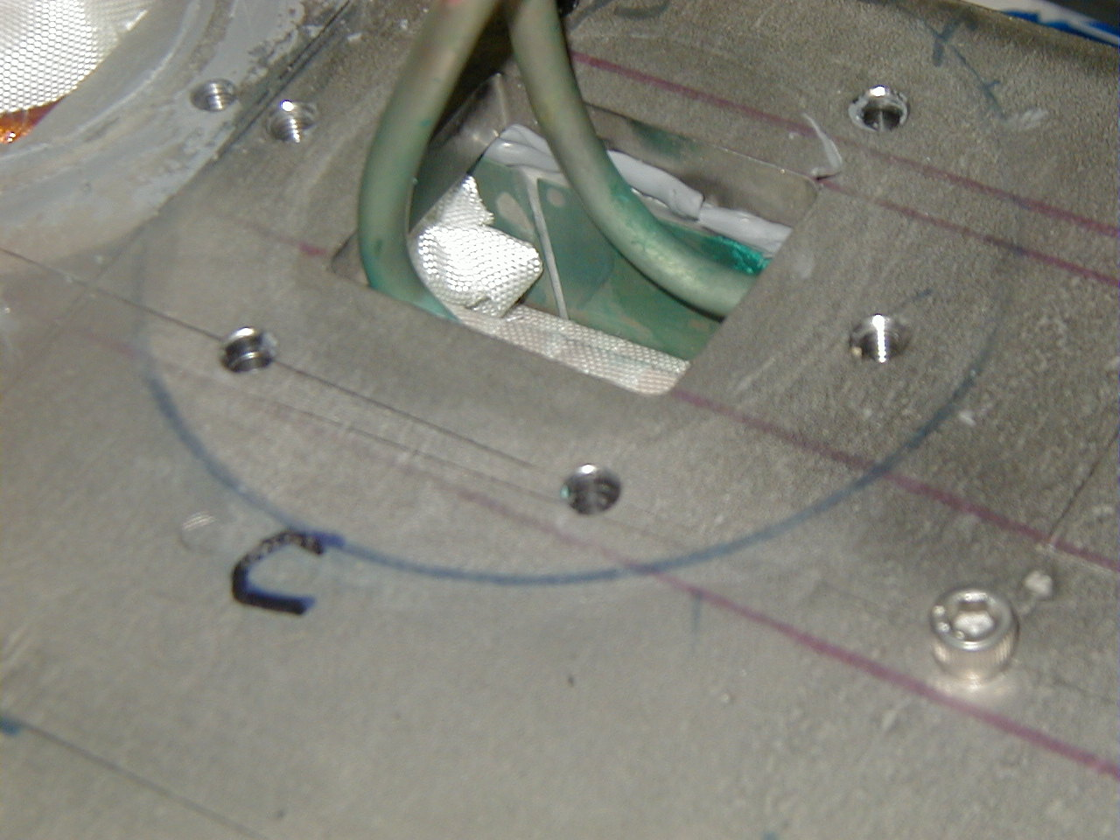
Cooling Tubes pressing hard against cover
Photo #2 Cooling Tubes Exiting the Coil

Observation No. 2

The cavity around the leads and cooling tubes appears quite large. During a VPI process, this unfilled area would quickly fill with epoxy resin and could be susceptible to possible cracking due to thermal shock. Following conversations with ORNL, it was verified that this void area runs around the top of the entire length of the coil. This large unfilled cavity posses a serious problem when performing the VPI operation. During the VPI process, the epoxy will seek the passages with least resistance, and could conceivably bypass portions of the insulated coil, causing epoxy-starved areas within the coil. The NCSX/QPS insulation scheme relies on a good VPI to allow the resin to flow between the co-layered Kapton/glass insulation. Photo #3 shows this area with the top plate removed.

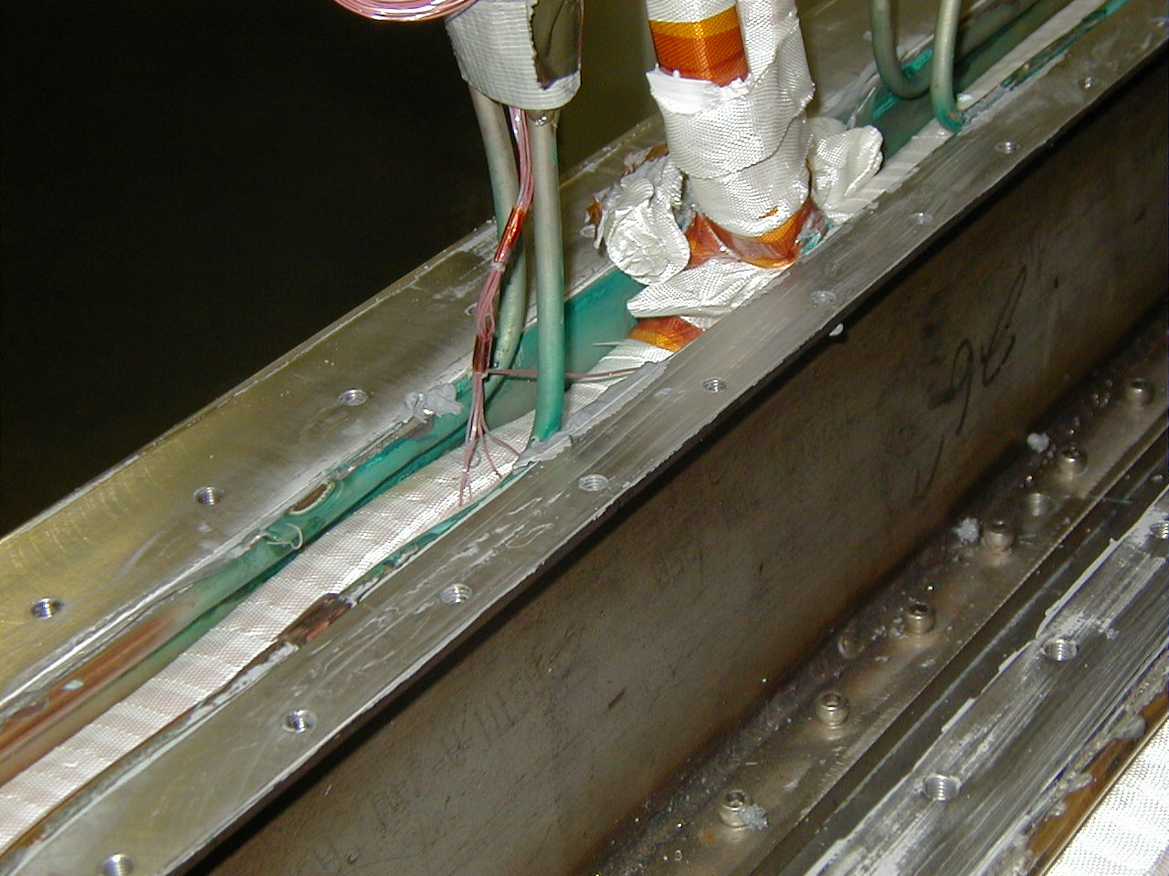
Photo#3 Unfilled Cavity Area

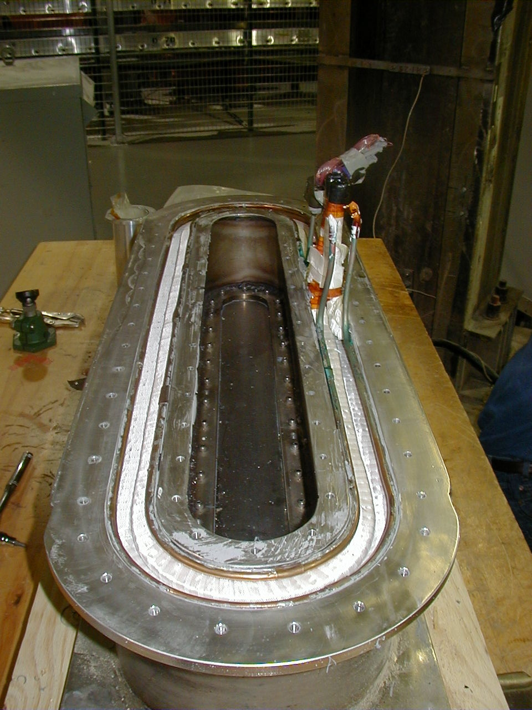
Open Cavity near top surface
Photo #4 UT Coil Without Top Plate

Observation No. 3 (Photo #5)

ORNL allowed us to remove the top plate to further our investigation. Following the removal of the plate, we were shocked to see what appears to be cutting oil and steel chips in the center cavity area of the coil form. The close proximity of these materials to the unimpregnated coil is a major concern with the integrity of the insulation. Even though it has been noted that the cover was on the coil when this hole was drilled, it does not relieve any concerns that I have concerning the quality of the coil and the possibility of oil or chips entering the insulation system.

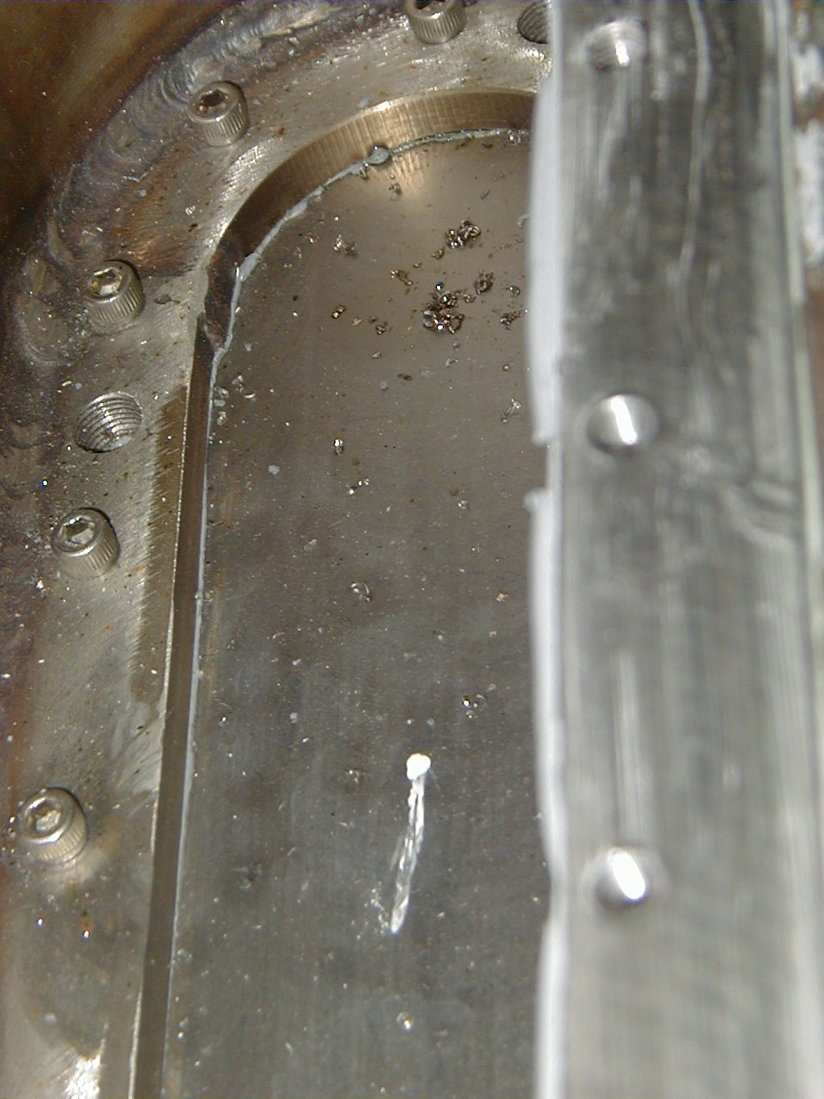
Steel chips and oil

Photo#5 Coil Center Cavity

Observation No. 4 (Photo #6)

Upon removal of the top plate, it was also noted that the threads of the epoxy fill hole had not been cleaned and had numerous steel filings in the threads. This hole was directly facing the coil surface. Another similar hole is located on the bottom surface of the coil, but has not been inspected. Whether any of the filings have dropped onto the glass insulation is not obvious but is a possibility. During any VPI operation, epoxy would carry these steel filings into the dry glass and possibly cause an electrical short.

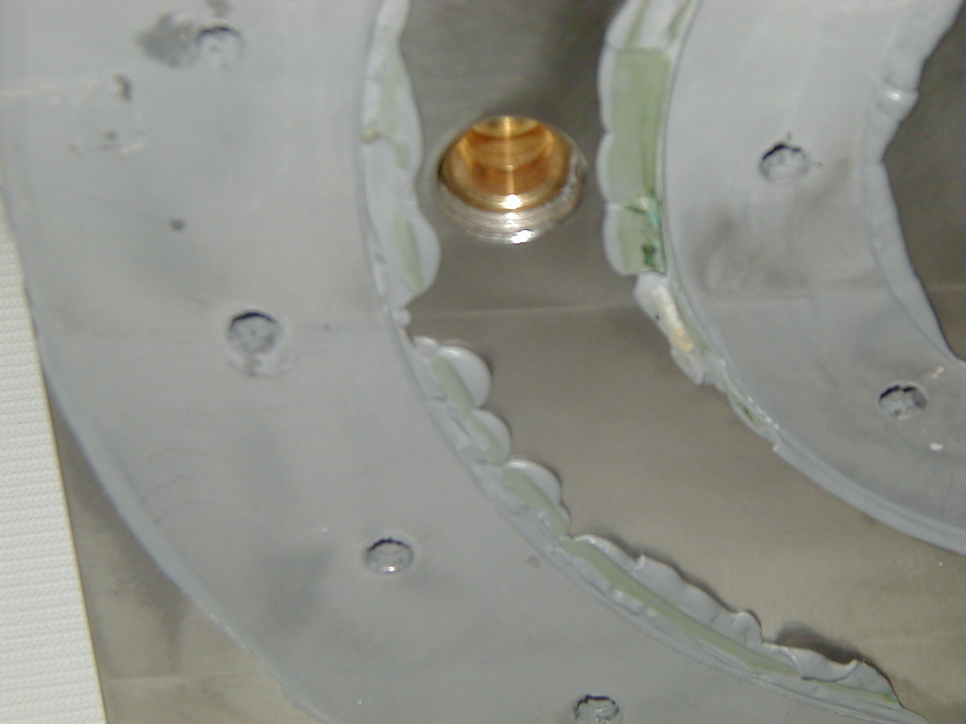
Threaded hole where filings were observed

Photo #6 View of Epoxy Fill Hole

Additional Observations

ORNL provided us with photos of the coil winding operation at U of T. Several observations were made. The first is the technicians were handling the insulated conductor with bare unprotected hands. The oils and dirt on your hands could possibly inhibit the wicking of epoxy into the glass insulation. Clean cotton gloves should always be used. Another observation is that the technicians used short sections of the conductor as spacers during winding. This is acceptable, providing no copper stands from the conductor became loose and found them selves imbedded in the turn insulation. I would recommend the use of pre-fabricated spacers made from phenolic, nylon, aluminum etc.

Ground Wall:
There does not appear to be any ground wrap insulation on the sides of the coil. This would add additional electrical standoff to the winding form, and would provide a controlled flow path for the epoxy to move about the coil during VPI. One additional feature would be improved bundle strength.

Recommendations:

There were a number of observations, which were made, that all question the readiness of the UT coil for epoxy impregnation. The improper handling of the conductor; lack of CLEANLINESS during manufacturing; insufficient exit ports for VPI; and too many large unfilled cavities; are all major concerns.

I must first note, that it is not the intent of this report to question the technical ability or dedication of those individuals who wound the coil. However, it is obvious that additional training and education in the art of coil winding must be implemented so that these problems can be corrected.

I would recommend that the entire coil be rewound. This of course following ample instruction and training for the technicians in coil manufacturing etiquette. If this not an option, then I would recommend the following:

- Thorough cleaning of all visible surfaces including copper tubes. Besides the oil, steel filings and chips, excessive copper oxide was observed on cooling tubes just inside the top plate.
- Addition of more exit ports in the top plate to assist in the VPI. It would be extremely useful to have additional ports to track the progress of the resin during VPI.
- Added insulation and support between the coil leads. Better support and insulation between the leads is necessary. Protection around the area where the leads exit the top plate would also be useful.
- Addition of insulation around coolant tubes as they exit top plate. This would provide additional standoff between the copper tube and the coil can. Is there insulation between the copper plate and the winding form?
- Increase the openings in top plate around leads and coolant tubes.
- Fill top cavity with G-10, glass roving or glass tape to minimize resin rich areas and to enhance VPI performance.

Even these corrective actions cannot guarantee that dirt or metallic chips have not already entered the insulation. This work could be performed by either ORNL or PPPL.

Cc D. Williamson
B. Nelson
W. Reiersen
P. Heitzenroeder

