PPPL-NCSX Memorandum

To: Michael Kalish (PPPL)
From: Leonard Myatt (Myatt Consulting, Inc.)
Date: January 28, 2004
Subject: Thermal Transient Response of the Modular Coil Conductor

1.0 Executive Summary

This memo describes a thermal transient analysis of the NCSX Modular Coil conductor. The 2D ANSYS model of the conductor cross-section includes almost 2600 34-gage Cu strands, the impregnating epoxy, and glass-epoxy turn wrap insulation. The Cu strands dissipate ρJ² resistive heat from a reference scenario to heat the composite. Temperature contours and line plots through the conductor cross-section are used to illustrate the level of non-uniformity and determine the maximum thermal gradients during the transient. A hand-calculation converts the temperature gradients to thermal stresses.

The analysis shows that the worst-case 2T High-β scenario produces a temperature gradient of ~10K across the Cu/Epoxy composite, and 12K across the epoxy and glass outer layers. A classical thermal gradient hand calculation shows that the stress produced by these gradients is rather trivial (<200 psi) because of the relatively small gradients and soft materials. In-plane stresses from a 2D plane-stress analysis of the conductor cross-section with a temperature profile imported from the thermal model indicate a maximum stress of 1 ksi in the turn wrap. This is many safety factors below the tensile stress limit of a typical glass-filled epoxy.

In conclusion, this analysis shows that thermal gradients developed during any of the various reference Modular Coil current scenarios will not produce significant stresses in the conductor or insulation. This does not apply to stresses developed in the coil from coil-structure interactions during cool-down or EM body forces.

2.0 Analysis

The NCSX Modular Coils are driven through a variety of current scenarios, as detailed in a project spread sheet. This document also lists the dissipated energy and adiabatic temperature rise in each coil for each proposed current transient. A review of these reference scenarios indicates that the 2T High-Beta Scenario dissipates the most heat (20.5 MJ) and produce the largest temperature rise in the conductor (Modular Coil #2, 85K to 123K). There is some concern over the resulting temperature distribution within the conductor since the heat is dissipated entirely within the Cu wires, while the response of the impregnating epoxy and glass-filled epoxy turn-wrap insulation will lag behind. The objective of this analysis is to quantify the temperature distribution and stress.

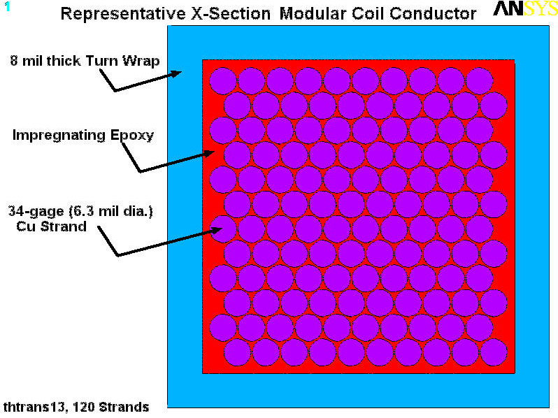
This analysis determines the thermal response of this M2 conductor cross-section by modeling a representative number of 34 gage Cu strands, impregnating epoxy and glass-epoxy turn wrap insulation. Fig. 2.0-1 is a plot of the 2D parametric ANSYS model of the conductor cross-section with only 120 strands (for clarity). There are analyses which are based on 208, 418, 810 and 2538 strand models. The last one is within 4% of the actual 2640 strands (44x5x12) used to make the Modular Coil cable. The text-based ANSYS input file is included as Sec. 4.1.
Fig. 2.0-1 Representative Modular Coil Conductor Cross-Section
The parametric conductor model is defined by the number and size of Cu strands (34-gage, 6.3 mil dia.), the center-to-center strand spacing (5% larger than the strand diameter chosen for meshing purposes), the serve thickness (4 mils), and the turn-wrap insulation thickness (8 mils). Thermal properties of the Cu, epoxy and turn-wrap insulation are taken from various reference at the nominal transient temperature of 100K (see the ANSYS input listing in sect. 4.1).

This idealized model is designed to simulate a cross-section through the Modular Coil conductor (see Fig. 2.0-2). However, the complexities of Cu strand deformities (produced by strand-to-strand contact during winding and forming operations) and a normal distribution in strand-to-strand spacing, would be both too difficult to model and probably not critical to the objectives of the analysis.

Fig. 2.0-2 Micrograph of the Modular Coil Conductor Cross-Section (Courtesy B. Nelson, ORNL)
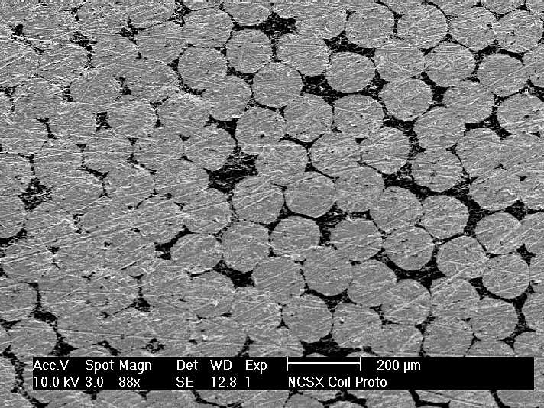
The thermal model is loaded by applying ρJ² heating to the Cu strand elements. Rather than formulating the analysis as a nonlinear problem with temperature-dependent resistivity (ρ), the model assumes a constant value (3.6e-9 Ω-m). The expected 85-125K temperature change does not produce a large enough change in the resistivity to justify the added complexity in the analysis. The current (I) as a function of time is taken from [Error: Reference source not found] and listed below;

Time Point #0: ( 0.0 s, 0 A)
Time Point #1: (0.000+0.85s,41561A)
Time Point #2: (0.097+0.85s,41561A)
Time Point #3: (0.192+0.85s,38338A)
Time Point #4: (0.197+0.85s,38338A)
Time Point #5: (0.197+1.94s,13725A), one L/R time constant beyond Time Point #4
Time Point #6: (0.197+4.12s, 1917A), three L/R time constants beyond Time Point #4

These currents are converted to current densities by dividing by the Cu area of the four parallel turn current paths. A project spreadsheet lists the total Cu area as 251.4 mm², which is a bit larger than the area of (4x2640) 6.3 mil circles (212 mm²).

Although the current history reported in [Error: Reference source not found] ends at Time Point #4, two additional Time Points are added to capture the effects of the current decay at one and three L/R time constants following the “crow-barred” terminals. It is assumed that the current varies linearly from one time-point to the next. All exposed surfaces are assumed to be thermally insulated, which is consistent with a conservative, adiabatic temperature rise calculation.

The model is run initially with a zero heat capacity for the insulation and epoxy. The resulting temperatures are compared to those listed in [Error: Reference source not found] which also ignores the heat capacity of the insulation, to confirm the accuracy of the model.

The model is also used to simulate a number of different conductor cross-sections, as indicated earlier (208, 418, 810 and 2538 strand configurations). This approach evolved from some uncertainty in the computational resources required to handle the full 2640-strand conductor. Transient analyses of the smaller strand-count models ran relatively quickly, and provided hope that an analysis of the full conductor would be achievable. Indeed, analysis of the 2538-strand model completed in ~ 4 hours. Then, rather than drop the results of the smaller strand-count models, they are presented to show the effect of conductor size on temperature non-uniformity.
3.0 Results

The first analysis is designed simply to confirm the accuracy of the 2D model. Only the Cu strands are given a heat capacity. Table 3.0-1 lists the temperature as a function of time for the most temperature-limiting transient (2T High-Beta Scenario). One column lists the values taken from [Error: Reference source not found], while the other column lists values taken from this ANSYS model.

There is relatively good agreement between the two calculations during the well-defined portion of the transient; the spreadsheet lists the current in the Modular coils at the time points from 0 to 1.047s. The currents beyond 1.047s are defined by an L/R decay, and are not necessarily identical to the values used in the spreadsheet calculation. Also, the Cu resistivity and heat capacity are assumed to be constants during the transient. This will affect the thermal calculation, especially later in the transient when temperatures vary more significantly from the initial condition. This could explain the discrepancy between the two calculations at the final time-point.

Fig. 3.0-1 is a plot of the temperature distribution in a 120-strand conductor cross-section at t=1.047s. The distribution is perfectly uniform because the heat capacity of the epoxy and turn insulation is ignored in this analysis. The legend indicates a temperature of 115K which is in reasonably good agreement with the 114K reported in [Error: Reference source not found]. This is sufficient to prove that the model is working properly, given the limitations of constant thermal and electrical properties.

In all of the following analyses, the epoxy and turn insulation are given more realistic heat capacity values. A number of different strand-counts are modeled in order to assess the impact of the conductor size on temperature non-uniformity.

Fig. 3.0-2 is a plot of the temperature distribution in the 208-strand cross-section at the end of the 2T High-β scenario (1.047s). In this case, the inner strands are at a slightly higher temperature than the outer strands. This temperature distribution is also illustrated by the line plot of Fig. 3.0-3 which shows the temperature as a function of the diagonal distance across the conductor. In general, the temperature in the strand region is fairly uniform, with a maximum differential of 6.8K occurring at the 1.042s (or 1.047s) time point. The curve for the 1.047s time-point is not plotted since it is essentially coincident with the 1.042s curve. The largest gradients occurs between the edge strand and the inner of the turn-wrap, in a medium representing the serve and epoxy. In this model, the gradient between the edge of the outer strand and the outer edge of the turn-wrap is 11.5K.

Figs. 3.0-4 & 3.0-5, Figs. 3.0-6 & 3.0-7 and Figs. 3.0-8 & 3.0-9 are similar pairs of plots for the 418, 810 and 2538-strand models. Results are qualitatively identical to the 208-strand configuration. However, the longer heat paths between the un-heated insulation and the center of the Cu-strands of the large conductors (higher strand-count) produce slightly higher temperatures. The maximum center-to-edge strand differential is 8.6K for the 418 strand conductor, 9.7K for the 810 strand conductor, and 10.2K for the 2538 strand conductor.

This is an interesting result: conductors with strand-counts varying by more than an order of magnitude (208 to 2538 strands) have temperature non-uniformities varying by only 7 and 10K. In reality, the temperature variation within the cable cross-section may be even smaller from 3D effects. Because of the twisting in the cabling process, the position of each strand within the cross-section will vary with distance along the cable. Strands located in the middle of the cable in one axial position will drift toward the edge of the cable at some other axial distance. Conversely, strands at the outer edge of the cable in one axial position will drift toward the cable center at some other axial distance. Axial conduction along the high-conductivity Cu strand will tend to ameliorate some of these temperature gradients.

It is also interesting to note that the maximum gradient between the edge of the outer strand and the outer corner of the turn-wrap is 11.6±0.1K in all of the models. So, there is a larger (and steeper) temperature gradient across the outer layer of insulation than there is across the entire Cu/epoxy cable . In both cases, however, the gradient is small (10-12K).

At this point, it would be helpful to calculate the stress produced by these thermal gradients. The classical hand calculation for a thermal gradient (ΔT) induced stress is given below:

σ = Eα(ΔT/2)
where,

- E is the elastic modulus (~2 Mpsi in the epoxy-Cu composite, and 4 Mpsi in the Epoxy-Glass turn-wrap).
- α is the coefficient of thermal expansion (~15 μ/K in the epoxy-Cu composite, and ~8 μ/K in the Epoxy-Glass turn-wrap).
- ΔT is the thermal gradient (~10K in the epoxy-Cu composite, and 12K in the Epoxy-Glass turn-wrap).

Substituting into the equation yields;

σ(Cu/Epoxy Composite) = (2 Mpsi)(15 μ/K)(10K/2) = 150 psi
σ(Glass/Epoxy Turn Wrap) = (4 Mpsi)(8 μ/K)(12K/2) = 200 psi

Even if E or α are in error by a factor of two, theses stresses will be well below 500 psi.

There is another stress condition that is worth evaluating; the stresses in the plane of the conductor cross-section from a “warm” Cu/Epoxy composite and a “cool” glass/epoxy wrap. This situation is handled by importing the detailed temperature distribution into a stress model. Fig. 3.0-10 shows the stress intensity in the conductor cross-section. Here, the Cu/Epoxy composite is assigned a modulus of ~2 Mpsi, while the CTE values are 14μ/K for the Cu and 20μ/K for the epoxy. The result is a maximum stress in the turn wrap of about 7 MPa (1 ksi). This is also considered a relatively small stress, as glass-filled epoxy can handle in-plane tensile stresses approaching 800 MPa. It is worth noting that the transverse modulus of the Cu/Epoxy composite is not well documented. The 2 Mpsi used in this analysis comes from [Error: Reference source not found] which is for axial tension loading.

Clearly, with materials this soft, and thermal gradients this small, there can be no significant stress from the temperature distribution produced by the worst-case 2T High-β scenario.
Table 3.0-1 Comparison of Temperature Responses, Project Spreadsheet [Error: Reference source not found] and 2D Model

Time [s] into  2T High-β Scenario | Results From [Error: Reference source not found] | Results from 2D ANSYS Model
0 | 85 | 85
0.85 | 106 | 107
0.947 | 110 | 111
1.042 | 114 | 115
1.047 | 114 | 115
4.228 | 123 | ~135

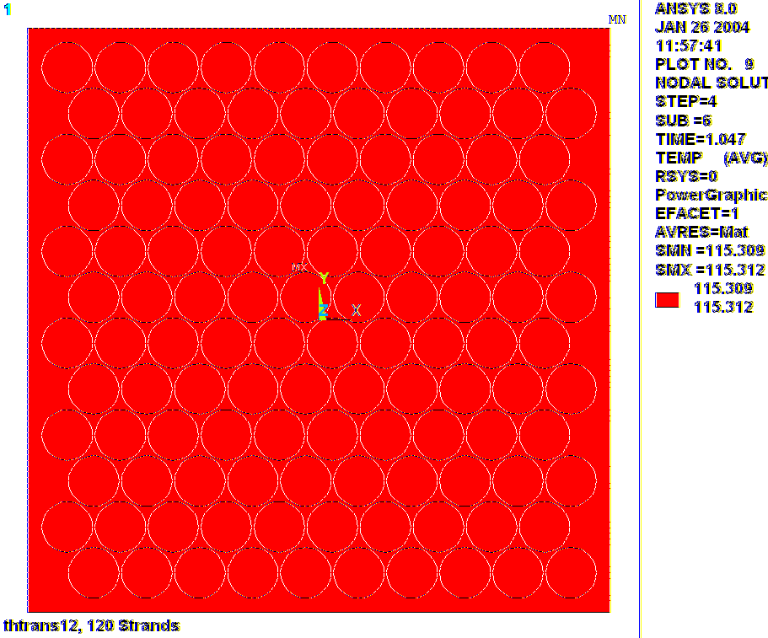
Fig. 3.0-1 Temperature Distribution in 120-strand model, Zero Heat Capacity Insulation, t=1.047 s

Fig. 3.0-2 Temperature Distribution in 208-strand model, t=1.047 s
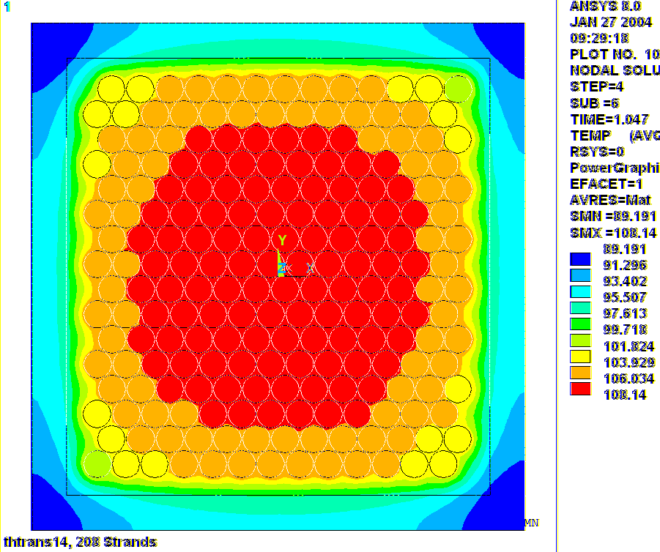
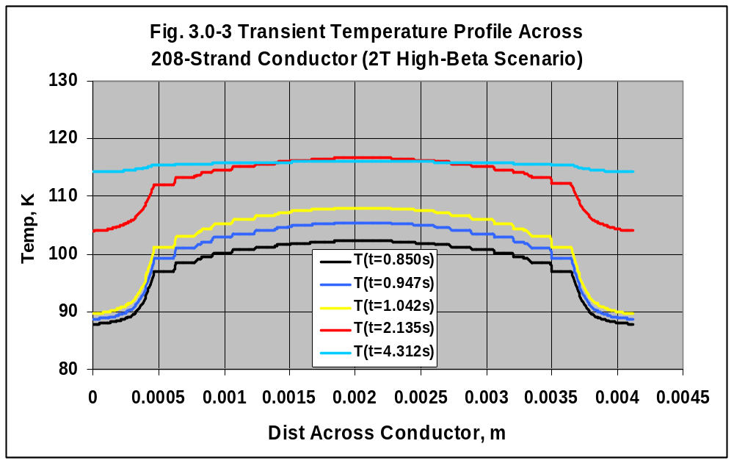
Fig. 3.0-4 Temperature Distribution in 418-strand model, t=1.047 s
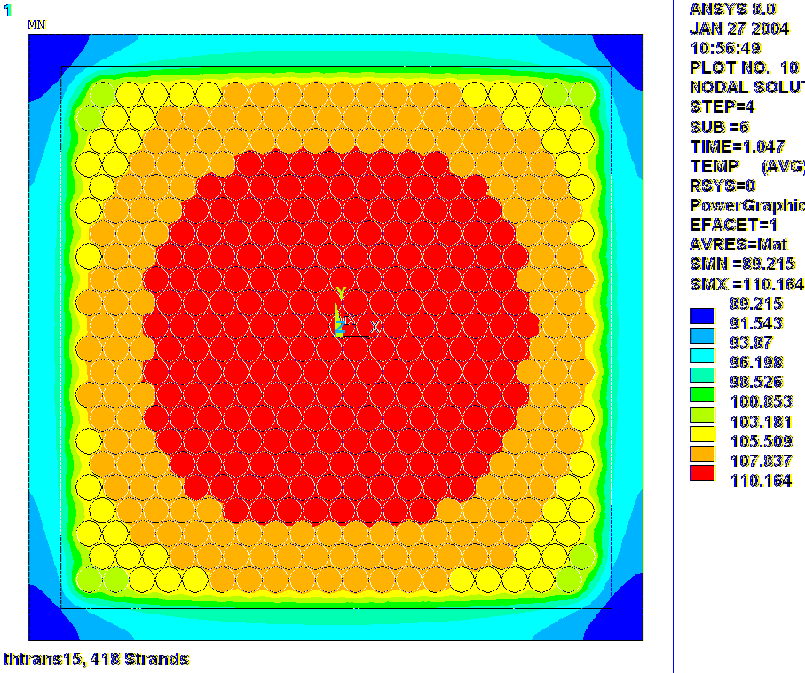
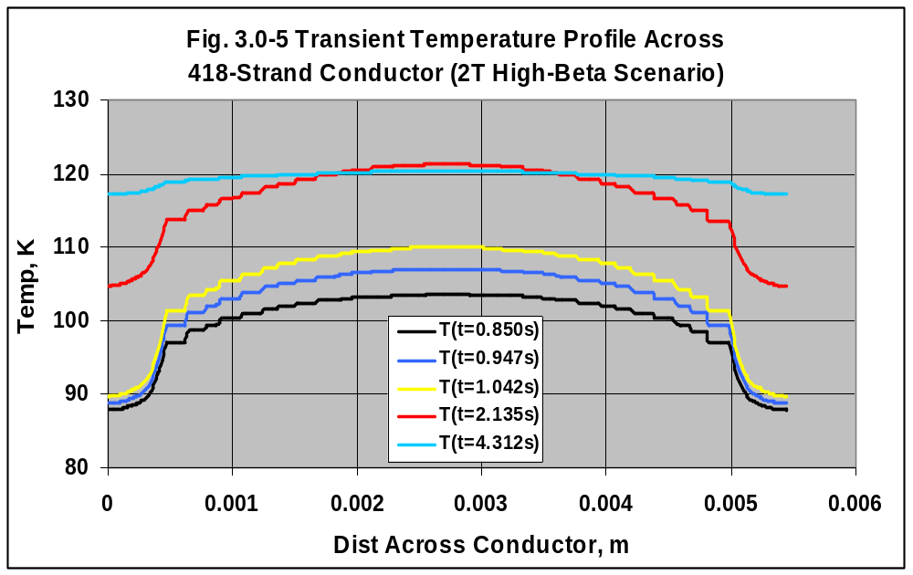
Fig. 3.0-6 Temperature Distribution in 810-strand model, t=1.047 s
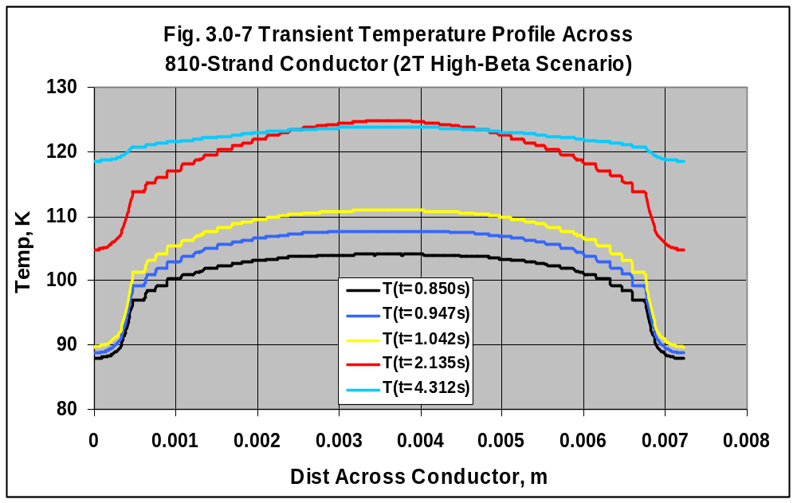
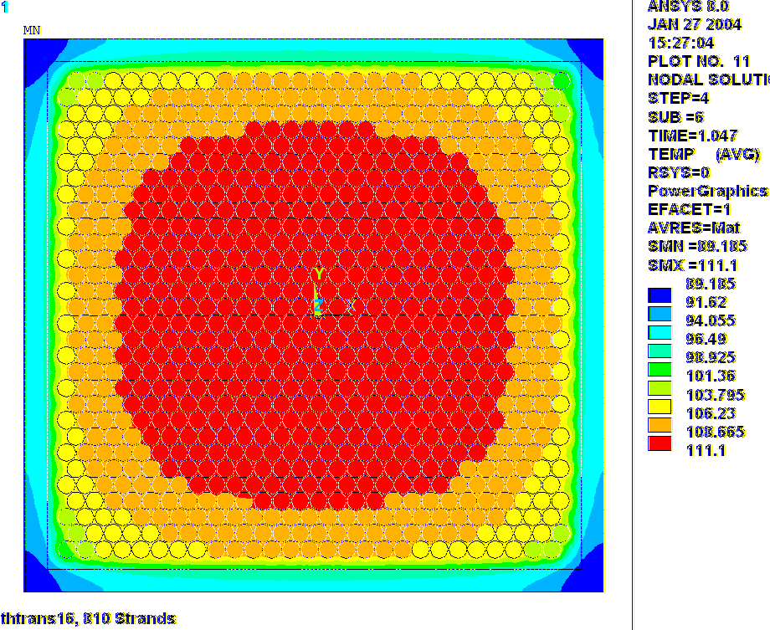
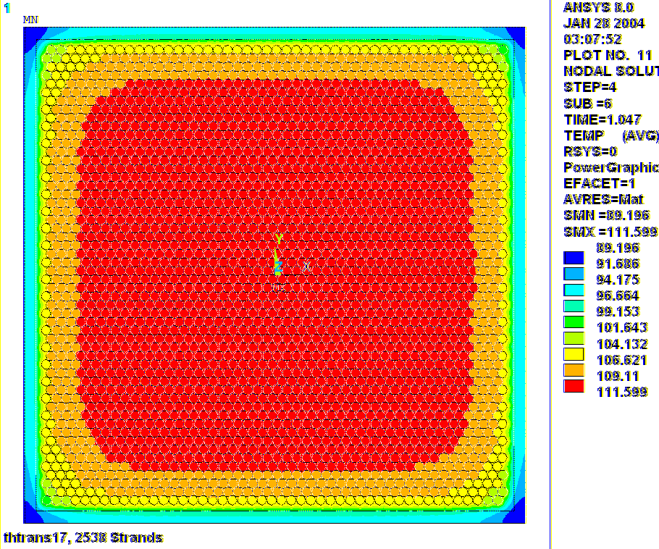
Fig. 3.0-8 Temperature Distribution in 2538-strand model, t=1.047 s
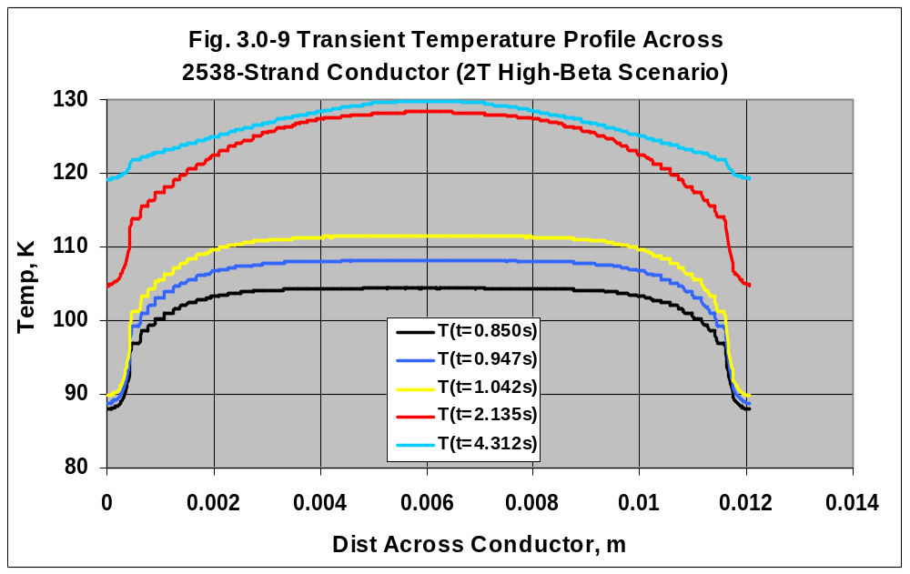

Fig. 3.0-10 Stress Intensity in the 418-Strand cross-section, temperatures from t=1.047s
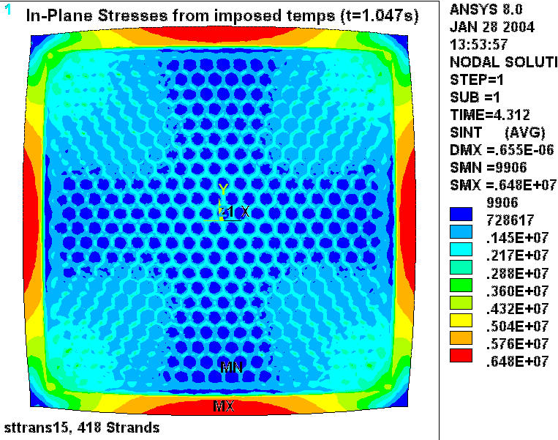
Note: The time listed in the plot legend is misleading. Because the stress analysis is initiated after the completion of the thermal transient, the default time comes from the final load step of the thermal analysis. The temperatures are read from the thermal analysis results file at time-point 1.047s, and plotted in Fig. 3.0-11.
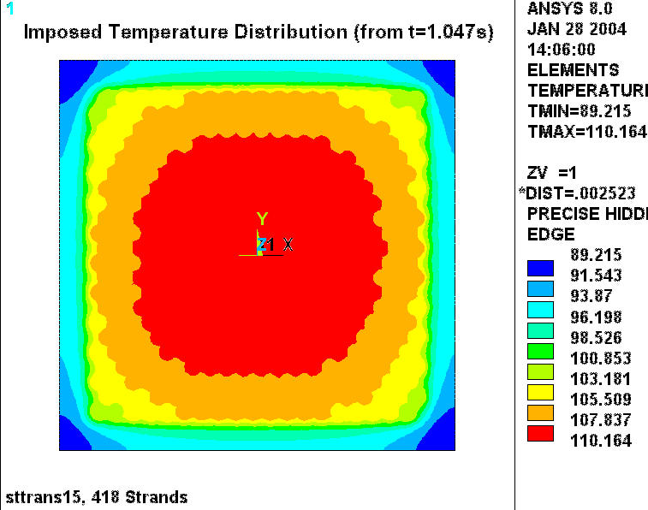
Fig. 3.0-11 Imposed Temperature Distribution on Conductor Cross-Section (t=1.047s)

Notice that this contour plot of imposed nodal temperatures is identical to the thermal model results shown in Fig. 3.0-4.
4.0 Attachments

4.1 ANSYS Input File (circa 01/26/03)

/batch
rn=4
/filnam,thtrans1%rn%
/show,thtrans1%rn%,grp
/GRAPHICS,POWER
/prep7
!resu
!*go,:1000
/prep7
/com
/com 2D Thermal Transient Analysis of the NCSX Modular Coil Conductor
/com Model designed to evaluate thermal response of epoxy & Cu strands
/com
/com Run Status
/com
/com 10: M2 2T High Beta Scenario, made-up Epoxy properties
/com 12: M2 2T High Beta Scenario, epoxy with zero thermal capacity, 120 strands, 8 mil turn-wrap
/com 13: M2 2T High Beta Scenario, defendable properties, 120 strands, 8 mil turn-wrap
/com 14: M2 2T High Beta Scenario, defendable properties, 208 strands, 8 mil turn-wrap

/com
/com Misc Parameters
/com
k=0.0254 ! english to si conversion factor
t=1e-6 ! a tiny dimension (also the length of coil/case gaps)
pi=acos(-1) ! Pi
*afun,deg ! trig functions in degrees
/pnum,mat,1
/num,1
/type,1,4

/com
/com Design Parameters
/com
k_dim=2 ! 2: 2D, 3: 3D
l_tot=0.63*k ! length of model
deltaz=0.001 ! Imposed Axial Displacement, +=Tension, -=Compression
nez=100/2 ! number of axial elements

/com
/com Current History (from TDS_XL_C08R00_C1.xls)
/com
tref,85
t1=0.0+0.85
i1=41561
t2=0.097+0.85
i2=41561
t3=0.192+0.85
i3=38338
t4=0.197+0.85
i4=38338
t5=0.197+0.85+(1*(9.23e-3/8.48e-3)) ! 1 time constant
i5=38338*(0.358)
t6=0.197+0.85+(3*(9.23e-3/8.48e-3)) ! 3 time constants
i6=38338*(0.050)

/com Cable Parameters
kshape_s1=1 ! 0 circular array of conductors, 1 square array
n_s1=200 ! number of Stage 1 strands
d_s1=0.0063*k ! diameter of Stage 1 strands
p_s1=0.63*k !2.5*k ! pitch length of Stage 1 bundle
a_cu=251.4e-6 ! total Cu Area carrying coil current (from TDS_XL_C08R00_C1.xls)
pitchx_s1=1.05*d_s1 ! wire pitch in X
pitchy_s1=1.05*d_s1*sin(60) ! wire pitch in Y
t_tw=0.008*k ! turn wrap insulation thickness

/com
/com element types
/com
et,1,55 ! 2D TEMP
et,10,200,1 ! 2D line w/mid-side nodes
et,11,200,6 ! 2D quad

/com
/com Cu Strand
/com
mp, ex,2,137e9
mp,alpx,2,14e-6
mp,nuxy,2,0.34
mp,c,2,250
mp,dens,2,8950
mp,rsvx,2,3.6e-9
mp,kxx,2,470

/com
/com CTD-101K Epoxy
/com
mp, ex,3,3.4e9
mp,alpx,3,20e-6
mp,nuxy,3,0.34
mp,c,3,1100
mp,dens,3,1200
mp,rsvx,3,0
mp,kxx,3,0.15

/com
/com Ground wrap, X is through thickness
/com
mp, ex,4,16e9
mp, ey,4,28e9
mp, ez,4,28e9
mp,alpx,4,25e-6
mp,alpy,4,8e-6
mp,alpz,4,8e-6
mp, gxy,4,5e9
mp, gyz,4,5e9
mp, gxz,4,5e9
mp,nuxy,4,0.2
mp,nuyz,4,0.2
mp,nuxz,4,0.2
mp,c,4,1100
mp,dens,4,1800
mp,rsvx,4,0
mp,kxx,4,0.3 ! from Reed's NISTIR 5024 (yellow book)

/com
/com Make the Stage 1 cross-section
/com
ncx_s1=(4/pi)*sqrt(n_s1)
ncy_s1=(4/pi)*sqrt(n_s1)
csys
wpcsys
pcirc,,d_s1/2
agen,ncx_s1,all,,,pitchx_s1
cm,row1,area
agen,2,all,,,pitchx_s1/2,pitchy_s1
!cmsel,u,row1
!agen,2,all,,,,-d_s1*(1-sin(60)),,,,1
allsel
agen,nint(ncy_s1/2),all,,,,2*pitchy_s1!*sin(60)
/com Move Array to 0,0
*get,xmn,kp,,mnloc,x
*get,xmx,kp,,mxloc,x
*get,ymn,kp,,mnloc,y
*get,ymx,kp,,mxloc,y
agen,2,all,,,-(xmx+xmn)/2,-(ymx+ymn)/2,,,,1

/com Select the central ~n_si strands
csys,1
*get,rmx_s1,kp,,mxloc,x
*do,j,1,200
*if,kshape_s1,eq,0,then
csys,1
asel,s,loc,x,,rmx_s1*(0.5+j/200)
*else
csys
asel,s,loc,x,-rmx_s1*(0.5+j/200)/sqrt(2),+rmx_s1*(0.5+j/200)/sqrt(2)
asel,r,loc,y,-rmx_s1*(0.5+j/200)/sqrt(2),+rmx_s1*(0.5+j/200)/sqrt(2)
*endif
*get,n_sel,area,,count
*if,n_sel,ge,n_s1,exit
cm,atemp_s1,area
*enddo
!cmsel,s,atemp_s1
asel,invert
adele,all,,,1
allsel
*get,nmod_s1,area,,count
cm,a_s1,area

/com
/com Overlap with epoxy
/com
allsel
type,10
esize,d_s1/10
lmesh,all
csys
*get,xmn,node,,mnloc,x
*get,xmx,node,,mxloc,x
*get,ymn,node,,mnloc,y
*get,ymx,node,,mxloc,y
csys,1
*get,rmx_s1,node,,mxloc,x
wpcsys
lclear,all

*if,kshape_s1,eq,0,then
pcirc,,1.05*rmx_s1
pcirc,,1.05*rmx_s1+t_tw
*else
rectng,1.05*xmn,1.05*xmx,1.05*ymn,1.05*ymx
rectng,1.05*xmn-t_tw,1.05*xmx+t_tw,1.05*ymn-t_tw,1.05*ymx+t_tw
*endif
allsel
aovlap,all

/com
/com Assign attributes & mesh areas before dragging
/com
*if,kshape_s1,eq,0,then
csys,1
ksel,s,loc,x,,rmx_s1+t
lslk,,1
asll,,1
aatt,2
asll
asel,u,mat,,2
aatt,3
asel,s,mat,,0
aatt,4
*else
csys
ksel,s,loc,x,xmn-t,xmx+t
ksel,r,loc,y,ymn-t,ymx+t
lslk,,1
asll,,1
aatt,2
asll
asel,u,mat,,2
aatt,3
asel,s,mat,,0
aatt,4
*endif
/title,thtrans1%rn%,Structural Model of %nmod_s1% Strand Cable
/com
/com Mesh areas (before dragging in Z)
/com
type,11
cel=d_s1/3
asel,s,mat,,3
esize,cel/3
!MSHAPE,1,2D
!MSHKEY,0
amesh,all
asel,s,mat,,2,4,2
!MSHKEY,2
esize,cel/2
amesh,all
allsel
modmesh,detach
*if,k_dim,eq,3,then
/com
/com Extrude in Z
/com
esel,all
nsle
*get,e_strt,elem,,num,min
*get,e_stop,elem,,num,max
*get,nmx,node,,num,max
*get,nmn,node,,num,min
dn2=nmx-nmn+1
csys,1
ngen,nez+1,dn2,all,,,,360*(l_tot/p_s1)/nez,l_tot/nez
/com
/com Make the elements
/com
modmesh,detach
type,1
*do,j,e_strt,e_stop,1
*if,esel(j),ne,1,cycle
*get,ni,elem,j,node,1
*get,nj,elem,j,node,2
*get,nk,elem,j,node,3
*get,nl,elem,j,node,4
*get,m_num,elem,j,attr,mat
mat,m_num $edele,j $en,j,ni,nj,nk,nl,ni+dn2,nj+dn2,nk+dn2,nl+dn2
*enddo
egen,nez,dn2,all
*endif
esel,all
emodif,all,type,1
/com Nix the turn wrap
esel,s,mat,,4
!edele,all
esel,all
nsle
nsel,invert
ndele,all
allsel
/title,thtrans1%rn%, %nmod_s1% Strands
eplo
save
fini
/solu
antyp,trans
solcon,on
timint,on
autots,on
kbc,0
nsubst,10,1000,5
outres,all,1
/com
/com Apply Js
/com
esel,s,mat,,2
bfe,all,hgen,1,3.6e-9*(i1/a_cu)**2
allsel
time,t1
solve
esel,s,mat,,2
bfe,all,hgen,1,3.6e-9*(i2/a_cu)**2
allsel
time,t2
solve
esel,s,mat,,2
bfe,all,hgen,1,3.6e-9*(i3/a_cu)**2
allsel
time,t3
solve
esel,s,mat,,2
bfe,all,hgen,1,3.6e-9*(i4/a_cu)**2
allsel
time,t4
solve
esel,s,mat,,2
bfe,all,hgen,1,3.6e-9*(i5/a_cu)**2
allsel
time,t5
solve
esel,s,mat,,2
bfe,all,hgen,1,3.6e-9*(i6/a_cu)**2
allsel
time,t6
solve
save
fini
:1000
/post1
/auto
*do,j,1,6
set,j
allsel
plns,temp
esel,s,mat,,2,3
nsle
plns,temp
*enddo
fini
/exit,all
/eof

ANSYS Release 8.0, UP20030930, INTEL NT, ANSYS, Inc., Canonsburg, PA.
http://ncsx.pppl.gov/NCSX_Engineering/Requirements/Specs/GRD/Rev1/TDS_XL_C08R00_c3.pdf
CoilData_XL_C08R00.xls
Leonard Myatt, “Mechanical Properties of the Modular Coil Conductor, Test Data & Modeling,” January 6, 2004.

