NCSX

Copper Cable Keystone Tests

By: Jim Chrzanowski

November 5, 2001

SCOPE: Perform tests on the proposed rectangular compacted copper cable to determine the amount of Keystoning which would result during winding of the Modular coils for NCSX. Two Keystone trials were performed winding the copper braid conductor in both directions. Trial #1 was performed winding the conductor with the narrow side against the mandrel. Trial #2 was performed winding the conductor with the wide side against the mandrel.

- Measurements were taken with the copper cable conductor bare. (See Table 1)
- One half-lapped layer of dry glass insulation was applied over the bare conductor. (1 inch wide x 0.007 inches thick)
- Measurements were taken with insulation on conductor. (See Table 1)
- The insulated conductor was hand wound onto a mandrel with a measured diameter of 3.181 inches.
- Once wound, conductor measurements were taken. These steps were repeated for both trial sets.

Table 1- Initial Conductor Measurements
Location | Bare | Insulated | Bare | Insulated
 | Side A | Side A | Side B | Side B
1 | 0.631 | 0.653 | 0.519 | 0.541
2 | 0.637 | 0.655 | 0.520 | 0.542
3 | 0.640 | 0.660 | 0.525 | 0.553
4 | 0.640 | 0.660 | 0.529 | 0.548
5 | 0.640 | 0.664 | 0.525 | 0.547
6 | 0.640 | 0.660 | 0.534 | 0.554
7 | 0.640 | 0.665 | 0.539 | 0.558
8 | 0.642 | 0.668 | 0.538 | 0.556
9 | 0.633 | 0.660 | 0.537 | 0.557
10 | 0.635 | 0.660 | 0.535 | 0.557
11 | 0.635 | 0.650 | 0.535 | 0.556
12 | 0.635 | 0.665 | 0.530 | 0.548
Average | 0.637 | 0.660 | 0.531 | 0.551

Trial #1- Conductor Trial #2- Conductor
Winding Direction Winding Direction

Side A Bare
Side B Bare

Side B Side A
Center Line- Winding Axis

Results of Keystone Tests

Trial #1 Trial #2

Side C

Side C

Side A Side B Side A Side B

Side D Side D
Center Line- Winding Axis

Table –2 Keystone Results- Trial #1
Location | Insulated | Insulated | Insulated | Insulated
 | Side A | Side B | Side C | Side D
1 | 0.663 | 0.650 | 0.505 | 0.631
2 | 0.652 | 0.647 | 0.510 | 0.645
3 | 0.668 | 0.655 | 0.504 | 0.638
4 | 0.658 | 0.662 | 0.510 | 0.649
5 | 0.680 | 0.670 | 0.520 | 0.661
6 | 0.667 | 0.660 | 0.512 | 0.646
7 | 0.658 | 0.650 | 0.515 | 0.650
8 | 0.665 | 0.640 | 0.514 | 0.662
9 | 0.670 | 0.645 | 0.510 | 0.640
Average | 0.665 | 0.653 | 0.511 | 0.647

Table-3 Keystone Results- Trial #2
Location | Insulated | Insulated | Insulated | Insulated
 | Side A | Side B | Side C | Side D
1 | N/A | N/A | 0.716 | 0.635
2 | 0.545 | 0.543 | 0.719 | 0.624
3 | 0.542 | 0.541 | 0.721 | 0.641
4 | 0.577 | 0.572 | 0.723 | 0.640
5 | 0.552 | 0.591 | 0.735 | 0.640
6 | 0.570 | 0.593 | 0.733 | 0.650
7 | 0.561 | 0.575 | 0.735 | 0.641
8 | 0.521 | 0.554 | 0.748 | 0.628
9 | 0.539 | 0.550 | 0.722 | 0.628
Average | 0.551 | 0.565 | 0.728 | 0.636

Summary of Results

Trial #1…..Conductor Measurements
0.511 in.

Conductor Conductor
Before After
0.660 in. Winding 0.665 in. Winding 0.653 in.

0.551 in. 0.647 in.
Center Line- Winding Axis

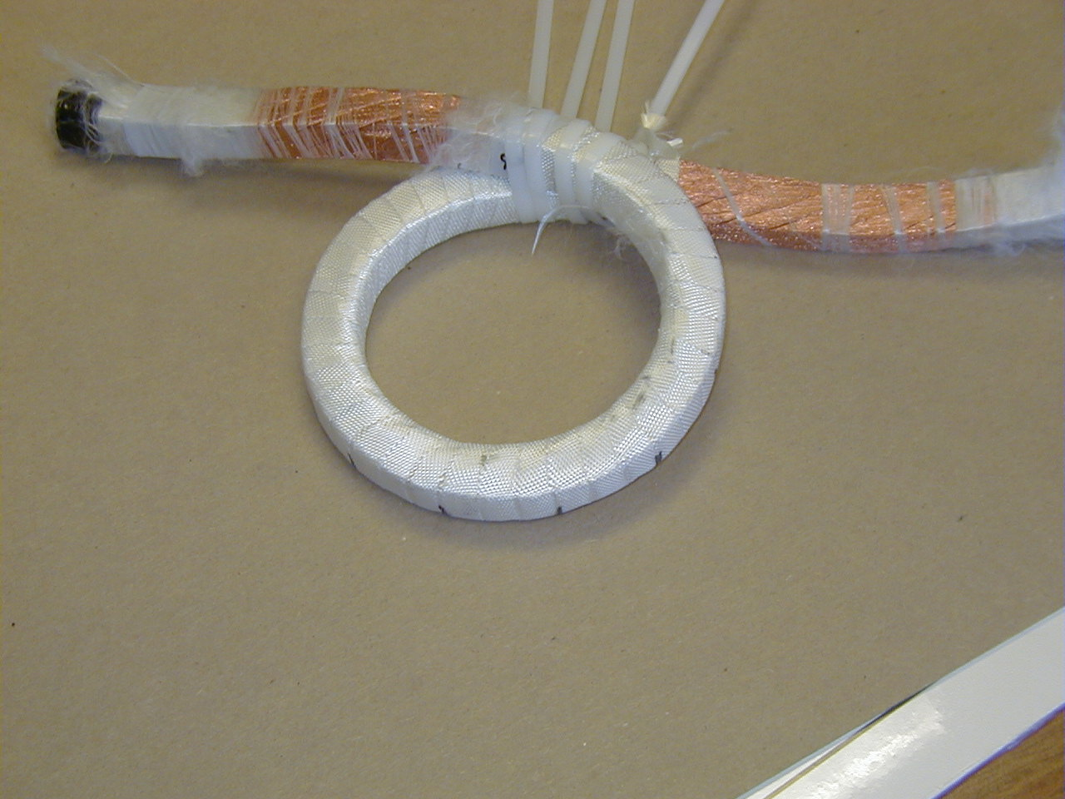
Figure 1- Trial #1 “Conductor Removed from Mandrel”

Trial #2….. Conductor Measurements

0.660 in. 0.636 in.

Conductor Conductor
0.551 in. Before 0.551 in. After 0.565 in.
Winding Winding

0.728 in.

CL Winding Axis
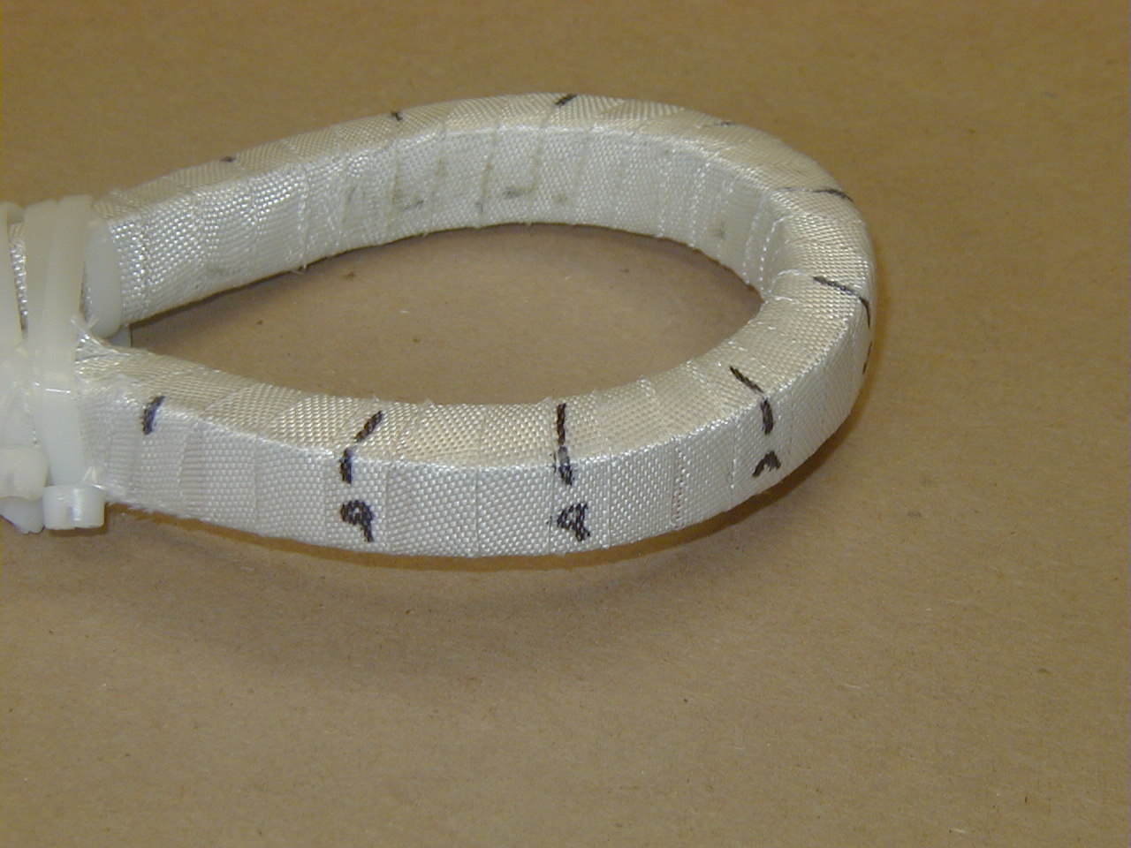
Figure 2- Trial #2 “Conductor Removed from Mandrel”

Note: Any discrepancies in measurements are a result of conductor not being entirely rectangular prior to start of Trial #1 and reuse of same copper cable conductor for Trial #2.

