NCSX

Coil Development Program

Test Series #5

Vacuum Impregnation (VPI)
Straight Tee Section

Written By: James H. Chrzanowski
February 28, 2002

TEST SERIES #5- VPI of Straight Tee Specimens

- Purpose: To prepare and to vacuum impregnate a straight length tee section similar to the Modular coil cross-section with (36) insulated compacted copper rope specimens for material property testing. This test series will also be used to develop the VPI process and to evaluate the integrity of the proposed bag mold for future coil impregnations.

- Materials and equipment:
  - Compacted copper rope (0. 5 inch x 0.63 inch)
  - Dry glass insulation (0.007 inch thick x 1 inch wide)
  - Kapton insulation (0.00325 inch thick x ¾ inch wide)
  - 3-part epoxy system. …Product no. CTD-101K (Composite Technology Development Inc.)
  - Stainless tee-section
  - Vacuum oven
  - Epoxy delivery system
  - ½ inch Chemflour tubing

- Test Procedure:
The following steps are to be used as a guide. The Test Director has the authority to modify the tests. All information from these tests is to be documented in the Logbook, including preparation activities, collected data, and changes to the SOW.

- Preparations:
  - Note: Cotton gloves shall be worn during the handling of the copper insulation and during the insulating process.

A. Conductor Preparation
  - Cut (36) compacted copper rope specimens approximately 48 inches in length.

  - Apply (1) ½ lapped layer of dry glass (0.007 in. thick) and (2) ½ lapped layer of composite insulation dry-glass & Kapton tape over each copper conductor. (See figure No. 1)

  - Once completed, cover conductors to ensure cleanliness prior to installing into the mold.

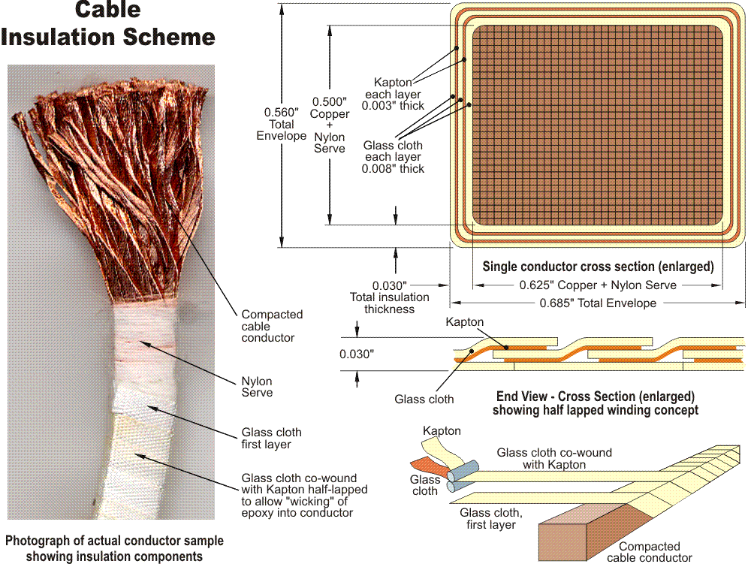
0.054 in.
0.040 in.
0.014 in.

Figure No. 1

End View- Cross Section [enlarged] showing half lapped winding concept

B. Tee Section Preparation
- Thoroughly clean and degrease the Tee section. (See Figure 2)

- Apply spray mold release over all faces of the Tee section, which will be in contact with the epoxy resin.

- Lay (3) layers of 0.010-inch thick dry glass onto the open faces of the tee section. Leave sufficient glass to over wrap the entire bundle once the (18) turns are in position.

- Install (2) layers of 9 turns each of the insulated copper conductors onto each side of the tee section. [36 turns total] See figure No. 4. Ensure that the turns are held securely in place during the assembly process.

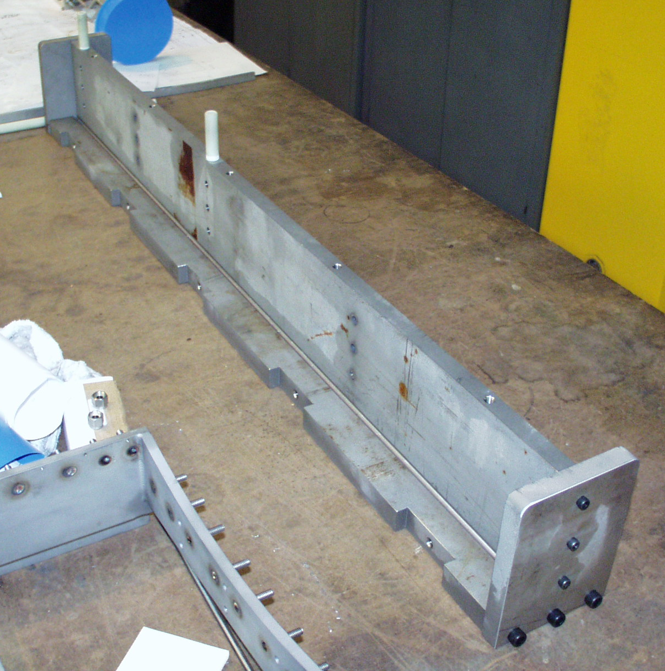

Straight Tee Section- Figure No. 2

- Overlay the dry glass ground wrap over the outside surface of the turns and secure in place with Kapton tape.

- Repeat this process for the opposite side of the tee section. [1]

- Install the final coil clamps [2]

- Install the epoxy feed sprues into the bundle at 7 locations. Three locations on the top edge of the tee, and four locations at two of the coil clamps (2 per clamp) as shown in figure no. 3. Seal them in place with silicone RTV. [3]

- Install (2) layers of silicone rubber tape over the coil ground wrap and clamps, forming a bag over the specimen. [4]

- Seal the edges of the silicone tape with silicone RTV. [5]. Once RTV cures, pump down and look for leaks.

- Install epoxy impregnated felt between the clamps. [6]

- Install strong backs between the clamps to secure the ends of the silicone bag and impregnated glass. [7]

Epoxy enters the mold cavity through the Feed Sprues

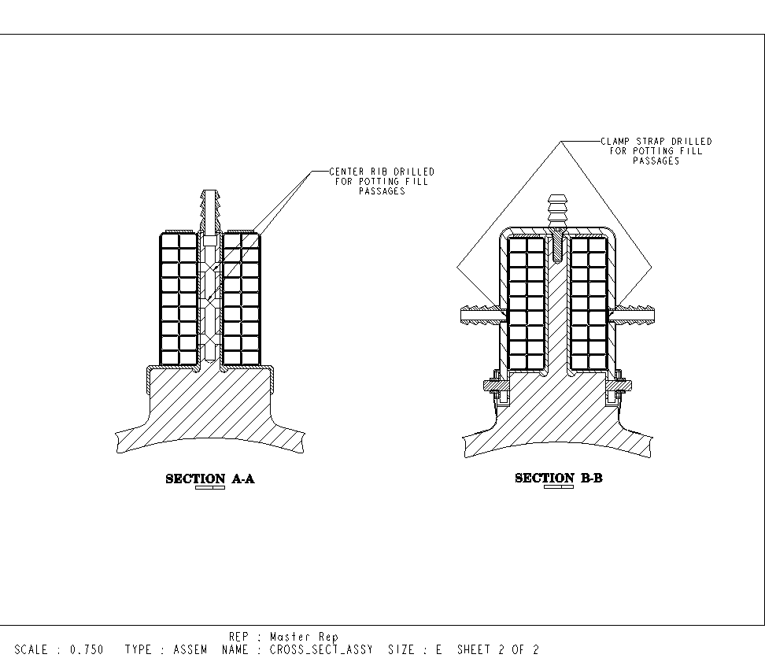

Epoxy Spru Configuration- Figure No. 3

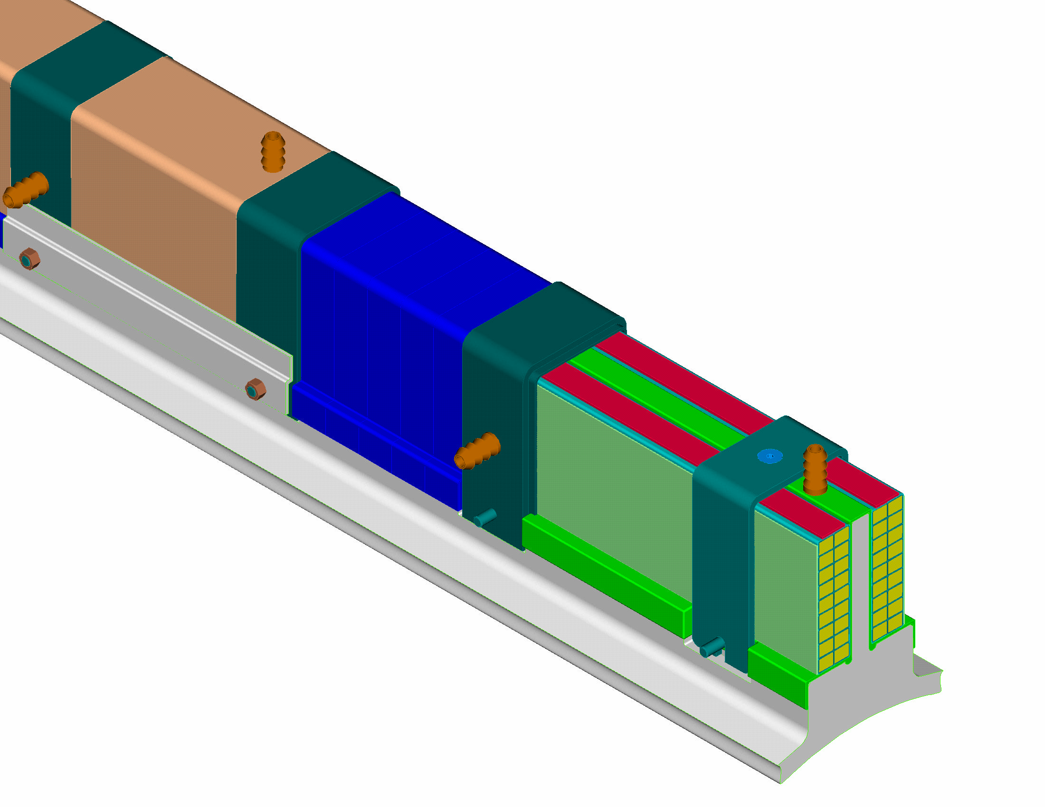
[4]
[5]
[3]
[7]
[6]
[1]
[2]

Bag Mold Assembly Figure No. 4

- Secure ½ inch ID “Chemflour” tubing to the (7) Spru inlet and outlets.

- Install the mold into the vacuum oven and secure into position.

- Rotate the oven with the Tee specimen from the horizontal to vertical position using the overhead jib crane. Secure in position.

Test Director verify: ______________________ Date: __________

- Connect the bag mold Sprues to the epoxy delivery system per the diagram in shown in Figure No. 5. Close all valves.

- Apply a vacuum to the mold as soon as possible by opening valves V6, V7, V8, V9, V10 and V12.

- Open valve V13 and place the vacuum oven under an equal vacuum as is being applied to the bag mold.

VALVE IDENTIFICATION KEY

V1…. To epoxy fill tank #1 V7…. To upper return port on clamp
V2…. To lower fill port on clamp V8…. To upper return port on tee
V3…. To lower fill port on tee V9…. To upper return port on clamp
V4…. To mid fill/return port on tee V10…. To epoxy fill tank from mid tee port
V5…. To mid fill port on tee V11…. Vac. pump to epoxy fill tank
V6…. To mid return port on tee V12…. Vac. pump to epoxy overfill tank
V13… Vacuum to oven
P
V
Pressure gauge Vacuum gauge

C. Epoxy Preparation
Epoxy components by weight: CTD-101K (3-part epoxy system)
  - Resin: (Part A) 100.0 parts-by-weight
  - Hardener: (Part B) 90.0 parts-by-weight
  - Accelerator: (Part C) 1.5 parts-by-weight

- Approximately 3.5-gallon mixture will be prepared for the injection.

- Components should be pre-heated to 40-45 degrees C for at least 4 hours prior to mixing.

- Weigh out the components per the ratio’s identified above.

- Combine the components into a container and thoroughly mix for approximately 15 minutes.

- Pour off approximately 1.5 pints to be used for viscosity measurements during impregnation.

Note: The viscosity of the resin is to be monitored throughout the process.

D. VPI Procedure

- Pour the mixed components into the epoxy fill tank and seal the lid.

- Open valve V11 and apply a vacuum to the mixed epoxy components. Maintain a 2-3 Torr vacuum on the epoxy until the boiling (degassing) of the mixture has subsided (Test Directors discretion).

- Close valve V11 and vent the epoxy tank to atmosphere.

- Open valves V2, V3 and V4.

- Slowly open valve V1 to allow the epoxy to enter the lower end of the mold via sprues A, B and C.

- Continue until epoxy resin is exiting sprue D. (Test Directors discretion)

- Close valve V6 and open valve V5.

- Continue filling the bag mold until epoxy is observed exiting sprues E, F and G. Allow 24 to 36 inches of epoxy to fill each line. Close valves V7, V8, V9, V10 and V12. Vent the overfill tank.

- Close valve V13 and SLOWLY vent the vacuum oven.

- The Test Director may elect to milk the epoxy through the mold following filling. The pressures in the mold and vacuum should closely match. The following steps should be followed for the “Milking Process”.

  - Open valves V1, V2, V3, V4, V6, V7, V8, V9, V10 and open the vent on the fill tank. Close valve 5.
  - Slowly apply pressure to the overfill tank and vacuum oven to a maximum of 3 psig, keeping the pressure equal.
  - This will allow epoxy to flow from the overfill lines back through the coil. DO NOT allow any of the air (nitrogen) in the overfill lines to re-enter the mold.
  - Reverse this process by slowly venting the overfill tank and applying the pressure to the fill tank.
  - Repeat this step as required. (Test Directors discretion)
  - Once finished, slowly vent the tanks and oven.
  - Close valves V1, V2, V3 and V4.

- Once the Test Director feels that the impregnation of the Tee specimen is complete, begin to slowly ramp up the oven temperature to 110 degrees C cure temperature at a ramp-up rate of 20 degrees per hour.

- During the entire cure process, maintain a 3 psig pressure inside of the vacuum oven.

- Maintain the oven temperature for 5 hours at 110 degrees C.

- During this process the viscosity samples should periodically checked until the samples GEL.

- After 5 hours at 110 degrees C, ramp-up the oven to 125 degrees C.

- Maintain the oven temperature for 15 hours at 125 degrees C.

- At the end of the cure cycle, shut off the oven, and allow the mold to return to room temperature. DO NOT open the oven until the mold has returned to a temperature of at least 40 degrees C.

- Remove the mold from the oven.

- CAREFULLY open up the mold and examine the impregnated Tee specimen.

VPI DATA SHEET
________________________________________________________________________

Date of Test: Test Director:

Team Members: ________________________________________________________________________
EPOXY MIX DATA
Weight of components- Part A

Part B
Part C
Mixing time:

VACUUM READINGS:
Mold prior to impregnation:

Degassing of epoxy:

During VPI process:
Oven: Mold:

During the Cure Cycle (Oven):

PROCESS TIMES:

Start of Degassing operation: _________ End of Degassing operation: __________

Start of Epoxy Fill: _____________ End of Epoxy Fill: ______________

Start of Ramp Up: ______________ Cure Temp. Reached: ________ (110 deg. C)

Start of Ramp Up: ______________ Post Cure Temp. Reached: ________ (125 deg. C)

End of Cure Cycle: __________________

NOTES and OBSERVATIONS:

OVEN DATA SHEET: Date: _______________ Sheet No. ________

Time | Temperature Degrees C | Notes | Time | Temperature Degrees C | Notes

OVEN DATA SHEET: Date: _______________ Sheet No. ________

Time | Temperature Degrees C | Notes | Time | Temperature Degrees C | Notes

OVEN DATA SHEET: Date: _______________ Sheet No. ________

Time | Temperature Degrees C | Notes | Time | Temperature Degrees C | Notes

OVEN DATA SHEET: Date: _______________ Sheet No. ________

Time | Temperature Degrees C | Notes | Time | Temperature Degrees C | Notes

NOTES AND OBSERVATIONS

