NCSX

Coil Development Program

Test Series #10
Statement of Work

Winding of Racetrack Test Coil

Written By: James H. Chrzanowski
June 26, 2003

TEST SERIES #10- Winding of Racetrack Coil

- Purpose: Test series No. 10 has several parts.
  - Fabricate a 28-turn coil using similar materials and construction techniques as is being planned for the modular coils.
  - Instrument the coil with strain gauges and thermocouples embedded in the coil structure to monitor temperature and strain during operation.
  - Once completed the coil will be tested under cryo conditions at maximum operating current being planned for the modular coils. VPI and testing will be covered under separate Worksheets.

- Materials and equipment:
  - Compacted copper rope (0.539 inch x 0.660 inch)
  - Dry S-glass T/T insulation (0.007 inch thick x 1 inch wide)
  - Dry S-glass ground wrap insulation (0.010 inch thick x 2/4 or 6 inch wide)
  - 2-mil Kapton insulation (0.00325 inch thick x ¾ inch wide)
  - Stainless steel winding form (Drawing no. SE1405-006)
  - Winding clamps
  - Copper cladding
  - Copper coil clamps
  - Stain gauges
  - Thermocouples
  - CRC” Chlor-Free Degreaser

- Procedure:
The following steps are to be used as a guide. The ATI or his designee has the authority to modify the tasks within this statement of work. All pertinent information from these activities are to be documented in this work document, including preparation activities, collected data, and changes to the SOW.

- Prerequisites:
  - Note: Cotton or latex gloves shall be worn during the winding operations and any handling of the conductor or insulation. Once the coil components (winding form, copper cladding etc.) have been cleaned, gloves must also be worn during handling.

  - Pre-job Briefing complete: Date: __________________________
Completed by: ____________________________________

- Preparation Activities:

  - Conductor Preparation
    - Cut (2) specimens of compacted copper rope cable approximately 150 feet in length.

    - Pre-insulate the conductor with (1) half lapped layer of dry glass (0.007 in. thick x 1 in. wide, followed by (2) half lapped layers of composite insulation (0.007 in. thick x 1 in. wide S-glass and 0.00325 in. thick x ¾ in. wide Kapton tape)

    - Spool the insulated conductor on large diameter spools, to minimize any keystoning. The conductors will be wound onto the winding form starting from thy middle of the conductor length. To achieve this, spool each 150 foot length from each end onto (2) 75 foot spools.

  - Copper Cladding
    - Custom fit each copper cladding section to the winding form.

    - Remove all sharp edges and burrs.

    - Clean the cladding using “CRC” Chlor-Free Degreaser, then mold release the side that will be facing the winding form.

  - Winding Form Preparation
    - Clean the racetrack winding form and copper cladding using “CRC” Chlor-Free Degreaser. (Figure no. 1)

    - Install strain gauges onto the winding form per ATI’s direction. Tack weld strain gauges in place. Identify the location of these strain gauges on diagrams below. (Figures no. 2 and 3)

    - Seal strain gauges using high temperature silicone sealant.

    - Mold release the entire winding surface of the racetrack winding form, and the winding form facing the coil bundle.

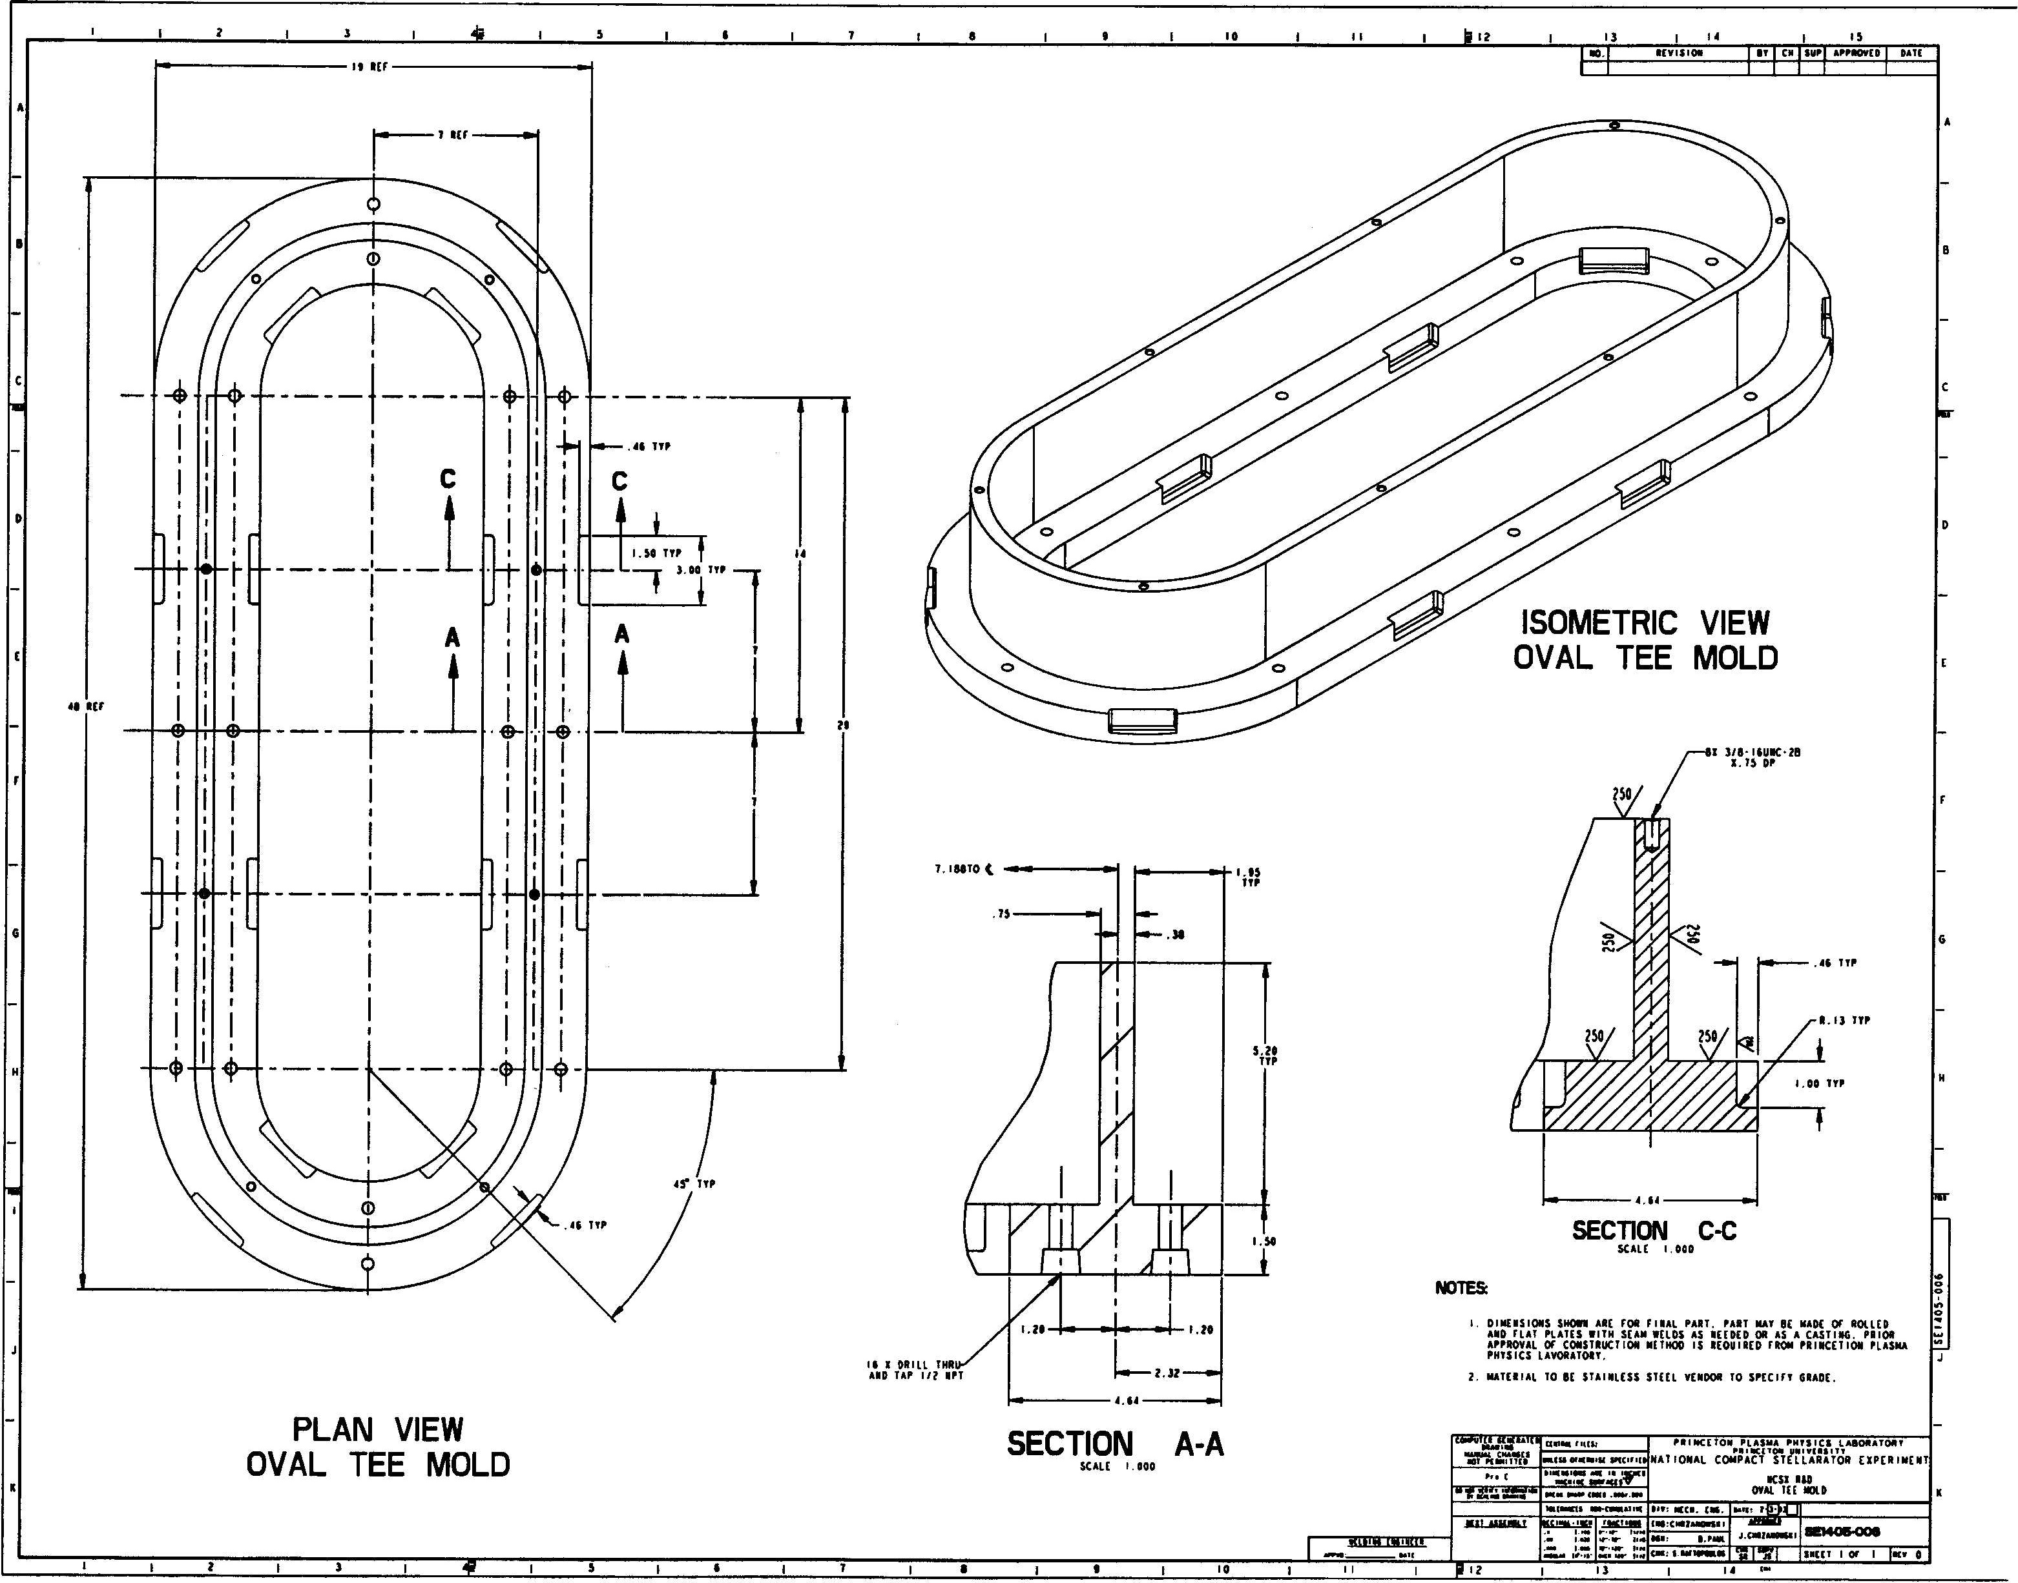
Figure No. 1- Stainless Steel Winding Form

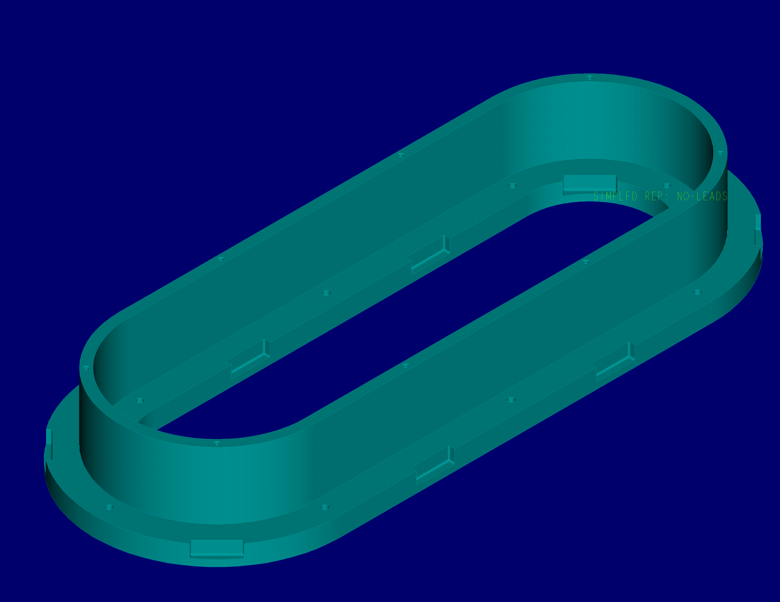
Figure No. 2- Strain Gauge Locations
Figure No. 3- Typical Strain Gauge Positioning
- Winding Procedure:
  - Install the copper cladding onto the winding face. Hold in place with double face tape and Kapton tape. (Figure No. 4)
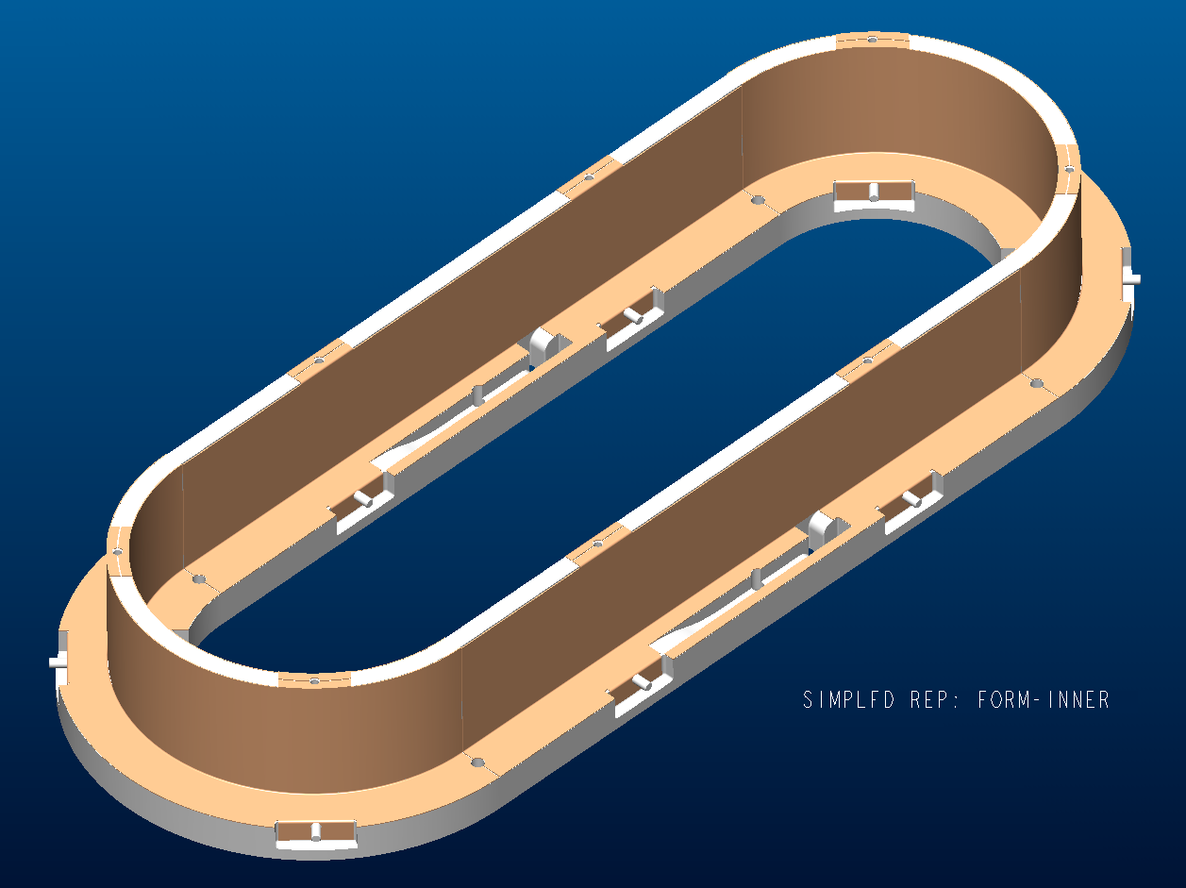

Inner Wall Copper Cladding

  - Install winding clamps onto stainless steel winding form.

  - Apply (3) butt lapped layers of 0.010-inch ground wrap onto the outer tee of the winding form. Stagger the ends of the layers so that no edges align with layers below. The ground wrap should be of sufficient length to completely wrap the outside surface of the bundle following winding.

  - Position half of the spooled conductor under the winding form for winding the second layer of conductor.

  - Position the conductor (middle of 150 ft. spool) onto the winding form at the middle of the straight side. Secure in place using winding clamps and C-clamps. Care should be taken not to over clamp conductor because of possible damage to the insulation.

  - Begin winding the conductor onto the winding form in a clockwise direction. Secure the conductor in place as you wind using the winding clamps. Using a phenolic tap-block, tap the conductor to set turn in place.

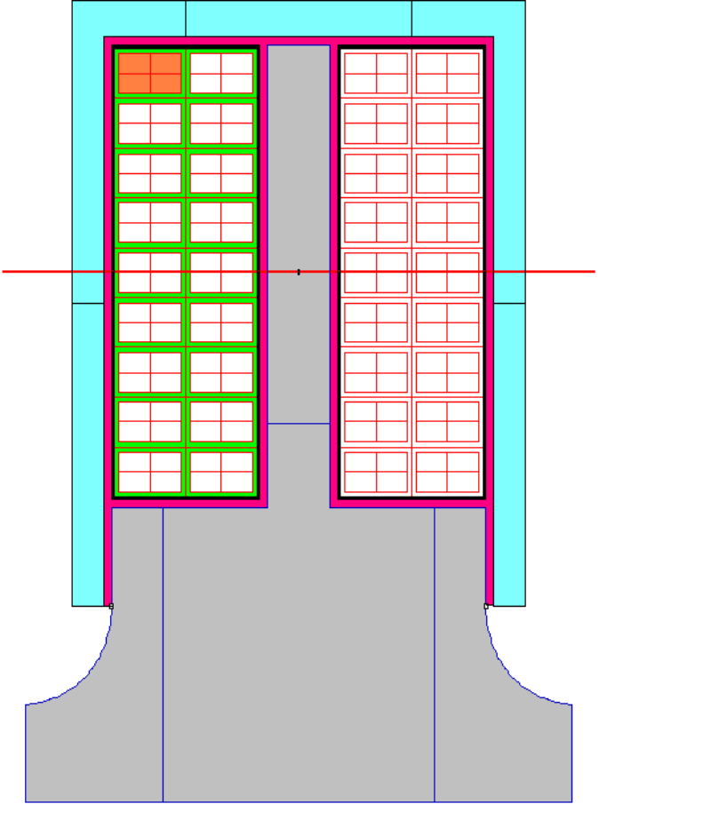

Turn 1
Turn 14

Turn 13
Turn 2

Turn 12
Turn 3

Turn 11
Turn 4

Turn 10
Turn 5

Turn 9
Turn 6

Turn 8
Turn 7

Figure 5 –Outer Tee Coil Turn Designations

  - Using calipers and measuring devices per ATI, measure the height and width of the turns once a full turn has been wound. Document the information in Table number 1.

  - Continue winding until the first layer (7 turns) has been wound.

  - Secure the end of the conductor (lead area).

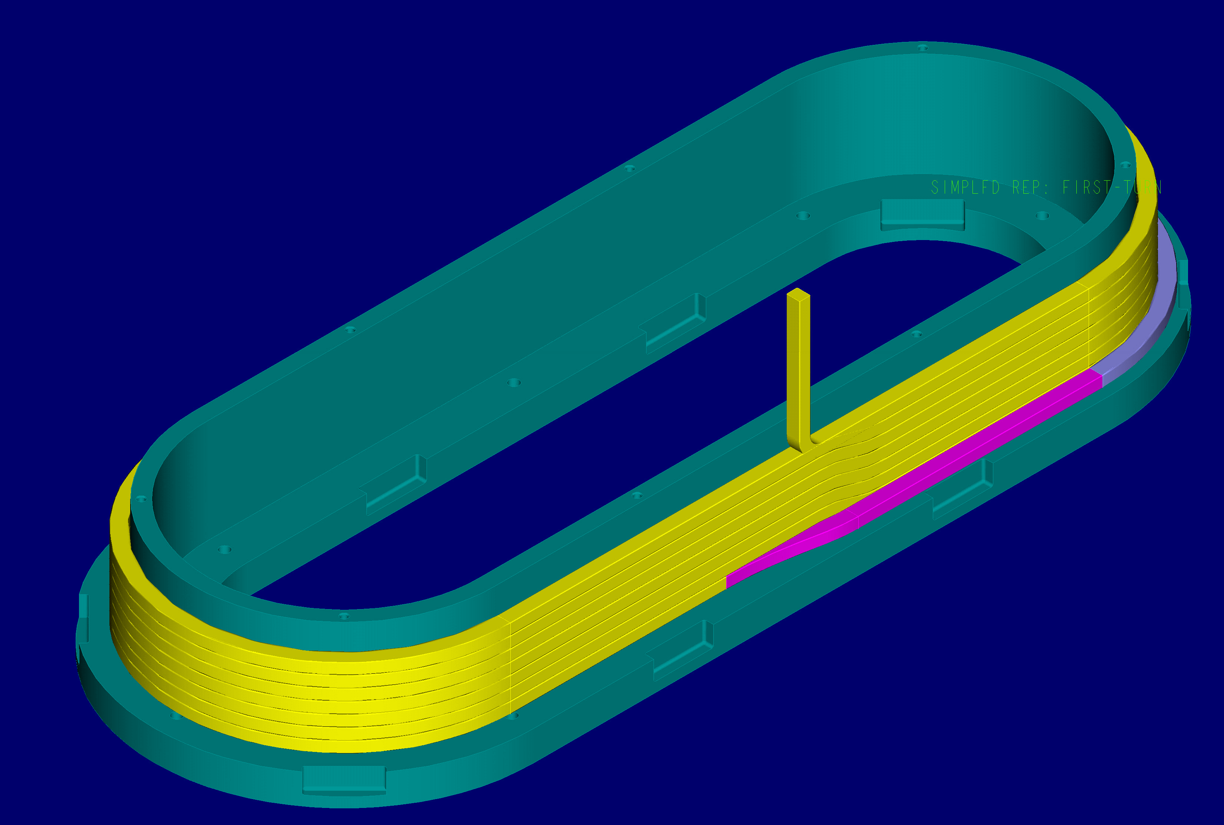
Figure No. 6- First Layer of Conductors

Table 1- First Layer of Outside Tee Measurements
Position | 1 | 2 | 3 | 4 | 5 | 6 | 7 | 8 | 9 | 10
Turn No.7
Height (in.)
Width (in.)
Measured By |  |  |  |  |  |  |  | Date
Turn No.6
Height (in.)
Width (in.)
Measured By |  |  |  |  |  |  |  | Date
Turn No.5
Height (in.)
Width (in.)
Measured By |  |  |  |  |  |  |  | Date
Turn No.4
Height (in.)
Width (in.)
Measured By |  |  |  |  |  |  |  | Date
Turn No.3
Height (in.)
Width (in.)
Measured By |  |  |  |  |  |  |  | Date
Turn No.2
Height (in.)
Width (in.)
Measured By |  |  |  |  |  |  |  | Date
Turn No.1
Height (in.)
Width (in.)
Measured By |  |  |  |  |  |  |  | Date

Instrument used for measurements:_____________________________________
Notes and or Observations:

  - Install thermocouples onto turns 1, 4 and 7. Use Kapton tape to hold thermocouples in place. See figure number 7 below for locations.

Thermocouples

Figure No. 7 Thermocouple Locations

  - Using the second half of the 150 ft. of spooled copper conductor, begin winding the remaining 7 turns of insulated copper conductor in the counterclockwise direction. (Figure No. 8) Use a phenolic tap-block to set the turns in place. Care must be taken not to damage the insulation.

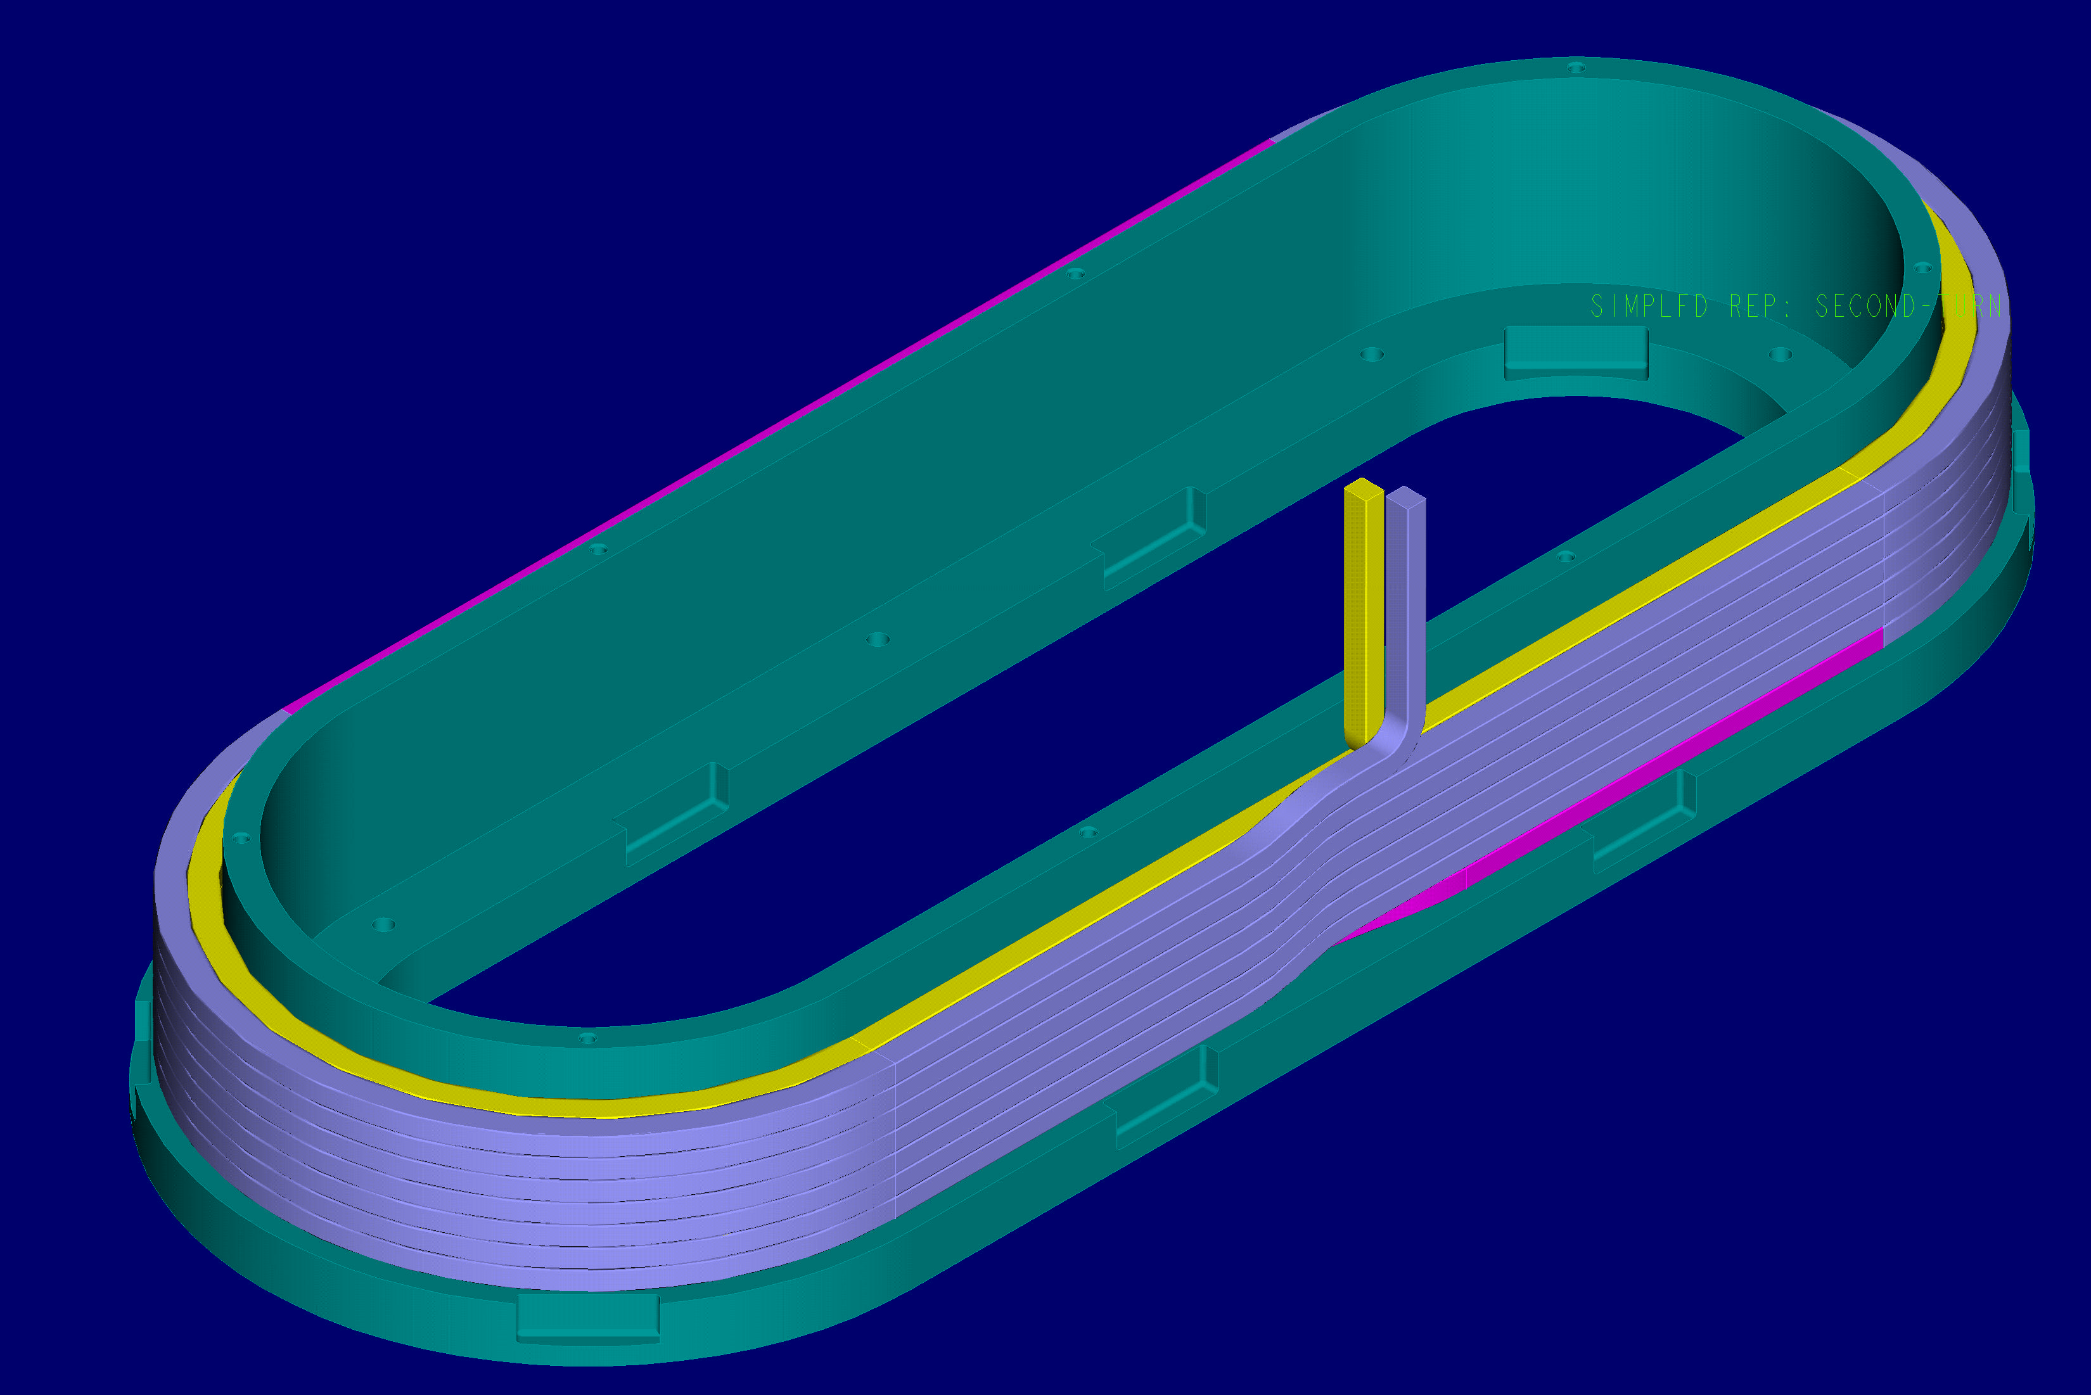
Figure No. 8- Second layer of outer Tee

  - Using calipers and measuring devices per ATI, measure the height and width of the turns once a full turn has been wound. Document the information in Table number 2. (See figure number 5 for turn designations)

  - Continue winding until the second layer (7 turns) has been wound.

  - Secure the end of the conductor (lead area).

Table No. 2- Second Layer of Outside Tee Measurements
Position | 1 | 2 | 3 | 4 | 5 | 6 | 7 | 8 | 9 | 10
Turn No.8
Height (in.)
Width (in.)
Measured By |  |  |  |  |  |  |  | Date
Turn No.9
Height (in.)
Width (in.)
Measured By |  |  |  |  |  |  |  | Date
Turn No.10
Height (in.)
Width (in.)
Measured By |  |  |  |  |  |  |  | Date
Turn No.11
Height (in.)
Width (in.)
Measured By |  |  |  |  |  |  |  | Date
Turn No.12
Height (in.)
Width (in.)
Measured By |  |  |  |  |  |  |  | Date
Turn No.13
Height (in.)
Width (in.)
Measured By |  |  |  |  |  |  |  | Date
Turn No.14
Height (in.)
Width (in.)
Measured By |  |  |  |  |  |  |  | Date

Instrument used for measurements:_____________________________________
Notes and or Observations:

  - Wrap ground wrap insulation around the outside surface of the bundle and secure with Kapton tape.

  - Apply (3) butt lapped layers of 0.010-inch ground wrap onto the inner tee surface of the winding form. Stagger the ends of the layers so that no edges align with layers below. The ground wrap should be of sufficient length to completely wrap the outside surface of the bundle following winding.

  - Position half of the spooled conductor under the winding form for winding the second layer of conductor.

  - Position the conductor (middle of 150 ft. spool) onto the winding form at the middle of the straight side. Secure in place using winding clamps and C-clamps. Care should be taken not to over clamp conductor because of possible damage to the insulation.

  - Begin winding the conductor onto the winding form in a clockwise direction. Secure the conductor in place as you wind using the winding clamps. Using a phenolic tap-block, tap the conductor to set turn in place. See figure number 9 for turn designations.

Turn 14
Turn 1

Turn 13

Turn 12

Turn 11

Turn 10

Turn 2
Turn 7
Turn 3
Turn 4
Turn 5
Turn 6
Turn 8
Turn 9

Figure 9 –Inner Tee Coil Turn Designations

  - Using calipers and measuring devices per ATI, measure the height and width of the turns once a full turn has been wound. Document the information in Table number 3.

  - Continue winding until the first layer (7 turns) has been wound. See figure number 10.

  - Secure the end of the conductor (lead area).

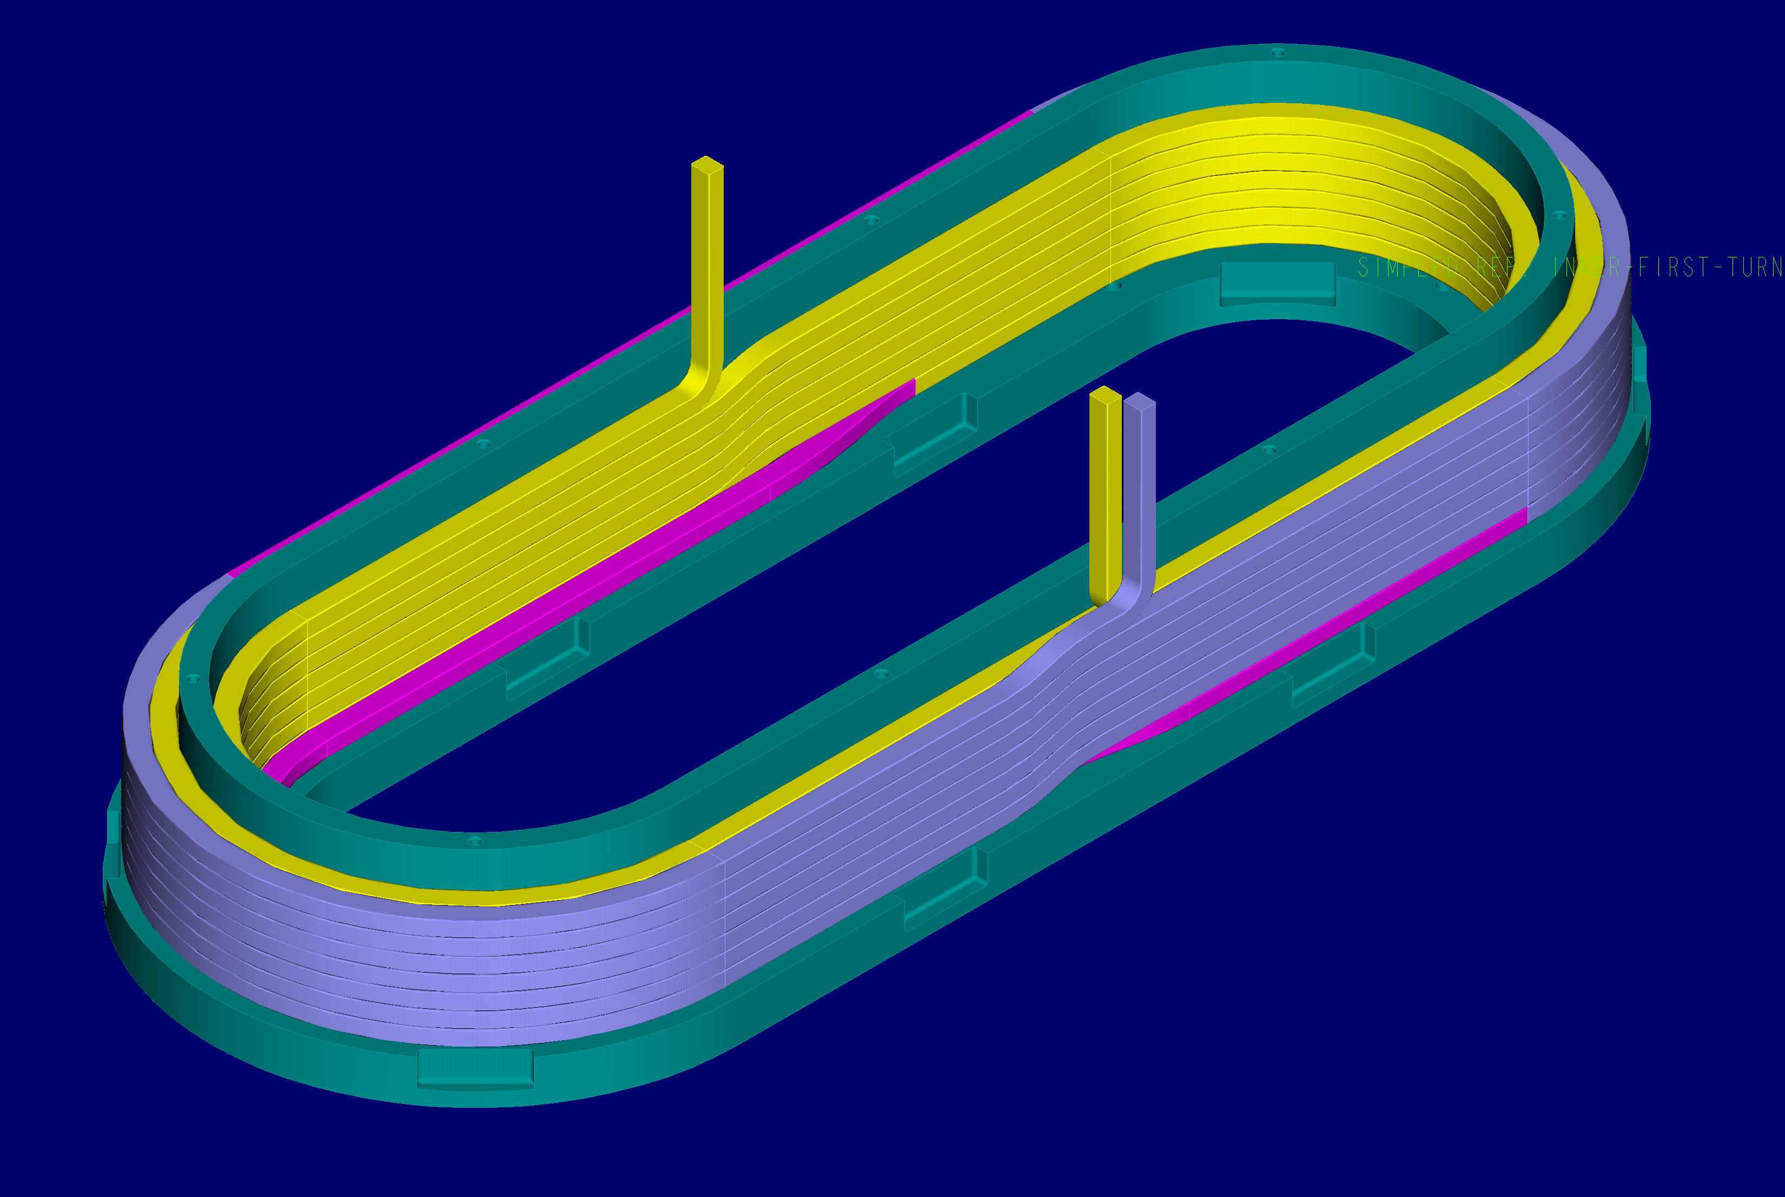
Figure No. 10- First Layer of Conductors Inner Tee

Table 3- First Layer of Inside Tee Measurements
Position | 1 | 2 | 3 | 4 | 5 | 6 | 7 | 8 | 9 | 10
Turn No.7
Height (in.)
Width (in.)
Measured By |  |  |  |  |  |  |  | Date
Turn No.6
Height (in.)
Width (in.)
Measured By |  |  |  |  |  |  |  | Date
Turn No.5
Height (in.)
Width (in.)
Measured By |  |  |  |  |  |  |  | Date
Turn No.4
Height (in.)
Width (in.)
Measured By |  |  |  |  |  |  |  | Date
Turn No.3
Height (in.)
Width (in.)
Measured By |  |  |  |  |  |  |  | Date
Turn No.2
Height (in.)
Width (in.)
Measured By |  |  |  |  |  |  |  | Date
Turn No.1
Height (in.)
Width (in.)
Measured By |  |  |  |  |  |  |  | Date

Instrument used for measurements:_____________________________________
Notes and or Observations:

  - Install thermocouples onto turns 1, 4 and 7 of inner tee bundle. Use Kapton tape to hold thermocouples in place. See figure 6 for locations.

  - Using the second half of the 150 ft. of spooled copper conductor, begin winding the remaining 7 turns of insulated copper conductor in the counterclockwise direction. (Figure No. 11) Use a phenolic tap-block to set the turns in place. Care must be taken not to damage the insulation.

Figure No. 11- Second layer of Inner Tee

  - Using calipers and measuring devices per ATI, measure the height and width of the turns once a full turn has been wound. Document the information in Table number. (See figure number 9 for turn designations)

  - Continue winding until the second layer (7 turns) has been wound.

  - Secure the end of the conductor (lead area).

Table No. 4- Second Layer of Inside Tee Measurements
Position | 1 | 2 | 3 | 4 | 5 | 6 | 7 | 8 | 9 | 10
Turn No.8
Height (in.)
Width (in.)
Measured By |  |  |  |  |  |  |  | Date
Turn No.9
Height (in.)
Width (in.)
Measured By |  |  |  |  |  |  |  | Date
Turn No.10
Height (in.)
Width (in.)
Measured By |  |  |  |  |  |  |  | Date
Turn No.11
Height (in.)
Width (in.)
Measured By |  |  |  |  |  |  |  | Date
Turn No.12
Height (in.)
Width (in.)
Measured By |  |  |  |  |  |  |  | Date
Turn No.13
Height (in.)
Width (in.)
Measured By |  |  |  |  |  |  |  | Date
Turn No.14
Height (in.)
Width (in.)
Measured By |  |  |  |  |  |  |  | Date

Instrument used for measurements:_____________________________________
Notes and or Observations:

  - Wrap ground wrap insulation around the outside surface of the bundle and secure with Kapton tape.

  - Install outer wall of copper cladding around both the inner and outer tees along with the copper coil clamps. See figures 12 and 13.

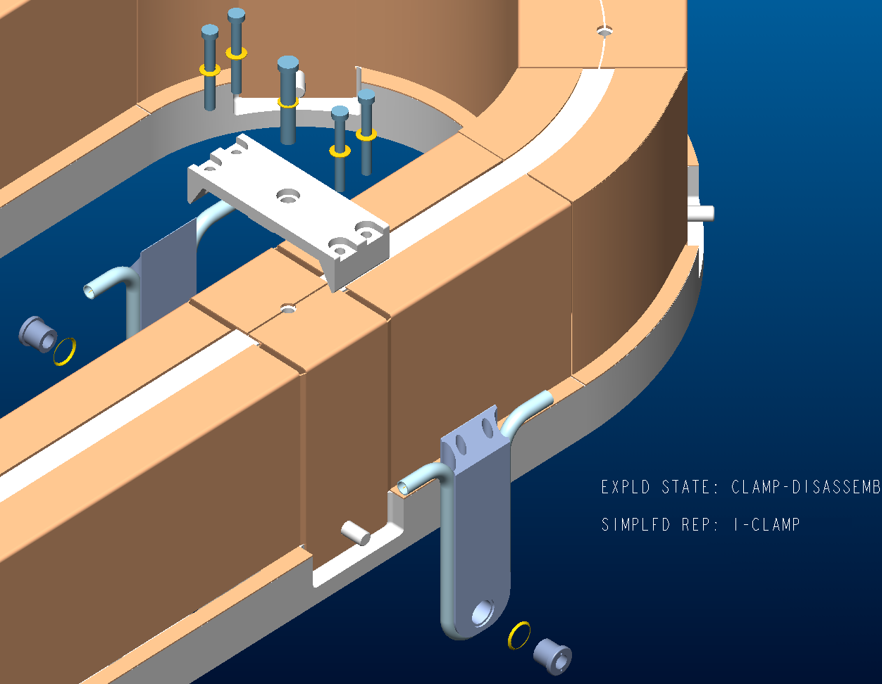

Figure Number 12 Copper Cladding and Coil Clamps
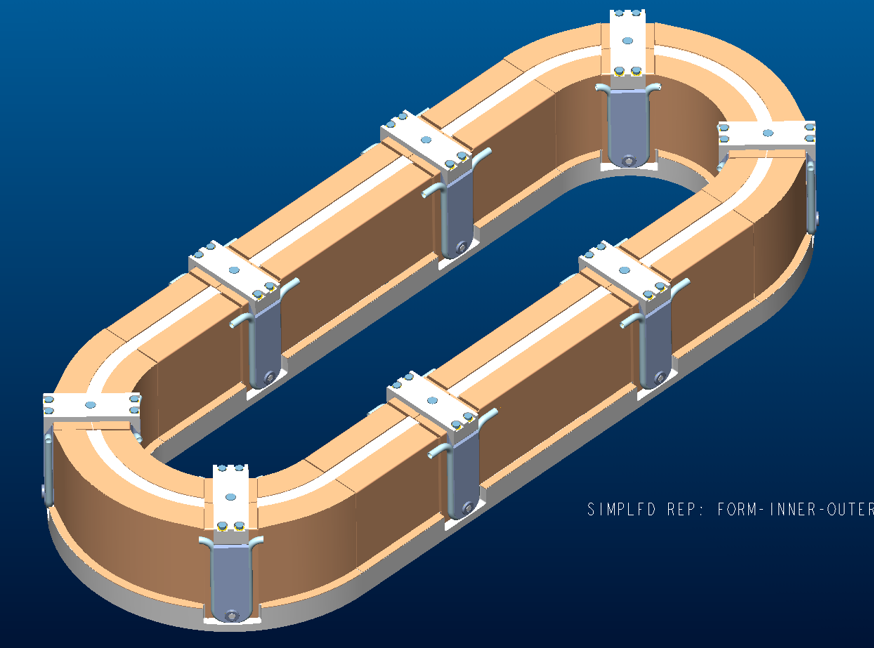

Figure Number 13 Copper Cladding and Coil Clamp

  - Connect the cooling tubes on the coil clamps using compression fittings. See figures 14 and 15.
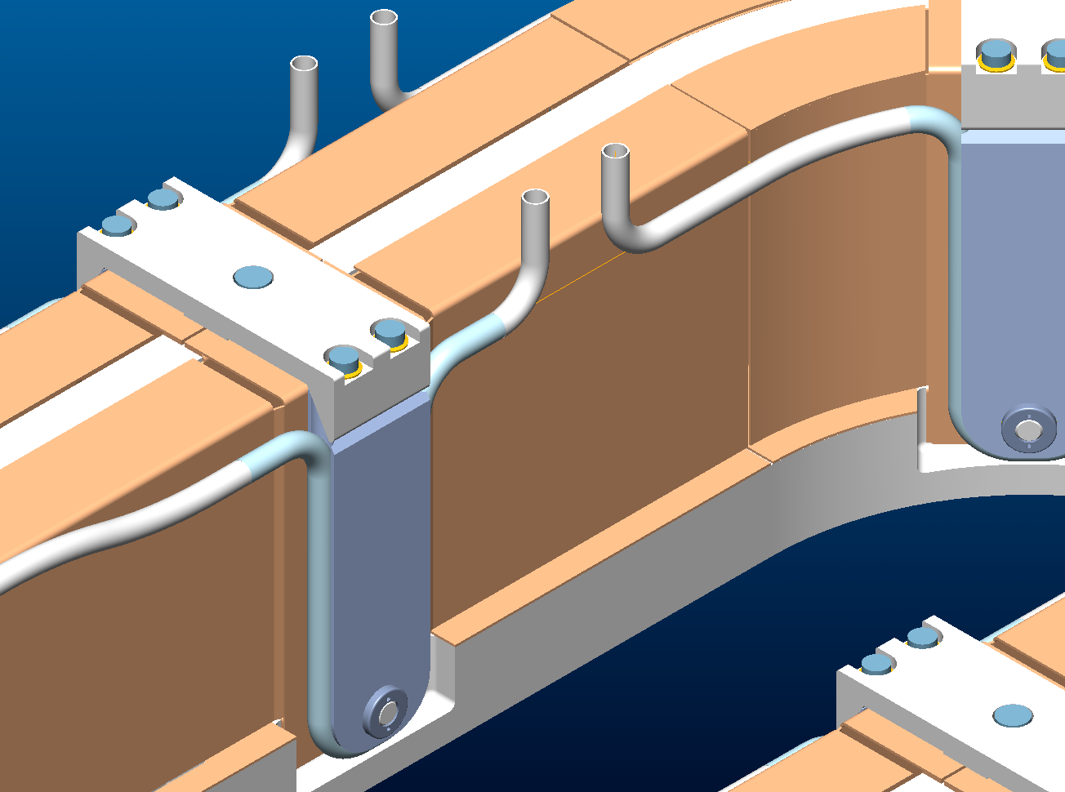

Figure number 14- Cooling Tubes and clamps
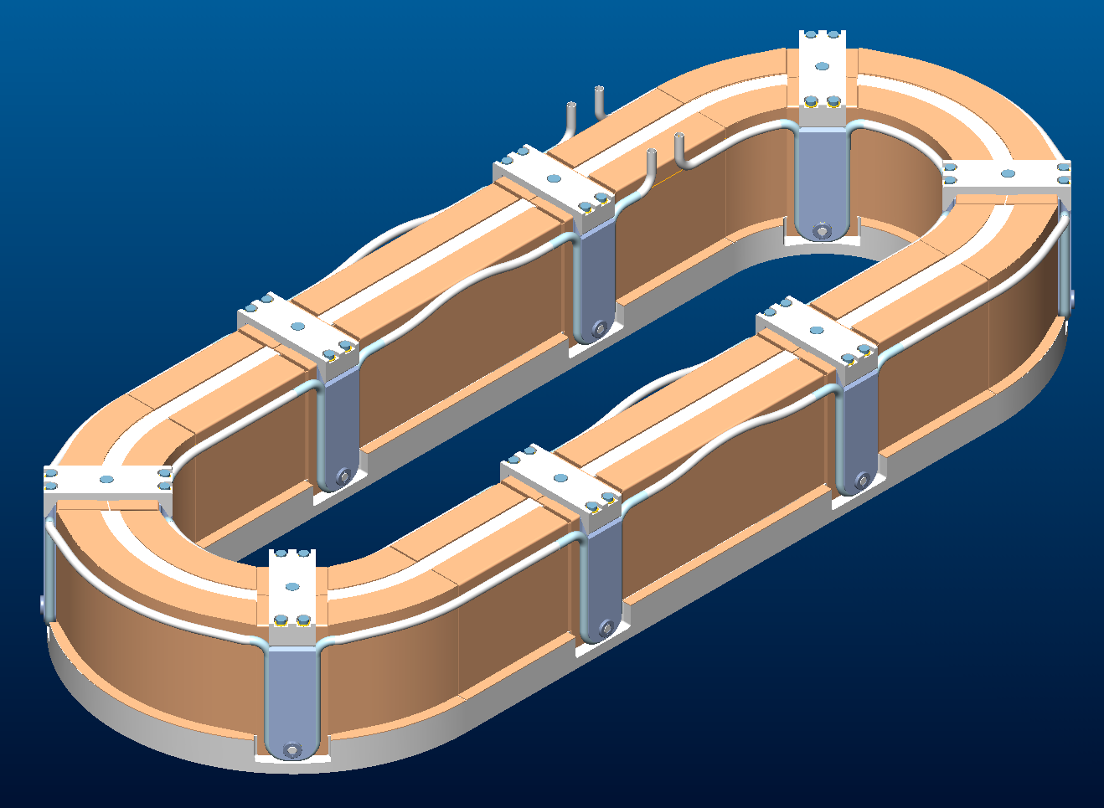

Figure 15- Cooling Tubes and Clamps

  - Using silver solder, solder a copper tube around the ends of the conductor leads to provide an electrical connection point for power tests. Leads should be at least 12 inches form the coil bundle.

  - Take precautions to protect the balance of the coil from the soldering operations.

- Winding Completion:
  - Name of technicians involved with winding operations:
__________________________________________

__________________________________________

__________________________________________

__________________________________________

  - Date winding operations started: ____________________________

  - Date completed and ready for VPI mold: _________________________

  - ATI’s signature: ___________________________________________

NOTES AND OBSERVATIONS:

