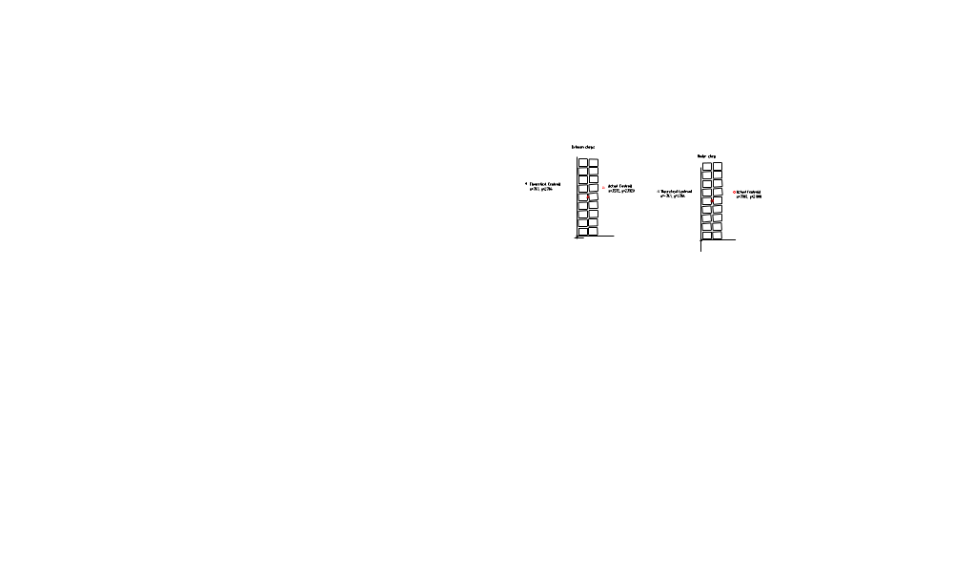

The theoretical magnetic center of the stack is at X=0.763, Y=2.766. This is based on the following build-up of materials:

-3 layers of ground wrap, 0.010” each layer
-0.054” thick layer of glass & Kapton insulation surrounding the conductor
-0.5” by 0.625” conductor
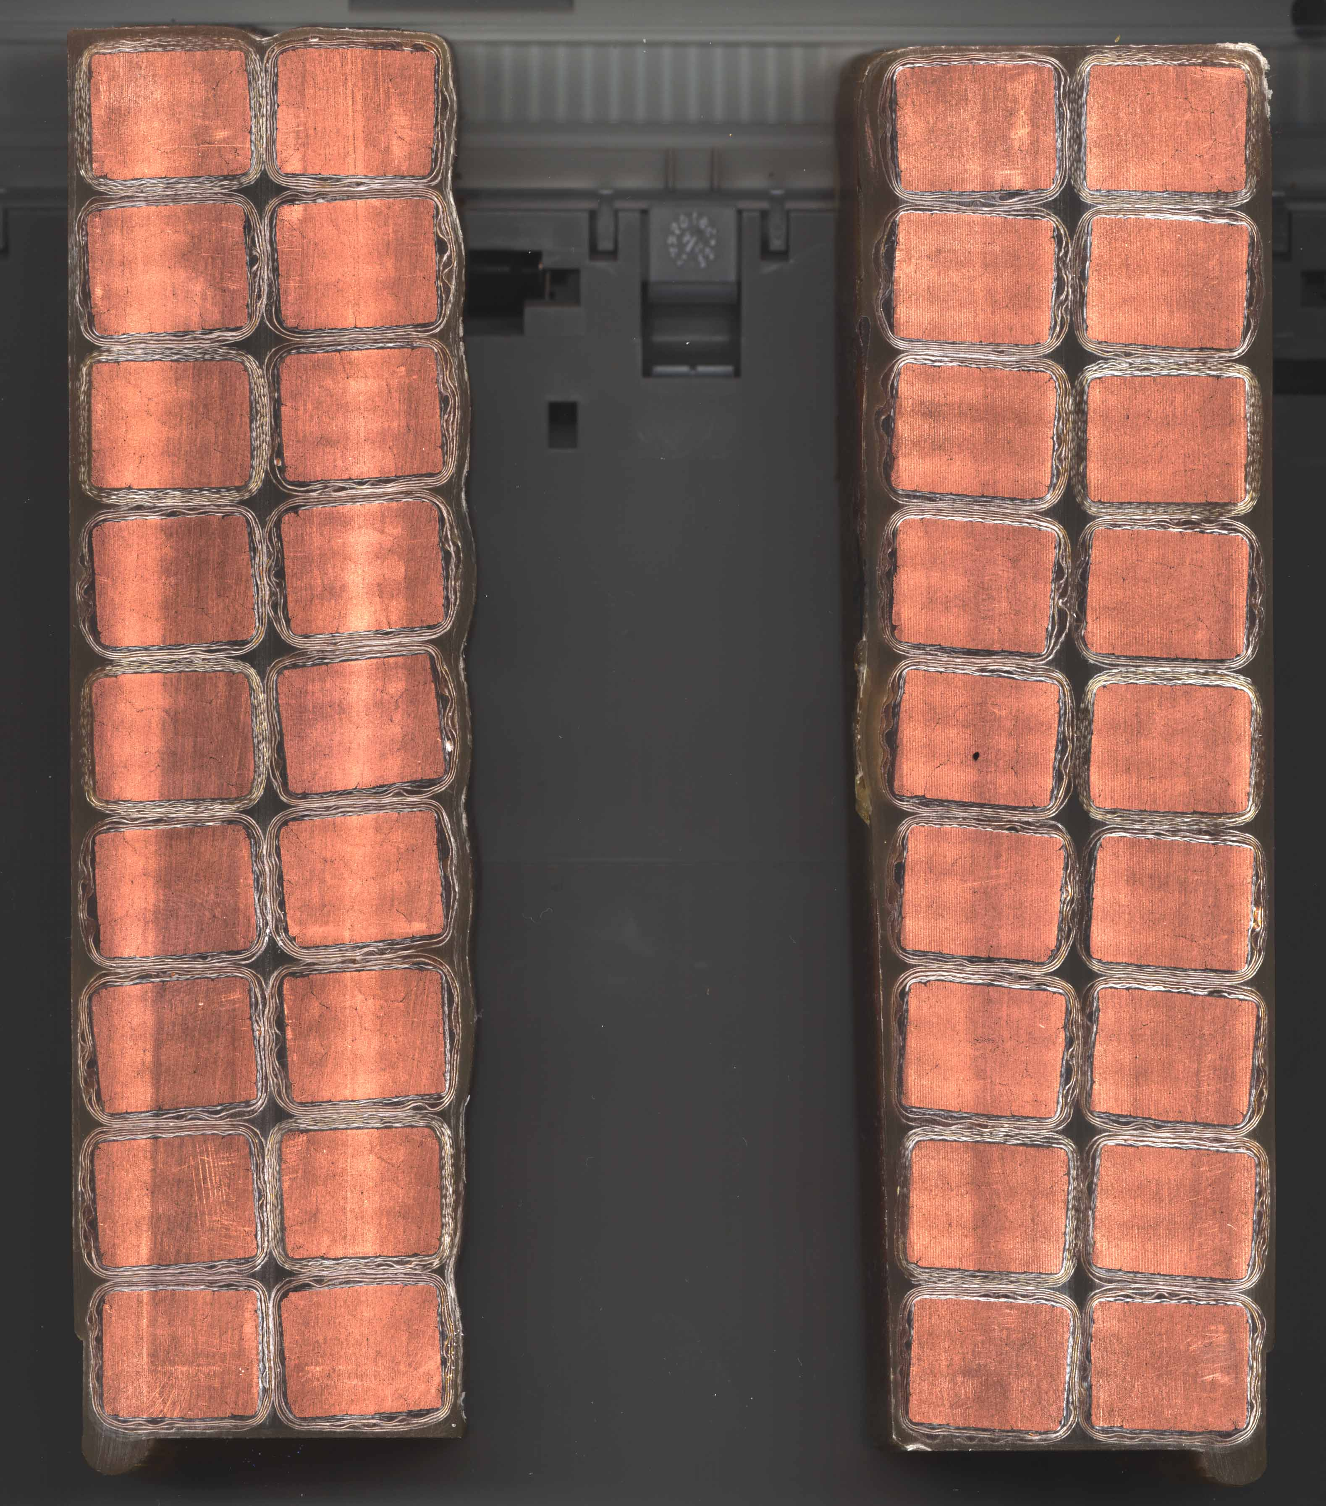

Midway between clamps on left side Under clamp on right

