Statement of Work for

Test Program to Determine the

Mechanical and Thermal Properties

Of the Epoxy/Insulation System

For

NCSX Modular and

Poloidal Field Coils

NCSX-SOW-142-02-00

DRAFT C

approvals

Prepared by: ______________________________________________________

I. Zatz, Cognizant Engineer for Modular and PF Coil Testing

Concur: _________________________________________________________

J. Chrzanowski, Cognizant Engineer for Modular Coil Winding and Assembly (WBS 142)

Concur: _________________________________________________________

D. Williamson, Modular Coils (WBS 14) WBS Manager

Concur: _________________________________________________________

B. Nelson, Stellarator Core Systems (WBS 1) Project Engineer

Concur: _________________________________________________________

F. Malinowski, PPPL Procurement QA Representative

Approved by: ____________________________________________________

W. Reiersen, Engineering Manager

REVISIONS

Revision No. | Affected Pgs. | Date
0 (Initial Release) | All

Table of Contents
 | Page

1. GENERAL INFORMATION
1.1 Introduction | 1
1.2 Background | 1
1.3 Conductor Description | 5
1.4 Scope | 5
1.5 Applicable Documents | 5

2. Work Requirements
2.1 Vacuum Impregnation of the Modular Coil Conductor | 5
2.2 Test Specimen Preparation | 8
2.3 Mechanical and Thermal Testing | 9
2.4 Subcontractor’s Recommendations | 10
2.5 Additional Manufacturing Development and Testing Activities | 10
2.6 Firm Fixed Cost and Schedule Proposal | 10

3. Quality Assurance
3.1 Inspection / Surveillance / Audit by PPPL | 11
3.2 Subcontractor’s Responsibility for Conformance | 11
3.3 Subcontractor’s Quality Assurance Program | 11
3.4 QA Plan | 11
3.5 Inspection and Test Procedures | 11
3.6 Document Traceability and Records | 12
3.7 Equipment / Material Identification and Status | 12
3.8 Calibration of Test and Measuring Equipment | 12
3.9 Control of Special Processes | 12
3.10 Process History | 12

4. DELIVERABLES
4.1. QA Plan | 12
4.2. Weekly Reports | 13
4.3. Procedures | 13
4.4. Documentation | 13

1. GENERAL INFORMATION

1.1 Introduction

Stellarators are a class of magnetic fusion confinement devices characterized by three dimensional magnetic fields and plasma shapes and are the best-developed class of magnetic fusion devices after the tokamak. The stellarator concept has greatly advanced since its invention by Dr. Lyman Spitzer, the founding director of the Princeton Plasma Physics Laboratory (PPPL), during the 1950’s. A traditional stellarator uses only external magnetic fields to shape and confine the plasma. The National Compact Stellarator Experiment (NCSX) is the first of a new class of stellarators known as “compact stellarators.” The differentiating feature of a compact stellarator is the use of plasma current in combination with external fields to accomplish shaping and confinement. This combination permits a more compact device. The NCSX project is managed by PPPL in partnership with the Oak Ridge National Laboratory. This Subcontract will be administered by PPPL. Operation of NCSX is scheduled to begin in July 2007.

In preparation for fabrication of critical components, PPPL is initiating manufacturing development and testing activities. This Statement of Work (SOW) is for two of these activities - the vacuum impregnation of the modular coil and poloidal field coil conductors, followed by the mechanical and thermal testing of these conductors (both individually and in bundles). General information about the NCSX Project can be found on the Project Web site at http://www.pppl.gov/ncsx/.

1.2 Background

Figure 1 is a sectional view of the NCSX device showing its major components. Note the modular coil set with an integral shell; the vacuum impregnation and testing of these modular coil cables are the subjects of this SOW.

The modular coil windings are shown in Figure 2 without their associated winding forms to permit the complex shape of the windings to be more readily seen. There are three distinct shapes; six of each make up the complete modular coil set. To fabricate these windings to the precise shapes required, stranded copper cable conductor is wound on the machined stainless steel winding forms, as shown in Fig. 3. In addition to defining the shape of the coils, the winding forms also provide the strong structural support necessary to react electromagnetic loads as high as 7000 lbs. / in. Note: Figures 1-3 are only for illustration and should not be used in the performance of this Scope of Work.

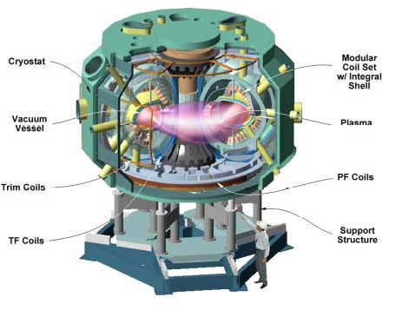

Fig. 1. The NCSX Device and Definition of its Major Components

Note in particular the Modular Coil Set with Integral Shell. This integral shell is comprised of the (18) winding forms that are the subject of this SOW. A typical winding form is shown in Fig. 3.

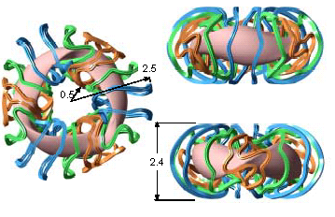

Fig. 2. The NCSX Modular Coil Windings

The windings are shown without their associated winding forms so their complex shapes can be easily seen. In order to manufacture these windings to their precise shapes, stranded copper conductor is wound on the machined winding forms (shown in Fig.3), which are the subject of this Statement of Work. Six of each of the three winding form shapes are required. (Dimensions in meters)

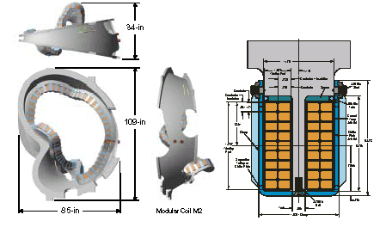

Fig. 3. NCSX Modular Coil Details

Shown is one of the three winding form shapes. The left view shows a sectional view of the form with the stranded cables conductors wound in place on both sides of the “T” section. The winding form serves two very important functions: it defines the precise shape of the winding and provides the required structural support.

1.3 Conductor Description

A single modular coil conductor turn is comprised of four rectangular compacted copper ropes in a two-by-two configuration. Individual copper ropes measure 0.25-inch by 0.3125-inch. These conductors are vacuum impregnated as described in Section 2.1.2. Poloidal field (PF) coils are comprised of turns of conventionally wound OFHC CDA 104 copper bar stock. Typical dimensions for an individual PF conductor are 0.875-inch by 0.875-inch.

Groups of conductors are placed on a mold where they are bonded into bundles forming the modular and PF coils. For simplification, this SOW will involve the bundling of four modular and PF coil conductor turns in two-by-two configurations for the purpose of vacuum impregnation and testing (Figure 4).

1.4 Scope

The scope of this SOW includes two separate tasks. The first is the production of lengths of vacuum impregnated modular coil conductors. These lengths will be used to fabricate a sufficient quantity of vacuum impregnated specimens to be used to perform mechanical and thermal testing of the conductors individually and in bundles. PF conductors will be tested in vacuum impregnated bundles, only. The second task, the actual test program, shall conform to accepted testing standards as rigorously as possible and be used to determine specified properties of the conductors and bundles in various configurations. The Subcontractor shall submit a firm fixed price and schedule proposal for these efforts.

1.5 Applicable Documents

ASTM standards shall be adhered to as rigorously as possible. Any deviation from those standards shall be made in coordination with PPPL.

2. WORK REQUIREMENTS: The tasks described below should be performed approximately in the order indicated. It is expected that the Subcontractor may be working on several in parallel. Schedule requirements are described in the Subcontract. Subcontractor suggested variations in these requirements are discussed in Section 2.4.

2.1 Vacuum Impregnation of the Modular Coil Conductor

2.1.1 Conductor Fabrication: The Subcontractor shall fabricate vacuum impregnated modular coil conductors in lengths of approximately 45 inches. PPPL will provide the mold, the necessary compacted copper rope (four braided ropes are used in each modular coil conductor turn), and the proper dry glass tape and Kapton. The Vendor shall provide the OFHC CDA 104 bar stock for the PF coils. Vendor shall provide the epoxy. Vendor shall provide the necessary molds to be used for the fabrication of both the modular coil and PF coil bundles for the test program. Figure 4 details the four coil and bundle configurations involved with this SOW. Fabrication sequence will involve the following:
- Adaptation of the PPPL's provided mold with the Subcontractor’s vacuum impregnation fixturing
- Implementation of the wrapping and insulating technique to apply the glass fabric tape and Kapton to the conductors per Section 2.1.2
- Vacuum impregnation and curing of the conductors per Section 2.1.3 and 2.1.4
- Visual and microscopic evaluation as to the degree of impregnation per Section 2.1.5

2.1.2 Materials: The vacuum impregnated modular coil conductors are comprised of the following components:

• Compacted copper conductor braided rope (provided by PPPL)

(4) Individual ropes 2 x 2 [0.250" x 0.3125"] are used to form a single modular coil conductor

• Turn Insulation scheme as noted on Figure 4

- (1) 1/2 lapped layer 0.007 inch thick dry glass tape, treated to improve adhesion of epoxy

- (2) 1/2 lapped co-wound layers glass/Kapton insulation

• 0.007 inch thick glass insulation, treated to improve adhesion of epoxy

• 0.003 inch thick Kapton insulation, treated to improve adhesion of epoxy

• Ground insulation (Multiple turns)

(2) 1/2 lapped layer 0.007 inch thick glass tape, treated to improve adhesion

• Epoxy

Product: CTD-101K (Composite Technology Development Inc.)

Mixing Ratio's:

Resin (Part A) 100.0 pbw (parts by weight)

Hardener (Part B) 90.0 pbw

Accelerator (Part C) 1.5 pbw

Turn insulation scheme for individual PF coil conductors:

• Turn insulation scheme as noted on Figure 4

Note: These layers are not co-wound

- (2) 1/2 lapped 0.003 Kapton

- (2) 1/2 lapped 0.007 dry glass tape

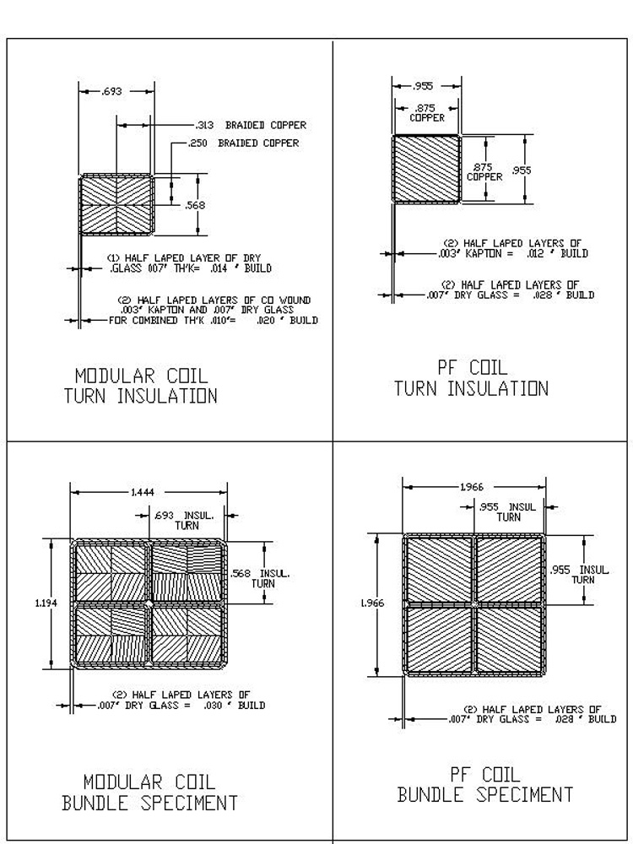

Fig. 4. NSCX Modular Coil and PF Conductor Turn Insulation Scheme

Shown above are the components of assembling the modular and PF coil conductors and bundles

2.1.3 Impregnation Process: Preheat components to 40 degrees C. After mixing, degas components. Vacuum impregnate copper insulated samples using the materials and epoxy system as described in Sect. 2.1.2.

2.1.4 Cure Cycle:

• Following VPI, ramp up specimen from starting point of 40-45 degrees C

• Ramp up 20 degrees C per hour to a temperature of 110 degrees C (Gel temperature)

• Hold at 110 ± 2 degrees C for 5 hours

• Ramp up to 125 degrees C (Cure temperature)

• Hold at 125 ± 2 degrees C for 16 hours

• Ramp down 10 degrees C per hour until sample reaches room temperature

2.1.5 Acceptance Criteria: Any defects or alterations to the cured specimens may cause a change in the test results. Accordingly, impregnated specimens shall be free of cracks, dry spots and voids. In addition, the surfaces of the specimens shall not be patched or repaired.

2.1.6 Final Inspection: Describe the final inspection methods proposed to assure that the impregnated modular and PF conductors and bundles meet all of the requirements of Section 2.1.5. The degree of epoxy penetration within the modular coil conductor body shall be noted.

2.2 Test Specimen Preparation: Three geometries will be tested; individual VPI modular coil conductors, two-by-two bonded bundles of modular conductors, and two-by-two bonded bundles of PF conductors.

The Subcontractor shall fabricate a sufficient quantity of specimens for tension and flexural testing of a single modular coil conductor at four different temperatures. Six test specimens of each type will be needed at each temperature, resulting in a total of 24 specimens for each test. Additionally, the Subcontractor shall produce specimens for measurement of Thermal Conductivity and Specific Heat. Assuming a 45-inch, useable section of insulated conductor is produced from a single impregnation run, the following number of production runs would be needed:
- Tension specimens – assumed to be 15 inches long, 8 production runs
- Flexural specimens – assumed to be 10 inches long, 6 production runs
- Thermal Conductivity and Specific Heat – specimen size TBD (in coordination with PPPL), 1 production run

The Subcontractor shall produce two-by-two bonded bundle specimens for shear and flexural testing of both the modular coil conductors and the PF conductors. Production of these specimens will require the fabrication by the Subcontractor of a mold capable of ensuring adequate resin impregnation to all four conductors for each of the two geometries. The Subcontractor shall test these specimens in shear and in flexure. As with the single modular coil conductor above, 24 test specimens of each test will need to be produced for both the modular coil and PF coil bundles. A mold size approximately 30-inches long is envisioned, enabling one shear and one flexural specimen to be taken from one production run. Vendor shall recommend mold size. With a 30-inch mold size, the following number of production runs would be needed:
- Shear specimens – assumed to be 7 inches long
- Flexural specimens – assumed to be 16-18 inches

Each production run would produce one flexural specimen and one to two shear specimens. Accordingly, 24 production runs are necessary for each of the series of tests to be performed on both the modular coil and PF coil bundles.

2.3 Mechanical and Thermal Testing: The Subcontractor shall conduct testing at four temperatures: 77 K, 100 K, 150 K, and 295 K (adjustable for altitude). Six (6) specimens of each type shall be tested at each temperature. The tests to be performed are described below:

2.3.1 Mechanical Tests on a Single Modular Coil Conductor

2.3.1.1 Tension / compression Tests: The Subcontractor shall perform these tests in accordance with an applicable ASTM test standard (such as ASTM D3039), modified as necessary to conform to the specimen’s insulated nature. The Subcontractor shall fabricate appropriate grips as required to grip the conductor and assure uniform load distribution. Two strain gages shall be bonded to each specimen, on opposing sides, to determine elastic modulus and Poisson’s ratio. Yield strength, ultimate strength, modulus, Poisson’s ratio, and failure mode shall be reported in tension for both the modular and PF coils conductor samples and in compression for the modular coil conductor only. Failure criteria shall be determined through consultation with PPPL prior to the start of testing.

2.3.1.2 Flexure Tests: The Subcontractor shall perform flexural testing in accordance with ASTM D790, which uses a 3-point bend fixture. The Subcontractor shall fabricate test fixturing, as required, to support the specimens. The flexural strength and the flexural modulus of the specimens shall be reported. The Subcontractor shall perform an evaluation of the results to determine if the properties are dependent on conductor orientation.
      - Thermal Expansion Tests: The Subcontractor shall determine the coefficient of thermal expansion for a temperature range from 77 K to 295 K (adjusted for altitude).
      - VPI Shrinkage evaluation: The Subcontractor shall determine the longitudinal and transverse shrinkage of the cable conductor samples due to the epoxy impregnation and cure, by measuring the free length of the sample prior to VPI and after VPI. The measurement should be accurate enough to detect shrinkage to a resolution of 0.1%.

2.3.2 Thermal Properties of a Single and Bundled Modular Coil Conductor

2.3.2.1 Thermal Conductivity and Specific Heat: The Subcontractor shall fabricate specimens for testing at the four temperatures listed in Section 2.3. Thermal conductivity tests will be required in multiple configurations and directions to establish a comprehensive set of property data. The thermal conductivity for a single modular coil conductor following VPI will be necessary in all three principle axis directions due to its dependence on geometry. In addition, it will be necessary to establish the thermal conductivity of the individual insulation components so that the property can be extrapolated for the actual, larger modular coil bundle. This will include the testing of an individual layer of turn insulation, only, as well as the independent measure of the ground insulation layer at each of the specified temperatures.

2.3.3 Mechanical Testing of Two-by-Two Modular Coil and PF Conductor Bonded Bundles

2.3.3.1 Shear Tests: The Subcontractor shall perform shear tests on two-by-two bonded conductor bundles in accordance with ASTM D2344, which is a Short-Beam Shear test using a three point bend test fixture. The Subcontractor shall fabricate test fixturing, as required, to support the specimen. The apparent shear strength and flexural modulus shall be reported.

2.3.3.2 Flexural Tests: The Subcontractor shall perform flexural testing on bonded bundles in accordance with ASTM D790, which uses a 3-point bend fixture. The Subcontractor shall fabricate test fixturing, as required, to support the specimens. The flexural strength and the flexural modulus of the specimens shall be reported. The Subcontractor shall perform an evaluation of the results to determine if the properties are dependent on bundle orientation.

2.4 Subcontractor’s Recommendations: The Subcontractor shall recommend changes to the vacuum impregnation process and test program, outlined in Sections 2.1-2.3, that could make the modular and PF coils easier to manufacture, reduce costs, improve performance, or improve the fabrication schedule. In the event that the Subcontractor cannot perform any of the tests as specified, the Subcontractor shall indicate as such and suggest an alternative test method, subject to PPPL approval.

2.5 Additional Manufacturing Development And Testing Activities: The Subcontractor shall perform and document any additional agreed upon manufacturing development and testing activities that are necessary to develop the knowledge required to produce the vacuum impregnated modular and PF coil conductors and reduce the technical, cost, and schedule risk. (These additional activities are to be defined in the Subcontractor’s Proposal and shall be set forth in the Subcontract.)

2.6 Firm Fixed Price and Schedule Proposal: The Subcontractor shall provide a firm fixed price and schedule proposal for the vacuum impregnation of the modular and PF coil conductors and bonded bundles and the subsequent test program as outlined in Sections 2.1-2.3 and provided in the Subcontract.

3. Quality Assurance

3.1 Inspection/ Surveillance/Audit by PPPL: Authorized representatives of PPPL and the U. S. Government shall have the right at all reasonable times to visit the Subcontractor's premises and those of Subcontractor's suppliers during the performance of the Subcontract for the purposes of inspection, surveillance, audit and/or obtaining any required information as may be necessary to assure that items or services are being furnished in accordance with specified requirements. Such visits shall be coordinated with the Subcontractor's personnel to minimize interference with the normal operations of said premises. The Subcontractor shall make available records and documentation necessary for this function and shall provide all reasonable facilities and assistance for the safety and convenience of PPPL and/or U. S. Government representatives in the performance of their duties. PPPL and the U. S. Government recognize the Subcontractor's right to withhold information concerning proprietary processes. The Subcontractor agrees to insert the paragraph above in each lower-tier procurement issued hereunder.

3.2 Subcontractor's Responsibility for Conformance: Neither PPPL review and/or approval of Subcontractor's documents nor PPPL inspection of Subcontractor's items or services shall relieve the Subcontractor of responsibility for full compliance with requirements of the purchase order/contract. The Subcontractor is responsible for assuring that all requirements and restrictions are imposed on any subtier suppliers.

3.3 Subcontractor’s Quality Assurance Program: The Subcontractor shall establish and maintain an effective Quality Assurance Program to assure that the Subcontractor’s work meets the required quality and is performed in accordance with contractual requirements. Subcontractor’s quality assurance function shall be organized to have sufficient authority and independence to identify quality problems, verify conformance of supplied items or services to specified requirements and obtain satisfactory resolution of conflicts involving quality.

3.4 QA Plan: The Subcontractor shall provide a Quality Assurance (QA) Plan for PPPL review and approval. The Quality Assurance Plan shall describe the specific quality assurance and quality control procedures and practices, including procedures and/or protocols for containment control and cleanliness, to meet the requirements of this subcontract and associated specification.

3.5 Inspection and Test Procedures: Inspections and tests shall be performed in accordance with written procedures referencing criteria for acceptance or rejection. Actual data and accept/reject status for each inspection and test shall be documented for each test specimen.

3.6 Document Traceability and Records: The Subcontractor shall maintain a system of documentation whereby objective evidence of required operations, inspections, examinations, and tests is systematically compiled, indexed and stored. Such objective evidence may include "travelers"; and material test, certification, inspection, examination, test and discrepancy reports; which shall be complete, legible, and validated by responsible personnel and shall be traceable to subject items.

3.7 Equipment/Material Identification and Status: Material and specimen identification shall be maintained throughout the program and be traceable to the records.

3.8 Calibration of Test and Measuring Equipment: Inspections and tests shall be performed using properly calibrated measuring and test equipment. Subcontractor shall have in its possession the necessary equipment to perform the required inspections and tests. Calibration standards shall be traceable to the National Institute for Standards and Technology (NIST) or equivalent acceptable to PPPL and shall not be used for shop inspections, but instead be protected against damage or degradation.

3.9 Control of Special Processes: Subcontractor shall use trained and qualified personnel and written procedures for the performance of this work

3.10 Process History: Subcontractor shall provide to PPPL, with the shipment release request, a Process History, which includes a compilation of documents, detailing the objective evidence of the acceptability of the work performed. The Process History shall include as a minimum, but not be limited to, the following:

3.10.1 Material Certifications: The Subcontractor shall submit Material Test Reports showing actual relevant chemical, mechanical, and electrical properties of materials used and providing traceability to the actual material. Material certifications from sub-tier suppliers shall also be submitted. One copy is to be submitted upon Subcontractor acceptance for use.

3.10.2 Inspection and Test Reports: Copies of the original reports of all required inspections, tests and examinations, which have been properly validated by authorized personnel.

4. DELIVERABLES

4.1 QA Plan: Subcontractor's QA Plan for this SOW shall be provided within two (2) weeks after award of contract.

4.2 Weekly Reports: Weekly status reports covering technical, administrative, and Quality activities shall be provided to Princeton’s Technical and Administrative Representatives by e-mail every Friday during the period of performance.

4.3 Procedures: Provide written procedures (Section 2.1.1) within two (2) weeks after award of contract for:

• Wrapping and insulating the conductors and conductor bundles

• Vacuum Impregnation

• Visual and microscopic inspection

(Do we need to ask for mechanical/thermal test procedures, ie which ASTM procedure will they use? )

4.4 Documentation: Provide inspection and test reports as described in Sect. 3.11 of this SOW along with the actual test specimens.

PRINCETON UNIVERSITY

Ata ATTACHMENT 1.

PLASMA PHYSICS LABORATORY—PPPL

PRODUCT QUALITY CERTIFICATION AND SHIPPING RELEASE
PROJECT | ITEM DESCRIPTION |  |  |  | SHIPMENT NUMBER
PPPL Subcontract / Order No. | REV. | ITEM NO. | SUPPLIER REFERENCE NO. |  | REV. | QUANTITY SHIPPED

SUPPLIER'S CERTIFICATION

This is to certify that the products and services identified herein have been produced under a controlled quality assurance program and are in conformance with the procurement requirements including applicable codes, standards and specifications as identified in the above-referenced documents unless noted below. Any supporting documentation will be retained in accordance with the procurement requirements.

SIGNED: _________________________________________ DATE: __________________________

TITLE: _________________________________ COMPANY: _______________________________

PPPL (AUTHORIZED REPRESENTATIVE) SHIPPING RELEASE

This is to certify that evidence supporting the above Supplier's Certification statement has been audited and no product/service nonconformances from procurement requirements have been found unless noted below. This product/service is hereby released for shipment.

This section serves as the Quality Assurance release for the above described product for shipment. It does not constitute an acceptance thereof and does not relieve the Vendor, Manufacturer or Contractor of any and all responsibility or obligation imposed by the purchase contract. It does not waive any rights the Purchaser may have under the purchase contract, including the Purchaser's right to reject the above described material upon discovery of any deviations from requirements of the purchase contract, drawings and specifications.

NONCONFORMANCES FROM PROCUREMENT QUALITY REQUIREMENTS:

REMARKS/PRODUCT SERIAL NUMBERS:

BY PPPL QA REPRESENTATIVE (OR DESIGNEE) |  |  |  | DATE

