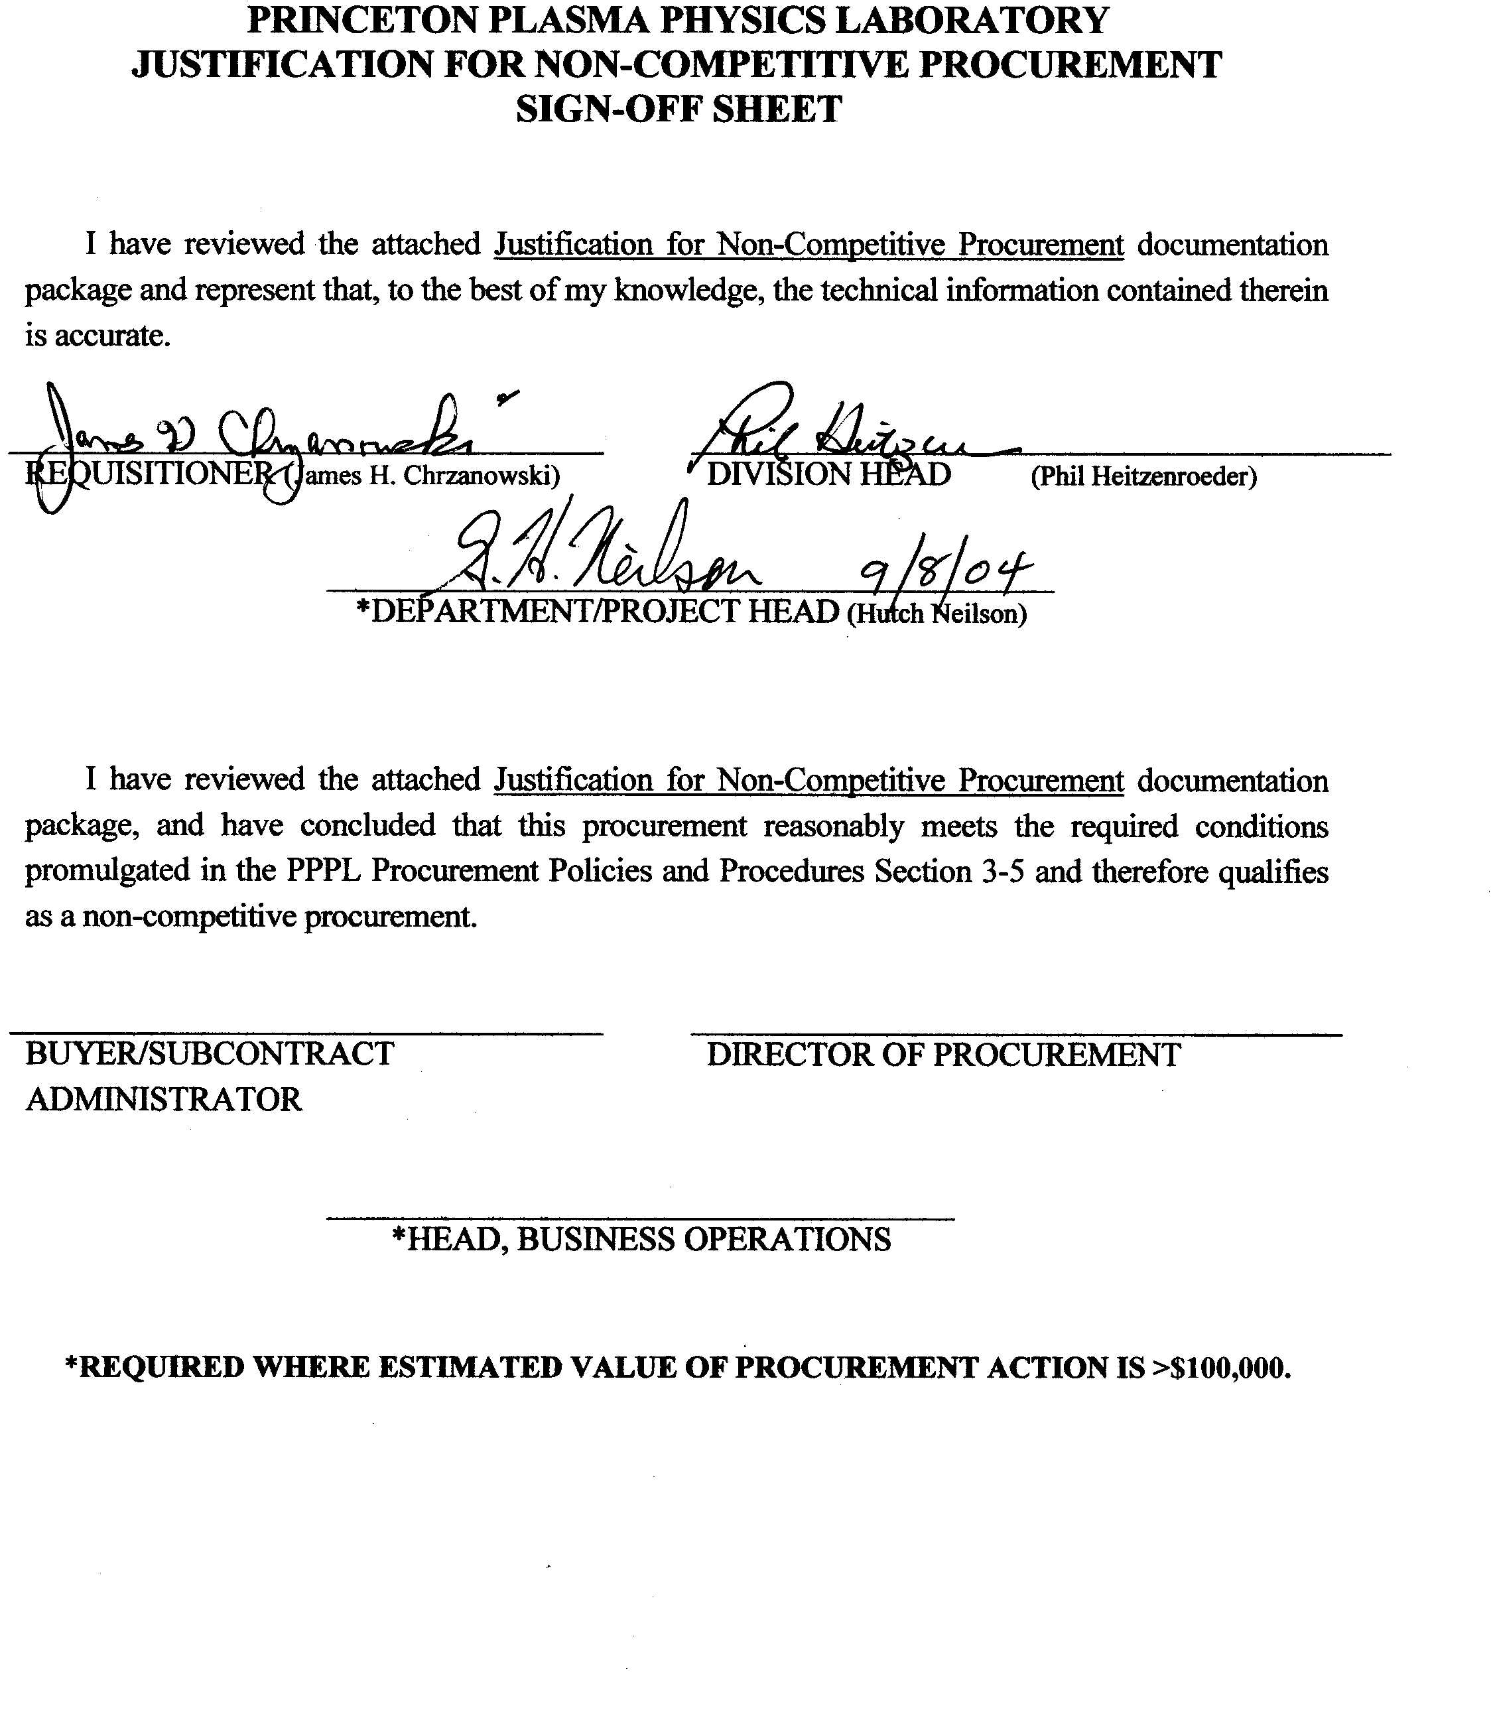

JUSTIFICATION FOR NON-COMPETITIVE PROCUREMENT

NOTE: This form is to be used by requisitioners for development of Non-Competitive (Sole Source) Justifications for purchase orders or subcontracts for supplies and services exceeding $5,000.00 in value.

I recommend that negotiations be conducted with:
New England Electric Wire Technologies (NEEWT)

(NAME OF VENDOR)

for the supplies and services identified herein.

PURCHASING QUESTIONNAIRE

A. Description of Item or Service: (A brief general non-technical description, general statement of application and significance of the Procurement.)
Compacted copper rope conductor that will be used for manufacturing the NCSX modular coils. The conductor size and construction was developed through an extensive R&D program. Sufficient conductor will be procured for manufacturing (18) plus (2) spare modular coils

B. Planning Reference: (Prior purchases, estimated future requirements, long-range objectives, if any.)
During the R&D phase of the program, various types of copper rope conductors were procured from NEEWT and tested by PPPL. The construction of these conductors involved interaction between NEEWT and NCSX engineering to minimize conductor keystoning and to maximize the packing factor. At the conclusion of the R&D program a conductor size and construction type has been selected and is documented in specification NCSX-CSPEC-142-03-00. This conductor will be used for all of the NCSX modular coils.

C. Prior Action: (Briefly describe any Vendor contacts made. Is this a continuation of prior work or related to other procurement actions?)
Conversations have been held with NEEWT technical staff during the development of the specification and statement of work. Testing and QC requirements were discussed.

D. Why is Competitive Procurement not considered feasible?
On January 19, 2004 a “Source Sought” announcement was posted on the Federal Business Opportunities Web in hopes of finding additional sources. Only (2) responses were received. Of these, one was submitted by a reseller of NEEWT cable. The second offered a technically unacceptable alternative.

This conductor is unique in construction, not typical for coil manufacturing. Once the wire rope is constructed, it must be compacted to close tolerance dimensions and insulated. These requirements make this conductor a non-typical product. NEEWT continues to be the only known source for this material.

E. How were cost estimates, as shown on the requisition, developed?
Estimates were based upon previous procurements of conductor from NEEWT during the R&D program.

F. What basis was used to develop schedule requirements? (Explain urgency and willingness to relax schedule, if significant cost savings can be identified with a relaxed schedule.)
Schedule requirements were developed based upon the overall NCSX project schedule. Partial delivery of the conductor needs to be available (on-site) prior to the delivery of the first modular coil casting. Delivery of conductor could be staggered providing the entire conductor inventory is delivered in FY05.

G. Supplier has the following exclusive capabilities: |  | Yes |  | No
- Specially trained personnel. |  | X |  | □
- Demonstrated specialized experience and/or proven performance. |  | X |  | □
- Unique or vital facilities and test equipment. |  | X |  | □
- Exclusive patent rights, trade secrets, etc. |  | □ |  | X
- Unique knowledge of matching or mating items. |  | X |  | □
- Only source of replacement parts for equipment purchased from same supplier. |  | □ |  | X
- Will void responsibility for integrated system performance if other Supplier items are introduced. |  | N/A |  | □
- Only known source of quality equipment; equipment from other known Supplier sources has been demonstrated to be unacceptable or inferior. |  | X |  | □
H. Drawings and specifications are not adequate for competitive solicitation. |  | □ |  | X

