B1 inside radius on septum winding surface

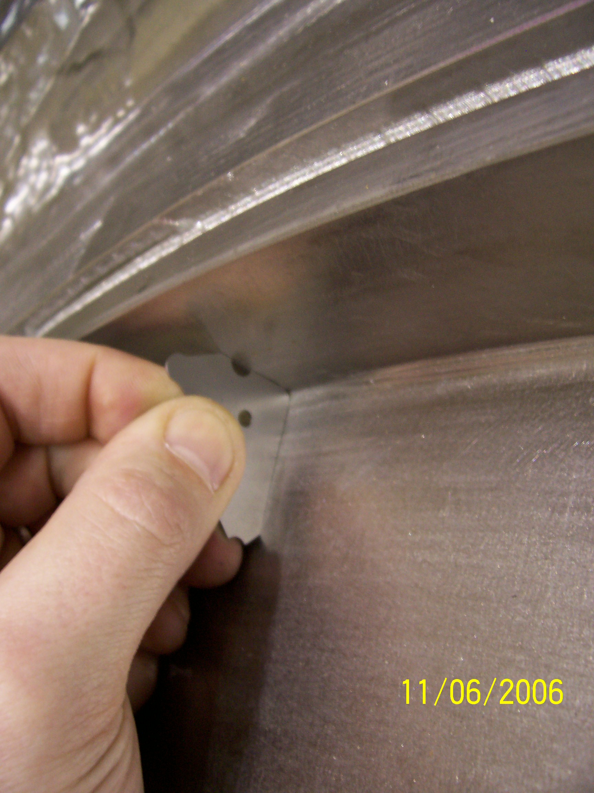
Transition from acceptable to not acceptable

7/64” radius gauge between clamp #33 & 34 – Acceptable

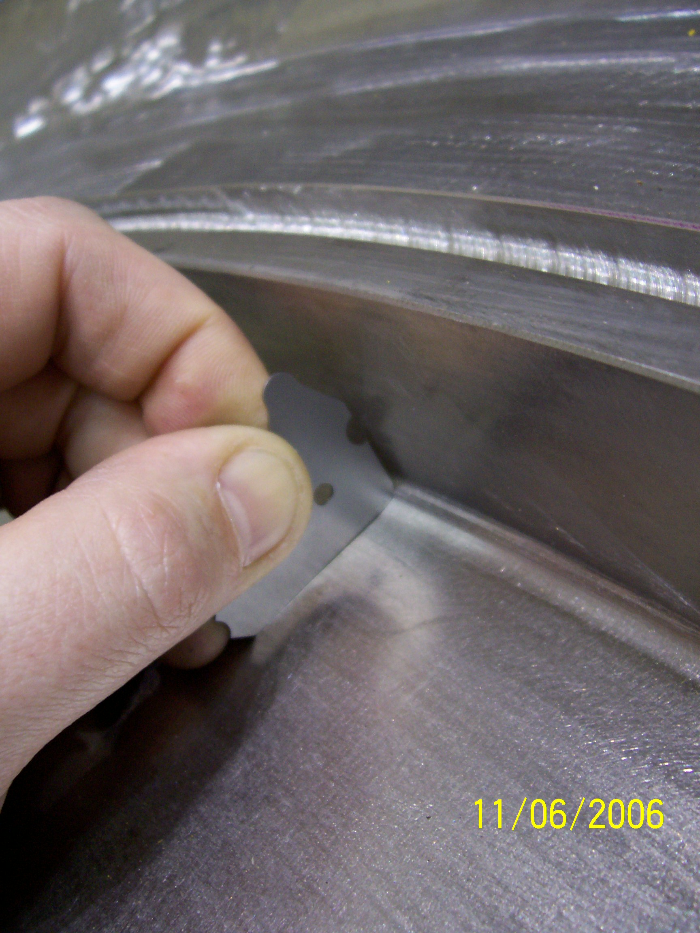

7/64” (0.1094) gauge between clamp #33 & 21 – Not Acceptable

Representative pictures from other out of tolerance areas.

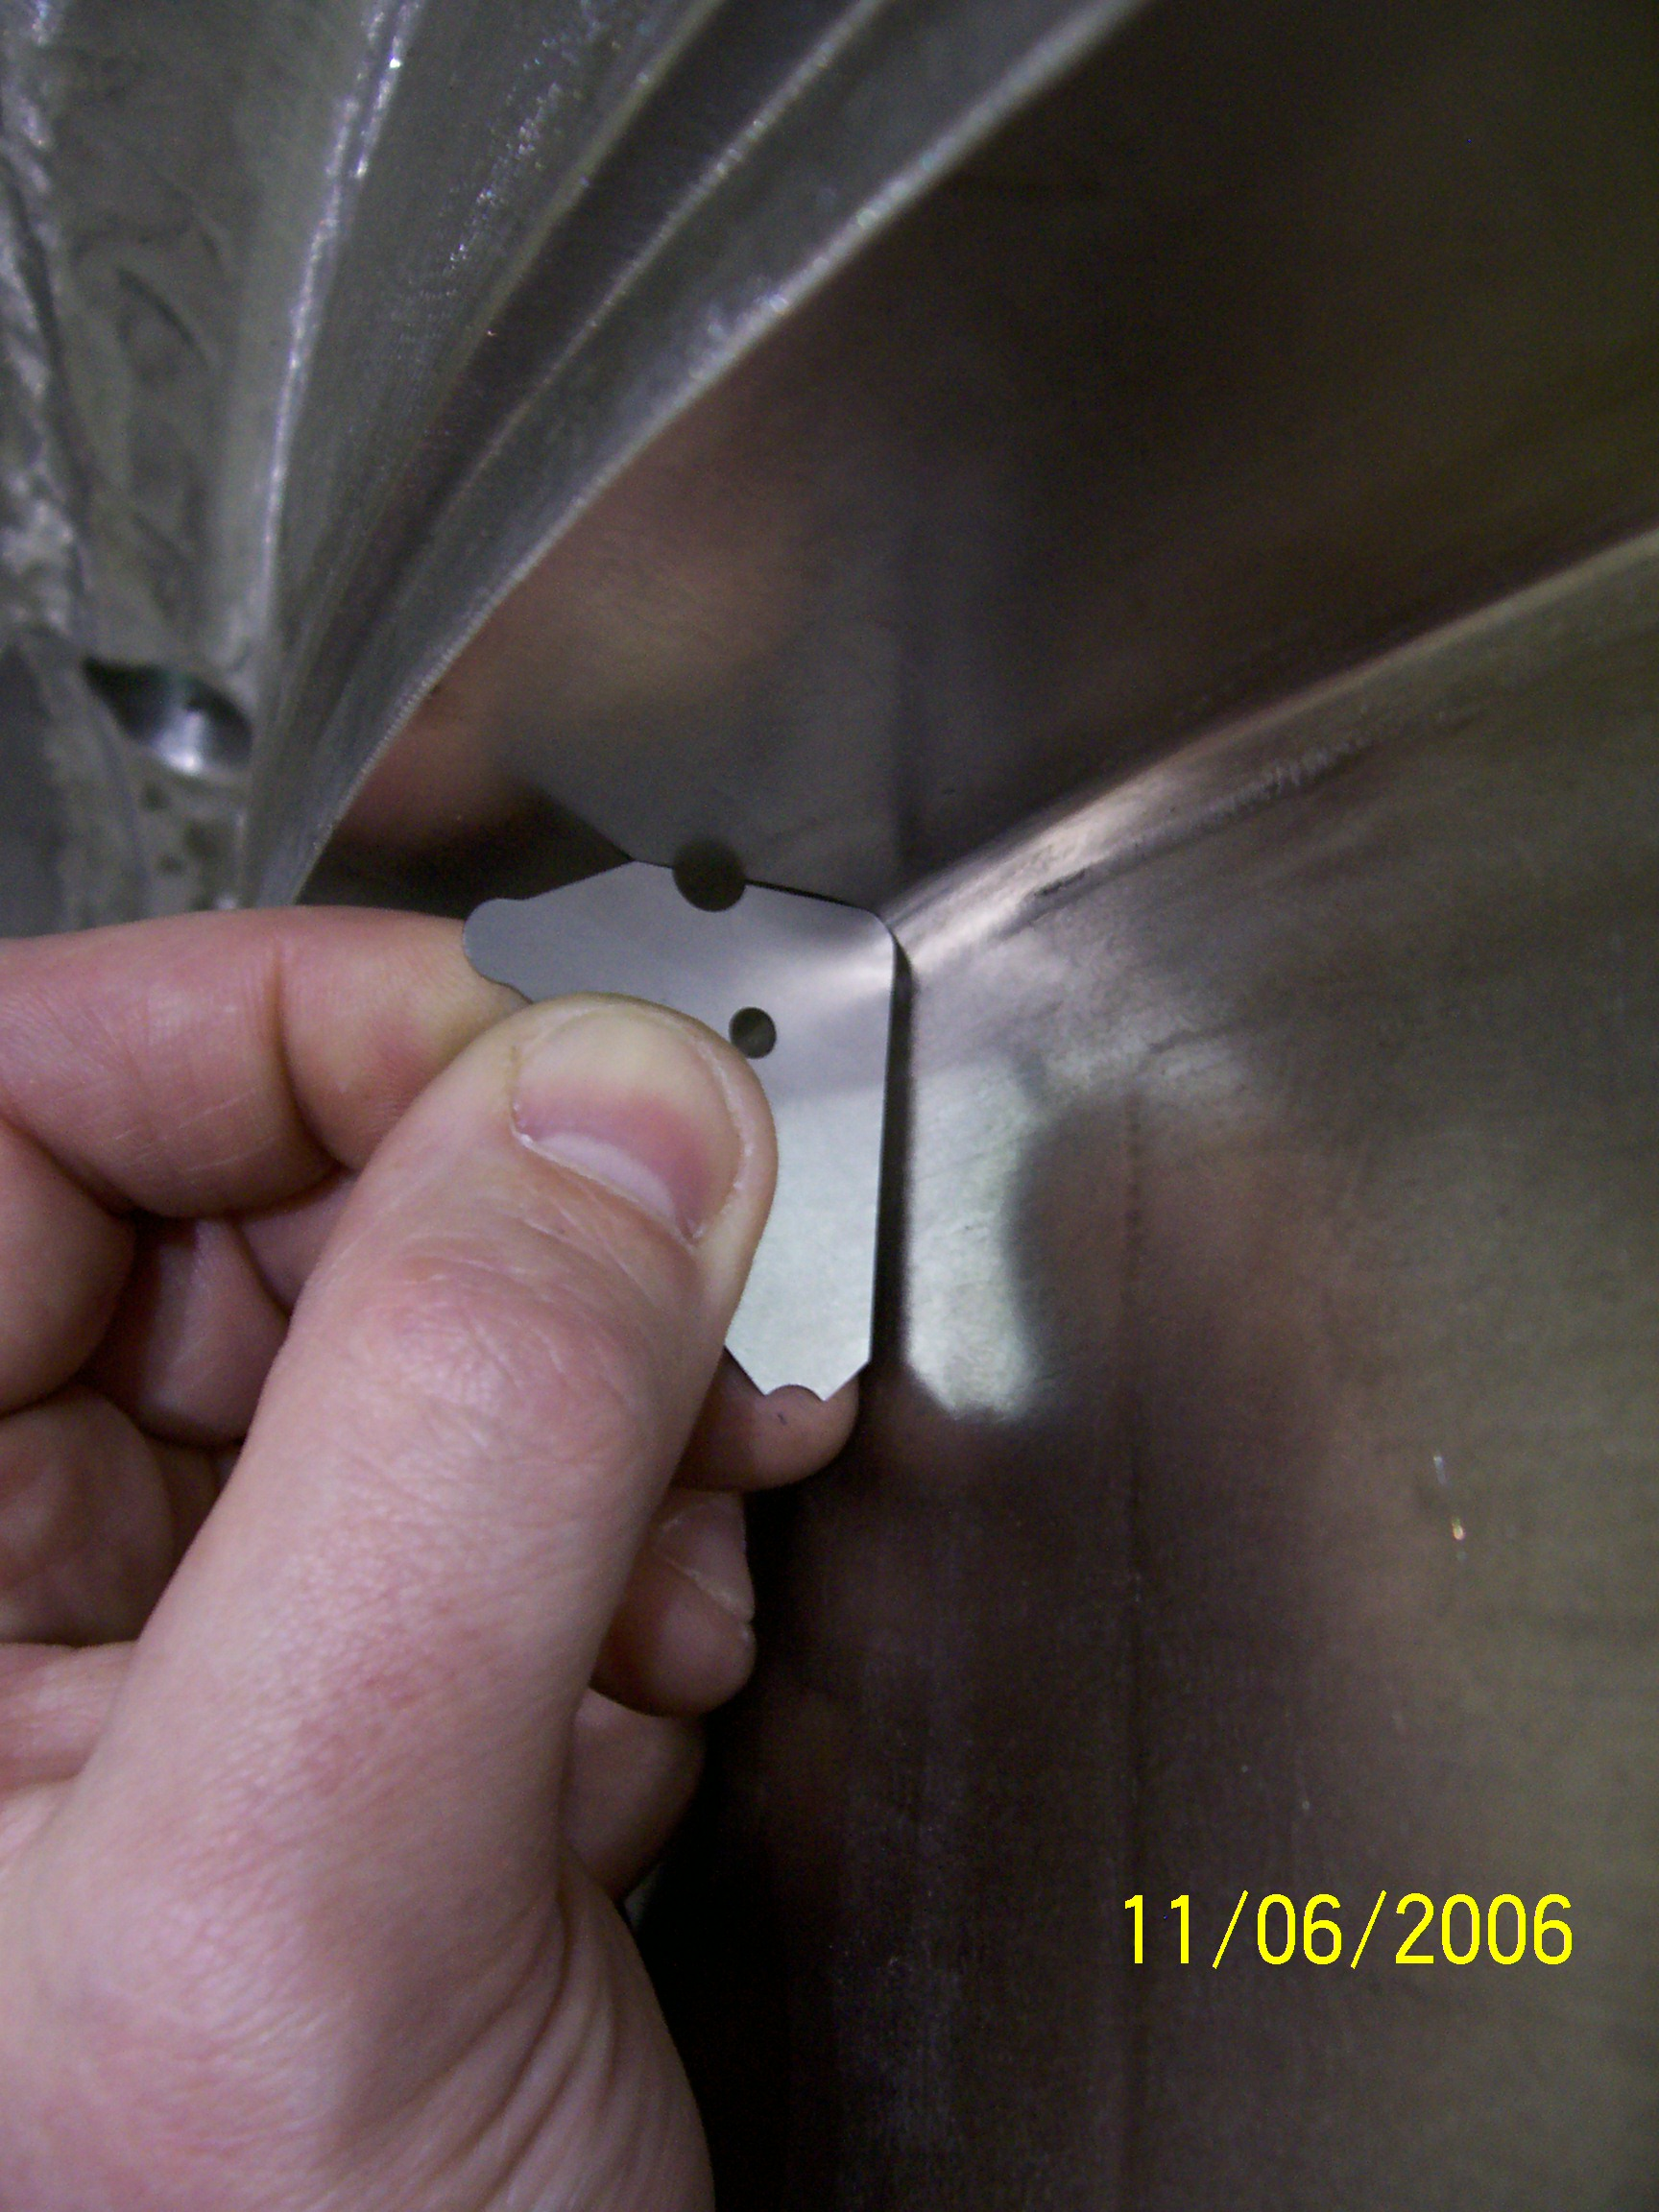

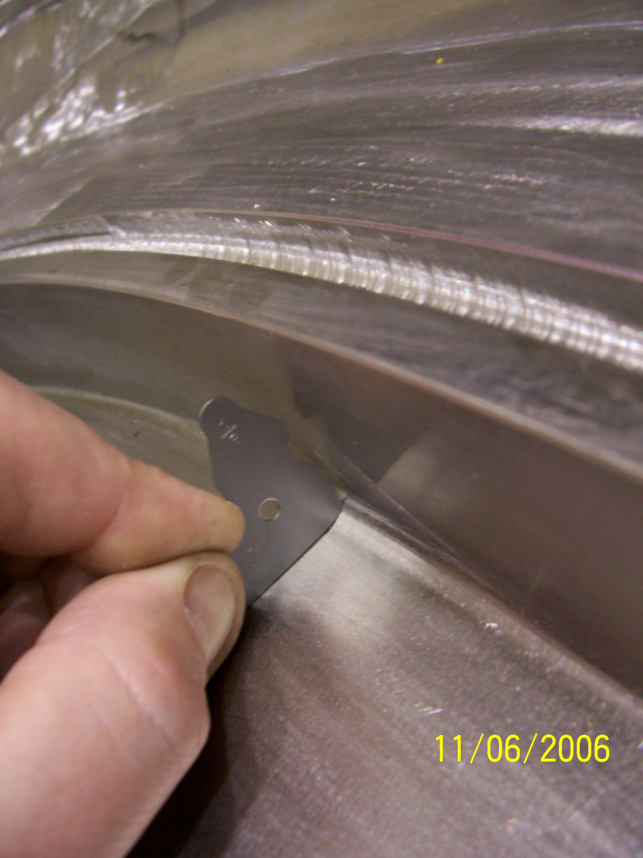

1/8” gauge representing the maximum of the tolerance (0.11” +/-0.01”).



