STATEMENT OF WORK

For

NCSX Modular Coil

Winding Development Activities

NCSX-SOW-142-00

Revision: 00

Dated: October 23, 2002

approvals

Prepared by: ____________________________________ Date________________

J.H. Chrzanowski, NCSX Coil Engineer

Review: ________________________________________ Date ________________

D. Williamson, NCSX Coil Systems Mgr.

Review: _______________________________________ Date _________________

B. Nelson, NCSX Stellarator Core Systems Mgr.

Approved by: ___________________________________ Date ___________________

W. Reiersen, NCSX Engineering Project Manager

REVISIONS

Revision No. | Affected Pgs. | Date
0 (Initial Release) | All

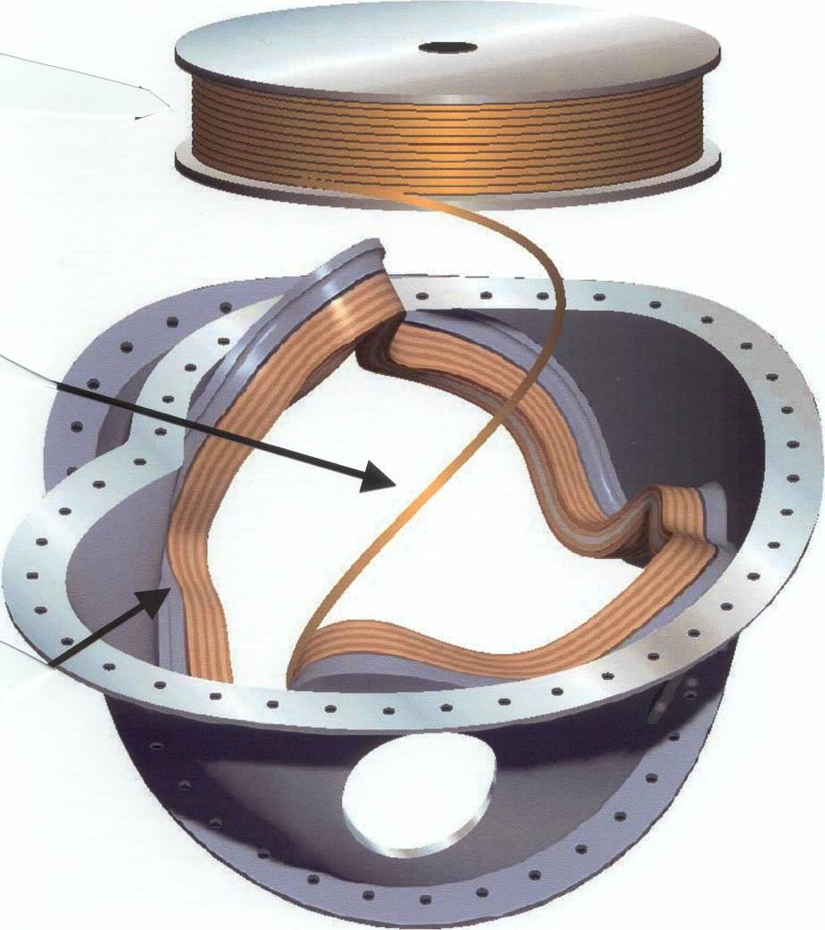

Table of Contents

Page

SCOPE

- APPLICABLE DOCUMENT

3. Requirements
  - Statement of Work Activity

    - Development of the necessary NEPA and WP documentation for completing the winding development activities.
    - Generation of Job Hazard Analysis (JHA) Forms
    - Selection of epoxy resin system for impregnating the Modular Coils.
    - Development of VPI Process for Modular coils.
    - VPI of Test Coil from University of Tennessee (UT).
    - Fabrication of Tensile Test Specimens.
    - Keystone Tests
    - Design and Fabrication of Tooling and Equipment
    - Winding and VPI of Prototype Modular Coil
    - Procedures & Process Plan for Winding and VPI of Prototype Modular Coil

  - Materials:

  - Environment, Safety, and Health

4. DELIVERABLES
4.1.

- SCOPE:
The scope of this Statement of Work (SOW) includes those activities associated with the development of a sound plan for the fabrication of the NCSX modular coils. Specifically it includes the development of the necessary tooling and equipment for winding and impregnating the modular coils; the selection of an epoxy resin system for impregnating the modular coils plus the development of a vacuum-pressure-impregnation (VPI) plan including delivery system. Additional work includes a study of tolerance control during the coil-winding phase.

- APPLICABLE DOCUMENTS

  - ES&H 5008 PPPL Health and Safety Manual
  - TBD Specification for the Modular Coils Windings
  - ENG-032 Work Planning Procedure
  - ESH-014 NEPA Review System
  - ENG-014 Job Hazard Analysis
  - Integrated Safety Management (ISM).

- REQUIREMENTS

  - STATEMENT OF WORK ACTIVITY
The tasks described below are not necessarily in the order that they are to be completed. It is expected that several of these activities will be worked in parallel. Delivery requirements are described later in the SOW. (Section 4.0)

    - Development of the necessary NEPA and WP documentation for completing the winding development activities.

Work Planning Form (WP): This procedure is used to plan the anticipated requirements of a job, to define the scope of work, to perform hazards analysis, to provide for all environmental, safety, and health issues as part of the work planning and review process, to establish procedural and testing requirements, to make other determinations as necessary, and to provide clear approvals indicating ownership of the work. It is one of the systems that implement the requirements of P-001, Graded Approach. (Reference document ENG-032 “Work Planning”)

NEPA (National Environ. Policy Act): This document will be generated to assure compliance with NEPA through independent review of activities. (Reference document ESH-014 “NEPA Review System”)

    - Generation of Job Hazard Analysis (JHA) Forms
Generate the necessary JHA’s to identify existing and potential workplace hazards and to evaluate the risk of worker injury or illness associated with the winding development efforts. JHA’s will be generated for all work activities associated with this SOW. (Reference document ESH-014 “Job Hazard Analysis”)

    - Selection of epoxy resin system for Impregnating the Modular Coils
Involves the process of review and selection of epoxy systems that will meet the electrical, thermal and mechanical requirements of the Modular coils. Activities will include:

      - Selection of various epoxy systems for evaluation

      - In-house characterization and testing of the epoxy resin systems selected for evaluation

      - Obtaining the services of an outside epoxy consultant to provide epoxy consultation and testing facilities to the NCSX project in the final selection of an epoxy system for impregnating the modular coils. SOW to be developed.

    - Development of VPI Process for impregnating Modular coils
Develop and demonstrate a process plan for vacuum impregnating the modular coils. Activities include:

      - Design/develop an encapsulating system that would provide an external shell around the modular coil during the VPI process. The system must be able to withstand pressure levels between milli-torr (vacuum) to a maximum 20-psi pressure, while operating in a heated autoclave environment (130 deg C).

      - Design and fabricate 10-12 short coil beam specimens to be used during the VPI trial. These specimens would be representive of various sections of the modular coils. Insulated copper conductors would be placed onto the winding form per the present modular coil design specifications. Beam specimens would also be used in the development of the mold and tooling. See figure 2

      - Vacuum-pressure-impregnate the short coil beam specimens to develop the VPI process for epoxy impregnating the modular coils.

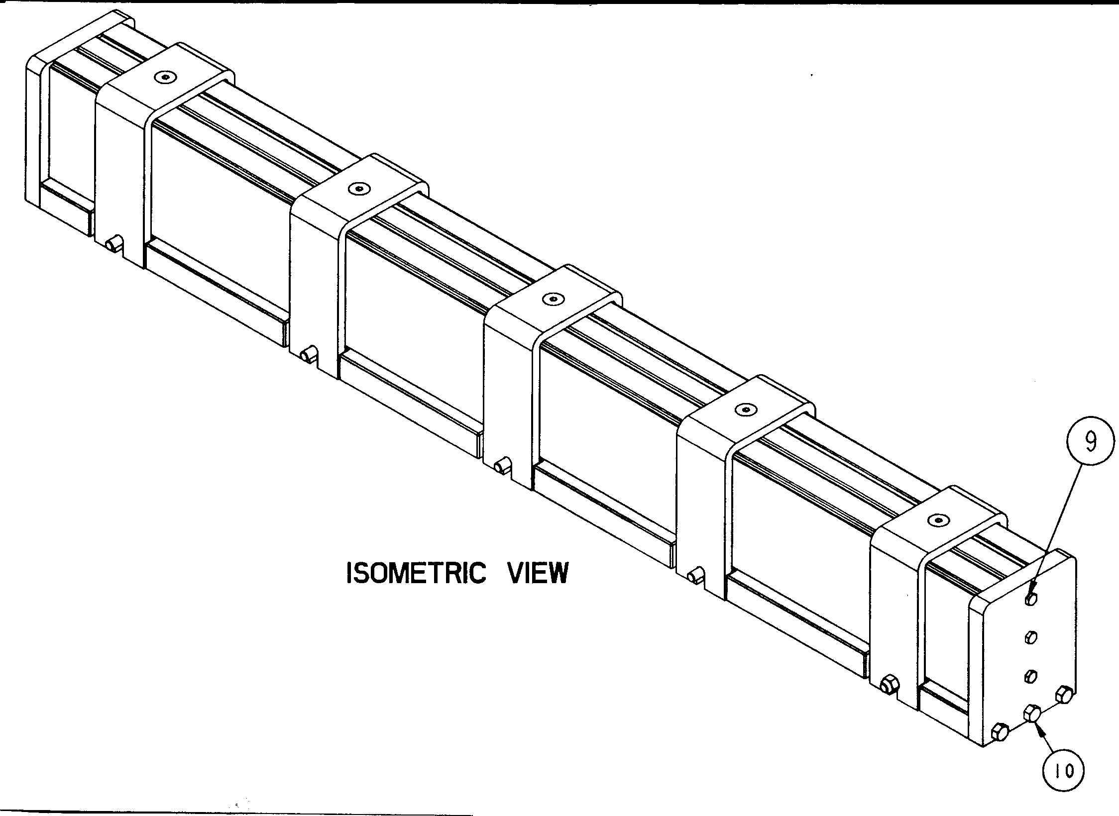
Figure 2

      - Develop an epoxy delivery process and system for introducing the epoxy into the modular coil bundle during the epoxy impregnation process.

      - Generate a complete process plan for vacuum impregnating the modular coils including mold assembly, coil preparation, epoxy preparation, delivery system assembly, and VPI steps including cure cycle and epoxy characterization during the VPI.

    - VPI of Test Coil from University of Tennessee (UT)
Princeton Plasma Physics Laboratory (PPPL) will prepare and vacuum-pressure-impregnate a canned coil from the University of Tennessee. This coil will be constructed using comparable conductor and insulation as will be used for the NCSX modular coils. The UT coil will be impregnated using one of the epoxy systems being evaluated by the NCSX project. Complete process records will be documented and provided to UT following VPI completion. See figure 3

Final electrical tests will be performed on the impregnated coil per written agreement with ORNL.

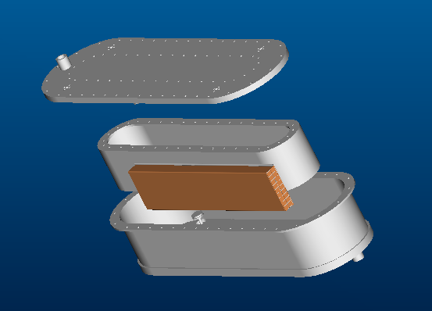
Figure 3 University of Tennessee Test Coil

    - Fabrication of Tensile Test Specimens

A minimum of (12) straight length (approximately 45 inch length) compacted copper rope conductor specimens will be insulated using the proposed modular coil insulating scheme and vacuum impregnated using one of the epoxy systems being evaluated by the NCSX project. (See Figure 4)

These specimens will be used for tensile tests and the development of baseline for the modular coil copper conductor data. This activity includes the design and fabrication of a mold for impregnating the specimens.

Note: The oversight of these tensile tests is not part of this SOW.

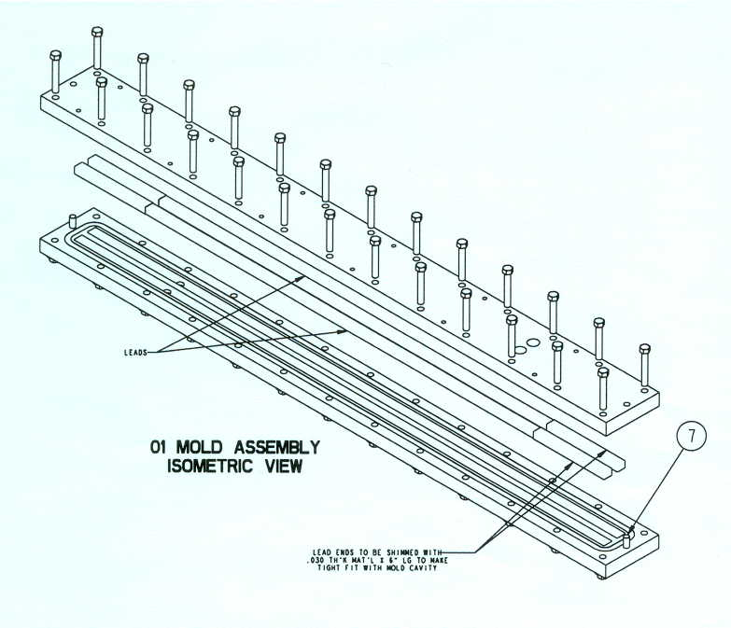
Figure 4 VPI Mold for Conductor Tensile Specimens

    - Keystone Tests
These tests will be used to study tolerance control during the winding process. Maintaining tight current center tolerances is essential during the winding process to ensure efficient operation and performance of the modular coils. Keystoning of the copper braid conductor will occur during the winding process due to the number of tight bends and twists in the modular coils.

Keystoning is a term used for the cross-sectional changes that occurs to a conductor during the winding operation.

A model of a typical modular coil will be designed/fabricated and used in these trials. Insulated compacted copper rope conductor will then be wound onto the form. A “FARO” mechanical measuring arm will be used to determine the degree of conductor growth as a result to winding. These tests will be performed using various conductors as determined by the NCSX project. Use of a single vs. multiple conductors will also be evaluated. A result of these tests may require special tooling to compensate/correct keystoning. The data obtained from these tests will be provided to the modular coil form design group in support of the PDR.

    - Design and Fabrication of Tooling and Equipment
Design, fabricate and demonstrate the tooling necessary for winding, handling and vacuum impregnating the modular coils. The final modular coil fabrication plan will require (2) winding stations plus (1) vacuum-pressure-impregnation station. Some of the major tooling will include:

      - Autoclave (vacuum/bakeout system)
      - Winding station (support coils plus misc. winding tooling)
      - Conductor Payout System
      - Automatic Taping head
      - Hold-down winding clamps
      - Epoxy delivery system
      - Coil handling equipment (lifting, etc.)

    - Winding and VPI of Prototype Modular Coil
The final activity for the winding development program will include a full demonstration of winding and vacuum impregnating a modular coil. A prototype modular coil will be wound onto one of the prototype stainless steel coil forms. The final NCSX project copper conductor, insulation and epoxy systems will be used. This activity will be used to verify/develop the fabrication procedures, verify the efficiency of the winding/VPI equipment, and to train the lead technicians responsible for the winding and VPI stations.

    - Procedures & Process Plan for Winding and VPI of Prototype Modular Coil
Develop the final process plan and procedures for winding, vacuum impregnating and testing of the modular coils.

  - MATERIALS

    - Epoxy Resin
      - CTD-101K (primary candidate)
Modified (3-part) anhydride cured epoxy system with excellent performance at cryogenic temperatures.

Materials: Designation: Parts By Weight:
Resin: Part A 100.0
Hardener: Part B 90.0
Accelerator: Part C 1.5

Cure:
Initial Cure: 5 hours @ 110 deg. C
Post Cure: 16 hours @ 125 deg. C

      - Alternate epoxy systems
TBD

    - Copper conductor
“Rectangular compacted copper cable”: Various conductor sizes and numbers may be tested. TBD

    - Insulation
      - Glass Tape
S-glass (Harness Satin Weave) with reactive amino silane finish
Temperature class: 180 deg. C
Nominal thickness: 0.008 inches (mm) tape
Nominal width: 1.0-inch tape

      - Glass Tape/co-wound with Kapton
S-glass (as noted in3.2.3.1)
Kapton:
1 mil treated to assure epoxy bonding
Nominal thickness: 0.0035 inch (0.051 mm)
Nominal width: 1.0 inch
Dielectric strength: 7.5 KV per layer
Temperature Class: 180 deg. C

  - ENVIRONMENT, SAFETY, AND HEALTH (ES&H)

    - All work activities associated with this SOW shall comply with PPPL safety procedures and programs.

    - All personnel shall be adequately trained and have the appropriate certifications as required.

    - Proper use of JHA’s, Confined Space Permits, Flame permits, Radiation Work permits, Lock-out/Tagout of energy sources, and restrictions on working alone shall be complied with.

- DELIVERABLES
The section identifies the activities being completed per this SOW. It also includes activity completion dates, and identifies the project milestone that activity is supporting.

  - Development of NEPA and WP documentation (Reference section 3.1.1)
Completion Date: Nov. 1, 2002

  - Generation of Job Hazard Analysis (JHA) Forms (Reference section 3.1.2)
Completion Date: Prior to the start of all new R&D activity

  - Selection of epoxy resin system for impregnating the Modular Coils.
(Reference section 3.1.3)
Completion Date: March 1, 2003
Supports: Modular Coil Winding PDR (May 03)

  - Development of VPI Process for Modular coils (Reference section 3.1.4)
Completion Date: August 31, 2003
Supports: Modular Coil Winding PDR (May 2003) –preliminary report
Winding of Prototype Modular coil (March 2004)

  - VPI of Test Coil from University of Tennessee (UT) (Reference section 3.1.5)
Completion Date: December 1, 2002
Supports: N/A

  - Fabrication of Tensile Test Specimens (Reference section 3.1.6)
Completion Date: January 30, 2003
Supports: PDR for Modular coils (May 2003)

  - Keystone Tests (Reference section 3.1.7)
Completion Date: April 1, 2003
Supports: PDR for Modular coil winding forms (May 2003)

  - Design and Fabrication of Tooling and Equipment (Reference section 3.1.8)
Completion (Design) Date: April 30, 2003
Supports: PDR for Modular coil winding (May 2003)

Completion (Fabrication) Date: February 2004
Supports: Winding of Prototype Modular coil

    - Autoclave (vacuum/bakeout system) highest priority
    - Winding station (support coils and misc. tooling during winding)
    - Conductor Payout System
    - Automatic Taping head
    - Hold-down winding clamps
    - Epoxy delivery system
    - Coil handling equipment (lifting, etc.)

  - Winding and VPI of Prototype Modular Coil
Reference section 3.1.9
Completion Date: May 31, 2004
Supports: FDR for Modular coil winding (TBD)

  - Final Procedures & Process Plan for Winding and VPI of Prototype Modular Coil
Reference section 3.1.10
Completion Date: July 31, 2004
Supports: Start of Modular Coil Fabrication

