AUTOCLAVE
PERSONNEL ACCESS

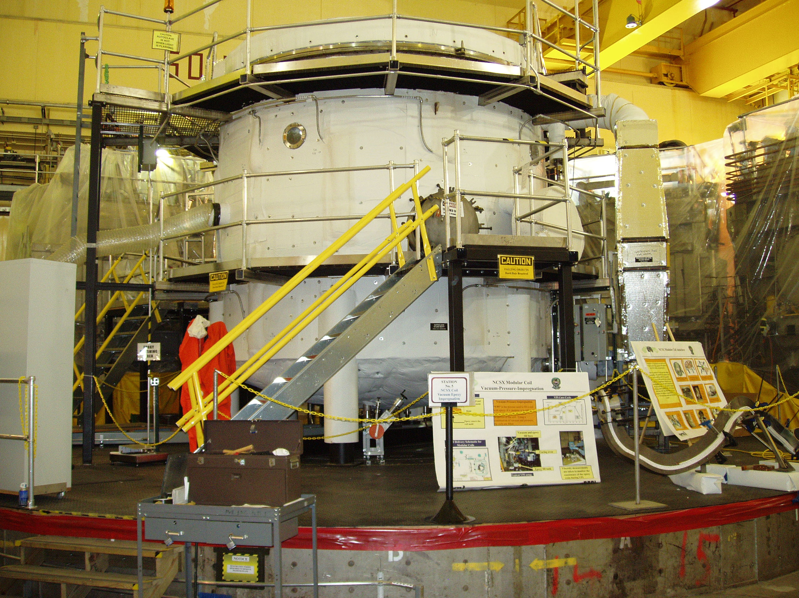

PROCEDURE LOG BOOK

D-NCSX-OP-763

