Princeton Plasma Physics Laboratory
Procedure
‘
Procedure Title: Modular Coil Fabrication-Winding Form Preparation Activities

Number:  D-NCSX-MCF-001 |  | Revision:  03 |  |  | Effective Date:  Expiration Date:  (2 yrs. unless otherwise stipulated)
Procedure Approvals
Author: James H. Chrzanowski |  |  |  |  |  | Date:
ATI: James H. Chrzanowski |  |  |  |  |  | Date:
RLM: Larry Dudek |  |  |  |  |  | Date:
Responsible Division: NCSX Project
Procedure Requirements
Designated by RLM
LABWIDE:
X | Work Planning Form # WP-1188 & 1138 (ENG-032) |  |  | Lockout/Tagout (ESH-016)
 | Confined Space Permit (5008,SEC.8 Chap 5) |  |  | Lift Procedure (ENG-021)
 | Master Equip. List Mod (GEN-005) |  | X | ES&H Review (NEPA, IH, etc.) NEPA 1283
 | RWP (HP-OP-20) |  |  | Independent Review
 | ATI Walkdown |  | X | Pre-Job Brief
X | Post-job Brief *
D-SITE SPECIFIC:
X | D-Site Work Permit (OP-AD-09) |  |  | Door Permit (OP-G-93)
 | Tritium Work Permit (OP-AD-49) |  |  | USQD (OP-AD-63)
X | Pre-Job Brief (OP-AD-79) |  |  | T-Mod (OP-AD-03)
 | ** DCA/DCN (OP-AD-104) #

* Required for installations involving internal vacuum installations, critical lifts, and for the initial installation of repetitive work.
** OP-AD-104 was voided by procedure ENG-032. However, DCA’s that were open at the time of adoption of ENG-032 are still considered valid for work approval purposes.

REVIEWERS (designated by RLM) Rec’d/
Incorp.
Comments
Accountable Technical Individual. …………J. Chrzanowski
Test Director
Independent Reviewer Mike Anderson, Eugene Kearns x
D-Site Shift Supervisor
Dimensional Control Coordinator ……………………………….. Brent Stratton x
NCSX Field Supervisors…………….Tom Meighan, Steve Raftopoulos x
Vacuum
Project Engineer for Stellerator Systems (WBS 1) Manager……Brad Nelson (ORNL)
NCSX ………………………………………………………..P.J. Fogarity (ORNL) x
Quality Assurance/Quality Control. …………………………Judy Malsbury x
Maintenance and Operations Division
Energy Conversion System/Motor Control Division
Engineering ……………………………………..
Environmental Restoration & Waste Management Division
Environmental, Safety & Health……………………………………Jerry Levine x
Industrial Hygiene………………………………………………... Bill Slavin x
Health Physics…………………
RLM ………………………………………………………………..Larry Dudek

TRAINING (designated by RLM)
No training required ______________ | Instructor Jim Chrzanowski
Personnel (group, job title or individual name) |  | Read Only | Instruction  Pre-job  Briefing | Hands On
Lead Tech. |  |  | X
Technicians performing task |  |  | X
Field Supervisors |  |  | X
Quality Control Representative |  |  | X
Training Rep.
RLM Larry Dudek

RECORD OF CHANGE
Revision | Date | Description of Change
00 | 11/22/04 | Initial release
01 | 5/19/05 | Release for Revision 1
02 | 8/2/05 | Release for Revision 2  -General description of changes:  1)Included the fitup and installation of the lead terminal and filler blocks [6.19]  2)More detail for winding form inspection [6.7]  3)Addition of Kapton tape on edges of casting [6.15]  4)Added reference to winding form product specification
03 | 1/3/06 | General description of changes  - Added new figure 1 of poloidal break arrangement  - Added safety note 6.7.3 using scaffolding  - Section 6.12.1 Tapped hole ID rewritten  - Section 6.15- Lead block fitup rewritten  - Section 6.22- Cladding installation rewritten  - General reformatting and rearrangement of some sections in proper order  - Added new figures throughout

TABLE OF CONTENTS

1 Scope 1
1.1 Introduction 1
1.2 Scope 1
1.3 Identification of winding form being prepared: 1
2 Applicable Documents 1
2.1 NCSX-MIT/QA-142-01: 1
2.2 NCSX-PLAN-MFOP-00: 1
2.3 D-L-NCSX-983 Lifting Modular Coil Winding Forms 1
2.4 D-L-NCSX-984 Lifting Modular Coil Assemblies 2
2.5 NCSX-CSPEC-141-03-08 Product Specification for MC Winding Forms 2
2.6 D-NCSX-MCF-005 Dimensional Control & Metrology for the NCSX MC 2
2.7 D-NCSX-PLAN-MCWDC Modular Coil Dimensional Control Plan 2
3 Safety Requirements: 2
3.1 Job Hazard Analysis: 2
4 Prerequisites and Conditions 2
4.1 Pre-Job Briefing: 2
4.2 Daily Operations Startup and Shutdown: 2
4.3 Torque Values: 2
5 Materials and Parts for Station No. 1 2
6 Daily Station Activities 3
6.1 Daily Startup Activities: 3
6.2 Daily Shutdown Activities: 3
7 Fabrication Process 3
7.1 Winding Form Delivery 4
7.1.1 Visual Inspection 4
7.2 Winding Form Rework Activities: 4
7.3 Transport Winding Form to the Modular Coil Mfg. Facility (MCMF): 5
7.4 Mount WF to Support Ring Assembly: 5
7.5 Install MCWFA in Turning Fixture: 7
7.5.1 Installation Instructions: 7
7.6 MC Winding Form Acceptance Inspections: 8
7.6.1 Surface Inspection: [CSPEC section 4.2.4] 9
7.6.2 Relative Magnetic Permeability [CSPEC section 4.2.5] 9
7.6.3 Dimensional Inspection for Winding Form Acceptance 10
7.7 Verification of the Electrical Properties of the Poloidal Break 10
7.7.1 Test Criteria 10
7.7.2 Test Director: 11
7.7.3 Safety Requirements & Conditions 11
7.7.4 Testing of Mid-Plane Insulation: 11
7.7.5 Testing of Bolt Insulation 12
7.8 Installation of Additional Monuments and Stud Adapters- TIG Welding 14
7.8.1 Installation Steps: 14
7.9 Cleaning/inspecting Tapped Holes 15
7.10 Identification Numbers: 16
7.11 Seal Poloidal Break 16
7.12 Establish Winding Surface Baseline Values: 16
7.13 Installation of Winding Clamp Weld Studs: 16
7.14 Installation of Lead Block Mounting Pucks [Type C only] 18
7.15 Initial Lead Block Fitup s [Type C only] 19
7.16 Cleaning: 20
7.17 Kapton Edging: 21
7.18 Mold Release: 22
7.19 Winding clamps 22
7.20 Installation of Terminal Assembly 22
7.20.1 Install Base Studs: 23
7.20.2 Quality Control Inspection: 23
7.20.3 Component Installation Sequence: 24
7.21 Inner wall copper cladding 26
7.21.1 Cladding Preparation: 26
7.21.2 Cladding Installation- General Notes: 26
7.21.3 Installation of Vertical Cladding Strips: 28
7.21.4 Installation of Horizontal Cladding Strips: 28
8 Station No. 1 MCWF Preparation Completion: 30
8.1 Document Verification: 30
8.2 Field Package: 30
8.3 Approval: 30

LIST OF FIGURES

Figure 1-Mounting support brackets to casting 6
Figure 2-Position Casting in Assy. Fixture 6
Figure 3- Install Support Ring 6
Figure 4-Install Lifting Beam 6
Figure 5-Rotate Casting/Ring Assembly 6
Figure 6- Turning Fixture 7
Figure 7- Upper Support Plates 8
Figure 8- Typical Poloidal Break 13
Figure 9- Typical Stud Adapters 14
Figure 10- Stud Weld Fixture 17
Figure 11-Upper Lead Blocks & Bushing 20
Figure 12- Install Top Plate 20
Figure 13- Install Lead Positioning Blocks 20
Figure 14-Kapton Edge Installation 21
Figure 15- Mold Release and Masked Surfaces 21
Figure 16- Winding Clamps 22
Figure 17- Electrical Insulator and Adjustment Studs 24
Figure 18-Installation of Lead Terminal Base 24
Figure 19-Install Studs and Insulating Sleeves 25
Figure 20-Jumper #1 and Insulating Plate Installed 25
Figure 21-Final Jumper#4 Installed and Secured 25
Figure 22- Install Terminal Lugs 26
Figure 23- Cladding Positioning Block 27
Figure 24- Installation of Cladding 27
Figure 25-Applying Adhesive to Vertical Cladding 28
Figure 26-Applying Accelerator 28
Figure 27- Positioning Vertical Cladding 28
Figure 28- Applying Adhesive to Horizontal Cladding 29
Figure 29- Applying Accelerator [Horizontal] 29
Figure 30-Positioning Horizontal Cladding 29
Figure 31-Verifying Cladding standoff w/Voltage Probe 30

Scope

Introduction

The Modular Coil Manufacturing Facility is divided into 5 workstations. Each workstation has a specific set of tasks that will be performed as part of the overall fabrication process. The fabrication procedures will address the manufacturing, inspection, test and QC inspection points for a specific workstation.
- Station No. 1… Winding Form Preparation & Post VPI Activities
- Station No. 2… Winding Station / Molding and VPI Preparation [TRC coil prep &
- Winding operations]
- Station No. 4… Winding Station / Molding and VPI Preparation
- Station No. 5… VPI and Autoclave Activities
- Deleted Reference to Station 7

Scope

This procedure prepares each Modular Coil Winding Form (MCWF) or Twisted Racetrack Coil winding form (TRC) for winding. It includes:
- Mounting the winding form to the turning fixture
- Verification of electrical integrity of poloidal break
- Installation of measurement monuments
- Winding Form inspection and measurements
- Installation of clamp studs
- Cleaning of winding form
- Fitup and installation of terminal blocks
- Installation of winding clamps
- Installation of the inner cladding plates

Identification of winding form being prepared:

Station Number: ________ (Location where work will be performed)

Winding Form Type: _______________ [Type A, B, C or Twisted Racetrack Coil (TRC)]

MC Winding Form ID No: _________________

Modular Coil Identification Number: ___________

Applicable Documents

NCSX-MIT/QA-142-01:
All applicable documents associated with this procedure, are identified in the MIT/QA Plan, document number NCSX-MIT/QA-142-01.

NCSX-PLAN-MFOP-00:
All Modular Coil work processes are governed by the “Manufacturing Facility Operations Plan”, document number NCSX-PLAN-MFOP-00.

D-L-NCSX-983 Lifting Modular Coil Winding Forms

D-L-NCSX-984 Lifting Modular Coil Assemblies

NCSX-CSPEC-141-03-08 Product Specification for MC Winding Forms

D-NCSX-MCF-005 Dimensional Control & Metrology for the NCSX MC

D-NCSX-PLAN-MCWDC Modular Coil Dimensional Control Plan

Safety Requirements:

All work will be performed in a safe manner in accordance with the PPPL Environmental, Safety and Health Manual ES&H 5008 and the “Integrated Safety Management” (ISM) policy.

Job Hazard Analysis:
A JHA will be generated for each workstation, identifying existing or potential workplace hazards and to evaluate the risk of worker injury or illness associated with job tasks. (Reference document ESH-004 “Job Hazard Analysis”) The IH representative will review the JHA’s for accuracy as well as completeness. It will be reviewed with all activity participants at the Pre-Job briefings.

Prerequisites and Conditions

Pre-Job Briefing:
A pre-job briefing will be held, describing the processes and safety issues prior to starting any part of this procedure. Attendance shall be documented via training sign-in sheet.

Pre job Briefing complete: ________________________________ _________________
MC Field Supervisor Date

Daily Operations Startup and Shutdown:
Each working day, it is required to complete and initial the daily operations startup log to ensure that the station is ready to commence work activities for the day. The signoff log is located in the Daily Station Log. See section 6.1 and 6.2 for details.

Torque Values:
Unless a torque value is specified, the following values shall be used whenever the procedure requires a torquing operation: (Low carbon steel hardware)

3/8-16UNC …… 18 ft-lbs 3/8-24UNF …… 19 ft-lbs ½-13 UNC …… 38 ft-lbs ½ -20 UNF …… 40 ft-lbs 5/8-11 UNC…. 83 ft-lbs 5/8-18 UNF… 95 ft-lbs
¾-10 UNC..…… 105 ft-lbs ¾-16 UNF ……. 102 ft-lbs 1-8 UNC … 236 ft-lbs 1-14 UNF …….. 212 ft-lbs 1 1/4 UNC …… 432 ft-lbs 1 ½-6 UNC …...732 ft-lbs

Materials and Parts for Station No. 1
The following materials and/or equipment will be used with this procedure. MSDS’s for chemicals will be located in a notebook in the winding facility.

General Description | Material | Reference Document/Product No.
Cladding | Copper | Drawing list to be added as addendum for each coil type as drawings are approved
Solvent | Chlorine-Free Degreaser | CRC Product No. 03185 [MSDS #05032]
Solvent | Acetone | MSDS# 00561
Studs for coil clamp to casting stud | Stainless steel grade 316 | 3/8-16 UNC x 2.5 inches long [other lengths may be required in tight areas]
Mold release | Release agent dry lubricant | “Miller-Stephenson” -PTFE MS122DF
MC Turning Fixture | Equipment | Drawing no. SE144-008
Rolled Ring Assembly | Fixture | Drawing no. SE144-007
Casting to Ring Assy. Fixture | Fixture | Drawing no. SE144-050
Weld stud alignment fixture | Fixture | Drawing no. SE144-085
Stud Welder unit | Equipment- TRW Nelson | Model no. 101 Series 4500
Supports and hardware for MC mounting casting to turning rings | Fixture | See drawing SE144-050
Supports and hardware for TRC mounting casting to turning rings | Fixture | See drawing SE144-200
Cladding and edge insulation | Kapton-Type HN adhesive back | 0.00325 inch thick
Cement- for adhering cladding | Adhesive cement | 3M Product no.CA40H
Adhesive accelerator for cement | Accelerator | 3M Pronto Surface Activator
Winding clamps | Equipment | Drawing SE144-080
RTV sealer for poloidal break | Sealant | RTV108
Alcohol | Ethanol | MSDS
Severn Gauge | Equipment | Permeability indicator # 6424
Thread-locker | Loctite | Loctite 2440 medium strength thread-locker

Daily Station Activities

Daily Startup Activities:

- Check all daily supplies needed:
- Turn on the Turning Fixture power switch to verify operation.
- Check stud welder for operation [Only if being used that day]
- Check station for cleanliness
- Check that the day’s travelers and procedures are in their document holder.
- Date and initial daily Startup Log located at the back of Station Log Book.

Daily Shutdown Activities:

- Turn off power to Turning Fixture.
- Turn off stud welder and secure for off hours.
- Clean entire workstation area.
- Verify that all Traveler and data sheet information is complete.
- The Lead Technician shall verify that the Station’s Log Book has been completed and signed for the day.
- Cover the Modular coil casting with plastic tarp.
- Date and initial daily Shutdown log located at the back of Station Log Book

Fabrication Process
This fabrication procedure is to be used as guide to complete the preparation of the winding form for coil winding. Deviation from this procedure for processes that DO NOT affect the design of the coil can be made with the concurrence of the MC Field Supervisor. These deviations shall be documented in the procedure and initialed by the MC Field Supervisor prior to implementing the deviations. Deviations that may effect the design of the coil requires a Request for Deviation “RFD” approval. The RFD must be approved prior to proceeding. Procedure changes need to be incorporated into the document via “Minor Procedure Changes” or “Revisions”.

Winding Form Delivery

Visual Inspection
Upon receipt of a winding form, perform a visual inspection of the shipping crate and casting. Look for any obvious defects or damage as a result of shipment.

Inspection Findings:

Inspection Performed by: _________________________ Date: __________________

Findings Verified:
QC Representative: ____________________________ Date: ____________________

Winding Form Rework Activities:
It may be necessary to modify or rework portions of the winding form prior to starting the casting preparation activities. These modifications or changes need to be identified and documented in this procedure. All Non-conformance documents shall also be identified in this procedure.

- Winding form does not require any rework or modifications

Verified:

Field Supervisor: ____________________________ Date: ____________________

QC Representative: ____________________________ Date: ____________________

- Winding form does require modifications or rework.

Verified:

Field Supervisor: ____________________________ Date: ____________________

- Identify all rework or modifications that need to be performed on winding form. Include reference NCR numbers.

Rework Activities:

- Modifications have been completed:

Verified:

Field Supervisor: ____________________________ Date: ____________________

QC Representative: ____________________________ Date: ____________________

Transport Winding Form to the Modular Coil Mfg. Facility (MCMF):
Transport a MCWF or TRC from its storage area to the MCMF using either a folk lift or lift procedure D-L-NCSX-983. Position the winding form on the floor supported by wooden blocks.

Mount WF to Support Ring Assembly:
Mount the appropriate support brackets to the casting that will allow the winding form (MCWF) to be joined with the Turning Fixture support ring. (Error: Reference source not found)
[Reference drawing SE-144-050]

Note: Each coil type (A, B, C, TRC) have different support brackets that will join the MCWF to Turning Fixture support rings.

- Transport the MCWF to station 1a using lift procedure D-L-NCSX-983. Position the MCWF with lower support brackets into the assembly fixture [station 1a]. (Error: Reference source not found) [Note: the TRC will not be assembled in the assembly fixture]

- Position a support ring into the assembly fixture around the casting, and secure the winding form and support ring together with support brackets. Note the orientation of the ring in relation to the lifting beam and pivot locations. (Error: Reference source not found)

- Secure the support/lifting beam to the joined MCWF and ring support [MCWFA}. (Error: Reference source not found)

- Verify that all hardware has been torqued [see section 4.3 for torque values] and that the MCWFA is ready for transport to the Station No. 1b Turning Fixture.

Verified:

Lead Technician: ____________________________ Date: ____________________

Field Supervisor: ____________________________ Date: ____________________

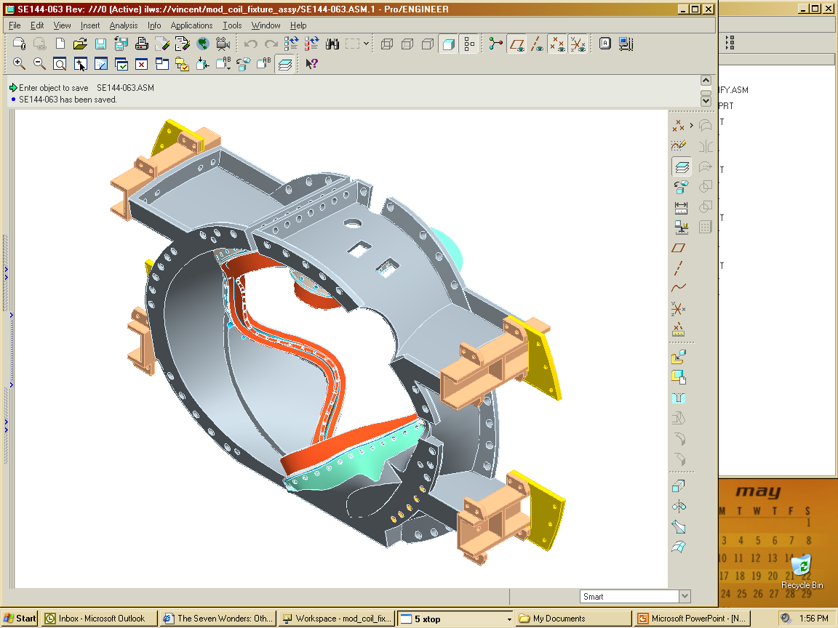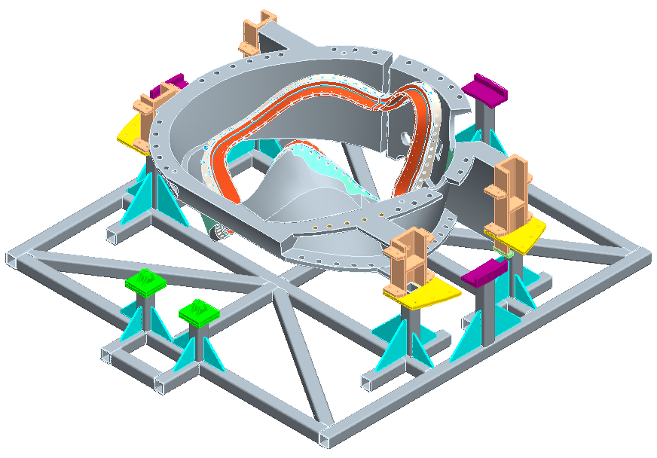
Figure 1-Mounting support brackets to casting
Figure 2-Position Casting in Assy. Fixture

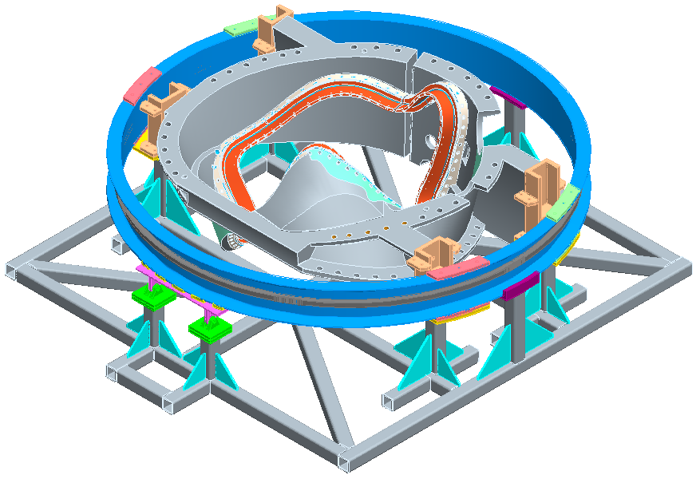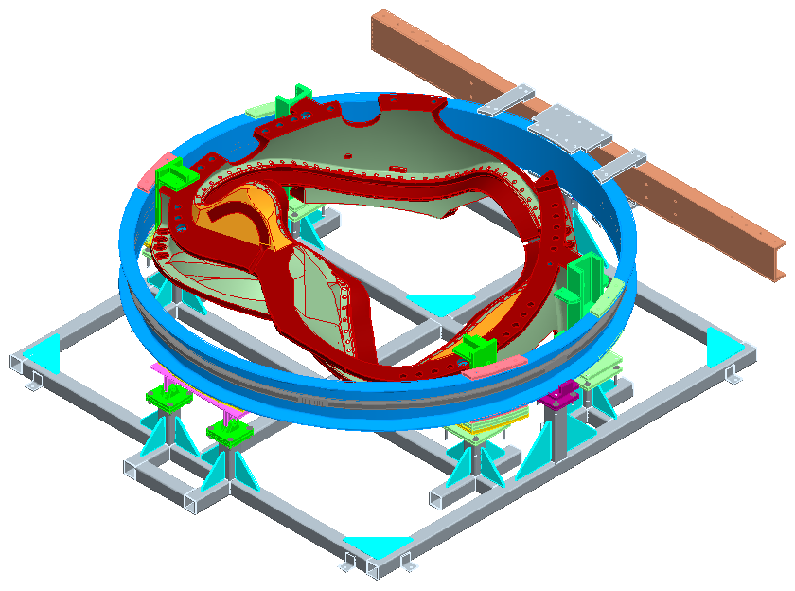
Figure 3- Install Support Ring
Figure 4-Install Lifting Beam

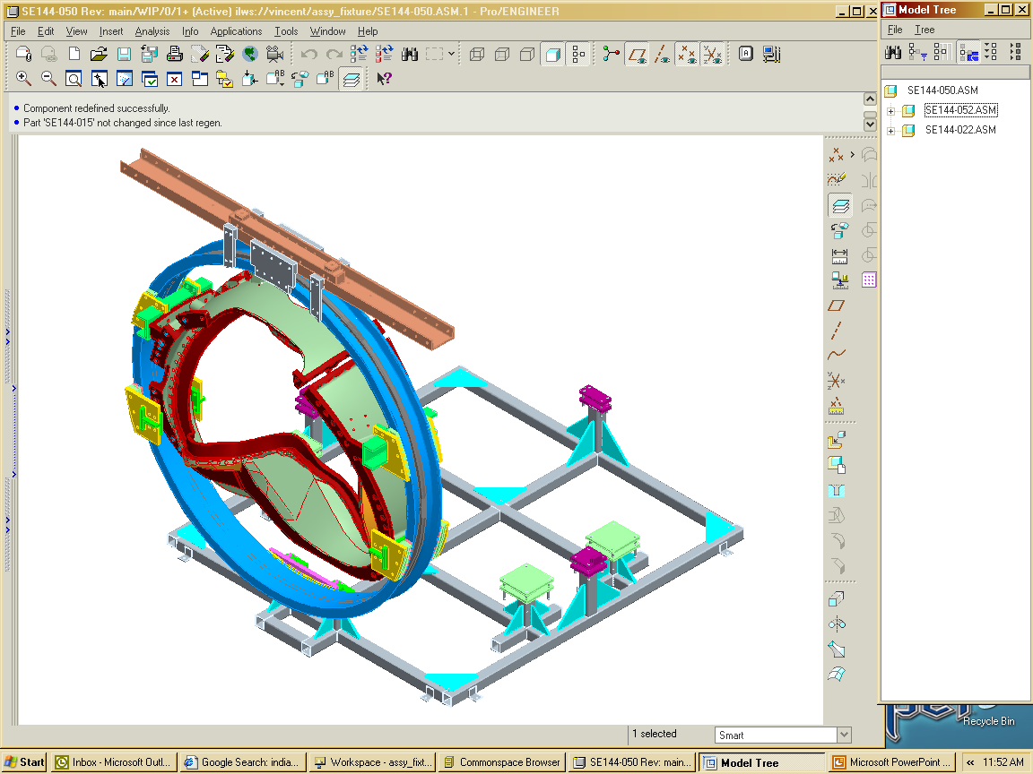
Figure 5-Rotate Casting/Ring Assembly

Install MCWFA in Turning Fixture:
Using lift procedure D-L-NCSX-984, carefully raise the MCWFA until it is in the vertical position. (Error: Reference source not found) Transport and install MCWFA into the Station No. 1 turning fixture. Secure the MCWFA to the turning fixture.

Verified by: _________________________ Date: __________________
Field Supervisor

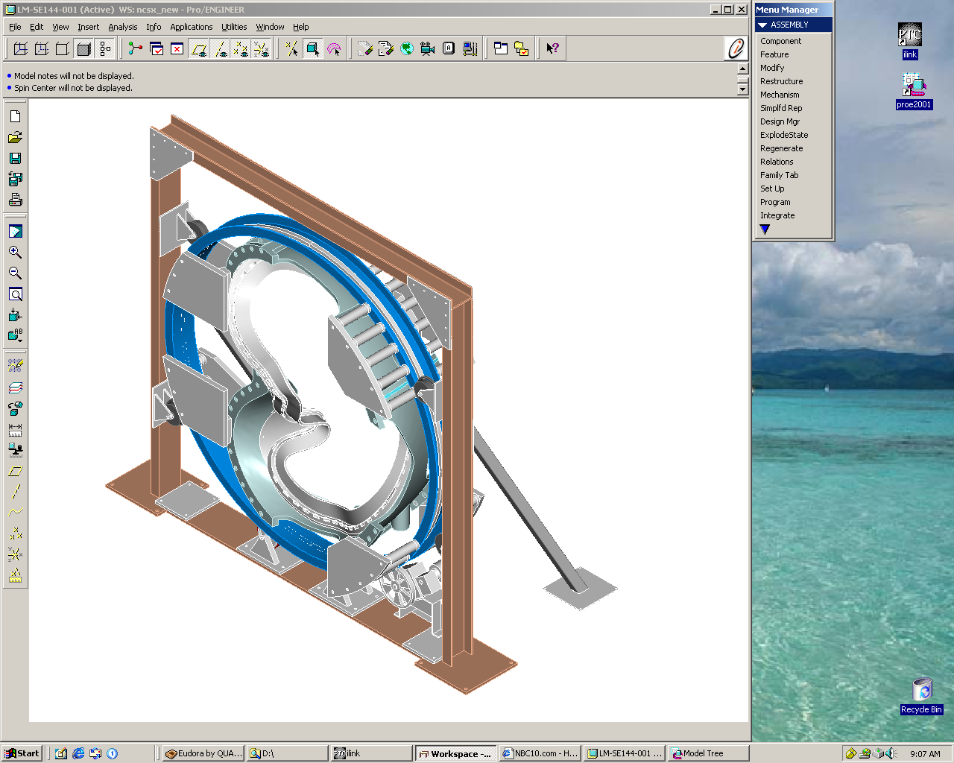
Turning Fixture Support Ring
Turning Fixture Support Plates & spaces assembly
Turning Fixture-Upper Support/Lifting Beam
Turning Fixture Drive System
Turning Fixture Support Ring Guide Rollers
Turning Fixture Support Frame

Figure 6- Turning Fixture

Installation Instructions:

- Compress the springs under the gear box (drive system) until they are bottomed.

- SAFETY NOTE: Use scaffolding or appropriate ladders while working on upper section of turning fixture. Scaffolding must be inspected prior to use per Section 9 Chapter 5 in PPPL ES&H Manual.

- Lower the MCWF and ring assembly into the turning fixture using the corner brackets for alignment. Bolt up one end loosely (use spud wrenches to align holes).

- Install the upper guide rollers and align all of the guide rollers to the support ring. NOTE: Sling the rollers and raise them into position with rope. Do not climb up ladder with roller assembly in hand.

- Decompress springs under the gear box (drive unit) until gear is fully engaged with ring gear rack. This must be verified prior to proceeding.

Verified by: _________________________ Date: __________________
Lead Technician

- Decompress springs under the gear box (drive unit) until gear is fully engaged with ring gear rack. This must be verified prior to proceeding.

- Verify that the upper support/lift beam is in proper position and secured with appropriate hardware that is torqued to the proper value.

Verified by: _________________________ Date: __________________
Lead Technician

- Remove the upper support plates between the support-ring and lift beam. This operation must be verified prior to operating turning fixture. Figure 7- Upper Support Plates

Verified by: _________________________ Date: __________________
Lead Technician

Upper Support Plates

Figure 7- Upper Support Plates

- To ensure proper alignment and operation of the turning fixture, rotate the MCWFA a full revolution [in both directions] using the foot-pedal control. Re-adjust the alignment rollers as required. Alignment of MCWFA to the turning fixture is complete.

Verified by: _________________________ Date: __________________
Lead Technician

MC Winding Form Acceptance Inspections:
There are a number of inspections that need to be made of the winding form prior to final acceptance of the winding form from the vendor. These need to be completed prior to starting winding preparation activities. These inspections are based upon the requirements identified in the MC Product Specification “NCSX-CSPEC-141-03”.

Surface Inspection: [CSPEC section 4.2.4]
Spot inspect the surface finish of the machined tee section using either a surface profilometer or comparator. The two “L” machined surfaces of the tee must have a RMS (root mean square) surface finish <125 µ-inches. Also verify that the part is free of sharp edges and burrs.

Surface Inspection Findings:

Surface Finish verified by:

Field Supervisor: ____________________________ Date: ____________________

QC Representative: ____________________________ Date: ____________________

Relative Magnetic Permeability [CSPEC section 4.2.5]
Spot check the relative magnetic permeability of the winding form surface and poloidal break hardware using a Severn gauge. The Acceptance Criteria: < 1.02μ.

Magnetic Permeability verified by:

Field Supervisor: ____________________________ Date: ____________________

QC Representative: ____________________________ Date: ____________________

Permeability Inspection Findings:

Dimensional Inspection for Winding Form Acceptance
Per section 4.2.6 of the Modular Coil Winding Form Product specification NCSX-CSPEC-141-03-08, a thorough measurement of the MCWF machined winding surfaces, flange surfaces, and bolt holes shall be made to verify the dimensions and tolerances of the winding form. The NCSX project will perform spot measurements besides that provided by the vendor to verify the dimensional integrity of the delivered winding form.

Additional measurements have been made by PPPL and verified as being acceptable:
Verified By:
Metrology Engineer: ____________________________ Date: ____________________

Dimensional Control Coordinator: ________________________ Date: _______________

QC Representative: ____________________________ Date: ____________________

- Acceptance inspections and measurements have been completed and have verified that the winding form is acceptable for use on NCSX.

Winding Form has been accepted:

Verified By:
Metrology Engineer: ____________________________ Date: ____________________

Dimensional Control Coordinator: ________________________ Date: _______________

QC Representative: ____________________________ Date: ____________________

Comments:

Verification of the Electrical Properties of the Poloidal Break
Verify the electrical integrity of the poloidal break, via a megger test. [See Figure 8- Typical Poloidal Break] [Not required for TRC]

Test Criteria

- Test Voltage: 250 volts - Acceptance criteria for this test: >500 k-ohms

Test Director:
The Test Director for this test is: _____________________________

Safety Requirements & Conditions
The following safety and prerequisites shall be used for performing test of the Poloidal break.

- All personnel involved with these tests shall be familiar with the hazards and work procedure to minimize accidents that may occur.

- A “Safety Watch” shall be appointed by the Test Director. The Test Director shall clearly describe to the Safety Watch his/her responsibilities.

Name of Safety Watch: ______________________

Responsibilities have been clearly discussed with Safety Watch:

Verified: ________________________________ Date: ________________
Test Director

- Responsibilities of a Safety Watch include as a minimum:

a) Monitoring the operations in an attempt to prevent careless or unsafe activities.

b) Shutting down the power in case of an accident.

c) Contacting ESU in case of accident

d) Additional responsibilities of a Safety Watch can be found in the ES&H Manual Section 2, Chapter 2.2.6.

- During the test, the “Test Area” shall be roped-off and suitable “danger high voltage” signs and flashing lights displayed.

Test Area has been safed:

Verified by: _________________________ Date: __________________
Test Director

- The test operator shall stand on an electrical safety mat during the test operation.

- Approved rubber electrical safety gloves shall be worn by test members during grounding operations which occur once the test has been completed, and the test equipment turned off.

- Upon completion of test and before the components are declared safe to touch, the coil being tested shall be properly discharged using a “Ground Hook”. After a minimum period of 10 seconds, while the ground hook is still in place, attach a ground cable to the coil. The ground hook may be removed once the ground cable is in place.

Testing of Mid-Plane Insulation:

- Electrically connect (jumper) the poloidal joint mid-plane to the modular coil for this test.

- Measure the insulation resistance between the mid-plane plate and each bolt. The test results shall be in compliance with the requirements noted in Section 7.7.1.

Mid-Plane to Each Bolt- Megger Test Results
Test Components | Voltage Level Volts | Resistance  k-Ohms | Remarks
Bolt 1 to Mid | 250
Bolt 2 to Mid | 250
Bolt 3 to Mid | 250
Bolt 4 to Mid | 250
Bolt 5 to Mid | 250
Bolt 6 to Mid | 250
Bolt 7 to Mid | 250

Casting Temperature __________deg. C

Equipment ID Number: __________________________ Calibration Date: _____________

Megger Results: Acceptable: _______________ Unacceptable: ____________

Test Director Signoff: _____________________________ Date: ______________

Quality Control Witness: __________________________ Date: ______________

Remarks:

Testing of Bolt Insulation

- Electrically connect (jumper) together all of the bolts and the modular coil winding form for this test.

- Measure the insulation resistance between the electrically connected (jumpered) combination and the mid-plane. The test results shall be in compliance with the requirements noted in Section 7.7.1.

Mid-Plane to Bolts & Winding Form- Megger Test Results
Test Components | Voltage Level Volts | Resistance  k-Ohms | Remarks
Mid-plane to Bolts & WF | 250

Equipment ID Number: __________________________ Calibration Date: _____________

Megger Results: Acceptable: _______________ Unacceptable: ____________

Test Director Signoff: _____________________________ Date: ______________

Remarks:

- If the test results were within the test criteria identified in section 7.7.1 proceed to section 7.8.

- If the test results are unacceptable, the field supervisor shall review the test results with NCSX project management to determine corrective action. All corrective actions shall be performed under the direction of the Field Supervisor. Once completed repeat the electrical tests. All corrective actions shall be documented and added to the RUN copy.

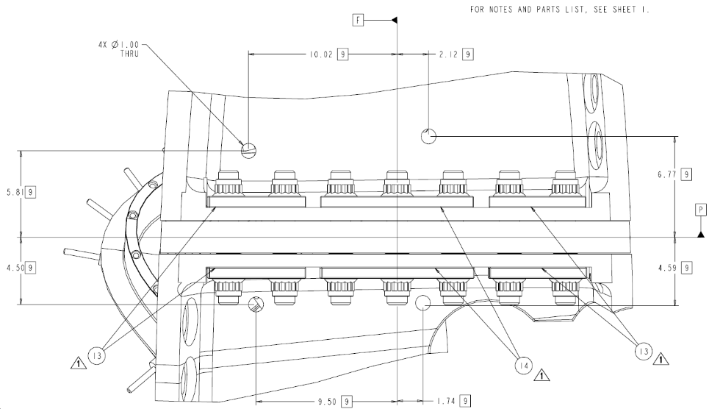

Figure 8- Typical Poloidal Break

Installation of Additional Monuments and Stud Adapters- TIG Welding
All welding shall be performed by weld certified individuals and requirements of ES&HD 5008, Section 9 Chapter 15 for safe welding must be followed.

Installation Steps:

- Notify the ESU and obtain a flame permit daily prior to starting welding operation.

- On some castings, due to the geometry of the winding form, it may be necessary to add stud adapters directly to the casting prior to the installation of studs. This information will be identified on the appropriate casting drawings. These adapters shall be Tig welded directly to the casting. See Figure 9- Typical Stud Adapters

- Stud Adapters are required for this casting: YES: _________ NO: __________
[Lead Technician verify:]

- Installation of stud adapters has been completed.

Weld Date: _______________ Obtain Flame Permit: ______________

Weld Operator: ______________________________ Fire Watch: _____________

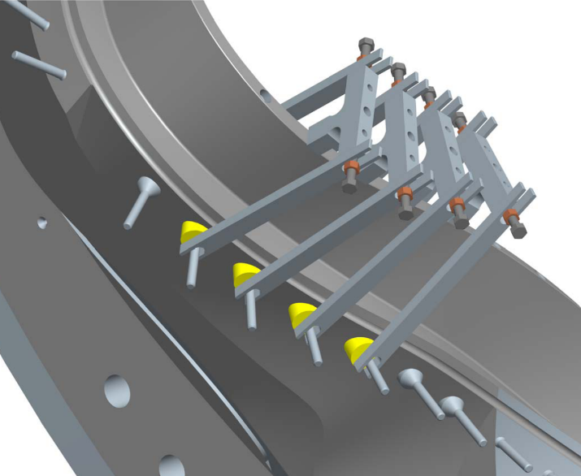
Typical stud adapters
Figure 9- Typical Stud Adapters

- The metrology engineer shall determine the location of additional monuments that need to be added to the MCWF. These monuments will be used by the metrology group for measuring the location of the winding surfaces and coil turns.

Location verified by: _________________________ Date: __________________
Metrology Engineer

- Installation of additional monuments has been completed.

Weld Date: _______________ Obtain Flame Permit: ______________

Weld Operator: ______________________________ Fire Watch: _____________

Installation of stud adapters and monuments have been completed and inspected by:

Field Supervisor: ____________________________ Date: ____________________

QC Representative: ____________________________ Date: ____________________
(Weld inspect)

File name and location of additional reference monuments:

Cleaning/inspecting Tapped Holes
Inspect the tapped holes in the MCWF for evidence of metal chips or oil residue. Using a bottlebrush, clean cotton rags and “Chlor-Free Degreaser”; thoroughly clean any chips or oil residue remaining from the casting manufacturing process. After cleaning, check each threaded hole using a brass or bronze thread plug or bolt. Re-tap and clean as required RECORD FINDINGS.

Tapped Hole Inspection Findings:

Verified by: _________________________ Date: __________________
Lead Technician

Identification Numbers:

- Verify that the winding form vendor has properly identified the clamp locations on top of the septum next to the tapped holes. The clamp location numbers will be provided on the appropriate coil winding form drawings. See Figure 15- Mold Release and Masked Surfaces

Verified by: _________________________ Date: __________________
Lead Technician

- Identify each coil side of the MCWF with either an “A” or “B”. This information will be provided from the coil drawings. Use large stick-on letters that can be clearly seen.

Seal Poloidal Break

- Wipe the outside surface of the poloidal break seams using clean lint free wipe with Chlor-free degreaser and ethanol. Do not saturate the cloth.

- Seal the poloidal break seams using RTV 108 sealant. Apply sealant over all seams that will be inside of the Bag mold. Smooth the RTV with putty knife. This seal is required for successful VPI operations.

Poloidal Break has been sealed:

Verified by: _________________________ Date: __________________
Lead Technician

Establish Winding Surface Baseline Values:
The Metrology engineer shall measure the winding surfaces and establish reference values to be used during coil manufacturing using procedure D-NCSX-MCF-005. A summary of all data shall be inserted into Section 9 of the Coil Field Package.

Measurements completed and reference values established.
File name and location of additional reference monuments:

Verified by:

Metrology Engineer: ____________________________ Date: ____________________

Dimensional Control Coordinator: ________________________ Date: _______________

QC Representative: ____________________________ Date: ____________________

Installation of Winding Clamp Weld Studs:
Install stainless steel studs for the winding clamps on each side of the winding form. All welding shall be performed by weld certified individuals and requirements of ES&HD 5008, Section 9 Chapter 15 for safe welding must be followed.

- Notify the ESU and obtain a flame permit daily prior to starting welding operation.

- Position the stud alignment fixture Figure 10- Stud Weld Fixture onto the casting using the tapped hole in the septum to secure the fixture in place. Check the orientation of the fixture to the casting prior to welding.
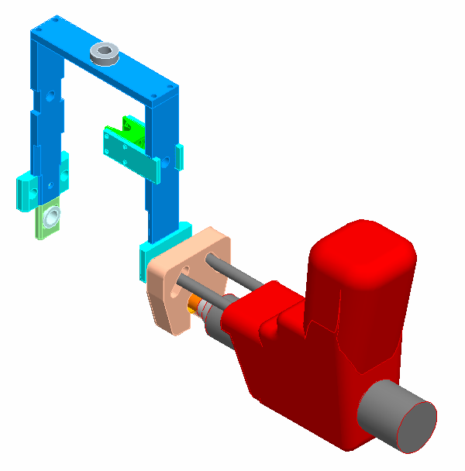

Figure 10- Stud Weld Fixture

- Using the stud welder, weld grade 316 stainless steel studs on each side of the winding. Studs shall be positioned per appropriate coil drawings. In some inaccessible locations it may be necessary to use shorter studs and they may need to be TIG welded into position.

- [The stud weld operator shall fill out and submit to the Coil Facility Manager a “Filler Request Form” which is required to maintain their certification. The Coil Facility Manager is responsible for submitting the forms to the weld engineer and training group]

Stud Welder Settings:
Stud Weld Model: “TRW Nelson” Series 4500 Model 101
Time: approximately 3.5 seconds
Current: 5.75 amps

Verified by Lead Technician

Stud Weld Date: _______________ Obtain Flame Permit: ______________

Stud Weld Operators: ______________________________ Fire Watch: _____________
***************************************************************************

Stud Weld Date: _______________ Obtain Flame Permit: ______________

Stud Weld Operators: ______________________________ Fire Watch: _____________
***************************************************************************

Stud Weld Date: _______________ Obtain Flame Permit: ______________

Stud Weld Operators: ______________________________ Fire Watch: _____________
***************************************************************************

Stud Weld Date: _______________ Obtain Flame Permit: ______________

Stud Weld Operators: ______________________________ Fire Watch: _____________
***************************************************************************

- Deleted Permeability requirements for winding clamp studs

- After welding, remove the alignment fixture and clean the weld. Remove all excess weld material.

- Repeat process for each clamp position, until all studs have been installed.

- Each welded stud shall be inspected by a QC weld inspector (100% inspection). Welded studs rejected by QC will be removed, surface cleaned and replaced with a new stud. Attach all QC inspection reports to procedure.

Inspection and acceptance of welded studs complete

.

Q.C. Weld Inspector: _____________________ Date: ________________

Summary of Results: [Add additional QC reports to back of procedure]

Installation of Lead Block Mounting Pucks [Type C only]

- Temporarily install the cladding and groundwrap in the lead area sides A & B for fitup of the lower fillers.

- Install the lead block alignment fixture for positioning the bosses (pucks) and tack weld the bosses to the winding form. [Drawings: fixture-SE142C-280; weld detail SE141-123]

- Remove alignment fixture and finish Tig welding the bosses to the winding form.

Verified by Lead Technician

Weld Date: _______________ Obtain Flame Permit: ______________

Weld Operator: ______________________________ Fire Watch: _____________

- Using a Severn permeability indicator measure the relative magnetic permeability of the welds. Acceptance criteria: <1.02 μ.

Weld permeability verified by: _____________________ Date: ________________

QC Inspector

- Each welded puck shall be inspected by a QC weld inspector (100% inspection). Welded pucks rejected by QC will have their welds ground out and re-welded. Attach all QC inspection reports to procedure.

Installation completed and inspected by:

Field Supervisor: ____________________________ Date: ____________________

QC Representative: ____________________________ Date: ____________________
(Weld inspect)

Initial Lead Block Fitup s [Type C only]
If the final G-11 lead block components are not available, use the sterolithophy components for fitup.

- Loosely mount the lower lead blocks with ½” socket head bolts with 2 special washers that fit in the counter bored holes. Tilt the lower lead blocks backward away from the tee and slip (2) “shim” washers onto the ½” bolts that will screw into the bosses. [4/block, 8 total] Carefully tilt the lower blocks up straight and push against the bosses. Leave the bolts loose not tight.

- Attach the upper lead blocks on each side and position them so the upper and lower block faces are flush and the triangular insert grooves are aligned. Insert a temporary filler strip into the 4 grooves and tighten the 3/8” socket head bolts into each end to secure the upper and lower blocks as a single unit. [Figure 11-Upper Lead Blocks & Bushing]

- Insert a bushing into the #1 hole in the top of the tee and fit the top plate onto the bushing (there is a recessed hole in the bottom of the top plate that seats the bushing) and insert the 3/8” bolt into the middle hole of the top plate and lightly tighten. [Figure 12- Install Top Plate]

- Position, push, tap on, whatever the upper winding blocks to line up with the 3 inner holes on each side of the top plate and insert the ¼” screws and lightly tighten.

- Once all bolts have been engaged, tighten the top, center bolt first to seat the box to the top of the tee. Then tighten the ½” bolts in the lower winding blocks and snug it against the welded bosses. If it appears that the upper and lower winding blocks are not flush on each side of the front surface, the box needs to be disassembled and either remove or add a shim to the side that seems to be either protruding or recessing.

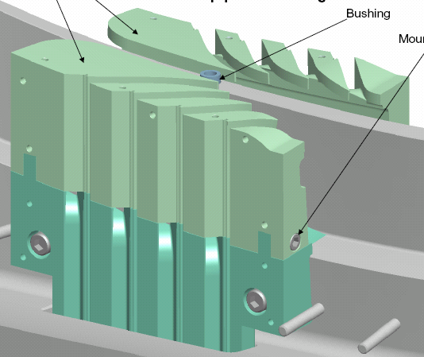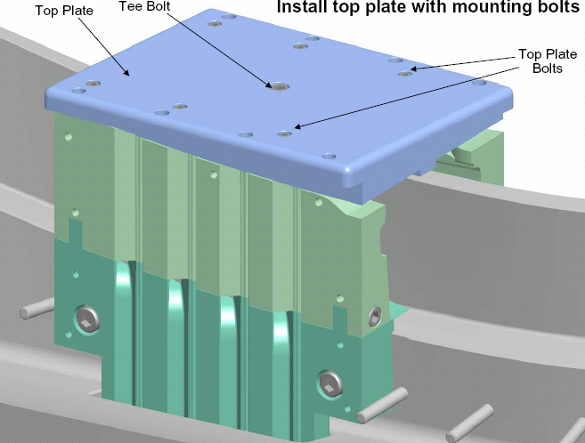
Figure 11-Upper Lead Blocks & Bushing
Figure 12- Install Top Plate

- Once the lead block components are tight, the surfaces are flush, and the grooves aligned, tighten down on the ½” bolts on the lower winding blocks.

- Glue small positioning blocks (G-10 or phenolic) to the tee as they are pressed firmly against the sides of the lower winding blocks using the same glue as was used for the cladding, only be liberal with the amount so that the blocks will stay put until knocked or chipped off before the bagging operation. [Figure 13- Install Lead Positioning Blocks]

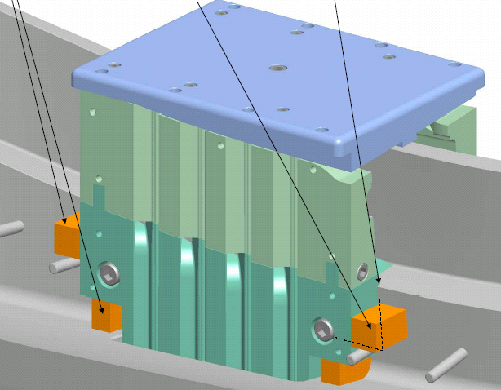
Positioning Blocks
Figure 13- Install Lead Positioning Blocks

- The top plate and the upper/lower winding blocks can now be disassembled and removed.

Cleaning:
Using CRC Industrial “Chlor-Free Degreaser and clean lint free wipes thoroughly clean (wipe down) the entire MCWF. Then wipe surface using Ethanol and lint free wipes.

Lead Technician verify: _____________________ Date: ________________

Kapton Edging:
Prior to mold releasing, install (1) layer of 0.00325 inch thick adhesive back Kapton tape onto the edges of the tee casting where the cladding bends around corners. [Figure 14-Kapton Edge Installation]

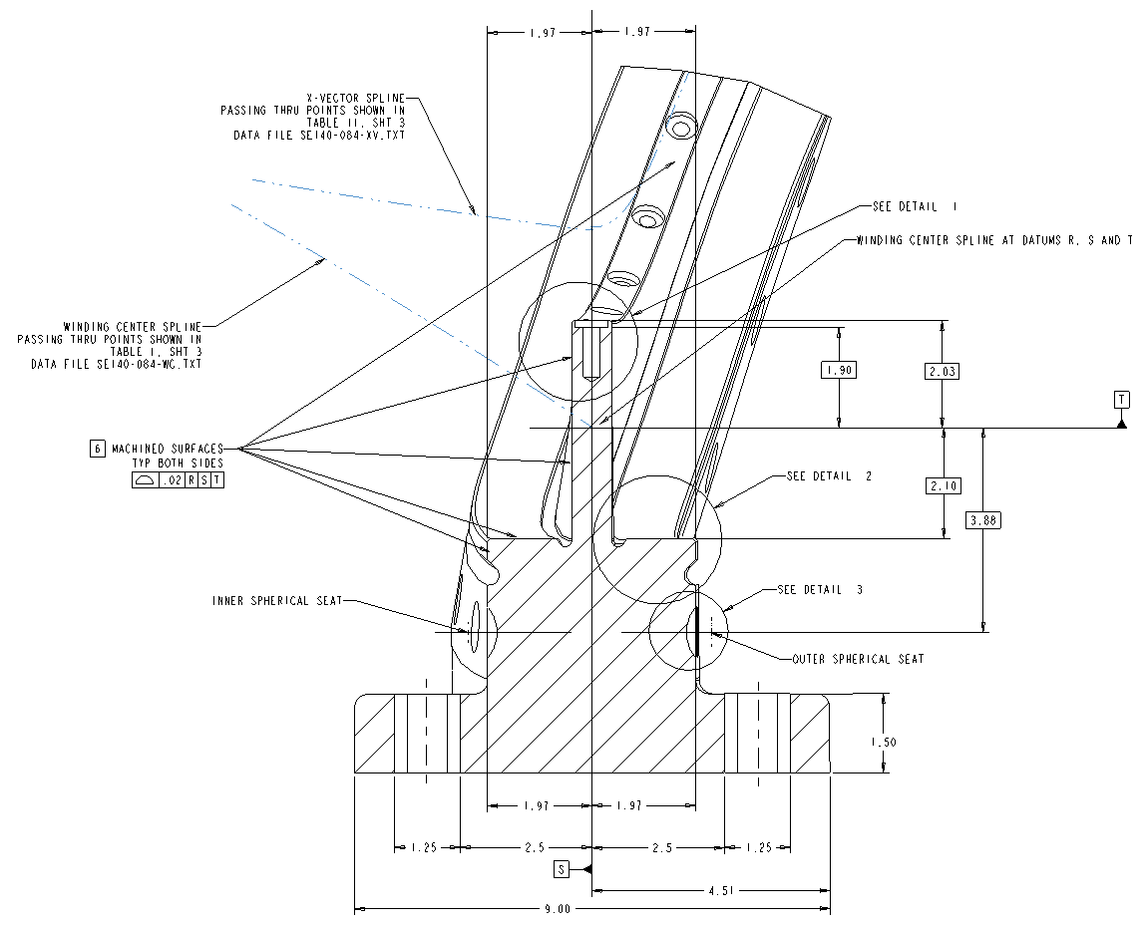
Kapton edge installation

Figure 14-Kapton Edge Installation

- The installation of the Kapton edging tape has been completed:

Verified:

Lead Technician: ____________________________ Date: ____________________

Field Supervisor: ____________________________ Date: ____________________

Masked areas
X
Location of clamp ID numbers

Areas identified with “V” marks are to be mold released.

Figure 15- Mold Release and Masked Surfaces

Mold Release:
Mask the surfaces identified in Figure 9 with masking tape. Apply (3) coats of mold release (“Miller-Stephenson”-PTFE MS122DF) to the winding surfaces. Allow each coat to dry to the touch prior to applying the next coat. Figure 15- Mold Release and Masked Surfaces identifies the surfaces to be coated and masked.

Lead Technician verify: _____________________ Date: ________________

Winding clamps
Mount the top tee section of the winding clamps to the MCWF as shown in Figure 16- Winding Clamps The clamps are located approximately every 3 inches along the entire length of the MCWF. Secure the winding clamp tee to the top of the septum using the appropriate hardware. Use the (2) side bars to assist in the positioning of the top section, but do not leave in place.

Installation of winding clamp tees is complete:

Lead Technician verify: _____________________ Date: ________________

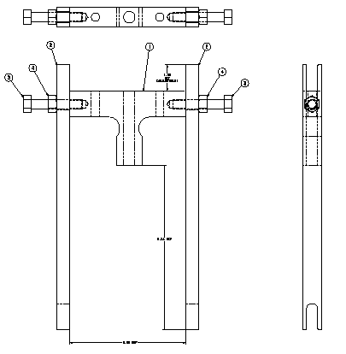
Top Winding Clamp Tee
Sidebars
Figure 16- Winding Clamps

Installation of Terminal Assembly
The terminal assembly is required to set the position of the cable connectors. Except for the stud welding activities, the terminal assembly can be assembled at either station 1b [winding form prep] or at one of the winding stations. This is at the discretion of the Field supervisor.

Install Base Studs:

- Using the G-11CR mounting base locate the position of the (2) 3/8-16 studs. [Figure 17- Electrical Insulator and Adjustment Studs

- Notify the ESU and obtain a flame permit daily prior to starting welding operation.

- TIG weld the (2) 3/8-16 studs to the winding form.

Weld Date: _______________ Obtain Flame Permit: ______________

Weld Operator: ______________________________ Fire Watch: _____________

Quality Control Inspection:

- Each of the welded studs shall be inspected by a QC weld inspector (100% inspection). Welded studs rejected by QC will be removed, surface cleaned and replaced with a new stud. Attach all QC inspection reports to procedure.

Inspection and acceptance of welded studs complete

.

Q.C. Weld Inspector: _____________________ Date: ________________

Summary of Results: [Add additional QC reports to back of procedure]

- Permeability Check: Each stud and weld shall be checked with a Severn permeability indicator to verify that the relative magnetic permeability is below the acceptance criteria. If the permeability exceeds the acceptance criteria the stud must be removed and replaced and/or the Field Supervisor must approve the variation via a non-conformance report (NCR).
Acceptance Criteria: 1.02μ.

Permeability Inspection Findings:

Stud Weld permeability verified by: _____________________ Date: ________________

QC Representative

Component Installation Sequence:

- Install the electrical insulator sheet and height adjustment nuts onto the studs just welded. [Figure 17- Electrical Insulator and Adjustment Studs]
Adjustment Studs
Electrical Insulator Sheet
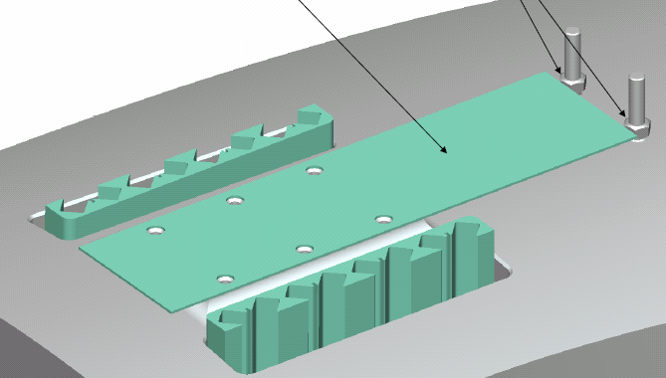
Figure 17- Electrical Insulator and Adjustment Studs

- Install the G-11CR base plate and secure in place with 0.375 mounting hardware and Loctite 2440. [Figure 18-Installation of Lead Terminal Base]

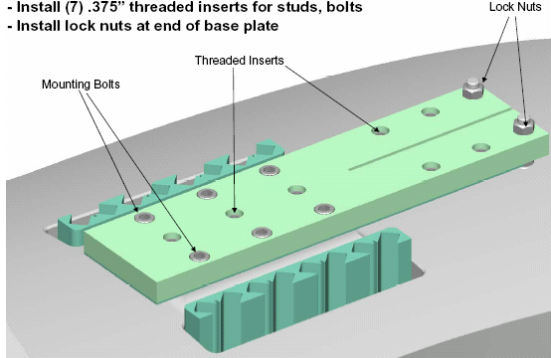
Figure 18-Installation of Lead Terminal Base

- Install the (3) studs and insulating sleeves into the G-11CR base plate using Loctite 2440 on the threads per manufacturer’s instructions. Figure 19-Install Studs and Insulating Sleeves

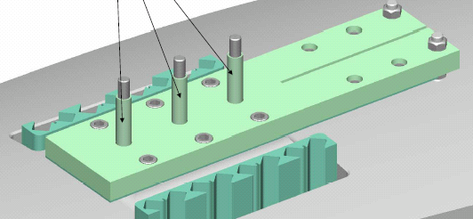
Figure 19-Install Studs and Insulating Sleeves

- Begin installing the copper jumpers and insulating plates. Begin with jumper #1 then an insulating plate. Continue to alternate between jumpers and insulators until Jumper #4 has been installed. Then secure in place with Belleville washers, flat washer and nut. Do not torque the jumper hardware at this time. [Figure 20-Jumper #1 and Insulating Plate Installed and Figure 21-Final Jumper#4 Installed and Secured]

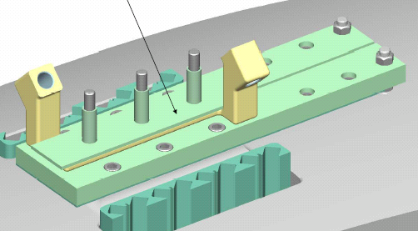
Figure 20-Jumper #1 and Insulating Plate Installed

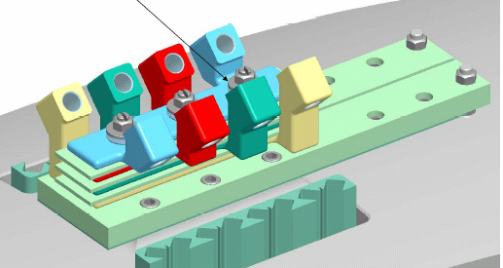
Figure 21-Final Jumper#4 Installed and Secured

- Install and epoxy in-place the insulating divider plate in the groove provided in the G-11 base. Mount the terminal lugs to the G-11 base plate and secure in position with appropriate hardware. Figure 22- Install Terminal Lugs

Note: the figure does not reflect the final configuration for the G-11 divider plate.

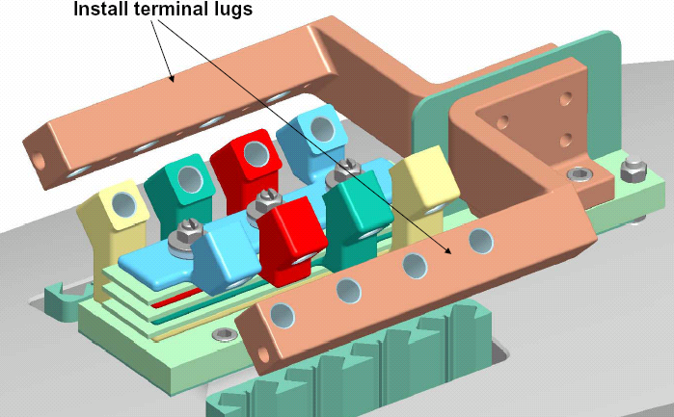
Figure 22- Install Terminal Lugs

- Installation of the Lead Terminal Assembly is complete. Note: it will be necessary to disassemble some of these components during the mounting of the copper leads to the terminal lugs.

Verified:

Lead Technician: ____________________________ Date: ____________________

Field Supervisor: ____________________________ Date: ____________________

Inner wall copper cladding

Cladding Preparation:

- Select the inner wall copper cladding being used for the coil type being manufactured. [Parts shall be deburred prior to use] Clean the copper plates with ethanol and clean lint free wipes. EXTREME CARE must be taken during handling of the cladding because of the potential for sharp edges. It is recommended that Kevlar gloves be used if possible during this installation.

- Apply (1) layer of adhesive backed Kapton tape (0.00325 in. thick) to the backside of the cladding that is facing the winding surfaces. Trim the Kapton insulation to the cladding profile. Slit the Kapton between fingers.

Cladding Installation- General Notes:

- Note: The cladding may be installed at either station 1b [Winding Form Prep] or in one of the winding clean rooms, at the discretion of the Field Supervisor.

- Fitup each section of copper cladding to the inner wall using the cladding mapping drawings. Customizing of each section of copper cladding will be required. Some pre-forming can be performed, but final fitup will be performed with cladding piece in position. Install cladding on both sides “A” and “B”.

- Use the cladding positioning block [Figure 23- Cladding Positioning Block, to fitup and align the vertical cladding strips.

- Secure the cladding positioning block to the winding form. The positioning block helps to align and position the vertical cladding strips. Use the positioning block to fit up each piece of cladding to the winding form. The cladding should fit snug to the positioning guide. Once the cladding has been fit, remove and re-clean if necessary. Check that there are no sharp edges or burrs.

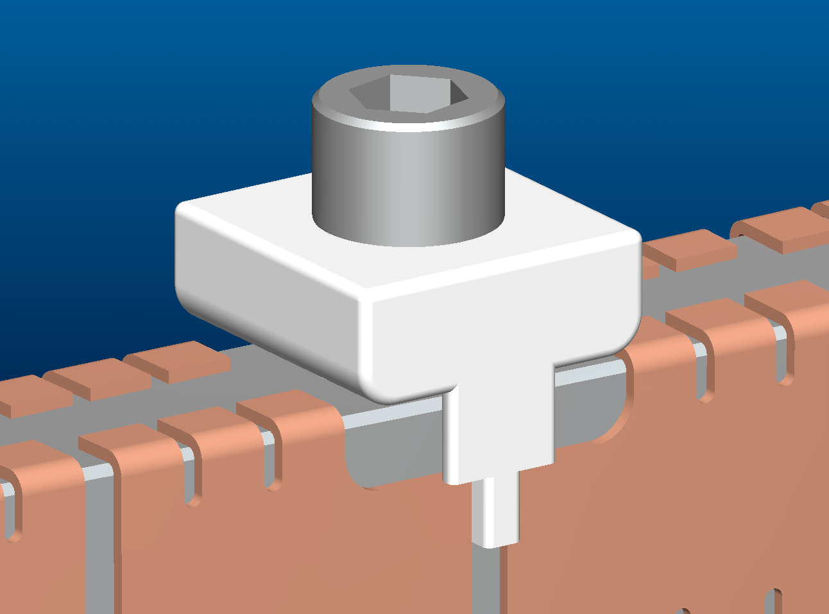
During alignment, the cladding should fit snug against the edge of the tab

Winding form
Copper cladding
Figure 23- Cladding Positioning Block

- Secure the insulated cladding to the winding form winding surfaces using 3M adhesive cement #CA40H. CARE should be taken to avoid any buildup of cement under cladding.

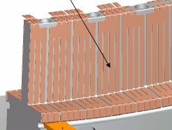
Location of adhesive- backside of cladding

Figure 24- Installation of Cladding

Installation of Vertical Cladding Strips:

- Apply a minimal quantity [drop] to the back of the cladding at the top bend and on the back of the outside fingers of the strip on the bottom. Evenly spread out the adhesive to a thin film avoiding any thick areas on the cladding. See Figure 24- Installation of Cladding for location of adhesive. Figure 25-Applying Adhesive to Vertical Cladding. Do not apply adhesive to the upper - sections of the cladding.

- Prior to placing the cladding in its final position, apply by brush 3M Accelerator “Pronto Surface Activator” to small area of MCWF where the adhesive on the cladding will mate with the winding form. [Figure 26-Applying Accelerator]

- Place the cladding into position and hold in place for 5 seconds. Then continue with remaining cladding pieces. [Figure 27- Positioning Vertical Cladding]

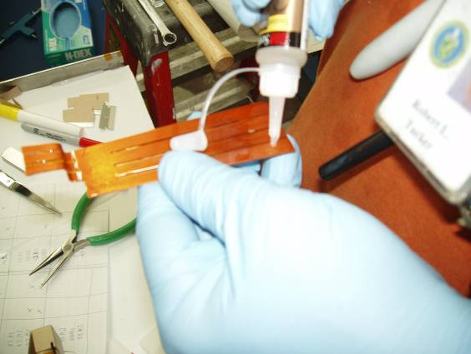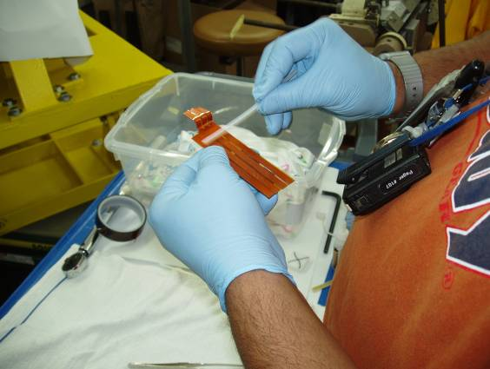
Figure 25-Applying Adhesive to Vertical Cladding

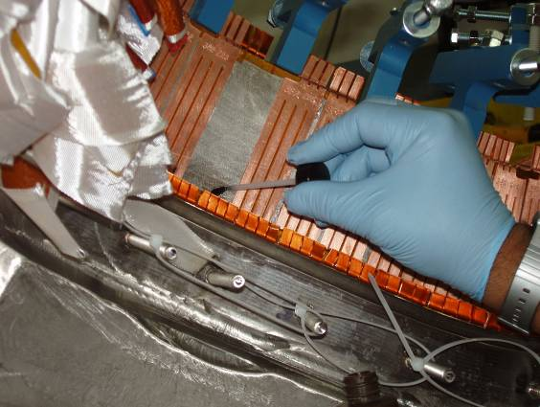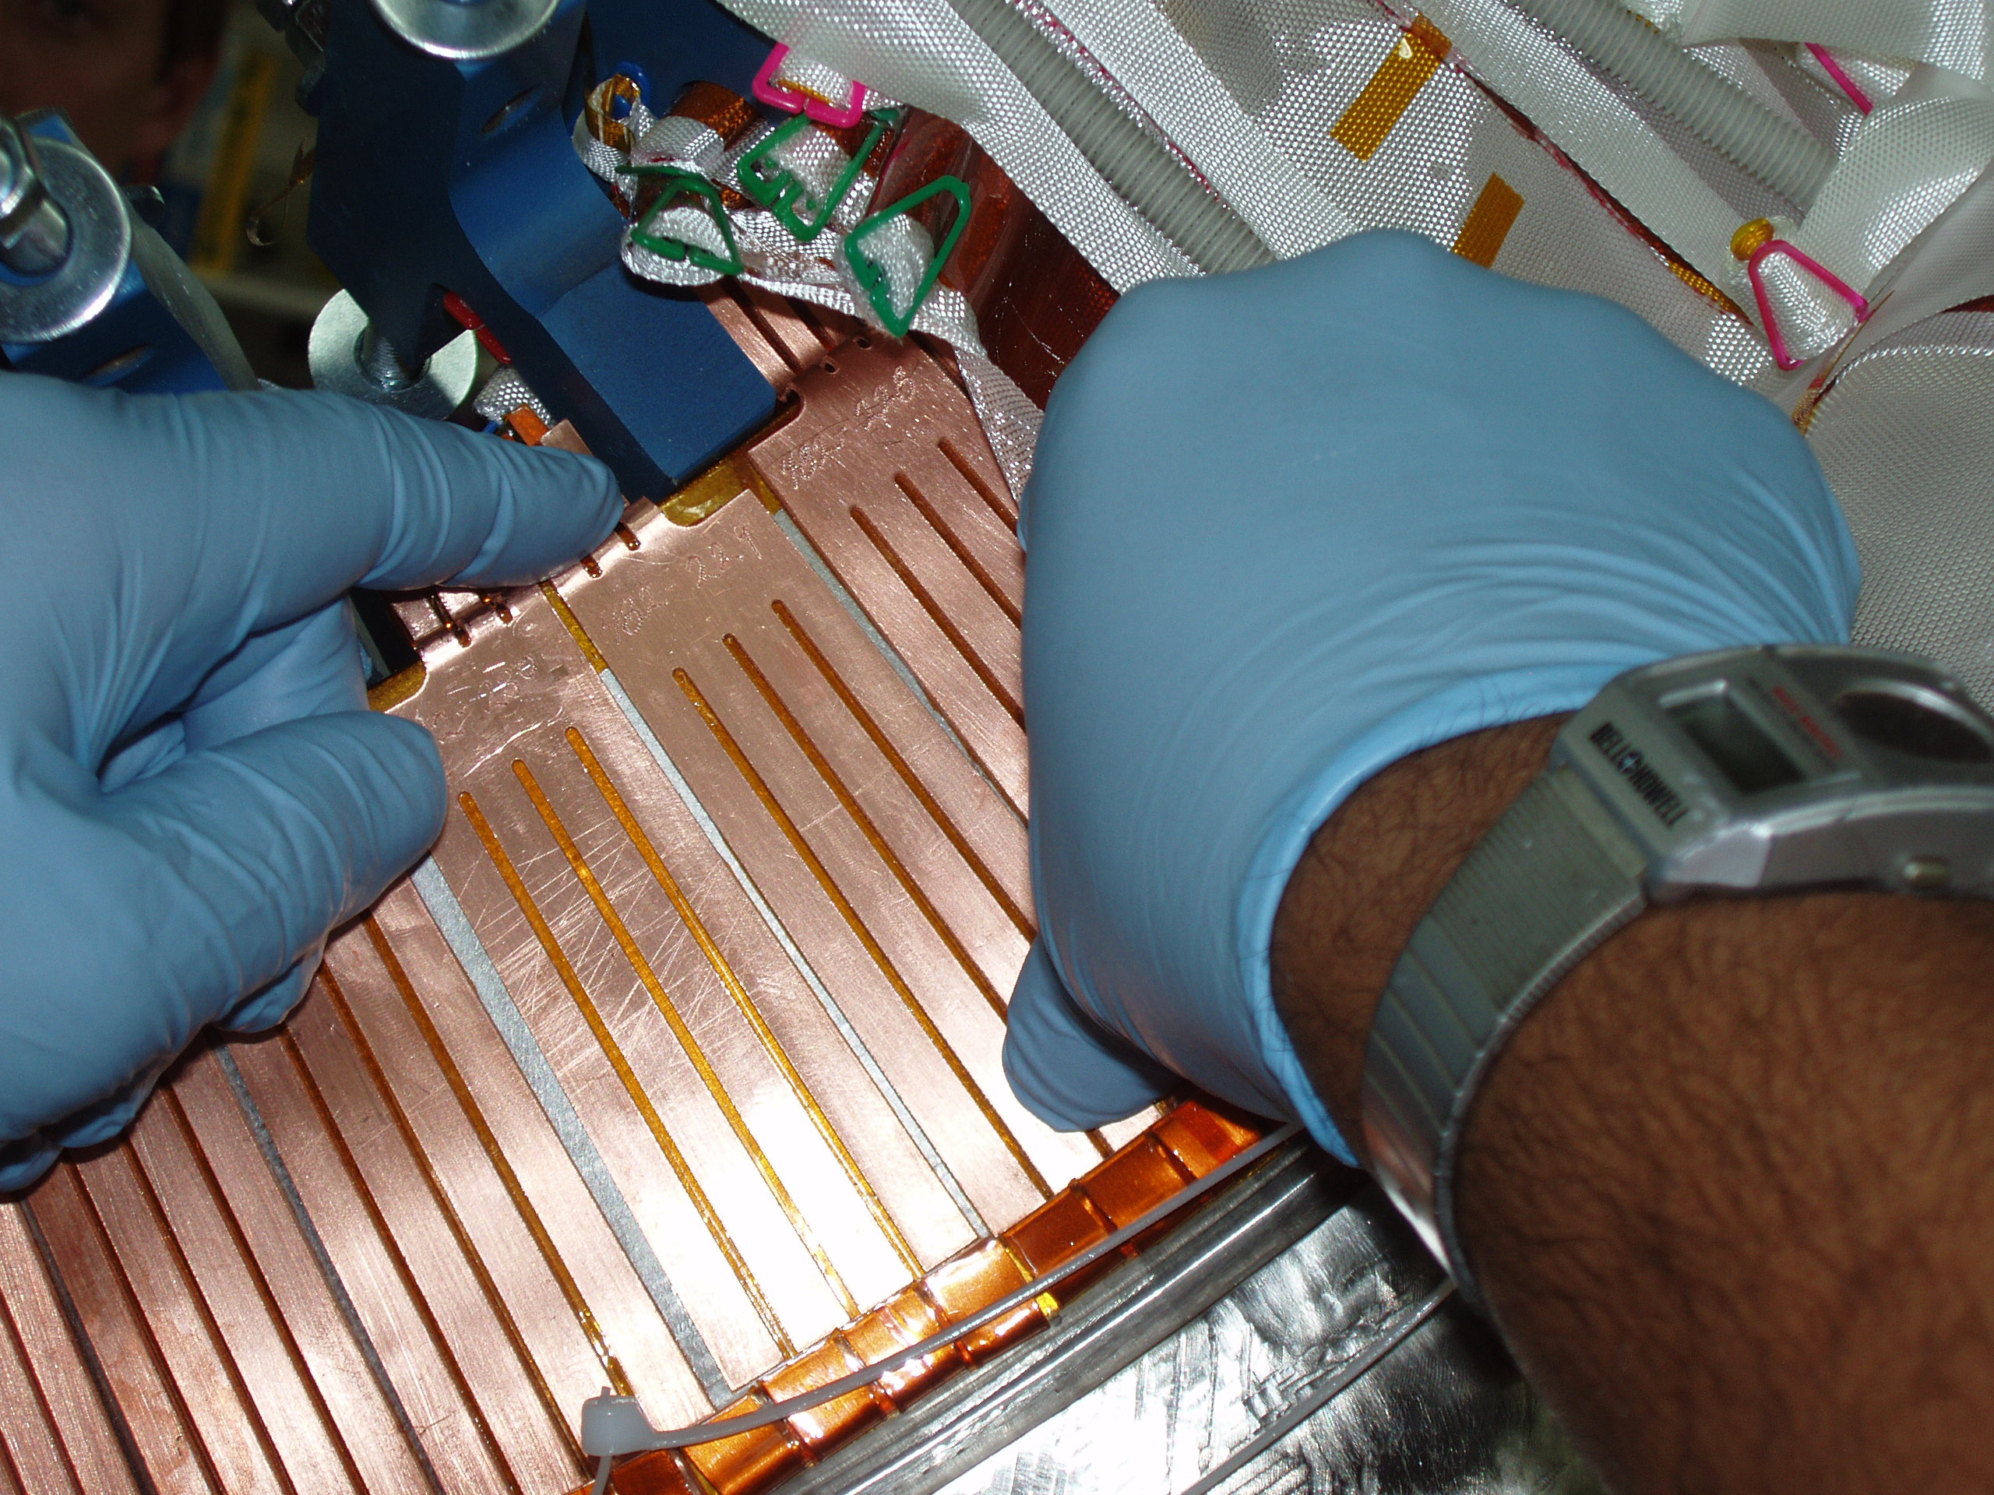
Figure 26-Applying Accelerator
Figure 27- Positioning Vertical Cladding

Installation of Horizontal Cladding Strips:

- Apply a minimal quantity [drop] to the back of the cladding at the edge bend and on the back of the outside fingers of the strip on the short leg of the cladding. Evenly spread out the adhesive to a thin film avoiding any thick areas on the cladding. See Figure 24- Installation of Cladding for location of adhesive. Figure 28- Applying Adhesive to Horizontal Cladding].

- Prior to placing the cladding in its final position, apply by brush 3M Accelerator “Pronto Surface Activator” to small area of MCWF where the adhesive on the cladding will mate with the winding form. [Figure 29- Applying Accelerator [Horizontal]]

- Place the cladding into position and hold in place for 5 seconds. Then continue with remaining cladding pieces. [Figure 30-Positioning Horizontal Cladding]

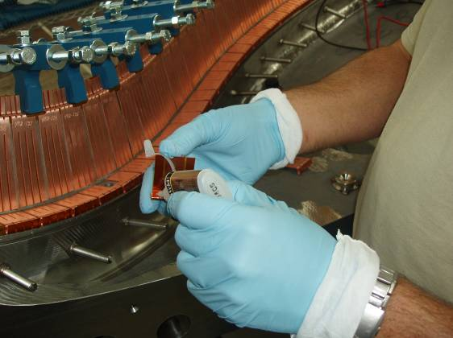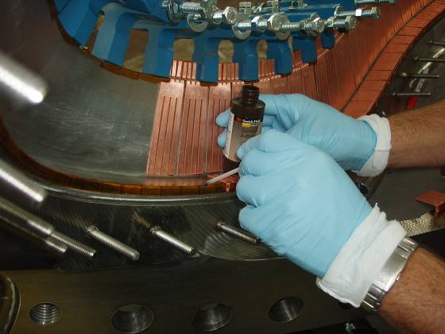
Figure 28- Applying Adhesive to Horizontal Cladding
Figure 29- Applying Accelerator [Horizontal]

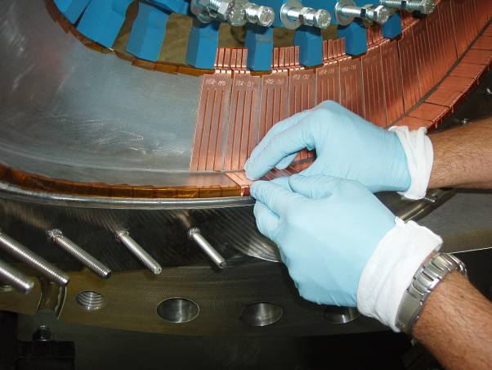
Figure 30-Positioning Horizontal Cladding

- During the installation of the cladding, continue to verify that the cladding is electrically isolated from the winding form using a multi-meter. Once all of the cladding has been installed, verify that each section of cladding is electrically isolated from its adjacent piece.

Equipment Name & ID Number: _____________________ Calibration Date: ___________

- Under the oversight of a Quality Control representative a final check shall be made to verify that the cladding is positioned to the winding form with minimal buildup between cladding and the form. Using a voltage probe or multi-meter with a depth stop [<0.060 inch] insert the probe between each pair of cladding until the stop rests on the cladding surface. If the probe light is on, it indicates that the cladding is acceptable and within the required buildup. If the probe does not light, then the cladding piece must be removed and reapplied. [Figure 31-Verifying Cladding standoff w/Voltage Probe] Quality Control shall sign off that the cladding has been satisfactorily inspected.

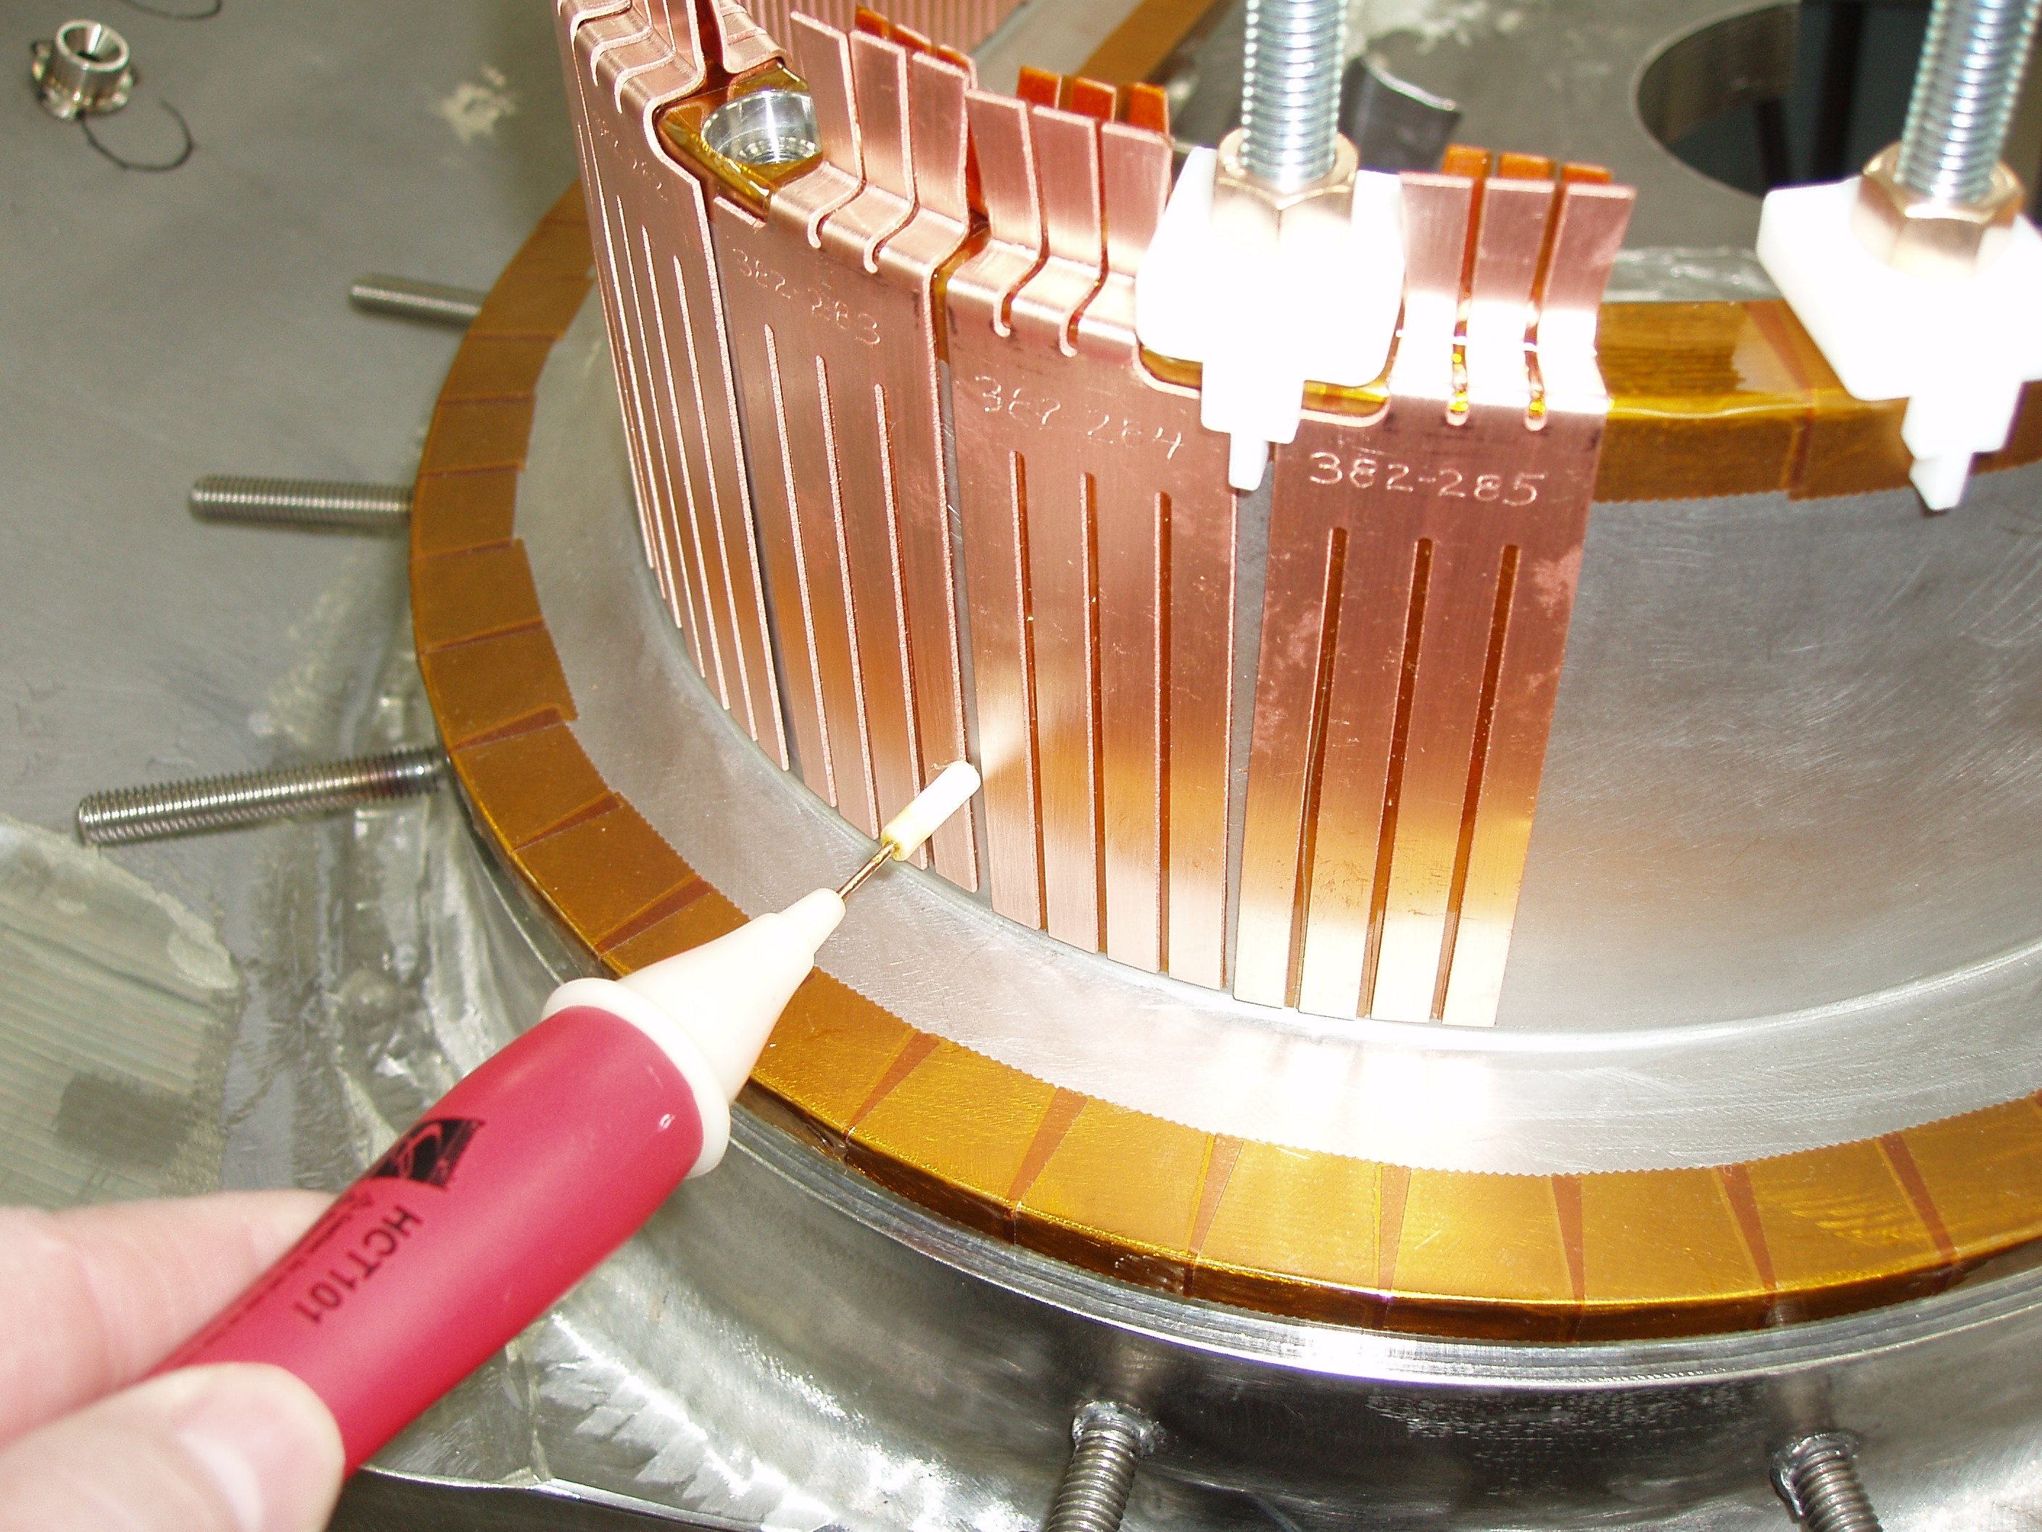

Figure 31-Verifying Cladding standoff w/Voltage Probe

- Installation of the cladding has been satisfactorily completed.

Installation of the Inner Copper Cladding is complete (sides “A” and “B”) including verification of the integrity of dielectric break and the cladding positions are satisfactory.

Lead Technician: ____________________________ Date: ____________________

Field Supervisor: ____________________________ Date: ____________________

Quality Control: _____________________________ Date: ____________________

Station No. 1 MCWF Preparation Completion:

Document Verification:
Verify that all pertinent data on the procedure and data sheets have been completed.

Field Package:
Ensure that all data sheets, photographs, QC inspection sheets, etc are included in the Field Package.

Approval:
Prior to releasing a modular coil from one station to the next it is required that the all-responsible individuals sign the release indicating that all processes at that station have been satisfactorily completed. The release will include signatures from the Station Lead Technician, Field Supervisor and the QC representative.

All winding form preparation activities have been satisfactorily completed.

Lead Technician: ____________________________ Date: ____________________

Field Supervisor: ____________________________ Date: ____________________

QC shall verify completion of documentation:

Quality Control Representative: _________________________ Date: ________

The winding form is ready for transfer to the next station:

DELETE TABLE 2

