Princeton Plasma Physics Laboratory
Procedure
‘
Procedure Title: Modular Coil Fabrication-Winding Station Activities

Number:  D-NCSX-MCF-002 |  | Revision:  02 |  |  | Effective Date:  Expiration Date:  (2 yrs. unless otherwise stipulated)
Procedure Approvals
Author: James H. Chrzanowski |  |  |  |  |  | Date:
ATI: James H. Chrzanowski |  |  |  |  |  | Date:
RLM: Larry Dudek |  |  |  |  |  | Date:
Responsible Division: NCSX Project
Procedure Requirements
Designated by RLM
LABWIDE:
X | Work Planning Form # WP-1188 & 1138 (ENG-032) |  |  | Lockout/Tagout (ESH-016)
 | Confined Space Permit (5008,SEC.8 Chap 5) |  |  | Lift Procedure (ENG-021)
 | Master Equip. List Mod (GEN-005) |  | X | ES&H Review (NEPA, IH, etc.) NEPA 1283
 | RWP (HP-OP-20) |  |  | Independent Review
 | ATI Walkdown |  | X | Pre-Job Brief
X | Post-job Brief *
D-SITE SPECIFIC:
X | D-Site Work Permit (OP-AD-09) |  |  | Door Permit (OP-G-93)
 | Tritium Work Permit (OP-AD-49) |  |  | USQD (OP-AD-63)
X | Pre-Job Brief (OP-AD-79) |  |  | T-Mod (OP-AD-03)
 | ** DCA/DCN (OP-AD-104) #

* Required for installations involving internal vacuum installations, critical lifts, and for the initial installation of repetitive work.
** OP-AD-104 was voided by procedure ENG-032. However, DCA’s that were open at the time of adoption of ENG-032 are still considered valid for work approval purposes.

REVIEWERS (designated by RLM) Rec’d/
Incorp.
Comments
Accountable Technical Individual. …………J. Chrzanowski
Test Director
Independent Reviewer Mike Anderson, P.J Fogarty [ORNL] X
D-Site Shift Supervisor
Independent.. Wayne Reiersen X
NCSX Dimensional Control Coordinator ……………………….Brent Stratton X
Vacuum
NCSX Field Supervisors… Steve Raftopoulos, Tom Meighan X
Project Engineer for Stellerator Systems (WBS 1) Manager……Brad Nelson (ORNL) X
WBS Manager for Modular Coils (WBS14).. …………………
Quality Assurance/Quality Control. …… Colin Phelps X
Maintenance and Operations Division
Energy Conversion System/Motor Control Division
Engineering ……………………………………..
Environmental Restoration & Waste Management Division
Environmental, Safety & Health……………………………………Jerry Levine X
Industrial Hygiene………………………………………………... Bill Slavin X
Health Physics…………………
RLM ………………………………………………………………..Larry Dudek

TRAINING (designated by RLM)
No training required ______________ | Instructor Jim Chrzanowski
Personnel (group, job title or individual name) |  | Read Only | Instruction  Pre-job  Briefing | Hands On
Lead Tech. |  |  | X
Technicians performing task |  |  | X
Field Supervisors |  |  | X
Quality Control Representative |  |  | X
Training Rep.
RLM Larry Dudek

RECORD OF CHANGE

Revision | Date | Description of Change
00 | 11/19/04 | Initial release
01 | 8/1/05 | General description of changes:  Includes new concept for chill plates and epoxy shell for bag mold. Additional changes as result of winding the Twisted Racetrack Coil and new lead block design [changes identified with side bar]
02 | 5/24/06 | -Revamped entire procedure to reflect changes in manufacturing sequence  -Added new figures throughout procedure  -Modified braze procedure steps  -Changed location of diagnostic flux loops  -Added joint resistance test section of connectors  -Modified table and clarified description of assemblies for cooling tube tests  -Added additional notes for positioning coil leads  -Modified text for setting side bars of winding clamps  -Text changes are noted with side bars  -Added soldering of coil joints

TABLE OF CONTENTS

1 Scope 1
1.1 Introduction 1
1.2 Scope 1
1.3 Identification of Coil being manufactured: 1
2 Applicable Documents 1
2.1 NCSX-MIT/QA-142-01: 1
2.2 NCSX-PLAN-MFOP-00: 1
2.3 D-L-NCSX-983 Lifting Modular Coil Winding Forms 1
2.4 D-L-NCSX-984 Lifting Modular Coil/ Ring Assemblies 1
2.5 D-NCSX-MCF-005 Dimensional Control & Metrology for the NCSX MC 1
2.6 D-NCSX-PLAN-MCWDC Modular Coil Dimensional Control Plan 2
3 Safety Requirements: 2
3.1 Job Hazard Analysis: 2
4 Prerequisites & Conditions: 2
4.1 Pre-Job Briefing: 2
4.2 Daily Operations Startup and Shutdown: 2
4.3 Reference Torque Values: 2
5 Materials and Parts for this station 2
6 Fabrication Process 3
6.1 Daily Startup Activities: 3
6.2 Daily Shutdown Activities: 3
6.3 Loading of Conductor Payout Spool: 4
6.4 Transporting MCWF from Casting Prep Station 1b to Winding Station: 4
6.5 Cladding Inspection: 7
6.6 Installation of Winding Clamp Side Bars 7
6.7 Installation of Inner Groundwrap Insulation 8
6.8 Install Lower G-11CR Winding Blocks 10
6.9 Dimensional Inspection 10
6.10 Positioning Lacing bands onto Winding Form 11
6.11 Position Leads for Side “A” Winding 11
6.12 Brazing Side “A” Lower Lead Connectors: 12
6.13 Fitup of Leads- Side “A” 18
6.14 Insulate Lower Leads- Side “A” 18
6.15 General Winding Notes: 19
6.16 Metrology Measurements/Tolerance Control: 20
6.17 Winding Operation- Side “A” 21
6.18 Upper Side “A” Leads 24
6.19 Preparation for Winding Side “B” 25
6.20 Positioning of lower leads for side “B” winding 27
6.21 Brazing Side “B” Lower Lead Connectors: 27
6.22 Fitup of Leads- Side “B” 30
6.23 Insulating Side “B” Lower Leads 30
6.24 General Winding Notes: 30
6.25 Winding Operation Side “B” 30
6.26 Upper Side “B” Leads 34
6.27 Winding Pack Adjustments 34
6.28 Completion of Groundwrap Installation 35
6.29 General Procedure- Outer Chill Plate/Cooling Tube Assembly: 36
6.30 Chill Plate Installation: 41
6.31 Cooling Tube Pressure Tests: 41
6.32 Flow Check: 42
6.33 Cooling Tube Electrical Test: 43
6.34 Installation of Diagnostic Loops 44
6.35 Final Positioning of Upper Leads sides “A” and “B” 45
6.36 Brazing Side “A” and “B” Upper Leads: 46
6.37 Fitup of Leads- Sides “A” and “B” 50
6.38 Insulate Upper Leads- Side “A” and “B” 50
6.39 Coil Joint Assembly 51
6.40 Lead Area-Upper Chill Plates 56
6.41 Cooling Tube Pressure Tests: 56
6.42 Flow Check: 56
6.43 Cooling Tube Electrical Test: 57
6.44 Winding Block Filler Strips 57
6.45 Outer Lead Chill Plate and Side Plates 58
6.46 Install Top Plate 59
6.47 Completion of Sides “A” and “B”: 59
6.48 Pre-VPI Electrical Insulation Tests: 60
6.49 Installation of Bag Mold: 62
7 Completion of Activities at Winding Station: 67
7.1 Document Verification: 67
7.2 Field Package: 67
7.3 Approval: 68

Index of Figures

Figure 1- Orientation of Copper spools 4
Figure 2- Conductor Identification 4
Figure 3- Upper Support Plates 5
Figure 4- Turning Fixture 6
Figure 5-Location of Side bar Shims 8
Figure 6- Groundwrap scheme 9
Figure 7- Winding Clamp-Groundwrap Storage 10
Figure 8- Re-installation of Lower Winding Blocks 10
Figure 9- Position of Lacing Straps 11
Figure 10-Cross-section of Lacing straps position 12
Figure 11- Cable Connector 13
Figure 12- Connector w/Phenolic Blocks 13
Figure 13-Conductor in Forming Block 13
Figure 14- Removing Nylon Serve from Conductor 13
Figure 15- Conductor in Connector 14
Figure 16- Basic Setup for Brazing Lead Connectors 14
Figure 17- Front Face- "Nibco" Braze Unit Control 15
Figure 18- Carbon Tong Positioning & Sil-Fos Feed 15
Figure 19- Heating Copper Connector 16
Figure 20- Feeding Sil-Fos Position B 16
Figure 21- Feeding Sil-Fos Position C 16
Figure 22- Positioning leads 19
Figure 23-Schematic of Turn Insulation Tester 19
Figure 24-"Whisker detector" 20
Figure 25- Conduction Identification 27
Figure 26- Groundwrap Overlap Scheme 36
Figure 27- Staking Chill Plates 37
Figure 28- Outer Chill Plates 38
Figure 29- Setting Chill Plate and Tubing 39
Figure 30- Front Face- "Nibco Soldering Unit Control 40
Figure 31- Soldering Cooling Tube (photos a & b) 40
Figure 32- Cleaning of Soldered Chill Plates 41
Figure 33- Chill Plates in Lead Area 41
Figure 34- Outer Chill Plates 41
Figure 35- Chill Plate Assembly Identification 43
Figure 36-Diagnostic Loops 45
Figure 37- Upper Lead Winding Block 46
Figure 38- Upper Lead Blocks and Leads 51
Figure 39- Typical Joint 52
Figure 40- Final Terminal Connections Identification 52
Figure 41- Front Face "Nibco" Soldering Unit 53
Figure 42- Soldering Connector 54
Figure 43- Soldering Figure 54
Figure 44-Upper Lead Area Chill Plates 55
Figure 45- Winding Block Filler Strips 58
Figure 46- Outer Lead Area Chill Plate 59
Figure 47- Lead Area Side Plates 59
Figure 48-Top Plate Bushing 60
Figure 49- Lead Area Top Plate 60
Figure 50- Glass Roving Between Cooling Tubes 62
Figure 51- Installation of Bag Mold 63
Figure 52- Silicone Bag Mold 63
Figure 53- Sprue washers and extensions 64
Figure 54-Epoxy/Glass Mixture- "Cotton Candy" 66
Figure 55-Application Epoxy Glass Shell 66
Figure 56- Epoxy/Glass shell 67

Index of Tables

Table 1 -Measured conductor cross-section- Side A: 4
Table 2 -Measured conductor cross-section- Side B: 27
Table 3-Cooling Tube Flow Results 42
Table 4- Joint Data 53
Table 5 - Solder Joint Data 54
Table 6-Cooling Tube Flow Results 57
Table 7- Pre-VPI Bag Mold Megger Test Results 61
DELETE Table 8- Type "C" Coil Drawings 68

Scope

Introduction
The Modular Coil Manufacturing Facility is divided into 5 workstations. Each workstation has a specific set of tasks that will be performed as part of the overall fabrication process. This procedure addresses the manufacturing, inspection, test and QC inspection points for a specific workstation.
- Station No. 1… Winding Form Preparation & Post VPI Activities
- Station No. 2… Winding Station -Molding and VPI Preparation
- Deleted Reference to Station 3
- Station No. 4… Winding Station -Molding and VPI Preparation
- Station No. 5… VPI and Autoclave Activities
- Deleted Reference to Station 7

Scope
This procedure is used to wind the compacted copper rope conductor onto the modular coil winding forms. It includes:
- Installing the WF in the turning fixture
- Installation of Groundwrap insulation
- Winding of coils
- Lacing of turns
- Termination of coil leads
- Metrology measurements
- Installation of Diagnostic flux loops
- Application of outer chill plates and cooling tubes
- Application of Bag Mold

Identification of Coil being manufactured:

Station Number: ________________________

Winding Form Type: _______________ (A, B, C or Twisted Racetrack Coil [TRC])

Modular ID Coil Number: __________________

Applicable Documents

NCSX-MIT/QA-142-01:
All applicable documents associated with this procedure, are identified in the MIT/QA Plan, document number NCSX-MIT/QA-142-01.

NCSX-PLAN-MFOP-00:
All Modular Coil work processes are governed by the “Manufacturing Facility Operations Plan”, document number NCSX-PLAN-MFOP-01.

D-L-NCSX-983 Lifting Modular Coil Winding Forms

D-L-NCSX-984 Lifting Modular Coil/ Ring Assemblies

D-NCSX-MCF-005 Dimensional Control & Metrology for the NCSX MC

D-NCSX-PLAN-MCWDC Modular Coil Dimensional Control Plan

Safety Requirements:
All work will be performed in a safe manner in accordance with PPPL Environmental Safety & Health Directives ES&H 5008 and the “Integrated Safety Management” (ISM) policy.

Job Hazard Analysis:
A JHA will be generated for each winding station, identifying existing or potential workplace hazards and to evaluate the risk of worker injury or illness associated with job tasks. (Reference document ESH-004 “Job Hazard Analysis”) The IH representative will review the JHAs for accuracy as well as completeness. It will be reviewed with all activity participants at the Pre-Job briefings.

Prerequisites & Conditions:

Pre-Job Briefing:
A pre-job briefing will be held prior to the first time that revision of the procedure is used or if being performed by a new crew. The briefing will describe the processes and safety issues [JHA] associated with procedure. Attendance shall be documented via training sign-in sheet.

Pre job Briefing complete: _______________________________ _________________
MC Field Supervisor Date

Daily Operations Startup and Shutdown:
Each working day, it is required to complete and initial the daily operations startup log to ensure that the station is ready to commence work activities for the day. The signoff log is located in the Daily Station Log. See section 6.1 and 6.2 for details.

Reference Torque Values:
Unless a torque value is specified or the fastening material is something other than low carbon steel, the following values shall be used whenever the procedure requires a torquing operation:

3/8-16UNC …… 18 ft-lbs 3/8-24UNF …… 19 ft-lbs ½-13 UNC …… 38 ft-lbs ½ -20 UNF …… 40 ft-lbs 5/8-11 UNC…. 83 ft-lbs 5/8-18 UNF… 95 ft-lbs
¾-10 UNC..…… 105 ft-lbs ¾-16 UNF ……. 102 ft-lbs 1-8 UNC … 236 ft-lbs 1-14 UNF …….. 212 ft-lbs 1 1/4 UNC …… 432 ft-lbs 1 ½-6 UNC …...732 ft-lbs

Materials and Parts for this station
The following materials and/or equipment will be used with this procedure.

General Description | Material | Reference Document/Product No.
Conductor | CDA 101 compacted copper rope | NCSX-CSPEC-142-03-01
Turn Insulation- glass tape | S-2 Dry glass 0.004 in. thick
Ground insulation-glass tape | S-2 Dry glass 0.007 in. thick
Ground insulation | Kapton- 5mil Type HN
Ground insulation | Kapton- 2mil Type HN
Diagnostic Flux loops | 316 SS Mineral cable insulated with Teflon heat shrink tubing | A.R.i. Incorp.  [0.032 dia. w/ 0.006 in. thk. sleeve]
Solvent | Chlor-Free Degreaser | CRC Product No. 03185 [MSDS #05032]
Solvent | Acetone | MSDS# 00561
Lead winding and enclosure fillers | G-11CR | Drawing list to be added as addendum for each coil type as approved
Chill Plates | C10100 Copper | Drawing list to be added as addendum for each coil type as approved
Cooling tubes | Copper
Lead support structures  (winding blocks) | G-11CR | Drawing list to be added as addendum for each coil type as approved
Lead terminal Assembly | Copper and G-11CR | SE142C-050
Cable connector | OFS Copper | SE142C-059
Braze material | Sil-Fos | MSDS # 03437
Turning Fixture | Equipment | Drawing no. SE144-008
Conductor payout spool | Equipment | Drawing no. SE144-120
Winding clamps | Equipment | Drawing SE144-080
Bag sealing agent | 2-part RTV 11 (white) | MSDS #02214
Bag mold material | Self-fusing Tape | Product no.7643A24 2 in. wide gray silicone tape
Bag mold shell material | chopped glass tape w/ epoxy*
Epoxy system for shell mold | *Resin/hardener 3561/2039 | MSDS # 03516 & 03515
Bag sealing | RTV 108 (caulking) | MSDS #01525
Braze inhibitor | Nicrobraz Green Stop-Off | MSDS #4748
Adhesive Tape for Lacing | 3M High Performance tape | Product no. 3M9485PC
Solder for chill plate tubes | 95/5% Tin/ Antimony solder
Lacing strips | “E”-glass untreated | 0.007 inch. Thick x 0.50 inch wide

Fabrication Process
This fabrication procedure is to be used as guide to complete the station no. 2 & 4 activities. Deviation from this procedure for processes that DO NOT affect the design of the coil can be made during the winding process with the concurrence of the MC Field Supervisor. All deviations shall be documented in the procedure and initialed by the MC Field Supervisor prior to implementing the deviations. Deviations that may effect the design of the coil requires a Request for Deviation “RFD” approval. The RFD must be approved prior to proceeding. Procedure changes need to be incorporated into the document via “Minor Procedure Changes” or “Revisions”.

Daily Startup Activities:

Check all daily supplies needed:

Verify operation of all equipment needed that day.

Check station for cleanliness

Check that safety guards are intact

Check that safety equipment needed for day’s activities are available

Check that the day’s travelers and procedures are in their document holder.

Once completed, date and initial daily log at the back of the Station Log Book.

Daily Shutdown Activities:

Turn off power to equipment not in use.

Clean entire workstation area.

Verify that all Traveler and data sheet information is complete.

The Lead Technician shall verify that the Station’s Log Book has been completed and signed for the day.

Once completed, date and initial daily log at the back of the Station Log Book.

Loading of Conductor Payout Spool:
Load (4) spools of copper conductor into the conductor payout spool fixture. Position the spools in the fixture with the upper spools (1 and 2) being fed from the bottom side and lower spools (3 & 4) being fed from the topside [See Figure 1- Orientation of Copper spools] [Note: the cable lead connectors may be brazed onto the conductors prior to installing the copper spools per section 6.13]

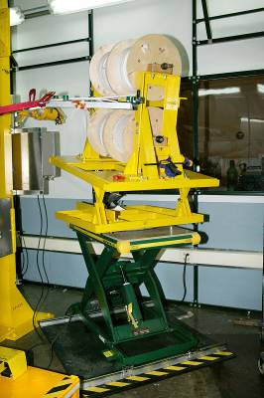
Conductor Spools 1 and 2
Conductor Spools 3 and 4
Figure 1- Orientation of Copper spools

  - The height, angle and pitch of the conductor payout spool relative to the winding station shall be modified during the winding operation. This will help to minimize any twisting or excessive keystoning of the conductor prior to being laid in position.

  - Measure the conductor cross-sectional dimensions with Vernier calipers using light pressure. Record the measured data in space below. [Figure 2- Conductor Identification and Table 1 -Measured conductor cross-section- Side A:]
#3
Width (Inches)
Septum
#2
Height
(Inches)
#4
#1

Figure 2- Conductor Identification

Table 1 -Measured conductor cross-section- Side A:
Conductor Number | #1 | #2 | #3 | #4
Width (Inches):
Height (Inches):

Transporting MCWF from Casting Prep Station 1b to Winding Station:
Using lift procedure D-L-NCSX-984 the modular coil winding form shall be transferred from the turning fixture [Figure 4- Turning Fixture] at station 1b to the turning fixture at either station 2 or 4.
Note: This move will occur prior to or following the installation of the inner wall copper cladding.

Station 1b Preparations:

Install the upper support plates that secure the support ring to the support/lift beam. This operation must be verified prior to proceeding. See Figure 3- Upper Support Plates

Verified by: _________________________ Date: __________________
Lead Technician

- SAFETY NOTE: Use scaffolding or appropriate ladders while working on upper section of turning fixture. Scaffolding must be inspected prior to use per Section 9 Chapter 5 in PPPL ES&H Manual.

Using the lift procedure data sheet rig the upper support/lift beam to the overhead crane.
Remove Upper Support Plates
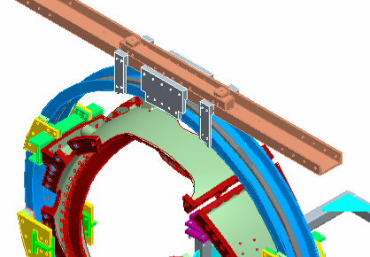

Figure 3- Upper Support Plates

  - Once a slight load has been taken, remove the hardware that secures the upper support/lift beam to the turning fixture frame.

  - Compress the springs under the gear box (drive system) until they are bottomed.

  - Disengage and remove the upper guide rollers. NOTE: Sling the rollers and raise them into position with rope. Do not climb up ladder with roller assembly in hand.

  - Carefully raise the winding form/ring assembly from station 1b and transport to either modular coil winding stations no. 2 or 4. Install the MCWF into the turning fixture via the ceiling hatch.

Note: During the installation of the MCWF into the turning fixture, to minimize risk of potential dirt contamination, the rooms must be isolated from each other. This only applies if a coil is already in the adjacent winding station.

Verified by: _________________________ Date: __________________
Field Supervisor

Winding Station [2 or 4] Preparations:
Activities associated with receiving modular coil at winding stations.

  - Prior to installing the MCWF compress the springs under the gear box (drive system) until they are bottomed.

  - Measure the inside width of the winding form ring (where the roller guide wheels engage) and record the smallest value. [Narrowest dimension].

  - Adjust the lower wheels on the winding station so that they are centered in the frame AND are set at a width that is one-half inch greater than the value recorded in the previous step.

  - Lower the MCWF and ring assembly into the turning fixture using the corner brackets for alignment. Bolt up one end loosely (use spud wrenches to align holes).

- SAFETY NOTE: Use scaffolding or appropriate ladders while working on upper section of turning fixture. Scaffolding must be inspected prior to use per Section 9 Chapter 5 in PPPL ES&H Manual.

  - Install the upper guide rollers and align all of the guide rollers to the support ring. NOTE: Sling the rollers and raise them into position with rope. Do not climb up ladder with roller assembly in hand.

  - Decompress springs under the gear box (drive unit) until gear is fully engaged with ring gear rack. The upper set of springs MUST be completely disengaged. This must be verified prior to proceeding.

Verified by: _________________________ Date: __________________
Lead Technician
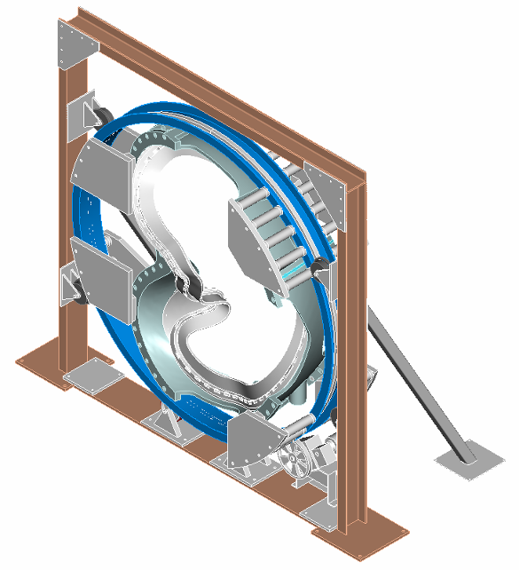
Turning Fixture Support Ring
Turning Fixture Support Plates
Turning Fixture-Upper Support/Lifting Beam
Turning Fixture Drive System
Turning Fixture Support Roller Guide Rollers
Turning Fixture Support Frame

Figure 4- Turning Fixture

- Verify that the upper support/lift beam is in proper position and secured with appropriate hardware that is torqued to the proper value. [See section 4.3]

Verified by: _________________________ Date: __________________
Lead Technician

- Remove the upper support plates between the support-ring and lift beam. This operation must be verified prior to operating turning fixture. [See Figure 3- Upper Support Plates]

Verified by: _________________________ Date: __________________
Lead Technician

  - Adjust the upper alignment rollers (both on the vertical and horizontal beams) so that the ring is aligned vertically and is centered within the turning fixture frame. A pry bar can be used to position the upper half of the ring so that these adjustments can be made. The rollers should be set so that there is one-quarter inch clearance to the ring flanges.

  - To ensure proper alignment and operation of the turning fixture, rotate the MCWF a full two revolution in either direction, using the foot-pedal control. Re-adjust the alignment rollers as required. Alignment of MCWF to the turning fixture is complete.

Verified by: _________________________ Date: __________________
Lead Technician

Cladding Inspection:
If the cladding was installed prior to transport to the winding station, inspect cladding for any damage, movement or contamination that may have occurred during installation of MCWF into the turning fixture. Repair and/or clean as required.

Verified by: _________________________ Date: __________________
Lead Technician

Installation of Winding Clamp Side Bars
Based upon measurements previously taken of the winding surfaces, the metrology engineer shall provide data for shimming each winding clamp side bar for sides A and B. This will set the maximum width of the coil bundle.

The shim dimensions have been provided by the Metrology engineer.

Shim dimensions received and verified by:

Metrology Engineer: ____________________________ Date: ____________________

Dimensional Control Coordinator: __________________________Date: _____________

Using the data provided by the metrology engineer and pre-fabricated gauge blocks set the positions of each side clamp to ensure that they are parallel to the septum.

The winding team shall install the correct shim washers on the weld studs between the casting and the side bar nuts. [See Figure 5-Location of Side bar Shims] Remove the side bars after the shims have been installed.

A record of the shim washer thicknesses used for each side bar shall be kept as part of the documentation in the procedure.

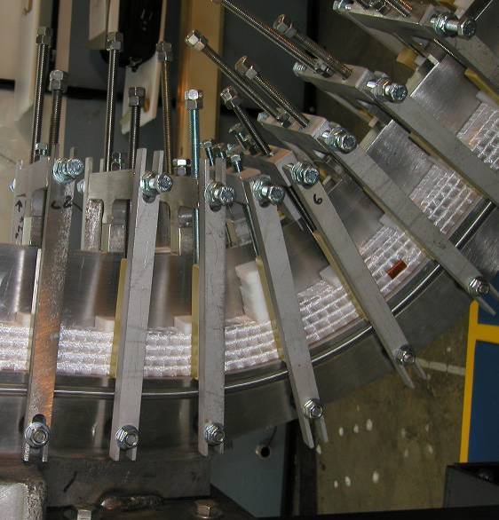
Location of washer shim packs (behind side bars)
Figure 5-Location of Side bar Shims

Shim installation complete:
Verified by: _________________________ Date: _____________
Metrology Engineer

Installation of Inner Groundwrap Insulation
Position the inner layers of ground wrap insulation onto the MCWF [Sides “A” and “B”] winding surfaces directly over the copper cladding. Since the Ground wrap insulation is being installed as individual lengths, it is necessary to roll the excess insulation on the top side of the winding form and store in place until the final GW operations begin. Ensure that the position of the rolled groundwrap insulation is high enough above the coil tee so that it does not get trapped by the upper layers of the coil during winding. Hold in position with non-conductive fasteners. On the lower side, a minimum of 4 inches should extend beyond the winding surface. This end cannot be rolled, but should remain loose. (See Figure 7- Winding Clamp-Groundwrap Storage)

Note: Ensure that personnel handling the insulation are wearing either cotton and/ or latex surgical gloves
  - Apply pre-cut layers (approximately 18 inches long) of ground wrap insulation Figure 6- Groundwrap scheme

  - Start date/Shift: ___________________

Winding Form Septum
Winding surface

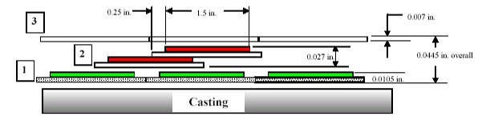
Figure 6- Groundwrap scheme

Layer 1 (Inner): [Against winding form]
Apply (1) Butt lapped layer of composite insulation
- 0.007 inch thick S-2 glass [nominal 2 inch wide]
- 0.0035 (HN) Kapton tape [nominal 1.5 inch wide] with adhesive back

Layer 2 (Mid):
Apply (1) half-lapped layer of composite insulation:
  - 0.007 in. thick glass [2 inch nom. wide]
  - 0.0065(HN) Kapton [1.5 nom. wide] with adhesive

Layer 3 (Outer): [Winding surface]
Apply (1) Butt lapped layer of S-2 glass tape
- 0.007 in. thick S-2 glass [2 inch nom. wide]

  - Application of the inner ground wrap has been satisfactorily completed.

Verified Sides “A” and “B” complete:

Lead Technician: ____________________________ Date: ____________________

Field Supervisor: ____________________________ Date: ____________________

Notes:

Winding clamp Base
Sidebars
Upper excess ground wrap shall be rolled for storage, but shall remain beyond winding surface. Hold in place with non-conductive fasteners.
Lower excess ground wrap shall extend a minimum of 4 inches beyond winding surface.

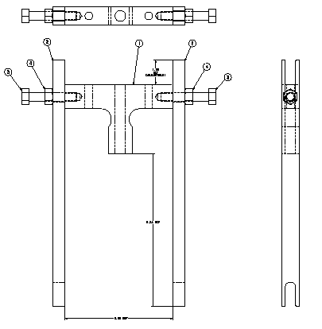
Figure 7- Winding Clamp-Groundwrap Storage

Install Lower G-11CR Winding Blocks
Using the guide blocks previously installed on the winding form, mount the lower G-11CR winding blocks on both sides “A” and “B”. Secure hardware. Note: Customizing of the ground wrap is required in the lead area. [Figure 8- Re-installation of Lower Winding Blocks] Once installed, remove guide blocks from winding form.

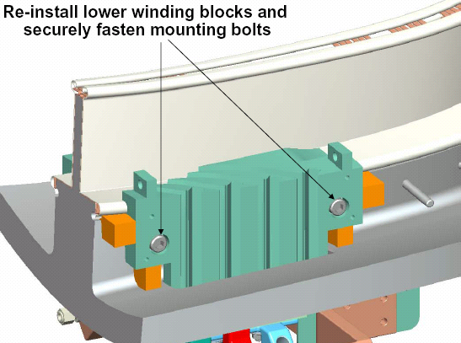
Figure 8- Re-installation of Lower Winding Blocks

Dimensional Inspection

DELETE

Positioning Lacing bands onto Winding Form

Place single bands of 0.004 inch thick x 0.5 inch wide x 18 inch long glass tape onto the groundwrap (sides “A” and “B”) in positions located either side of the winding clamps. [See Figure 9- Position of Lacing Straps and Figure 10-Cross-section of Lacing straps position]

The bands of lacing can be temporarily held in place with strips of Kapton adhesive back tape on the vertical surface only. Note: The Kapton strips must be removed prior to being trapped by layers of conductor during winding operations.

The upper bands of lacing shall be rolled and stored with the Groundwrap insulation. Hold in position with non-conductive fasteners. On the lower side, a minimum of 6 inches should extend beyond the winding surface. This end cannot be rolled, but should remain loose. [See Figure 10-Cross-section of Lacing straps position]

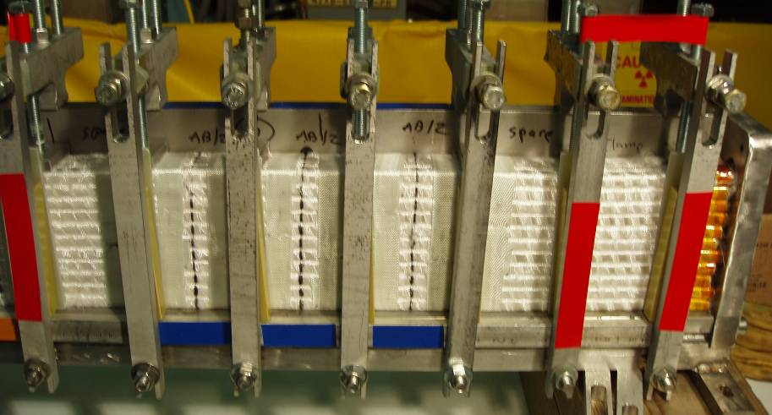
Glass lacing bands will be positioned on either side of winding clamp as shown. View shows bands after winding.
Figure 9- Position of Lacing Straps

Installation of Lacing Bands Sides “A” and “B” is complete.

Verified:

Lead Technician: ____________________________ Date: ____________________

Field Supervisor: ____________________________ Date: ____________________

Position Leads for Side “A” Winding

Feed sufficient copper from each of the (4) conductor spools located on the payout spool fixture until they reach the MCWF. Note: the conductor shall be fully supported between the payout spool and the winding form.

Determine the length of each conductor that is required to reach the terminal connections.

Position of lacing bands on winding form
Location of Kapton strips used to hold the lacing in position.
Figure 10-Cross-section of Lacing straps position

Brazing Side “A” Lower Lead Connectors:
The cable lead connectors will be brazed to the cable conductor using flameless “Nibco” resistive heating carbon tongs and Sil-Fos braze material. Only braze qualified individuals [per BPS-008] can perform the lead brazes and requirements of ES&HD 5008, Section 9, Chapter 15 for safe brazing must be followed.

Notify the ESU and obtain a flame permit prior to starting brazing operation.

Verified by: _________________________ Date: __________________
Lead Technician

Area preparation: Protect the surrounding coil area from any dirt or carbon that may occur as a result of the brazing operation. The area between clean rooms MUST be isolated if a coil is in the adjacent room. The ceiling hatch should be open during the brazing operations.

Copper Cable Connector: Clean the copper cable connector [Figure 11- Cable Connector] [drawing no. SE142C-059] using acetone-degreasing agent Scotchbrite and clean lint free wipes. Use a wire bottlebrush on the inner bore along with the acetone. Once cleaned, do not touch the components with bare hands. Coat the threads of the cable connector and 0.25 inch from end of connector with “Nicrobraz” [Figure 18- Carbon Tong Positioning & Sil-Fos Feed. This coating will minimize the braze material from adhering to the external surfaces. Do not get any of the “Nicrobraz” inside of the connector since this will effect the quality of the braze joint.

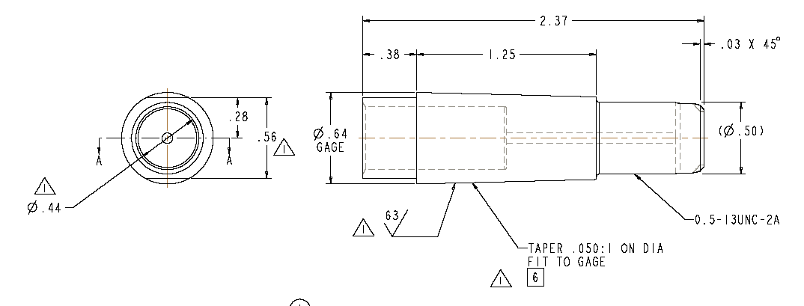

Figure 11- Cable Connector

Conductor Preparation Step 1: Reshape the copper rope conductor using phenolic form blocks to provide a proper fit between the cable and cable connector. The nylon “serve” and turn insulation shall remain in place during the rounding operation. See Figure 13-Conductor in Forming Block

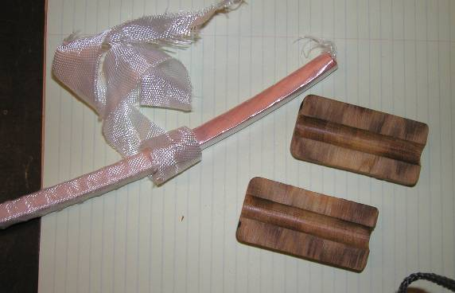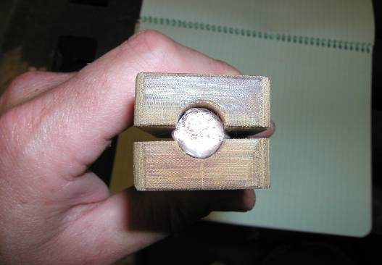
Figure 12- Connector w/Phenolic Blocks
Figure 13-Conductor in Forming Block

Conductor Preparation Step 2: Once formed, carefully remove the Nylon serve (covering) from the very end of the (approx. ¼ inch) conductor. [Figure 14- Removing Nylon Serve from Conductor] Measure the depth of the cable connector and transfer that measurement to the outside of the conductor serve.

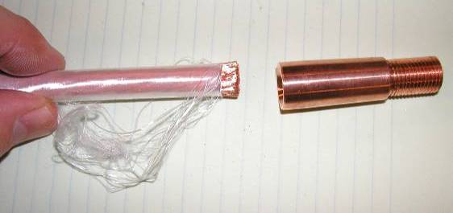
Figure 14- Removing Nylon Serve from Conductor

Conductor Preparation Step 3: Carefully slide the end of the conductor into the connector. Once the conductor is engaged with the connector, carefully remove additional Nylon serve (covering) so that the bare conductor can be fully inserted into the inner connector bore. Use the measurement marking that is on the nylon serve from the step 6.12.5. Continue sliding the conductor into the connector, until it bottoms out. See Figure 15- Conductor in Connector

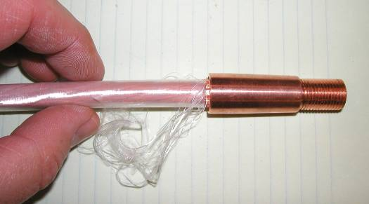
Figure 15- Conductor in Connector

Conductor Preparation Step 4: Strip back approximately 5.5 inches of the nylon serve starting at the copper cable connector.

Position the bare copper rope conductor into the water chill blocks and position the Argon gas-head directly over and approximately 4 inches from the copper connector. Chill plates should be positioned on the bare conductor to the edge of the insulation. [Figure 16- Basic Setup for Brazing Lead Connectors]

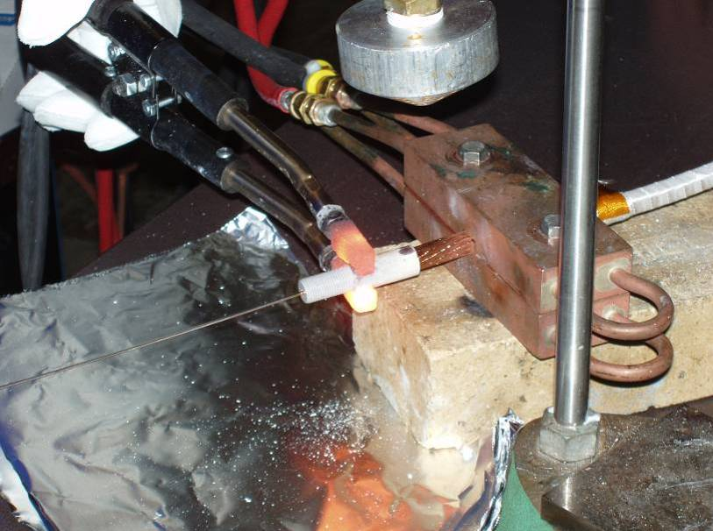
Argon Gas Head
Water Chill Block
Sil-Fos Rod being fed
Carbon Tongs
Figure 16- Basic Setup for Brazing Lead Connectors

Set the toggle switch on the control unit to “B”. [Figure 17- Front Face- "Nibco" Braze Unit Control]

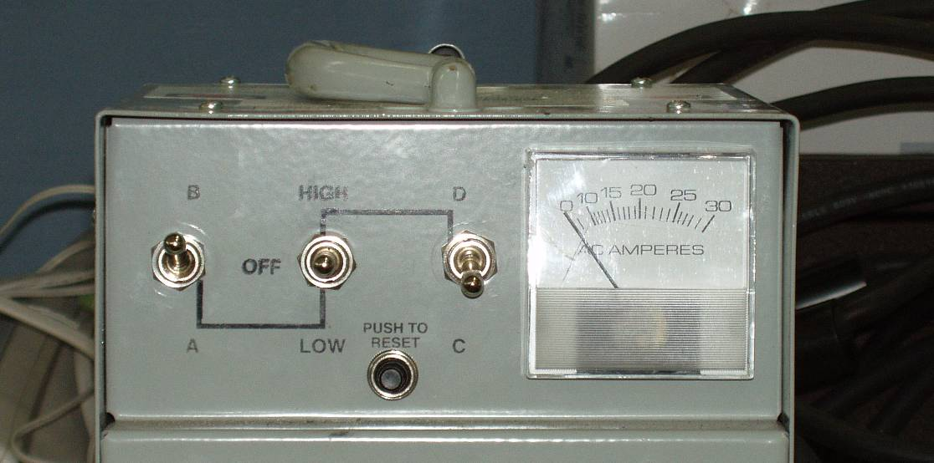
Figure 17- Front Face- "Nibco" Braze Unit Control

Position the carbon tongs 1/4 -3/8 inch from the conductor end of the copper connector [A]. [Figure 18- Carbon Tong Positioning & Sil-Fos Feed and Figure 19- Heating Copper Connector]

Move the center toggle switch down to LOW, and using the carbon tongs heat the copper connector. The current on the meter should read approximately 15 amps. Once at temperature, feed the Sil-Fos rod first from the conductor side [B] [Figure 20- Feeding Sil-Fos Position B] using approximately 1/3 to 1/2 of a Sil-Fos rod. Then feed through the feedhole at the threaded end of the connector [C] [Figure 21- Feeding Sil-Fos Position C] using 1/2 to 2/3 of a Sil-Fos rod.

Sil-Fos Rod
B
C
Location of Carbon Tongs
Nicrobraz threads and 0.25 in. of conductor end
Sil-Fos Rod
A
Cable conductor
0.25 to 0.38 inch

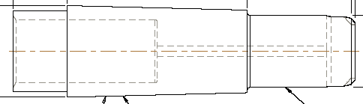

Figure 18- Carbon Tong Positioning & Sil-Fos Feed

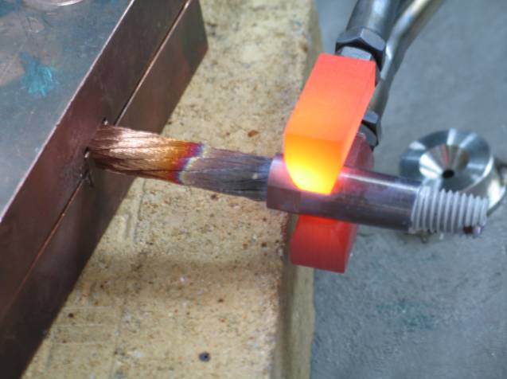
Figure 19- Heating Copper Connector

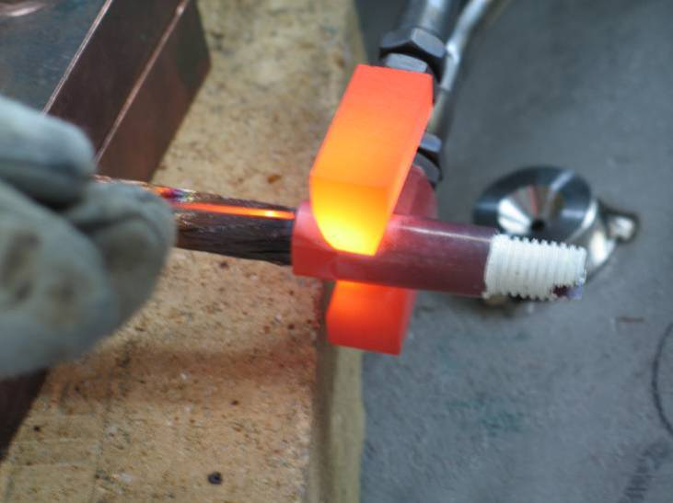
Figure 20- Feeding Sil-Fos Position B

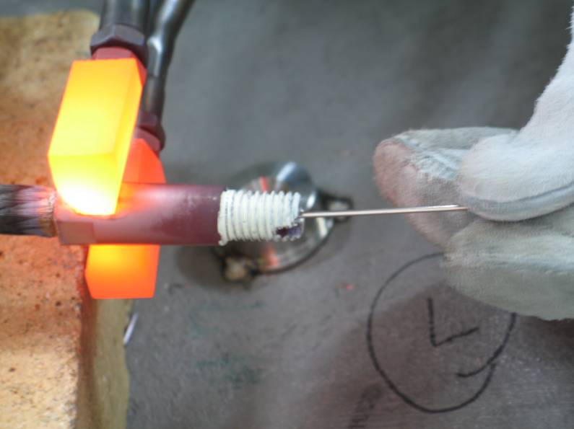
Figure 21- Feeding Sil-Fos Position C

Repeat the process with each of the copper cable connectors.

Clean the braze area, removing any excess Sil-Fos. Remove the remaining Nicrobraz from the surfaces. Do not use wire brush for cleanup. If a file is used, ensure that any file marks are buffed out using fine sandpaper to ensure smooth surface.

A QC welding inspector shall inspect each brazed lead connector following cleanup. If a lead connector braze is rejected, the connector must be removed and the connector braze remade.

Silver plate the copper lugs following inspection and prior to assembly. Inspect for any high ribs that may become more evident following silver-plating. Dress up connector if needed and re-silver-plate.

LOWer CABLE CONNECTOR #1 Pancake “A”:

Date Brazed: ______________________ Braze performed by: _____________

QC Inspected by: ______________________ Date: ___________________

Notes:

LOWer CABLE CONNECTOR #2 Pancake “A”:

Date Brazed: ______________________ Braze performed by: _____________

QC Inspected by: ______________________ Date: ___________________

Notes:

LOWer CABLE CONNECTOR #3 Pancake “A”:

Date Brazed: ______________________ Braze performed by: _____________

QC Inspected by: ______________________ Date: ___________________

Notes:

LOWer CABLE CONNECTOR #4 Pancake “A”:

Date Brazed: ______________________ Braze performed by: _____________

QC Inspected by: ______________________ Date: ___________________

Notes:

Fitup of Leads- Side “A”

Carefully route the connector end of the conductors into the lower lead block. Pre-form the conductors during the fitup to conform to the lead block. Remove the formed conductors.

Insulate Lower Leads- Side “A”
Once the connectors have been brazed and leads prefit, the leads need to be insulated.

Apply by hand (1) half-lapped layer of composite insulation [0.007 in. thick glass tape/ 0.0065(HN) Kapton tape w/ adhesive back] over each of the individual conductors starting from the point that the conductors separate to the conductor connector. [Figure 22- Positioning leads

Position the first layer of (4) conductors into the conductor slots in the lower lead guide block. The conductors shall be placed in alternating slots. Care must be taken during this operation, to minimize any damage to the over wrap insulation. Mate the copper connectors with the female jumpers. Secure connectors in-place but do not torque at this time. [Figure 22- Positioning leads]

Verified:

Lead Technician: ____________________________ Date: ____________________

Field Supervisor: ____________________________ Date: ____________________

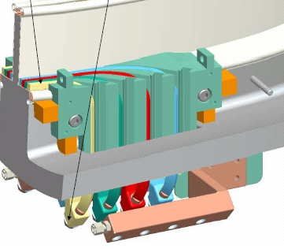
Position leads in lower lead guide block and into copper jumpers
The Kapton/glass lead insulation shall be applied between points A and B on each conductor
A
B
Figure 22- Positioning leads

General Winding Notes:
Once the first set of coil leads have been positioned and secured, the winding operation can begin.

Using the foot control start the rotation of the turning fixture in the direction that the coil is to be wound. [Determined by coil drawings and guidance of field supervisor] The speed of the turning fixture shall be decided by the Field Supervisor and lead technician as required to suit the coil manufacturing operation.

During the winding process, the pre-insulated copper rope conductors will be scanned with an electrical short indicator [“Whisker Detector”] that will identify any copper fibers that may protrude from the insulation causing turn to turn or turn to ground shorts. [Figure 23-Schematic of Turn Insulation Tester] If a copper whisker is detected, the whisker will be removed and one strip of adhesive backed Kapton tape will be wrapped around the conductor at the point where the whisker was detected prior to proceeding.
The unit shall be tested prior to starting the initial winding operation on either side of the winding form.
Copper plate
Grounded copper plates or rollers
4- Insulated conductors
Figure 23-Schematic of Turn Insulation Tester

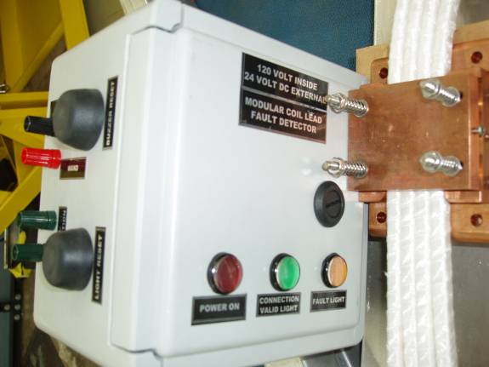
Conductor “Whisker” detector copper shell
“Whisker” detector control unit
Figure 24-"Whisker detector"

Re-install the winding clamp side bars as part of the winding of the first layer of turns.

Wind the 4-in-hand conductors onto the MCWF until the first several coil clamps have been cleared. Stop the winder at that point.

During the winding process, as a general rule, remove the minimal number of winding clamps necessary to allow sufficient space for the conductors to be wound onto the winding form.

Tightening the upper coil clamps to 30 in-lbs and tightening the side bars until snug against the shim washers shall be repeated whenever clamps are replaced after adding another layer of conductor in a given area.

During the winding operations as the turns are laid onto the winding form, gently tap the turns with a G-10 setting tool and soft face hammer. This operation will set the turns in place and help minimize keystoning of the conductor.

Ensure that the Kapton strips that were installed in section 6.10 to hold the lacing strips in position are removed prior to being trapped by layers of conductor during winding.

Metrology Measurements/Tolerance Control:

During the winding operations, additional measurements may be required to verify the precise vertical and radial builds of the turns. The location and frequency of measurements will be determined by the NCSX Metrology Engineering and the Dimensional Control Coordinator.

Procedure D-NCSX-MCF-005 describes the use of the “Romer” measuring arm and the steps required to perform measurements. All data collected [in summary form] will be added to Section 9 of the Coil Field Package titled “Metrology Data”.).

To maintain tolerance control the use of “Lacing” bands and predetermined criteria described in 6.15.6 for tightening the winding clamps will be used.

Winding Operation- Side “A”

Wind layer number 1
Note all observations, abnormalities or measurements that were taken. All measurement data shall be added to Section 9 of the Coil Field Package titled “Metrology Data”.

Notes:

Completion of Layer 1

Verified by: _________________________ Date: __________________
Lead Technician

Wind layer number 2
Note all observations, abnormalities or measurements that were taken. All measurement data shall be added to Section 9 of the Coil Field Package titled “Metrology Data”.

Notes:

Completion of Layer 2

Verified by: _________________________ Date: __________________
Lead Technician

Wind layer number 3
Note all observations, abnormalities or measurements that were taken. All measurement data shall be added to Section 9 of the Coil Field Package titled “Metrology Data”.

Notes:

Completion of Layer 3

Verified by: _________________________ Date: __________________
Lead Technician

Wind layer number 4
Note all observations, abnormalities or measurements that were taken. All measurement data shall be added to Section 9 of the Coil Field Package titled “Metrology Data”.

Notes:

Completion of Layer 4

Verified by: _________________________ Date: __________________
Lead Technician

Wind layer number 5
Note all observations, abnormalities or measurements that were taken. All measurement data shall be added to Section 9 of the Coil Field Package titled “Metrology Data”.

Notes:

Completion of Layer 5

Verified by: _________________________ Date: __________________
Lead Technician

Wind layer number 6
Note all observations, abnormalities or measurements that were taken. All measurement data shall be added to Section 9 of the Coil Field Package titled “Metrology Data”.

Notes:

Completion of Layer 6

Verified by: _________________________ Date: __________________
Lead Technician

Wind layer number 7
Note all observations, abnormalities or measurements that were taken. All measurement data shall be added to Section 9 of the Coil Field Package titled “Metrology Data”.

Notes:

Completion of Layer 7

Verified by: _________________________ Date: __________________
Lead Technician

Wind layer number 8
Note all observations, abnormalities or measurements that were taken. All measurement data shall be added to Section 9 of the Coil Field Package titled “Metrology Data”.

Notes:

Completion of Layer 8

Verified by: _________________________ Date: __________________
Lead Technician

Wind layer number 9
Note all observations, abnormalities or measurements that were taken. All measurement data shall be added to Section 9 of the Coil Field Package titled “Metrology Data”.

Notes:

Completion of Layer 9

Verified by: _________________________ Date: __________________
Lead Technician

Wind layer number 10 [Note: Maximum turns in Type C and TRC coils]
Note all observations, abnormalities or measurements that were taken. All measurement data shall be added to Section 9 of the Coil Field Package titled “Metrology Data”.

Notes:

Completion of Layer 10

Verified by: _________________________ Date: __________________
Lead Technician

Wind layer number 11 [Note: Maximum turns in Type A and B coils]
Note all observations, abnormalities or measurements that were taken. All measurement data shall be added to Section 9 of the Coil Field Package titled “Metrology Data”.

Notes:

Completion of Layer 11

Verified by: _________________________ Date: __________________
Lead Technician

Upper Side “A” Leads

The upper side “A” leads cannot be finalized at this time.

Measure and determine the length of conductor that is required to complete the final coil leads. Add several additional inches to the required length.

Tape the end of the conductor at cut line so that the conductor rope does not unravel. Cut the four conductors.

Secure the four conductors to the side “A” bundle. Insert the leads into plastic sleeves to protect the conductor insulation until ready for final positioning and brazing. Suspend and tie leads to coil bundle. These leads will be finalized once the side “B” bundle has been completed.

Side “A” is now secured, and work can begin on the side “B” bundle.

Verified:

Lead Technician: ____________________________ Date: ____________________

Field Supervisor: ____________________________ Date: ____________________

Preparation for Winding Side “B”

Reposition modular coil in turning fixture
Once the turns on side “A” of the Modular Coil have been wound, using lift procedure D-L-NCSX-984 the coil needs to be repositioned to enable the side “B” turns to be wound.

Note: To minimize potential dirt or contaminant risk, during the MCWF installation operation, if a coil is being wound in the adjacent station, the rooms must be isolated from each other.

Install the upper support plates that secure the support ring to the support/lift beam. This operation must be verified prior to proceeding. See Figure 3- Upper Support Plates

Verified by: _________________________ Date: __________________
Lead Technician

- SAFETY NOTE: Use scaffolding or appropriate ladders while working on upper section of turning fixture. Scaffolding must be inspected prior to use per Section 9 Chapter 5 in PPPL ES&H Manual.

Using the lift procedure data sheet rig the upper support/lift beam to the overhead crane.

  - Once a slight load has been taken, remove the hardware that secures the upper support/lift beam to the turning fixture frame.

  - Compress the springs under the gear box (drive system) until they are bottomed.

  - Disengage and remove the upper guide rollers. NOTE: Sling the rollers and raise them into position with rope. Do not climb up ladder with roller assembly in hand.

  - Carefully reposition the modular coil in the turning fixture to allow winding of pancake “B” via the ceiling hatch.

Verified by: _________________________ Date: __________________
Field Supervisor

  - Lower the MCWF and ring assembly into the turning fixture using the corner brackets for alignment. Bolt up one end loosely (use spud wrenches to align holes).

- SAFETY NOTE: Use scaffolding or appropriate ladders while working on upper section of turning fixture. Scaffolding must be inspected prior to use per Section 9 Chapter 5 in PPPL ES&H Manual.

  - Install the upper guide rollers and align all of the guide rollers to the support ring. NOTE: Sling the rollers and raise them into position with rope. Do not climb up ladder with roller assembly in hand.

  - Decompress springs under the gear box (drive unit) until gear is fully engaged with ring gear rack. This must be verified prior to proceeding.

Verified by: _________________________ Date: __________________
Lead Technician

- Verify that the upper support/lift beam is in proper position and secured with appropriate hardware that is torqued to the proper value. [See section 4.3]

Verified by: _________________________ Date: __________________
Lead Technician

- Remove the upper support plates between the support-ring and lift beam. This operation must be verified prior to operating turning fixture. [See Figure 3- Upper Support Plates]

Verified by: _________________________ Date: __________________
Lead Technician

  - To ensure proper alignment and operation of the turning fixture, rotate the MCWF a full two revolutions in either direction, using the foot-pedal control. Re-adjust the alignment rollers as required. Alignment of MCWF to the turning fixture is complete.

Verified by: _________________________ Date: __________________
Lead Technician

DELETE: Inspect Cladding

Conductor Payout Spool:
Load (4) spools of copper conductor into the conductor payout spool fixture. Position the spools in the fixture with the upper spools (1 and 2) being fed from the bottom side and lower spools (3 & 4) being fed from the topside (See Figure 1- Orientation of Copper spools)
[Note: the cable lead connectors may be brazed onto the conductors prior to installing the copper spools per section 6.3]

Positioning of lower leads for side “B” winding

Feed sufficient copper from each of the (4) conductor spools located on the payout spool fixture until they reach the MCWF. Note: the conductor shall be fully supported between the payout spool and the winding form.

Measure the conductor cross-sectional dimensions with Vernier calipers using light pressure. Record the measured data in space below.
#3
Width (Inches)
Septum
#2
Height
(Inches)
#4
#1

Figure 25- Conduction Identification

Table 2 -Measured conductor cross-section- Side B:
Conductor Number | #1 | #2 | #3 | #4
Width (Inches):
Height (Inches):

Brazing Side “B” Lower Lead Connectors:
The cable lead connectors will be brazed to the cable conductor using flameless “Nibco” resistive heating carbon tongs and Sil-Fos braze material. Only braze qualified individuals [per BPS-008] can perform the lead brazes and requirements of ES&HD 5008, Section 9, Chapter 15 for safe brazing must be followed.

Area preparation: Protect the surrounding coil area from any dirt or carbon that may occur as a result of the brazing operation. The area between clean rooms MUST be isolated if a coil is in the adjacent room. The ceiling hatch should be open during the brazing operations.

Notify the ESU and obtain a flame permit prior to starting brazing operation.

Verified by: _________________________ Date: __________________
Lead Technician

Copper Cable Connector: Clean the copper cable connector [Figure 11- Cable Connector] using acetone-degreasing agent Scotchbrite, and clean lint free wipes. Use a wire bottlebrush on the inner bore along with the acetone. Once cleaned, do not touch the components with bare hands. Coat the threads of the cable connector and 0.25 inch from end of connector with “Nicrobraz” [Figure 18- Carbon Tong Positioning & Sil-Fos Feed. This coating will minimize the braze material from adhering to the external surfaces. Do not get any of the “Nicrobraz” inside of the connector since this will effect the quality of the braze joint.

Conductor Preparation Step 1: Reshape the copper rope conductor using phenolic form blocks to provide a proper fit between the cable and cable connector. The nylon “serve” and turn insulation shall remain in place during the rounding operation. See Figure 12- Connector w/Phenolic Blocks and Figure 13-Conductor in Forming Block.

Conductor Preparation Step 2: Once formed, carefully remove the Nylon serve (covering) from the very end of the (approx. ¼ inch) conductor. [Figure 14- Removing Nylon Serve from Conductor] Measure the depth of the cable connector and transfer that measurement to the outside of the conductor serve.

Conductor Preparation Step 3: Carefully slide the end of the conductor into the connector. Once the conductor is engaged with the connector, carefully remove additional Nylon serve (covering) so that the bare conductor can be fully inserted into the inner connector bore. Use the measurement marking that is on the nylon serve from the step 6.12.5. Continue sliding the conductor into the connector, until it bottoms out. See Figure 15- Conductor in Connector

Conductor Preparation Step 4: Strip back approximately 5.5 inches of the nylon serve starting at the copper cable connector.

Position the bare copper rope conductor into the water chill blocks and position the Argon gas-head directly over the copper connector. Chill plates should be positioned on the bare conductor to the edge of the insulation. [Figure 16- Basic Setup for Brazing Lead Connectors]

Set the toggle switch on the control unit to “B”. [Figure 17- Front Face- "Nibco" Braze Unit Control]

Position the carbon tongs 1/4 -3/8 inch from the conductor end of the copper connector [A]. [Figure 18- Carbon Tong Positioning & Sil-Fos Feed and Figure 19- Heating Copper Connector]

Move the center toggle switch down to LOW, and using the carbon tongs heat the copper connector. Once at temperature, feed the Sil-Fos rod first from the conductor side [B] [Figure 20- Feeding Sil-Fos Position B] using approximately 1/3 to 1/2 of a Sil-Fos rod. Then feed through the feedhole at the threaded end of the connector [C] [Figure 21- Feeding Sil-Fos Position C] using 1/2 to 2/3 of a Sil-Fos rod.

Repeat the process with each of the copper cable connectors.

Clean the braze area, removing any excess Sil-Fos. Remove the remaining Nicrobraz from the surfaces. Do not use wire brush for cleanup. If a file is used, ensure that any file marks are buffed out using fine sandpaper to ensure smooth surface.

A QC welding inspector shall inspect each brazed lead connector following cleanup. If a lead connector braze is rejected, the connector must be removed and the connector braze remade.

Silver plate the copper lugs following inspection and prior to assembly. Inspect for any high ribs that may become more evident following silver-plating. Dress up connector if needed and re-silver-plate.

Lower CABLE CONNECTOR #1 Pancake “B”:

Date Brazed: ______________________ Braze performed by: _____________

QC Inspected by: ______________________ Date: ___________________

Notes:

Lower CABLE CONNECTOR #2 Pancake “B”:

Date Brazed: ______________________ Braze performed by: _____________

QC Inspected by: ______________________ Date: ___________________

Notes:

Lower CABLE CONNECTOR #3 Pancake “B”:

Date Brazed: ______________________ Braze performed by: _____________

QC Inspected by: ______________________ Date: ___________________

Notes:

Lower CABLE CONNECTOR #4 Pancake “B”:

Date Brazed: ______________________ Braze performed by: _____________

QC Inspected by: ______________________ Date: ___________________

Notes:

Fitup of Leads- Side “B”

Carefully route the connector end of the conductors through the lower side “B” lead block and into the copper jumpers. Pre-form the conductors during the fitup to conform to the lead block. Carefully remove the formed conductors.

Insulating Side “B” Lower Leads
Once the connectors have been brazed and leads pre-fit, the leads need to be insulated.

Apply by hand (1) half-lapped layer of composite insulation [0.007 in. thick glass tape/ 0.0065(HN) Kapton tape w/ adhesive back] over each of the individual conductors starting from the point that the conductors separate to the conductor connectors. [Figure 22- Positioning leads

Re-position the first layer of (4) conductors into the conductor slots in the lower lead guide block. The conductors shall be placed in alternating slots. Care must be taken during this operation, to minimize any damage to the over wrap insulation. Position the conductors into the copper jumpers. Secure the connectors in-place but do not torque at this time. [Figure 22- Positioning leads]

Verified:

Lead Technician: ____________________________ Date: ____________________

Field Supervisor: ____________________________ Date: ____________________

General Winding Notes:
See section 6.15 for “General Winding Notes”.

Winding Operation Side “B”

Wind layer number 1
Note all observations, abnormalities or measurements that were taken. All measurement data shall be added to Section 9 of the Coil Field Package titled “Metrology Data”.

Notes:

Completion of Layer 1

Verified by: _________________________ Date: __________________
Lead Technician

Wind layer number 2
Note all observations, abnormalities or measurements that were taken. All measurement data shall be added to Section 9 of the Coil Field Package titled “Metrology Data”.

Notes:

Completion of Layer 2

Verified by: _________________________ Date: __________________
Lead Technician

Wind layer number 3
Note all observations, abnormalities or measurements that were taken. All measurement data shall be added to Section 9 of the Coil Field Package titled “Metrology Data”.

Notes:

Completion of Layer 3

Verified by: _________________________ Date: __________________
Lead Technician

Wind layer number 4
Note all observations, abnormalities or measurements that were taken. All measurement data shall be added to Section 9 of the Coil Field Package titled “Metrology Data”.

Notes:

Completion of Layer 4

Verified by: _________________________ Date: __________________
Lead Technician

Wind layer number 5
Note all observations, abnormalities or measurements that were taken. All measurement data shall be added to Section 9 of the Coil Field Package titled “Metrology Data”.

Notes:

Completion of Layer 5

Verified by: _________________________ Date: __________________
Lead Technician

Wind layer number 6
Note all observations, abnormalities or measurements that were taken. All measurement data shall be added to Section 9 of the Coil Field Package titled “Metrology Data”.

Notes:

Completion of Layer 6

Verified by: _________________________ Date: __________________
Lead Technician

Wind layer number 7
Note all observations, abnormalities or measurements that were taken. All measurement data shall be added to Section 9 of the Coil Field Package titled “Metrology Data”.

Notes:

Completion of Layer 7

Verified by: _________________________ Date: __________________
Lead Technician

Wind layer number 8
Note all observations, abnormalities or measurements that were taken. All measurement data shall be added to Section 9 of the Coil Field Package titled “Metrology Data”.

Notes:

Completion of Layer 8

Verified by: _________________________ Date: __________________
Lead Technician

Wind layer number 9
Note all observations, abnormalities or measurements that were taken. All measurement data shall be added to Section 9 of the Coil Field Package titled “Metrology Data”.

Notes:

Completion of Layer 9

Verified by: _________________________ Date: __________________
Lead Technician

Wind layer number 10 [Note: Maximum turns in Type C and TRC coils]
Note all observations, abnormalities or measurements that were taken. All measurement data shall be added to Section 9 of the Coil Field Package titled “Metrology Data”.

Notes:

Completion of Layer 10

Verified by: _________________________ Date: __________________
Lead Technician

Wind layer number 11 [Note: Maximum turns in Type A and B coils]
Note all observations, abnormalities or measurements that were taken. All measurement data shall be added to Section 9 of the Coil Field Package titled “Metrology Data”.

Notes:

Completion of Layer 11

Verified by: _________________________ Date: __________________
Lead Technician

Upper Side “B” Leads

The upper side “B” leads cannot be finalized at this time.

Measure and determine the length of conductor that is required to complete the final coil leads and add several additional inches.

Tape the end of the conductor at cut line so that the conductor rope does not unravel. Cut the four conductors.

Secure the four conductors to the side “B” bundle. Insert the leads into plastic sleeves to protect the conductor insulation until ready for final positioning and brazing. Suspend and tie leads to coil bundle. These leads will be finalized once the bundles have been dimensionally set, lacing locked in position, groundwrap completed and chill plates installed.

Side “B” is now secured, and work can begin on dimensionally positioning bundles.

Verified:

Lead Technician: ____________________________ Date: ____________________

Field Supervisor: ____________________________ Date: ____________________

Winding Pack Adjustments

Using the Romer measuring arm and procedure D-NCSX-MCF-005, measure the top and side walls of the coil bundle on sides A and B. Oversight of these activities is the responsibility of the Metrology Engineer and Dimensional Control Coordinator.

The metrology engineer will provide data to the coil team for making adjustments to the winding packs to adjust coil current centers. Additional measurements may be required as identified by the metrology engineer. Oversight of these activities is the responsibility of the Metrology Engineer and Dimensional Control Coordinator.

Final position of the Side “A” and side “B” current centers are approved. Include final data in coil book section 9.0.

Side “A” and side “B” adjustments are complete and verified by:

Metrology Engineer: ____________________________ Date: ____________________

Dimensional Control Coordinator: __________________________Date: _____________

Once winding packs have been adjusted [tensioning tool may be used], lock the turns into position by securing lacing bands using 3M High Performance Adhesive Transfer Tape [Product no. 3M9485PC]. Only apply the adhesive tape along upper half of the overlapping bands. Acceptance Criteria: Bands shall be snug to the bundle.

DELETE: final measurement after lacing

Using Hysol 3561/2039, carefully paint the outside lower surface of the overlapping lacing bands in the area that is not secured with the adhesive tape. Special attention shall be made not to get any Hysol epoxy on the adjacent turn insulation.

All adjustments of the winding packs are complete and ready for Groundwrap insulation.

Side “A” complete and verified by:

Metrology Engineer: ____________________________ Date: ____________________

Side “B” complete and verified by:

Metrology Engineer: ____________________________ Date: ____________________

Completion of Groundwrap Installation

Complete the outer groundwrap insulation on both coil bundles A & B. Overlap the individual layers of Groundwrap and secure in position with adhesive back Kapton tape. Remove the minimum number of clamps needed to complete a section of the ground wrap. [Figure 26- Groundwrap Overlap Scheme]

The ground wrapping of the “A” and “B” pancakes has been satisfactorily completed.

Side “A” Complete and Verified:
Lead Technician: ____________________________ Date: ____________________

Field Supervisor: ____________________________ Date: ____________________

Side “B” Complete and Verified:

Lead Technician: ____________________________ Date: ____________________

Field Supervisor: ____________________________ Date: ____________________

Ground Wrap Notes:

Layer 3
Layer 2
1 inch overlap typ. every layer
3.5 in.
1.5 in.
2.5 in.
Layer 1
Figure 26- Groundwrap Overlap Scheme

General Procedure- Outer Chill Plate/Cooling Tube Assembly:

Chill Plate Preparation:

Select the outer chill plates that are being used for the coil type being manufactured. The outer chill plates shall be de-burred prior to use. Clean the copper plates with ethanol and clean lint free cotton cloths. EXTREME CARE must be taken during handling of the cladding because of the sharp edges. It is recommended that Kevlar gloves be worn while handling the chill plates during the deburring operations.

General Chill Plate Installation Notes:

During the fitup and installation of the chill plates, remove the minimum number of winding clamps to perform the installation activities.

Fitup each copper chill plate to the outer ground wrap wall of the modular coil using the chill plate mapping drawings for guidance. Customizing of each copper chill plate will be required. Chill plates must be formed in place for proper fitup. Ensure that there are no sharp edges or burrs as a result of the customizing activities. Reclean if necessary.

Identify the location where the epoxy feed sprues will be positioned on the coil bundle. The chill plates in those positions will need to be pre-punched with a ¾ inch diameter hole prior to installation on the coil bundle.

The chill plates typically interface with the inner copper cladding at points A and B identified on Figure 28- Outer Chill Plates.

Once a chill plate is in position, CAREFULLY peen over the cladding tabs at points A and B using a ball peen hammer and G-10 block. Then stake the cladding and chill plate together using a staking tool. [This tool controls the depth of the stake, so that it does not break through the insulation on the back side of the cladding.] [Figure 27- Staking Chill Plates]

Note: Extreme care must be taken to ensure that during the staking process occurs over the septum at point A or above the VPI groove at point B. This is necessary to ensure that the coil bundle is not damaged and that the Kapton on the back side of the cladding is not punctured.

During the installation of the chill plates, continue to verify that the chill plates are electrically isolated and are not forming a loop using a multi-meter. Ensure that the chill plates are not touching the winding clamps on top of the septum.

Equipment Name & ID Number: _____________________ Calibration Date: ___________

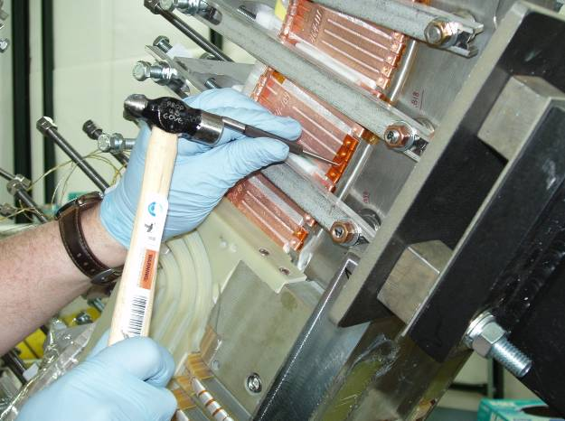

Figure 27- Staking Chill Plates

Point B- Stake cladding to chill plate
Point A- Stake cladding to chill plate
Solder cooling tubes to chill plates
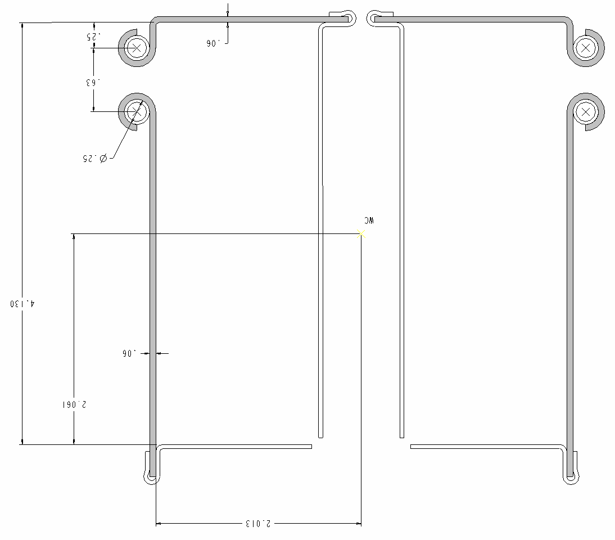
Figure 28- Outer Chill Plates

General Cooling Tube to Chill Plate Assembly Steps:

The pre-tinned copper cooling tubes need to be installed after the chill plates have been secured to the cladding.

Using the appropriate cooling tube routing drawing, identify the locations where the cooling tubes will exit the coil bundle.

Using acetone-degreasing agent Scotchbrite and clean lint free cotton cloths clean the entire cooling tube. Once cleaned, do not touch the cooling tube with bare hands.

Position the tubing, and carefully begin mating the cooling tube with the chill plates, loosely hand forming the chill plate fingers over the tube.

Once the tube has been positioned, secure the chill plate fingers around the cooling tube with the G-10 tube setting block and light weight hammer. Position the setting tool block over the formed chill plate finger/cooling tube and gently tap until the copper fingers are secure around the cooling tube. [Note: The fingers may be formed manually with duck billed pliers.] Repeat process for every interfacing finger. [Figure 29- Setting Chill Plate and Tubing]

General Cooling Tube to Chill Plate Soldering Steps:
The cooling tubes will be soldered to the chill plates using flameless “Nibco” resistive heating carbon tongs and Rosin core Tin/Antimony solder (95%/5%) material. Requirements of ES&HD 5008, Section 9, Chapter 15 for safe brazing/soldering must be followed.

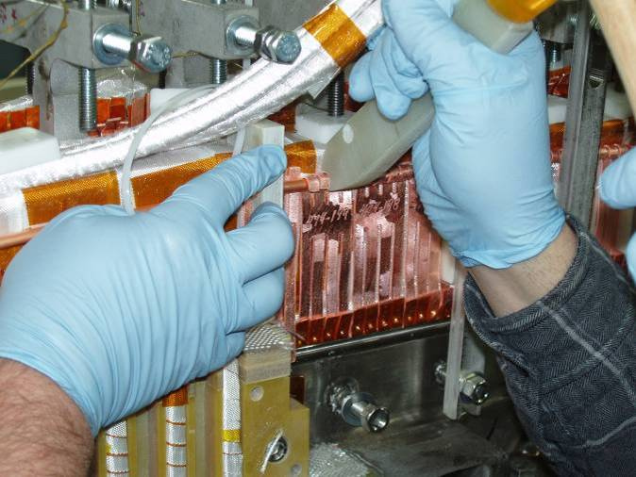
Figure 29- Setting Chill Plate and Tubing

Notify the ESU and obtain a flame permit prior to starting soldering operation.

Date Soldered: ________ Obtain Flame Permit: _______ Solder performed by: _____________

Date Soldered: ________ Obtain Flame Permit: _______ Solder performed by: _____________

Date Soldered: ________ Obtain Flame Permit: _______ Solder performed by: _____________

Date Soldered: ________ Obtain Flame Permit: _______ Solder performed by: _____________

Date Soldered: ________ Obtain Flame Permit: _______ Solder performed by: _____________

Date Soldered: ________ Obtain Flame Permit: _______ Solder performed by: _____________

Area preparation: Protect the surrounding coil area from any dirt or carbon that may occur as a result of the soldering operation. The area between clean rooms MUST be isolated if a coil is in the adjacent room. The ceiling hatch should be open during the soldering operations.

Position a metal sheet protector between the chill plate and ground wall insulation. This will protect the insulation from heat damage during soldering.

Place the carbon tongs onto the formed chill plate fingers. [Figure 31- Soldering Cooling Tube (photos a & b)]

Set the toggle switches on the control unit to “A” and “C”. [Figure 30- Front Face- "Nibco Soldering Unit Control]

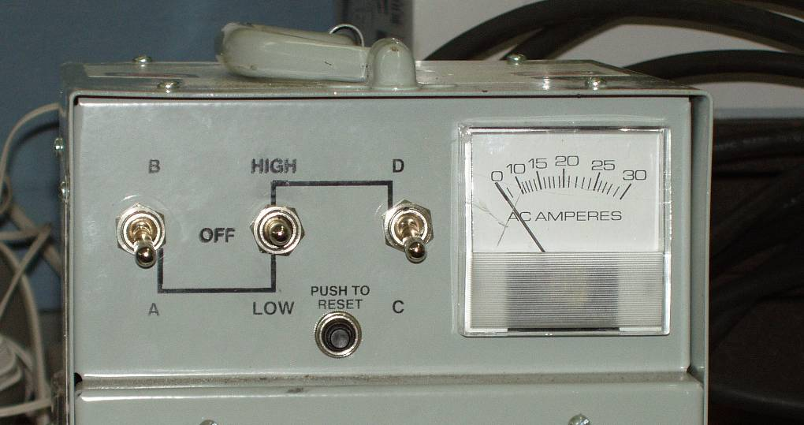
Figure 30- Front Face- "Nibco Soldering Unit Control

Place the center toggle switch to “LOW”, and using the carbon tongs heat the chill plate/cooling tube assembly. Once at temperature, feed the rosin core solder between the tube and copper fingers. [See Figure 31- Soldering Cooling Tube (photos a & b)]

Clean the solder area, removing any excess solder and flux. Use a stainless steel wire brush, and vacuum cleaner, then wipe with ethanol dampened lint free clean cloth. [Figure 32- Cleaning of Soldered Chill Plates]

Repeat the process with each of the chill plate interfaces.

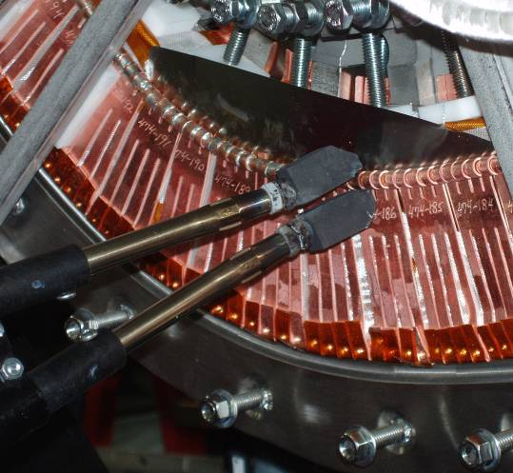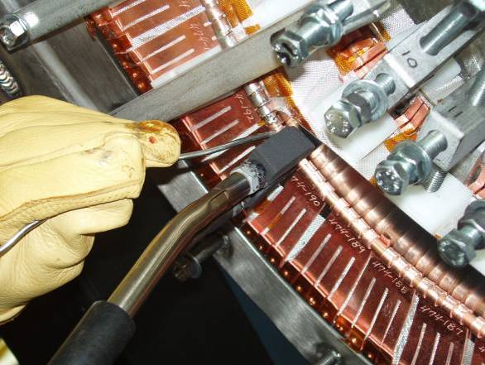
Figure 31- Soldering Cooling Tube (photos a & b)

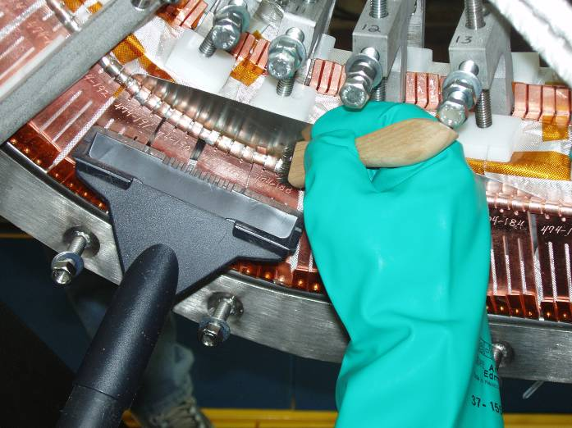
Figure 32- Cleaning of Soldered Chill Plates

Chill Plate Installation:

Install the modified upper and lower chill plates and cooling tubes in the lead area on both sides “A” and “B”. Fitup and trimming of components will be required. Use approved NCSX assembly drawings. See Figure 33- Chill Plates in Lead Area

Continue installing the balance of the chill plates and cooling tubes per section 6.29.2 and 6.29.3. [Figure 34- Outer Chill Plates]

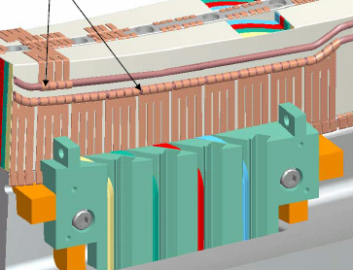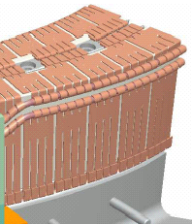
Outer Chill Plates
Lead Area Chill plates
Figure 33- Chill Plates in Lead Area
Figure 34- Outer Chill Plates

Cooling Tube Pressure Tests:
Prior to soldering, the chill plate cooling tubes will be helium leak tested to verify the integrity of the cooling tubes. See Figure 35- Chill Plate Assembly Identification for identification of assemblies.

Place compression fittings on each end of the coolant tubes.

Using engineering procedure ENG-014 (Guidelines for Hydrostatic and Pneumatic Testing) test the individual cooling tubes.

Pressurize the coolant tubes with helium to 200 psi and isolate from the pressure source.

All safety precautions including the use of PPE’s shall be followed as outlined in the Job Hazard Analysis sheet and recommendations made by the PPPL Industrial Hygienist.

Gauges shall have a minimum 5-psi graduation.

Verified by: _________________________________ Date: __________________
Quality Control Representative

Acceptance criteria: The test pressure shall be maintained without any detectable drop in pressure within the resolution of the gauge for at least ten minutes from the time the system was isolated from the pressure source, during which time there shall be no change in the pressure reading on the calibrated pressure gauge.

Record test data in the table below [Table 3-Cooling Tube Flow Results]

Flow Check:
Flow nitrogen or air through each flow package to verify that there are no blockages.

Record test data in the table below [Table 3-Cooling Tube Flow Results]

Table 3-Cooling Tube Flow Results
Tube designation | Flow Path Blockage check | Pressure Leak check | Electrical test, tube to ground
Side A Zone 1 Inner
Side A Zone 1 Outer
Side A Zone 2 Inner
Side A Zone 2 Outer
Side A Zone 3 Inner
Side A Zone 3 Outer
Side B Zone 1 Inner
Side B Zone 1 Outer
Side B Zone 2 Inner
Side B Zone 2 Outer
Side B Zone 3 Inner
Side B Zone 3 Outer

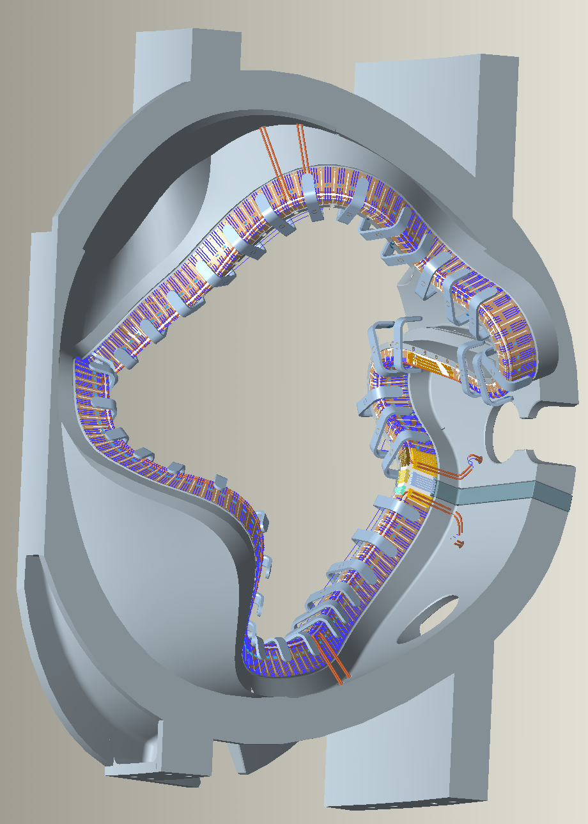
Inner Cladding Assembly
Outer Cladding Assembly
ZONE 1
ZONE 3
ZONE 2

Figure 35- Chill Plate Assembly Identification

Cooling Tube Electrical Test:

Verify that cooling tubes are not grounded and electrically isolated to modular coil winding form using a multi-meter.

Equipment Name & ID Number: ___________________ Calibration Date: ___________

Record test data in the table below [Table 3-Cooling Tube Flow Results]. See Figure 35- Chill Plate Assembly Identification for identification of assemblies.

Cooling Tube inspections/tests are completed and verified by:

Lead Technician: ____________________________ Date: ____________________

Field Supervisor: ____________________________ Date: ____________________

Quality Control: _____________________________ Date: ____________________

Once all of the chill plates and cooling tubes have been fitup and secured in position. Solder the cooling tubes to the chill plates per section 6.29.4.

Notes:

Cooling Tubes have been soldered and inspections are completed and verified by:

Lead Technician: ____________________________ Date: ____________________

Field Supervisor: ____________________________ Date: ____________________

Quality Control: _____________________________ Date: ____________________

Installation of Diagnostic Loops

Diagnostic flux loops are to be positioned on the outside surface of the chill plates, just above the upper cooling tube as identified in Figure 36-Diagnostic Loops. Actual position will be determined by NCSX drawings and the Diagnostic representative.

Notify the Diagnostic representative that the installation of the flux loops is ready to begin. Diagnostic group shall provide flux loops.

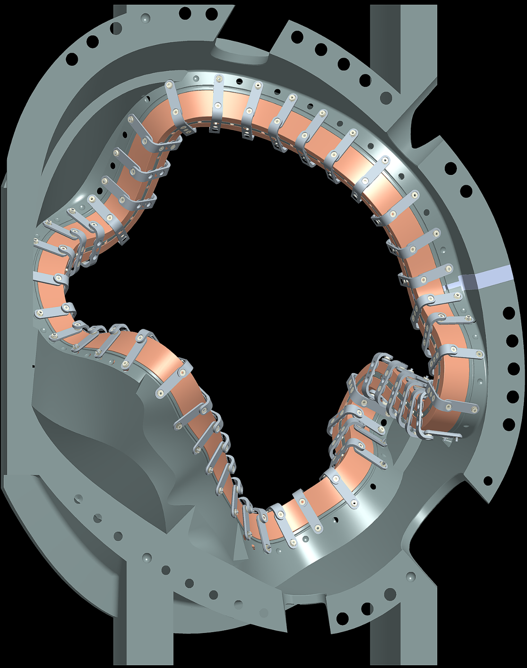
Verified by: _________________________ Date: __________________
Lead Technician

Carefully position the flux loop per direction of Diagnostic representative and initially secure in place with 3M adhesive cement #CA40H. Then follow-up with a small quantity of RTV108 adhesive located every 2 to 3 inches.

Route the Flux loop leads through the lead area and exit the coil in a groove in the upper G-11 lead blocks. The flux loops need to be twisted starting at the point where they join and continue as they run though the lead area (2 inch pitch).

Once the Flux loops are positioned, measure their position using the “Romer” measuring arm and attach data to procedure. Provide data to the Diagnostic representative.

Notes:

Flux Loop Locations- on top of chill plates

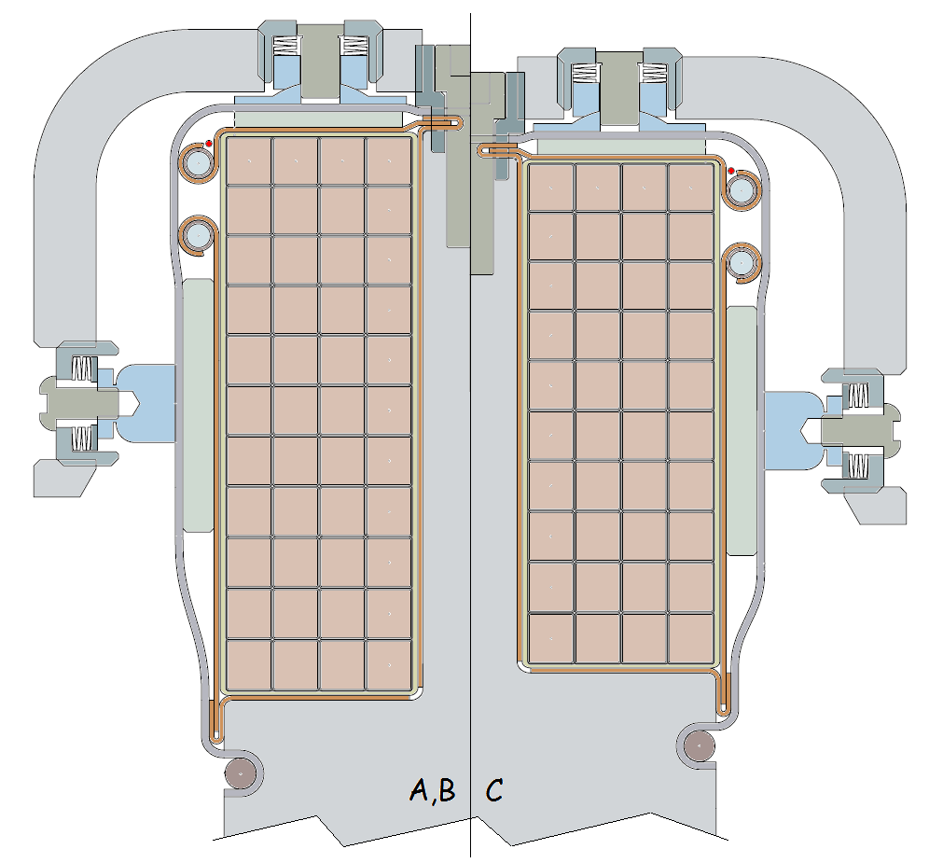
Figure 36-Diagnostic Loops

Installation of Flux Loops complete-Verified:

Lead Technician: ____________________________ Date: ____________________

Diagnostic Representative: ____________________________ Date: ____________________

Final Positioning of Upper Leads sides “A” and “B”

Mount the upper lead winding blocks to the MCWF for both sides “A” and “B” and secure in position with appropriate hardware. [Figure 37- Upper Lead Winding Block] Install glass cloth between G-11 fillers and fill all voids with glass tape or roving.

A field supervisor will inspect the lead areas on both sides “A and “B” and determine whether additional Kapton and/or glass insulation needs to be installed.

Complete:
Verified by: _________________________ Date: __________________
Field Supervisor

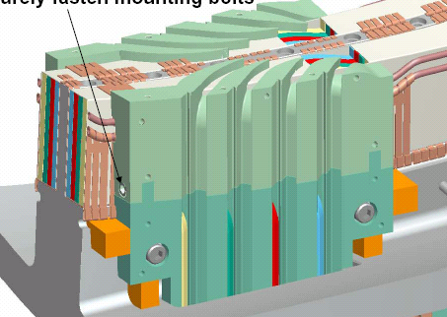
Upper Lead Winding Block
Figure 37- Upper Lead Winding Block

Upper Lead Winding Blocks are installed on sides “A” and “B”.

Complete:
Verified by: _________________________ Date: __________________
Lead Technician

Pre-determine the length of conductor that will become the coil leads for both sides “A” and “B” and make final cut. Tape the end of the conductor at cut line so that the conductor rope does not unravel. Cut the four conductors.

Brazing Side “A” and “B” Upper Leads:
The lead cable connectors will be attached using a flameless “Nibco” resistive heating carbon tongs and Sil-Fos braze material. Only braze qualified individuals [Per BPS-008] can perform the lead brazes and requirements of ES&HD 5008, Section 9, Chapter 15 for safe brazing must be followed.

Area preparation: Protect the surrounding coil area from any dirt or carbon that may occur as a result of the brazing operation. The area between clean rooms MUST be isolated if a coil is in the adjacent room. The ceiling hatch should be open during the brazing operations.

Notify the ESU and obtain a flame permit prior to starting brazing operation.

Verified by: _________________________ Date: __________________
Lead Technician

Copper Cable Connector: Clean the copper cable connector [Figure 11- Cable Connector] using acetone-degreasing agent Scotchbrite, and clean lint free wipes. Use a wire bottlebrush on the inner bore along with the acetone. Once cleaned, do not touch the components with bare hands. Coat the threads of the cable connector and 0.25 inch from end of connector with “Nicrobraz” [Figure 18- Carbon Tong Positioning & Sil-Fos Feed. This coating will minimize the braze material from adhering to the external surfaces. Do not get any of the “Nicrobraz” inside of the connector since this will effect the quality of the braze joint.

Conductor Preparation Step 1: Reshape the copper rope conductor using phenolic form blocks to provide a proper fit between the cable and cable connector. The nylon “serve” and turn insulation shall remain in place during the rounding operation. See Figure 12- Connector w/Phenolic Blocks and Figure 13-Conductor in Forming Block

Conductor Preparation Step 2: Once formed, carefully remove the Nylon serve (covering) from the very end of the (approx. ¼ inch) conductor. [Figure 14- Removing Nylon Serve from Conductor] Measure the depth of the cable connector and transfer that measurement to the outside of the conductor serve.

Conductor Preparation Step 3: Carefully slide the end of the conductor into the connector. Once the conductor is engaged with the connector, carefully remove additional Nylon serve (covering) so that the bare conductor can be fully inserted into the inner connector bore. Use the measurement marking that is on the nylon serve from the step 6.36.5. Continue sliding the conductor into the connector, until it bottoms out. See Figure 15- Conductor in Connector

Conductor Preparation Step 4: Strip back approximately 5.5 inches of the nylon serve starting at the copper cable connector.

Position the bare copper rope conductor into the water chill blocks and position the Argon gas-head approximately 4 inches directly over the copper connector. Chill plates should be positioned on the bare conductor to the edge of the insulation. [Figure 16- Basic Setup for Brazing Lead Connectors]

Set the toggle switch on the control unit to “B”. [Figure 17- Front Face- "Nibco" Braze Unit Control]

Position the carbon tongs 1/4 -3/8 inch from the conductor end of the copper connector [A]. [Figure 18- Carbon Tong Positioning & Sil-Fos Feed and Figure 19- Heating Copper Connector ]

Move the center toggle switch down to LOW, and using the carbon tongs heat the copper connector. Once at temperature, feed the Sil-Fos rod first from the conductor side [B] [Figure 20- Feeding Sil-Fos Position B] using approximately 1/3 to 1/2 of a Sil-Fos rod. Then feed through the feedhole at the threaded end of the connector [C] [Figure 21- Feeding Sil-Fos Position C] using 1/2 to 2/3 of a Sil-Fos rod.

Repeat the process with each of the four inner copper cable connectors on sides “A” and “B”.

Clean the braze area, removing any excess Sil-Fos. Remove the remaining Nicrobraz from the surfaces. Do not use wire brush for cleanup. If a file is used, ensure that any file marks are buffed out using fine sandpaper to ensure smooth surface.

A QC welding inspector shall inspect each brazed lead connector following cleanup. If a lead connector braze is rejected, DO NOT cut off the connector. The field supervisor along with the weld engineer shall make a determination as to the corrective action.

Silver plate the copper lugs following inspection and prior to assembly. Inspect for any high ribs that may become more evident following silver-plating. Dress up connector if needed and re-silver-plate.

Repeat the process with each of the four inner copper cable connectors on sides “A” and “B”.

Upper CABLE CONNECTOR #1 Pancake “A”:

Date Brazed: ______________________ Braze performed by: _____________

QC Inspected by: ______________________ Date: ___________________

Notes:

Upper CABLE CONNECTOR #2 Pancake “A”:

Date Brazed: ______________________ Braze performed by: _____________

QC Inspected by: ______________________ Date: ___________________

Notes:

Upper CABLE CONNECTOR #3 Pancake “A”:

Date Brazed: ______________________ Braze performed by: _____________

QC Inspected by: ______________________ Date: ___________________

Notes:

Upper CABLE CONNECTOR #4 Pancake “A”:

Date Brazed: ______________________ Braze performed by: _____________

QC Inspected by: ______________________ Date: ___________________

Notes:

Upper CABLE CONNECTOR #1 Pancake “B”:

Date Brazed: ______________________ Braze performed by: _____________

QC Inspected by: ______________________ Date: ___________________

Notes:

Upper CABLE CONNECTOR #2 Pancake “B”:

Date Brazed: ______________________ Braze performed by: _____________

QC Inspected by: ______________________ Date: ___________________

Notes:

Upper CABLE CONNECTOR #3 Pancake “B”:

Date Brazed: ______________________ Braze performed by: _____________

QC Inspected by: ______________________ Date: ___________________

Notes:

Upper CABLE CONNECTOR #4 Pancake “B”:

Date Brazed: ______________________ Braze performed by: _____________

QC Inspected by: ______________________ Date: ___________________

Notes:

Fitup of Leads- Sides “A” and “B”

Carefully route the connector end of the conductors through the upper lead blocks. Pre-form the conductors during the fitup to conform to the lead block. Remove the formed conductors.

Insulate Upper Leads- Side “A” and “B”
Once the connectors have been brazed and leads prefit, the leads need to be insulated.

Apply by hand (1) half-lapped layer of composite insulation [0.004 in. thick glass tape/ 0.0065(HN) Kapton tape w/ adhesive back] over each of the individual conductors starting from the point that the conductors separate to 6 inches from the conductor end. [Figure 38- Upper Lead Blocks and Leads]

Position the last layer of conductors [4 each side] on sides “A” and “B” into the conductor slots in the upper lead guide block. Care must be taken during this operation, to minimize any damage to the over wrap insulation. [Figure 38- Upper Lead Blocks and Leads]

A
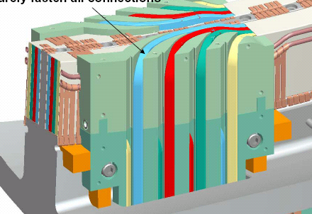
Upper conductor leads
The Kapton/glass lead insulation shall be applied between points A and B [below casting] on each conductor.
“B” At the terminals outside of the casting
Figure 38- Upper Lead Blocks and Leads

Coil Joint Assembly

Assemble all of the cable connectors to the terminal blocks per drawing SE142C-049.

[Figure 39- Typical Joint and Figure 40- Final Terminal Connections Identification]

During the initial assembly use a special spacer [provided by Field Supervisor] and nut.

Torque all of the connectors to 15 ft.-lbs.

During the torquing operation hold the stud in position using the slot on the threaded end of the connector and the modified screwdriver that snuggly fits the slot.

DO NOT use the wrench flats on the cable side of the connector.

Remove the nut and spacer and install the permanent hardware.

If the nose of the connector protrudes beyond the jumper, ensure that the ID of the washers is large enough to accommodate the protruding connector.

Measure the joint resistance between the connector and the terminal blocks [points A and B]. See Figure 39- Typical Joint [Acceptance criterion is < 1 micro-ohms.]

Note: If the joint resistance measures higher than the acceptance criteria loosen up joint, reseat the connector and re-torque to 15 ft-lbs. Several attempts may be required.

Record the joint resistance and torque verification in Table 4- Joint Data below.

Joint Preparations for soldering
- Peel back the turn insulation and nylon serve a minimum of 1 inch from the connector.
- Insert a thermocouple into the cable approximately 0.5 inch from the connector.
- Re-position the coil so that the conductor side of the lugs is facing up and the 3/32 inch diameter solder feed hole is on the side of the connector. Coil will have to be re-positioned several times to complete soldering of all connections.

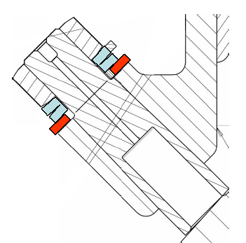
Flat Washer
Belleville Washers
SS Nut
A
B

Figure 39- Typical Joint

Side A
Side B
A-1
A-4
A-5
A-6
A-8
A-7
A-2
A-3
B-1
B-4
B-5
B-6
B-8
B-7
B-2
B-3

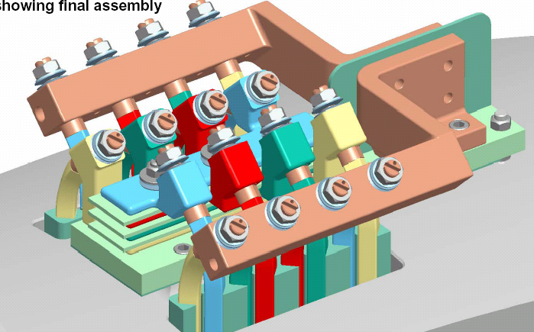
Figure 40- Final Terminal Connections Identification

Area preparation: Protect the surrounding coil area from any dirt or carbon that may occur as a result of the soldering operation. The area between clean rooms MUST be isolated if a coil is in the adjacent room. The ceiling hatch should be open during the soldering operations.

Notify the ESU and obtain a flame permit prior to starting soldering operation.

Verified by: _________________________ Date: __________________
Lead Technician

Table 4- Joint Data
Joint ID | Pre-solder  Joint Resistance  [μ-ohms] | Max. Temp. ºC | Post-solder Joint Resistance  [μ-ohms] | Torque Verify 15 ft-lb | Joint ID | Pre-solder  Joint Resistance  [μ-ohms] | Max. Temp. ºC | Post-solder Joint Resistance  [μ-ohms] | Torque Verify 15 ft-lb
A-1 |  |  |  |  | B-1
A-2 |  |  |  |  | B-2
A-3 |  |  |  |  | B-3
A-4 |  |  |  |  | B-4
A-5 |  |  |  |  | B-5
A-6 |  |  |  |  | B-6
A-7 |  |  |  |  | B-7
A-8 |  |  |  |  | B-8

Solder the joint connections.
- Set the toggle switch on the “Nibco” Braze Unit Control unit to “LOW”. [See Figure 41- Front Face "Nibco" Soldering Unit
- Position the carbon tongs on the copper jumper.
- Insert a thermocouple into the cable approximately ½” from the back of the connector.
- Turn the toggle switch on the “Nibco” Braze Unit to “B” to begin heating.
- Monitor the heat on the thermocouple and begin applying flux once the temperature reaches 80 to 100 ºC.
- At approximately 200°C the solder will begin melting when touching the conductor connector.
- Begin feeding the solder from the conductor end of the joint. [Point A] Figure 42- Soldering Connector
- Once solder starts flowing turn the power setting on the “Nibco” Braze Unit Control unit down to the “A” position to keep the temperature on the cable conductor as low as possible. [Goal: temperature should be < 250ºC]
- Begin filling the joint from the side feedhole with 95/5% [Tin /Antimony]. The solder should be centered in the hole so that it melts on the conductor connector and not the female jumper. Continue filling until the solder starts rising out of the fill hole. [Point B]
- Once filled shut down power unit and remove carbon tongs.
- Record maximum reached temperature in Table 5 - Solder Joint Data

Figure 41- Front Face "Nibco" Soldering Unit

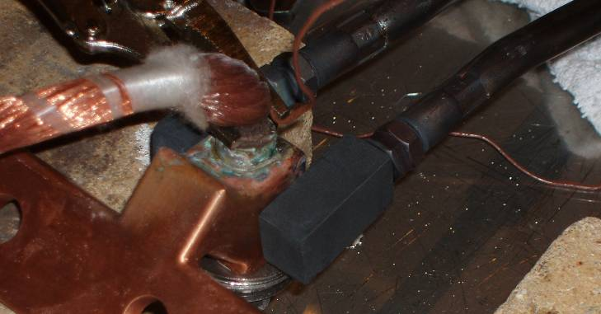
Figure 42- Soldering Connector

Point A
Point “B”- 3/32” Solder fill hole
Thermocouple location
0.5 inch

Figure 43- Soldering Figure

Repeat the process with each of the sixteen cable connector to terminal jumper connections.

Clean the solder area, removing any excess solder in the area of the feed-hole.

A QC welding inspector shall inspect each soldered joint following cleanup. If a lead joint is rejected, it will have to be re-soldered in place.

Table 5 - Solder Joint Data
Joint ID | Max. Temp. ºC | Soldered By: | Date Soldered | QC Inspected By: | Date Inspected:
A-1
A-2
A-3
A-4
A-5
A-6
A-7
A-8
B-1
B-2
B-3
B-4
B-5
B-6
B-7
B-8

Notes:

The lead installation activities have been completed.

Verified by:
Lead Technician: ____________________________ Date: ____________________

Field Supervisor: ____________________________ Date: ____________________

Quality Control: _____________________________ Date: ____________________

Notes:

Upper Lead Chill Plates
Flux loops- inside upper G-11 lead block
Flux loops- outside of lead blocks
Flux loops- twisted pair starting here
Flux loops- outside of lead blocks

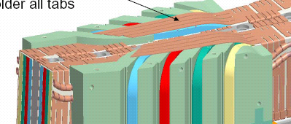
Figure 44-Upper Lead Area Chill Plates

Lead Area-Upper Chill Plates
Install the remaining upper chill plates on the top side of the lead area. Fitup and solder in place per section 6.32.2. [Figure 44-Upper Lead Area Chill Plates]

Installation of the Outer Chill Plates is complete and plates are electrically isolated:

Lead Technician: ____________________________ Date: ____________________

Field Supervisor: ____________________________ Date: ____________________

Quality Control: _____________________________ Date: ____________________

Cooling Tube Pressure Tests:
The chill plate cooling tubes will be helium leak tested to verify the integrity of the cooling tubes.

Place compression fittings on each end of the coolant tubes.

Using engineering procedure ENG-014 (Guidelines for Hydrostatic and Pneumatic Testing) test the individual cooling tubes.

Pressurize the coolant tubes with helium to 200 psi and isolate from the pressure source.

All safety precautions including the use of PPE’s shall be followed as outlined in the Job Hazard Analysis sheet and recommendations made by the PPPL Industrial Hygienist.

Gauges shall have a minimum 5-psi graduation.

Verified by: _________________________________ Date: __________________
Quality Control Representative

Acceptance criteria: The test pressure shall be maintained without any detectable drop in pressure within the resolution of the gauge for at least ten minutes from the time the system was isolated from the pressure source, during which time there shall be no change in the pressure reading on the calibrated pressure gauge.

Record test data in the table below [Table 6-Cooling Tube Flow Results]. See Figure 35- Chill Plate Assembly Identification for identification of chill plate assemblies.

Flow Check:
Flow nitrogen or air through each flow passage to verify that there are no blockages.

Record test data in the table below [Table 6-Cooling Tube Flow Results]

Cooling Tube Electrical Test:

Verify that cooling tubes are not electrically isolated from all of the other cooling tubes and from the modular coil winding form using a multi-meter.
Equipment Name & ID Number: ___________________ Calibration Date: ___________

Record test data in the table below [Table 6-Cooling Tube Flow Results].

Table 6-Cooling Tube Flow Results
Tube designation | Flow Path Blockage check | Pressure Leak check | Electrical test, tube to ground
Side A Zone 1 Inner
Side A Zone 1 Outer
Side A Zone 2 Inner
Side A Zone 2 Outer
Side A Zone 3 Inner
Side A Zone 3 Outer
Side B Zone 1 Inner
Side B Zone 1 Outer
Side B Zone 2 Inner
Side B Zone 2 Outer
Side B Zone 3 Inner
Side B Zone 3 Outer

Cooling Tube inspections/tests are completed and verified by:

Lead Technician: ____________________________ Date: ____________________

Field Supervisor: ____________________________ Date: ____________________

Quality Control: _____________________________ Date: ____________________

Winding Block Filler Strips

Install the pre-insulated (w/Kapton tape) copper filler strips into the conductor slots in the upper G-11CR winding block fillers. Complete sides “A” and “B”. [Figure 45- Winding Block Filler Strips]

Place adhesive backed Kapton tape over the lower winding block mounting hardware. [Figure 45- Winding Block Filler Strips]

Installations are complete Sides “A” and “B”:

Verified by: _________________________ Date: __________________
Lead Technician

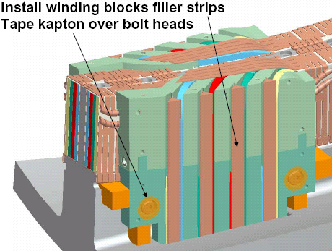
Figure 45- Winding Block Filler Strips

Outer Lead Chill Plate and Side Plates

To ensure that there are no interferences pre-fit the outer lead chill plate to the lead area. [Figure 46- Outer Lead Area Chill Plate]

Remove the outer chill plate from the lead area. Assemble the chill plate to the G-11CR side plates. Place (1) layer of 0.010 dry glass tape between the chill plate and G-11CR side plates.

Re-install the chill plate/side plate assembly and secure in place with the appropriate hardware. Repeat the assembly process for both sides “A” and “B”. [Figure 47- Lead Area Side Plates] Seal all seams with RTV-108.

Assembly of the outer lead area chill plate and side plates is complete.

Installations complete Sides “A” and “B”:

Verified by: _________________________ Date: __________________
Lead Technician

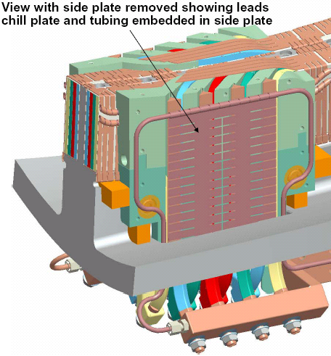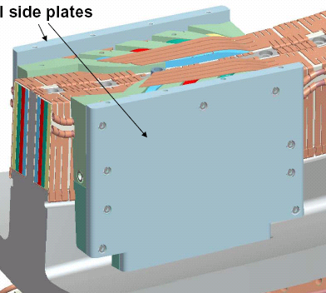
Lead G-11CR Side Plates
Outer Lead Chill Plates
Figure 46- Outer Lead Area Chill Plate
Figure 47- Lead Area Side Plates

Install Top Plate

Install the top plate bushing and mount the G-11CR top plate to the side plates. Secure top plate to side plates and center tee with the appropriate hardware. [Figure 48-Top Plate Bushing & Figure 49- Lead Area Top Plate]

Installations complete Top Plate:

Verified by: _________________________ Date: __________________
Lead Technician

Completion of Sides “A” and “B”:
The “A” and “B” sides are complete and ready for the installation of the bag mold.

Pancakes “A” and “B” have been completed and are ready for bag mold installation.

Lead Technician: ____________________________ Date: ____________________

Field Supervisor: ____________________________ Date: ____________________

QC shall verify completion of documentation:

Quality Control: _____________________________ Date: ____________________

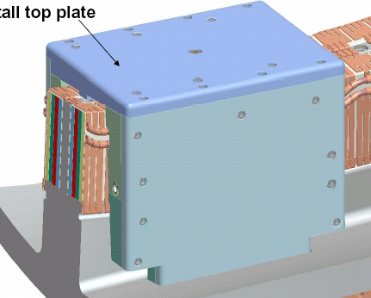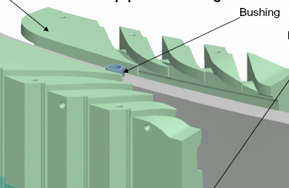
Top Plate Bushing
Lead G-11CR Top Plate
Figure 48-Top Plate Bushing
Figure 49- Lead Area Top Plate

Pre-VPI Electrical Insulation Tests:
Prior to applying the “Bag Mold” perform a low voltage Megger test to verify the integrity of the coil insulation.

Perform a preliminary Megger test of the completed coil prior to transporting to the autoclave.

Coil Voltage level: 500 volts

Coil Insulation Resistance: 1K Meg ohms

The Test Director for this test is: _____________________________

Safety Requirements and Conditions:

The following safety and prerequisites shall be used for performing test of the Modular Coil.

All personnel involved with these tests shall be familiar with the hazards and work procedure to minimize accidents that may occur.

A “Safety Watch” shall be appointed by the Test Director. The Test Director shall clearly describe to the Safety Watch his/her responsibilities.

Name of Safety Watch: ______________________

Responsibilities have been clearly discussed with Safety Watch:

Verified: ________________________________ Date: ________________
Test Director

Responsibilities of a Safety Watch include as a minimum:

a) Monitoring the operations in an attempt to prevent careless or unsafe activities.

b) Shutting down the power in case of an accident.

c) Contacting ESU in case of accident

d) Additional responsibilities of a Safety Watch can be found in the ES&H Manual Section 2, Chapter 2.2.6.

During the test, the “Test Area” shall be roped-off and suitable “danger high voltage” signs and flashing lights displayed.

Test Area has been safed:

Verified by: _________________________ Date: __________________
Test Director

The test operator shall stand on an electrical safety mat during the test operation.

Approved rubber electrical safety gloves shall be worn by test members during grounding operations which occur once the test has been completed, and the test equipment turned off.

Upon completion of test and before the components are declared safe to touch, the coil being tested shall be properly discharged using a “Ground Hook”. After a minimum period of 10 seconds, while the ground hook is still in place, attach a ground cable to the coil. The ground hook may be removed once the ground cable is in place.

Electrically ground the winding form, and chill plate cooling tubes.

Measure the insulation resistance of pancakes “A” and “B”. The test results shall be in compliance with the requirements noted in Section 6.45.1. Pancakes “A” and “B” are connected together at the terminal block. If the test results are questionable, project will be contacted, and the terminal block may be disassembled to allow testing of each separate pancake.

Table 7- Pre-VPI Bag Mold Megger Test Results
Test Coil | Test Voltage Level Volts | Measured Resistance  Ohms | Remarks
Pancake “A” | 500
Pancake “B” | 500

Coil Temperature: __________________ Degrees C

Equipment ID Number: _____________________________ Calibration Date: _____________

Megger Results: Acceptable: _______________ Unacceptable: ____________

Test Director Signoff: _____________________________ Date: ______________

Quality Control Verify: __________________________ Date: ______________

Field Supervisor: __________________________ Date: ______________

Installation of Bag Mold:

Once the chill plates and cooling tubes have been installed, the installation of the “bag mold” can commence.

During this procedure, to maintain dimensional control the number of adjacent winding clamps that can be removed should be no more than three. [Some areas may require removal of more clamps due to available working space]

Mount the G-11 sprue washers to the chill plates in the areas that were pre-cut to accommodate the epoxy feed sprues. Secure in place using 3M adhesive cement #CA40H. Pre-apply by brushing, 3M Accelerator “Pronto Surface Activator” to the chill plate that will mate with the washer. Apply the cement to the sprue washer and place on to the chill plate. Apply a small amount of silicone RTV 108 on the sides of the washers to secure them in place. Repeat for all sprue locations. [Figure 53- Sprue washers and extensions]

Install the final G-10 pressure pads in the areas where the final coil clamps will be placed. These pads shall be held in position with small amount of silicone RTV 108. All void areas behind the pads will be filled with glass insulation or roving. Include a listing of the final clamp locations to the back of this procedure.

Install glass roving (rope) in the areas between the cooling tubes. [Figure 50- Glass Roving Between Cooling Tubes]

Apply (1) layer of dry glass tape (0.010 inch thick) over the chill plates and cooling tubes in all areas not covered by the G-10 push pads. Secure glass in place with adhesive backed Kapton tape.
Glass roving
Figure 50- Glass Roving Between Cooling Tubes

Apply (2) half-lapped layers of the silicone rubber tape over the modular coil bundle chill plate and cooling tube assembly. The silicone tape extends from the Side “A” seal groove across the top to the Side “B” seal groove. Apply bead of adhesive RTV caulking in the seal groove prior to positioning the silicone tape. (Figure 51- Installation of Bag Mold & Figure 52- Silicone Bag Mold)

Apply bead of Silicone adhesive at base of seal groove
(2) ½ lapped layers of Silicone rubber tape from groove A to B
Winding clamps with spacers are used to secure tubing in seal groove (Typ.)

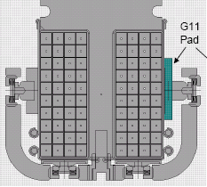
A
B
Figure 51- Installation of Bag Mold

Hold the silicone rubber bag mold in the groove using 5/16” (or 3/8 inch) refrigeration tubing. Use the special VPI winding clamps with spacers to hold the tube in place. (Figure 51- Installation of Bag Mold & Figure 52- Silicone Bag Mold)

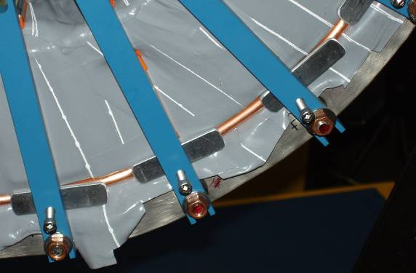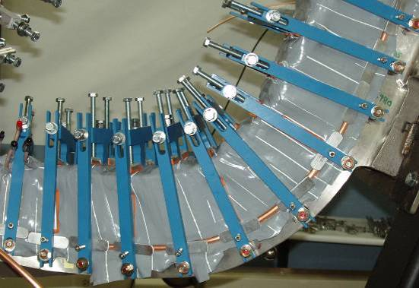
Figure 52- Silicone Bag Mold

It is important to note that the bag mold should only be installed in small sections. Removal of too many clamps will result in possible loosening of turns. Do not remove any more than five adjacent clamps at one time if possible. [Some areas may require removal of more clamps due to available working space] Once a section of coil is complete, immediately reinstall the winding clamps to the bundle. Tighten the upper and side clamps until they are hand snug against the silicone bag. Modified mold released side bars will be used during VPI cycle. These side bars have additional tapped holes for holding the edges of the epoxy/glass shell in position.

Tape the exposed conductors between the winding form and coil terminals with (2) half-lapped layers of the silicone rubber tape. Tape should extend onto the copper connector.

During the taping of the lead conductors, install 1/8 inch diameter [Chemflor] exit tubes on each conductor. This will help to draw the epoxy down each of the lead conductors during the VPI operation.

Seal all external joints of the G-11 CR lead cover plates with RTV108.

Install the long and short sprue extension to the sprue washers. This requires cutting the bag where the washers are located. The lead technician shall decide whether a long or short extension will be used. [Figure 53- Sprue washers and extensions]

Cement the sprue extensions to the sprue washers. Secure in place using 3M adhesive cement #CA40H. Pre-apply by brushing, 3M Accelerator “Pronto Surface Activator” to the washer that will mate with the sprue extension. Apply the cement to the sprue extension and place on to the washer. Press the silicone skirt that is around the sprue extension directly to the silicone bag. Repeat for all sprue locations.

All sprues have been installed and bag is ready for RTV coating:
Verified:

Lead Technician: ____________________________ Date: ____________________

Field Supervisor: ____________________________ Date: ____________________

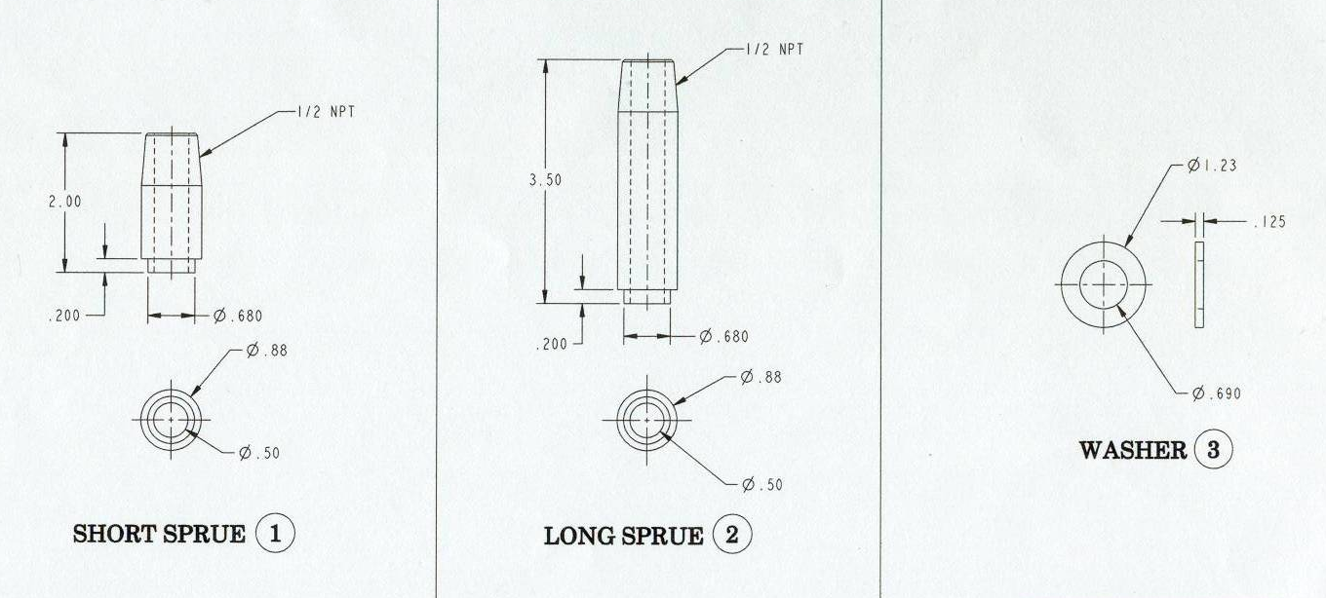
Figure 53- Sprue washers and extensions

Once the entire bag and sprues have been installed, cap the sprues and apply a vacuum to the bag mold. This will help the silicone bag to conform to the bundle.

Check for any gross vacuum leaks. Repair leaks with adhesive RTV108. Continue to pump on bag to achieve lowest possible vacuum.

Vacuum pressure (achieved):

Notes:

Once the vacuum of the bag has reached < 80 Torr vacuum, Paint the outer surface of the silicone bag with 2- part RTV 11 (white) to seal any small leaks in the bag. Allow the RTV to dry for minimum 12 hours.

Vacuum pressure (achieved):

Notes:

After 12 hour cure the bag mold has been sealed and is ready for installation of outer shell.
Verified:

Lead Technician: ____________________________ Date: ____________________

Field Supervisor: ____________________________ Date: ____________________

Once the vacuum of the bag has reached < 50 Torr vacuum, the epoxy shell can be installed.

Install epoxy shell:
An epoxy shell will now be installed over the silicone bag to provide structural support during the epoxy filling process.

Mix sufficient glass/epoxy using 2-part Hysol -epoxy system with mix ratio recommended by the epoxy supplier. (Resin 3561 /Hardener 2039). Document all epoxy mixing data.

Epoxy mix ratio used:
100 pbw of Resin………. Hysol RE2039
30 pbw of Hardener……. Hysol HD3561

Quantity of epoxy mixed:
2 gallon mixture [working batch]

“Cotton Candy” mix data:
100 grams of part “A”
30 grams of part “B”
30 grams of chopped glass

Thoroughly mix by hand the epoxy and glass components until it begins to take on the appearance of “Cotton Candy”. [Figure 54-Epoxy/Glass Mixture- "Cotton Candy"]

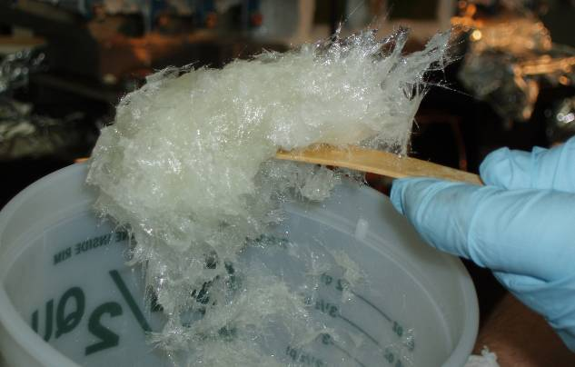
Figure 54-Epoxy/Glass Mixture- "Cotton Candy"

Begin applying the “Cotton Candy” over all areas of the exposed silicone bag mold between side bars to a thickness of at least ¼ inch. Build up the areas around the sprues to provide additional support. [Figure 55-Application Epoxy Glass Shell]

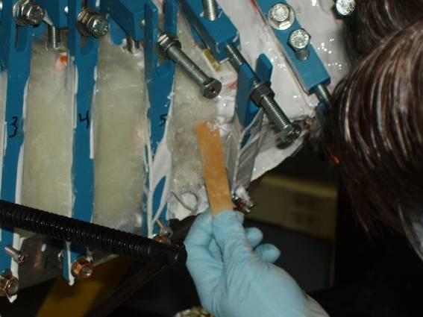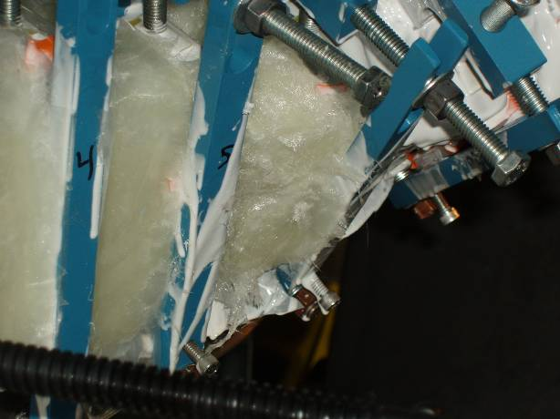
Figure 55-Application Epoxy Glass Shell

Once an area has been completed, install mold released plates over “cotton Candy” and secure in place with stainless steel clips that fasten to the side bars. Continue the application of the “Cotton Candy” until the silicone “Bag Mold” has been fully covered. [Figure 56- Epoxy/Glass shell]

Once the epoxy shell has been installed additional clamps may be added as required per direction of the field supervisor.

Allow 24 hours for the Hysol to totally cure before proceeding with the next activity.

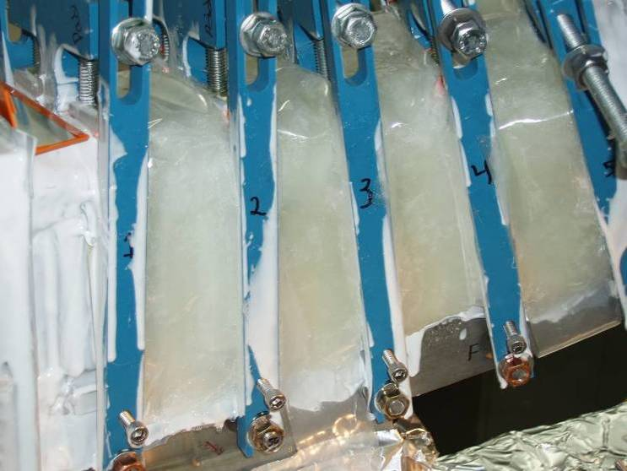
Figure 56- Epoxy/Glass shell

Installation of the “Bag Mold” is complete:

Lead Technician: ____________________________ Date: ____________________

Field Supervisor: ____________________________ Date: ____________________

Quality Control: _____________________________ Date: ____________________

Comments:

Completion of Activities at Winding Station:

Document Verification:
Verify that all pertinent data in the procedure and data sheets have been completed.

Field Package:
Ensure that all data sheets, photographs, QC inspection sheets, etc are included in the Field Package.

Approval:
Prior to releasing a modular coil to the Vacuum-Pressure-Impregnation station (VPI), it is required that the all-responsible individuals sign the release indicating that all processes at the winding station have been satisfactorily completed. The release will include signatures from the Station Lead Technician, Field Supervisor and the QC representative.

All winding form preparation activities have been satisfactorily completed.

Lead Technician: ____________________________ Date: ____________________

Field Supervisor: ____________________________ Date: ____________________

QC shall verify completion of documentation:

Quality Control Representative: _________________________ Date: ________

The modular coil with “Bag Mold” is ready for transfer to the VPI station no. 5:

Comments:

DELETE Table 8- Type "C" Coil Drawings

