Princeton Plasma Physics Laboratory
Procedure
‘
Procedure Title: Modular Coil Fabrication-Post VPI Activities

Number:  D-NCSX-MCF-004 |  | Revision:  03 |  |  | Effective Date:  Expiration Date:  (2 yrs. unless otherwise stipulated)
Procedure Approvals
Author: James H. Chrzanowski |  |  |  |  |  | Date:
ATI: James H. Chrzanowski |  |  |  |  |  | Date:
RLM: Larry Dudek |  |  |  |  |  | Date:
Responsible Division: NCSX Project
Procedure Requirements
Designated by RLM
LABWIDE:
X | Work Planning Form # WP-1188 & 1138 (ENG-032) |  |  | Lockout/Tagout (ESH-016)
 | Confined Space Permit (5008,SEC.8 Chap 5) |  |  | Lift Procedure (ENG-021)
 | Master Equip. List Mod (GEN-005) |  | X | ES&H Review (NEPA, IH, etc.) NEPA 1283
 | RWP (HP-OP-20) |  |  | Independent Review
 | ATI Walkdown |  |  | Pre-Job Brief
 | Post-job Brief *
D-SITE SPECIFIC:
X | D-Site Work Permit (OP-AD-09) |  |  | Door Permit (OP-G-93)
 | Tritium Work Permit (OP-AD-49) |  |  | USQD (OP-AD-63)
 | Pre-Job Brief (OP-AD-79) |  |  | T-Mod (OP-AD-03)
 | ** DCA/DCN (OP-AD-104) #

* Required for installations involving internal vacuum installations, critical lifts, and for the initial installation of repetitive work.
** OP-AD-104 was voided by procedure ENG-032. However, DCA’s that were open at the time of adoption of ENG-032 are still considered valid for work approval purposes.

REVIEWERS (designated by RLM) Rec’d/
Incorp.
Comments
Accountable Technical Individual. …………J. Chrzanowski
Test Director
Independent Reviewer Buddy Kearns X
D-Site Shift Supervisor
Independent
NCSX Dimensional Control Coordinator ……………………….
Vacuum
NCSX Field Supervisors… Tom Meighan X
Project Engineer for Stellerator Systems (WBS 1) Manager……Brad Nelson (ORNL)
Independent NCSX Engineering ………………… P.J. Fogarty (ORNL)
Quality Assurance/Quality Control. …… Colin Phelps X
Maintenance and Operations Division
Energy Conversion System/Motor Control Division
Engineering ……………………………………..
Environmental Restoration & Waste Management Division
Environmental, Safety & Health……………………………………Jerry Levine X
Industrial Hygiene………………………………………………... Bill Slavin X
Health Physics…………………
RLM ………………………………………………………………..Larry Dudek

TRAINING (designated by RLM)
No training required ______________ | Instructor Jim Chrzanowski
Personnel (group, job title or individual name) |  | Read Only | Instruction  Pre-job  Briefing | Hands On
Lead Tech. |  |  | X
Technicians performing task |  |  | X
Field Supervisors |  |  | X
Quality Control Representative |  |  | X
Training Rep.
RLM Larry Dudek

RECORD OF CHANGE

Revision | Date | Description of Change
00 |  | Initial release
01 | 6/6/06 | Revamped entire procedure to reflect changes in manufacturing sequence  -Added new figures throughout procedure  -Added finalization of diagnostic flux loops  -Added joint resistance test section of connectors  -Modified table and clarified description of assemblies for cooling tube tests  -Added more detail of turning fixture installation  -Added more detail for final clamp installations  -Removal of prosthetic filler  -Added removal of studs and bag mold details
02 | 9/18/06 | -Added safety notes throughout procedure identifying PPE’s  -Revised pneumatic testing description & added schematic 6.13  -Added reference to use of pneumatic impact wrenches throughout procedure  -Added cooling tube termination details 6.9 and 6.10  -Added additional electrical tests
03

TABLE OF CONTENTS

1 Scope 1
1.1 Introduction 1
1.2 Scope 1
1.3 Identification of winding form being prepared: 1
2 Applicable Documents 1
2.1 NCSX-MIT/QA-142-01: 1
2.2 NCSX-PLAN-MFOP-00: 1
2.3 D-NCSX-MCF-005 Dimensional Control & Metrology for the NCSX MC 1
2.4 D-NCSX-PLAN-MCWDC Modular Coil Dimensional Control Plan 1
2.5 D-L-NCSX-984 Lifting Modular Coil Assemblies 2
2.6 D-L-NCSX-996 Lifting Finished Modular Coil Assemblies 2
3 Safety Requirements: 2
3.1 Job Hazard Analysis: 2
4 Prerequisites & Conditions: 2
4.1 Pre-Job Briefing: 2
4.2 Daily Operations Startup and Shutdown: 2
4.3 Reference Torque Values: 2
5 Materials and Parts for this station 2
6 Fabrication Process 3
6.1 Daily Startup Activities: 3
6.2 Daily Shutdown Activities: 3
6.3 Install MC or TRC in Turning Fixture: 3
6.4 Clamp Removal 5
6.5 Stud Removal 5
6.6 Prosthetic Filler Removal [Type A and B coils only] 6
6.7 Bag Removal 7
6.8 Coil Inspection: 7
6.9 Termination of cooling tubes: 8
6.10 Brazing of couplings to cooling tubes: 8
6.11 Tubes are secured and installation of electrical sleeving is complete. 10
6.12 Installation of cooling jumper around poloidal break 11
6.13 Cooling Tube Pressure Tests 11
6.14 Flow Check: 12
6.15 Cooling Tube Electrical Test: 13
6.16 Dimensional Inspection- DELETE 13
6.17 Coil Clamp Installation 13
6.18 Finalization of Diagnostic Loops 17
6.19 Modular Coil Electrical Joints: 18
6.20 Final Electrical Testing of Coil [Room Temperature] 19
6.21 Name Tag Installation: 23
6.22 Strain Gages and Thermocouples [Optional at this point] 23
6.23 Transporting MCWF from Casting Prep Station 1b to Station 1a: 25
6.24 Disassembly of coil/casting from Support Ring Assembly: 25
7 Completion of Activities at Post VPI Station: 27
7.1 Document Verification: 27
7.2 Field Package: 27
7.3 Action Ticket: 27
7.4 Approval: 27

List of Figures

Figure 1- Upper Support Plates 4
Figure 2- Turning Fixture 5
Figure 3 - Cooling Tube Sleeving Insulation 8
Figure 4- Termination of Cooling Lines 8
Figure 5- Front Face- "Nibco" Braze Unit Control 9
Figure 6- Cooling Tube Zone Identification 12
Figure 7-Pressure Test Schematic 12
Figure 8- G-11 Pad Location 14
Figure 9- Coil Clamp Assembly 14
Figure 10- Torque Reference Locations 15
Figure 11- Typical Spring Washer Stack Up 15
Figure 12-Typical Winding Clamp Arrangement 15
Figure 13-Electrical Joint Test Setup 18
Figure 14- Final Terminal Connections Identification 19
Figure 15- Coil Resistance 22
Figure 16- Modular Coil Name Tag [example] 23
Figure 17- Casting Assy. Fixture- Vertical Position 26
Figure 18- Casting Assy. Fixture in Horizontal Position 26
Figure 19- Assy. Fixture without Lift/Support Beam 26
Figure 20- Coil without Support Ring 26
Figure 21-Sensor Locations for Type “C” Casting- DELETE 27
Figure 22- Sensor Locations for Type “B” Casting- DELETE 27
Figure 23-Sensor Location for Type “A” Casting- DELETE 27

List of Tables

Table 1- Cooling Tube Test Results 13
Table 2- Coil Clamp Torque Data 16
Table 3- Joint Resistance 18
Table 4 - Final Megger Test Results 21
Table 5- Coil Sensor Table 24

Scope

Introduction

The NCSX Coil Manufacturing Facility is divided into 5 workstations. Each workstation has a specific set of tasks that will be performed as part of the overall fabrication process. This procedure addresses the manufacturing, inspection, test and QC inspection points for a specific workstation required to manufacture the modular coils.

- Station No. 1… Winding Form Preparation & Post VPI Activities
- Station No. 2… Winding/Bag Mold Station
- Station No. 3… Winding/Bag Mold Station- Future upgrade
- Station No. 4… Winding Form Preparation- Future upgrade
- Station No. 5… VPI and Autoclave Activities

Scope

This procedure identifies the post VPI activities for each Modular Coil (MC) or Twisted Racetrack Coil (TRC). It includes:
- Installing the MC into the turning fixture
- Cleanup of the coil following VPI
- Preparation of coil for final coil clamps
- Installation of the coil clamps
- Room temperature electrical testing of coil
- Termination of cooling tubes
- Installation of thermocouples & strain gauges
- Disassembly of coil/winding form from support ring

Identification of winding form being prepared:

Station Number: ________ (Location where work will be performed)

Winding Form Type: _______________ [Type A, B, C or Twisted Racetrack Coil (TRC)]

MC Winding Form ID No: _________________

Applicable Documents

NCSX-MIT/QA-142-01:
All applicable documents associated with this procedure, are identified in the MIT/QA Plan, document number NCSX-MIT/QA-142-01.

NCSX-PLAN-MFOP-00:
All Modular Coil work processes are governed by the “Manufacturing Facility Operations Plan”, document number NCSX-PLAN-MFOP-00.

D-NCSX-MCF-005 Dimensional Control & Metrology for the NCSX MC

D-NCSX-PLAN-MCWDC Modular Coil Dimensional Control Plan

D-L-NCSX-984 Lifting Modular Coil Assemblies

D-L-NCSX-996 Lifting Finished Modular Coil Assemblies

Safety Requirements:
All work will be performed in a safe manner in accordance with PPPL safety policies ES&H 5008 and “Integrated Safety Management” (ISM) policy.

Job Hazard Analysis:
JHA’s will be generated for each workstation, identifying existing or potential workplace hazards and to evaluate the risk of worker injury or illness associated with job tasks. (Reference document ESH-004 “Job Hazard Analysis”) The IH representative will review the JHA’s for accuracy as well as completeness. It will be reviewed with all activity participants at the Pre-Job briefings.

Prerequisites & Conditions:

Pre-Job Briefing:
A pre-job briefing will be held prior to the first time that revision of the procedure is used or if being performed by a new crew. The briefing will describe the processes and safety issues [JHA] associated with procedure. Attendance shall be documented via training sign-in sheet.

Pre job Briefing complete: _______________________________ _________________
MC Field Supervisor Date

Daily Operations Startup and Shutdown:
Each working day, it is required to complete and initial the daily operations startup log to ensure that the station is ready to commence work activities for the day. The signoff log is located in the Daily Station Log. See section 6.1 and 6.2 for details.

Reference Torque Values:
Unless a torque value is specified or the fastening material is something other than low carbon steel, the following values shall be used whenever the procedure requires a torquing operation:

3/8-16UNC …… 18 ft-lbs 3/8-24UNF …… 19 ft-lbs ½-13 UNC …… 38 ft-lbs ½ -20 UNF …… 40 ft-lbs 5/8-11 UNC…. 83 ft-lbs 5/8-18 UNF… 95 ft-lbs
¾-10 UNC..…… 105 ft-lbs ¾-16 UNF ……. 102 ft-lbs 1-8 UNC … 236 ft-lbs 1-14 UNF …….. 212 ft-lbs 1 1/4 UNC …… 432 ft-lbs 1 ½-6 UNC …...732 ft-lbs

Materials and Parts for this station
The following materials and/or equipment will be used with this procedure. MSDS’s for chemicals will be located in a notebook in the winding facility.

General Description | Material | Reference Document/Product No.
Solvent | Acetone | MSDS# 00561
Short Coil Clamp Assembly | 316L stainless steel | SE1405-257P
Name tag | Aluminum
MC Turning Fixture | Equipment | Drawing no. SE144-008
Rolled Ring Assembly | Fixture | Drawing no. SE144-007
Casting to Ring Assy. Fixture | Fixture | Drawing no. SE144-050
Multi-Meter | Equipment
Megger Electrical Tester | Equipment
Swagelock fittings | copper
Teflon tubing for electrical breaks | Teflon
Expandable foam
Strain gage adhesive | M-Bond | AE-10
Modular coil stands | Steel | SE144-031

Fabrication Process
This fabrication procedure is to be used as guide to complete Post VPI activities. Deviation from this procedure for processes that DO NOT effect the design of the coil can be made with the concurrence of the MC Field Supervisor. These deviations shall be documented in the procedure and initialed by the MC Field Supervisor prior to implementing the deviations. Deviations that may effect the design of the coil requires a Request for Deviation “RFD” approval. The RFD must be approved prior to proceeding. Procedure changes need to be incorporated into the document via “Minor Procedure Changes” or “Revisions”.

Daily Startup Activities:

Check all daily supplies needed:

Verify operation of all equipment needed that day.

Check station for cleanliness

Check that safety guards are intact

Check that safety equipment needed for day’s activities are available

Check that the day’s travelers and procedures are in their document holder.

Once completed, date and initial daily log at the back of the Station Log Book.

Daily Shutdown Activities:

Turn off power to equipment not in use.

Clean entire workstation area.

Verify that all Traveler and data sheet information is complete.

The Lead Technician shall verify that the Station’s Log Book has been completed and signed for the day.

Once completed, date and initial daily log at the back of the Station Log Book.

Install MC or TRC in Turning Fixture:
Using the steps outlined in procedure D-NCSX-MCF-003 [VPI], prepare the VPI’d coil for transfer from the autoclave.
Note: Station 1b or station 4 may not be available to receive a coil from station 5. If not, transfer the coil to station 1a and lower/store coil until station 1b or 4 is available.

Station 1b or 4 Preparations:
Activities associated with receiving modular coil at winding stations.

Prior to installing the MCWF, compress the springs under the gear box (drive system) until they are bottomed

Measure the inside width of the winding form ring (where the roller guide wheels engage) and record the smallest value. [Narrowest dimension]

Adjust the lower wheels on the winding station so that they are centered in the frame and are set at a width that is one-half inch greater than the value recorded in the previous step.

Lower the MCWF and ring assembly into the turning fixture using the corner brackets for alignment. Bolt up one end loosely (use spud wrenches to align holes).

- SAFETY NOTE 1: Use scaffolding or appropriate ladders while working on upper section of turning fixture. Scaffolding must be inspected prior to use per Section 9 Chapter 5 in PPPL ES&H Manual.

Install the upper guide rollers and align all of the guide rollers to the support ring. NOTE: The rollers are hinged and swing into position. Lifting is not required.

- SAFETY NOTE 2: Safety glasses MUST be worn when operating the pneumatic impact wrenches

Decompress springs under the gear box (drive unit) until gear is fully engaged with ring gear rack. The upper set of springs MUST be completely disengaged. This must be verified prior to proceeding.

Verified by: _________________________ Date: __________________
Lead Technician

Verify that the upper support/lift beam is in proper position. Then secure the appropriate hardware using a pneumatic impact wrench. Hardware shall be torqued to the proper value. [See section 4.3]

Verified by: _________________________ Date: __________________
Lead Technician
Remove Upper Support Plates
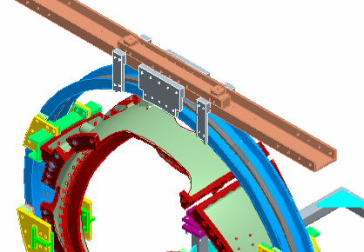

Figure 1- Upper Support Plates

Using a pneumatic impact wrench remove the upper support plates between the support-ring and lift beam. This operation must be verified prior to operating turning fixture. [See Error: Reference source not found]

Verified by: _________________________ Date: __________________
Lead Technician

Adjust the upper alignment rollers (both on the vertical and horizontal beams) so that the ring is aligned vertically and is centered within the turning fixture frame. A pry bar can be used to position the upper half of the ring so that these adjustments can be made. The rollers should be set so that there is one-quarter inch clearance to the ring flanges.

To ensure proper alignment and operation of the turning fixture, rotate the MCWF a full two revolution in either direction, using the foot-pedal control. Re-adjust the alignment rollers as required. Alignment of MCWF to the turning fixture is complete.

Verified by: _________________________ Date: __________________
Lead Technician

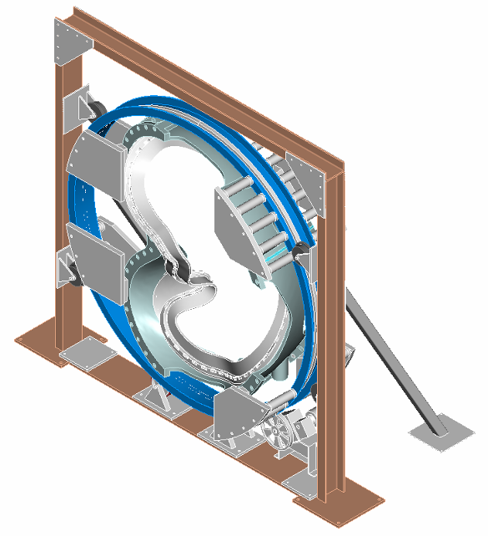
Turning Fixture Support Ring
Turning Fixture Support Plates
Turning Fixture-Upper Support/Lifting Beam
Turning Fixture Drive System
Turning Fixture Support Roller Guide Rollers
Turning Fixture Support Frame

Figure 2- Turning Fixture

Clamp Removal

Remove the winding clamp side bars, tees and sheet metal mold plates. All hardware and components including the shim washers shall be saved, cleaned and reused for the next coil impregnation.

Stud Removal

Identify and mark the studs that should be removed from winding form per appropriate drawings provided by NCSX management and the field supervisors. Carefully remove the winding clamp studs using the stud removal tool. This will break the stud from the winding form leaving the stud base.

- SAFETY NOTE: Technicians shall wear safety glasses and leather gloves while using the stud removal tool

- SAFETY NOTES for Grinding Operations:

Ensure that the coil is protected. Areas that are not protected by the epoxy/glass shell must be covered prior to start of grinding
    - Safety glasses, face shields and leather gloves MUST be worn during grinding
    - Notify the ESU and obtain a flame permit prior to starting grinding operations.

Grind away the tack welds holding the stud adapters [Type C only] to the winding form. Measure the magnetic permeability of the tack weld locations after grinding.

Grind the stud bases of both the stainless steel and Inconel studs that were removed. If the clamp studs were Inconel, it is only necessary to remove [grind] any sharp edges that may remain and it is not necessary to measure the permeability. If the clamp studs were 316SS measure the magnetic permeability of the remaining stud base using a calibrated Severn permeability indicator to verify that the relative magnetic permeability is below the acceptance criteria. If the permeability exceeds the acceptance criteria the stud base must be removed by grinding.
Acceptance Criteria: <1.02μ

Removal of the studs and stud adapters has been completed and permeability has been measured and is in compliance.

Verified by: _________________________ Date: __________________
Lead Technician

Quality Control Representative: __________________________ Date: _____________

Prosthetic Filler Removal [Type A and B coils only]
Remove the stainless steel prosthetic filler pieces.

Carefully remove the stainless steel prosthetic filler by grinding away the tack welds. Extreme care shall be taken to ensure that no harm comes to the coil during the removal of the prosthetic filler.

DO NOT damage the prosthetic filler during removal since it will be used for multiple coils.

Measure the magnetic permeability of the tack weld areas using a calibrated Severn permeability indicator to verify that the relative magnetic permeability is below the acceptance criteria. If the permeability exceeds the acceptance criteria additional grinding will be necessary.
Acceptance Criteria: <1.02μ

Verified by: _________________________ Date: __________________
Lead Technician

Quality Control Representative: __________________________ Date: _____________

Bag Removal

Carefully remove the epoxy/glass structure from the coil bundle. Note: the epoxy shell can be removed prior to removing the studs. This is at the discretion of the field supervisor.

Caution note: Extreme care shall be taken around the cooling tubes. Do not use sharp instruments or tools near these tubes without tube protection.

- SAFETY NOTE 1: Use leather gloves during this process, since the epoxy/glass structure has sharp edges. Safety glasses are also required for this operation.

During the shell/bag removal, do not actively remove the G-11 sprue rings that are attached to the chill plates. However, it is acceptable if rings fall off during the bag removal process. See Figure 8- G-11 Pad Location

Once the epoxy/glass shell structure has been removed, carefully remove the silicone rubber bag mold that surrounds the coil bundles. This may require some scraping with putty knives. See caution note in 6.7.2.

The epoxy/glass structural shell and bag mold have been removed and the coil is ready for final inspection.

Verified by: _________________________ Date: __________________
Lead Technician

Coil Inspection:

Carefully inspect boundary of winding packs and winding form for any evidence of epoxy cracks, gaps between winding and winding form, or other relative motion.

Inspect VPI boundary for leaks, “ballooning” or other defects that could affect coil performance or geometry.

Inspection Findings:

Verified by: ____________________________ Date: ____________________
Field Supervisor

____________________________ Date: ____________________
Q.C. Representative

Termination of cooling tubes:
Each of the cooling tubes must be terminated to accommodate the final connection to the modular coil cooling system.

Using approved NCSX drawings carefully cut each of the cooling tubes to correct length using a tube cutter.

Once the tubes have been cut carefully form the cooling tubes as shown in Figure 4- Termination of Cooling Lines.

Apply heat shrink Teflon tubing over the cooling tubes from the point where the tubes exit the chill plates through the clearance holes in the winding forms. [Figure 3 - Cooling Tube Sleeving Insulation] Do not shrink the sleeving at this time. Pull the sleeving away from the clearance holes until the couplings have been brazed in place.

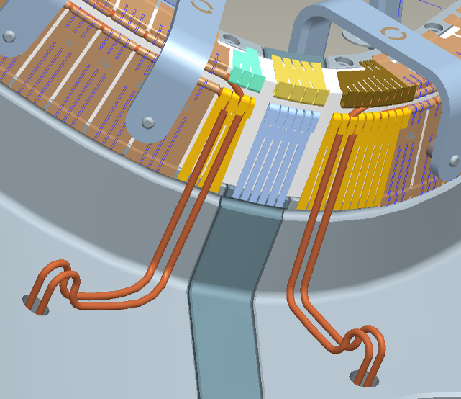
Heat-shrink sleeving [typ] from chill plates through winding form
Figure 3 - Cooling Tube Sleeving Insulation

Brazing of couplings to cooling tubes:

Couplings will be brazed to the cooling tubes using flameless “Nibco” resistive heating carbon tong and Sil-Fos Braze material. Only braze qualified individuals can perform the cooling tube termination brazes and requirements of ES&HD 5008, Section 9, Chapter 15 for safe brazing must be followed. See Figure 4- Termination of Cooling Lines

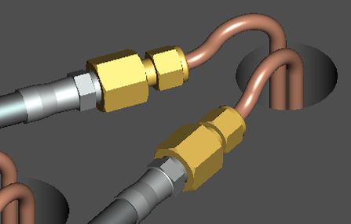
Braze Coupling to cooling tube
Fill the cooling tube penetration hole with expanding foam after brazing
This figure does not necessarily reflect the final coupling that will be used
Figure 4- Termination of Cooling Lines

Notify the ESU and obtain a flame permit prior to starting brazing operation.

Verified by: _________________________ Date: __________________
Lead Technician

Clean the copper cooling tube and coupling using acetone-degreasing agent Scotchbrite and clean lint free wipes. Use a wire bottlebrush on the inner bore along with the acetone. Once cleaned, do not touch the components with bare hands.

Assemble together the coupling to the cooling tube.

- SAFETY NOTE: Braze operator MUST wear safety glasses and flame retardant jacket plus welding or leather gloves.

Set the toggle switch on the control unit to TBD. [Figure 5- Front Face- "Nibco" Braze Unit Control]

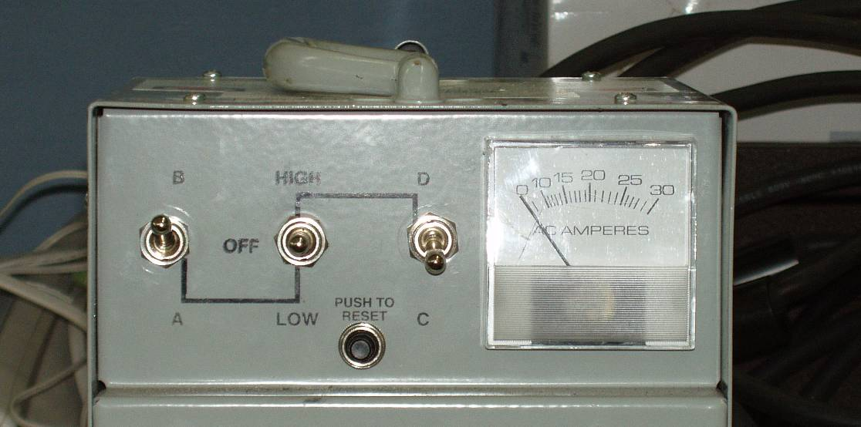
Figure 5- Front Face- "Nibco" Braze Unit Control

Position the carbon tongs. [TBD]

Move the center toggle switch to TBD position, and using the carbon tongs heat the copper coupling. The current on the meter should read approximately TBD amps. Once at temperature, feed the Sil-Fos rod from the cooling tube side.

Repeat the process with each of the cooling tube couplings.

Carefully clean the braze area, removing any excess Sil-Fos.

A QC welding inspector shall inspect each brazed cooling tube to coupling joint following cleanup. If a cooling tube braze is rejected, the coupling must be removed and the coupling braze remade.

COOLING TUBE TO COUPLING BRAZES SIDE “A”:

Date Brazed: ______________________ Braze performed by: _____________

Date Brazed: ______________________ Braze performed by: _____________

Date Brazed: ______________________ Braze performed by: _____________

QC Inspected by: ______________________ Date: ___________________

Notes:

COOLING TUBE TO COUPLING BRAZES SIDE “b”:

Date Brazed: ______________________ Braze performed by: _____________

Date Brazed: ______________________ Braze performed by: _____________

Date Brazed: ______________________ Braze performed by: _____________

QC Inspected by: ______________________ Date: ___________________

Notes:

Reposition the heat shrink Teflon tubing so that the insulation covers the tubing up to the coupling and using a heat gun shrink into position.

Once the co-wound diagnostic loops have also been routed through the clearance holes the cooling tubes and diagnostic loops will be secured in place with expanding urethane foam. [See section 6.11]

Cooling tubes have been terminated and electrical sleeving installed.

Verified by:

Lead Technician: ____________________________ Date: ____________________

Quality Control: _____________________________ Date: ____________________

Finalization of Diagnostic Loops

The routing of the diagnostic flux loops needs to be completed. Actual position will be determined by NCSX drawings and the Diagnostic representative.

Notify the Diagnostic representative that the final routing of the flux loops is ready to begin.

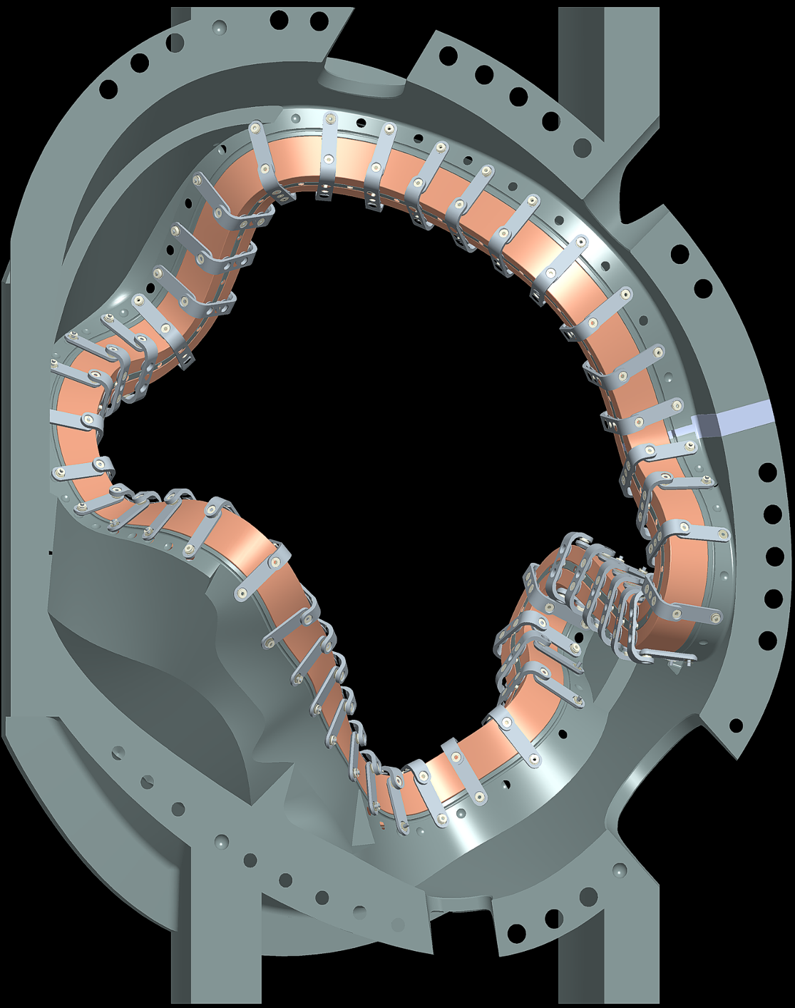
Verified by: _________________________ Date: __________________
Lead Technician

Position the diagnostic boxes on the outside of the winding form per direction of the Diagnostic representative. Using the stud gun, weld Inconel studs to the winding form to secure the boxes in position.

- Notify the ESU and obtain a flame permit daily prior to starting welding operation.

- SAFETY NOTE: Technician MUST wear fire retardant clothing, safety glasses and leather gloves during the stud welding operation.

Verified by Lead Technician

Stud Weld Date: _______________ Obtain Flame Permit: ______________

Stud Weld Operator: ______________________________ Fire Watch: _____________

Carefully route the twisted flux loops (2 inch pitch) per direction of Diagnostic representative from the G-11 lead blocks through the cooling tube clearance holes in the winding form and into the previously installed diagnostic boxes. Initially secure the flux loops in place with adhesive tape. Then tack-weld stainless clips to the winding form.

- Notify the ESU and obtain a flame permit daily prior to starting welding operation.

Route the Flux loop leads through the lead area and exit the coil in a groove in the upper G-11 lead blocks.

Route the co-wound leads through the clearance holes in the winding form per directive from the Field Supervisor. Note: the diagnostic leads share the clearance hole with the cooling tubes.

Using NCSX approved expanding urethane foam; fill the cooling tube clearance holes through the winding form to secure the tubes and co-wound diagnostic loops in position.

- SAFETY NOTE: While working with the expandable foam, personnel MUST wear chemical goggles, gloves [Nitrile or leather]. It is also required that additional ventilation is provided.

The cooling tubes and co-wound diagnostic loops are secured in the clearance holes with expandable foam.

Verified by:

Lead Technician: ____________________________ Date: ____________________

Finalization of Flux Loops complete-Verified:

Lead Technician: ____________________________ Date: ____________________

Diagnostic Representative: _____________________ Date: ___________________

Installation of cooling jumper around poloidal break

Prepare Teflon jumper tubes for installation; to jumper the poloidal break areas.

Install the Teflon jumper tubes and tighten connections on all outboard circuits

Cooling Tube Pressure Tests
Perform a final pressure test to verify the integrity of the cooling tubes.

Connect the cooling tubes together using compression fittings to form a series connection so that the entire system can be tested together. If there is a problem, the connections can be broken and the system tested in sections. See Figure 6- Cooling Tube Zone Identification

Using engineering procedure ENG-014 (Guidelines for Hydrostatic and Pneumatic Testing) test the individual cooling tubes. See pressure test schematic Figure 7-Pressure Test Schematic

- SAFETY NOTE 1: Each member of the test team shall wear goggles and a full face shield whenever pressure is applied to the system being tested.

- SAFETY NOTE 2: The area where the test is being performed shall be roped off to prevent access to the general work force with signs posted on the ropes warning about the test.

- SAFETY NOTE 3: The test system MUST have a pressure relief valve that is set no more than 25 psig over the test pressure.

- SAFETY NOTE 4: All safety precautions including the use of PPE’s shall be followed as outlined in the Job Hazard Analysis sheet and recommendations made by the PPPL Industrial Hygienist.

Pressurize the coolant tubes with nitrogen to 200 psi and isolate from the pressure source.

Gauges shall have a minimum 5-psi graduation.

Verified by: _________________________________ Date: __________________
Quality Control Representative

Acceptance criteria: The test pressure shall be maintained without any detectable drop in pressure within the resolution of the gauge for at least ten minutes from the time the system was isolated from the pressure source. Any leaks or failure to maintain pressure requires a repair and retesting.

Record test data in the table below [Error: Reference source not found]

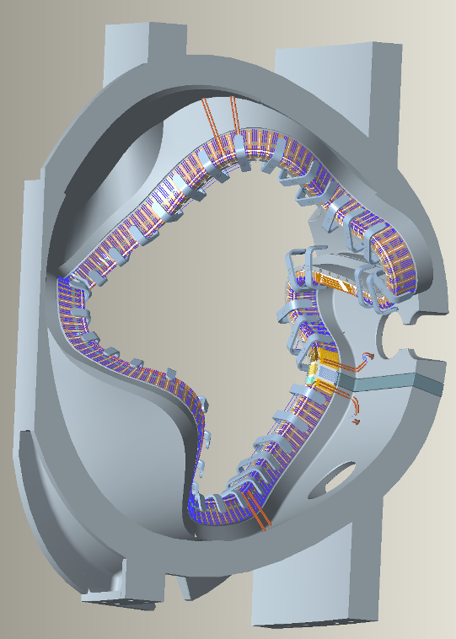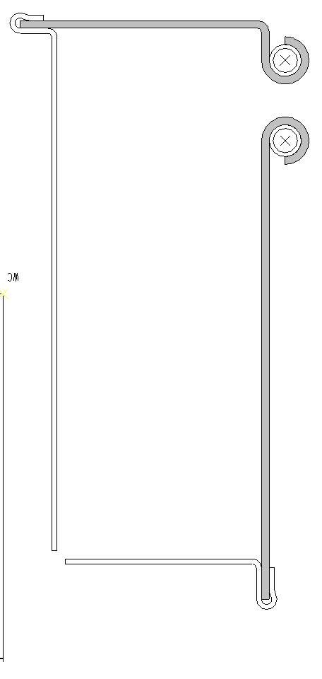
Inner Cladding Assembly
Outer Cladding Assembly
ZONE 1
ZONE 3
ZONE 2
Figure 6- Cooling Tube Zone Identification

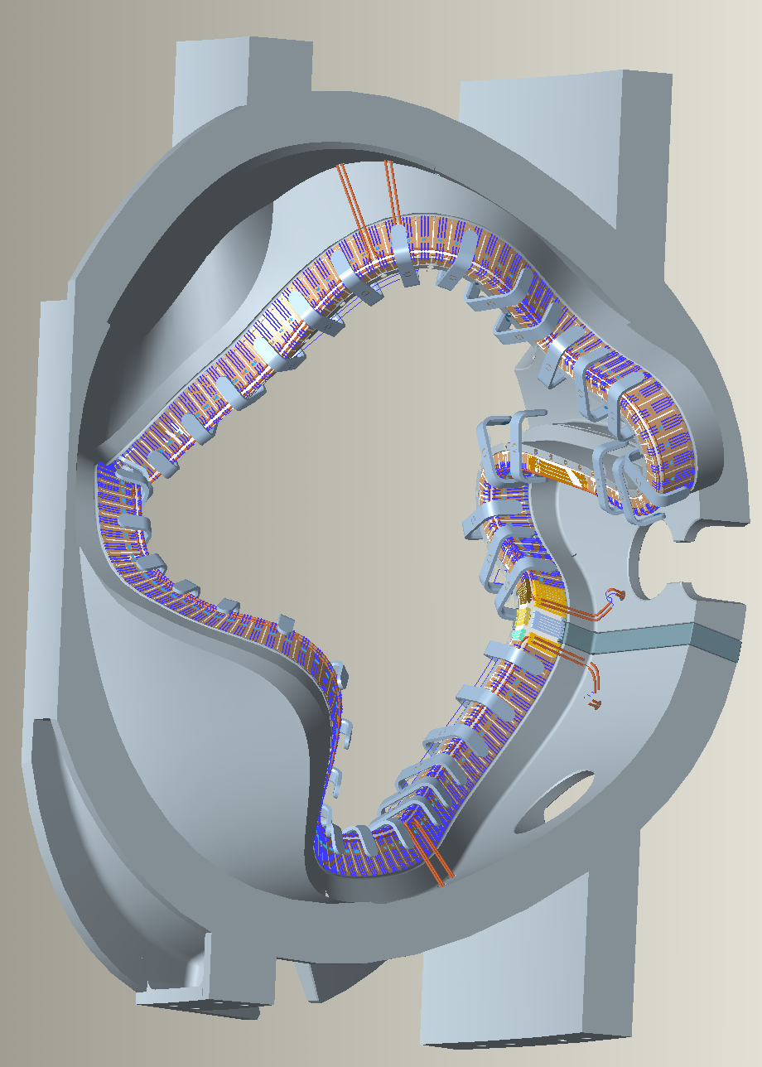
N2
Pressure relief valve 225 psi
Pressure gauge
Nitrogen regulator
Vent valve

Figure 7-Pressure Test Schematic

Flow Check:
Flow nitrogen or air through each flow package to verify that there are no blockages.

Record test data in the table below [Error: Reference source not found]

Cooling Tube Electrical Test:

Verify that cooling tubes are electrically isolated from all of the other cooling tubes and from the modular coil winding form using a multi-meter. Document findings in Error: Reference source not found

Equipment Name & ID Number: ___________________ Calibration Date: ___________

Record test data in the table below [Table 1- Cooling Tube Test Results].

Table 1- Cooling Tube Test Results
Tube designation | Flow Path Blockage check | Pressure Leak check | Electrical test, tube to ground
Side A Zone 1 Inner
Side A Zone 1 Outer
Side A Zone 2 Inner
Side A Zone 2 Outer
Side A Zone 3 Inner
Side A Zone 3 Outer
Side B Zone 1 Inner
Side B Zone 1 Outer
Side B Zone 2 Inner
Side B Zone 2 Outer
Side B Zone 3 Inner
Side B Zone 3 Outer

Cooling Tube inspections/tests are completed and verified by:

Lead Technician: ____________________________ Date: ____________________

Field Supervisor: ____________________________ Date: ____________________

Quality Control: _____________________________ Date: ____________________

Dimensional Inspection- DELETE

Coil Clamp Installation

Remove any excess epoxy that may be on the G-11 pads. See Figure 8- G-11 Pad Location

Use NCSX approved drawings to install a final winding clamp assembly. See Figure 9- Coil Clamp Assembly

Verify good fit between clamp surfaces and G11 pad surfaces. Adjust clamp as required for best fit.

Secure the top horizontal bar with 3/8-16 UNC socket head cap screw. Torque bolt to 13 ft-lbs. Location no. 4 in Figure 10- Torque Reference Locations

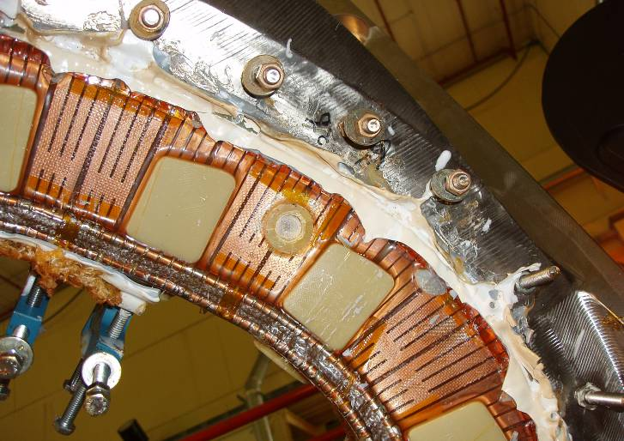
G-11 Pad Locations
G-11Sprue Ring
Figure 8- G-11 Pad Location

Each clamp will provide 125 lbs of pre-load. This is accomplished by hand tightening the pusher screw until it is in full contact with the G-11 coil pad. Then turn the screw an additional 1/4 turn. [Locations # 1, 2, 3 and 5] See Figure 10- Torque Reference Locations for identification numbers of joints. Record all torque verifications in Error: Reference source not found

Once all of the final coils clamps have been torqued, the temporary bolts at locations 3 and 5 shall be removed and replaced with set screws. The hardware shall be wire-locked and or tack welded together to ensure that the bolts will not loosen during operation.

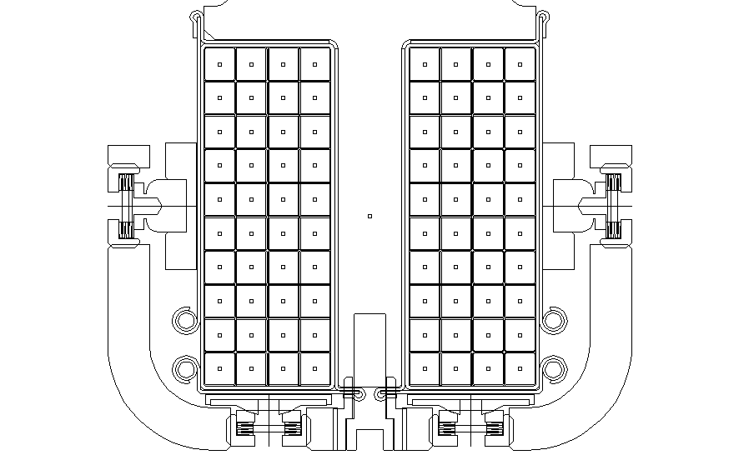
Figure 9- Coil Clamp Assembly

Location No. 4
Location No. 3
Location No. 5

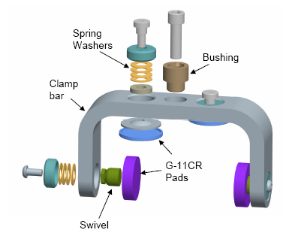
Location No. 2
Location No. 1
Figure 10- Torque Reference Locations

Figure 11- Typical Spring Washer Stack Up

Figure 12-Typical Winding Clamp Arrangement
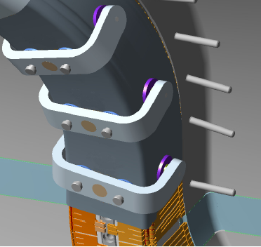

Table 2- Coil Clamp Torque Data
Torque verified | Torque  #1 | Torque  #2 | Torque  #3 | Torque  #4 | Torque  #5
Clamp No.
1
2
3
4
5
6
7
8
9
10
11
12
13
14
15
16
17
18
19
20
21
22
23
24
25
26
27
28
29
30
31
32
33
34
35
36
37
38
39
40
41
42
43
44
45
46
47
48
49

All of the clamp hardware has been torqued and secured.

Verified By:

Lead Technician: ____________________________ Date: ____________________

Field Supervisor: ____________________________ Date: ____________________

Quality Control: _____________________________ Date: ____________________

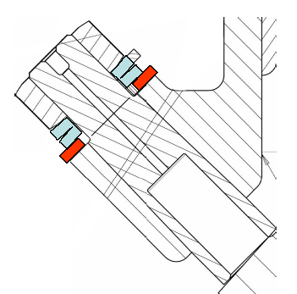
Flat Washer
Belleville Washers
SS Nut
A
B

Figure 13-Electrical Joint Test Setup

Modular Coil Electrical Joints:

Measure the joint resistance between the connector and the terminal blocks [points A and B]. See Figure 13-Electrical Joint Test Setup [Acceptance criterion is < 1 micro-ohms.]

Verify the torque value of the joint nuts. Torque to 15 ft-lbs

Record the joint resistance and torque verification in Table 3- Joint Resistance below.

Table 3- Joint Resistance
Joint ID | Joint Resistance  [μ-ohms] | Torque Verify 15 ft-lb | Wire Tie Nuts | Joint ID | Joint Resistance  [μ-ohms] | Torque Verify 15 ft-lb | Wire Tie Nuts
A-1 |  |  |  | B-1
A-2 |  |  |  | B-2
A-3 |  |  |  | B-3
A-4 |  |  |  | B-4
A-5 |  |  |  | B-5
A-6 |  |  |  | B-6
A-7 |  |  |  | B-7
A-8 |  |  |  | B-8

Wire-lock and/or tack weld each of the nuts to ensure that during operation they do not loosen. Record verification that joints have been wire tied.

Verified by: _________________________ Date: __________________
Lead Technician

Side A
Side B
A-1
A-4
A-5
A-6
A-8
A-7
A-2
A-3
B-1
B-4
B-5
B-6
B-8
B-7
B-2
B-3
Coil Resistance measured across terminal leads

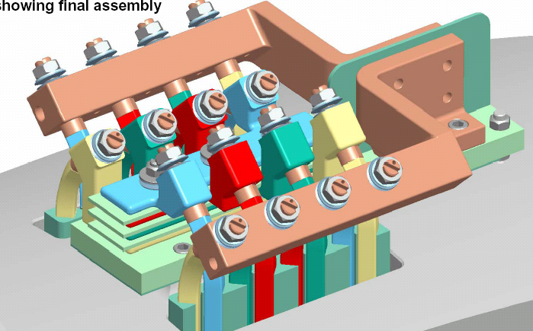
Figure 14- Final Terminal Connections Identification

Final Electrical Testing of Coil [Room Temperature]
This series of electrical tests will be performed at room temperature to verify the integrity of the coil insulation prior to transporting to the field period assembly area.

Tests/measurements to be performed:
  - Capacitance
  - Inductance
  - Coil resistance
  - Polarization Index
  - Insulation resistance

Test Director:
Test Director for this test series is: _______________________

Safety Requirements & Conditions

The following safety requirements and prerequisites shall be used for performing tests on the Modular Coils.

All personnel performing these tests shall be familiar with the hazards and work procedure to minimize accidents that may occur.

A “Safety Watch” shall be appointed by the Test Director. The Test Director shall clearly describe to the Safety Watch his/her responsibilities.

Name of Safety Watch: ______________________

Responsibilities have been clearly discussed with Safety Watch:

Verified: ________________________________ Date: ________________
Test Director

Responsibilities of a Safety Watch include as a minimum:

a) Monitoring the operations in an attempt to prevent careless or unsafe activities.

b) Shutting down the power in case of an accident.

c) Contacting ESU in case of accident

d) Additional responsibilities of a Safety Watch can be found in the ES&H Manual Section 2, Chapter 2.2.6.

During the test, the “Test Area” shall be roped-off and suitable “danger high voltage” signs and flashing lights displayed.

Test Area has been safed:

Verified by: _________________________ Date: __________________
Test Director

The test operator shall stand on an electrical safety mat during the test operation.

Approved rubber electrical safety gloves shall be worn by test members during grounding operations which occur once the test has been completed, and the test equipment turned off.

Upon completion of test and before the components are declared safe to touch, (dielectric joint) being tested shall be properly discharged using a “Ground Hook”. After a minimum period of 10 seconds, while the ground hook is still in place, attach a ground cable to the casting and poloidal mid-plane. The ground hook may be removed once the ground cable is in place.

Electrically ground the winding form, and chill plate cooling tubes. Care must be taken not to damage the tubes with the grounding clips.

Coil Capacitance Measurement

Equipment Name: ___________________________________________________

Equipment ID Number: __________________________ Calibration Date: _____________

Coil Inductance Measurement

Equipment Name: ___________________________________________________

Equipment ID Number: __________________________ Calibration Date: _____________

Coil Resistance Measurement
Measure the resistance of the entire modular coil at the terminal leads. [See Figure 14- Final Terminal Connections Identification]

Acceptance criteria: As specified in specific Modular coil design specification [A, B and C]

Coil Resistance: ____________________ per specification

Equipment Name: ___________________________________________________

Equipment ID Number: __________________________ Calibration Date: _____________

Using the bridge probe, make pressure contact on the ends of the system bus being tested.

Record the resistance readings in Figure 15- Coil Resistance.

Place temperature sensor on the surface of the bus leads and record the temperature of the copper after the reading stabilizes.
R20 = 254.5 x Rc
234.5 + Tc
Where: Rc = measured resistance of the conductor (milliohms)
Tc = temperature of coil when resistance measurement is made (degrees C)

Figure 15- Coil Resistance
Measured System Resistance (Rc)  mΩ at Tc | System Resistance corrected to 20 deg. C (R20) | Calculated System Resistance @ 20 deg.C  [per MC specification]
Rc:
Tc:

Resistance Results: Acceptable: _______________ Unacceptable: ____________

Test Director Signoff: _____________________________ Date: ______________

Polarization Index [PI] Measurement
The Polarization Index (PI) is a RATIO. Insulation at the specified voltage is taken at 1 minute (R1) and at 10 minutes (R10). The ratio R10/R1 is the PI.

Equipment Name: ___________________________________________________

Equipment ID Number: __________________________ Calibration Date: _____________

Acceptance criteria: Polarization Index [PI] >4

Insulation Resistance Measurement

Perform a Final Megger test of the completed coil prior to transporting to the field period assembly.

Coil Voltage level: 7500 volts

Acceptance criteria: Coil Insulation Resistance: >1K Meg ohms

Complete the steps below and perform the insulation resistance test [Megger] of pancakes “A” and “B”. Pancakes “A” and “B” are connected together at the terminal block.

Test director shall verify that all safety requirements and prerequisites have been performed prior to starting the test.
  - Verify that the turning fixture is well grounded to building steel.
  - Place the megger test set on a firm, stable surface.
  - Securely connect a ground cable between building steel and the test unit.
  - Connect the megger ground lead to the coil casting.
  - Connect a ground cable to the chill plates.
  - Connect the megger power lead to the coil leads.
  - Measure the insulation resistance to ground. The test results shall be in compliance with the requirements noted in Section 6.17.3.

Table 4 - Final Megger Test Results
Test Voltage | Insulation Resistance Minimum 1KMΩ | Observations
1000
2000
3000
2500
5000
7500

Equipment Name: ___________________________________________________

Equipment ID Number: __________________________ Calibration Date: _____________

Megger Results: Acceptable: _______________ Unacceptable: ____________

Test Director Signoff: _____________________________ Date: ______________

Quality Control Witness: __________________________ Date: ______________

Remarks:

Name Tag Installation:
Mount a permanent name plate to the outside of the winding form adjacent to the leads. The name tag will include the name of the item and the part and serial number of the item. [E.g. NCSX Modular Coil Type C Assembly, P/N SE140-103, S/N C1.] See Figure 16- Modular Coil Name Tag [example] Mounting details TBD

Name Tag Information:
Name of Item: Modular Coil Coil Type: __________ S/N: ______________

Part number [Dwg No.]: ________________________

Installation of name plate complete:

Verified by: _________________________ Date: __________________
Field Supervisor

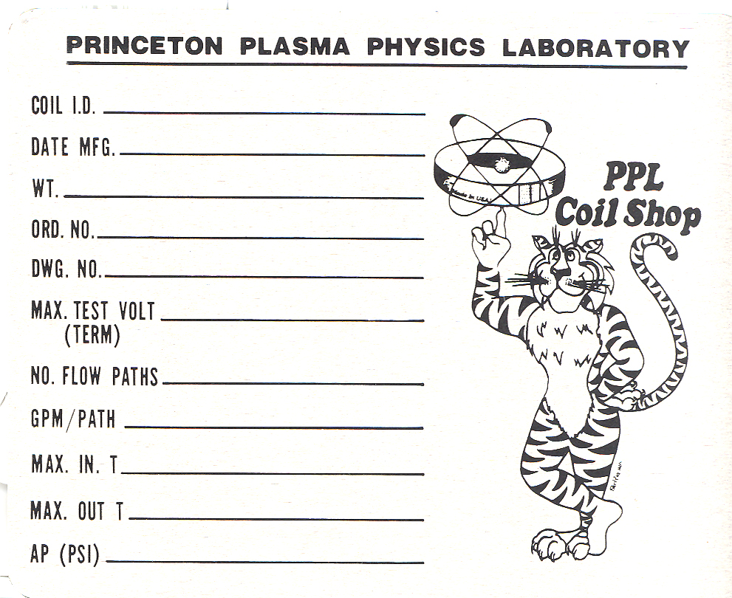
NCSX Modular Coil Type C Assy
May 31, 2006
6050 lbs
SE141-103
7.5 kV
N/A
N/A
8
N/A
C1
N/A

Figure 16- Modular Coil Name Tag [example]

Strain Gages and Thermocouples [Optional at this point]
The strain gages and thermocouples may not be installed at this time. If that is the case the post VPI activities at station 1b are complete. Otherwise install strain gages and thermocouples to the finished coil in the locations identified by the WBS 14 manager. This information will be added as an addendum to this procedure.

Use the following steps to attach the strain gages.

Degrease and clean the surface with Isopropyl alcohol.

Dry abrade the gauging surface with 220 to 320 grit silicon-carbide paper to remove any scales or oxides on the base material to improve adhesion.

Degrease and clean the surface with Isopropyl alcohol.

Dry abrade the gauging surface with 220 to 320 grit silicon-carbide paper to remove any scales or oxides on the base material to improve adhesion.

Apply M-Prep Conditioner A and wet-abrade the gage area. Then repeat procedure by wet abrading and wiping using 400 grit silicon-carbide paper.

Apply liberal amount of M-Prep Neutralizer 5A to the gage area. Remove the Neutralizer by slowly wiping through the gage area using a gauze sponge.

Remove the gage from its transparent envelope and place bonding side down on a chemically clean glass plate or empty gage box. Using Kapton tape as a carrier, position the gage/tape assembly onto the specimen. Holding the tape at a shallow angle, wipe the assembly onto the specimen surface.

Lift the gage end of the assembly [about a 45 º angle] until the gage and terminal are free of the specimen surface.

Apply a thin layer of prepared adhesive [M-Bond AE-10] to both the specimen and back of the gage.

Lift the end of the tape and bridge over the adhesive at approximately a 30º angle. With a piece of gauze, slowly make a single wiping stroke over the gage/tape assembly. Use a firm pressure with your fingers when wiping over the gage.

Using the “Romer” measuring arm, document the position of the sensors that were just installed on to the coil.

Installation of sensors is not required at this time:

Verified by: _________________________ Date: __________________
Field Supervisor

Table 5- Coil Sensor Table
No. | Sensor Type* | Description
1
2
3
4
5
6
7
8
9
10
11
12
* Sensor type: Stain gauge or thermocouple

Installation of sensors is complete:

Verified by: _________________________ Date: __________________
Field Supervisor

Transporting MCWF from Casting Prep Station 1b to Station 1a:
Using lift procedure D-L-NCSX-984 the modular coil winding form shall be transferred from the turning fixture [Figure 2- Turning Fixture] at station 1b to the casting assembly fixture at station 1a.

Install the upper support plates that secure the support ring to the support/lift beam. This operation must be verified prior to proceeding. See Error: Reference source not found

Verified by: _________________________ Date: __________________
Lead Technician

- SAFETY NOTE 1: Use scaffolding or appropriate ladders while working on upper section of turning fixture. Scaffolding must be inspected prior to use per Section 9 Chapter 5 in PPPL ES&H Manual.

- SAFETY NOTE 2: Safety glasses MUST be worn when operating the pneumatic impact wrenches

Remove the balance weights and plates on the bottom of the ring assembly.

Using the lift procedure data sheet rig the upper support/lift beam to the overhead crane.

Once a slight load has been taken, remove the hardware that secures the upper support/lift beam to the turning fixture frame.

Compress the springs under the gear box (drive system) until they are bottomed.

Disengage and remove the upper guide rollers. NOTE: The rollers are hinged and swing into position. Lifting is not required

Carefully raise the winding form/ring assembly from station 1b and transport to stations 1a, directly over the casting assembly fixture.

Verified by: _________________________ Date: __________________
Lead Technician

Disassembly of coil/casting from Support Ring Assembly:

Secure the coil support ring to the casting assembly fixture. Figure 17- Casting Assy. Fixture- Vertical Position

Using the overhead crane, carefully lower the coil/support ring assembly until the coil is in the horizontal position and resting on the support stands. Figure 18- Casting Assy. Fixture in Horizontal Position

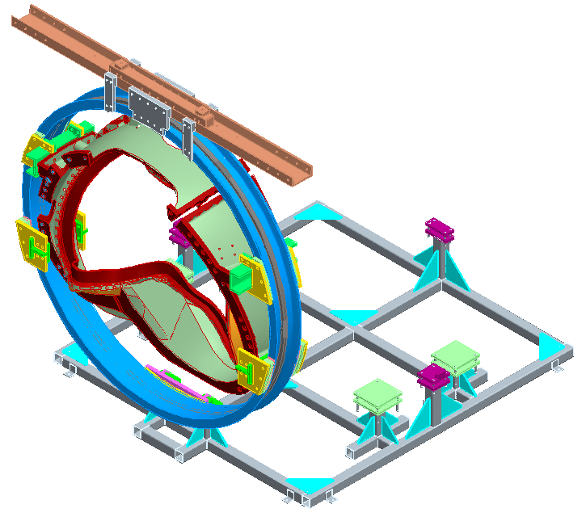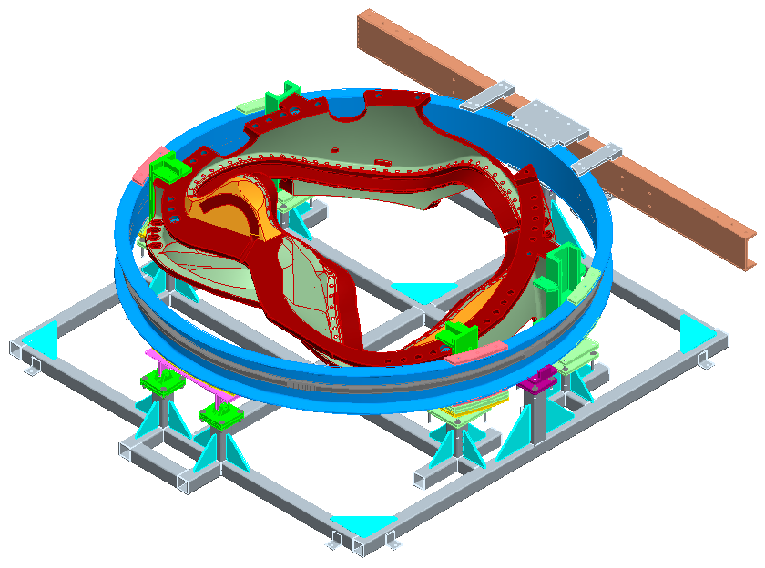
Secure support ring to assy. fixture
Figure 17- Casting Assy. Fixture- Vertical Position
Figure 18- Casting Assy. Fixture in Horizontal Position

Disassemble the support/lifting beam and support brackets between the support ring and casting

- SAFETY NOTE: The use of leather gloves and steel tipped shoes is required during the assembly of the support brackets to the winding form and ring assembly.

Lift the support ring from the assembly fixture and transport to storage area. Figure 19- Assy. Fixture without Lift/Support Beam

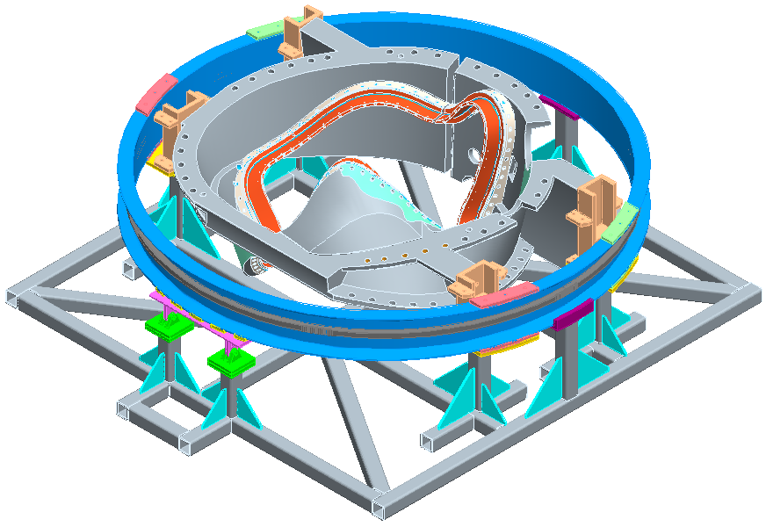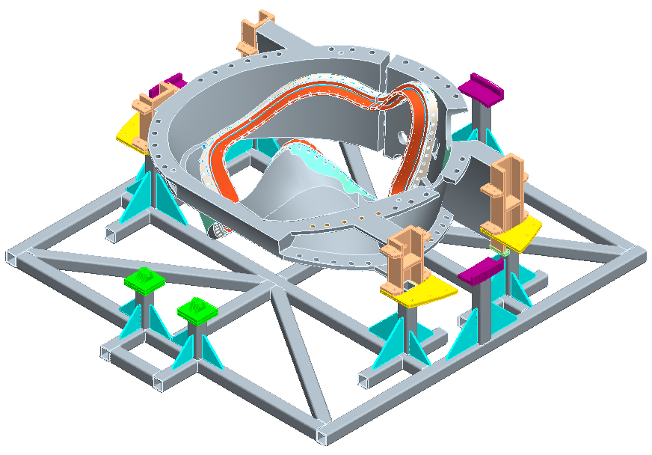
Figure 19- Assy. Fixture without Lift/Support Beam
Figure 20- Coil without Support Ring

Mount the coil stands to the completed winding form. [SE144-031]

Using lift procedure D-L-NCSX-996 [Finished Modular Coil Lift Procedure] transfer the completed modular coil from station 1a to a location determined by the Field Supervisor.

Verified:

Lead Technician: ____________________________ Date: ____________________

Field Supervisor: ____________________________ Date: ____________________

Completion of Activities at Post VPI Station:

Document Verification:
Verify that all pertinent data in the procedure and data sheets have been completed.

Field Package:
Ensure that all data sheets, photographs, QC inspection sheets, etc are included in the “Coil Field Package”.

Action Ticket:
An “Action Ticket” shall be generated by the Field Supervisor, identifying outstanding tasks that need to be completed prior to the modular coil considered complete. Once all tasks have been completed it shall be signed by the Field Supervisor and QC representative. The “Action Ticket” shall be secured to the winding form/coil and remain until all tasks have been completed. It shall be displayed in plane view. Place completed “Action Ticket” in the Document Packet once it has been completed.

Approval:
Prior to releasing a modular coil , it is required that the all-responsible individuals sign the release indicating that all processes at the Post VPI station have been satisfactorily completed. The release will include signatures from the Station Lead Technician, Field Supervisor and the QC representative.

All Post VPI activities have been satisfactorily completed.

Lead Technician: ____________________________ Date: ____________________

Field Supervisor: ____________________________ Date: ____________________

QC shall verify completion of documentation:

Quality Control Representative: _________________________ Date: ________

Figure 21-Sensor Locations for Type “C” Casting- DELETE

Figure 22- Sensor Locations for Type “B” Casting- DELETE

Figure 23-Sensor Location for Type “A” Casting- DELETE

