Princeton Plasma Physics Laboratory
Procedure
‘
Procedure Title: Personnel Access of the NCSX Autoclave

Number:  D-NCSX-OP-763 |  | Revision:  00 |  |  | Effective Date:  Expiration Date:  (2 yrs. unless otherwise stipulated)
Procedure Approvals
Author: James H. Chrzanowski |  |  |  |  |  | Date:
ATI: James H. Chrzanowski |  |  |  |  |  | Date:
RLM: Larry Dudek |  |  |  |  |  | Date:
Responsible Division: NCSX Project
Procedure Requirements
Designated by RLM
LABWIDE:
X | Work Planning Form # WP-1188 & 1138 (ENG-032) |  | X | Lockout/Tagout (ESH-016)
X | Confined Space Permit (5008,SEC.8 Chap 5) |  |  | Lift Procedure (ENG-021)
 | Master Equip. List Mod (GEN-005) |  | X | ES&H Review (NEPA, IH, etc.) NEPA 1283
 | RWP (HP-OP-20) |  |  | Independent Review
 | ATI Walkdown |  | X | Pre-Job Brief
X | Post-job Brief *
D-SITE SPECIFIC:
X | D-Site Work Permit (OP-AD-09) |  |  | Door Permit (OP-G-93)
 | Tritium Work Permit (OP-AD-49) |  |  | USQD (OP-AD-63)
X | Pre-Job Brief (OP-AD-79) |  |  | T-Mod (OP-AD-03)
 | ** DCA/DCN (OP-AD-104) #

* Required for installations involving internal vacuum installations, critical lifts, and for the initial installation of repetitive work.
** OP-AD-104 was voided by procedure ENG-032. However, DCA’s that were open at the time of adoption of ENG-032 are still considered valid for work approval purposes.

REVIEWERS (designated by RLM) Rec’d/
Incorp.
Comments
Accountable Technical Individual. …………J. Chrzanowski
Test Director
Independent Reviewer Buddy Kearns X
D-Site Shift Supervisor
Independent …………………………………………….Hutch Neilson, Wayne Reiersen XX
NCSX Dimensional Control Coordinator ……………………….
Vacuum
NCSX Field Supervisors… Tom Meighan & Steve Raftopoulos X X
Project Engineer for Stellerator Systems (WBS 1) Manager……
Independent NCSX Engineering …………………
Quality Assurance/Quality Control. …… Colin Phelps X
Maintenance and Operations Division
Energy Conversion System/Motor Control Division Ray Camp X
Engineering ……………………………………..
Environmental Restoration & Waste Management Division
Environmental, Safety & Health……………………………………Jerry Levine, Glenn Anderson X
Industrial Hygiene………………………………………………... Bill Slavin X
Health Physics…………………
RLM ………………………………………………………………..Larry Dudek X

TRAINING (designated by RLM)
No training required ______________ | Instructor Jim Chrzanowski
Personnel (group, job title or individual name) |  | Read Only | Instruction  Pre-job  Briefing | Hands On
Lead Tech. |  |  | X
Technicians performing task |  |  | X
Field Supervisors |  |  | X
Quality Control Representative |  |  | X
Training Rep.
RLM Larry Dudek

Purpose

The purpose of this procedure is to define the requirements and provide a checklist for the safe access of the NCSX Modular Coil Autoclave for the purpose of supporting the vacuum-pressure epoxy impregnation (VPI) of the modular coils for NCSX. It will also include a checklist for Unsafing the autoclave once access is no longer required.

Scope

This procedure will provide the details necessary to access the autoclave chamber in a safe and consistent manner.

An “Access Checklist” MUST be completed at the beginning of each shift that entry into the autoclave is required.

An “Unsafing Checklist” MUST be completed once all activities in the autoclave have been completed, and entry is no longer required.

A copy of the checklist, properly filled in, serves as a permanent record of the procedure each time it is performed.

Responsibilities:

It is the responsibility of the Modular Coil Field Supervisor to ensure the implementation of and adherence to this procedure for autoclave access.

It is the responsibility of the Station 5 [Autoclave/VPI] Lead Technician to complete the autoclave access checklist. The checklist shall be posted along with an approved confined space permit at the personnel access door until the access has been completed. The completed checklist shall be added to the Modular Coil Field Package Book in Section 5. The lead technician shall be appointed by the Field Supervisor.

Applicable Documents:

Confined Space Permit

ESH-016 Lockout/Tagout Procedure

D-NCSX-MCF-003 VPI Procedure

Prerequisites & Conditions:

Pre-Job Briefing:
A pre-job briefing for the autoclave crew will be held prior to the first entry of a new confined space permit. The briefing will describe the processes and safety issues [JHA] associated with the entry. Attendance shall be documented via training sign-in sheet.

- Safety Note 1: Prior to every entry, individuals entering the autoclave are responsible for verifying that the conditions stipulated in the confined space permit are valid and that the Lockout/Tagout of potential hazard sources is in effect.

Access Procedure
The attached “Access Checklist” Must be completed each shift prior to entering the Autoclave. A description of the requirements and safing activities is as follows:

A Confined Space Permit [CSP] MUST be obtained from the PPPL Industrial Hygienist and posted at the entrance to the autoclave. The Responsible person as designated on the CSP or his designee MUST initial all implemented requirements on the CSP prior to initial entry.

Ensure that the air monitor is in calibration, fully charged and located in the autoclave prior to entry. Record the instrument serial number, and calibration date on the [CSP].

Monitor the oxygen level of the autoclave prior to entry. Record the oxygen readings at least daily on the CSP.

All personnel entering the autoclave or acting as Safety Watch MUST be aware of the hazards prior to entering. Individuals should review the Confined Space Permit that is posted at the Autoclave entrance.

A Safety Watch MUST be posted at the entrance to the autoclave during entry.

All electrical power brought into or used in the autoclave MUST be protected by GFCI during entry.

Means of communication with ESU for emergency response MUST be in place and tested prior to entry.

SAFE the electrical hazards associated with the Autoclave. This can be accomplished by following the steps in sections 6.8.1 thru 6.8.2.

Shed load:

- Safety Note 1: During the de-energizing of the electrical boxes personnel MUST be qualified with current Electric Utilization Training

- Safety Note 2: Personnel MUST wear safety glasses (or goggles) and fire retardant natural fiber clothing [long-sleeve and long pants]. Fire retardant coverall’s are located at the high voltage electrical boxes.

Turn the autoclave heater controller temperature set points to lowest setting.

Turn to the “OFF” position the Air Heating Starter #MS-4-ACLV. [See Figure 1] The air heating starter #MS-4-ACLV is located on the North side of the autoclave on the 102 ft. elevation. [See figure 6]

Turn to the off position the vacuum pump starters’ #MS-1-ACLV & MS-2-ACLV [See Figure 2]. The vacuum pump starters #MS-1-ACLV & MS-2-ACLV are located on the south side of the test cell next to the autoclave vacuum pumps. [See figure 6]

Lock-out/Tag-out of electrical sources:
This section describes the de-energization and lockout/Tagout of the electrical boxes providing power to the autoclave. [Systems are >240 VAC]

- Safety Note 1: During the de-energizing of the electrical boxes personnel MUST be qualified with current Electric Utilization Training

- Safety Note 2: Personnel MUST wear safety glasses (or goggles) and fire retardant natural fiber clothing [long-sleeve and long pants]. Fire retardant coverall’s are located at the high voltage electrical boxes.

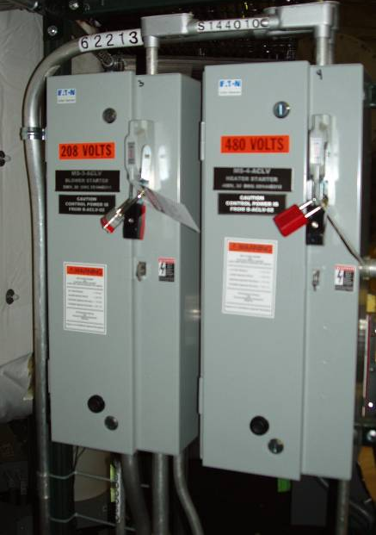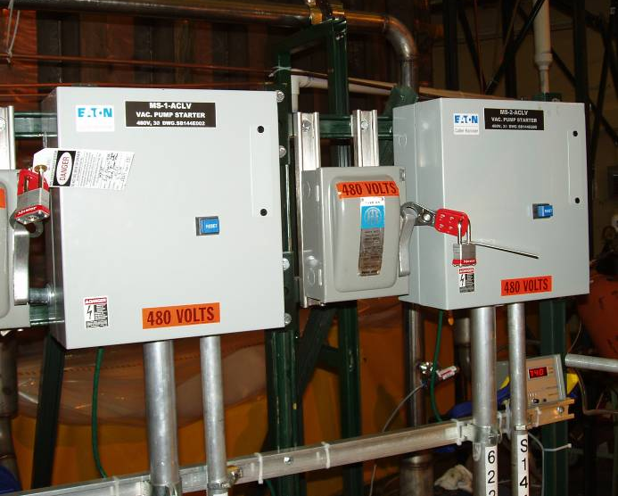
Figure 1- Air Heating Starter Figure 2- Vacuum Pump Starters

Verify that system ready lights on the side of box #B-ACLV-01 are lit. [See Figure 3] Box #B-ACLV-01 is located in the southwest side of the Test Cell, behind station 4 [See Figure 6]

De-energize circuits and LOCK OUT/TAG OUT Electrical Boxes #PCB-66 and PCB-67 [See Figure 3] using LO/TO procedure ESH-016. Electrical Boxes #PCB-66 and PCB-67 are located in the southwest corner of the Test Cell, behind station 4 [See Figure 6].

Fill out LO/TO log for tags placed in accordance with ESH-016.

System ready lights on side of box #B-ACLV-01 should now be OFF. This verifies that the circuits are de-energized.

Open [de-energize] switch #PD-201 and LOCK OUT/ TAG OUT by using LO/TO procedure ESH-016. [See figure 4] Electrical Switch #PD-201 is located in the southwest corner of the Test Cell, behind station 4. [See Figure 6]

Fill out LO/TO log for tags placed in accordance with ESH-016.

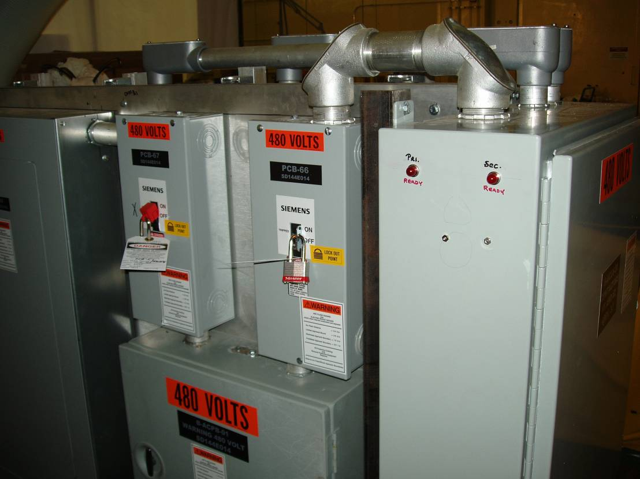
Ready Lights on box B-ACLV-01
Box PCB-66
Box PCB-67
Figure 3- Electrical Box PCB-66 and PCB-67

Figure 3- Electrical Boxes PCB-66 and PCB-67

Figure 3- Electrical Boxes #PCB-66 and PCB-67

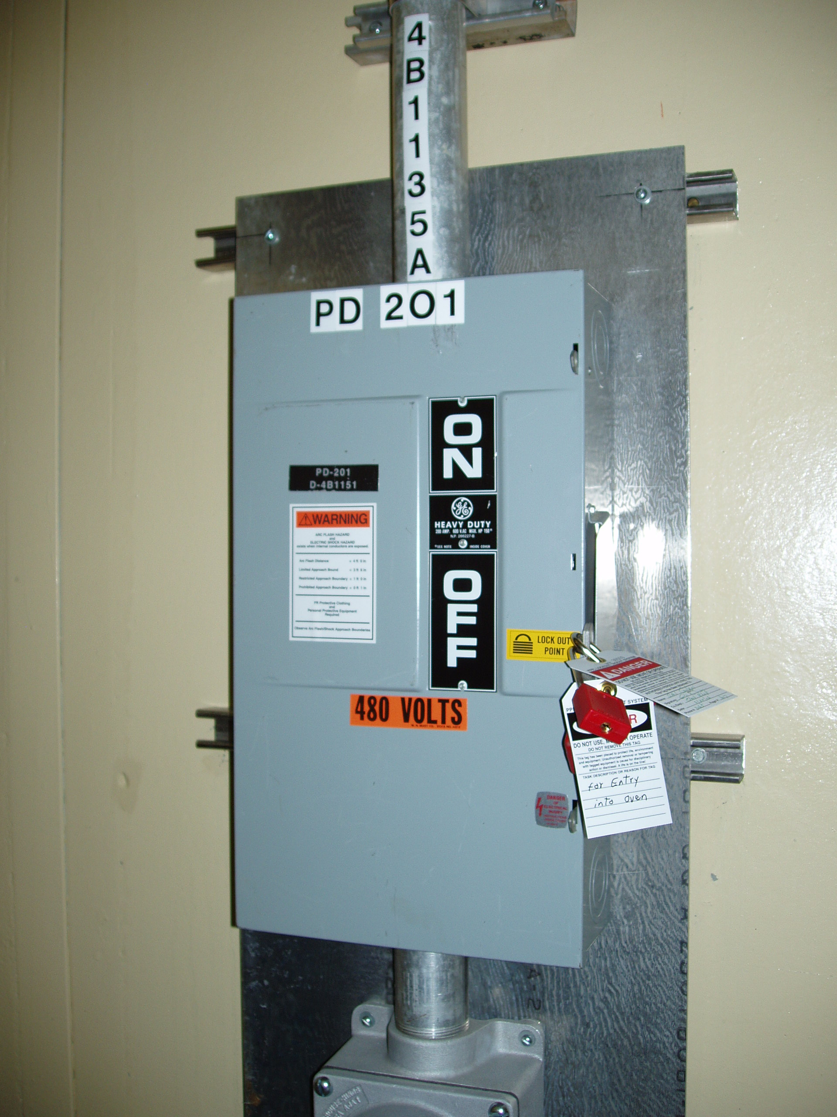 Figure 4- Electrical Switch PD-201

SAFE the inert gas source using steps 6.9.1 thru 6.9.3.

Disconnect both the 10 PSI line from the N2 bottles. [See figure 5] The inert gas source is located on the south side of the test cell next to the autoclave vacuum pumps. [See figure 6]

Place lock-out device and LOCK OUT/ TAG OUT on disconnected end of line.

Fill out the LO/TO log for tags placed in accordance with ESH-016.

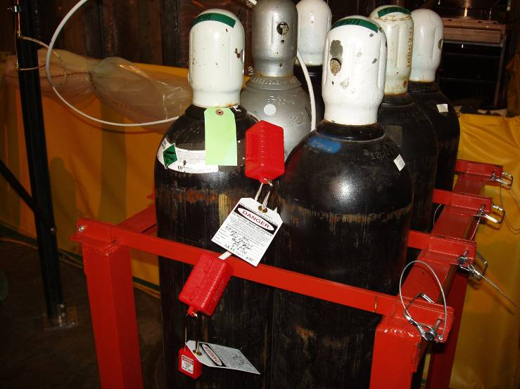
Figure 5- Nitrogen Gas Source

Air Heating Starter (MS-4-ACLV) [102’ elev] Fig. 1
Panels PCB-66 & 67 [Fig. 3]
Switch PD-201 [Fig. 4]
Vacuum Pump starters
(MS-1-ACLV & MS-2-ACLV) [Fig. 2]
Nitrogen Gas Source [Fig. 5]
Autoclave Entrance
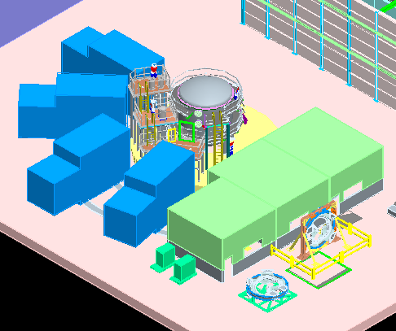
Figure 6- Location of Shut off Controls in Winding Facility

Ensure that there is sufficient ventilation in the autoclave during entries. If the lid is in position, forced ventilation may be required. This is at the discretion of the PPPL IH representative. If the lid has been removed, forced ventilation is not required unless otherwise noted by the PPPL industrial hygienist.

Post the current check list at the point of entry into the autoclave. Place used checklists in the Checklist Log Book that will be located at Station 5 [Autoclave]

Ensure that the current JHA for performing work in the autoclave is posted at Station 5.

HOT ENTRY
During the VPI operation, it may become necessary to enter the autoclave to make a repair to the “bag” mold or epoxy lines after the VPI process has begun. Entry into the autoclave can only be made if the temperature inside the autoclave is <50º C. [Reference: procedure D-NCSX-MCF-003 section 6.11]

- Besides the requirements identified above additional steps are required as outlined below prior to entry:

The autoclave blower MUST be in the purge mode.

A minimum of 6 air exchanges MUST be completed prior to entry. [Approximately 30 minutes]

Industrial Hygiene MUST be contacted prior to entry.

Personnel Protective Equipment MUST be used during entry [See safety note below].

- Safety Note: Personnel entering the hot autoclave MUST use the approved personnel protective equipment as identified below:
  - Position heat protection blankets in the entry way of the autoclave
  - Insulated gloves [heat] Must be worn
  - Flame retardant overalls with long sleeves and legs MUST be worn.

Unsafing Procedure
The attached “Unsafing Checklist” Must be completed once when all entries are complete and the confined space permit is being withdrawn. No entry is allowed once this checklist has been completed. A description of the requirements and Unsafing activities is as follows:

Note: The Field supervisor MUST first approve the start of the “Unsafing” procedures.

Close and secure the door [hatch] to the autoclave. This step MUST be completed prior to any subsequent step.

Remove the properly filled out “Confined Space” Permit and return to the PPPL Industrial Hygienist.

Remove the last active “Access Checklist” and place in the Access Checklist log Book.

Remove the lock and tag from the inert gas source using LOCK OUT/TAG OUT procedure.

Fill out LO/TO log indicating that the lock and tag has been removed in accordance with ESH-016.

Remove the lock and tag from the switch #PD-201 using LOCK OUT/TAG OUT procedure.

Fill out LO/TO log indicating that the lock and tag has been removed in accordance with ESH-016.

Remove the lock and tag from the Electrical Boxes #PCB-66 and PCB-67 the using LOCK OUT/TAG OUT procedure.

Fill out LO/TO log indicating that the lock and tag has been removed in accordance with ESH-016.

Once the locks and tags have been removed, leave the electrical circuits in the OPEN position until the autoclave is ready to be used.

- Safety Note 1: During the re-energizing of the electrical boxes personnel MUST be qualified with current Electric Utilization Training

- Safety Note 2: Personnel MUST wear safety glasses (or goggles) and fire retardant natural fiber clothing [long-sleeve and long pants]. Fire retardant coverall’s are located at the high voltage electrical boxes.

AUTOCLAVE ACCESS CHECKLIST [each shift]
Individual completing
Checklist: ___________________________________________ Date: ___________________

Modular Coil ID [in autoclave]: ________________________

Note: Checklist must be completed at the beginning of each shift that autoclave entry is required. INITIAL

6.1 Obtain a Confined Space Permit and verify that all permit requirements have been completed. __________

Normal _______________ Hot Entry ___________ [check one]

6.2 Air monitor is fully charged, calibrated and operational. __________

6.3 Monitor oxygen level prior to entry. __________

6.4 Personnel entering the autoclave have been informed of hazards. __________

6.5 A Safety Watch is posted at autoclave entrance. __________

6.6 All electrical power used in Autoclave MUST be GFCI. __________

6.7 Communication with ESU in place and tested. __________

6.8 All electrical systems have been de-energized, locked and tagged. List LO/TO number in space provided.

-Electrical box PCB-66 is de-energized, locked, tagged and logged. LO/TO# _________ __________

-Electrical box PCB-67 is de-energized, locked, tagged and logged. LO/TO# _________ __________

-Electrical Switch PD-201 is de-energized, locked, tagged and logged. LO/TO# _________ __________

6.9 Inert gas supply has been disconnected and locked, tagged and logged. LO/TO# _________ __________

6.10 Air ventilation: [check one] __________

Force air ventilation is not required [Lid removed]: __________

Force air ventilation is required and implemented: __________

6.11 Checklist is posted at entrance to autoclave. ___________

6.12 Ensure that the current JHA is posted. ___________
6.13 “Hot” Entries: Besides the steps above, the following MUST be completed.
6.13.1 The autoclave blower MUST be in the purge mode. ___________

6.13.2 A minimum of autoclave 6 air exchanges are complete ___________

6.13.3 The PPPL Hygienist has been contacted ___________

6.13.4 Personnel Protective equipment for “Hot” entry is available. ___________

AUTOCLAVE UNSAFING CHECKLIST

Field Supervisor Approving
Unsafing Operation: ____________________________________ Date: __________________

Individual completing
Checklist: ____________________________________ Date: ___________________

Modular Coil ID [in autoclave]: ________________________

Note: This checklist must be completed once all entries into the autoclave have ended and systems can be Unsafed.
INITIAL

7.1 Close and secure the door [hatch] to the autoclave. [MUST be completed first] __________

7.2 Remove the “Confined Space” Permit and return to the PPPL IH. __________

7.3 Remove the last active “Access Checklist” and place in the Access Checklist log book __________

7.4 Remove the lock and tag from the Inert gas supply __________

- Fill out LO/TO log indicating that the lock and tag has been removed __________

7.5 Remove the lock and tag on Electrical Switch PD-201 __________

- Fill out LO/TO log indicating that the lock and tag has been removed __________

7.6 Remove the lock and tag from electrical box PCB-66 __________

Remove the lock and tag from electrical box PCB-67 __________

- Fill out LO/TO log indicating that the lock and tag has been removed __________

-----------------------------------------------------------------------------------------------------------------------------------------------------
All systems have been Unsafed and entry into the Autoclave is prohibited.

Verified: __________________________________________ Date: _________________________
Lead Technician

Verified: __________________________________________ Date: _________________________
Modular Coil Field Supervisor

