NCSX

Modular Coil Winding Facility

Operations Plan

NCSX-PLAN-MCWFOP-01-00

March 15, 2004

Author: _______________________________________ Date: __________________
James H. Chrzanowski- Coil Facility Manager

Reviewed By: _________________________________ Date: __________________
Steve Raftopoulos- Field Supervisor

Reviewed By: _________________________________ Date: __________________
Tom Meighan- Field Supervisor

Reviewed By: _________________________________ Date: __________________
Judy Malsbury- NCSX QA Representative

Reviewed By: _________________________________ Date: __________________
Jerry Levine- PPPL Safety Representative

Reviewed By: _________________________________ Date: __________________
Bill Slavin- PPPL IH Representative

Approved By: _________________________________ Date: __________________
Phil Heitzenroeder- RLM for Coil Facility

RECORD OF CHANGE

Revision | Date | Description of Change

TABLE OF CONTENTS

Section Description Page

- Introduction and Scope
  - Introduction
  - Scope

- Applicable Documents

- General Description of Modular Coils

- Facilities and Work Stations
  - Facility Description
  - Work Station Description

- Manufacturing Inspection & Test Plan (MIT)

- Responsibilities

- General Facility Operating Guidelines

- Safety and Training Requirements
  - Integrated Safety management (ISM)
  - Job Hazard Analysis Survey (JHA)
  - Safety Walk-Thru
  - Training
  - Personal Protective Equipment (PPE’s)
  - Safety Meetings

- Meetings and Communication
  - Daily Startup Meeting
  - Safety Meeting
  - Pre-job Briefing
  - Post-job Briefing

- Documentation Control

- Quality Assurance/Quality Control

- Introduction and Scope

  - Introduction
The National Compact Stellerator Experiment (NCSX) Modular coils will be manufactured at the Princeton Plasma Physics Laboratory (PPPL) for the NCSX Project. This document describes the general operating plan that will be used during the manufacturing of the modular coils.

  - Scope
    - This document will describe how the modular coil facility will function during the coil-manufacturing phase. This document includes:
      - General description of the Modular Coils
      - Description of the manufacturing facility and workstations.
      - General description of the MIT plan and procedures.
      - Flow plan outlining the operation in the facility.
      - Responsibilities during manufacturing
      - Safety & Training Requirements
      - General operating guidelines
      - Meetings and Communication
      - Documentation Control
      - Quality Assurance/Quality Control

    - This “General Operating Plan” along with the Manufacturing, Inspection and Test (MIT) plan will govern the processes by which the modular coils will be fabricated.

- Applicable Documents

  - ESH-004……………… Job Hazard Analysis
  - ES&H 5008…………… PPPL Environmental, Safety and Health Manual
  - NCSX-MIT/QA-142-01-00…Mfg., Inspection, Test/QA Plan for Modular Coils
  - NCSX-CSPEC-140-XX Modular Coil Specification
  - WP-1019 ……………… Work Planning Form for Winding Prototype Mod.Coil
  - WP-1038 …………… Work Planning Form for Winding Production Mod Coil
  - ESH-008 ……………… Access to Radiological Areas (RCA’s)
  - NEPA 1283 …………... Modular Coil Development and Production

- General Description of Modular Coils
The Modular Coil Set consists of three field periods with 6 coils per period for a total of 18 coils. Due to symmetry, only three different coil shapes are required to make up the complete coil set. Each modular coil is constructed by winding pre-insulated rectangular compacted copper cable onto a stainless steel cast winding form. Each coil consists of two double pancake windings. Once wound, the entire coil will be vacuum-pressure impregnated (VPI) with epoxy. The winding forms are bolted together to form a complete torus and are electrically insulated from each other at the bolted flange interfaces. The coil set will be pre-cooled to cryogenic temperatures before each experimental pulse by helium or nitrogen gas. Figure no.1 shows the (3) different modular coil types.

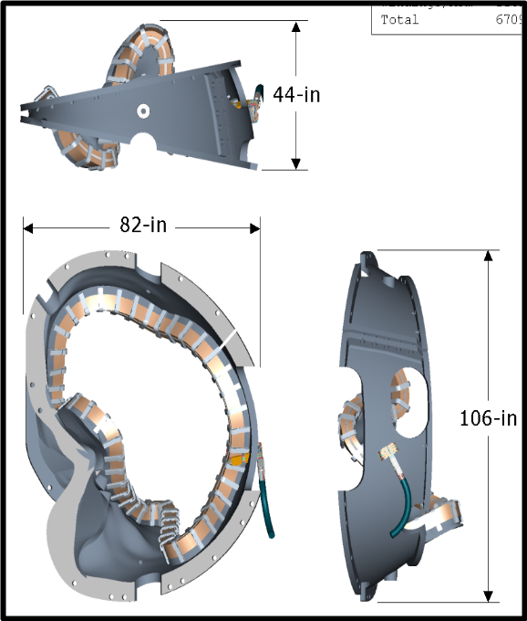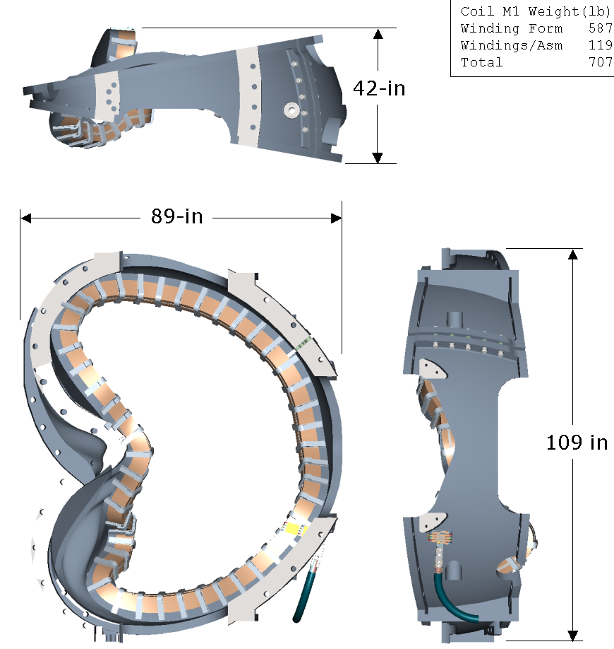
Type B Type A

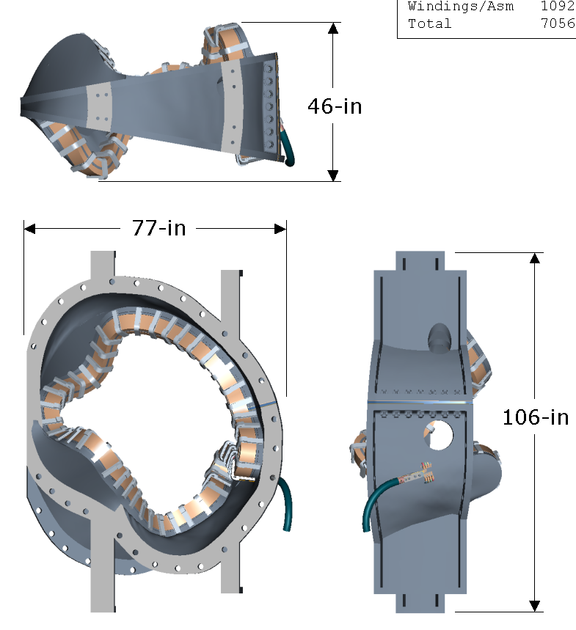
Figure No. 1- Modular Field Coils
Type M3

- Facilities and Work Stations
The Modular Coils will be fabricated in the vacated TFTR Test Cell at D-site. The winding operations will share the test cell with the Field Period Assembly operations. The coil testing facility as well as the coil storage area will be located in the Test Cell basement. The Test Cell has adequate climate control needed for comfort and tolerance control and crane capabilities. There are a total of six [6] workstations associated with the manufacturing of the modular coils. The facility [TFTR Test Cell] will from here on be identified as the “Coil Manufacturing Facility”. The basement area will be identified as the Coil Test Facility and the Modular Coil Storage Area.

  - Facilities Description:
    - Crane Capacity: The manufacturing facility has an overhead trolley crane with (2) hooks.
Load capacity: Large hook- 110 Ton
Small hook/ 25 Ton

    - Climate Control: The coil manufacturing facility environment will be maintained at a constant 75 degrees F +/- 5 degrees with 50% relative humidity +/- 10%

    - Work Space: Test Cell has over 14,000 square feet of floor space that will be shared between the coil manufacturing facility, field period assembly activities plus the remaining neutral beams from TFTR. The coil winding facility will need a minimum of 3500 square feet of floor space.

  - Work Station Descriptions:
There are a total of [6] work stations associated with the production of the Modular Coils. Stations 1 thru 5 are located in the Coil Manufacturing Facility (Test Cell). Station No. 6 is located in the basement.

    - Station No. 1- Casting Preparation:
At this station the modular coil castings are inspected, measured and cleaned. The coil clamp studs are welded in position, and the inner chill plates and inner diagnostics are installed

    - Stations 2 & 3- Coil Winding:
At these (2) stations the cable conductors are wound onto the stainless steel winding forms. Work at this station includes the installation of the Groundwrap insulation as well as completion of the coil leads. These stations will be enclosed with a ceiling and walls to better control the cleanliness of the winding environment.

    - Station No. 4- Mold Preparation:
At this station, the outer chill plates, outer diagnostics, coil clamps and “Bag Mold” are installed. This station will be enclosed with a ceiling and walls to better control the cleanliness of the winding environment. Additional ventilation will be provided to minimize fumes from the epoxy work being performed inside of the enclosure.

    - Station No. 5- Autoclave/VPI:
This station is comprised of the autoclave [vacuum/pressure oven], epoxy mixing station and epoxy control station for performing the epoxy vacuum-pressure-impregnation of the modular coils.

    - Station No. 6- Test Facility:
This station is located in the Test Cell basement. Each of the modular coils will be electrically tested at liquid nitrogen temperatures to ensure the integrity of the coils.
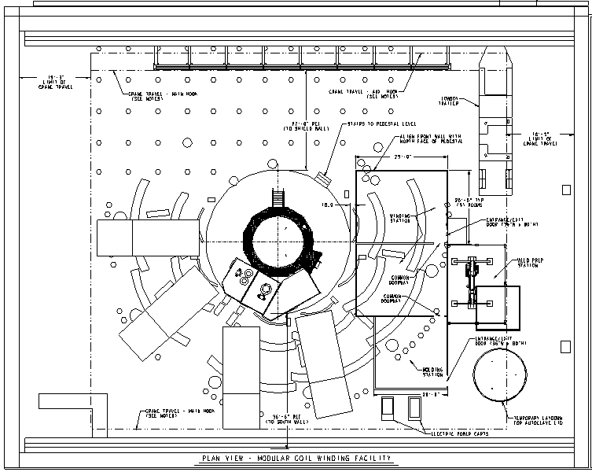

Future Field Period Assembly Area

Coil Exit

Station #2

Station #5
Station #3

Station #1

Station #4

Figure No. 2- Coil Winding Facility Layout

- Manufacturing Inspection & Test Plan (MIT)
The Manufacturing Inspection & Test Plan (MIT) will govern all manufacturing activities. This document will describe the steps required to successfully manufacture, inspect and test the Modular coils. The (MIT) plan document number NCSX-MIT-142-01-00 will identify procedures, travelers; test plans, Field Packages etc. necessary to complete the production of the modular coils.

  - Figure No. 3, below outlines the Flow Plan of the Manufacturing operations.
MODULAR COIL FABRICATION OUTLINE
Casting Preparation
Mount casting to support ring
Measure casting surfaces
Install clamp studs
Clean casting
Install inner chill plates
Install Diagnostics
Winding Facility Activities
Station No.1
Casting Preparation
VPI/Autoclave Activities
Install coil in autoclave and prepare coil for VPI
Vacuum impregnate coil
Cleanup and remove coil
Station No.5
VPI/Autoclave Station
Molding & VPI Preparation
Install outer Diagnostics
Install Outer Chill plates
Install bag mold
Vacuum leak check bag
Install final coil clamps

Station No.4
Molding/VPI Preparation
Winding Operations
Install inner ground wrap insulation
Position leads
Wind side “A” of modular coil
Complete leads
Coil Measurements/electrical tests
Rotate coil
Position leads
Wind side “B” of coil
Positioning leads
Complete ground wrap sides A & B
Station No.2
Winding Station A
Station No.3
Winding Station B
Material Receipt
Conductor receipt & inspection
Casting receipt & inspection
General product inspection guidelines
Material Receipt
Coil Testing Activities
Transport modular coil to test stand
Cold test the modular coil
Basement Activities
Station No.6
Coil Testing

- Responsibilities
This section identifies by discipline, those individuals who will staff the manufacturing facility.

  - Manufacturing Facility Manager: Responsible for the overall operation of the Modular Coil Manufacturing Facility and successful completion of the modular coils. Duties include managing the Field Supervisors; heading daily startup meetings and ensuring that both Integrated Safety Management (ISM) and risk management are incorporated in all aspects of the manufacturing activities.

  - Field Supervisors: The Field Supervisors (FS) report to the Manufacturing Facility Manager and are responsible for managing the lead technicians and field crews. Each FS will have a primary station responsibility as well as sharing the overall supervisory responsibilities. In addition they are responsible for ensuring that ISM and risk management are incorporated in all aspects of the manufacturing activities.

  - Lift Engineer: The Lift Engineer shall monitor and retain overall responsibility for the hoisting and rigging of non-repetitive lifts. (Modular Coils)

  - Coil Test Director: This engineer is responsible for coordinating the testing of each coil in the Coil Test Station located in the Test Cell Basement. He reports to the Manufacturing Facility Manager.

  - Lead Technicians: Responsible for supervising the field crew activities at each workstation. They are also responsible for communicating all questions and/or concerns to the Field Supervisor; filling the station log book on a daily basis; and for ensuring that ISM and risk management are incorporated in all aspects of the manufacturing activities. The Lead Technician reports to the Field Supervisors.

  - Field Crews: Report to the Lead Technician and are responsible for performing the manufacturing activities as identified in the MIT and procedures to successfully complete the fabrication of the Modular Coils. They are also responsible for ensuring that ISM is incorporated in all aspects of the manufacturing activities

  - Health Physics Representative: Responsible for coordinating with the Field Supervisors all health physics issues associated with work being performed in the Coil Manufacturing Facility (Test Cell).

[Note: The Manufacturing Facility is located in a Radiation Controlled Area (RCA) requiring HP coverage to ensure that activities conform to PPPL HP policy.]
Station No. 1
Casting Preparation
(1) Lead Tech. + [3] crew
Field Supervisor *
Steve Raftopoulos

Station No. 2 & 3
Winding stations
(2) Lead Techs + [3] crew
Field Supervisor *
Jim Chrzanowski

Field Supervisor *
Tom Meighan

Station No. 4 & 5
Mold prep & VPI
(1) Lead Tech. + [6] crew
Station No. 6
Coil Testing
(1) Lead Tech. + [TBD] crew
Coil Test Director
Geoff Gettelfinger

PPPL Responsible Line Manager
Phil Heitzenroeder
NCSX WBS 14 Manager
Dave Williamson
* Note: Each Field Supervisor has a primary station responsibility as well as sharing overall field management responsibilities.
Construction Safety Representative
Quality Control Representative
MC Manufacturing Facility Manager
Jim Chrzanowski
Industrial Hygiene Representative
Health Physics (HP) Representative

Indicates a communication link, and not a management link between the participants

Figure No. 4- Modular Coil Manufacturing Facility Organizational Chart

  - Industrial Hygiene Representative: Responsible for reviewing and approving Job Hazard Analysis (JHA) surveys and issuing Confined Space Work Permits. Provides IH technical support to the field supervisors, lead technicians and field crews.

  - Construction Safety Representative: Responsible for reviewing and ensuring that all field activities are being performed safely and in accord with PPPL safety requirements. Responsibilities include working with field supervisors, lead technicians and field crews, making recommendations for types of safety equipment to be used and how to perform work more safely.

  - Quality Control Representative: QC shall work as an independent group, reviewing field activities to ensure that procedures are being followed and that necessary travelers and data sheets are completed in a timely fashion. The QC representative shall apprise the Field Supervisors and Manufacturing Facility Manager of any concerns.

- General Facility Operating Guidelines

  - Field Supervisors appointed by the Manufacturing Facility Manager will supervise all field operations.

  - A Field Supervisor will ALWAYS be on duty in the Modular Coil Manufacturing Facility during working hours.

  - No food, gum, smoking or beverage will be allowed in the MC manufacturing facility. (Radiation Controlled Area “RCA”)

  - House-Keeping Rules:
“Good House-Keeping” is an essential element to the success of the manufacturing of the modular coils. The following steps will be taken to enforce this practice.

    - The coil winding and molding stations [Work Stations #2-4] will be housed in a clean environment with walls, ceiling and filtered airflow.

    - Only personnel associated with the coil manufacturing activities may enter Work Stations #2-4 unless approved by the Manufacturing Field Manager or Field Supervisors. Approved names will be posted outside each station.

    - Step-off pads will be used at the entrances of workstations 2-4, to minimize transport of foreign particulate and dirt into the work area. In addition, some sort of approved protection must be worn over street shoes such as booties or other approved foot coverage while in these areas.

    - Either latex or cotton gloves will be required to be worn during the handling of insulated conductor, insulation, fillers or other components used in the construction of the modular coils.

    - It is recommended that lab coats or Tyvex suits be worn by the crew during the winding and molding operations.

    - The manufacturing stations will be cleaned daily at the end of each shift.

  - Hard hats are not required in the Manufacturing Facility (Test Cell) unless the facility crane is in use directly overhead.

  - Each workstation will have a “Station Logbook” that will be filled in on a daily basis by the Lead Technician. Entries will include technical data associated with that station, daily progress, as well as problems and solutions that may arise.

  - A “Daily Summary Report”, outlining the day’s activities will be issued by the Field Supervisor on duty at the end of the shift. This report will briefly outline the day’s accomplishments as well as manufacturing issues he feels should be included. This report will be e-mailed to a pre-approved list of NCSX project management.

- Safety and Training Requirements
  - Integrated Safety Management (ISM): will be used throughout the coil manufacturing process. It is a “Common sense approach to Doing Work Safely”

    - Seven Guiding Principles for Safety Management
      - Line management responsibility for safety
      - Clear roles and responsibilities
      - Competence commensurate with responsibilities
      - Balanced priorities
      - Identification of safety standards and requirements
      - Hazard controls tailored to work being performed
      - Operations authorization

  - Job Hazard Analysis Surveys: JHA’s will be generated to identify existing or potential workplace hazards and to evaluate the risk of worker injury or illness associated with job tasks. (Reference document ESH-004 “Job Hazard Analysis”) The JHA’s will be reviewed by the IH representative for accuracy as well as completeness. It will be reviewed with all activity participants at the Pre-Job briefings.

  - Safety Walk-thru’s: Daily safety walk-thru’s will be performed by Industrial Hygiene, by Construction Safety and by field supervisors with the intention of identifying and correcting unsafe conditions or activities in the manufacturing area.

  - Training: Training of personnel is key to completing the NCSX fieldwork safely. Courses will be required for all personnel, instructing them in the proper use of tools and equipment; personal protective equipment (PPE’s); and general laboratory policy and safety requirements. All personnel entering the Coil Manufacturing Facility must be Radiation Safety Qualified, must wear current radiation dosimetry, and must sign the Radiation Work Permit (RWP)/Access Log daily.

  - Personal Protective Equipment [PPE’s]: The PPPL Industrial Hygiene and Construction Safety representatives will work together with the Coil Facility Manager to identify the necessary and correct personal protective equipment needed to ensure a healthy and safe work environment for the work force.

  - Safety Meetings: See section 9.2

- Meetings and Communication
Communication between management and the field crews is essential to ensure a successful and cohesive working group. In addition to the meetings described below, other meetings may be held “as required” to keep the work crew informed of laboratory or safety related items.

  - Daily Startup Meetings:
There will be a Daily Startup Meeting to review inter-actions, planning, scheduling and commitments for all activities associated with the Coil Manufacturing Facility.

    - Time: The meetings will be held at 7:10 AM Monday thru Friday prior to the start of field activities and will address the day’s scheduled activities.

    - Location: The meetings will be held in the WCC trailer conference room at D-site.

    - Chairman: The Manufacturing Facility Manager (MFM) or his designee (Field Supervisor) will chair this meeting.

    - Attendees should include the MFM, Field Supervisors, Lead Technicians, Field Crews, Health Physics Representative, Industrial Hygiene Representative, Quality Control Representative and Construction Safety Representative. This list may change depending upon the tasks being performed that day.

  - Safety Meetings:
There will be safety meetings typically every other week to discuss particular safety issues associated with the manufacturing of the modular coils and/or general safety related topics.

    - Time: The meetings will be held at 11:00 AM every other Tuesday and will address safety issues.

    - Location: The meetings will generally be held in the WCC trailer conference room at D-site. However, they may be held in other areas as deemed appropriate for the topic being discussed.

    - Chairman: Either a safety representative or a field supervisor will chair the meetings, as required.

    - Attendees should include the Field Supervisors, Lead Technicians, Field Crews, Health Physics Representative, Industrial Hygiene Representative, Quality Control Representative and Construction Safety Representative. This list may change depending upon the topic of the meeting that day.

  - Pre-Job Briefings: Pre-job briefings are held prior to the start of any new work activity. The purpose of the briefing is to discuss specific work activities, responsibilities of the participants, a review of the JHA/safety issues, and to respond to all questions and concerns. The participants at these briefings should include all individuals who will be involved with the activity including lead technician, field crews, and supervisors. Representatives from construction safety, Industrial Hygiene, Health Physics and Quality Control should be included as appropriate to the job.

  - Post-Job Briefings: A post-job briefing is held at the conclusion of a work activity. These briefings will be held at each station for every modular coil. The purpose of the briefing is to discuss the completed work activities. It should include lessons learned including technique problems, improvements and safety related issues. The participants at these briefings should include all individuals involved with the completed activity or procedure. It should include the lead technician, field crews, and supervisors. Representatives from construction safety, Industrial Hygiene, Health Physics and Quality Control will be included as appropriate to the job.

- Documentation

  - All NCSX associated documents used for manufacturing the modular coils will be under NCSX Project document control.

  - Special Case: The manufacturing of the “Twisted Racetrack Coil and Prototype coils” will be governed by DRAFT copies of the MIT and procedures that will not be approved documents. These documents are being developed and modified for the production coils in parallel to the manufacturing activities for the “Twisted Racetrack Coil and Prototype coil.

  - Each coil will have a separate “Traveler” that will follow the coil from station to station. It will be used to document completion of major activities as well as test results, and measurements. The Traveler will be further discussed in the MIT plan.

  - The Lead Technician or Field Supervisor will document all critical completions on the traveler. This will be completed using the signer’s initials or pre-approved stamps identifying the signer.

  - The “Travelers” will be filled out in a timely fashion once a particular activity has been completed.

  - All documents associated with the manufacturing will be stored in an appropriate location for an indefinite period of time or until the project authorizes their destruction. Documents may be stored either electronic or hard copy.

- Quality Assurance/Quality Control

  - Quality control during manufacturing will be the responsibility of the field supervisors, lead technicians as well as the Quality Control Representative.

  - Measurements and tests will typically be performed by the work crews and engineering. The QC representative should be made aware of planned tests and measurements, but unless required by the procedures, need not be present.

  - The QC representative will review the field activities on a daily basis; checking for completion of documentation as well as compliance with the approved procedures.

  - The QC representative will be a required signature on the traveler that the station activities have been completed and that the coil may move to the next station.

  - The QC representative will report to the laboratory appointed NCSX QA representative. He/she will also inform the Coil Facility Manager of any issues or findings that may be uncovered.

