Document reviewed: D-NCSX-MCF-003/002
Title: MC Fabrication- VPI Station Activities & Bag Mold for the A1 Modular Coil
Date: November 1, 2006
Attendees: Tom Meighan, Bud Kearns, Mike Dimattia, Lance Smith, Bob Tucker, Charlie Hughes, Ed Gilsenan, Jim Benchoff, Mike Anderson, Ron Jakober, Frank Jones, Mark Karlik, Bob Miller, Sly Vinson, Mike Dimattia, Steve Raftopoulos, Larry Dudek, Dave Moser, Mike Hause, Dan Stevens, Troy Hush, Jim Chrzanowski, Neil Gerrish

Comments from De-Briefing:
- This was the first type “A” coil to be epoxy impregnated. It was also the best vacuum achieved on the bag mold for any of the VPI operations [14.7 Torr]. The filling operation started at 10:20 AM, but a breech of the lower bag mold did occur early in the VPI process [11:25 AM]. A “HOT” autoclave entrance was safely made under the watchful eye of IH. The repair of the breech was successfully completed and VPI operations continued approximately 6.5 hours after the initial leak. The balance of the VPI operation went smoothly. The filling operations, including leak repair, took approximately 13 hours.

Safety Concerns:
- None- “Hot Access” into autoclave during repair of leak went smoothly

VPI Operations
- A shutoff and drain valve should be added at the upper manifold to allow for draining excess epoxy if it reaches the manifolds [Action: Bud Kearns]

- Excellent vacuum on the bag mold [14.7 Torr]

- Breech of the lower “Bag Mold” caused quite a stir and required entrance into the autoclave to make repairs. The cause of the breech was being investigated and a review of the bag process was held with the technicians. See below

- Once the Gel temperature was reached, it was observed that there remained sufficient epoxy in the all of the fill lines. [good]

Pre-VPI Activities:
- The Type “A” style coil allows for more viewing access from the autoclave windows. This along with the improved sprue labeling greatly enhanced the team’s ability to observe operations.

- The majority of the epoxy lines were routed and supported with minimal sag. However, there were several lines that should be addressed during the next Type “A” VPI. [Action: Bud Kearns]

Bag Mold Group Discussion:
Several observations were made they may of contributed to the breech in the lower bag mold.

- Insufficient number of exterior support clamps in the lower region where the breech occurred as a result of the positioning of the sprues.
Corrective Action: In the future the lead technicians will, when possible, reposition the sprues to ensure that as many side supports can remain as possible. Otherwise, supplementary clamps will be added at the time that the coil is being readied for the VPI in the autoclave. [No procedure change] [Action: All winding technicians]

- The thickness of the shell mold was insufficient in this area.
Corrective Action: This was stressed in the meeting that the shell thickness is an important element of the mold. In the future the shell in the lower portion of the coil shall be as thick as the aluminum side bars [approximately 0.5 inches] [Action: All winding technicians]

- It appears that only (1) half lapped layer of vulcanized tape was installed in this area.
Corrective Action: To ensure that (2) layers are applied, different color tapes will be used for each layer. [Action: Tom Meighan to procure]

- It was mentioned that some of the VPI grooves have an extremely sharp edge that could have caused the problem.
Corrective Action: Each winding form will be inspected by the casting preparation team and hand filed to remove any sharp edge. [Action: Jim Chrzanowski to add this inspection into procedure]

- The sharp edges of the chill plate/cladding pieces were thought to be the primary cause of the failure. Various methods for correcting this were discussed.
Corrective Action: The 0.010 glass tape that is presently applied over the top surface of the chill plate will be extended over and around the plate/cladding joint and held in place using the RTV108 sealant. [Action: Jim Chrzanowski] This will be added as a procedure change]

Reported by: James H. Chrzanowski 11/2/06

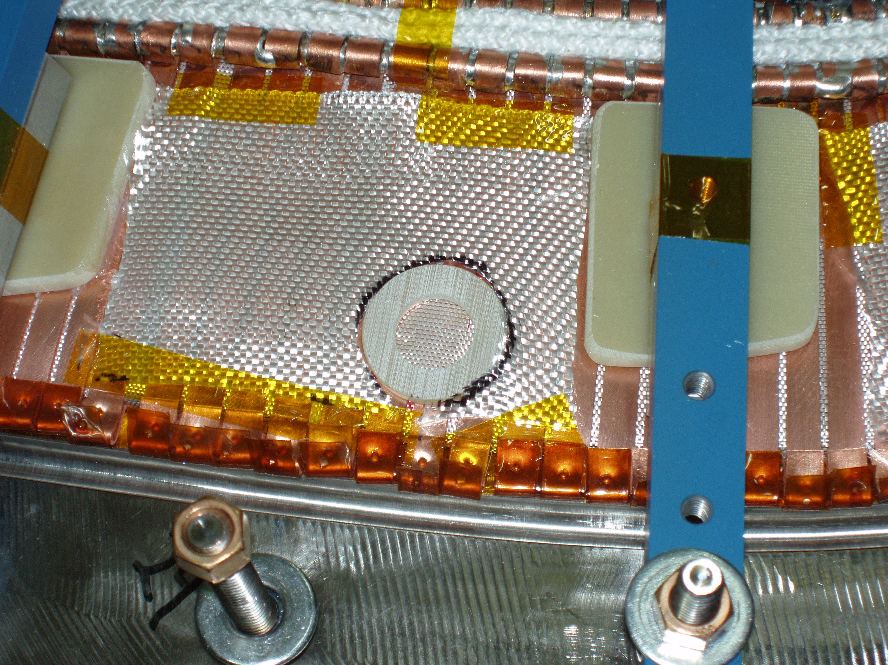
Area in question

