Princeton Plasma Physics Laboratory
Procedure
Procedure Title: Modular Coil Lead Repair-Part 1 Exploration

Number:  D-NCSX-RP-STEL-057 |  | Revision:  00 |  |  | Effective Date:  Expiration Date:  (2 yrs. unless otherwise stipulated)
Procedure Approvals
Author: James H. Chrzanowski |  |  |  |  |  | Date
ATI: James H. Chrzanowski |  |  |  |  |  | Date
RLM: Larry Dudek |  |  |  |  |  | Date
Responsible Division: NCSX Project
Procedure Requirements
Designated by RLM
LABWIDE:
 | Work Planning Form # WP- (ENG-032) |  |  | Lockout/Tagout (ESH-016)
 | Confined Space Permit (5008,SEC.8 Chap 5) |  |  | Lift Procedure (ENG-021)
 | Master Equip. List Mod (GEN-005) |  | X | ES&H Review (NEPA, IH, etc.) NEPA 1224
 | RWP (HP-OP-20) |  |  | Independent Review
 | ATI Walkdown |  | X | Pre-Job Brief
X | Post-job Brief *
D-SITE SPECIFIC:
X | D-Site Work Permit (OP-AD-09) |  |  | Door Permit (OP-G-93)
 | Tritium Work Permit (OP-AD-49) |  |  | USQD (OP-AD-63)
X | Pre-Job Brief (OP-AD-79) |  |  | T-Mod (OP-AD-03)
 | ** DCA/DCN (OP-AD-104) #

- Required for installations involving internal vacuum installations, critical lifts, and for the initial installation of repetitive work.
** OP-AD-104 was voided by procedure ENG-032. However, DCAs that were open at the time of adoption of ENG-032 are still considered valid for work approval purposes.

REVIEWERS (designated by RLM)
Accountable Technical Individual ………………… Jim Chrzanowski
Test Director
Independent Reviewer ……………………………………………Hutch Neilson, Mike Williams XX
D-Site Shift Supervisor …………………………
NSTX ……………………………..
Electrical …………………………….. Raki Ramakrishnan, Bob Marsala X
Vacuum
Computer
Field Supervisor Tom Meighan X
Quality Assurance/Quality Control ……………………………Colin Phelps X
AC Power
Maintenance and Operations Division
Energy Conversion System/Motor Control Division
D & D Rad Waste / H.P Coordinator…………………………………
Environmental Restoration & Waste Management Division
Water
Neutral Beam (Heating Systems Branch of Electrical Engineering)
Radiofrequency (Heating Systems Branch of Electrical Engineering)
Diagnostics
Environmental, Safety & Health ……………………
Industrial Hygience…………………………….. Neil Gerrish
Health Physics……………………………………
RLM……………………….. Larry Dudek X

TRAINING (designated by RLM)
No training required ______________ | Instructor _Jim Chrzanowski
Personnel (group, job title or individual name) |  | Read Only | Instruction  Pre-job  Briefing | Hands On
Technicians performing task |  |  | x
Training Rep.
RLM Larry Dudek

1.0 PURPOSE

This procedure will describe the precautions and steps required to remove the top G-11 plate from the modular coil lead block to expose the lead area. Once the top plate has been removed the lead area will be inspected to determine the location of the electrical short and the type of repair that is required.

- SCOPE

This procedure will include:
  - Prerequisites prior to starting work
  - Steps to be used to open the G-11 lead Box
  - Steps for diagnosing the location of the electrical fault

- REFERENCE DOCUMENTS

  - ESHD-5008, Environmental, Safety and Health Manual
  - Figures No. 1, 2, 3 and 4

- PREREQUISITIES & ES&H ISSUES

  - The ATI or his designee will hold a pre-job briefing. This meeting will include a discussion of the hazards associated with this repair via the Job Hazard Analysis (JHA) sheet. The meeting shall be documented with attendance sheets forwarded to the Training office.

Pre-job Briefing complete: ______________________ Date: ________
ATI Verify

  - Use appropriate Personnel Protective Equipment as outlined in the JHA and procedure.

- Preliminary Tests

  - Measure the resistance of the modular coil at the terminal leads.

    - Test equipment used:

Equipment ID No ___________________ Calibration Date: ______________

Coil Resistance [Rc]: ______________________________ mΩ

Measured By: ___________________________________ Date: ________________

  - Measure the coil inductance at room temperature:

    - Test equipment used:

Equipment ID No ___________________ Calibration Date: ______________

Coil Inductance [L]: ______________________________ henrys’

Measured By: ___________________________________ Date: ________________

  - Repeat the “Null Electrical Test” prior to starting the removal of the G-11 top plate. Compare the results with the tests that were performed in the basement Test Facility prior to cold testing C1. This test involves applying a floating DC current through the coil and then measuring the coil voltages in different locations with respect to ground to determine the null point of the coil.

  - Document the findings from the Null test.

Test Results

- Top Plate Removal procedure

  - During the removal of the top plate, precautions shall be taken to protect the diagnostic flux loops that exit the lead box on both sides of the coil. [Figure 1]

Verified: _______________________________ Date: ___________________
ATI

- SAFETY NOTE: Safety glasses and Kevlar/leather gloves MUST be worn when performing the steps to remove the top plate from lead enclosure.

  - To gain additional working space remove the closest coil clamp on either side of the G-11 lead enclosure.

  - Remove any RTV that may be covering the upper bolt holes and the outside of the seam between the top and side plates. A chisel or putty knife may be used for this operation. [Figure 1]

  - Remove the socket head cap screws that fasten the top plate to the side plates. [Figure 2]

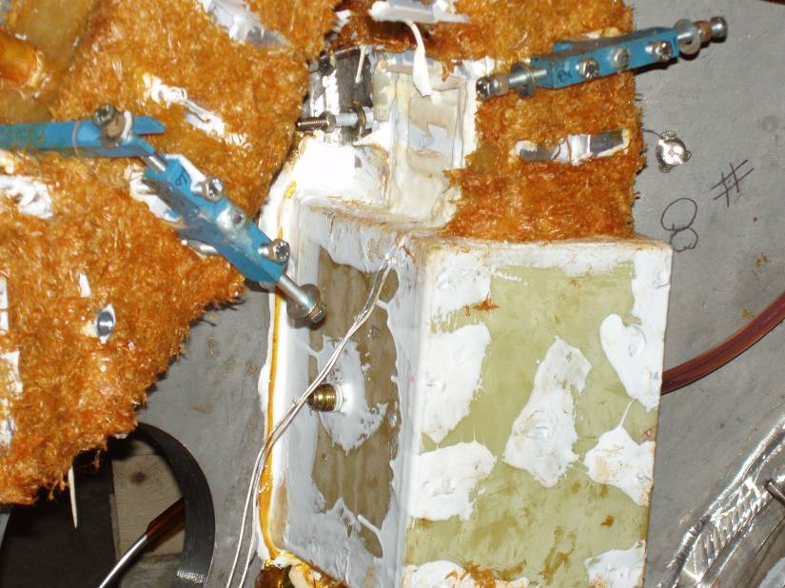
Diagnostic Flux Loops
Remove RTV covering bolt holes
Figure 1- Lead Block with Flux Loops

  - During assembly, the top and side plates were RTV’d together with silicone caulking. It is necessary to break that bond between the parts. Using a utility knife CAREFULLY cut along the seams of the top to side plate. There is no risk of cutting into the coil see figure 3.

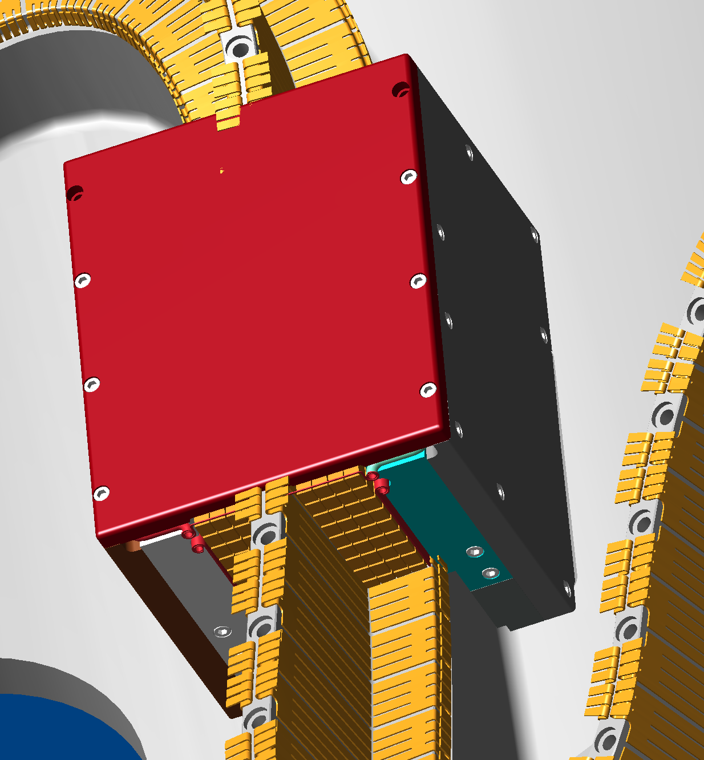
Remove all of the socket head cap screws from the top plate of the G-11 lead enclosure.

Figure 2- Top Plate with Hardware

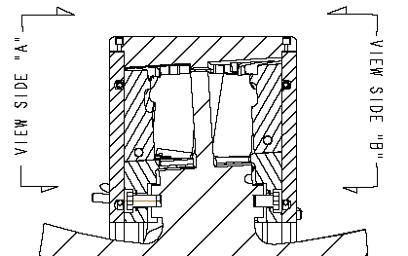
Cut along the seams of the top to side plates.

No cut or sharp objects in this area

Figure 3- Cross-section of Lead Area

  - Using a wedge or chisel, GENTLY pry the top plate away from the side plates. Any prying operations can only be performed directly over the side plates between the side and top plates. DO NOT pry or apply leverage against the coil or directly on the lead area. During this operation, care must be taken to ensure that there is no damage to the lead area. It may be necessary to gently tap the top plate to help release it from the epoxy impregnated lead area.

  - If the top plate cannot easily be removed, the ATI shall determine the next action to be taken for removing the top plate.

Results of top plate removal:

ATI: _________________________________ Date: _____________________

  - Once the top plate has been removed the upper lead area is ready for inspection.

  - Carefully inspect the upper lead area looking for any potential problems with the lead area. In particular, concentrate on the upper chill plates the cover the upper leads. [See figure 4]

Upper Lead Area Chill Plates
Suspect area
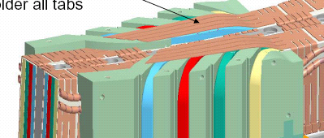

Figure 4- Upper Lead Area Exposed

  - If the problem area cannot be easily identified, additional diagnostic electrical tests may need to be performed.

  - If necessary, repeat the “Electrical Null” tests.

Test Results

  - If further tests are required to verify the problem area, identify those tests and obtain the approval of the NCSX Engineering Manager prior to proceeding.

Description of additional Diagnostic Tests:

  - Proposed test plan approved by NCSX Project Manager.

Approved to Proceed: _________________________________ Date: _______________
NCSX Engineering Manager

  - Once the problem area has been located describe the findings below. Based upon the findings, the ATI shall determine the actions required to make the repairs and shall prepare a repair procedure [D-NCSX-RP-STEL-058]. The repair procedure shall be peer reviewed by a group of engineering and project personnel as determined by the RLM.

Inspection Results:

- PROCEDURE COMPLETION
  - All work has been performed in accordance with this procedure.
  - All notes, observations and data sheets will be appended to this procedure document as permanent record. This procedure will be placed in the coil field package of the coil being repaired.

All work has been performed in accordance with this procedure.
Verified: ____________________________ Date: _________________
ATI

