- The two Prototype suppliers Major Tool and Rohwedder have submitted their Manufacturing, Inspection, and Test (MIT) plans and were authorized for fabrication on August 7th.
- Major Tool has begun fabrication of the dies and has one complete set.
- Rohwedder is having difficulties with their subcontractor but has made a proposal to resolve the issue and is vigorously working a solution that will be acceptable to us.

Major Tool and Machine, Inc. has begun fabrication of the NCSX prototype vacuum vessel. The first panel has been through the press, through the annealing, and its back in the press. The first panel will become the test piece for welding and distortion measurement. Following that, another plate for the real first panel will be pressed as well as panel three in our other large press. Frank Malinowski and Mike Viola will be visiting Major Tool the beginning of the week of October 20 to review procedures, assess progress, identify any concerns and answer questions.

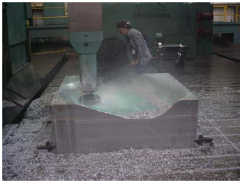

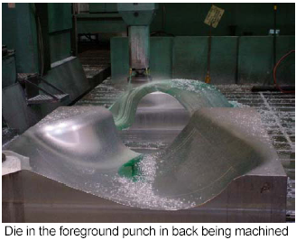

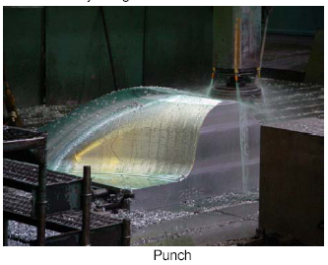

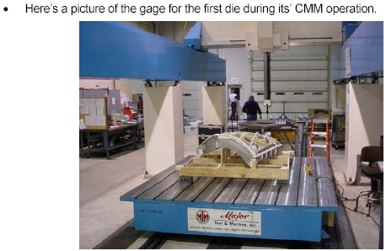

The picture below shows one of the dies with the production control leader standing in the die to demonstrate the size of the die (Phil’s about 6’-2”)

