National Compact Stellarator Experiment (NCSX) SubC# S-04344-F
Vacuum Vessel Manufacturing Development and Prototype Fabrication

Weekly Status Report 02/28/04 thru 03/05/04

Project Management

- Received P.O. amendment 4

Process Engineering

- Primary focus remains technical support for Manufacturing, inspection data analysis, preparation for and coordination assistance of the vacuum test, and MIT progression.
- Developmental experience:
  - Observed and documented the shrinkage and distortion resulting from the installation of the Port Extension. (ref. details listed in QC below) Though the method of positioning the Port Extension would be different for the VVSA, this experience and knowledge can be directly applied to the production vessel.

PVVS Fabrication

- Bake-out completed 04Mar04.
- Vacuum test in process 05Mar04
- Next steps: Remove and re-attach the Port Extension sub-assy. The actual re-attachment will not be started until Monday morning under the observation of Mike Viola.

Quality Control

- After the Port Extension was welded in place, the profile was re-inspected.
  - The Port Extension tube shrank (in length) approximately 3/16” during the welding. We anticipated this and left excessive stock on the length to be removed during cutting, and re-attaching. During re-attachment, the Port Extension will be trimmed longer than the print requirement to allow it to “shrink” to the drawing requirement when complete. This concept would be conveyed to production ports as well.
  - The PVVS wall distorted inward approximately 1/16” resulting from Port Extension Tube welding. We expect the distortion to be minimal from the re-attachment weld. This is based on the small diameter, thin wall of the tube, and the fact that the weld is away from the vessel wall. The larger, more complex ports may require weld shrinkage compensation development.
Photographs (preparation for bake-out / vacuum testing):

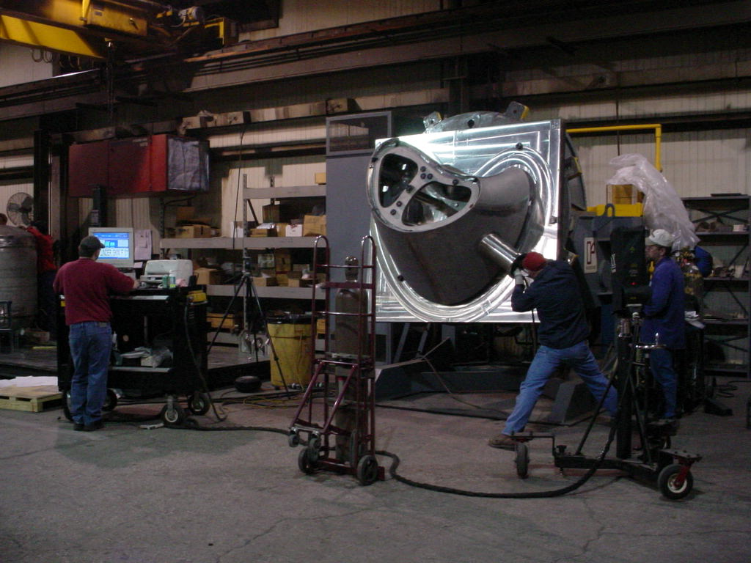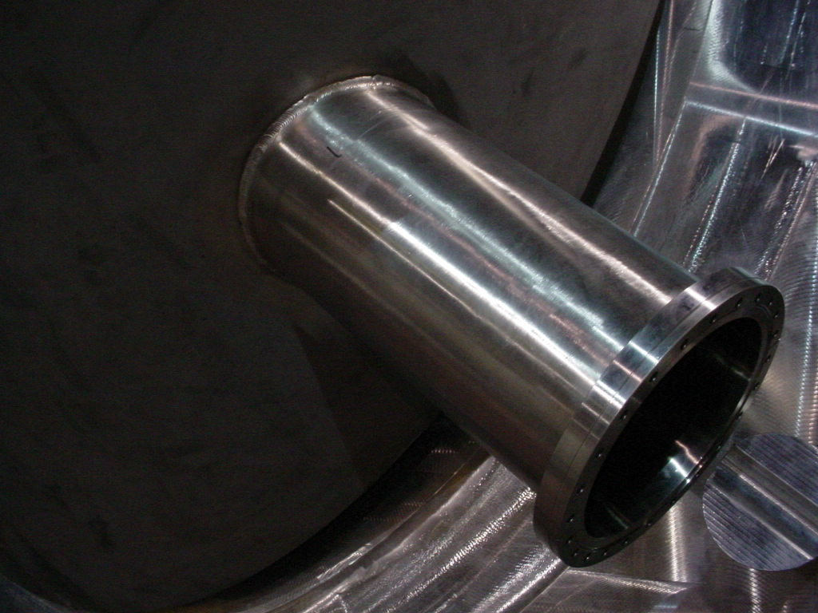

Photographs (bake-out @ 150C in MTM Oven):

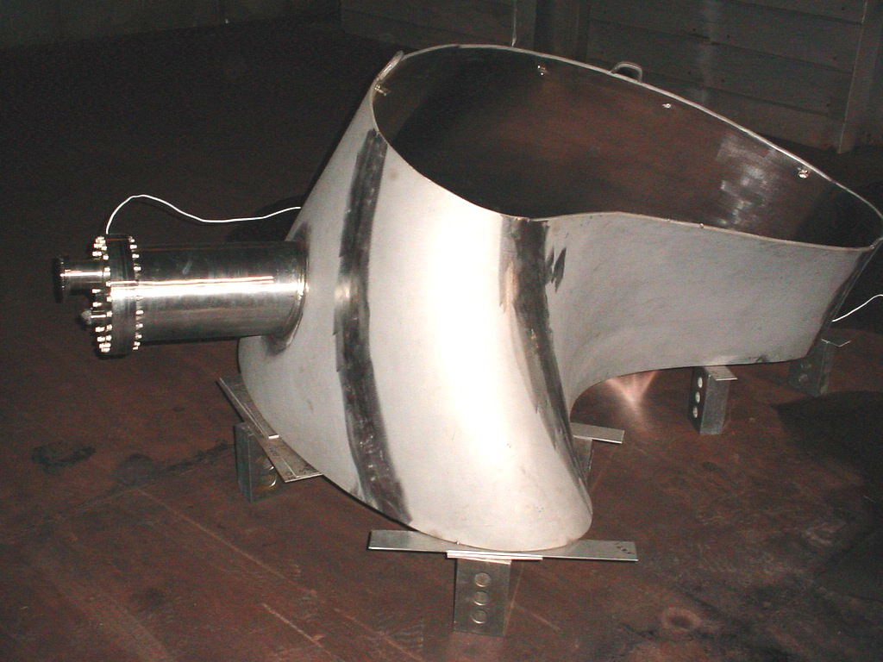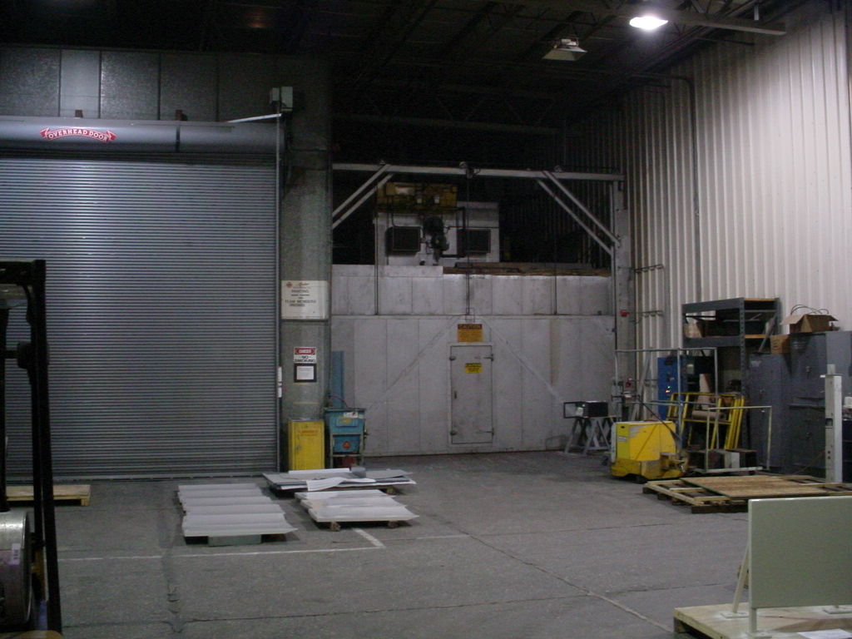

Photographs (vacuum testing):

