Major Tool & Machine, Inc.
Page: 1
1458 East 19th Street
MTM N/C: 19232
Date: 02/14/06
Indianapolis, IN 46218-4289
User ID: MCCORKLE

PRINCETON PLASMA PHYSICS LAB
Customer:
Telephone:
609-243-3655
Contact:
Mike Viola
mviola@pppl.gov
E-Mail:
609-243-3248
Fax:

S005243-F/Ln:1
Customer P.O.:
SE120-002 / PPPL NCSX VVSA
Part:
1
Qty:
0
Revision:
SE120-002
Drawing ID:

317-636-6433
Telephone:
DOUG MCCORKLE
Reported By:
Fax:
317-634-9420
E-Mail:
dMcCorkle@MajorTool.com

Problem:
Thermal cycle
1. During vessel ramp up: One zone (approximately 12 x 29") reached 524F while the rest of the shell was at about
314F. This exceeds the 90 Deg. F maximum temperature gradient (by 130F) allowed during the cycle. Located
from the tangent of the large radius of port 12 towards the center region between ports 5 and 7.
2. During port ramp up Port 7W reached 320F (9F above high limit)
3. During port ramp up, Port 11W reached 333F (22F above high limit)
4. During port soak, Port 10E temperature increased to 555F (244F above high limit). The port was above the high
limit of tolerance approximately 45 minutes.

Proposed Disposition:
Customer disposition required.

Number of additional pages:

Customer Disposition: [ ] Use As Is [ ] Rework [ ] Repair [ ] Scrap [ ] Replace

Date:
Title:
Technical Contact Approval:

Date:
Title:
Buyer Approval:

Title:
Date:

Major Tool Implemented By:

/Open
n:\mtmapps\Mtnonc14.qrp

Major Tool and Machine, Inc. 1458 East 19th Street, Indianapolis, IN 46218-4289 Tel: 317-636-6433 Fax: 317-634-9420

Nonconformance Report: Major Tool NC19232

This is for SE120-002 / PPPL NCSX VVSA

Problem:

Thermal cycle:
1. During vessel ramp up: One zone (approximately 12 x 29") reached 524F while the rest of the shell was at about 314F. This exceeds the 90 Deg. F maximum temperature gradient (by 130F) allowed during the cycle. Located from the tangent of the large radius of port 12 towards the center region between ports 5 and 7.
2. During port ramp up Port 7W reached 320F (9F above high limit)
3. During port ramp up, Port 11W reached 333F (22F above high limit)
4. During port soak, Port 10E temperature increased to 555F (244F above high limit). The port was above the high limit of tolerance approximately 45 minutes.

Doug McCorkle

Photo added by M. Viola for clarification (Note boxed region of 3 pads):

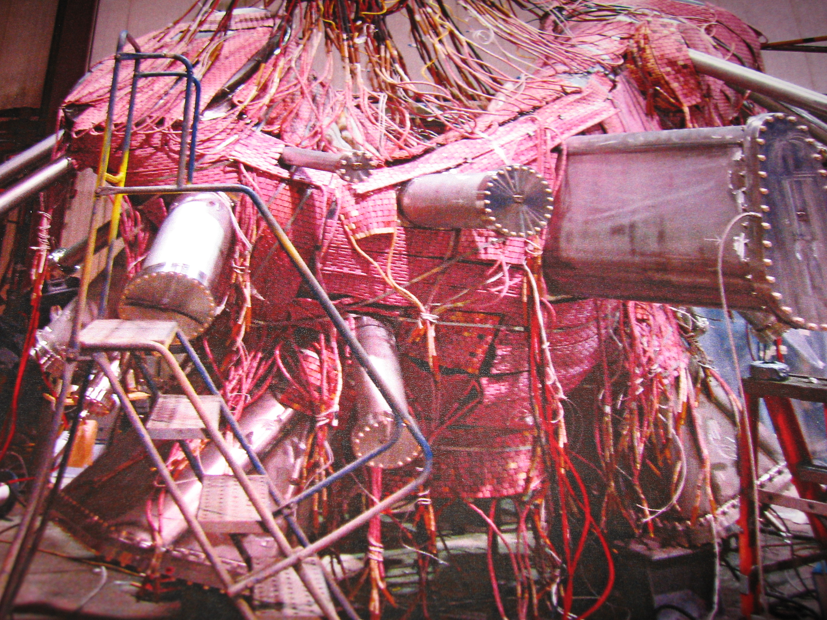

Project Disposition:

We acknowledge the thermal cycle deviations and based on the information received so far, project disposition is
use-as-is. However, this disposition will need to be revisited if damage from the heat excursions is detected.

Approvals:

___________________________________________
Procurement Technical Representative

____________________________________________
Responsible Line Manager:

____________________________________________
Project Quality Assurance:

