Major Tool & Machine, Inc.
Page: 1
1458 East 19th Street
MTM N/C: 19562
Date: 04/13/06
Indianapolis, IN 46218-4289
User ID: MCCORKLE

PRINCETON PLASMA PHYSICS LAB
Customer:
Telephone:
609-243-2441
Contact:
LARRY SUTTON
S-04286-F
E-Mail:
609-243-2021
Fax:

S005243-F/Ln:2
Customer P.O.:
/
Part:

Serial No./Qty:
2
Revision:
SE120-004
Drawing ID:
Links:
1-Type:W: 65678/2.0 Sub: 5 Op: 243

317-636-6433
Telephone:
DOUG MCCORKLE
Reported By:
Fax:
317-634-9420
E-Mail:
dMcCorkle@MajorTool.com

Problem:
THE RESULT OF PROFILE DEVIATION ON THE VESSEL ENDS CAUSES A MIS-ALIGNMENT TO THE
VESSEL FLANGES. REFER TO PHOTOS FOR ADDITIONAL DESCRIPTION.

Proposed Disposition:
Summary of repair procedure is attached and will be performed during normal manufacturing routing execution. TL
will confirm when completed.

Number of additional pages:

Customer Disposition: [ ] Use As Is [ ] Rework [ ] Repair [ ] Scrap [ ] Replace

Date:
Title:
Technical Contact Approval:

Date:
Title:
Buyer Approval:

Title:
Date:

Major Tool Implemented By:

802-MANAGEMENT DECISION
Root Cause 1:

Equipment:
SILVER TEAM, ENGINEERING
Resource:
CONTROL OF VESSEL END PROFILE HAS PROVEN TO BE MORE DIFFICULT THAN ORIGINALLY
ANTICIPATED. MODIFICATIONS TO THE FABRICATION PROCESS AND DISTORTION CONTROL
TECHNIQUES BASED ON LOT 1 EXPERIENCE HAVE IMPROVED THE PROFILE BUT OUT OF
TOLERANCE CONDITIONS STILL EXIST.
Description:
_ _ _ _ _ _ _ _ _ _ _ _ _ _ _ _ _ _ _ _ _ _ _ _ _ _ _ _ _ _ _ _ _ _ _ _ _ _

Action:
04/13/06 By: 775-D.MCCORKLE
Corr Actn: 1:
THE CONDITION WILL BE CORRECTED ACCORING TO THE ATTACHED DOCUMENTATION DURING
FOLLOWING MANUFACTURING SEQUENCES. TL WILL CONFIRM WHEN COMPLETED .
Description:
/Open
n:\mtmapps\Mtnonc17.qrp

Major Tool and Machine, Inc. 1458 East 19th Street, Indianapolis, IN 46218-4289 Tel: 317-636-6433 Fax: 317-634-9420

Nonconformance Report: Major Tool NC19562

This is for SE120-004 VVSA #2 end flange fit up and weld.

Problem:

THE RESULT OF PROFILE DEVIATION ON THE VESSEL ENDS CAUSES A MIS-ALIGNMENT TO THE
VESSEL FLANGES. REFER TO PHOTOS FOR ADDITIONAL DESCRIPTION.

MTM Recommended Disposition:

RECOMMEND LEAVING THE VESSEL WALL IN ITS CURRENT POSITION AND ALTERING THE WELD
SCHEME TO BLEND THE TWO SURFACES TOGETHER IF NO ASSEMBLY OR PLASMA INTERFERENCE
EXIST

See pictures below:
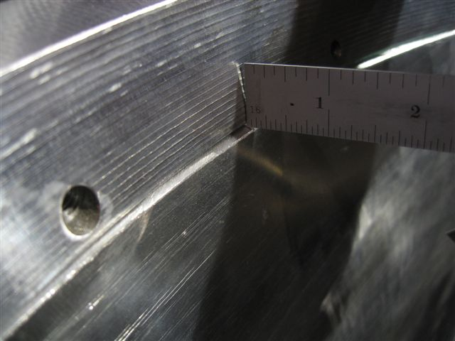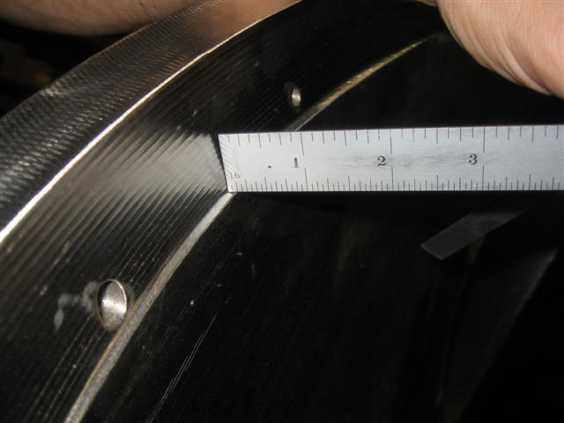
8 O’clock Inside of Flange B 8 O’clock Inside of Flange B

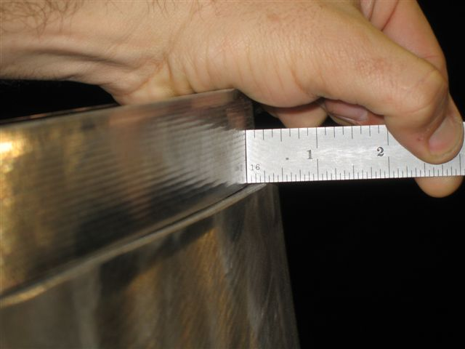
2 O’clock Outside of Flange B
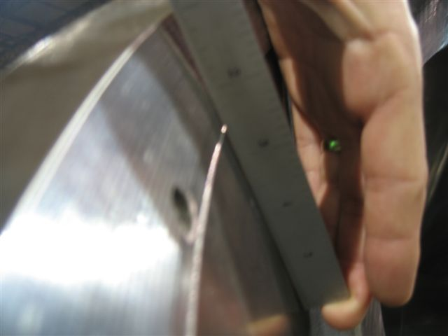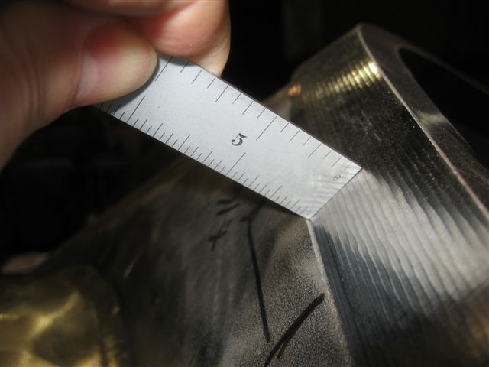
8 O’Clock Inside of Flange A (nearly flush) 10 O’clock outside of Flange A

Project Disposition:

Rework as Recommended by MTM.
Ensure weld size is equal or greater to original.

Major Tool Response:

Root Cause 1: 802-MANAGEMENT DECISION

Resource: SILVER TEAM, ENGINEERING

Description: CONTROL OF VESSEL END PROFILE HAS PROVEN TO BE MORE DIFFICULT THAN ORIGINALLY
ANTICIPATED. MODIFICATIONS TO THE FABRICATION PROCESS AND DISTORTION CONTROL
TECHNIQUES BASED ON LOT 1 EXPERIENCE HAVE IMPROVED THE PROFILE BUT OUT OF
TOLERANCE CONDITIONS STILL EXIST.

Corr Actn: 1: Action: 04/13/06 By: 775-D.MCCORKLE

Description: THE CONDITION WILL BE CORRECTED ACCORING TO THE ATTACHED DOCUMENTATION DURING
FOLLOWING MANUFACTURING SEQUENCES. TL WILL CONFIRM WHEN COMPLETED

For VVSA2, End A:
- The inside end of the vessel with the tolerances achieved is ACCEPTABLE as is.
- The vessel wall tolerance is +/- 0.188”.
- NCSX assumed a tolerance of +/-0.188”. this means that the flange can be in as much as 0.188” from an IDEAL wall position.
- Criteria for MTM:
  - MTM has completed the vessel shell forming and measured them. It is generally within the specified +/-0.188” with a few local regions slightly deviating from this.
  - MTM machined the flanges to an assumed tolerance of +/-0.188”. Any deviations beyond this +/-0.188 requires a NCR for either the pre-welded or post-welded condition.
  - Where the flange deviation combined with the shell deviation creates a poor match-up for welding an NCR shall be submitted with proposed corrective action.

- The current flange fits up to the vessel within the profile of the vessel shell everywhere but a few locations (need to add picts.)

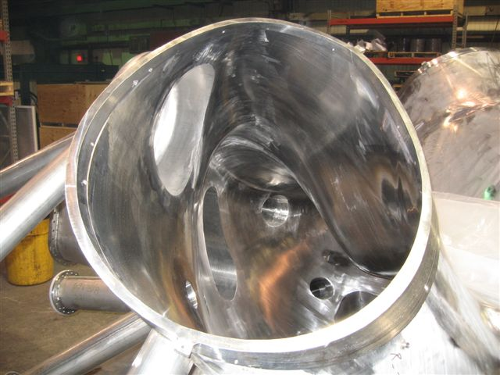
Will probably loose fiducial holes and clamp holes to “buttering” weld. These welds would have to be made without heavy cover plate welded on to heat sink & hold flange.
Consider doing “buttering” as part of field weld process

Flange to the outside of the vessel by ~0.125-0.188 “ over a length of ~ 12 “

If the vessel max. outwards tolerance coincided with the flange maximum inwards tolerance, this would be the condition

Weld would have to compensate for mismatch. Grind smooth
3/16”
¼”
Flange in this case is moved in 0.188”
.75-.188=.57
Need to specify min. weld ¼” fillet?? Blend & polish
0.57” worst case condition (.750flange-.188 tol.. Of shell

For VVSA2, end A, this maximum encroachment was evaluated by Art and is acceptable in the pre-welded condition.

Assuming that field weld shrinkage might move the wall and flange inwards by another 0.010”, this would still be acceptable.

Proposed fix for VVSA #2 and #3 end flanges

There are two conditions of concern from a VV assy viewpoint:
- shell outer surface is outside flange od, or
- shell inner surface is inside of shell id

- shell outer surface is outside flange od: MTM to do the following

- Make inside weld between flange and shell and clean up
- Weld leak check cover plate on
- Finish shell to flange weld on outside and butter up od of flange to match or exceed outside surface of shell
- Perform leak check
- Remove leak check cover plate
- Clean up face surface of flanges
- 3/8 minimum weld throat, smoothed out and blended for vacuum service on inside

- Shell inner surface is inside of shell id:

- PPPL will butter up id of flange by carrying assembly weld over to shell

Approvals:

___________________________________________
Procurement Technical Representative

____________________________________________
Responsible Line Manager:

