Princeton Plasma Physics Laboratory
Procedure
Procedure Title: USING THE Romer ARM for MEAsurements
Number:  D-NCSX-MCF-005 |  | Revision:  0 |  |  | Effective Date:  Expiration Date:  (2 yrs. unless otherwise stipulated)
Procedure Approvals
Author: Steve Raftopoulos |  |  |  |  |  | Date
ATI: Steve Raftopoulos |  |  |  |  |  | Date
RLM: Larry Dudek |  |  |  |  |  | Date
Responsible Division: NCSX
Procedure Requirements
Designated by RLM
LABWIDE:
X | Work Planning Form # WP-1138 & WP-1188 (ENG-032) |  |  | Lockout/Tagout (ESH-016)
 | Confined Space Permit  (5008,SEC.8 Chap5) |  |  | Lift Procedure (ENG-021)
 | Master Equip. List Mod (GEN-005) |  |  | ES&H Review (NEPA, IH, etc.)
 | RWP (HP-OP-20) |  |  | Independent Review
 | ATI Walkdown |  |  | Pre-Job Brief
 | Post-job Brief * |  |  | Hazard analysis
D-SITE SPECIFIC:
X | D-Site Work Permit (OP-AD-09) |  |  | Door Permit (OP-G-93)
 | Tritium Work Permit (OP-AD-49) |  |  | USQD (OP-AD-63)
 | Pre-Job Brief (OP-AD-79) |  |  | T-Mod (OP-AD-03)
 | ** DCA/DCN (OP-AD-104) #
** OP-AD-104 was voided by procedure ENG-032. However, DCAs that were open at the time of adoption of ENG-032 are still considered valid for work approval purposes.

- Purpose

  - The purpose of this procedure is to provide guidance for obtaining measurements of various NCSX components using the Romer CMM arm.

- Scope

  - This procedure covers the steps required to use the CMM arm for the collection of metrology data for NCSX components. Specifically:

    - Measuring the Modular Coil Winding Forms as delivered and during the coil winding process.
    - Measuring the Vacuum Vessel. (future revision)
    - Measuring other components against their CADD model(s).
    - Obtaining geometric features and/or point cloud data for objects without CADD models.

  - This procedure provides a mechanism for ensuring and documenting the following:

    - CMM arm is calibrated, per manufacturer’s instruction, prior to measurement.
    - Unique measurement instructions, specific to a particular object, are identified.
    - Information gathered during the measurement/inspection process is collected, labeled, and saved in a manner that it is readily available for further use.

  - Measurements shall be made by individuals that are trained in the operation of the CMM arm and the use of the PowerINSPECT software. This procedure DOES NOT provide instruction on the use of the CMM arm. Insert reference to qualification program or procedure here.

  - When measuring or inspecting a component against its CADD model, a measurement routine is typically used. The routine, which is run from the PowerINSPECT software, defines the measurement steps required to inspect the part. The routine can be defined prior to the actual measurement, or can be drafted in the field during the measurement process.

  - For critical components (such as the NCSX Modular Coils) the basis for the measurement routine will be defined in this procedure.

  - For non-critical components, the measurement data sheet can be used to define the requirements and objectives of the procedure. The metrology engineer or technician shall use this information to define the measurement routine.

- Definitions

  - “Best Fit” alignment Alignment option using a minimum of three, but typically performed with more than three points.
  - “Best Fit” optimization Optimization of the alignment using data obtained from the part.
  - CADD Computer Aided Design Drafting.
  - CMM Coordinate Measurement Machine.
  - “Free Form” alignment Alignment method used when there are no fiducial points.
  - Fiducial Points Reference features used for alignments.
  - “Length Check” procedure Process for calibrating the CMM to a NIST length standard.
  - “Surface Inspection” mode Taking data and comparing it to the CADD model
  - Three Point” alignment An alignment using only three points.
  - TRC Twisted Racetrack Coil

- References

  - PowerINSPECT 2.2 operating manual.
  - PowerINSPECT 3.0/3.050 operating manual.
  - PowerINSPECT Training manuals.
  - D-NCSX-MCF-001, “Modular Coil Fabrication – Winding Form Preparation Activities”
  - D-NCSX-MCF-002, “Modular Coil Fabrication – Winding Station Activities”
  - NCSX-MIT/QA-142-01 “Manufacture, Inspect and Test/Quality Assurance Plan”
  - NCSX-PLAN-MCWFOP-00 “Modular Coil Manufacturing Facility Operations Plan”

- Precautions and Limitations

  - The ROMER CMM arm is a delicate instrument. The precision encoders at every joint will be damaged if the CMM is bumped or dropped.
  - The Probe tips are susceptible to damage. If the operator suspects that the probe has been damaged, a different probe shall be used until the damaged probe has been repaired. Altered and/or replacement probes shall be calibrated to the particular CMM arm prior to use.
  - The accuracy and precision of measurements is greatly affected (or rendered invalid) if either the CMM or the measured component moves during the measurement. Ensure that both the CMM base and the measured component are secure and will not move relative to each other during the measurement process.
  - The CMM must remain be at a constant, stable temperature (preferably the same as the part) during calibration and subsequent measurements.
  - For Laser trackers, the air temperature and humidity should remain stable during the measurement process.

- Prerequisites

  - Prior to the start of the day’s measurement, the CMM shall undergo the “Length Check” procedure. The “Average Length” of the NIST standard as measured by the Romer CMM should be within the stated accuracy range of the particular CMM. For the 3000SCi units, the stared accuracy is +/- 0.1mm.
  - The “Measurement Requirements” section of the measurement data sheet shall be filled in prior to the start of a measurement.
  - The Modular Coil shall be mounted into the turning fixture in Station 1 and the coil shall be clean of oils and debris prior to the measurements.

- Procedures for “Critical Measurements”

  - NCSX Modular Coils and Twisted Racetrack Coil

Measuring the machined winding form:

    - With the CMM arm in its measuring stand, survey the winding form to determine whether or not the number of existing fiducial points are adequate to allow measurement of the entire coil.
    - If the fiducial points are not adequate, then weld additional fiducial points onto the casting. These additional fiducial points are typically ½ to 1 inch stainless steel spheres. The type, number and location of the additional fiducial points shall be approved by the Metrology Engineer. Care must be taken to avoid distorting the tooling ball targets or the castings by welding.
    - Within PowerINSPECT, create a unique file-name for the measurement. The file name should reference the particular coil designation. All subsequent measurements on that particular modular coil can be performed in separate PowerINSPECT files; however each filename should include the coil designation.
    - Install the 15mm probe onto the Romer CMM.
    - Verify calibration of CMM by performing the “Length Check” procedure.
    - If there are an adequate number of fiducial points with established coordinates, perform either a “three-point”, or a “Best-Fit” alignment (if more that 3 fiducial points are within reach of the CMM).
    - It’s preferable to have acceptance criteria for the alignment. This is a best fit - at what point is it not good enough and required to be repeated?
    - If there are none, or an inadequate number of fiducial points to perform an alignment, then perform a “Free Form” alignment to the part.
    - Using “Surface Inspection” mode, take inspection data along the winding surface. Break up the data into 4 separate inspection groups, one group for each sidewall and for each base of the winding surface. The points should be taken in a pattern as shown in figure 2. The width of the square pattern should be approximately 1.5 inches.

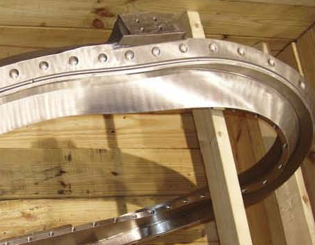
Coil “Base”

Coil “Sidewall”

Figure 1: Bare Casting. This is the TRC; the Full-sized Modular Coils are similar

Coil “Sidewall”

Coil “Base”
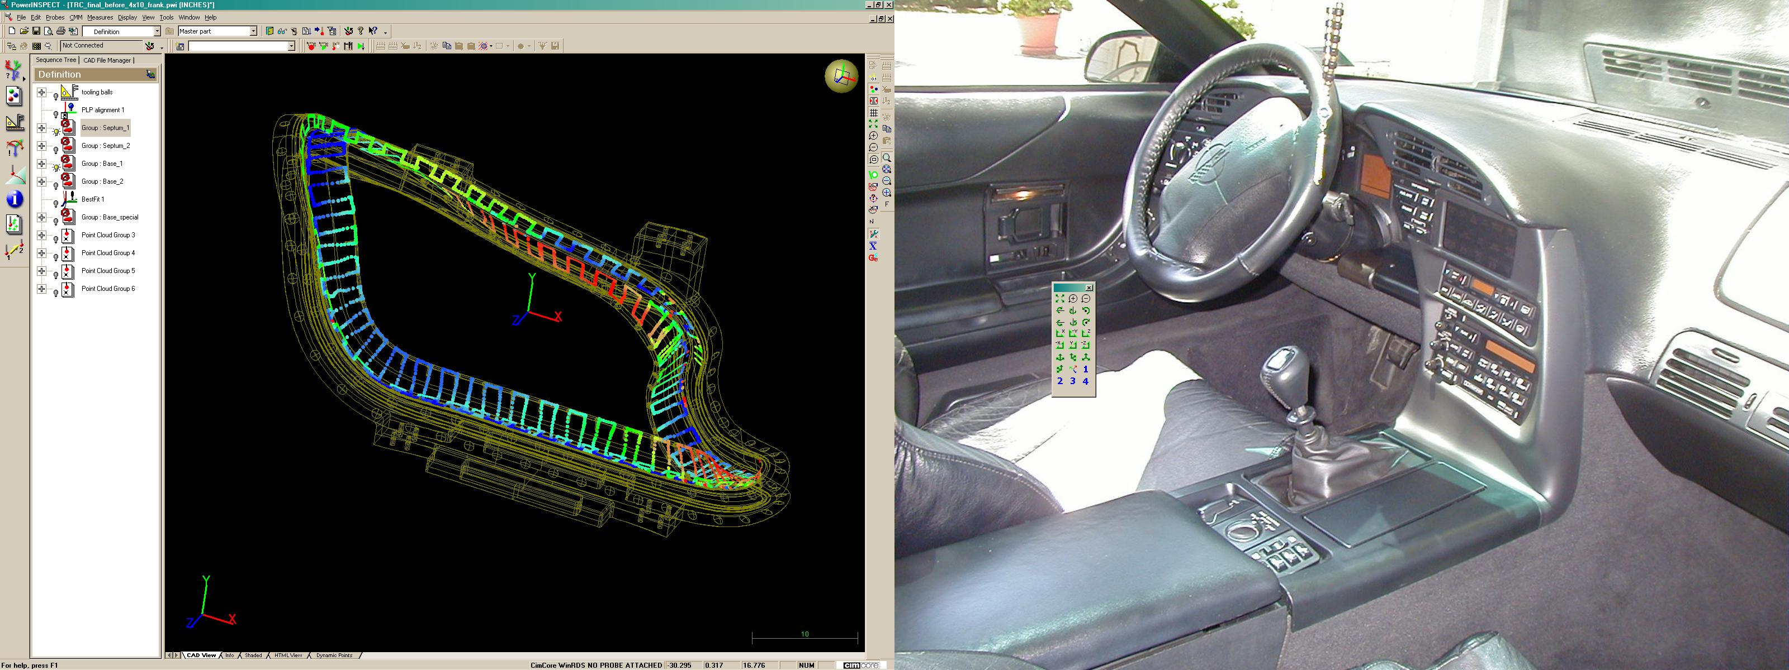

Figure 2: “Square wave” pattern for “Surface Inspection” of coil.

    - When the arm can no longer reach the unmeasured sections of the coil, rotate the coil, re-align and continue measuring the winding surface. Ensure that the coil is firmly locked in position and cannot move relative to the CMM base prior to re-alignment.
    - Refine the alignment with a “Best Fit” optimization using the inspection data from the winding surface.
    - Inspect the remaining areas of the Coil (Flanges, new Fiducial points, close fitting areas)
    - If point cloud data is desired, attach the Perceptron Laser Scanning probe (probe_8) to the CMM.
    - Calibrate the laser scanner using the Romer calibrating sphere.
    - Set the point cloud filter to take points on a 1/8-inch grid pattern. Take the point cloud data of the desired areas. Break up the point cloud into separate data groups as follows:
      - Winding surface – one group per sidewall & one group per base
      - Flanges – one group per flange
      - Cast surface – discretion of the metrology technician, but as general guidance, don’t generate point cloud groups larger than 5000 points.

Measuring the conductor during/after winding activities:

Note: These measurements are performed at one of the three winding stations – Station 2, 3 or 4

    - Align to the coil using either a “three-point” alignment, or a “Best-Fit” alignment (if more that 3 fiducial points are within reach of the CMM).
    - Using the 6-inch probe (Probe_4), take measurements across the top layer of the bundle and along the height of the bundle. Measure the high spot (typically the middle) of each conductor. Take measurements next to the clamp and midway between clamps.

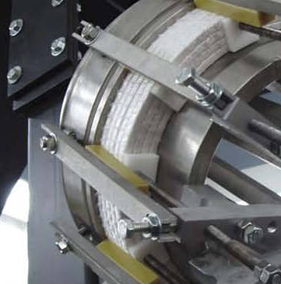

Figure 3: Locations for measuring the winding pack.
Measure winding pack next to clamp and midway between clamps.
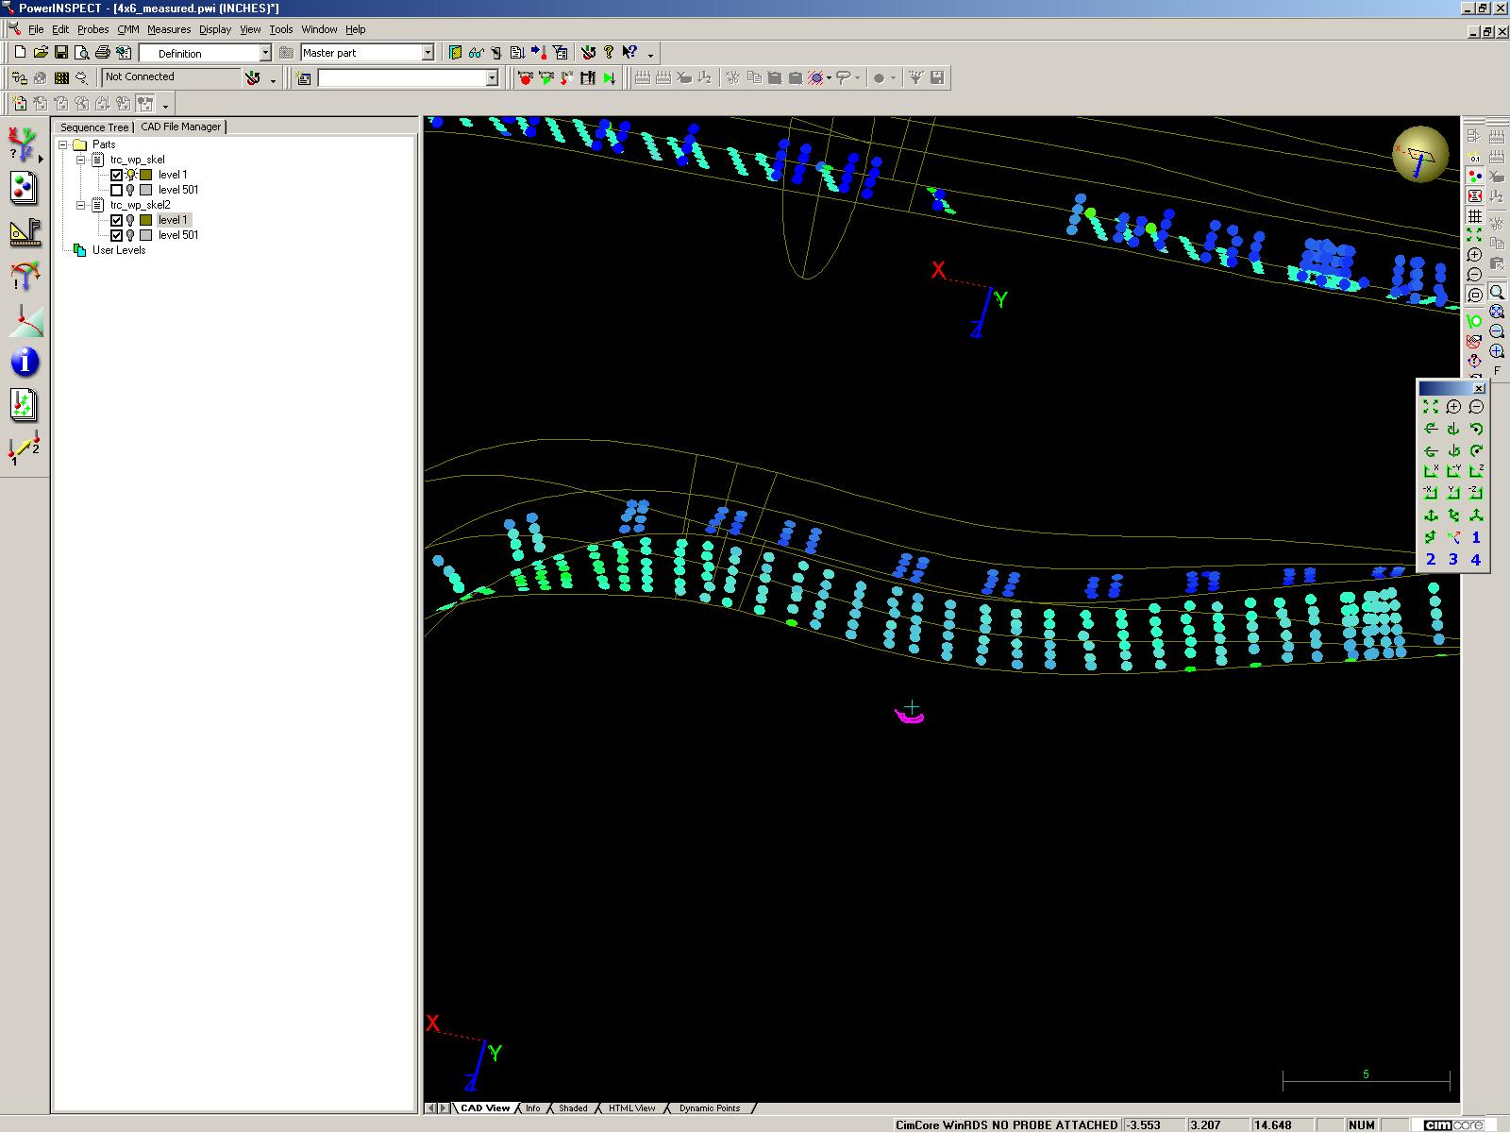

Figure 4: Winding Pack measurement data in PowerINSPECT

    - When the arm can no longer reach the unmeasured sections of the coil, rotate the coil, re-align and continue the measurements.
    - At the end of a measurement cycle, it not a bad idea to re-measure the fiducial points (which were used to establish the alignment) and ensure that points remained at the same locations. This verifies that the part and the measuring device didn’t move during the measurement.
    - When measurements are finished, create a PowerINSPECT (Excel) report and save it with the same designation as the PowerINSPECT data file.
    - Keep all measurement data from a particular coil with the traveler package for that coil.

- Post Measurements

  - Once measurements have been completed, shut down the system; carefully remove the CMM Arm from its stand and store in its storage compartment.

ROMER CMM Arm Measurement Data Sheet

Part 1: MEASUREMENT REQUIREMENTS (to be completed prior to the measurement)

Title of Measurement:
Requestor:
CADD file provided: If yes, name of file:
Winding Form Type: ________ (TRC, A, B, C) ___ Coil ID Number: _________________

Measurement objectives:
Special conditions/instructions:

Part2: MEASUREMENT DATA/RESULTS (to be completed after the measurement)

PowerINSPECT file name:
Inspection Report file name:

CMM Length Calibration: Length of NIST standard:
Length serial # : Acceptable Range of calibration:
Calibration expiration:
CMM Laser Probe Calibration: Laser scanner used?
Calibration Sphere measured dia.:
Measurement Objectives met?
Comments/Notes:

REVIEWERS (designated by RLM)
Accountable Technical Individual… S. Raftopoulos
Test Director…………………………
Independent Reviewer
D-Site Shift Supervisor…………….
NCSX……………………………J. Chrzanowski, Brad Nelson, L. Dudek
Vacuum……………………………….
Diagnostics
Quality Assurance/Quality Control……….J. Malsbury
Maintenance and Operations Division
Energy Conversion System/Motor Control System
D&D HP/Rad Waste Coordinator
Environmental Restoration & Waste Management Division
NCSX Mechanical/Vacuum…………….
Environmental, Safety, & Health ……
Industrial Hygiene……………………...
Health Physics…………………………..
NCSX Electrical…………………………

TRAINING (designated by RLM)
No training required ______________ | Instructor _________________________
Personnel (group, job title or individual name) |  | Read Only | Instruction Pre-job Briefing | Hands On
Lead Tech. |  | X
QC |  | X
Technicians performing task |  | X
NSTX Field Supervisors |  | X
NSTX Construction Manager |  | X
Training Rep.

RLM L. Dudek

