
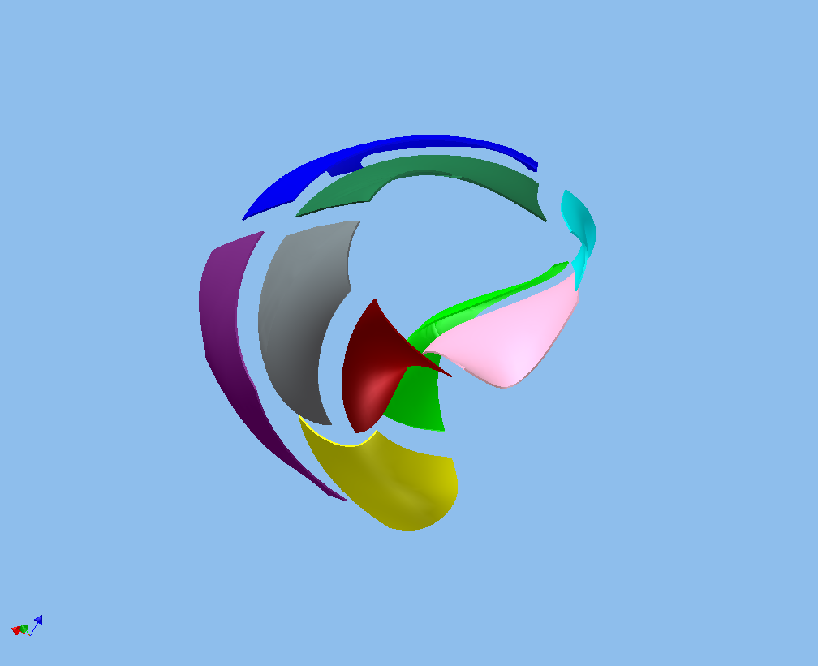


Panel Number: Color:
- Purple
- Yellow
- Blue
- Lt. Blue
- Green
- Pink
- Red
- Gray
- Dk. Green

