National Compact Stellarator Experiment (NCSX)

DRAFT Product Specification

Prototype Vacuum Vessel Segment
NCSX-CSPEC-121-01-01 DRAFT A

14 November 2002

Prepared by:
_______________________________________
P. Heitzenroeder, Technical Representative for WBS 12 Procurements
Concurrences:
_______________________________________
P. Goranson, Vacuum Vessel (WBS 12) WBS Manager
_______________________________________
B. Nelson, Project Engineer for Stellarator Core Systems (WBS 1)
_______________________________________
F. Malinowski, PPPL Procurement QA Representative
Approved by:
_______________________________________
W. Reiersen, Engineering Manager
Controlled Document
This is an uncontrolled copy of a controlled document once printed. Check the PPPL Procurement Web Site (http://oorm-1.pppl.gov/public/procurement/) prior to use to assure that this document is current.

Record of Revisions

Revision | Date | Description of Changes
Rev. 0 | 11/14/02 | Initial release
Rev 1 | 7/7/03 | Revision

Table of Contents

1 Introduction and Scope 1
1.1 Introduction 1
1.2 Scope 3
2 Applicable Documents 3
3 Requirements 4
3.1 Item Definition 4
3.2 Characteristics 7
3.2.1 Performance 7
3.2.1.1 Vacuum Performance 7
3.2.1.2 Surface Finish 7
3.2.1.2.1 Interior Surface Finish 7
3.2.1.2.2 External Surface Finish 7
3.2.1.3 Magnetic Permeability 7
3.3 Design and Construction 8
3.3.1 Fabrication Drawings 8
3.3.2 Materials, Processes, and Parts 9
3.3.2.1 Materials 9
3.3.2.1.1 Sheet, Strip, and Plate 9
3.3.2.1.2 Tubing and Pipe 9
3.3.2.1.3 Bar and Structural Shapes 9
3.3.2.1.4 Castings 9
3.3.2.1.5 Conflat Flanges 9
3.3.2.1.6 Weld Filler Metal 9
3.3.2.1.7 Bolts 9
3.3.2.1.8 Copper Seals 9
3.3.2.2 Welding 10
3.3.2.3 Cutting, Forming and Bending 11
3.3.2.4 Cleaning 11
4 Quality Assurance Provisions 11
4.1 General 11
4.1.1 Responsibility for Inspection 11
4.2 Quality Conformance Inspections 12
4.2.1 Verification of Vacuum Performance 12
4.2.2 Verification of Surface Finish 12
4.2.3 Verification of Magnetic Permeability 12
4.2.4 Verification of Dimensions and Tolerances 12
4.2.5 Materials 13
4.2.6 Weld Inspection and Examination 13
4.2.7 Verification of Cutting, Forming, and Bending 14
4.2.8 Verification of Cleaning Requirements 14
4.2.9 Inspection for Internal Defects 14
5 Preparation for delivery 14
5.1 Marking 14
5.2 Crating 14
5.3 Shipping 14

Introduction and Scope

Introduction
Stellarators are a class of magnetic fusion confinement devices characterized by three dimensional magnetic fields and plasma shapes and are the best-developed class of magnetic fusion devices after the tokamak. The stellarator concept has greatly advanced since its invention by Dr. Lyman Spitzer, the founding director of the Princeton Plasma Physics Laboratory (PPPL), during the 1950’s. A traditional stellarator uses only external magnetic fields to shape and confine the plasma. The differentiating feature of a compact stellarator is the use of plasma current in combination with external fields to accomplish shaping and confinement. This combination permits a more compact device. The NCSX project is managed by PPPL in partnership with the Oak Ridge National Laboratory. This Subcontract will be administered by PPPL. Operation of NCSX is scheduled to begin in July 2007.
The vacuum vessel is a key element in the stellarator core. The vacuum vessel is a contoured, three-period torus, which means that its geometry repeats every 120º toroidally. The geometry is also mirrored every 60º so that the first (0º to 60º) segment, if flipped over, is identical to the corresponding adjacent (60º to 120º) segment. The vacuum vessel assembly will be fabricated in three sub-assemblies that are bolted together and vacuum-sealed with double O-rings at flanges on the ends of each segment. Figure 1 shows the vessel segments during manufacture with the port reinforcements installed. The Subcontractor will need to supply temporary segment end covers so each segment can be individually tested. [“Reinforcement” is used in 4 places??]
With the exception of the large vertical ports and the neutral beam port located mid-segment, all port assembly extensions are required to be welded onto the three vessel sub-assemblies after installation of the modular coils and TF coils as part of the NCSX field period assembly operation. Assembly of the modular coils over a vacuum vessel sub-assembly is illustrated in Figure 2. Attachment of the port extensions is illustrated in Figure 3.
The vacuum vessel sub-assemblies will be supported from the modular coil shell structure via adjustable hangers. The interfacing fixed, structural brackets are part of the vacuum vessel assembly. ASME code stamping of the vacuum vessel sub-assemblies is NOT required.
Figure 1 - NCSX vacuum vessel sub-assemblies (partially fabricated)

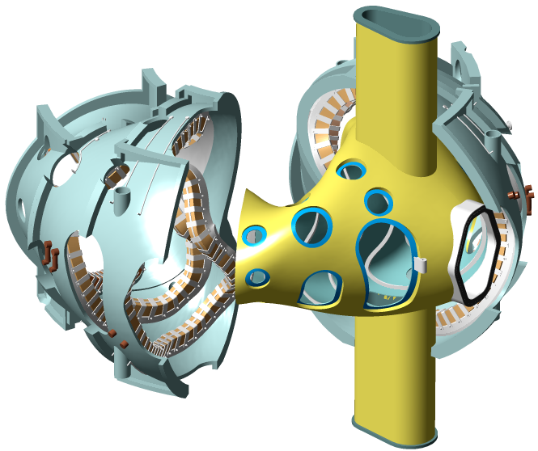
Figure 2 - Modular coils being assembled over vacuum vessel sub-assembly

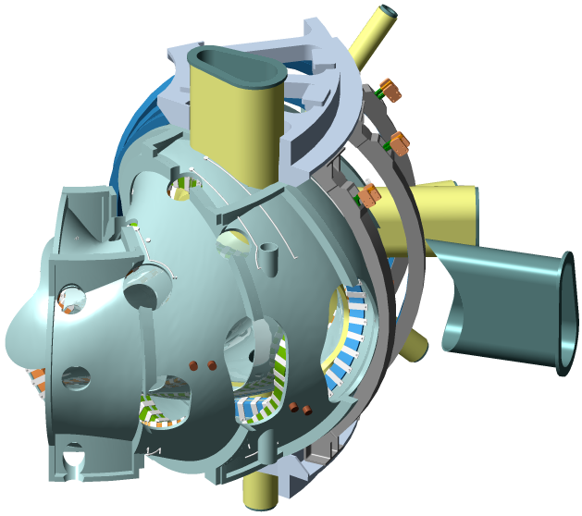
Figure 3 - Port extensions welded on after coils assembled

Scope
This specification establishes the manufacturing and acceptance requirements for the National Compact Stellarator Experiment (NCSX) Prototype Vacuum Vessel Segment (PVVS).

Applicable Documents
The versions of the United States Codes and Standards defined below are to be used in the performance of this work. Other equivalent foreign codes may be proposed:

- ASME B46.1-1995 Surface texture (Surface Roughness, Waviness, And Lay)
- ASME SFA specifications
- ASME SFA 5.14 Nickel and Nickel Alloy Bare Welding Rods Electrodes
- American Society of Mechanical Engineers (ASME), Boiler and Pressure Vessel Code, Sections V (Articles 6 and 9), VIII (Division 1), and IX, 1998 with 2000 Addendum.
- ASTM B 443-00 Standard Specification for Nickel-Chromium-Molybdenum-Columbium Alloy (UNS N06625) and Nickel-Chromium-Molybdenum-Silicon Alloy (UNS N06219)* Plate, Sheet, and Strip
- ASTM B 444-00 Standard Specification for Nickel-Chromium-Molybdenum-Columbium Alloys (UNS N06625) and Nickel-Chromium-Molybdenum-Silicon Alloy (UNS N06219)* Pipe and Tube
- ASTM B 705-00 Standard Specification for Nickel-Alloy (UNS N06625, N06219 and N08825) Welded Pipe
- ASTM B 446-00 Standard Specification for Nickel-Chromium-Molybdenum-Columbium Alloy (UNS N06625) and Nickel-Chromium-Molybdenum-Silicon Alloy (UNS N06219)* Rod and Bar
- ASTM A 240-02 Standard Specification for Chromium and Chromium-Nickel Stainless Steel Plate, Sheet, and Strip for Pressure Vessels and for General Applications
- ASTM A193/A193M-01b Standard Specification for Alloy-Steel and Stainless Steel Bolting Materials for High-Temperature Service
- ASTM E 498-95 Standard Test Method for Leaks Using the Mass Spectrometer Leak Probe Detector or Residual Gas Analyzer In the Tracer Probe Method
- ASTM A 800/A 800M–01 Practice for Steel Casting, Austenitic Alloy, Estimating Ferrite Content Thereof
- ASTM Spec. A 494-01 Standard Specification for Castings, Nickel and Nickel Alloy
- AWS D1.6: 1999 Structural Welding Code - Stainless Steel, (Paragraph 6.29.1)
- MSS SP-54-1999, Quality Standard for Steel Castings for Valves, Flanges and Fittings and Other Piping Components -- Radiographic Examination Method
- American Welding Society (AWS) QC1, Standard and Guide for Qualification and Certification of Welding Inspectors, 1996.
- American Society of Nondestructive Testing (ASNT) 2055, Recommended Practice SNT-TC-1A, 1996.
The above Standards and Codes set forth the minimum requirements. They may be exceeded by Seller with written permission from the Laboratory if, in Seller’s judgment, superior or more economical designs or materials are available for successful and continuous operations, as required by the specification.

Requirements

Item Definition
The PVVS is a 20º segment of a full (120º) vacuum vessel sub-assembly. The PVVS extends from 10º to 30º, where 0º marks the center of a full sub-assembly. This section of a full sub-assembly features three ports. The PVVS will feature only one of the three ports. Finished port reinforcement and the associated port extension are to be included as a part of the PVVS. A view of the PVVS is provided in Figure 4. A port attachment concept is shown in Figure 5.

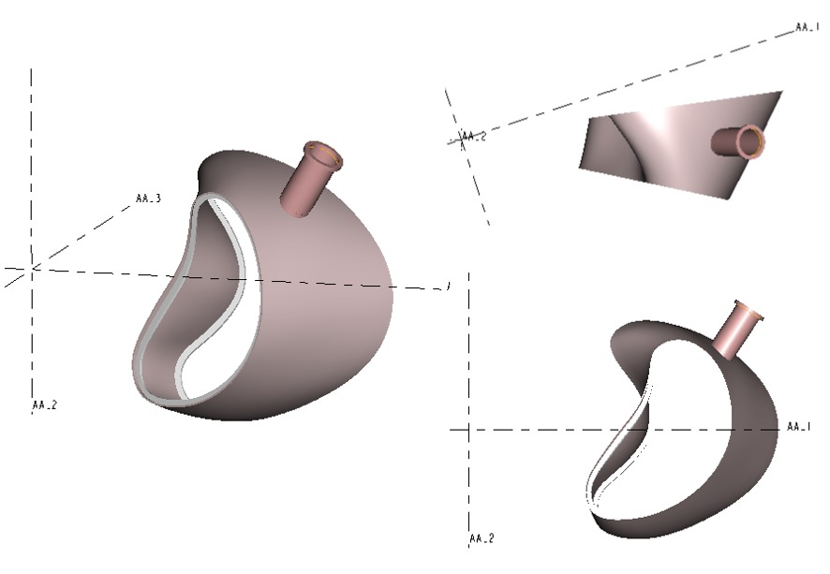
Figure 4 - View of PVVS

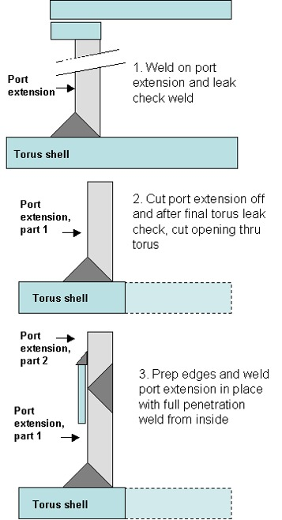
Figure 5 - Port attachment concept

Characteristics

Performance

Vacuum Performance
The port extension included in the PVVS is to be leak checked. The port configuration during vacuum leak testing shall be:
- Prior to leak checking, the assembly shall be cleaned as defined in Sect. 3.3.2.4
- A bake-out at 150 C for 6 hours is recommended to remove moisture in preparation for the leak check. It may be difficult to achieve the base pressure without baking.
- Vessel wall inside of reinforcement in place, as shown in Figure 4.
- Conflat flange, port cover, conflat seals and bolts in their operational configuration.
The port under test shall be evacuated using a turbo molecular pump to an internal pressure of <1 x 10⁻⁷ torr. The total helium leak rate for the port extension shall be <1.7 x 10⁻⁹ torr-l/s.
[NOTE: This appears fine as is. I see nothing in the NSTX spec that would improve this.]

Surface Finish

Interior Surface Finish
Interior surface weld beads, scratches, tooling marks and other surface imperfections resulting from fabrication shall be ground to a 32 micro inch finish and shall be verified per ASME B46.1.

External Surface Finish
Mill finish on the exterior surfaces of the vessel is acceptable.

Magnetic Permeability
Overall relative magnetic permeability of all components fabricated of nickel chromium alloy shall not exceed 1.01.
Overall relative magnetic permeability of all components fabricated of 316 LN Stainless Steel shall not exceed 1.02.
Overall relative magnetic permeability in welds (and heat affected zones) joining 316 LN to nickel chromium shall not exceed 1.2.

Design and Construction

Fabrication Drawings
The Pro/Engineer CAD files listed in Table 1 shall be used to manufacture the PVVS. Tolerance requirements are provided in those drawings.

Table 1 - Fabrication drawings (.drw) and models (.asm) for the prototype vacuum vessel segment
SE121-001P R0
SE121-002P R0
SE121-003P R0
The Pro/Engineer models and drawings of the PVVS are available through the PPPL anonymous FTP server. The FTP site is also accessible from the NCSX Manufacturing Web Page: (http://www.pppl.gov/me/NCSX_MFG/). The following FTP commands can be used to access the files:
ftp> ftp.pppl.gov
User: anonymous <- login as anonymous
Password: <- enter your email address
ftp> cd pub/ncsx/manuf <- lowercase
ftp> bin <- binary transfer mode
ftp> mget * <- retrieve files
ftp> quit

The files may also be accessed through a web browser using the following URL address:
ftp://ftp.pppl.gov/pub/ncsx/manuf/
ftp> ftp.pppl.gov
User: anonymous <- login as anonymous
Password: <- enter your email address
ftp> cd pub/ncsx/manuf <- lowercase
ftp> bin <- binary transfer mode
ftp> mget * <- retrieve files
ftp> quit

The files may also be accessed through a web browser using the following URL address:
ftp://ftp.pppl.gov/pub/ncsx/manuf/

Materials, Processes, and Parts

Materials

Sheet, Strip, and Plate
All as-supplied sheet, strip, and plate shall be annealed Alloy (UNS N06625) and meet the requirements of ASTM B 443. If the Subcontractor proposes casting, samples of after-cast material will be required to be submitted for analysis and approval by the Laboratory with the Approval Data.

Tubing and Pipe
All tubing and pipe shall be seamless or welded Alloy (UNS N06625) and meet the requirements of ASTM B 444 or ASTM B 705.

Bar and Structural Shapes
All bar and structural shapes shall be annealed Alloy (UNS N06625) and meet the requirements of ASTM B 446.

Castings (Section deleted)

Conflat Flanges
The conflat flange shall be fabricated of 304 stainless steel and meet the requirements of ASTM A 240.

Weld Filler Metal
Weld filler metal shall meet the requirements of the applicable ASME SFA specifications. Welding of stainless steel conflat flanges to Alloy (UNS N06625) ports shall use ASME SFA 5.14 ERNiCr-3 or ERNiCrMo-3 filler metal.

Bolts
Conflat flange bolts shall be ASTM A 193, Grade B8; silver-plated, 12-point bolt kits provided with flanges from the flange manufacturer.

Copper Seals
Conflat flanges shall use standard copper seals provided from the flange manufacturer.

Welding
All welding shall be done in accordance with welding procedures that are written and qualified in accordance with the ASME Code, Section IX. Welds may be made by the GTAW or GMAW processes. Welds using SMAW process are not permitted.
3.3.2.2.1 Where practicable, all full penetration weld joints shall be of the single beveled joint type, with the joint root located on the vacuum exposed side of the joint, Full penetration joints to be welded from both sides shall have the vacuum side welded using the GTAW process, followed by back-grinding on the non-vacuum side prior to completion of the joint. Exceptions require written PPPL concurrence.
3.3.2.2.2 Edges or surfaces of parts to be joined by welding shall be prepared by machining, grinding, or plasma arc cutting. Where thermal cutting is used, all scale must be removed by grinding. Grinding shall be performed using rubber or resin bonded aluminum oxide or silicon carbide grinding wheels not previously used on other than nickel alloy or stainless steel materials. Prior to welding, the joint edges and immediate weld area of the parts to be joined shall be cleaned of all oil, grease, scale or other foreign materials. For degreasing, swab the weld region with acetone or other PPPL approved solvent. No residual cleaning compounds shall be left on the surfaces prior to welding.
3.3.2.2.3 Workmanship controls shall be as follows:
a. When the initial pass or passes of a single welded full penetration joint are to be applied by a gas shielded process without the use of backing, the back side of the joint shall be purged with argon and the argon atmosphere shall be maintained until a minimum of ¼ inch weld metal thickness has been deposited.
b. Vertical position welding must proceed uphill.
3.3.2.2.4 Welding sequence and techniques shall be closely controlled in order to minimize distortion. Subcontractor's welding sequence and distortion control methodology shall be provided to PPPL for review and approval as part of the Manufacturing/Inspection/Test Plan. Subcontractor may propose alternate methods of welding and weld types other than those indicated on the drawings. These alternate methods must be fully documented and approved by PPPL prior to use.
3.3.2.2.5 Seal welds indicated on design drawings shall be continuous non-structural welds that function primarily to provide leak tightness.

Cutting, Forming and Bending
For the fabrication of the Vessel, all cutting, forming and bending shall be done in accordance with the ASME Boiler and Pressure Vessel Code, Section VIII, Division 1.

Cleaning
After completion of assembly and surface preparation, the PVVS interior shall be cleaned. All surfaces shall be degreased/cleaned using materials and procedures mutually agreed upon. As a minimum this procedure will include:
- Vapor degreasing or high pressure, high temperature washing with a nonchlorinated mild detergent to remove oils, greases, and die lubricant residues resulting from handling and fabrication of the Vessel.
- Solvent (i.e.. ethanol or isopropanol) wipe down of the surfaces. Blow drying of surfaces with oil-free instrument air.
- Use of lint-free wipes.

Quality Assurance Provisions

General
Tests and inspections shall be conducted at the supplier’s facility or otherwise suitable location. Actual data and accept/reject status for each inspection and test shall be documented. The reports shall contain sufficient information to accurately locate the area involved and to reproduce the inspection or test performed. This can be accomplished by reference to other Subcontractor-provided documents such as procedures and radiographs.

Responsibility for Inspection
The responsibility for performing all tests and verifications rests with the Subcontractor. PPPL reserves the right to witness or separately perform all tests specified or otherwise inspect any or all tests and inspections.

Quality Conformance Inspections

Verification of Vacuum Performance
Helium leak tests shall be performed to verify that the requirements stated in Sect. 3.2.1.1 are met.

Verification of Surface Finish
The interior surface finish shall be checked, to verify compliance with Section 3.2.1.2.1. Use of a roughness comparator specimen, in accordance with ASME B46.1 is acceptable. The exterior surface finish shall be visually examined to verify compliance with Section 3.2.1.2.2.

Verification of Magnetic Permeability
Magnetic permeability shall be measured in accordance with the requirements of ASTM A 800, Supplementary Requirement S1 but the measurements shall be taken in relative permeability rather than ferrite content. All surfaces and features shall be checked with a calibrated Severn Permeability Indicator or PPPL approved equivalent device with equal or better resolution for compliance with Section 3.2.1.6. The surfaces of the PVVS shell and port extension shall be checked and documented in a 6" x 6" grid. The welds at the conflat flanges and at the junction between the port extension, reinforcement, and vessel shell shall be checked every 1" (both inside and outside surfaces wherever possible).

Verification of Dimensions and Tolerances
With the PVVS unrestrained on a surface measuring table and the port extension supported to compensate for gravity load, all surfaces and features shall be dimensionally checked on a grid using instruments having resolution at least ten times the tolerance. A 1” grid size within 4" of the welds and a 6” grid size over the remainder is required. Alternate grid details may be acceptable with PPPL approval. These measurements shall be compared to the tolerances indicated on the applicable drawings. Verification of dimension and tolerances shall be done both before and after attachment of the port extension.

Materials
Material certifications traceable to the materials used shall be provided as defined below. Subcontractor is to develop and utilize process controls to assure traceability of materials to their certifications.
- N06625: showing actual chemical and physical properties
- Bolts: Manufacturer’s certification of grade
- Conflat flanges: Manufacturer’s statement
- Filler metal: showing actual chemical properties
If cast material is used, Subcontractor is to provide verification of properties from test coupons. Properties must meet those specified in Section 3.3.2.1.4.

Weld Inspection and Examination
4.2.6.1 Visual Examination: All welds are to be visually inspected using a written procedure prepared in accordance with Article 9 of Section V of the ASME Code. Welds designated with a "VT" in the tail of the welds symbol shall also be visually examined with 8X magnification, in accordance with Article 6, Section V, of the ASME Code. The acceptance criteria for the visually inspected welds is given in AWS D1.6, Paragraph 6.29.1. All welds that do not meet the stated acceptance criteria shall be documented, repaired, and re-inspected.
Visual weld inspection shall be done by inspectors certified to perform visual inspection of welds in accordance with AWS QC1 or SNT-TC-1A, Level II or Level III.
4.2.6.2 Volumetric Testing:
All welds are to be radiographically inspected using certified personnel and a written procedure in accordance with Article 2 of Section V of the ASME Code. The inspection and acceptance criteria shall be in accordance with ASME Section VIII, Division 1, UW-51.

All welds that do not meet the stated acceptance criteria shall be documented, repaired, and re-inspected

Special Process Procedures:
Copies of welding, heat treatment, NDE and special process procedures and qualification test records shall be available for review by PPPL. Welding procedure qualifications shall include evidence of compliance with magnetic permeability criteria.

Verification of Cutting, Forming, and Bending
Copies of cutting, forming, and bending procedures shall be available for review by PPPL.

Verification of Cleaning Requirements
Visually inspect the PVVS and examine records for compliance with Section 3.3.2.4.

Inspection for Internal Defects (DELETED_- pertained to castings).

Preparation for delivery

Marking
The PVVS shall have its weight engraved or stamped at its outer horizontal centerline with characters 1/4” high.

Crating
A crate shall protect the items from shock and weather conditions, including precipitation. The crate shall be built for moving on rollers, handling with slings from overhead cranes, and transport by forklifts.

Shipping
Subcontractor is responsible arranging shipment, and for the safe arrival of the vessel components at PPPL in Princeton, New Jersey, USA. Subcontractor’s name, shipper, purchase order number, contents and gross weight shall be marked on the shipping container.

Available from Severn Engineering Co. Annapolis, Md.

