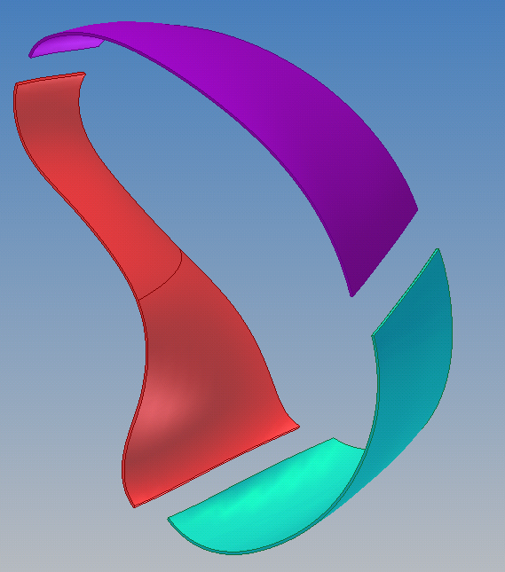
Segment A
Segment B
Segment C

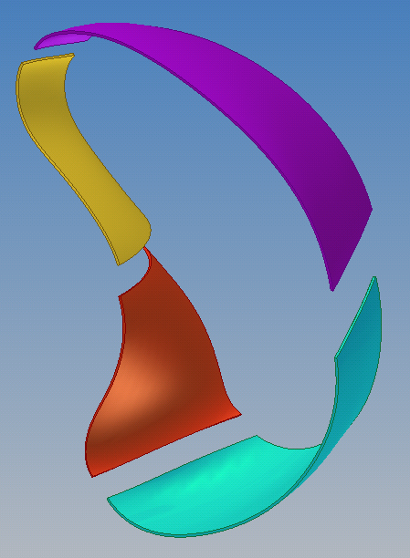
Segment B
Segment C
Segment A2
Segment A1

