National Compact Stellarator Experiment (NCSX)

Product Specification

Vacuum Vessel Sub-Assembly
NCSX-CSPEC-121-02-00
Draft C
22 March 2004

Prepared by:
_______________________________________
P. Goranson, Vacuum Vessel (WBS 12) Manager
Concurrences:
_______________________________________
P. Heitzenroeder, Technical Representative for WBS 12 Procurements
_______________________________________
B. Nelson, Project Engineer for Stellarator Core Systems (WBS 1)
_______________________________________
F. Malinowski, PPPL Procurement QA Representative
Approved by:
_______________________________________
W. Reiersen, Engineering Manager
Controlled Document
This is an uncontrolled copy of a controlled document once printed.
Check the NCSX Engineering Web Web prior to use to assure that this document is current.

Record of Revisions

Revision | Date | Description of Changes
Rev. 0 |  | Draft A
 |  | Initial Release
 |  | Draft B

1 SCOPE 3
2 APPLICABLE DOCUMENTS 4
3 REQUIREMENTS 5
3.1 System Definition 5
3.1.1 Geometry 5
3.1.2 Vacuum Vessel Subassembly (VVSA) 5
3.1.3 Description 5
3.2 Characteristics 6
3.2.1 Vacuum Performance 6
3.2.1.1 Port Extension Leak Check 7
3.2.1.2 Period Assembly Leak Check 7
3.2.2 Interior Surface Finish 8
3.2.3 Exterior Surface Finish 8
3.2.4 Magnetic Permeability 8
3.3 Design and Construction 8
3.3.1 Fabrication Drawings 8
3.3.2 Materials/Processes/Parts 9
3.3.2.1 Sheet, Strip, and Plate 9
3.3.2.2 Tubing and Piping 9
3.3.2.3 Bar and Structural Shapes 9
3.3.2.4 Conflat Flanges 9
3.3.2.5 Weld Filler Metal 9
3.3.2.6 Bolts 9
3.3.2.7 Seals 9
3.3.2.8 Welding 10
3.3.2.9 Cutting, Forming and Bending 10
3.3.2.10 Cleaning 10
3.3.2.11 Fabrication 10
3.3.2.12 Dimensions/tolerances 10
3.3.2.13 Segmentation 10
3.4 Documentation 11
4 QUALITY ASSURANCE REQUIREMENTS 11
4.1 General 11
4.1.1 Responsibility for Tests 11
4.1.2 Special Tests and Examinations 11
4.1.3 Quality Assurance Plan 11
4.1.4 Manufacturing/Inspection/Test Plan 11
4.1.5 Inspection/ Surveillance/Audit by NCSX Project 11
4.2 Quality Conformance Inspections 11
4.2.1 Verification of Vacuum Performance 11
4.2.2 Verification of Surface Finish 11
4.2.3 Verification of Magnetic Permeability 12
4.2.4 Verification of Dimensions and Tolerances 12
4.2.5 Materials 12
4.2.6 Weld Inspection and Examination 12
4.2.7 Verification of Cutting, Forming, and Bending 13
4.2.8 Verification of Cleaning Requirements 13

1 SCOPE
This specification covers the fabrication of three Vacuum Vessel Sub-Assemblies (VVSA’s) for the National Compact Stellarator Experiment (NCSX), including the supply of all required labor and materials, machining, fabrication, and factory acceptance inspections and tests. The Seller shall deliver each VVSA to the Princeton Plasma Physics Laboratory (Laboratory) site as a complete subassembly, including a spacer assembly, and separate (unattached) port extension assemblies. All of the labor for the final installation and assembly of the VVSA will be supplied by the Laboratory.

Figure 1 - NCSX vacuum vessel sub-assemblies (partially fabricated)

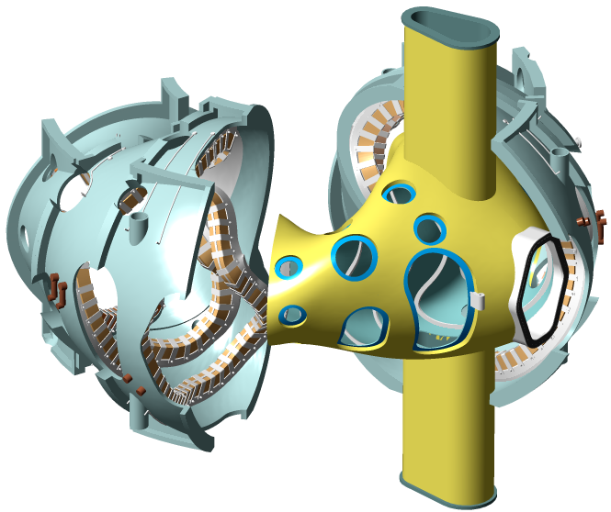

Figure 2 - Modular coils being assembled over vacuum vessel sub-assembly

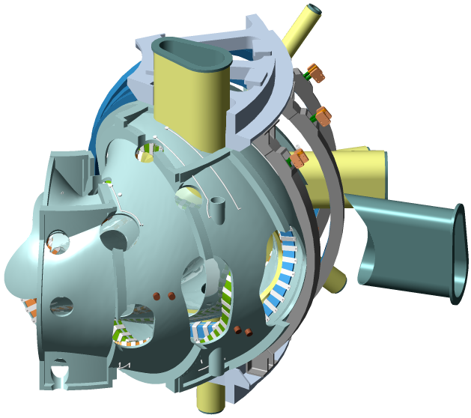
Figure 3 - Port extensions welded on after coils assembled

2 APPLICABLE DOCUMENTS

The versions of the United States Codes and Standards defined below are to be used in the performance of this work. Other equivalent foreign codes may be proposed:
- ASME B46.1-1995 Surface texture (Surface Roughness, Waviness, And Lay)
- ASME SFA specifications
- ASME SFA 5.14 Nickel and Nickel Alloy Bare Welding Rods Electrodes
- American Society of Mechanical Engineers (ASME), Boiler and Pressure Vessel Code, Sections V (Articles 6 and 9), VIII (Division 1), and IX, 1998 with 2000 Addendum.
- ASTM B 443-00 Standard Specification for Nickel-Chromium-Molybdenum-Columbium Alloy (UNS N06625) and Nickel-Chromium-Molybdenum-Silicon Alloy (UNS N06219)* Plate, Sheet, and Strip
- ASTM B 444-00 Standard Specification for Nickel-Chromium-Molybdenum-Columbium Alloys (UNS N06625) and Nickel-Chromium-Molybdenum-Silicon Alloy (UNS N06219)* Pipe and Tube
- ASTM B 705-00 Standard Specification for Nickel-Alloy (UNS N06625, N06219 and N08825) Welded Pipe
- ASTM B 446-00 Standard Specification for Nickel-Chromium-Molybdenum-Columbium Alloy (UNS N06625) and Nickel-Chromium-Molybdenum-Silicon Alloy (UNS N06219)* Rod and Bar
- ASTM A 240-02 Standard Specification for Chromium and Chromium-Nickel Stainless Steel Plate, Sheet, and Strip for Pressure Vessels and for General Applications
- ASTM A193/A193M-01b Standard Specification for Alloy-Steel and Stainless Steel Bolting Materials for High-Temperature Service
- ASTM A 800/A 800M–01 Practice for Steel Casting, Austenitic Alloy, Estimating Ferrite Content Thereof
- ASTM Spec. A 494-01 Standard Specification for Castings, Nickel and Nickel Alloy
- AWS D1.6: 1999 Structural Welding Code - Stainless Steel, (Paragraph 6.29.1)

- American Welding Society (AWS) QC1, Standard and Guide for Qualification and Certification of Welding Inspectors, 1996.
- American Society of Nondestructive Testing (ASNT) 2055, Recommended Practice SNT-TC-1A, 1996.

The above Standards and Codes set forth the minimum requirements. They may be exceeded by Seller with written permission from the Laboratory if, in Seller’s judgment, superior or more economical designs or materials are available for successful and continuous operations, as required by the specification.

ASME Code stamping of the vacuum VVSA section is not required.

3 REQUIREMENTS

System Definition

3.1.1 Geometry

The NCSX vacuum vessel is a contoured, three-period torus with a geometry that repeats every 120º toroidally. The geometry is also mirrored every 60º so that the top and bottom sections of the first (0º to 60º) segment, if flipped over, are identical to the corresponding sections of the adjacent (60º to 120º) segment.

3.1.2 Vacuum Vessel Subassembly (VVSA)

The VVSA consists of a Vacuum Vessel Period Assembly (Period Assembly) and a Spacer Assembly Three VVSA units will be welded together to form the vacuum vessel during final assembly at the operation site. The final assembly will be the responsibility of the Laboratory. The VVSA components to be fabricated and delivered by the Seller will include port stubs with openings bored out and the associated port extension assemblies with blank flanges, seals, and hardware.

3.1.3 Description

The subassembly sequence will entail welding the port assemblies onto the VVSA wall and then cutting them off, leaving stubs which will serve as reinforcement and locating positions for subsequent reinstallation of the port extensions. With the exception of the large vertical ports and the neutral beam port located mid-segment, all port assembly extensions are required to be welded onto the VVSA after installation of the modular coils and TF coils as part of the NCSX field period assembly operation. The stubs must be less than 1 inch high to permit the Modular Coils to slip over the VVSA. Reinstallation of port extensions will be the responsibility of the Laboratory. The VVSA configuration, port reinforcements (coils deleted for clarity) and definition of terminology used in this specification may be referenced in Figure 1. Figure 3 shows a completed NCSX VVSA. Several sizes of radial and vertical ports are used. The large rectangular outboard ports are designed to permit personnel access into the interior during final assembly of the field period and for maintenance of internal equipment. The field period assemblies will be supported from the modular coil shell structure via adjustable hangers. The interfacing structural bosses are a part of the VVSA and shall be supplied by the Seller. The VVSA will be traced with tubes, which will be used for cooling during operation and bake out between operational cycles. The coolant tubes will be attached via clips welded to the VVSA. The tubes will be supplied and assembled onto the VVSA by Laboratory personnel. The port attachment concept is shown in Figure 4. A complete field period assembly with VVSA, TF coils, Modular Coils, and Port Extensions is shown in Figure 5. The VVSA coordinate system is defined in the reference engineering drawings.

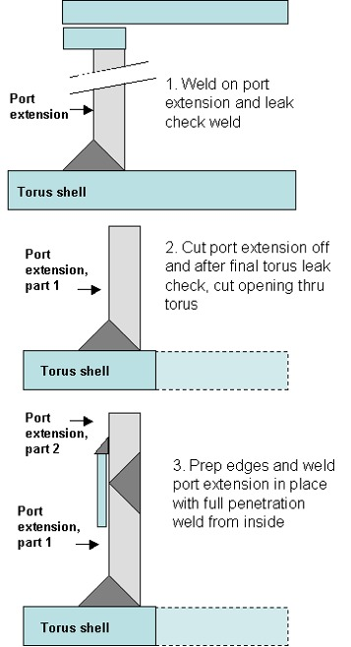

Figure 4 – Port attachment concept

3.2 Characteristics

3.2.1 Vacuum Performance

A Turbomolecular Pump (TMP) and a mechanical vacuum pump shall be used to evacuate the assembly under test.
A mass spectrometer leak detector shall be connected to the TMP fore-line. A detection sensitivity of 10⁻¹⁰ scc/sec shall be provided.
All leaks found shall be documented on nonconformance reports, and repaired. Seller's leak repair procedures shall be submitted to the Laboratory for approval prior to use.
Testing shall be in accordance with ASTME 498 and as delineated in the following paragraphs:

3.2.1.1 Port Extension Leak Check

The port extensions included in the VVSA shall be leak checked. The port configuration during vacuum leak testing shall be with the vessel wall inside of port extensions in place, as shown in Figure 4, step 1. Conflat flanges, o-ring flanges, port covers, seals, and bolts shall be in their operational configuration. Prior to leak checking, the assembly shall be cleaned as defined in Sect. 3.3.2.10. The large vertical ports will be leak checked with the Period Assembly per Section 3.2.1.2.

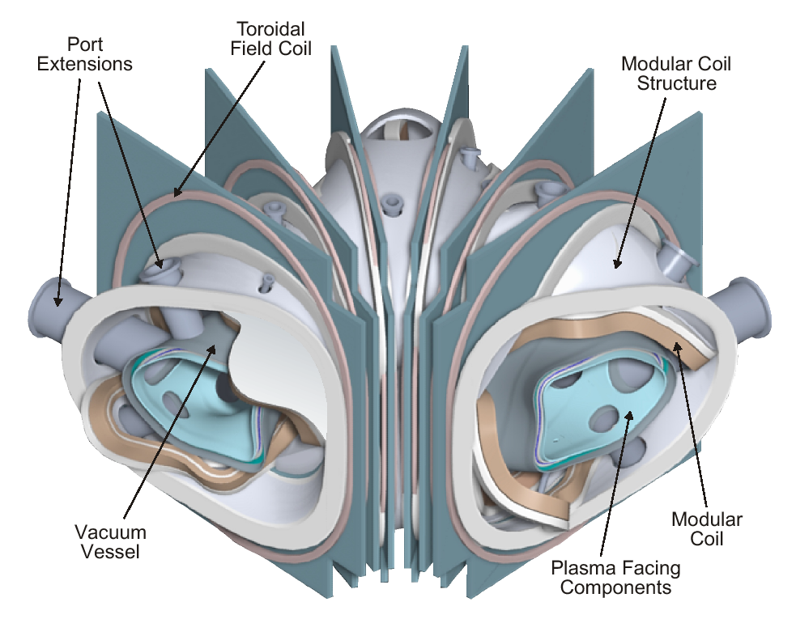
Figure 5 Field Period Subassembly (VVSA) with all port extensions assembled into Modular Coils.

3.2.1.2 Period Assembly Leak Check

        - A helium leak test of the Period Assembly shall be performed at the Seller’s facility. The testing shall be performed after cutting of the port extension to form port stubs and prior to final boring and machining of the holes. Accepted leak rates…?

        - The Period Assembly shall be leak checked in its entirety by temporarily blanking off the end flanges, large vertical ports, and neutral beam midline ports with the appropriate flange covers. The tests shall be performed a minimum of three times after cycling the temperature of the components from room temperature to 375+25 C. The Vertical Port flanges are o-ring sealed and shall not exceed 150 C during these tests. The means by which this is accomplished, whether by cooling the flanges or projecting them outside the heated region, shall be described in the Seller’s test plan for approval by the Laboratory. The Seller shall furnish and install all temporary test fixtures, flanges, blanking off plates, and gaskets required to seal the Period Assembly for leak checking purposes.
        - Other than used gaskets, all such equipment shall be delivered to the Laboratory at the conclusion of testing.

3.2.2 Interior Surface Finish

3.2.2.1 Interior (vacuum) surfaces of Inconel sheet stock used for fabrication of the VVSA wall and port extensions shall be the identified and marked. The interior surfaces of the sheet stock shall be mechanically polished to a 32 micro-inch finish. Interior surfaces of pipe and tubing used for port extensions shall be mechanically polished or electro-polished to a 32 micro-inch finish. Interior surface weld beads, scratches, and tooling marks resulting from fabrication shall be ground to a 32 micro-inch finish. Scratches, pits, weld pin holes and other surface imperfections exceeding depth limits set forth in the ASTM B 443 and Engineering Drawings shall be repaired by welding before finish grinding.
3.2.2.2 Tools utilized in grinding and lapping operations on the VVSA and its components shall be nonferrous ceramics or nonmagnetic stainless steel, which have never been in contact with other than austenitic stainless material.

3.2.3 Exterior Surface Finish

Mill finish on the exterior surfaces of the VVSA is acceptable, but any gouges greater than .04 inches deep shall be weld repaired and ground smooth.

3.2.4 Magnetic Permeability
Except for welds (and heat affected zones) joining stainless steel to nickel chromium which shall not exceed 1.2, overall relative magnetic permeability of all components
shall not exceed 1.02.

3.3 Design and Construction

3.3.1 Fabrication Drawings
All the Drawings and CAD models are provided in Pro-E® format and it is the Seller’s responsibility to work with this format. Vacuum Vessel Contour Pro-E® models are referenced on the fabrication drawings. Figures provided in the text of this document are to provide clarity and are for information only; equipment shall be provided in conformance with the following drawings and electronic files:

SE120-001 REV O, Vacuum Vessel Assembly
SE121-002 REV O, Vacuum Vessel Period Assembly
SE121-019 REV O, Vacuum Vessel Spacer Detail

.
The Pro/Engineer models and drawings of the VVSA are available through the PPPL anonymous FTP server. The following FTP commands can be used to access the files:
ftp> ftp.pppl.gov
User: anonymous <- login as anonymous
Password: <- enter your email address
ftp> cd pub/ncsx/manuf <- lowercase
ftp> bin <- binary transfer mode
ftp> mget * <- retrieve files
ftp> quit

The files may also be accessed through a web browser using the following URL address:
ftp://ftp.pppl.gov/pub/ncsx/manuf/

3.3.2 Materials/Processes/Parts

3.3.2.1 Sheet, Strip, and Plate
All as-supplied sheet, strip, and plate shall be annealed Alloy (UNS N06625) and meet the requirements of ASTM B 443.

3.3.2.2 Tubing and Piping
All tubing and pipe shall be seamless or welded Alloy (UNS N06625) and meet the requirements of ASTM B 444 or ASTM B 705.

3.3.2.3 Bar and Structural Shapes
All bar and structural shapes shall be annealed Alloy (UNS N06625) and meet the requirements of ASTM B 446.

3.3.2.4 Conflat Flanges
The conflat flange shall be fabricated of 304 stainless steel and meet the requirements of ASTM A 240.

3.3.2.5 Weld Filler Metal
3.3.2.5.1 Weld filler metal shall meet the requirements of the applicable AWS A series specifications or ASME SFA specifications. Certified material test reports shall be supplied for all materials (see section 4.3).
3.3.2.5.2 Welding of stainless steel conflat flanges to Inconel 625 (UNS N06625) ports shall use ASME/AWS SFA/A 5.14 ERNiCr-3 or ERNiCrMo-3 filler metal

3.3.2.6 Bolts
Conflat flange bolts shall be ASTM A 193, Grade B8; silver-plated, 12-point bolt kits provided with flanges from the flange manufacturer.
Rectangular o-ring ports shall use ASME SA 453 Grade 660 bolts.(A286 or Inco 718)

3.3.2.7 Seals
3.3.2.7.1 Metal Seals for Conflat flanges shall use standard copper seals provided from the flange manufacturer.

3.3.2.7.2 Custom racetrack-shaped and rectangular flanges will be sealed with Viton A o-rings on both the vacuum side and on the air side. Dimensions and o-ring grooves shall conform to specifications listed in the Engineering Drawings.

3.3.2.8 Welding
All welding shall be done by qualified personnel using written and qualified welding procedures in accordance with the ASME Code, Section IX. Welds may be made by the GTAW or GMAW processes. Welds using SMAW process are not permitted.

3.3.2.9 Cutting, Forming and Bending
For the fabrication of the Vessel, all cutting, forming and bending shall be done in accordance with the ASME Boiler and Pressure Vessel Code, Section VIII, Division 1.

3.3.2.10 Cleaning
After completion of assembly and surface preparation and prior to any heat treatment operation, the VVSA interior shall be cleaned. All surfaces shall be degreased/cleaned using materials and procedures mutually agreed upon. As a minimum this procedure will include:
- Vapor degreasing to remove oils, greases, and die lubricant residues resulting from handling and fabrication of the Vessel.
- Solvent (e.g. ethanol) wipe down of the surfaces.
- Blow drying of surfaces with oil-free instrument air.
- Use of lint-free wipes.

3.3.2.11 Fabrication
The VVSA wall shall be fabricated by forming, pressing, or other related processes that result in a smooth contour, conforming to the Pro-E® model supplied by the Laboratory.

3.3.2.12 Dimensions/tolerances
3.3.2.12.1 The VVSA overall dimensions and dimensional tolerances shall be in accordance with the referenced Engineering Drawings. Compliance with the dimensions and tolerances shall be done with the assembly completed, i.e. the port extensions cut off to form stubs, the holes bored, and vessel end flanges installed and after any required thermal cycling operations.
3.3.2.12.2
The Seller will be required to perform dimensional checks using full surface 3-D measurement equipment (eg laser tracker) to ensure that the surfaces are within the prescribed limits. The seller shall also perform VVSA wall thickness measurements using suitable method (e.g. ultrasonic).
3.3.2.12.3
Dimensional stability of the VVSA over an operating temperature range of room temperature to 375 C is a primary requirement. Fixturing and stress relieving of pressed subcomponents will be necessary to maintain the VVSA tolerances and to avoid subsequent distortion after welding.

3.3.2.13 Segmentation
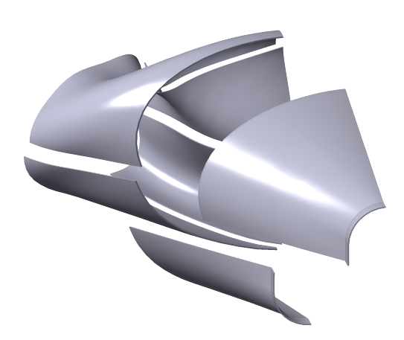
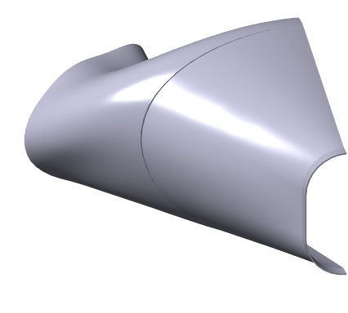
The VVSA is made up of contoured plate segments, welded together and mated to end flanges. A possible fabrication segmentation of a half (60 degree) VVSA is shown in Figure 7, which uses 6 shapes and 12 total pieces to form a VVSA. This configuration incorporates shapes that can be freely removed from a forming die without interference (entrapment) and minimizes the amount of plate deformation required during the forming process. The Seller may propose other segmentation schemes with the bid proposal for review and approval by the Laboratory. Schemes minimizing the number of segments (and subsequent welding) are preferred to schemes using more segments.

Figure 7 Fabrication segmentation scheme for a half period section of the VVSA.

3.4 Documentation

4 QUALITY CONFORMANCE INSPECTIONS

4.1 Responsibility for Tests
Tests and inspections shall be conducted at the Seller’s facility or otherwise suitable location.

4.2 Inspection and Test Documentation
4.2.1 Actual data, except where otherwise stated within this document, and accept/reject status for each inspection and test shall be documented.
4.2.2 The reports shall contain sufficient information to accurately locate the area involved and to reproduce the inspection or test performed. This can be accomplished by clear and direct reference to other Subcontractor-provided documents. The procedure, and, as applicable to the process, the technique and equipment used shall be clearly identified. References to calibrated measuring and test equipment shall include date of latest calibration.
4.2.3 Inspection and test reports shall identify the personnel performing the inspection or test and their certification level, where applicable. The reports shall be dated and verified by authorized personnel.

4.3 Verification of Vacuum Performance
Helium leak tests shall be performed to verify that the requirements stated in Section 3.2.1 are met.

4.4 Verification of Surface Finish
The interior surface finish shall be checked with a comparator to verify compliance with Section 3.2.2. The exterior surface finish shall be visually examined to verify compliance with Section 3.2.3. Actual values need be recorded only for any out-of-tolerance conditions

4.5 Verification of Magnetic Permeability
To verify conformance to Section 3.2.4, magnetic permeability shall be measured in accordance with the requirements of ASTM A 800, Supplementary Requirement S1, but with the measurements taken in relative permeability, rather than ferrite content. All surfaces and features shall be checked with a calibrated Severn Permeability Indicator for compliance with Section 3.2.1.6. The surfaces of the PVVS shell and port extension shall be checked and documented in a 6" x 6" grid. The welds at the conflat flanges and at the junction between the port extension, reinforcement, and vessel shell shall be checked every 1/2" (both inside and outside surfaces wherever possible). Actual values need be recorded only for any out-of-tolerance conditions.

4.6 Verification of Dimensions and Tolerances
With the VVSA unrestrained on a surface measuring table and the port extension supported to compensate for gravity load, all surfaces and features shall be dimensionally checked on a grid no coarser than 1-inch centers using instruments having resolution at least ten times the tolerance. These measurements shall be compared to the tolerances indicated on the applicable drawings. Verification of dimension and tolerances shall be done both before and after attachment of the port extension.

4.7 Materials
Material certifications traceable to the materials used shall be provided as defined below. Subcontractor is to develop and utilize process controls to assure traceability of materials to their certifications.
- N06625: showing actual chemical and physical properties
- Bolts: Manufacturer’s certification of grade
- Conflat flanges: Manufacturer’s certification of grade
- Filler metal: showing actual chemical properties

4.8 Weld Inspection and Examination

4.8.1 All welds are to be visually inspected using a written procedure prepared in accordance with Article 9 of Section V of the ASME Code. Welds designated with a "VT" in the tail of the welds symbol shall also be visually examined with 8X magnification. The acceptance criteria for the visually inspected welds are given in AWS D1.6, Paragraph 6.29.1. All welds that do not meet the stated acceptance criteria shall be documented, repaired, and re-inspected.

4.8.2 Visual weld inspection shall be done by inspectors certified to perform visual inspection of welds in accordance with AWS QC1 or SNT-TC-1A, Level II or Level III.

4.8.3 Copies of welding heat treatment, NDE and special process procedures and qualification test records shall be available for review by the Laboratory. Welding procedures qualifications shall include evidence of compliance with special magnetic permeability criteria.

4.8.4 Volumetric Testing

All welds are to be radiographically inspected using certified personnel and a written procedure in accordance with Article 2 of Section V of the ASME Code. The inspection and acceptance criteria shall be in accordance with ASME Section VIII, Division 1, UW-51. All welds that do not meet the stated acceptance criteria shall be documented, repaired, and re-inspected

4.9 Verification of Cutting, Forming, and Bending
Copies of cutting, forming, and bending procedures shall be available for review by the Laboratory.

4.10 Verification of Cleaning Requirements
Visually inspect the PVVS and examine records for compliance with Section 3.3.2.4.

Available from Severn Engineering Co. Annapolis, Md.

