SPEB REPORT

INTRODUCTION

The first meeting of the SPEB for the NCSX Vacuum Vessel met Wednesday 3 February 2004. The schedule was developed and selection criteria discussed. The selection criteria were established on 23 March 2004. While the original contract delivery date for the PVVS was 15 November 2003, the Major Tool PVVS was received on 16 April 2004 and the Rohwedder PVVS was received on 8 June 2004.

SELECTION PROCESS

The NCSX Vacuum vessel RFP 04-015F was issued to Major Tool and Rohwedder June ____24?__ requesting proposals to be returned on 22 July. Both proposals were received on time. The SPEB Selection board met Friday 23 July and Monday 26 July to discuss the proposals and develop questions for clarification. A specific set of questions for each bidder was sent on Monday 26 July. Oral presentations were provided to answer the questions on Wednesday 28 July by Major Tool and Thursday 29 July by Rohwedder/PMW. Technical evaluations were provided by each board member and discussed on Friday 30 July. The matrix of technical evaluations was reviewed by the board. Board members discussed their grades wherever either superior or unacceptable marks were given. The final step in the technical evaluation was to rank the technical merits of both bidders. The team started by comparing the unacceptable areas. While Major Tool only had one area of concern - the production of an MIT/QA plan that PPPL can interpret, approve, and use to plan oversight; Rohwedder had a number of significant unacceptable deficiencies. These included an unresolved technical uncertainty, which the board assessed as being of high risk. The team then discussed some of the areas of positive ratings and found that typically Major Tool had rankings based on actual performance, whereas much of Rohwedder/PMW’s evaluation was based on criteria categories with poor performance on the PVVS and an untested plan for improvement for the VVSA. Further detail is provided below. Major Tool was unanimously selected in each category.

 | RANK
CRITERIA CATEGORY | Major Tool vs. Rohwedder
Past Performance of PVVS FABRICATION (60%) | Major Tool
A. Prototype compliance with Subcontract Statement of Work and Specification Requirements in order of descending importance (40%) | Major Tool
B. Management (Performance relative to SOW) (20%) | Major Tool
Capability for VVSA FABRICATION (40%) | Major Tool
A. Technical capability for VVSA (25%) | Major Tool
B. Management for VVSA (15%) | Major Tool

HIGHLIGHTS OF MAJOR TOOL’S PVVS AND PROPOSAL

The Prototype PVVS vacuum vessel provided by Major Tool was well built; smooth, without flaws and within tolerance except for one point which exceeded the +/- 0.188” tolerance by only 0.013” This minor deviation was deemed acceptable by the cognizant engineer and the resulting nonconformance which this generated was dispositioned “use as is.” The one downtick on the evaluation was due to the complexity of their MIT/QA plan. Their plan is generated automatically by a software package called Visual Manufacturing which works well online for their shop and tracking shop activities but does not produce a print-out that lends itself easily to interpretation by a customer. Its output is in the format of a series of “cards” which are unlinked. During the prototype process approval phase, there was extraordinary reiterative communication necessary to understand and verify that their MIT/QA plan met our specification and would produce the desired result. However, the experience and dialog during this iterative process provided a strong basis for understanding for both PPPL and Major Tool. The prototype process proved to be most valuable for developing and demonstrating the processes necessary to produce the PVVS, as well as the documentation to assure that the specification was met. The Major Tool proposal included reusing the 5 dies produced for the prototype vacuum vessel. Their original plan of using 9 dies to produce the VVSA remains unchanged. They were responsive to our concern during the PVVS production regarding QA oversight by assigning a full time QA person to each of their production teams. They stated during the oral question and answer period that they found the PVVS production to have been very useful and resolved any technical questions. The Board unanimously agreed that their proposal posed minimal technical risk.

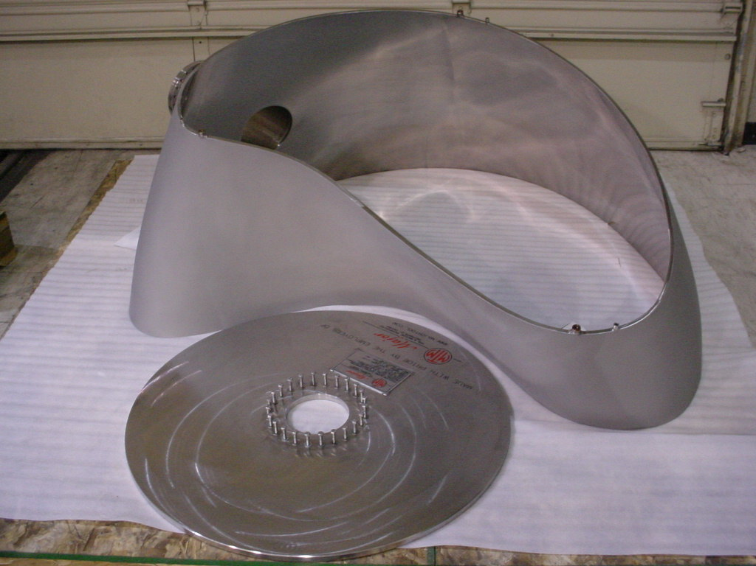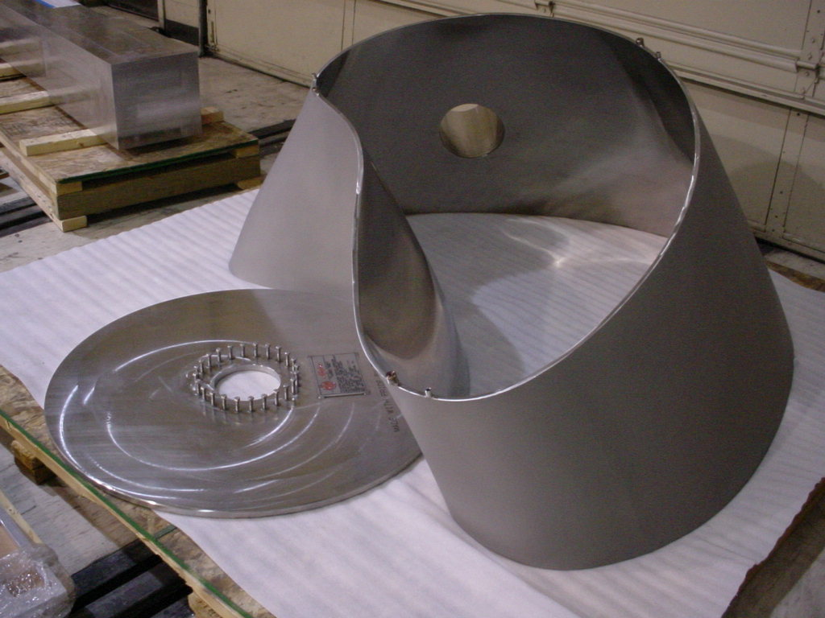
Smooth, well formed; within tolerance

HIGHLIGHTS OF ROHWEDDER/PMW’S PVVS AND PROPOSAL

Rohwedder teamed with NuVac initially and parted several months into the contract period. A replacement company, Precision Metal Works (PMW) was identified 16 October 2003 and accepted on 21 November 2003. The Prototype PVVS vacuum vessel provided by Rohwedder was remarkably distorted and grossly out of tolerance. Large percentages of the measurement points on each of their panels were out of tolerance, exceeding the +/- 0.188” tolerance by as much as 1.691”. Deviations of this scale on the VVSA would make the assembly of the NCSX modular coils over the vacuum vessel impossible. Additionally, their weld quality was remarkably poor for a vacuum container fabrication facility. There were weld flaws that did not meet the acceptance criteria of the PPPL specification, which were identified during the receipt inspection at PPPL and not noted by the Precision Metal Works subcontracted inspection company. In their proposal for the VVSA fabrication, the risk matrix still presented a number of incomplete resolutions to the problems identified during the prototype production. Their prepoposal teleconference answers presented orally and in writing included a number of areas where techniques and procedures had not yet been engineered or developed. The offered solution to the redesign of the dies still included several uncertainties and was not reassuring. Members of the evaluation board were not convinced that their proposed solution of using ¼” thick plates, water jet cut and laminated, as opposed to the previous design of 1” plates spaced 2” apart would achieve a workable die design. This concept has not been tested and proven and could result in another set of difficulties yet undiscovered. This was deemed a significant unresolved technical uncertainty by the Board.

ROHWEDDER/PRECISION METAL WORKS PHOTOS:
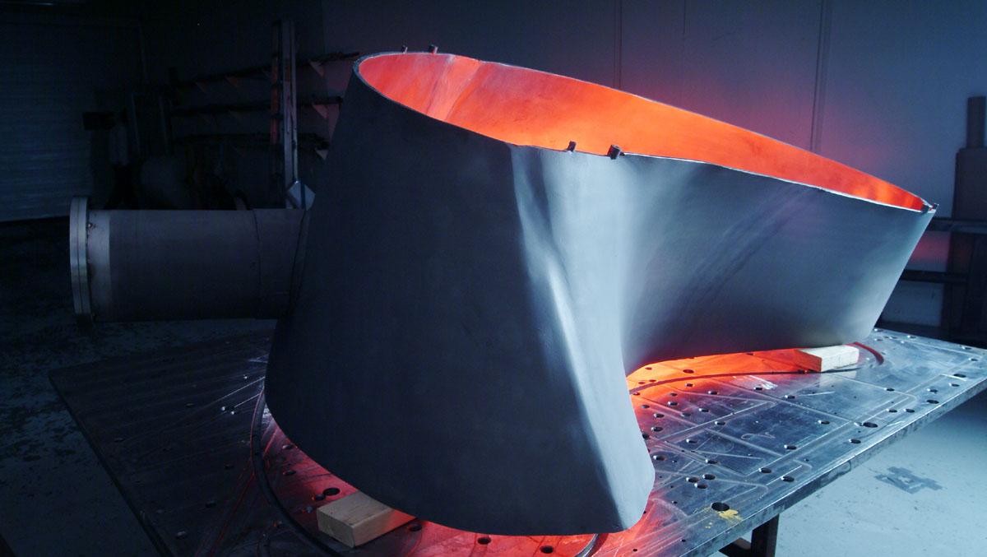
Poor Matching of segments
2” Strip added to compensate for lost material between A1 and A2
forming not smooth

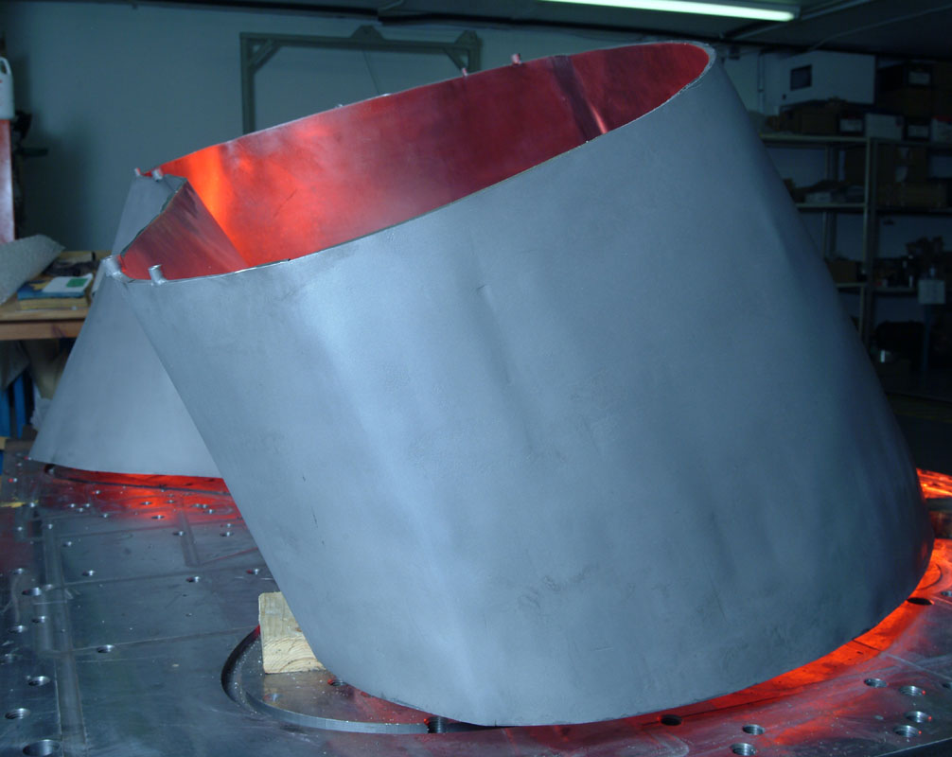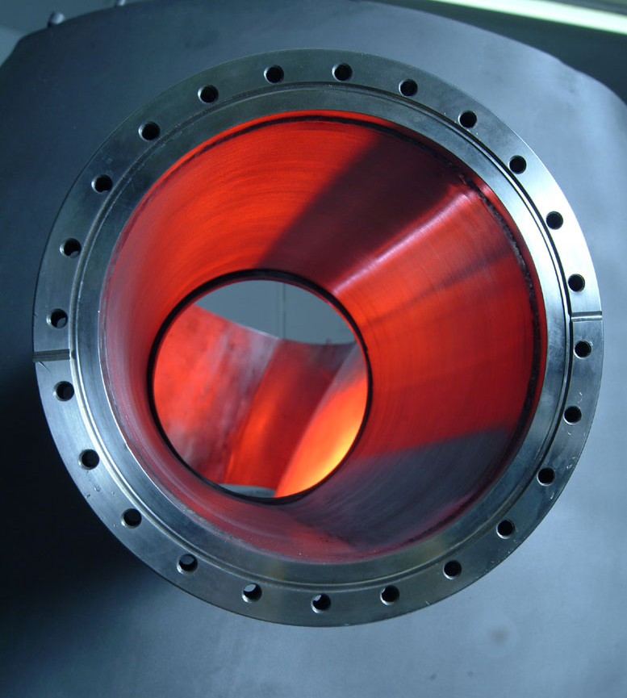
Dents from reworking
Scratches
PPPL PHOTOS:
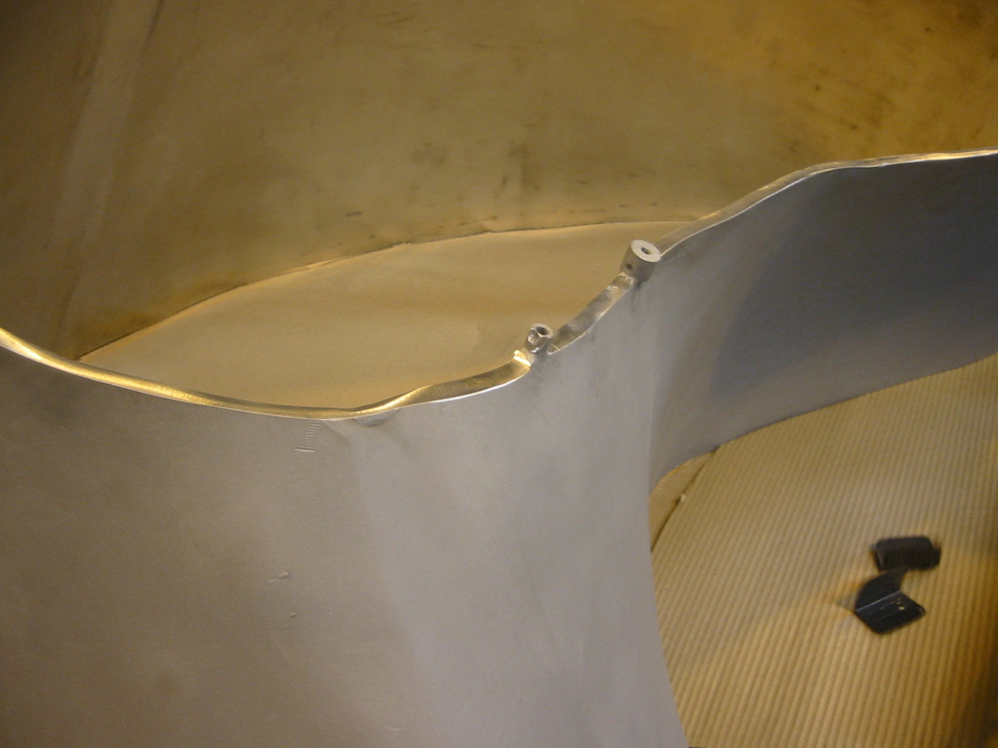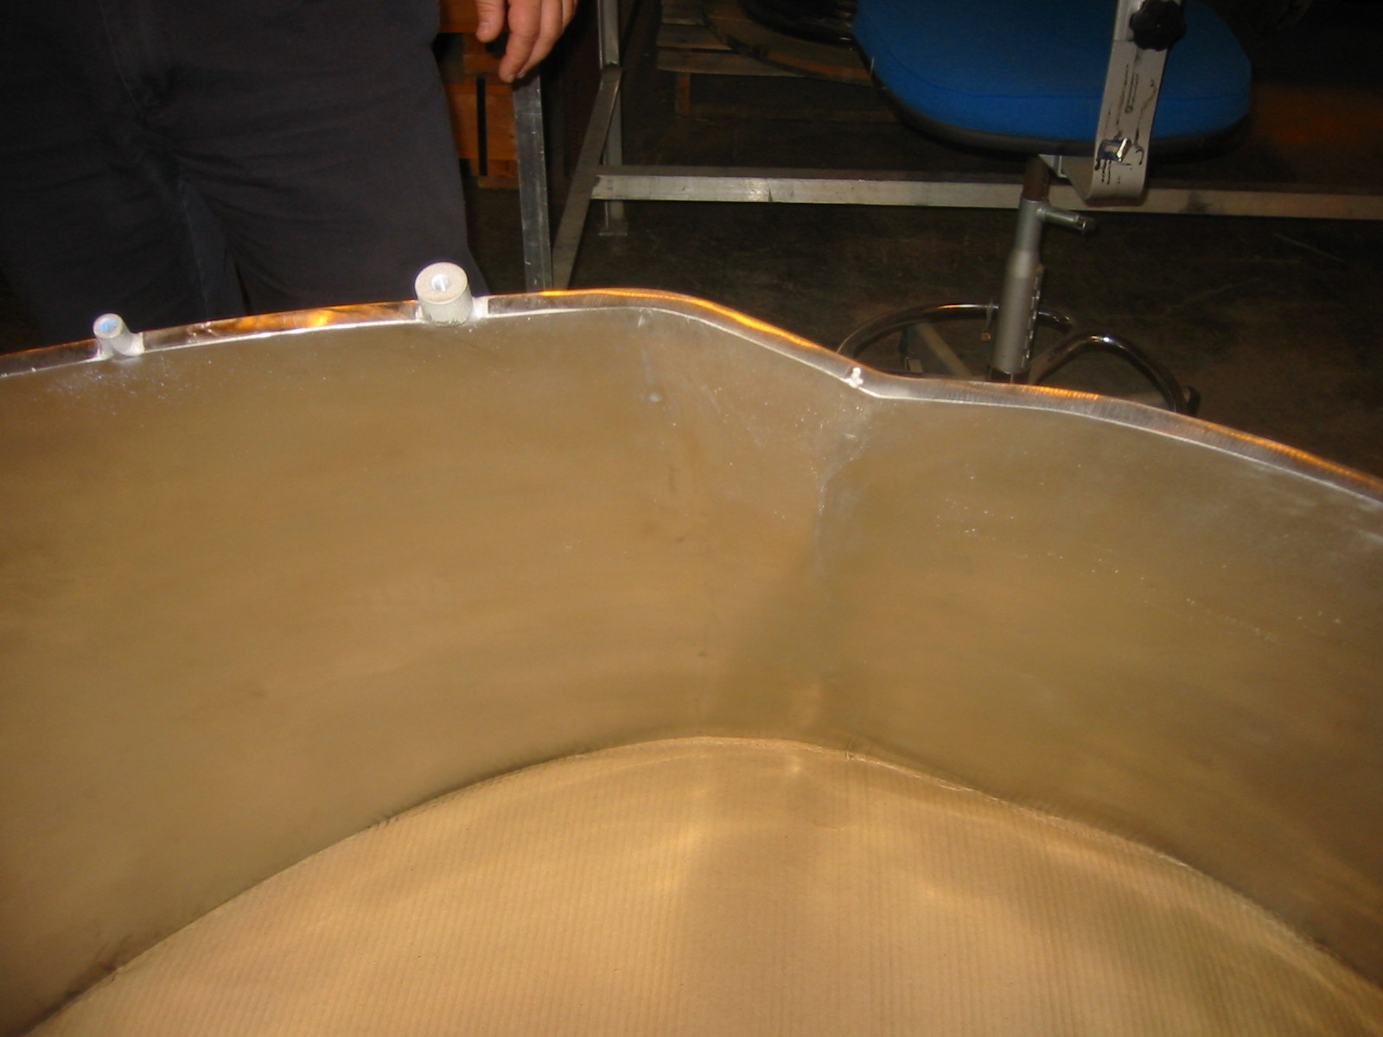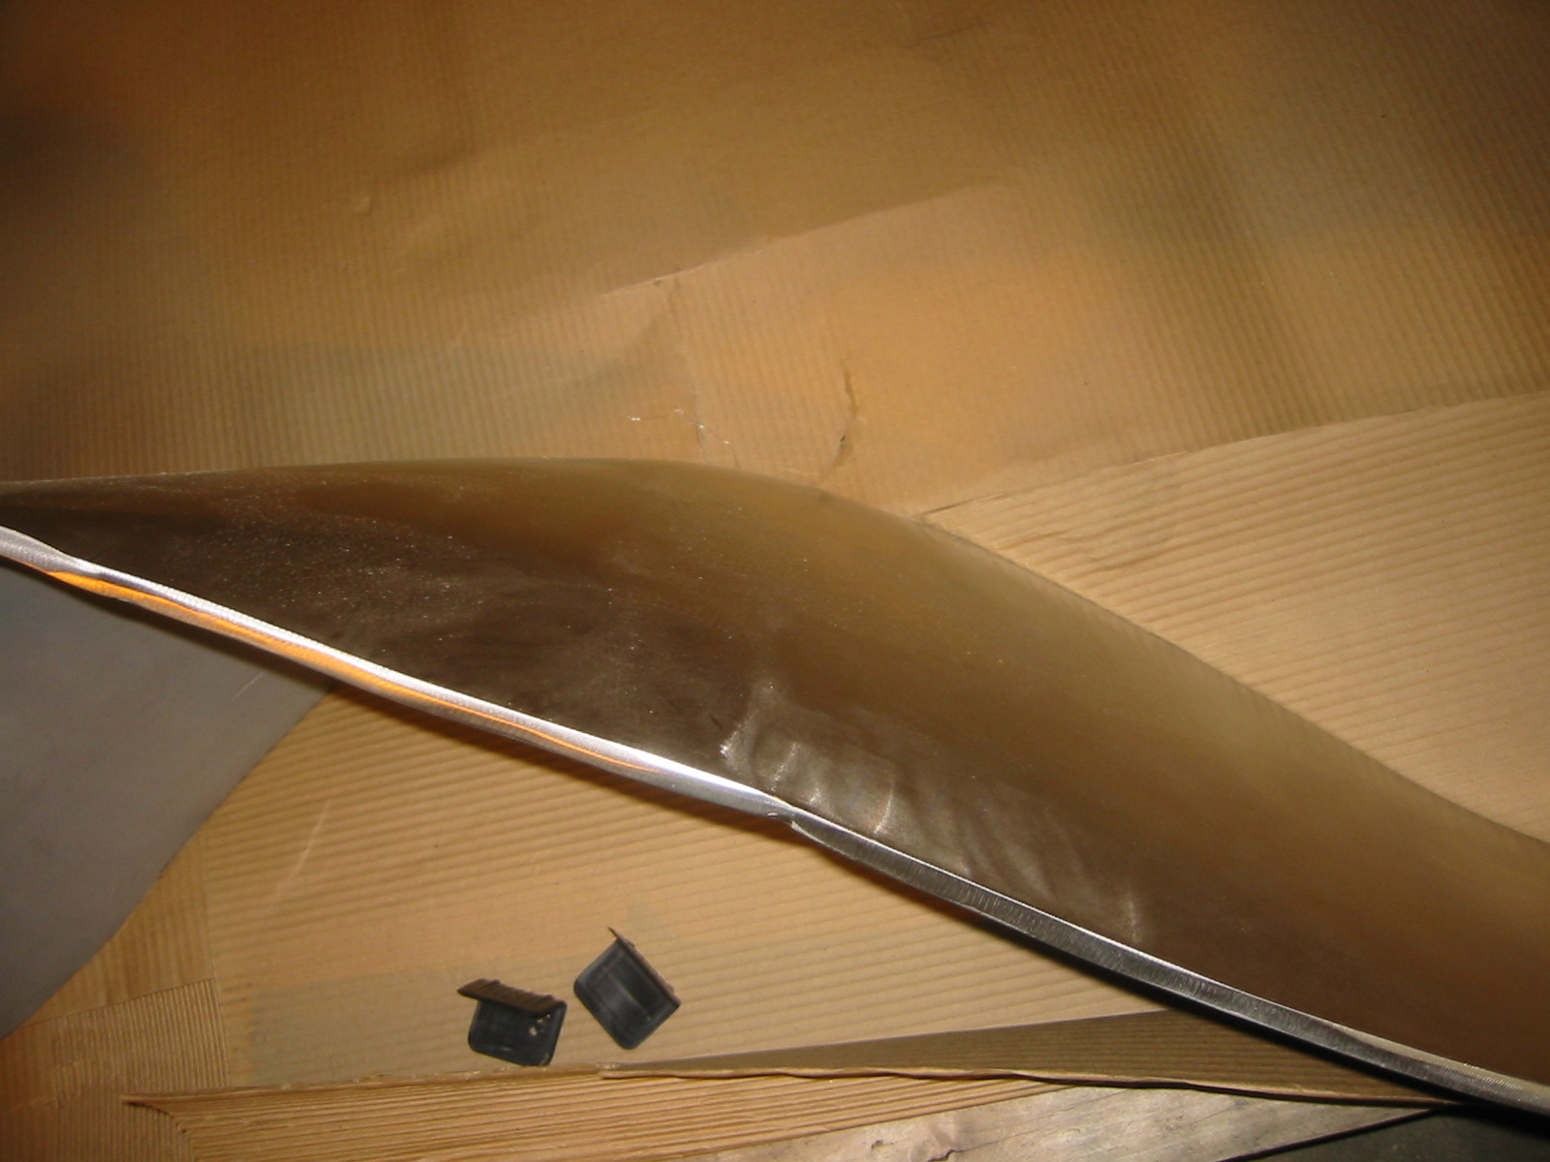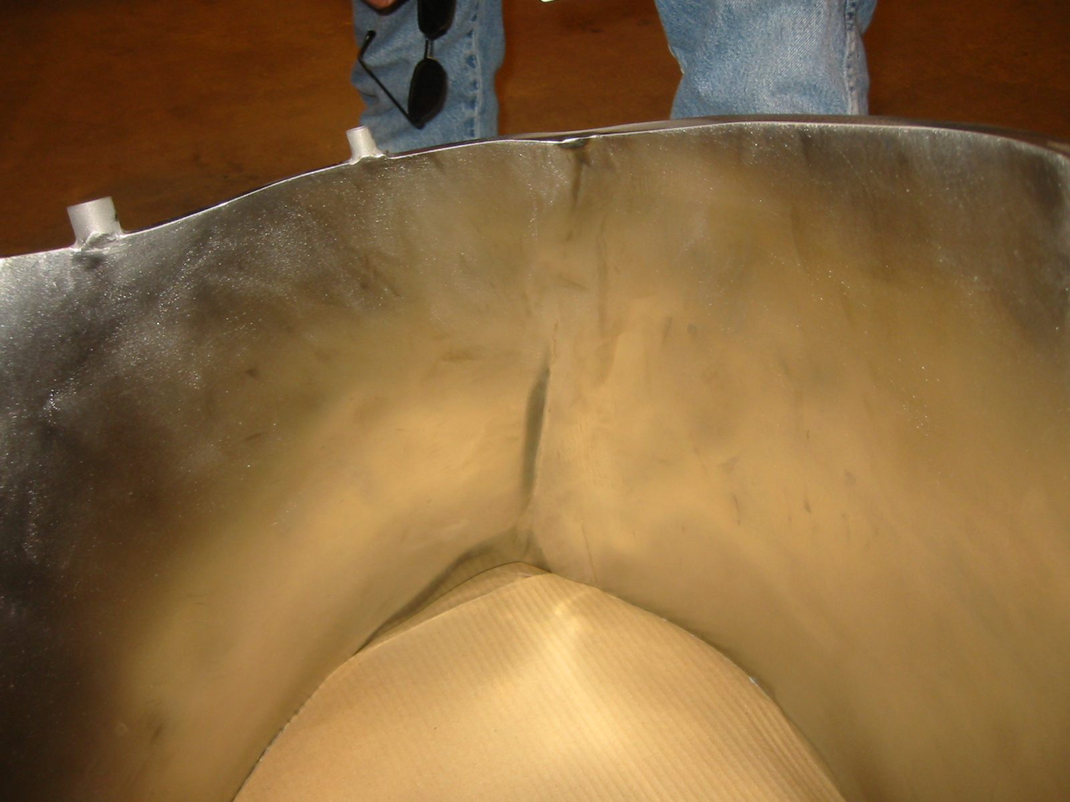
Uneven edge finishing
Out of tolerance; poor forming and matching
Incomplete weld

PRICE PROPOSALS

Upon completion of the technical evaluation, the fixed-price proposals were revealed. The Major Tool price was $4,858,060 and Rohwedder’s price was $7,181,677.

CONCLUSION

In conclusion, on the basis of technical and cost evaluation, the board unanimously recommends placing the order with Major Tool and Machine.

