Pre-Proposal Teleconference
PPPL RFP 04-015F for NCSX Vacuum Vessel Sub Assemblies
Thursday, July 29th, 2004
1:30 pm

with
Plasma Physics Laboratory
James Forrestal Campus
P.O. Box CN17
Princeton, NJ 08543

- Technico, the welding inspection subcontractor, did not identify some obvious weld flaws on the prototype that was shipped to PPPL. What assurance can you give that a more thorough inspection will be performed on the VVSA?

  - Technico provided the radiographic weld examination services and did find welds that were of poor quality and rejected them. The obvious flaws mentioned were not items that were part of the inspector’s inspection requirements. Rohwedder and PMW will use Skarborn Engineering and Technico for weld oversight and inspection to ensure that inspections are complete and thorough.
Rohwedder/PMW question to PPPL
#1 We have not received a report regarding the results of the inspection for the prototype shipped to PPPL, therefore we do not know what weld flaws are being referenced in this question. Is this report available so that we can review and provide an adequate response?
Response: Evaluator's comments (PPPL):
a . Overall, the piece exhibits excessive distortion, and ripples, both on the body and at the edge of the part. There are also some external dents on the vessel surface, as well as mechanical damage on the face of the welded flange.
b. Weld quality is sub-standard for vacuum quality welds. There are at least two incompletely welded joints, as well as some areas of undercut, overlap/rollover, and excessive weld-induced distortion.
c. The edge has been ground in an irregular manner, such that it appears to be very uneven.
d. The tube to shell weld is not a full-penetration weld; the tube has a rough cut edge at the end that is attached to the vessel. The re-welded port is out of round, and exhibits sub-standard weld quality.

Segments of the PVVS had distortions, ripples, dents, and out of tolerances prior to welding them together (see pictures below). Due to budget and time constraints we had to continue with the manufacturing process. As our initial segment were out of tolerance, this carried over to the PVVS being out of tolerance. We are confident that our new robust die design and added overlap in the dies will eliminate the forming issues.

Our new die design will incorporate the following:
- ¼” side by side rib layout for rigidity
- 4” minimum overlap for minimizing rippling/distortion
- Edge reinforcements for rigidity

The PVVS had the following issues:

- Ripples
Cause
  - Lack of overlap in die design
  - Segmentation too complex (Segment A could not be formed and had to be cut in half and reformed. The A2 portion of Segment A was flattened and then reformed which left a ripple through the segment)

Solution
  - Die design that includes a minimum of 4” of overlap
  - Segmentation scheme that is simple in complexity but efficient in minimizing number of welds needed

- Dents
Cause
  - Lack of rigidity in the dies required hand rework of segments and this led to dents

Solution
  - Robust die design
  - Die design that includes a minimum of 4” of overlap
  - Segmentation scheme that is simple in complexity but efficient in minimizing number of welds needed

- Distortions
Cause
  - Segment edges out of tolerance and rippled

Solution
  - Robust die design
  - Die design that includes a minimum of 4” of overlap
  - Segmentation scheme that is simple in complexity but efficient in minimizing number of welds needed

- Damage to Flange Face
  - There were some imperfections on the flange at receipt of the flange, however, the flange vacuum seal conflat blade was not damaged and the flange was not replaced due to time constraints. Our vacuum leak check of this port was successful and met PVVS specifications.

- Edge unevenly ground
  - During machining of the edges, some areas did not clean up smoothly due to the segments being out of tolerance and insufficient amounts of overlapping. Areas that did not clean up had to be ground to help blend the segments together. This unevenness can be prevented by designing robust dies, incorporating overlap in the die design and selecting the right segmentation scheme.

- Incomplete weld joints, undercut, and overlap/rollover
  - This was due to lack of material at segment edges where segments mated and ripples/distortions from lack of die rigidity and material overlap. The welds in these areas were very difficult to perform due to the way the segments lined up. The welds were cleaned up to try and achieve an aesthetically pleasing PVVS. This will be prevented by designing robust dies, incorporating overlap in the die design, and selecting the right segmentation scheme. In addition, we will expanded weld engineering oversight by Skarborn Engineering.

- Port weld lacked full penetration
  - The weld of the port onto the shell was not a full penetration weld. Vacuum integrity of the weld was achieved but full penetration was not. A new procedure will be developed to specify a full penetration vacuum quality weld with backside argon purging. This weld will also be qualified, practiced, and perfected prior to implementation on the VVSA. We will also use a better fit up method of the ports contour that takes the shape of the shell where it mates to the VVSA. In addition, the new die design we will minimize the segment out of tolerances thus allowing us to have a vessel contour that is very close to actual which will aid in the port fit up. This along with the new weld procedure will resolve the issue of the visible rough cut tube.

- Port out of round
  - There were difficulties in rolling the inconel material to this diameter. Full investigation of better methods for rolling these ports which will be included in a new procedure. The procedure will include methods of rolling, stress relieving, and re-rolling. There will also be a post seam weld stress relief process implemented.

- Port to stub weld sub-standard quality
  - The port to stub weld failed the radiographic exam. There was an NCR generated and it was offered to redo this port or re-demonstrate this process. Further discussions with PPPL deemed any rework unnecessary. There was a misunderstanding on what the backing ring was for. We now understand that the backing ring is to be consumed by the weld. We will reevaluate the procedure for this and implement changes. We will also provide weld engineering oversight (Skarborn Engineering) to help monitor weld processes. Our welders will be qualified on these welds prior to performing the welds.

In Summary, the above issues noted have been addressed by Rohwedder and PMW. Segmentations schemes have been revised to reduce the complexity of the forming process. Our die design will be more robust (1/4” ribs side by side, rigid enclosure, and edge reinforcements) which will eliminate the issue of die ribs moving during press operations. The die design will also include at least 4” of overlap all the way around each segment which will minimize our rippling issues. The die rib thickness is being reduced to help us achieve a better contour on the ribs at the steeper sides of the segments. We are confident that with the incorporation of the above solutions and continued risk management we can minimize these issues that occurred on the PVVS.

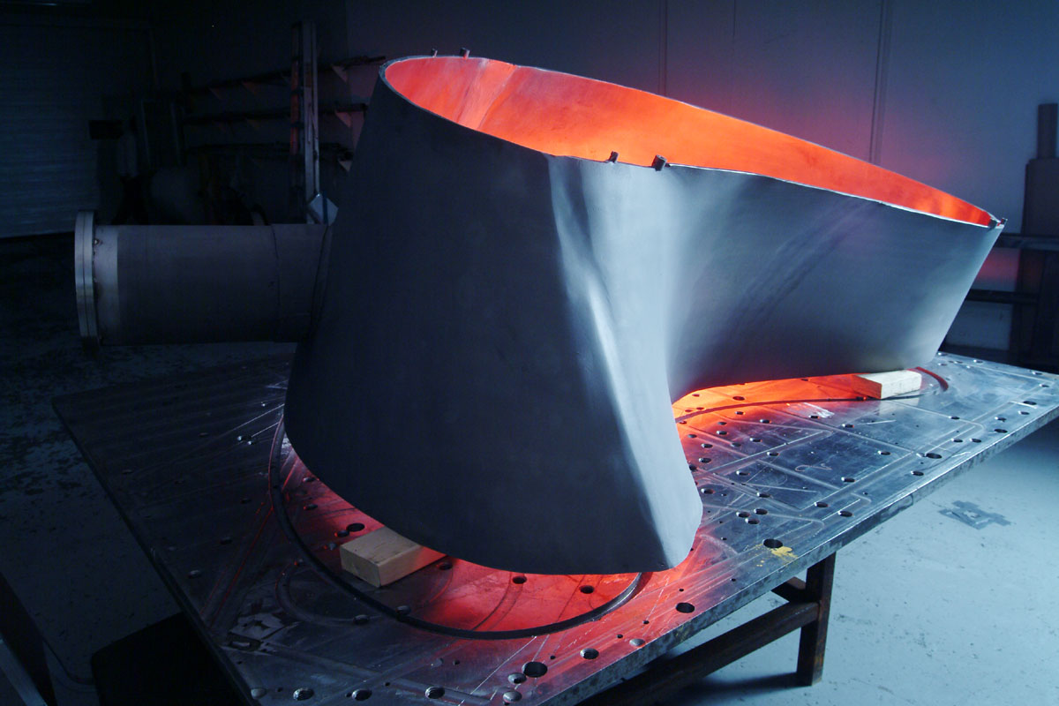
Poor Matching of segments
2” Strip added to compensate for lost material between A1 and A2

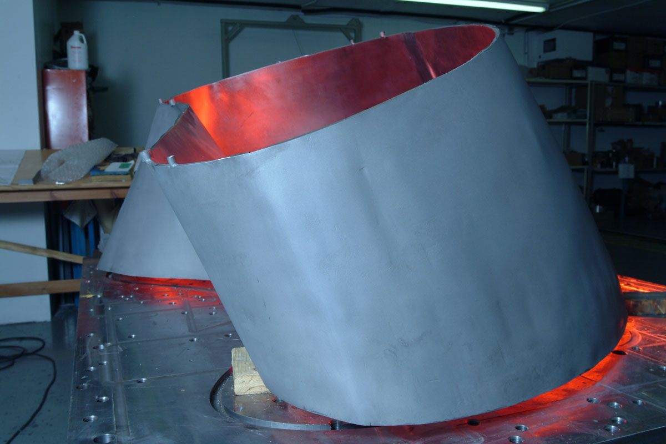
Dent from reworking
Dents from reworking

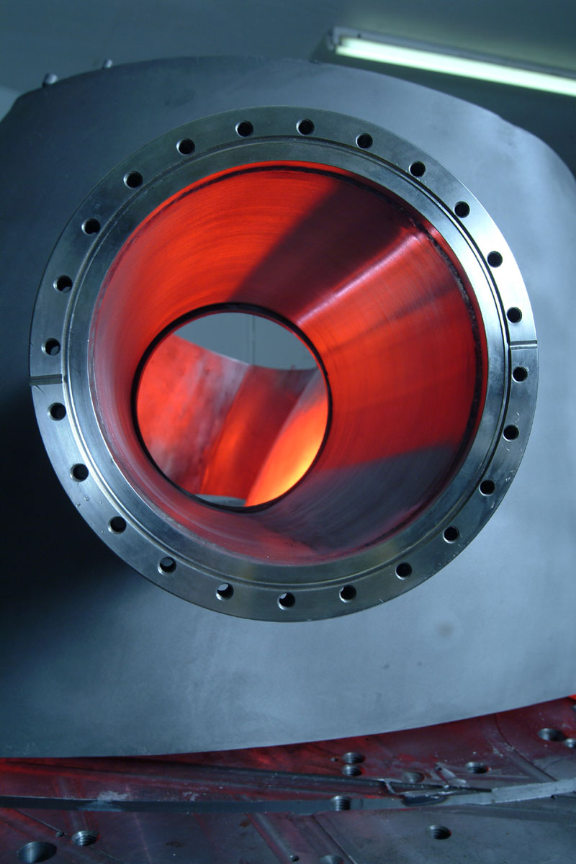
Scratch
Scratch

- Rohwedder and PMW do not have a welding engineer on their staff. There was a misinterpretation of ASME Code welder qualification requirements for the prototype. The complexity of welding on the VVSA is significantly greater than the prototype. What assurance can you give that there will be adequate welding engineering oversight during production welding of VVSA.

Although PMW does not have a welding engineer on staff, we are subcontracting out this expertise to Skarborn Engineering. Due to the complexity of the VVSA, Skarborn Engineering’s expertise will be drawn on extensively and they will be involved not only in the initial procedure development, but will also be used extensively during the placement of filler metal for visual inspections. They will also be on hand for the NDT testing.

- Fifteen die sets are proposed for each 60 degree segment, which will involve a far greater amount of welding than on the prototype. The prototype was not within tolerance. What specific measures are proposed to assure that fabrication of the VVSA will meet specified dimensional tolerances?

Rohwedder Question to PPPL

#3 We submitted our measurements and tolerances (data) and would be interested to know how these measurements compare to the ones that PPPL has documented?

Response:

PPPL used the Rohwedder/PMW measurement data. Re-measurement seemed unnecessary. The tolerance data was summarized for evaluation as follows:
Each panel was out of tolerance as follows:
Segment A1: Greatest reading (+/- 0.188" tolerance) = 0.356" 31% of points out of tolerance
Segment A2: Greatest reading (+/- 0.188" tolerance) = 0.924" 60% of points out of tolerance
Segment B: Greatest reading (+/- 0.188" tolerance) = 1.879" 73% of points out of tolerance
Segment C: Greatest reading (+/- 0.188" tolerance) = 1.399" 80% of points out of tolerance

Out of tolerances on the PVVS were directly related to the lack of strength and overlap in the die design. These issues have been addressed and will be incorporated in the new die design. Features incorporated into the new die design will be:

  - Edge supports will be used to prevent die deflection
  - Common Press fixture
  - ¼” side by side rib layout

- Lessons Learned Item No. 26 identifies weld cracks on the SST flange stitch weld, which the Rohwedder resolution describes as a “non-issue”. Cracks in structural stainless steel welds are always an issue. Please provide an acceptable resolution.

The SST flange was welded per drawing and procedures. The rigidity of the weld was there and further investigation indicated that the cracks may have been caused by early or fast movement away from the weld at end of stitch. An NCR was created for this and is provided in the Process History along with the Technico report. After discussions with PPPL repairs were not deemed necessary due to time constraints. Further procedural weld development will be done with our weld engineer along with weld samples to eliminate the weld cracking.

- Final MIT & QA Plans for the VVSA specifically address cleanliness and magnetic permeability, but do not address weld inspections, i.e. visual and radiographic examinations, as specified. Explain.

The MIT references the drawings which call out inspection types in the tail of the weld symbol. The MIT includes weld inspection as a last step after the VVSA is complete. The intermediate weld inspections will be added to the manufacturing process. The intent is to do these inspections after a 20 degree section is welded together. Presently, we are planning for 5 separate weld inspections per 60 degree. There will also be the final weld inspection as stated in the MITP.

- Section 2 page 26 1. – offer “several concepts for stiffening ribs” What is the technique of choice?

The concept that is preferred at this point is the use of ¼” ribs throughout the contour making a solid die assembly.

  - Edge supports will be used to prevent die deflection
  - Common Press fixture
  - ¼” side by side rib layout

- Section 2 page 26 2. – 1” ribs had to be hand contoured. ¼” ribs may still need contouring in highly formed regions. What is the alternative technique?

We can reduce the amount of contouring necessary by decreasing the thickness of the ribs. We have reduced this from 1” to ¼” and spacing between ribs has been eliminated. The ¼” ribs will be cut on a 2-axis water jet cutter cutting the critical profile at its low point. A 1/8” inconel scab plate will be used to achieve final contour.

For those areas where achieving contour is difficult the following alternatives will be considered:

  - Reduce the size of the ribs to 1/8” or 1/16
  - Rotate ribs 90 degrees

- Section 2 page 26 3. – Extend “VVSA dies 1-2” around the perimeter” seems to be arbitrary and insufficient to allow for and trim buckled regions. If dies need to be further enlarged, is this within your capability?

Our improved die design will compensate for a 4” overlap of the material. Our quote allows for extra material for at least 4” of overlap for large segments and even more for smaller segments.

- What is the new weld fixture design to add needed rigidity? How are segments held in the new fixture design? Is more information, maybe sketches available for the fixtures?

Due to schedule constraints on PVVS, we chose to utilize standard flexible welding bench to create the fixtures as work progressed and information was gathered. For the VVSA, the information gained during the PVVS will be utilized to design and fabricate flexible, yet rigid fixtures for each 20-degree segment. Each fixture will be designed in PRO-E. The fixtures will include multi-axis motion (translation and rotation) and locking mechanisms. The approach to fixturing for welding the 60º segment sections will be similar.

10. The intent of the backing ring was to replace backing gas. Argon cannot be expected to properly purge the tight fit of the ring. The ring should have been consumed in the weld. Radiographs indicated poor penetration. What is corrective action?

Rohwedder Question to PPPL

#10 Have we interpreted this question correctly? Does this question mean that the ring is for backing and full penetration and consumption through the welding process and is not there for Argon purging as previously done with the PVVS?

Response: PPPL
Yes that is correct. The PVVS SPEC only required Argon when a backing ring was not present.

Specification Section 3.3.2.2.3 Workmanship controls shall be as follows:

a. When the initial pass or passes of a single welded full penetration joint are to be applied by a gas shielded process without the use of backing, the back side of the joint shall be purged with argon and the argon atmosphere shall be maintained until a minimum of ¼ inch weld metal thickness has been deposited.

During discussions with PPPL it was understood that the backing ring was there for argon purging during the welding of the port back on. This is what we attempted but found that the argon purging was not effective. We had radiographic inspection rejections for this weld which indicated that we lacked penetration or had contamination on the backside of the weld. We setup the backing ring to have a gap with no intent of consuming it in the weld but to argon purge the weld backside to prevent contamination. It is now clear that the backing ring is not for argon purging and to be consumed in the full penetration weld. This will be our focus and the procedure will be tested and perfected prior to implementation.

- Section 2 page 31 – Operating engineer project level increased to CTO – however the Organizational Chart still shows Project level oversight only. David Thompson is not directly in the chain; Anthony Minei is listed– what percentage?

The Rohwedder Project Manager is the in-house champion for the customer, ensuring that the project is executed to the customer’s satisfaction. The Project Manager is assigned during the proposal phase of a project and remains on-board through final delivery and acceptance, monitoring the daily performance on the project to deliver on-time, within budget and to the technical specification. The Project Manager controls and coordinates the resources on the project to ensure compliance to the contract and technical specification. The Project Manager communicates with both the Rohwedder, Inc team as well as the customer. In addition, the Project Manager ensures that the risk management process is adhered too and risk mitigation plans are followed as well as ensuring that design reviews are held and action closed in a timely fashion. The Project Manager assigned by Rohwedder, Inc is Anthony (Tony) Minei. In the initial phases of the project (design and procurement phase), he will be spending on average 75% of his time managing the project. Once the project shifts to the manufacturing phase, he will spend on average 25% of his time on the job. This is possible because Rohwedder, Inc will place a full-time project lead at Precision Metal Works facility for the duration of the project.

A key member of the project team is the Chief Technical Officer (CTO) who is responsible for the overall technical compliance of the project. The CTO will provide guidance to the engineering team and ensure all technical specifications are met. He will chair all design reviews, validate all action items are properly closed and participate in the monthly project reviews and risk management process. David Thompson, Rohwedder Inc.’s CTO will be spending 50% to 60% of his time during the engineering, procurement and the manufacturing startup of the project. Once the initial manufacturing startup is complete, he will spend on average 25% of his time on the project.

The other key member of the project team will be David Rioux, the President of Precision Metal Works. Mr. Rioux will oversee all the manufacturing activities at PMW and act as the Production Manager. He will be responsible for the building addition and equipment procurement at PMW and will participate in all design reviews, monthly project reviews and risk management process as the manufacturing representative to ensure a smooth transition from engineering to manufacturing. Mr. Rioux will dedicate 50-75% of his time for the initial engineering, procurement (building expansion, tooling, and material), and manufacturing start up. The remaining balance of the project will be 25%.

The Project Management Team for the VVSA will consist of Anthony Minei as the Project Manager and team leader, David Thompson as the Chief Technical Officer and David Rioux as the Production Manager.

- Section 2 page 31 – How have miscommunications between PMW and Rohwedder been corrected?

During the manufacturing of the PVVS, communications were improved through bi-weekly management conference calls. To further improve communication for the VVSA project, the following steps will be taken:

- The Project Management Team will include Anthony Minei Project Manager from Rohwedder Inc, David Thompson CTO from Rohwedder Inc and David Rioux President and Production Manager from Precision Metal Works.
- The management team will teleconference weekly and participate in monthly project reviews, risk management reviews and all design reviews.
- Tom Gilmore from Precision Metal Works will be part of the engineering team working closely with Jeff Budd, Rohwedder’s lead project engineer that will finalize the segmentation design, die design and welding fixture design.
- Rohwedder will place a full time project manager/engineer at Precision Metal Works facility for the entire manufacturing phase of the project.

- Will the 15 segments be fixtured all together to control distortion during welding? Final VVSA geometry is slightly different than PVVS. Are you confident that 15 segments is an adequate number? Is the VVSA segmentation plan (15 per 60 degrees) firm? How many segments are planned for the spacers?

Fifteen segments is not a firm number for the 60 degree portion of the VVSA. Initial segmentation suggests that we divide the 60 degree portions into three 20 degree sections. The 20 degree sections will be cut into 5 segments. This results in a total of 15 segments for a 60 degree portion. The segments making up a 20 degree section will be fixtured and welded together. These fixtures will be locked together to weld the 20 degree sections together to form a 60 degree portion.

The spacer skin will be formed in the same manner as the VVSA segments but using 4-5 segments.

- Construction of building allows for 30 days. Is this reasonable? When is the new building required? What is the impact if it is delayed: What assurance is there that the new facilities and equipment will be installed and available for support of this Subcontract? Personnel trained?

We have allocated 30 days to complete our building expansion. This is a realistic completion date due to the fact that this is an addition to an existing building. All of our planning, site work, and most of the building engineering and expediting has been completed for a 250 ft. X 65 ft. expansion of our facility. We have been making plans for the building addition for 2 years. This project would not need as much floor space, hence the 75 ft. expansion. Our building is a pre-engineered off the shelf design, therefore it has a short delivery.

In our schedule we show the building and equipment being completed by 10/17/2004. Our manufacturing phase of the project is scheduled to commence the first of December. This is actually when the building and water jet equipment is required. If for some reason our building is not ready to occupy by December 1st, we can install the water jet equipment in our existing facility or we still have access to existing facilities that we can utilize. Also, we are utilizing a different die design, therefore, we can access subcontractors with 2-axis water jet capabilities to compensate for unforeseen schedule problems. In addition, available to us is our existing forming subcontractor if we run into schedule problems with our new forming equipment. We do not see personnel training as a problem due to the fact that we have negotiated with our key suppliers to have their technicians at our facility to train our operators during the start up of the machining for this project.

15. Install remaining port seals blank offs and leak check (3 days). Describe how you will install - 30 port blanks, pump down and leak check in 3 days?

Our plan is to do manifold leak checking of ports during the manufacturing process. This means we plan to do a manufacturing process with port flanges at both ends and leak check the entire port during the manufacturing process. Once completed, we will cut the ports to size and prepare for welding to the vessel. Once attached to the vessel, we will be primarily concerned with leak checking that weld. In addition, we will revisit the schedule to adjust timing of the final leak check process.

- How do they plan to handle the leak test of the multiple vacuum volumes and the large
completed assembly?

The MIT shows steps involved in attaching the ports and leak checking. All ports will be leak checked prior to any holes cut through the VVSA, even the neutral beam and vertical ports. The neutral beam and vertical ports will be pumped and leak checked prior to holes being cut into the VVSA. In addition, the vessel will be leak checked prior to any port holes being cut. This will help minimize the number of welds to be checked. Following the successful leak check the holes in the neutral beam and vertical ports will be cut. The new larger volume will then be checked. All remaining ports will be checked individually prior to them being cut off. Leak checking will be done with standard leak checking practices. These practices include tightly regulating helium flow, leak checking from the highest point down, and using methods of helium isolation. Shielding will be used to keep helium from drifting to unwanted areas as well as the use of a nitrogen blow off system aid in keeping helium in unwanted areas. A new dry roughing pump, turbo pump, and leak checking system will be used for this application. There is opportunity for additional leak checking support.

17. Is the router still used and the MITP regularly updated? Has the router been replaced by the MITP? Please explain how this works. Also, how is it assured that all steps in the top level (RI) MITP/QAP are included in the MITP or router level processing?

It was never the intent to have the MITP act as an updated document with traceability to part activity. It was modified to do this during manufacture of the PVVS however the proper routes to tracing production is laid out in our QA manual.

Once the Manufacturing and Inspection Test Plan (MITP) is generated by the planner and approved by the customer with all customer or authorized inspector hold points indicated, the planner will generate route cards (travelers) with the same information that is provided in the MITP including any hold points. A route card checklist is then created that records a route card number, quantities, date issued, date completed, and description. It is this route card checklist that provides the traceability to work being done on the floor. The route cards, route card checklist, and MITP shall have a corresponding number system to accommodate easy correspondence between each document.

18. Will the onsite oven be large enough to accept the entire segment?

The onsite oven will be and was intended to be large enough for the 120º VVSA without ports.

19. Key personnel lists eight Rohwedder folks and only two from PMW. How many of these RI employees will actually be active on the VVSA work? Although the proposal describes QA as heavily involved in the PVVS and in Risk Management and emphasizes the need for Far expertise, no QA personnel or Faro operators are listed as “key”. At minimum, isn’t the Faro operator key?

Key Rohwedder personnel active on the VVSA will include:-

David Thompson
Anthony Minei
Jeffrey Budd
Jason Gass (on a consulting basis, as needed)

Quality Assurance will be a very important function for the manufacturing of the VVSA. PMW will be adding additional QA personnel to be dedicated to the project. In addition to QA, PMW will be working closely with the FARO technician that was utilized for the PVVS and during some activities of the project he will be working full time at our facility. Rohwedder personnel will also be utilized to assist in various QA type monitoring and inspections.

- Lessons Learned #11 calls for an RI Engineer at PMW for the 1st segment and during system integration. Page 31 says a Project Manager will be positioned at PMW to support and direct daily activities. Please clarify.

Further evaluation of the project by the Rohwedder Project Management Team dictated the need for a full time Rohwedder Project Manager/Engineer to be located at PMW’s facility for the entire manufacturing process, not just the first 60º section and system integration. The Lessons Learned resolution will be updated to reflect this position.

21. Page 3 of the MIT shows a lot of simultaneous work. How large is the PMW portion of the team?

The simultaneous work or parallel work is to demonstrate what can be done at the same time. There will not be the capacity available to do all of these things at the same time. The items that are high priority will be scheduled to be worked on first and in parallel with other high priority items. Also, we can work on items such as ports or custom flanges before other material for other areas of work arrives. Our schedule was generated from this MIT and contains the step numbers of the MIT in it. The schedule illustrates our opportunities for work that can be done in parallel. We will be creative in organizing how we can efficiently and effectively perform as much parallel work as possible without compromising other processes.

22. In what ways are spacers “different” than main body of VVSA?

Rohwedder/PMW question to PPPL

#22 Need further clarification.

Response:

In your proposal you indicate that the spacers will be “different.” Do you mean different from each other or from the segment itself or in its manufacturing process? How will you form the shape of the spacer skin?

The spacers will likely differ from each other. Due to tolerance stack ups around the 360 degree vessel there may be need for modifications to the spacer to ensure proper fit up of the segments. It might mean just match machining holes in your facility for the clamping setup you will be doing or it could mean making adjustments to the width of the spacer to ensure that the gap is filled. The spacer skin will be formed in the same manner as the VVSA segments but using 4-5 segments. We have allowed for extra material in the event that there is a need for modifications. The FARO or other CMM device can be used to measure the inconsistencies.

