Conference call with American Exchangers, Inc.

AMEX attendees
Tom Muldoon – AMEX
John Puhl – JP Pattern
Don Block
Nobody from Ability Engineering

At PPPL
Phil Heitzenroeder
Mike Viola
Wayne Reiersen
Larry Sutton
Frank Malinowski
Mike Zarnstorff

At ORNL
Brad Nelson

Written question #1. Please elaborate on your plans in the following areas:
- Details of the explosion forming process you propose to use (tooling design and fabrication, verification of tooling dimensions to CAD inputs, preforming of plates, location of explosive charge, etc.)
- Heat treatment and dimensional control; expected thickness variation in the formed vessel wall. Do the vessel tolerances proposed in Doc. # NCSX-12-12002-PH seem reasonable to you?
- Tooling required for sizing shots and when in the manufacturing processing the sizing shots would be performed.
- You propose using a Faro Arm. Is this sufficient to obtain and verify our dimensions and tolerances?

High strain rate materials have lower yield for high strain rates.

Have you used hybrid concrete dies?

We have used on some pre-form earlier this year. Concrete is used extensively, but the steel mold inside is not commonly done. Steel is machined. Initial prototype will use wood. Final form will have stack of 6 inch heights.

Are they like rings?

They are pie pieces. HSX had 9 layers of pie shaped rings, with large containment ring around the outside. We envision 8-10 inch steel blocks with some type of segmentation so they can be removed after forming.

We will have continuous mold. We can do smaller panels, weld them together, then do final sizing shot. We may have 4 or 6 panels per field period. For the prototype will use concrete mold. We will shoot two pieces. For the production, we will have 100 inch diameter forged steel containment ring filled with concrete, then the steel inner pieces inside that.

Will the concrete be destroyed by motion?

We can fix it.

Do you have erosion of the dies?

At the end of HSX, we had some pulverization(?) damage on the dies.

What was material of HSX vessel?

I think it was 3/8?

Have you ever formed inconel?

We have formed it in smaller sections. It is pretty ductile.

There may be some things that could be improved from the HSX mold. They used 60 degree pie sections, and there were knife edges at the split lines. We should look at optimizing segmentation, maybe using 90, 180, etc. to improve mold life.

Will multiple shots need annealing in between?

There may be two or three shots on a given piece, with a final sizing shot of the whole assembly. The initial sizing is slightly undersize

What about wall thickness?

The wall thickness is a function of the process. This is actually a gentle forming process and we only see 1 to 3 % reduction in wall thickness.

What tolerance did you achieve on HSX?

We hit about 0.100 inches, but there may have been one region that was out about 0.200 inches.

Did you do part installation for HSX?

We did trim lines and port holes. These were mostly laser machined, programmed here and fixtured here but the laser cutting were done off-site. We would propose the same process for NCSX.

Do you do the final calibration shot the same way, big water filled bag?

Yes, but a tank of water is an option.

Pictures just arrived

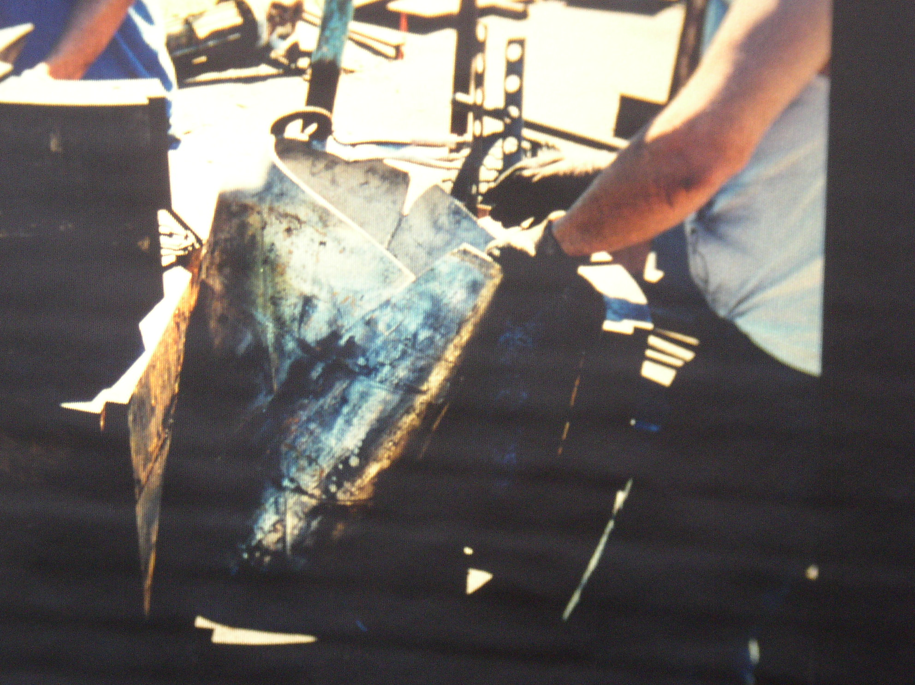

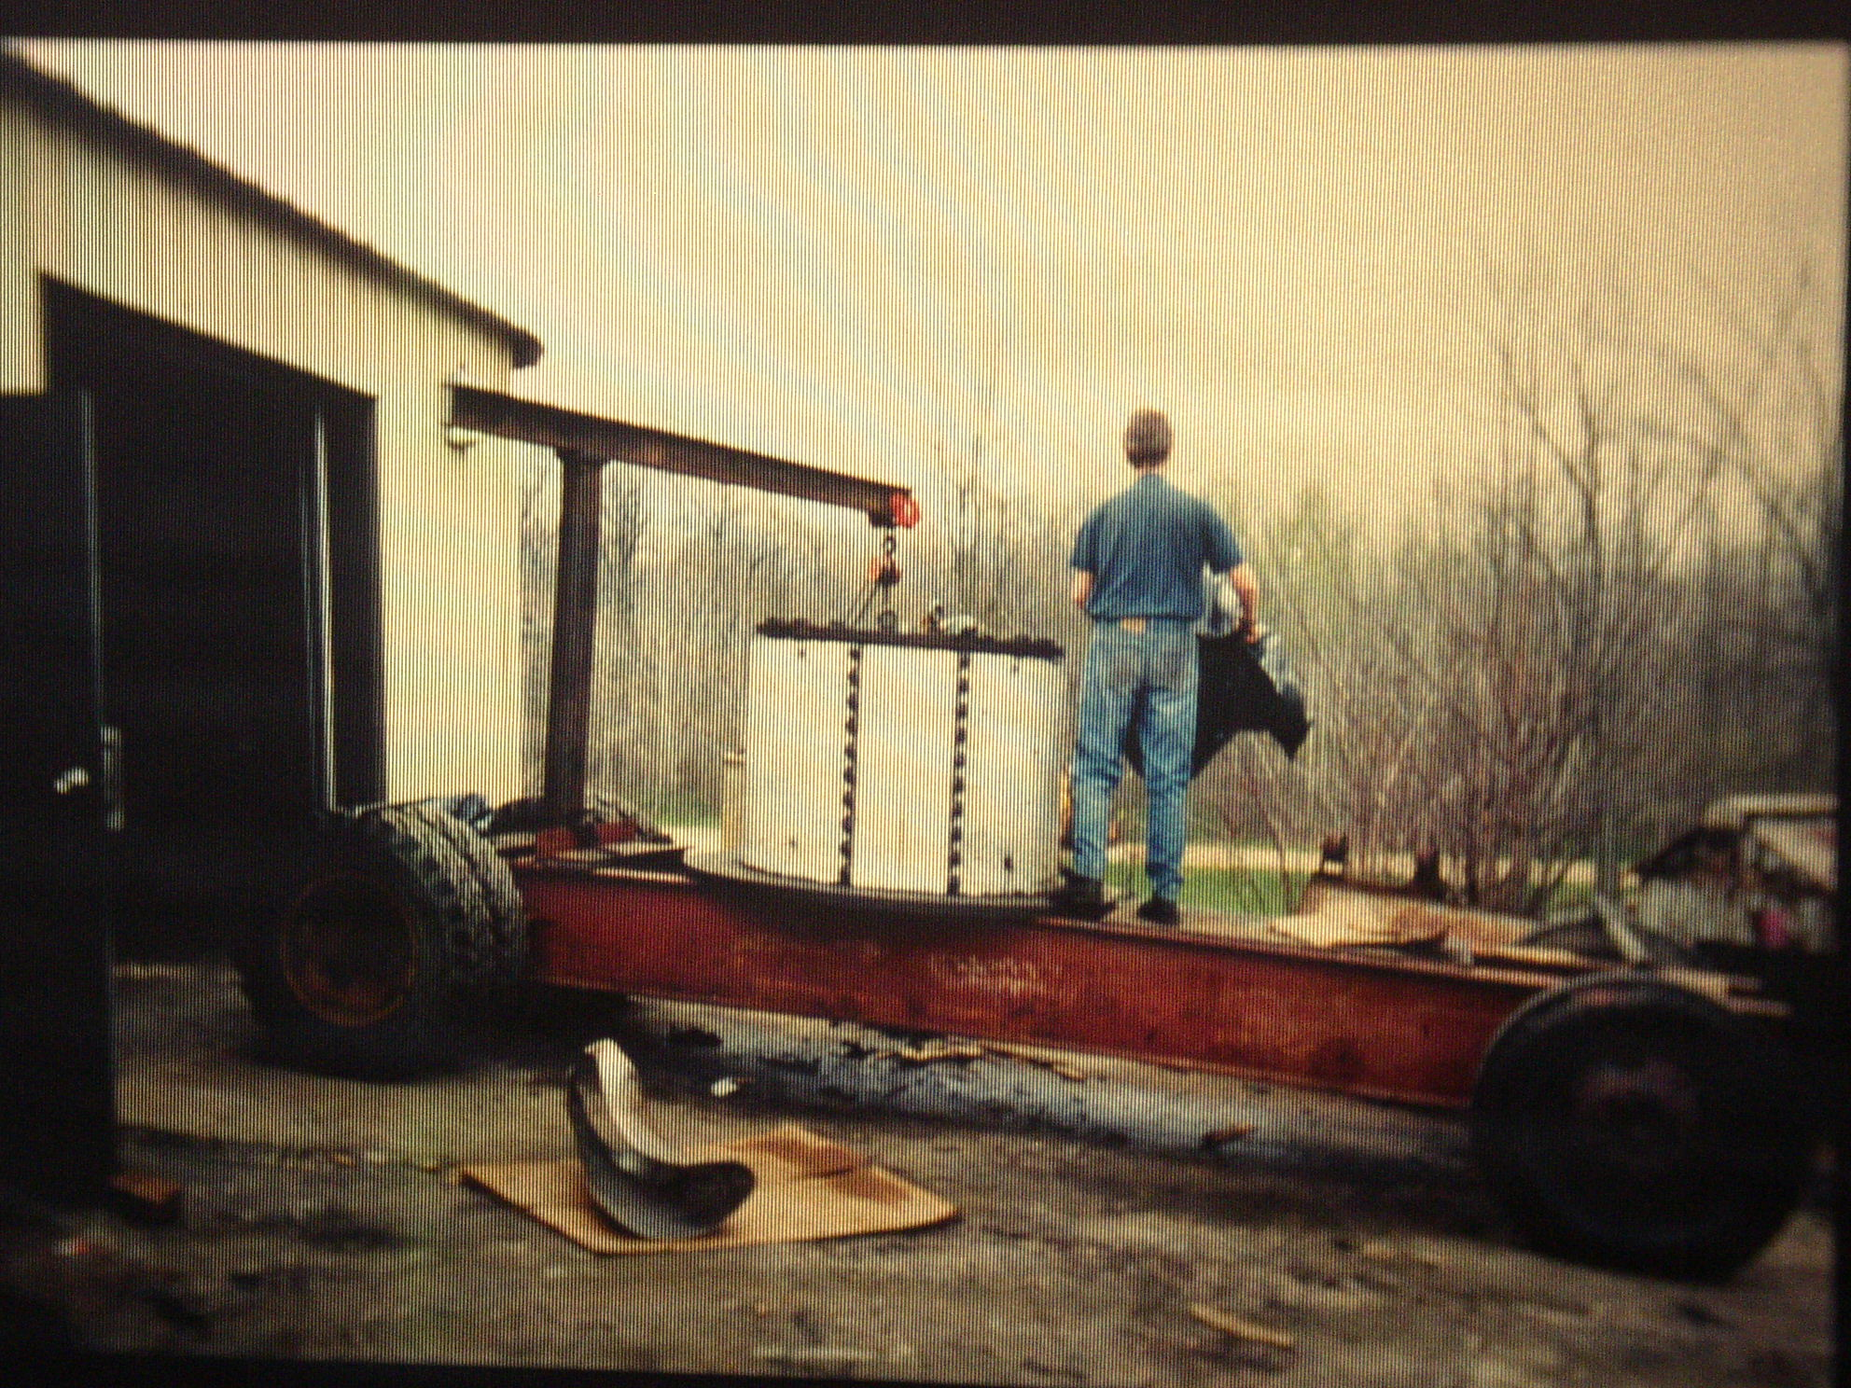

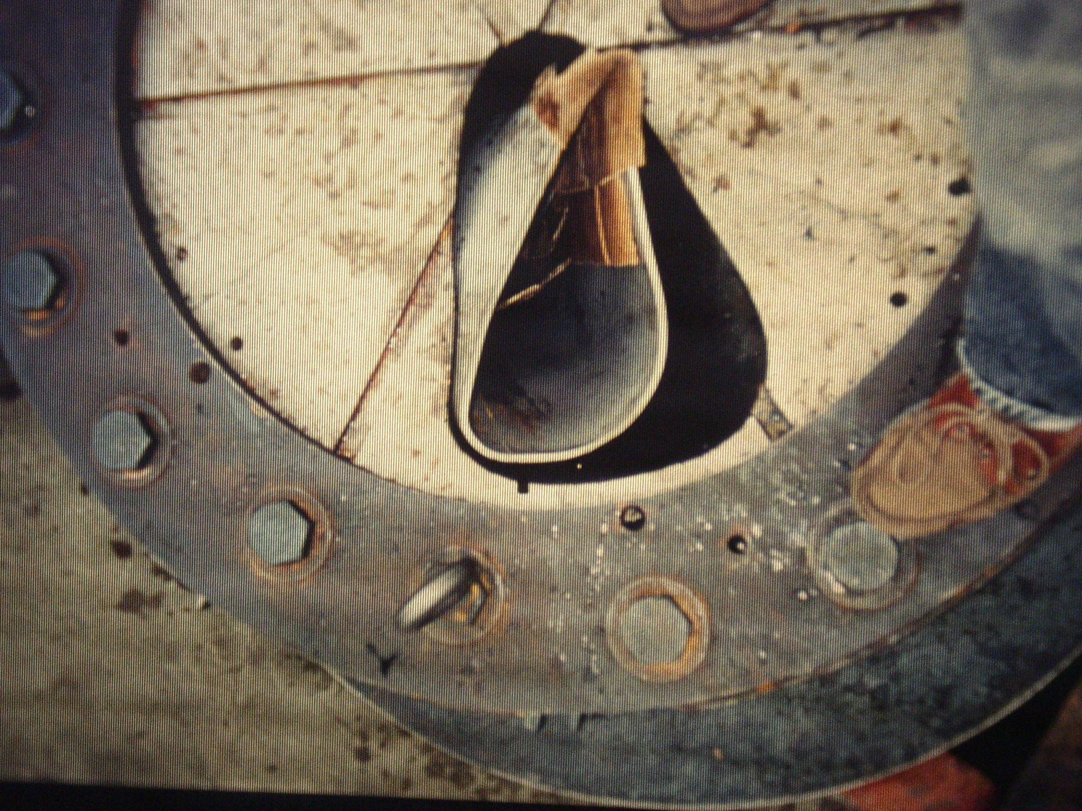

This is pre-formed shape ready for first shot

Are pie pieces staggered?

No, but we would change segmentation the next time.

What about surface contamination?

The annealing process burned everything out? They also buffed it with wire wheels.

We will change segmentation shape so the parting lines are more normal to the geometry of the formed part instead of normal to the outer containment vessel.

How did you make pre-form?

First we tried to fold it into u-shape. Then we built a die that allowed us to build it into a banana shape that allowed us to get the whole perform in place. You have to be careful how you load the plate, or the detonation will not allow the part to move back into the die(?) We used 80 ton hydraulic press to force pre-form into pre-form die.

More pictures, these are dies for HSX from JP Pattern (36” O.D. 1 layer):

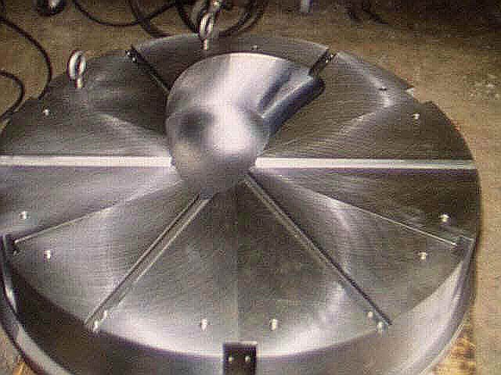

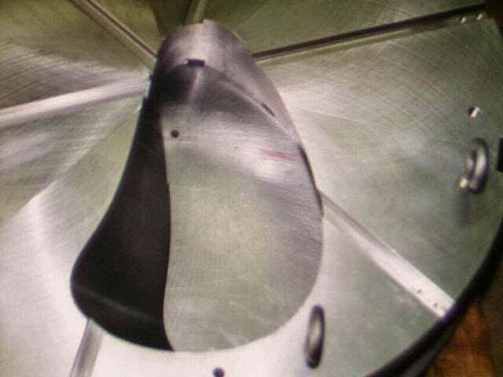

What about measurement?

We are using a Faro arm. The real key is putting datum points that can tie the part back to a coordinate system. We use a .25 inch sphere, and check back to the CAD model, which should tell us the Faro arm is 1/8 inch from the part. This is fairly simple, but you can’t lose control of the part. We only average and “best fit” once.

Who will make the ports on your team?

AMEX will make the ports. AET will weld ports to vessel. We will have them rolled or extruded to shape. AMEX or JP Pattern will make the flanges.

Written Question #2. Please discuss how you propose to qualify the Quality programs of subtier vendors.

Subtier vendors are AET on welding, and we would do a standard ASME audit on their procedures. JP Pattern had a quality plan that was sent to PPPL. AET is certified and has done a lot of vacuum quality welds, including an inconel vessel for MIT. We expect their procedures will be adequate and in accordance with ASME code requirements.

Will you qualify each partner as a supplier? Do you have a section in your manual on how you approve suppliers?

Yes, we will qualify each partner, but we do not have a procedure yet.

You propose to follow ASME rules?

Yes, we will fabricate in accordance to ASME code requirements. We will use the higher quality standard even though it is not code stamped.

We will likely have a DCMA inspector, but not a code inspector. We will be interested in who you qualify and how you qualify them.

We will not take on a subtier contractor without PPPL approval.

Written Question #3. Please report the costs of task 3.1.1 and confirm that it is included in your cost totals.

This was lost in the printing. We sent Larry the spreadsheet. The breakout is there.

Written Question #4. Your proposed costs for this manufacturing study and prototype fabrication are higher than we anticipated. Please comment on the significant cost drivers for this effort and any recommendations you might have with regards to our Statement of Work and Specification that could significantly reduce costs.

Written Question #5. Please comment on the tolerances we proposed in Doc. # NCSX-12-12002-PH (available at ftp://ftp.pppl.gov/pub/ncsx/manuf/production_vessel/20021221-vac-ves.pdf) and give us your recommendations, especially with regards to changes in tolerances which might result in significant cost reductions. (Please note: the original drawing, SE121-001P, was in error and showed a profile tolerance of 0.020 inches. This should have been 0.375 inches and has been corrected per Larry Sutton email of Jan 21, 2003) .

We are not concerned about the tolerances based on HSX experience.

We don’t want die-penetrant testing on vessel. What did you plan for testing the prototype vessel?

We expect to do one RT spot, about 10 inches. This would be similar to what we propose for production vessel.

What about verification of CAD conversion. Have you verified your ¼ scale wood die?

The first conversion is Pro-E to STEP, then STEP to Unigraphics. We can easily check geometry with CMM type device and check against CAD model.

What if molds are not strong enough for 3/8 inch inconel? How will this affect cost?

We are looking at large forged ring that is 80 inch I.D., 100 inch O.D., 5 feet tall. The concrete only takes the compressive force from dies to ring. We have one cut line on ring that we can prie apart to get the dies out. The ring is $54k. If the concrete does not work we can add in a heavy honeycomb structure filled with concrete.

Would $100k cover an all steel system?

It would only go up a little

Are ports covered under Inconel material, etc?

Yes

Is 18 month schedule ok?

Yes, we are confident in that schedule.

What about prototype scope? We assume you would have two halves formed, welded together with a final sizing shot. Would we save money with only half the ring and port? Would this be enough information provide firm fixed price schedule for production?

Full ring gives more information. Better off with full prototype. Ribs on inside require a lot of work, and we need the full prototype to give us the information on the rings.

Will you get Faro arm during prototype phase?

None of us own a Faro arm yet, but we have been on the lookout for one. JP Pattern will probably purchase one. There are a lot of shops that will work on a contract basis, as will Faro itself or Roamer.

Can you work on both contracts?

Block: No problem time-wise. Each contract stand-alone are around ½ time, but there is some leverage and savings doing both.

Muldoon: No problem. Maybe we could do some preliminary fit up between coils and vessel.

Puhl: All we are doing on the mod coils is CAD work, so it is a minor time constraint. The VV contract includes CAD work and machining. The two do not conflict at all.

What about resources/conflicts for both production contracts?

Puhl: No problem, since Remmele would take lead on coils. They do not interfere, we are not using any of our machinery for coil forms.

Block: We do not forsee any problems

Muldoon: The vessel does not take up very much space.

Both Tom and Don are listed as project managers. How does this work?

Don will issue all reports and follow contract paperwork. We do the rest and have bottom line responsibility.

How close together are participants?

Within 20 miles except for Ability Engineering, who are 100 miles away in Chicago. We will move vessel to them for welding and leak checking. We can bring portable Faro arm to them or bring the vessel back, it is only a two hour drive.

Does AET do Inconel?

Yes, LDX for MIT. It is going fine, fitup had some issues, rework due to changes. We are very confident in their ability. We expect 6 plates for 120 degree segment, maybe as few as four. There are still some issues on ribs.

What will Exact Metrology provide?

They are a Roamer(sp?) arm dealer and will do inspection on site.

More pictures of concrete mold:

