National Compact Stellarator Experiment (NCSX)

Statement of Work

Vacuum Vessel Sub Assembly (VVSA) Fabrication
NCSX-SOW-121-02-00

2 April 2004

Prepared by:
_______________________________________
M. Viola, Technical Representative for WBS 12 Procurements
Concurrences:
_______________________________________
P. Goranson, Vacuum Vessel (WBS 12) Manager
_______________________________________
B. Nelson, Project Engineer for Stellarator Core Systems (WBS 1)
_______________________________________
F. Malinowski, PPPL Procurement QA Representative
Approved by:
_______________________________________
W. Reiersen, Engineering Manager
Controlled Document
This is an uncontrolled copy of a controlled document once printed. Check the NSCX Manufacturing Web Page at http://www.pppl.gov/me/NCSX_MFG/ prior to use to assure that this document is current.
Record of Revisions

Revision | Date | Description of Changes
Rev. 0 | 04/02/04 | Initial release

Table of Contents
1 General Information 1
1.1 Introduction 1
1.2 Background 1
1.3 Scope 3
2 Applicable Documents 4
2.1 Product Specification for the PVVS 4
2.2 Product Specification for the VVSA 4
3 Work Requirements 4
3.1 Manufacturing Development Activities for the VVSA 5
3.1.1 Manufacturing Methods for Fabricating the VVSA 5
3.1.2 Subcontractor Recommendations 5
3.1.3 Preliminary MIT and QA Plans for the VVSA 5
3.1.4 Budgetary Cost and Schedule Estimate for the VVSA 6
3.2 PVVS Manufacture 6
3.2.1 MIT and QA Plans for the PVVS 6
3.2.2 PVVS Manufacture 6
3.3 Final Proposal 6
3.3.1 Final MIT and QA Plans for the VVSA 6
3.3.2 Firm Fixed Cost and Schedule Proposal 7
4 General Quality Assurance Provisions 7
4.1 Inspection/ Surveillance/Audit by PPPL 7
4.2 Subcontractor's Responsibility for Conformance 7
4.3 Nonconformances and Deviations 7
4.4 Subcontractor’s Quality Assurance Program 8
4.5 Manufacturing, Inspection, and Test (MIT) and Quality Assurance (QA) Plans 8
4.6 Inspection and Test Procedures 8
4.7 Document Traceability and Records 9
4.8 Equipment/Material Identification and Status 9
4.9 Calibration of Test and Measuring Equipment 9
4.10 Control of Special Processes 9
5 Deliverables 9
5.1 Weekly Reports 9
5.2 Monthly Earned Value Reports 10
5.3 Technical Reports 10
5.4 Prototype Vacuum Vessel Segment 10
5.4.1 Shipping Release Form 11
5.4.2 Process History 11
5.4.3 PPPL Receiving and Inspection 11
5.5 Tooling 11

General Information

Introduction
This Statement of Work is for the manufacturing of critical components for the National Compact Stellarator Experiment (NCSX), three (3) Vacuum Vessel Sub-Assemblies (VVSA’s). In preparation for production of the VVSA’s, PPPL initiated manufacturing development activities which included the production of a full-scale 20º Prototype Vacuum Vessel Segment (PVVS). The PVVS is defined in Specification NCSX-CSPEC-121-01; the manufacturing report is available at TBD. The PVVS and VVSA’s, fabricated of UNS 06625, are toroidal (donut-shaped) in major diameter, but highly shaped in the poloidal (short) direction. Three (3) 120º VVSA subassemblies including three connecting spool pieces comprise the complete NCSX vacuum vessel.
NCSX is the first of a new class of stellarators known as “compact stellarators.” Stellarators are a class of magnetic fusion confinement devices characterized by three dimensional magnetic fields and plasma shapes and are the best-developed class of magnetic fusion devices after the tokamak. The stellarator concept has greatly advanced since its invention by Dr. Lyman Spitzer, the founding director of the Princeton Plasma Physics Laboratory (PPPL), during the 1950’s. A traditional stellarator uses only external magnetic fields to shape and confine the plasma. The differentiating feature of a compact stellarator is the use of plasma current in combination with external fields to accomplish shaping and confinement. This combination permits a more compact stellarator design.
The NCSX project is managed by PPPL in partnership with the Oak Ridge National Laboratory. This Subcontract will be administered by PPPL. Operation of NCSX is scheduled to begin in July 2007. Further description of the NCSX can be found at http://www.pppl.gov/ncsx/.

Background
Figure 1 is a sectional view of the NCSX device showing its major components. Note in particular the vacuum vessel, which is the subject of this Statement of Work. In Figure 2, all but the vacuum vessel and its ports are removed from this drawing so the vessel and its ports can be clearly viewed. Note the symmetry in the vessel. It is comprised of 3 identical 120º vessel segments in the toroidal direction. Furthermore, Figure 3 shows that each segment is symmetric around its vertical midplane – the right 60º half segment is identical to the left half segment, but is inverted. Consequently, the vessel consists of six identical half segments. Figure 3 shows the three ports which will be installed at the factory. The others will be field installed at PPPL by PPPL; this is necessary to allow assembly of the other machine components around the vessel. The figures below are only for illustration and should not be used in the performance of this Scope of Work.
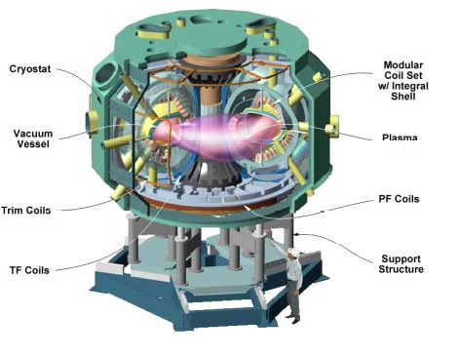
Figure 1 - The NCSX device and definition of its major components
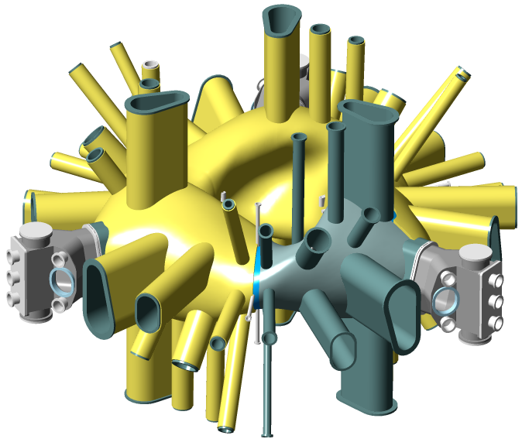
Figure 2 - NCSX with all components removed except the vacuum vessel and its ports

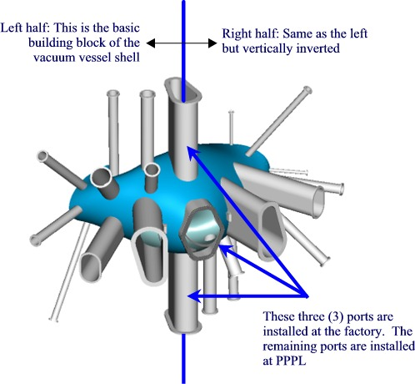
Figure 3 - Vacuum vessel sub-assembly with all ports installed

Scope
This SOW defines the production of the three 120º Vacuum Vessel Sub-Assembly (VVSA) including the three connecting spool pieces. The VVSA is defined in Specification NCSX-CSPEC-121-02.
This SOW focuses on the critical aspects of manufacturing the vessel: forming of the complex geometry; accurate location and fabrication of vessel ports; tolerance control; producing vacuum quality welds with low distortion; maintenance of low magnetic permeability; location and repair of vacuum leaks in welds, and timely, low-cost fabrication of the vessel. The Subcontractor shall develop and submit a firm fixed price and schedule proposal for producing the three (3) VVSA units including the three (3) connecting spool pieces.
The due dates for these deliverables are defined in the Subcontract.

Applicable Documents

Product Specification for the VVSA
The product specification for the VVSA (NCSX-CSPEC-121-02) is the complete specification for the 120º VVSA. A draft was posted on the Manufacturing Web Site on 9 May 03. This Specification lists the VVSA drawings currently available at the FTP site (via http://www.pppl.gov/me/NCSX_MFG/).
This Specification for the VVSA, NCSX-CSPEC-121-02, will be updated in 2004 after the PVVS is delivered and the Final Design Review (FDR) is completed. The updates will reflect the experience gained from this PVVS Subcontract effort and possible input from the FDR. The updated Specification will serve as the basis of a firm fixed cost and schedule proposal for production of three (3) VVSA's.

Work Requirements
The tasks described below should be performed approximately in the order indicated. It is expected that the Subcontractor may be working on several in parallel. Schedule requirements are described in Section 5.

Manufacturing Development Activities for the VVSA
Manufacturing development activities have been conducted to support the Final Design Review (FDR) for the Vacuum Vessel (WBS 12). Manufacturing methods for fabricating the VVSA have been identified by two potential fabricators. Recommendations for improving the design of the vacuum vessel and performing additional manufacturing development activities will be solicited from the Subcontractor and this report will be made available. Preliminary Manufacturing, Inspection, and Test (MIT) and Quality Assurance (QA) Plans will be developed that document the steps required for the manufacture, inspection, and testing of the VVSA’s. These documents will provide the basis for the budgetary cost and schedule estimates for the VVSA including connecting spool pieces.

Manufacturing Methods for Fabricating the VVSA
The Subcontractor shall describe the proposed manufacturing methods for forming, machining and finishing, welding and weld repair, heat treatment, vacuum testing, and inspecting the VVSA and accomplishing the specified Quality Assurance provisions.

Subcontractor Recommendations
The Subcontractor may recommend changes to the design or specification that could simplify manufacture of the VVSA, reduce costs, improve the fabrication schedule, or reduce risk. The Subcontractor may also recommend additional manufacturing development activities to reduce costs, improve the fabrication schedule, or reduce risk. PPPL reserves the right to accept or reject any or all of the Subcontractor’s recommendations, even in the event that the subcontract awarded is to another subcontractor. Additional manufacturing development activities accepted by PPPL will be set forth in a revised Statement of Work.

MIT and QA Plans for the VVSA
The Subcontractor shall produce Manufacturing, Inspection, and Test (MIT) and Quality Assurance (QA) Plans (per guidelines provided in Section 4.5) for the VVSA meeting the requirements of NCSX-CSPEC-121-02. These plans shall, at a minimum, include the following manufacturing steps:
- Forming methods to be used in the fabrication of the shell
- Methods for locating, machining, and welding the ports. (The spatial and angular orientation of ports is critical on NCSX.)
- Methods of controlling distortion of the vessel shell and maintaining the required tolerances
- Welding and NDE
- Vacuum testing (both to locate leaks in welds and verifying leak rate and base pressure)
- Cleaning and surface finishing operations
- Measurements of the complex formed surfaces and comparison with the reference Pro/Engineer model (including a minimum of three (3) reference datums each on the inside and outside surfaces e.g. tooling balls)
- Magnetic permeability control and verification
- Quality assurance plans that address all of the requirements of this SOW and the applicable specification.
- Methods for locating the port cut line and actual method of cutting of the ports within the surface profile, as indicated on the drawings.
- Method of cutting the hole in the vessel shell inside the port after it is cut in the above step.
- Method of reattaching the port by welding it from the inside.

Cost and Schedule Estimate for the VVSA
The Subcontractor shall prepare a Cost and Schedule Estimate for the VVSA and required tooling in the format provided in the subcontract.

Final Proposal

Final MIT and QA Plans for the VVSA
The Subcontractor shall develop final MIT and QA Plans (per guidelines provided in Sections 3.1.3 and 4.5) for the VVSA based on the updated documentation (see Sect. 2.1, para. 2). PPPL will provide an approved specification and associated Pro/Engineer models and drawings that are released for fabrication at least thirty days before the Final MIT and QA Plans for the VVSA are due. These documents are expected to be similar to those used in the performance of this SOW, but with updates based on the knowledge gained during the performance of these manufacturing development activities and the production of the PVVS.

Firm Fixed Cost and Schedule Proposal
The Subcontractor shall prepare a Final Firm Fixed Cost and Schedule Proposal for manufacturing the three (3) production VVSA's and required tooling.

General Quality Assurance Provisions

Inspection/ Surveillance/Audit by PPPL
Authorized representatives of PPPL and the U. S. Government shall have the right at all reasonable times to visit the Subcontractor's premises and those of Subcontractor's suppliers during the performance of the Subcontract for the purposes of inspection, surveillance, audit and/or obtaining any required information as may be necessary to assure that items or services are being furnished in accordance with specified requirements. Such visits shall be coordinated with the Subcontractor's personnel to minimize interference with the normal operations of said premises. The Subcontractor shall make available records and documentation necessary for this function and shall provide all reasonable facilities and assistance for the safety and convenience of PPPL and/or U. S. Government representatives in the performance of their duties. PPPL and the U. S. Government recognize the Subcontractor's right to withhold information concerning proprietary processes. The Subcontractor agrees to insert the paragraph above in each lower-tier procurement issued hereunder.

Subcontractor's Responsibility for Conformance
Neither PPPL review and/or approval of Subcontractor's documents nor PPPL inspection of Subcontractor's items or services shall relieve the Subcontractor of responsibility for full compliance with requirements of the contract. The Subcontractor is responsible for assuring that all requirements and restrictions are imposed on any sub-tier suppliers.

Nonconformances and Deviations
Nonconforming items shall be positively identified, and, where possible, segregated to prevent use. PPPL must be notified of nonconformances within one (1) business day. The Subcontractor shall document each nonconformance, identifying the extent and location of the nonconformance and proposing a disposition. The written concurrence of PPPL is required prior to implementing the disposition. The Subcontractor's system shall provide not only for timely resolution of nonconformances but also for analysis of nonconformances to determine root causes and to implement appropriate and effective corrective actions.

Subcontractor’s Quality Assurance Program
The Subcontractor shall maintain an effective Quality Assurance Program to assure that the Subcontractor’s work meets the required quality and is performed in accordance with contractual requirements. Subcontractor’s quality assurance function shall be organized to have sufficient authority and independence to identify quality problems, verify conformance of supplied items or services to specified requirements and obtain satisfactory resolution of conflicts involving quality.

Manufacturing, Inspection, and Test (MIT) and Quality Assurance (QA) Plans
Within the MIT Plan, the Subcontractor shall identify processes and materials and show their integrated flow into end items. The plan shall also identify critical manufacturing operations and inspections and tests. Procedures and/or protocols for contaminant control and cleanliness shall be included with the MIT. Preparing the Plan may include developing a flow chart and generating Process Sheets/Shop Travelers, etc. PPPL may designate selected manufacturing, inspection and/or test operations as mandatory “witness” points based on the MIT plan. Subcontractor shall provide PPPL with a minimum of five (5) working days notice in advance of witness points described in the MIT plan. Such witness points shall be mutually planned to minimize delays.
The Quality Assurance Plan shall describe the specific quality assurance and quality control procedures and practices to meet the requirements of this subcontract and associated specification. If the requirements of the QA Plan are addressed in the MIT Plan, then a separate QA Plan is not required.

Inspection and Test Procedures
Inspections and tests shall be performed in accordance with written procedures referencing criteria for acceptance or rejection. Actual data and accept/reject status for each inspection and test shall be documented.

Document Traceability and Records
The Subcontractor shall maintain a system of documentation whereby objective evidence of required operations, inspections, examinations, and tests is systematically compiled, indexed and stored. Such objective evidence may include "travelers"; and material test, certification, inspection, examination, test and nonconformance reports; which shall be complete, legible, and validated by responsible personnel and shall be traceable to subject items.

Equipment/Material Identification and Status
Material and equipment identification shall be maintained throughout the program and be traceable to records. Status of acceptability shall be readily discernible through the Subcontractor's use of tags, stamps, serial numbers or other positive means.

Calibration of Test and Measuring Equipment
Inspections and tests shall be performed using properly calibrated measuring and test equipment. Subcontractor shall have in its possession the necessary equipment to perform the required inspections and tests. Calibration standards shall be traceable to the National Institute for Standards and Technology (NIST) or equivalent acceptable to PPPL and shall not be used for shop inspections, but instead be protected against damage or degradation.

Control of Special Processes
Subcontractor shall use trained and qualified personnel and qualified written procedures in accordance with specified requirements for the performance of certain special processes, including but not limited to, welding, dimensional inspection, heat treatment, nondestructive examination, etc. Copies of special process procedures and personnel qualifications shall be submitted to PPPL for review and approval prior to performance of the work.

Deliverables

Weekly Reports
Brief weekly status reports covering technical, administrative, and Quality activities and notable problems/issues shall be provided to PPPL’s Technical and Administrative Representatives by e-mail by 9 AM every Friday during the period of performance.

Monthly Earned Value Reports
The Subcontractor shall prepare and submit monthly e-mail reports indicating earned value achieved. This will be a simplified earned value reporting requirement that will require the following actions by the Subcontractor in preparation for earned value reporting:
- The Subcontractor shall submit a resource-loaded (fully loaded dollars only) schedule that clearly indicates the tasks to be accomplished, the time frame over which each task will be accomplished, and the resources assigned to that task. This schedule will be submitted within three (3) weeks of contract award.
- The Subcontractor shall report (e-mail report satisfactory) costs and percent complete monthly. The first report shall be submitted at the end of the first full calendar month of the contract award (i.e., if contract awarded in August 2004, the first report will be provided at the end of September 2004 and cover the entire first period of performance).
- On an exception basis, PPPL will request explanation and proposed corrective action plan for those tasks that develop significant unfavorable schedule or cost variances.

Technical Reports
Provide one (1) electronic copy in Adobe Acrobat (.pdf) format of all reports. Required reports include the following:
- Report on manufacturing methods for fabricating the VVSA (ref. Section 3.1.1) and Subcontractor recommendations (ref. Section 3.1.2).
- MIT and QA Plans for the VVSA (ref. Section 3.1.3).
- Budgetary cost and schedule estimates for the three (3) production VVSA units including connecting spool pieces (ref. Section 3.1.4).
- MIT and QA Plans for the PVVS (ref. Section Error: Reference source not found).
- Report on additional manufacturing development activities (if any) accepted by PPPL (ref. Section 3.1.2).
- Final MIT and QA Plans and firm fixed cost and schedule proposal for the three (3) production VVSA units (ref. Section 3.2.1).

Vacuum Vessel Segment
Provide three (3) completed 120º VVSA’s including three (3) connecting spool pieces per this SOW. Packaging and shipping details shall be subject to prior PPPL approval.

Shipping Release Form
Prior to shipment of each VVSA or spool piece, the Subcontractor must have submitted to PPPL a completed and signed “Product Quality Certification and Shipping Release” form (Attachment 1 of this SOW) and received from PPPL written acceptance to ship.

Process History
Subcontractor shall provide to PPPL one (1) "paper" copy or one (1) "electronic" copy of the Process History, which includes a compilation of documents, detailing the objective evidence of the acceptability of the work performed. The Process History shall be complete and available at the time the Subcontractor requests Release for Shipment. The Process History shall include as a minimum, but not be limited to, material certifications and inspection and test reports.

PPPL Receiving and Inspection
PPPL will perform Receiving Inspection on items supplied by Subcontractor.

Tooling
All tooling specially fabricated for the performance of this SOW shall become the property of the United States Government. Disposition will be per direction of PPPL.

PRINCETON UNIVERSITY
ATTACHMENT 1
PLASMA PHYSIC LABORATORY—PPPL
PRODUCT QUALITY CERTIFICATION AND SHIPPING RELEASE
PROJECT | ITEM DESCRIPTION |  |  |  | SHIPMENT NUMBER
PPPL Subcontract / Order No. | REV. | ITEM NO. | SUBCONTRACTOR REFERENCE NO. |  | REV. | QUANTITY SHIPPED
SUBCONTRACTOR'S CERTIFICATION
This is to certify that the products and services identified herein have been produced under a controlled quality assurance program and are in conformance with the procurement requirements including applicable codes, standards and specifications as identified in the above-referenced documents unless noted below. Any supporting documentation will be retained in accordance with the procurement requirements.

SIGNED: _________________________________________ DATE: __________________________

TITLE: _________________________________ COMPANY: _______________________________
PPPL (AUTHORIZED REPRESENTATIVE) SHIPPING RELEASE
This is to certify that evidence supporting the above Subcontractor's Certification statement has been audited and no product/service nonconformances from procurement requirements have been found unless noted below. This product/service is hereby released for shipment.

This section serves as the Quality Assurance release for the above described product for shipment. It does not constitute an acceptance thereof and does not relieve the Vendor, Manufacturer or Subcontractor of any and all responsibility or obligation imposed by the purchase contract. It does not waive any rights the Purchaser may have under the purchase contract, including the Purchaser's right to reject the above described material upon discovery of any deviations from requirements of the purchase contract, drawings and specifications.

NONCONFORMANCES FROM PROCUREMENT QUALITY REQUIREMENTS:

REMARKS/PRODUCT SERIAL NUMBERS:

BY PPPL QA REPRESENTATIVE (OR DESIGNEE) |  |  |  | DATE

