Photographs of the test setup
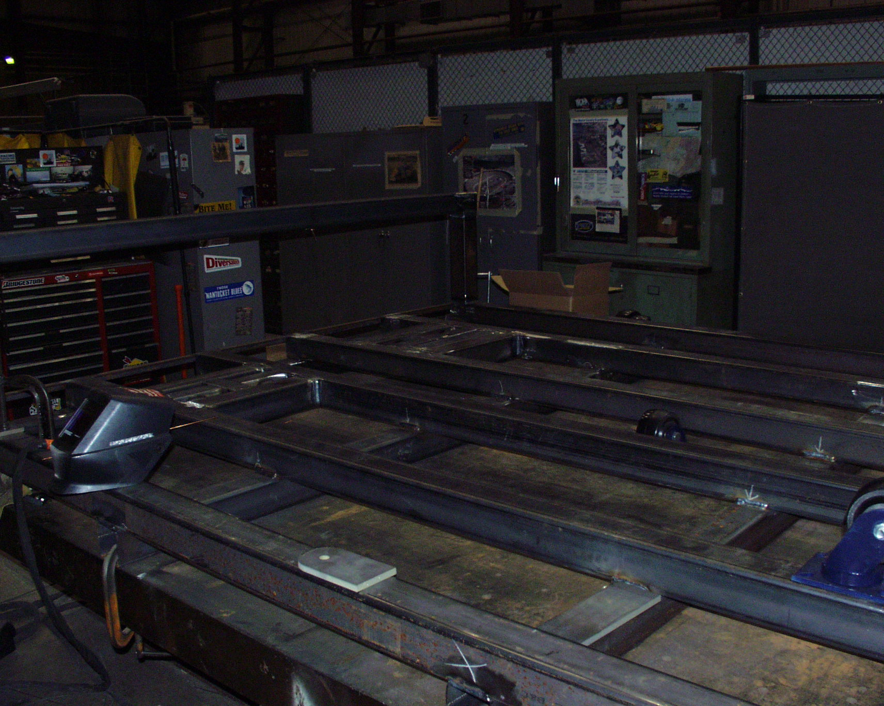
Figure 1-1 Cryostat carriage in fabrication

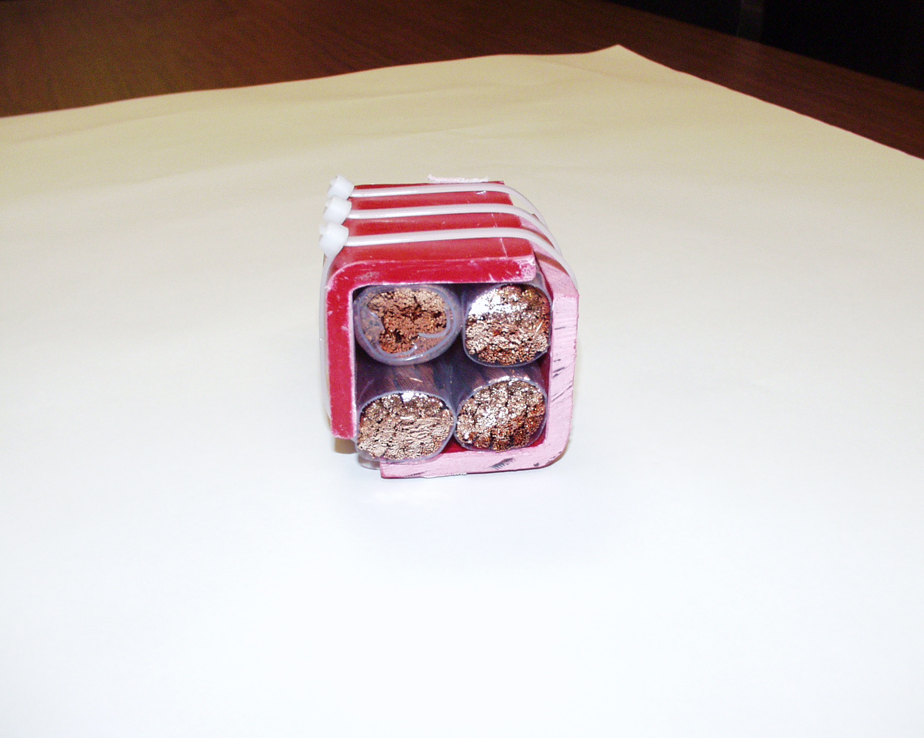
Figure 1-2 Cross-section of 4-conductor current feed with fiberglass angle supports

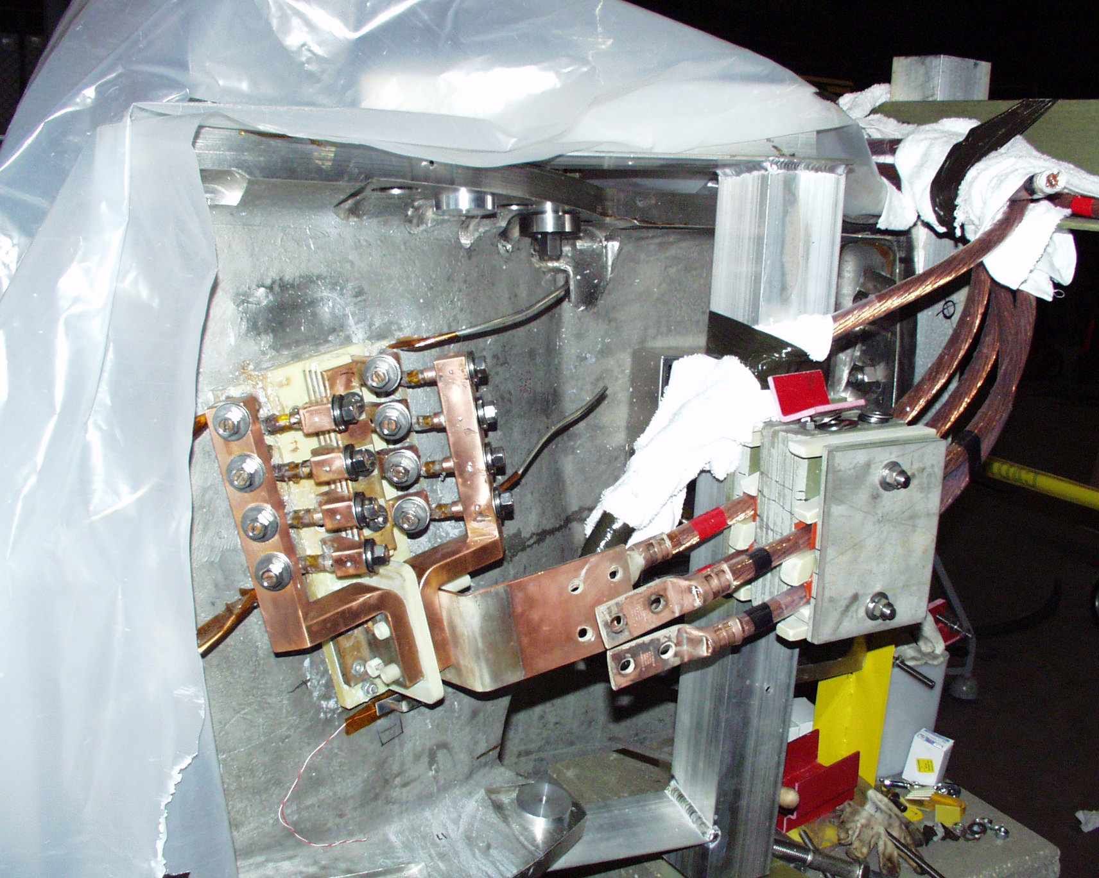
Figure 1-3 Connection of current feed to C1 coil

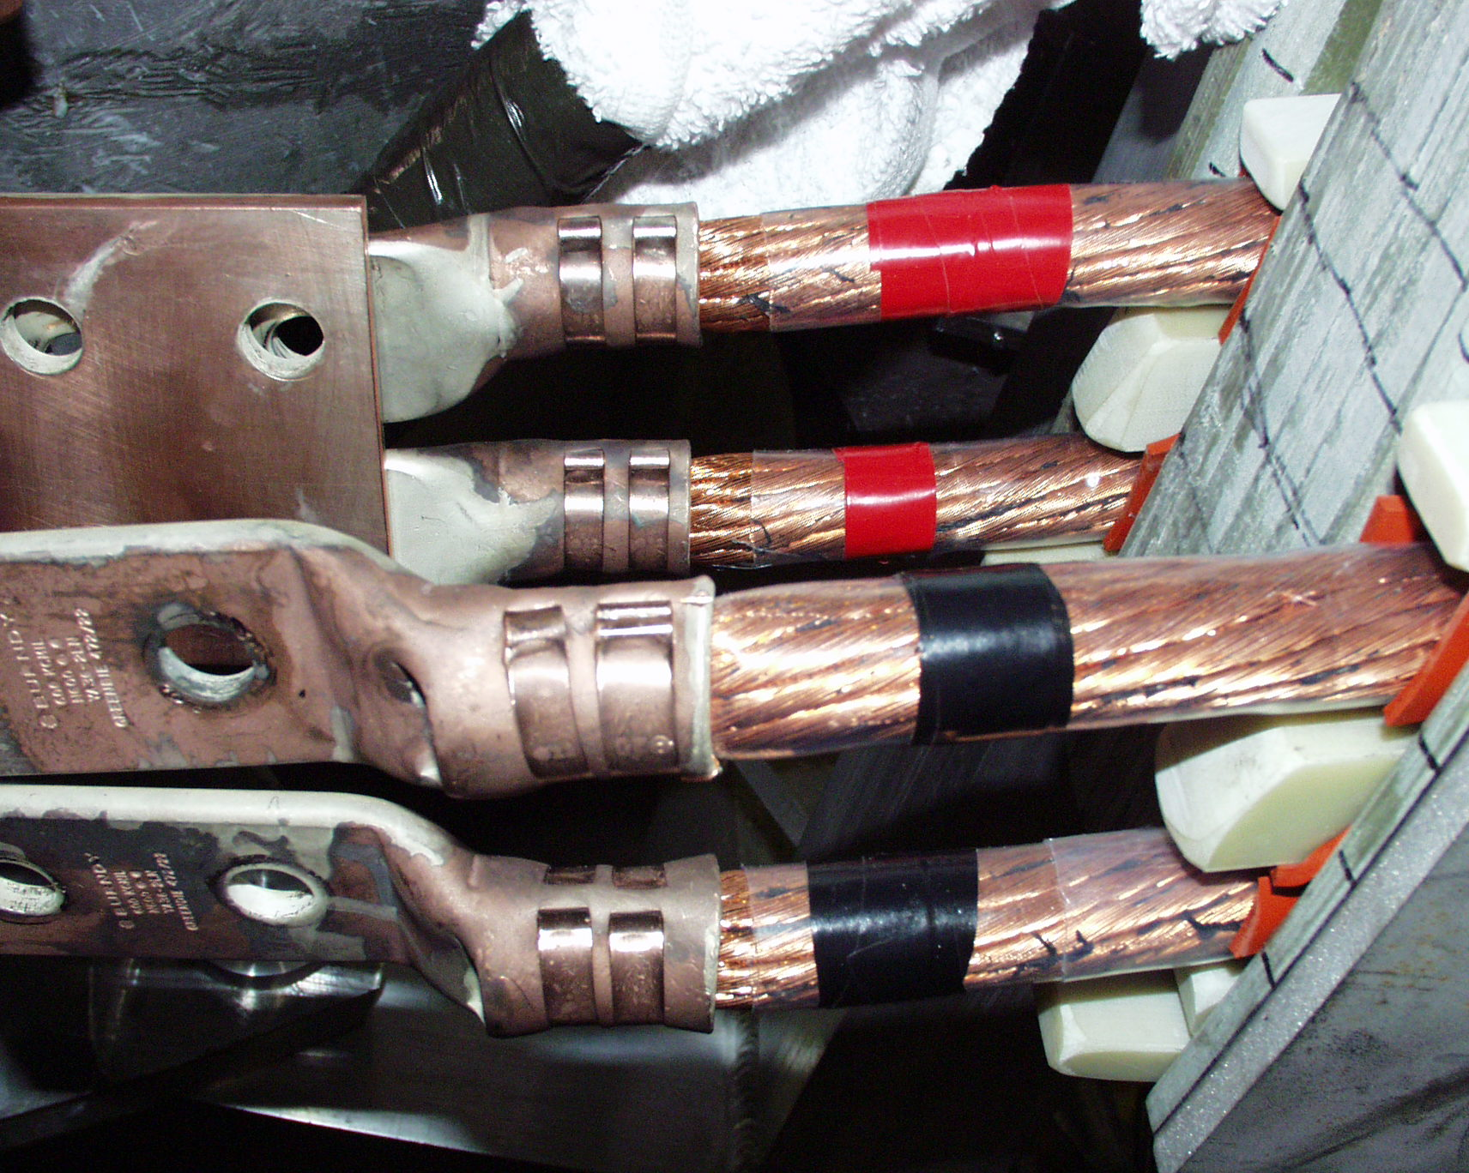
Figure 1-4 Crimped lugs on current feeds

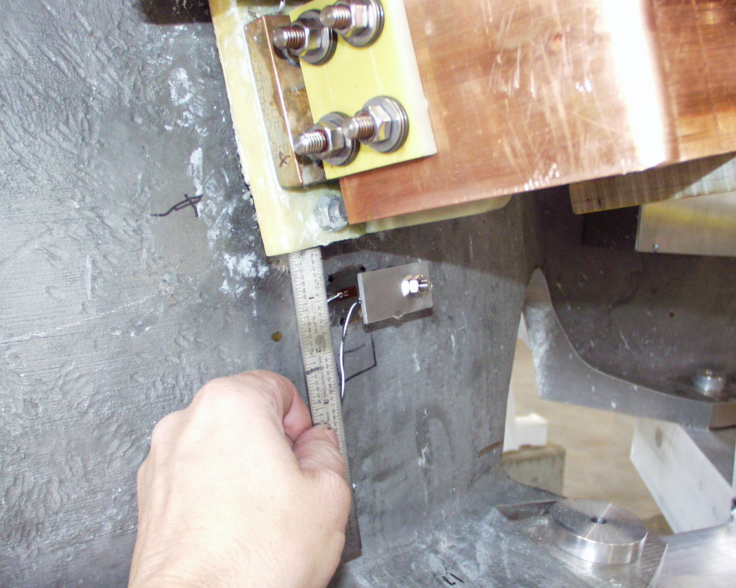
Figure 1-5 Strain gage 15 installation

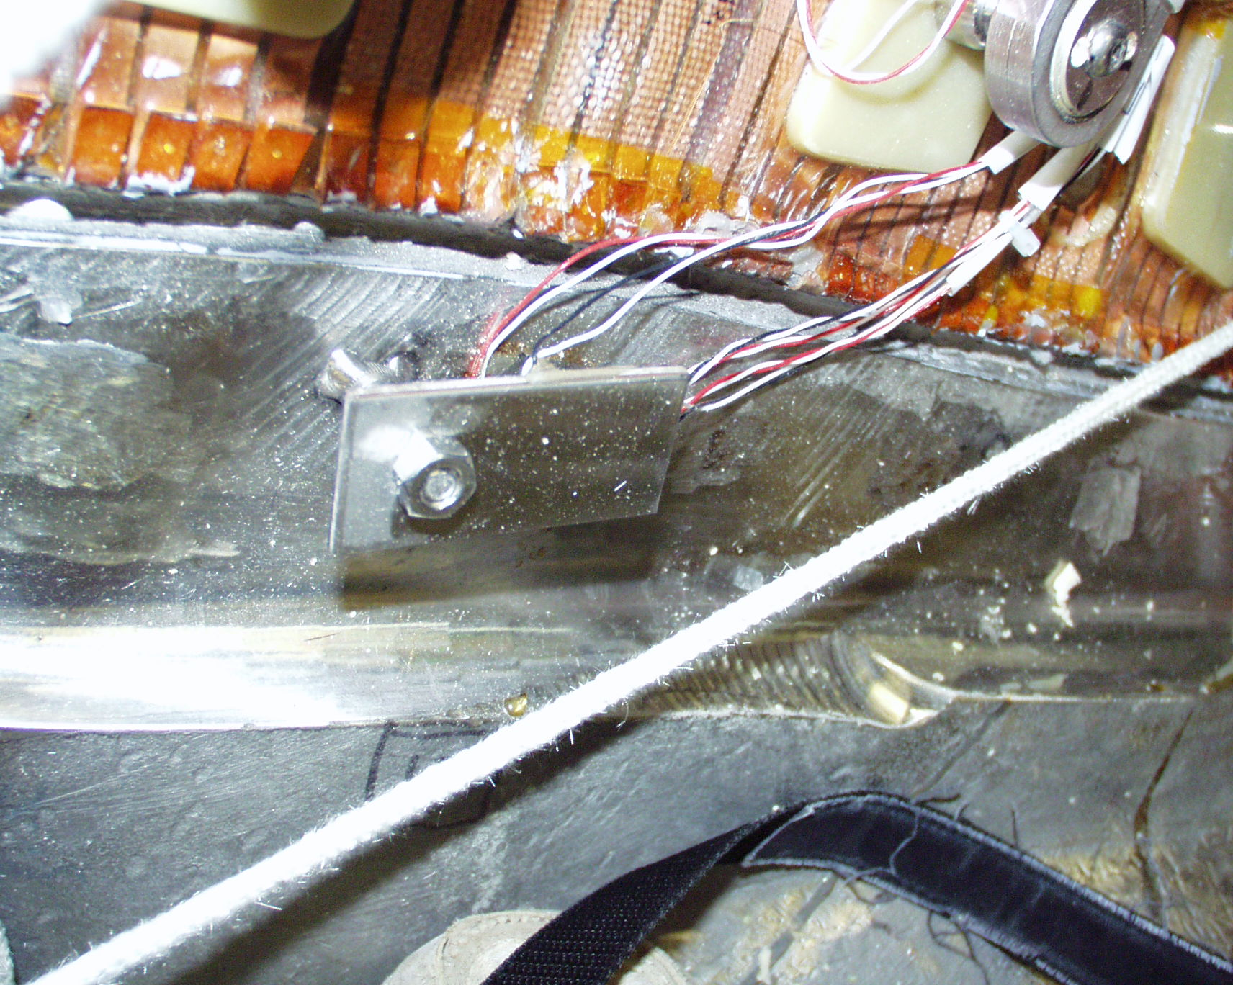
Figure 1-6 Strain gage installed at the base of the tee (typical)

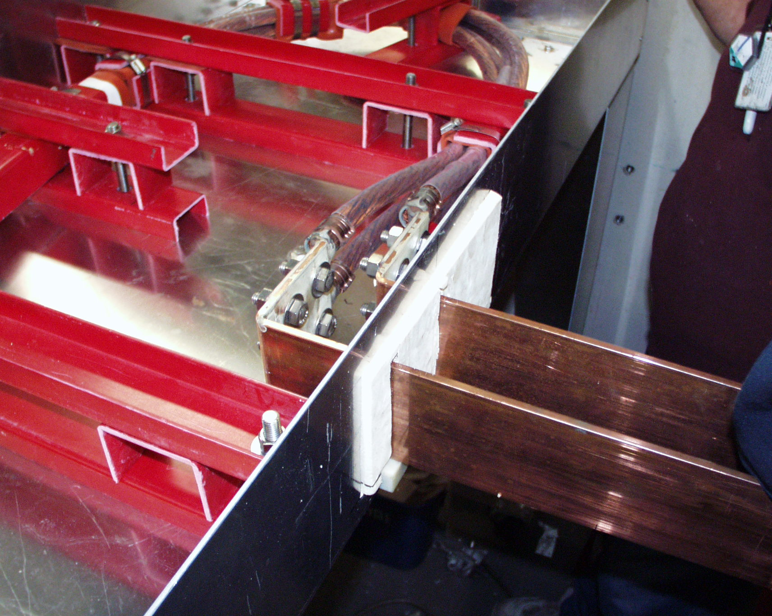
Figure 1-7 Bus connection to 4-conductor current feed inside thermal transition box

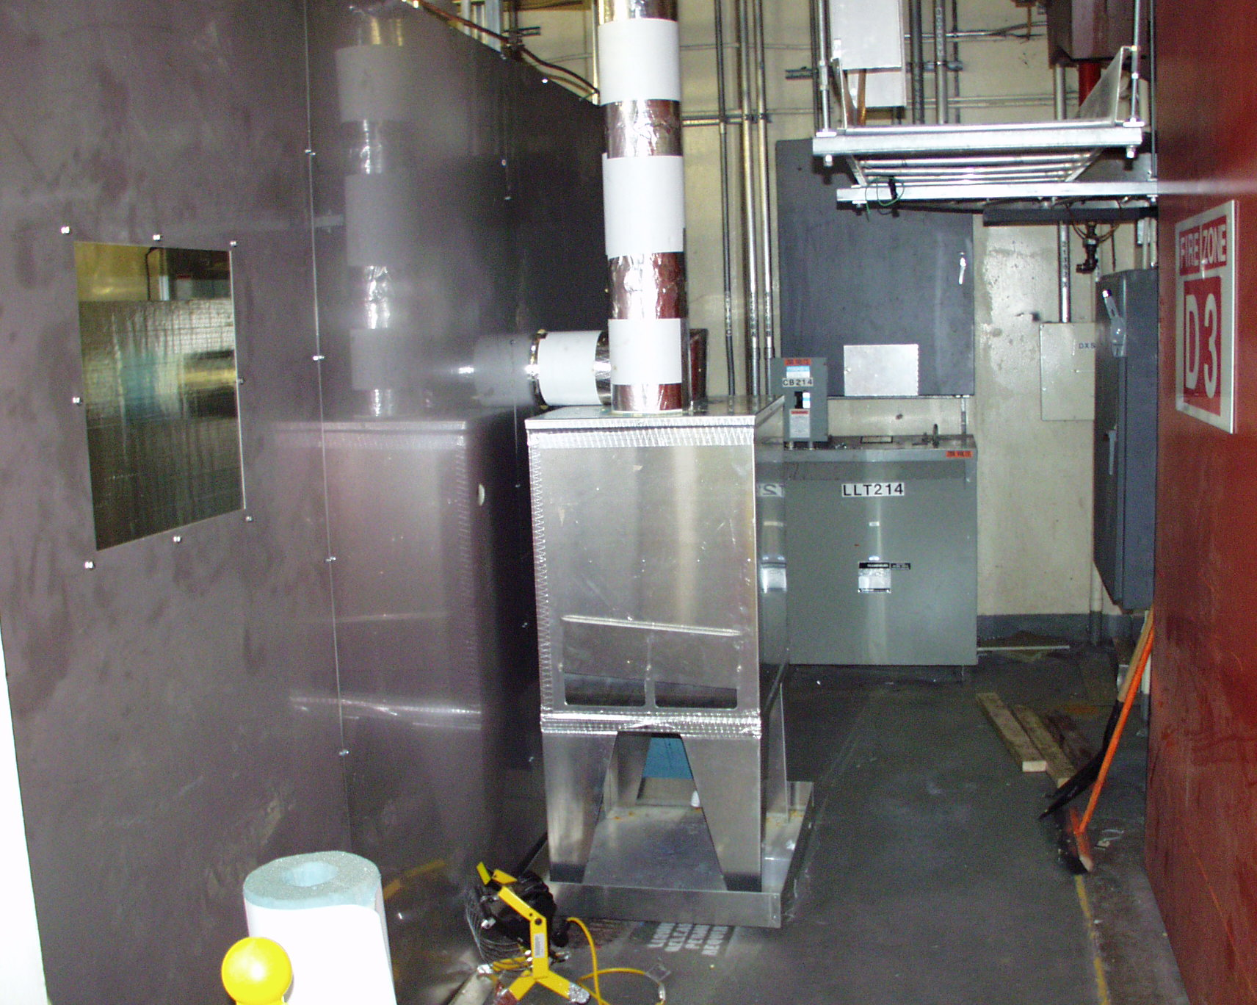
Figure 1-8 Connection of cryostat to facility exhaust

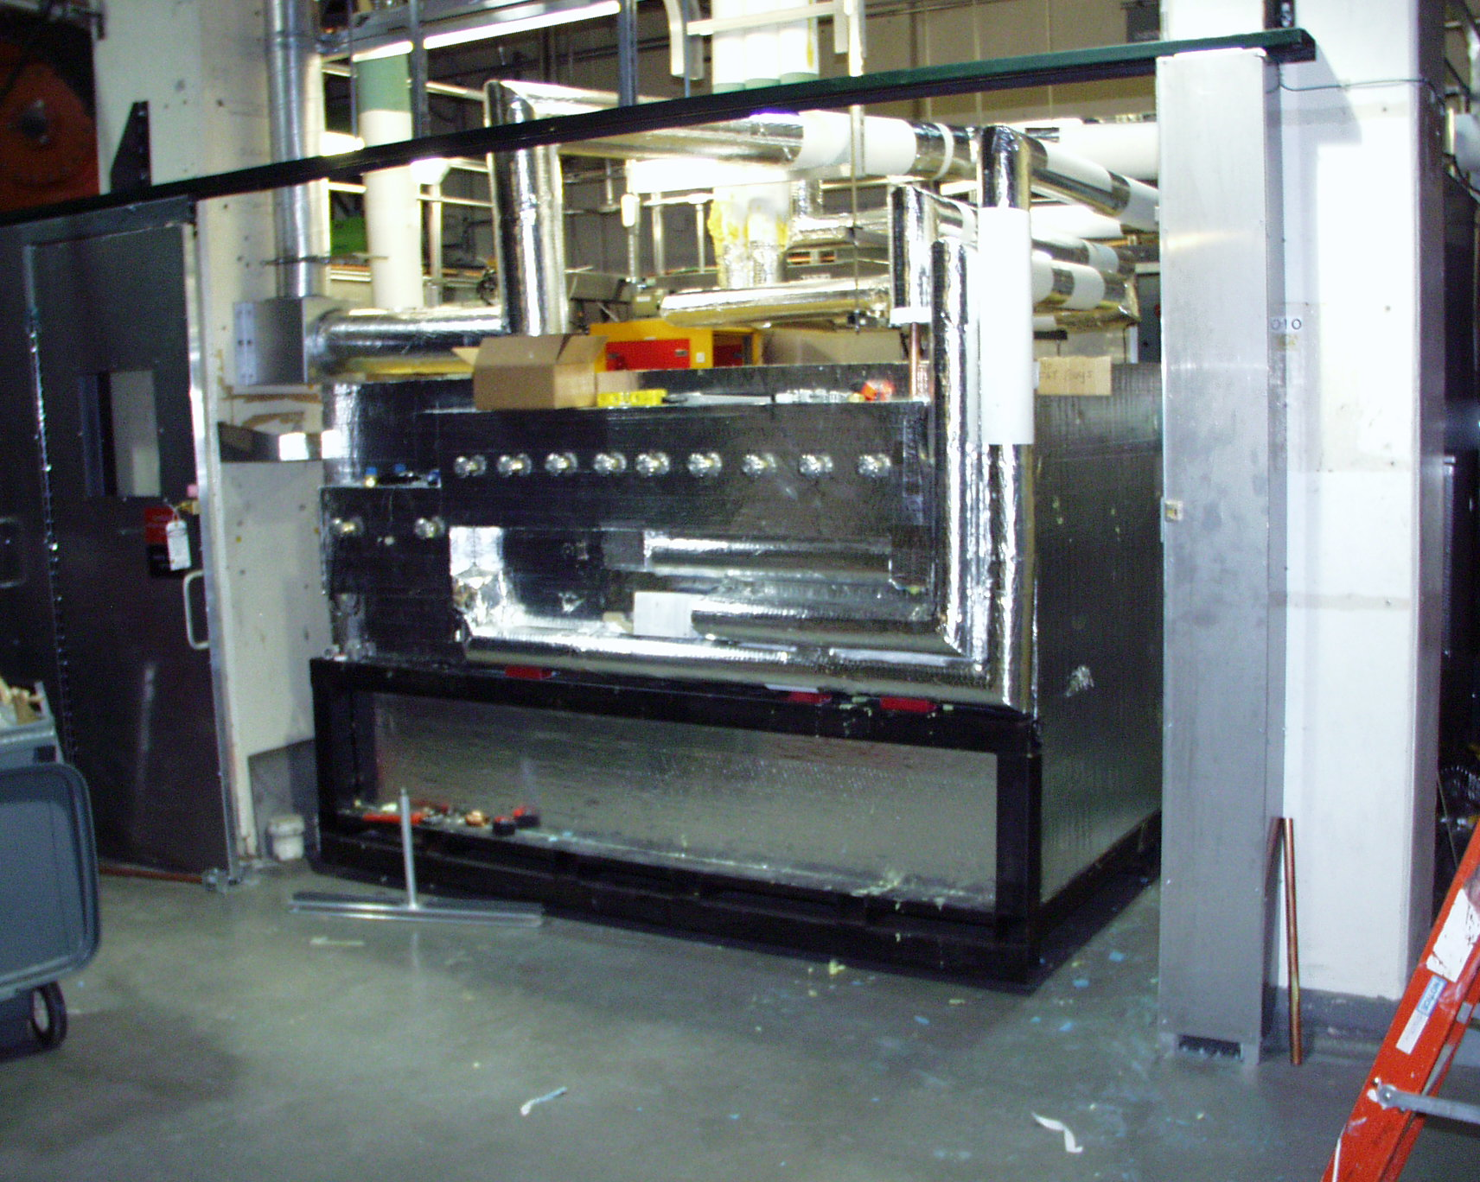
Figure 1-9 Cryostat inside Coil Test Facility

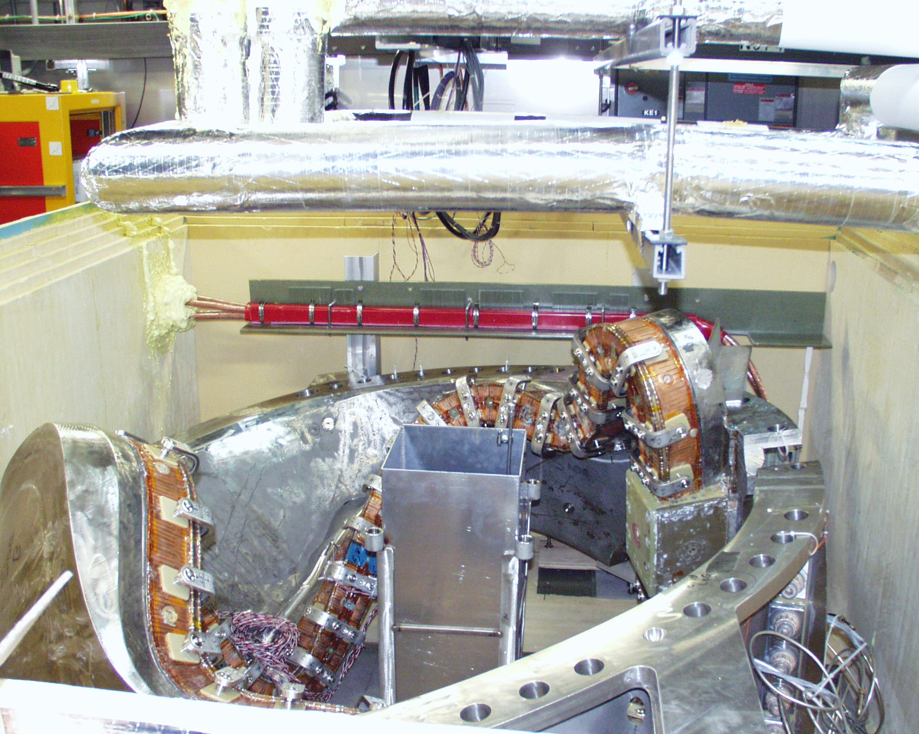
Figure 1-10 C1 coil inside cryostat

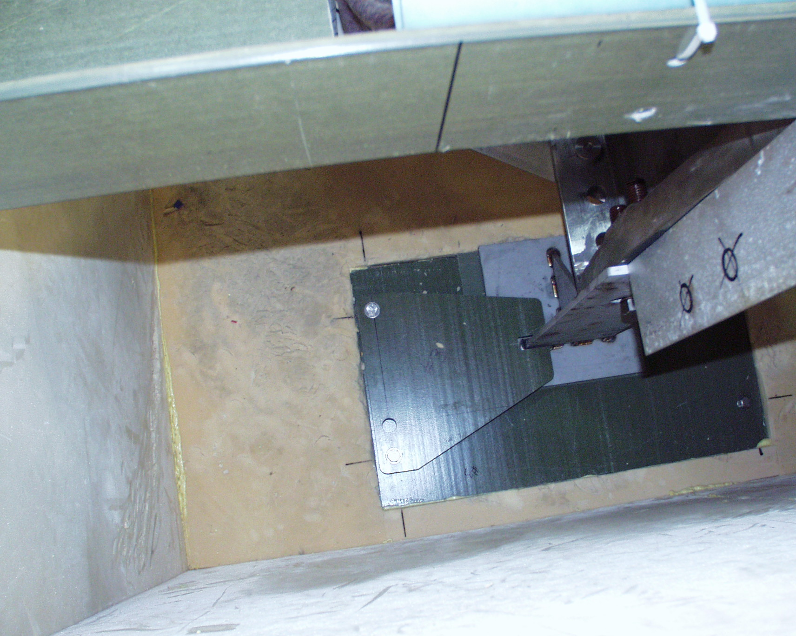
Figure 1-11 Restraints on C1 supports

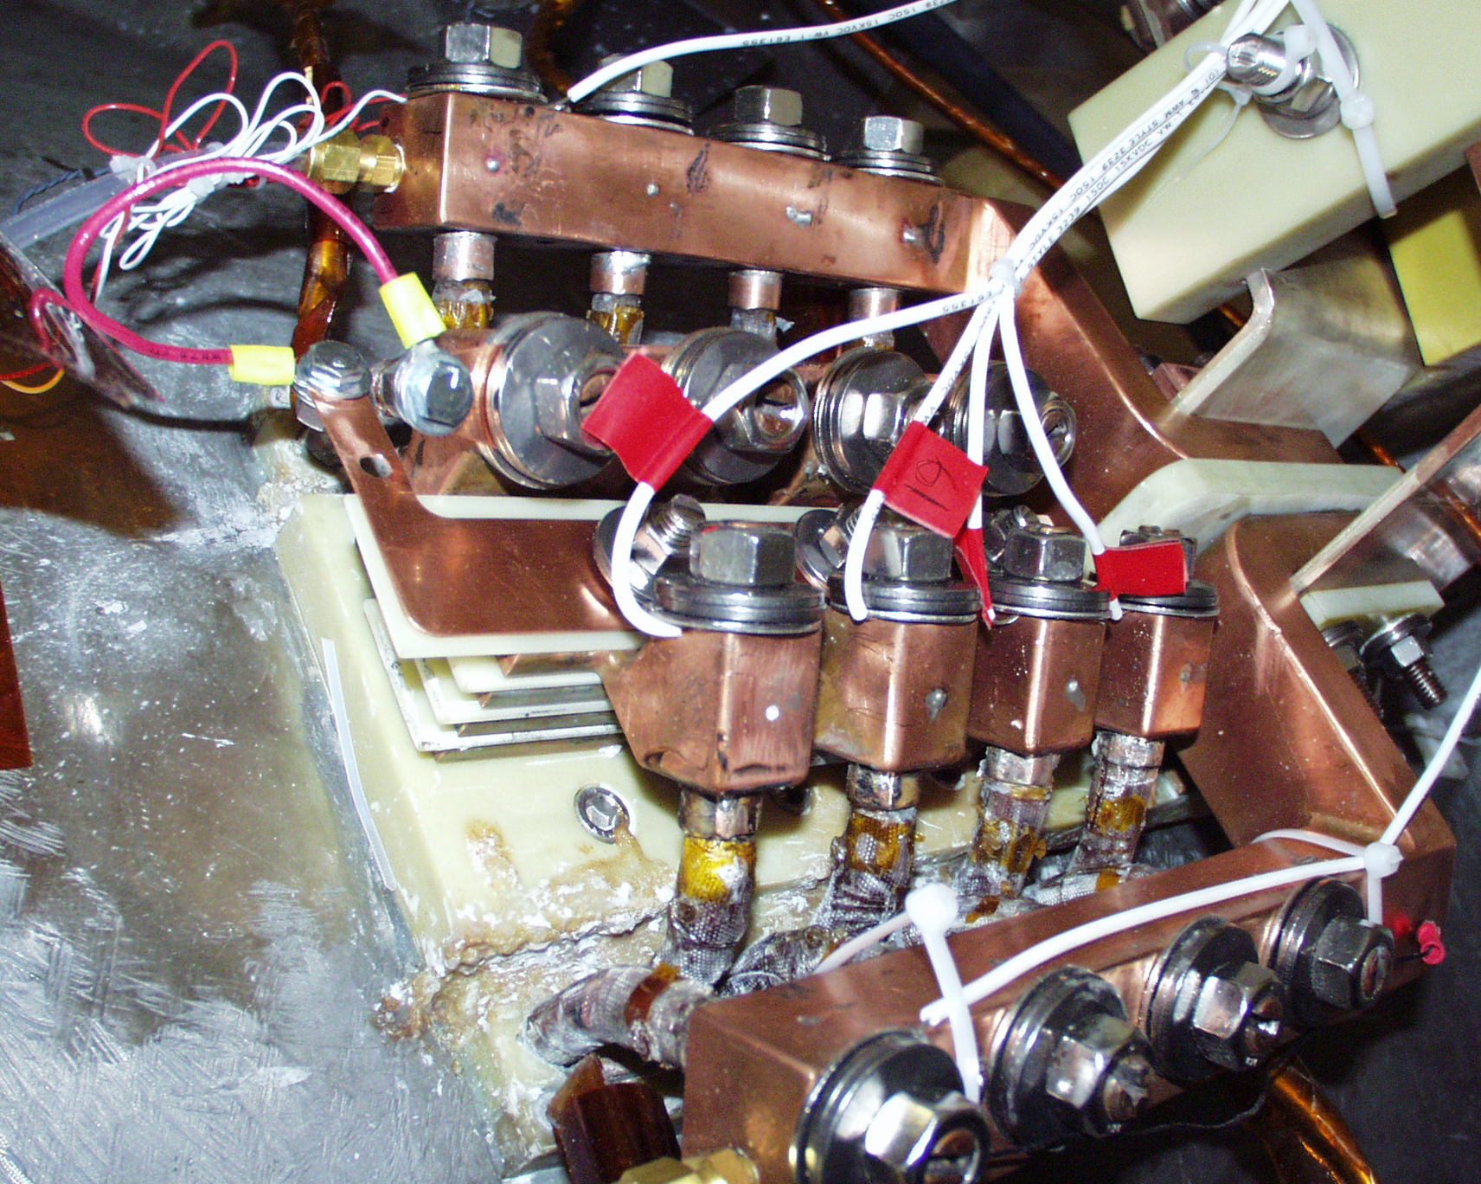
Figure 1-12 Instrumentation of jumper assembly

