Test Setup

Test Results

Cooldown
Cooldown of the C1 coil began on June 11 and continued until shots began to be taken on June 15. Cooldown was initiated by introducing product from the LN2 supply line. The line is used intermittently so initially, the product was warm gas. A maximum temperature difference of 50K was administratively enforced during cooldown. As the line cooled, so did the gas being supplied until eventually it became 2-phase product and then liquid. The liquid was caught in a tank in the center of the cryostat. The tank measured 12” on each side. The liquid column was approximately 28” tall.
During the first 40 hours, the cooldown followed an exponential curve that featured a decay time of 18 hours with an asymptote of approximately 120K. The cooldown versus time for one of the thermocouples embedded in the winding form is shown in Figure 1.
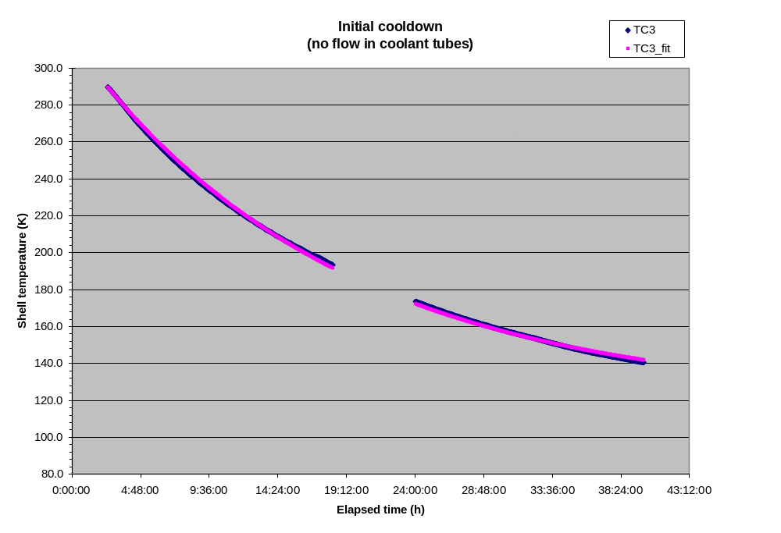
Figure 1 - Winding form cooldown versus time
The SRD requirement is for the modular coils to be cooled down to operating temperature (nominally 80K) within 96 hours. Cooling from 293K to 90K assuming an 85K interior temperature would require a decay time of 25 hours (if an exponential model applied). The cooldown of C1 was based on cooling the interior and exterior of the shell. In the stellarator, the space between the modular coil and vacuum vessel (the interior of the shell) will be filled with insulation. Therefore, the surface area exposed to GN2 will be reduced by more than half. The decay time should be inversely proportional to the exposed surface area and the convective heat transfer coefficient. The decrease in surface area will have to be compensated by an increase in the convective heat transfer coefficient. This will likely require a change from natural (free) convection to forced convection by either improved circulation (via a fan or blower) or increased throughput of GN2. Flow of GN2 needs to be provided to “dead spaces” in the stellarator core.
The asymptotic (bath) temperature of the cryostat was well above the desired 80K. This too needs to be addressed in the cryostat cooling system design. In equilibrium, the cryostat system can be modeled as shown in Figure 2.

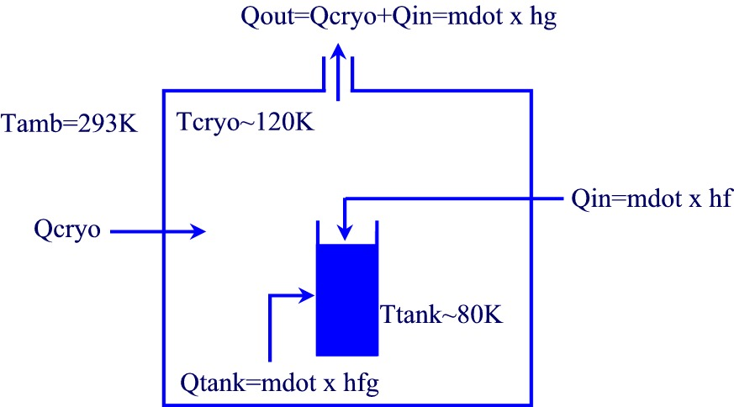
Figure 2 - Cryostat heat balance

Assuming a surface area of 32 m2 for the cryostat and a 6-inch wall of panels with an insulating value of R6 per inch, the heat leak into the cryostat would be approximately 860 W. If the temperature of the exhaust gas is 120K (the asymptotic temperature calculated for initial cooldown), then a mass flow of 0.0036 kg/s is required. Two thirds of the heat is removed by evaporating LN2 with the balance removed by the temperature rise in the exhaust gas.
In the stellarator, we want to minimize any temperature rise in the exhaust gas in order to keep the temperature as close to 80K as possible. This will likely require a large flow of cold (80K or below) purge gas. Evaporating the LN2 passively from a tank alone may not work because the temperature difference between the cryostat interior and the tank will be so small. The purge gas could be generated by flowing GN2 through a coil in the LN2 tank. The temperature of the cryostat interior would be controlled by controlling the flow of the purge gas. The flow of purge gas should also improve the heat transfer to the modular coil shell. The ability to introduce purge gas is also desirable for warming up the cold mass. The one caveat is that we may have to recycle the GN2 throughput in order to limit nitrogen consumption.
When the temperature inside the cryostat approached 130K, 2-phase product was introduced into the coolant channels. Ultimately, single phase LN2 was circulated through the winding pack which brought the chamber down in temperature to 100K (TC18 in Figure 3) in approximately ten (10) hours. This temperature was well above the 80K temperature envisioned for the coil environment. Thermocouples embedded in the winding form near the winding pack read as low as 92K (TC3) and 94K (TC2). The inlet temperature read as low as 83K (TC7) with an outlet temperature of 87K (TC9). Note that the beneficial effect of cooling the chamber brought about be cooling the winding pack with LN2 will not be manifest (at least not directly) in the stellarator because the winding pack will be thermally insulated. Note also that there were no measurements of the winding form temperature apart from the two thermocouples embedded deep in the winding form close to the winding pack. Additional thermocouples should be provided on the winding forms in the stellarator so temperature differences can be monitored.
The temperature of the winding form in the wings was not monitored. In the stellarator, this is an area of concern. The plasma-side surface of the wings is thermally insulated. The outside surface faces, but is not in good thermal contact with the plasma-side surface of the winding form into which it nests. It may be beneficial, perhaps necessary, to circulate gaseous nitrogen through the coolant tubes in order to cool the wings and also expedite initial cooldown.
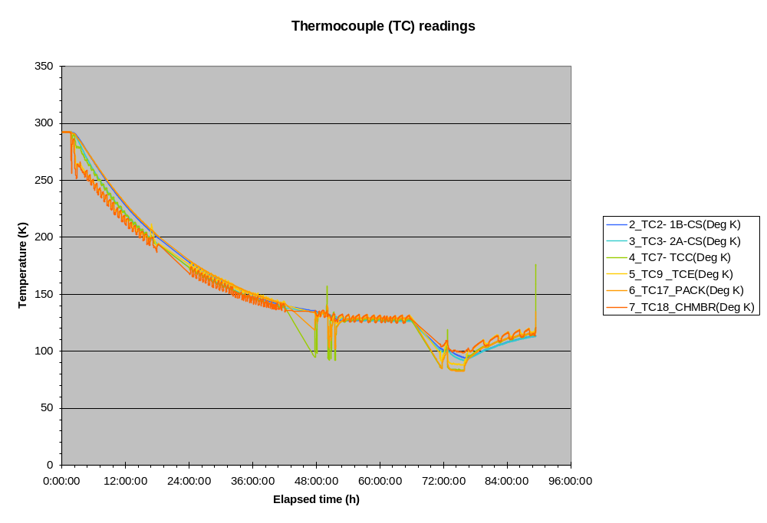
Figure 3 - Thermocouple readings during initial cooldown

Coil testing
A series of shots were taken with the coil cold on June 15 and June 16. Coil currents were increased from 5kA to 36.5kA. Coil currents were then decreased down to 15kA. The prescribed waveform was the same for all of the test shots. There was a 1s linear rise to full current, a 0.2s flattop, and a 1s linear ramp down to zero current. Intermediate 2kA shots were taken at approximately 10 minute intervals to measure the coil resistance and infer the average winding temperature. Test shots (above 2kA) were not initiated unless the coil resistance measured in the 2kA shots was at or below 1.8 milli-ohms which corresponds to an average winding temperature of approximately 98K. The coil was then allowed to warm back to room temperature during which time additional 15kA shots were taken. The sequence is shown in Table 1. 2kA shots and shots in which there were trips are not shown. All test data is available from the following URL:
http://ncsx.pppl.gov/NCSX_Engineering/R&D_Results/PPPL/C1%20Testing/Index_C1%20testing.htm
The purpose of the test shots is to validate our modeling of coil performance. If we successfully predict the performance of the C1 coil in the test shots, then we have increased confidence in the predicted performance during stellarator operation. There are several aspects of coil performance to be modeled, including [1] cooldown between shots; [2] thermal stresses from initial cooldown; and [3] incremental stresses and displacement due to EM loads during a shot.

Table 1 - Summary of test shots
Shot number | Date and time | Max current (kA) | Pre-shot outlet (TC9) temperature (K)
121400 | 6/15 2:54:31pm | 5 | 87.2
121405 | 6/15 3:33:43pm | 15 | 87.6
121408 | 6/15 3:52:39pm | 25 | 87.6
121419 | 6/16 9:54:18am | 35 | 92.1
121439 | 6/16 12:06:43pm | 36.5 | 89.6
121453 | 6/16 1:27:56pm | 36.5 | 88.9
121461 | 6/16 2:31:55pm | 36.5 | 88.8
121468 | 6/16 3:33:33pm | 25 | 88.6
121471 | 6/16 3:59:03pm | 15 | 88.6
121537 | 6/23 9:29:30am | 15 | 256.0
121540 | 6/23 10:14:37am | 15 | 258.2

Cooldown between shots
There are two diagnostics from which we can monitor cooldown between shots. The first diagnostic is the thermocouple data. The was a thermocouple mounted on the outside of the winding pack near hole 85 (TC17). The second diagnostic is the temperature inferred from the 2kA shots run between test shots.
Consider cooldown following Shot 121461 which was a full current (36.5kA) shot. A plot is shown in Figure 4. The thermocouple mounted on the surface of the winding pack (TC17) starts off with a temperature reading of 83.2K which is approximately equal to the inlet temperature reading 83.8K (TC7). During a shot, the temperature of the winding pack is estimated to increase by approximately 28K within the 2.2s shot duration. The temperature of the chill plate under TC17 rises over the next 4 minutes by 5.3K. Thereafter, the temperature of the chill plates drops with a decay time of approximately 13 minutes. After 15 minutes, TC17 still reads 85.7K which is 2.5K higher than the initial temperature. In order to accommodate the soak time to establish the temperature gradients needed to conduct the heat to the coolant and the subsequent thermal decay time, it appears necessary to accept a pre-shot temperature which is signficantly higher than the coolant temperature.
There are two phenomena that are occurring – temperature redistribution and cooling. The temperature on the surface of the winding pack can be approximated in the following way:

T_{a} is the asymptotic temperature to which the winding pack surface would decay and should approximate the local coolant temperature. T₀ is the initial temperature. ΔT is the increase in the surface temperature in the absence of cooling following a shot. α is the characteristic temperature redistribution rate. β is the characteristic heat removal rate. With an assumed coolant temperature of 83K (slightly less than the initial temperature of 83.2K), the “best fit” parameters are a ΔT of 9K, a characteristic temperature redistribution time (1/α) of 2 minutes, and a characteristic cooling time (1/β) of 13 minutes. Although the instantaneous temperature rise in the copper conductor is calculated to be 28K, the winding form in the vicinity of the winding pack acts as a heat sink as evidenced by the rise in temperatures in winding form thermocouples (TC2 and TC3). The assumed coolant temperature of 83K is reasonable because more than one hour transpired since the previous full current pulse. The agreement between the cooldown data following Shot 121461 and the simple model is good as shown in Figure 5.

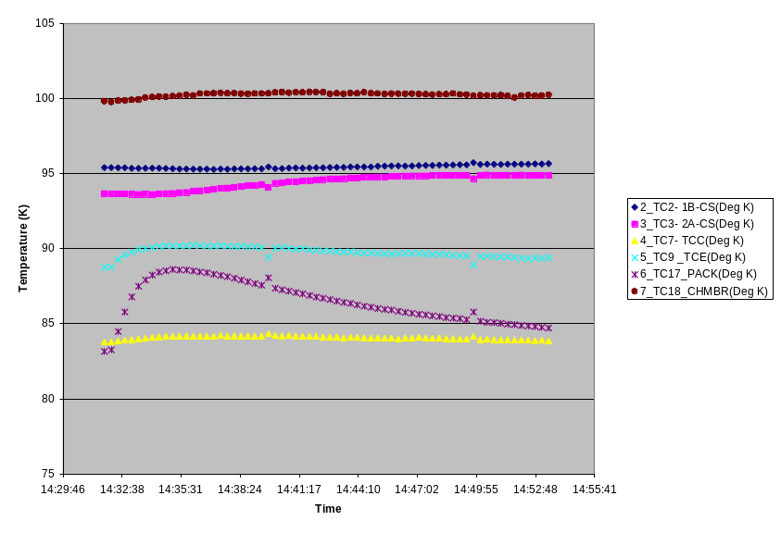
Figure 4 - Cooldown following Shot 121461

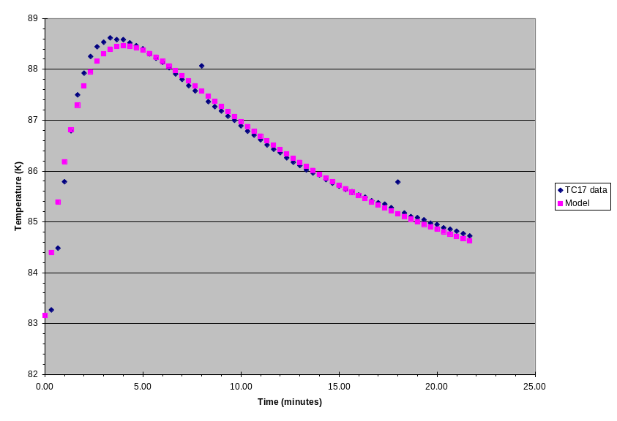
Figure 5 - Winding surface temperature following Shot 121461
The second diagnostic is the average winding temperature inferred from the 2kA shots between test shots. The data is shown in Figure 6. Clearly, there is significant noise in the measurement and variation during a shot due to current redistribution among the four parallel conductors (even at constant net current). Shot 121462 was run at 2:40pm (8 minutes after Shot 121461) and registered a resistance in the range of 1.8-2.3 milli-ohms (2.05 milli-ohm median). Shot 121463 was run at 2:50pm (18 minutes after Shot 121461) and registered a resistance in the range of 1.5-2.0 milli-ohms (1.75 milli-ohm median). The median temperatures during Shots 121462 and 121463 are calculated to correspond to temperatures of 103.7K and 96.5K respectively.
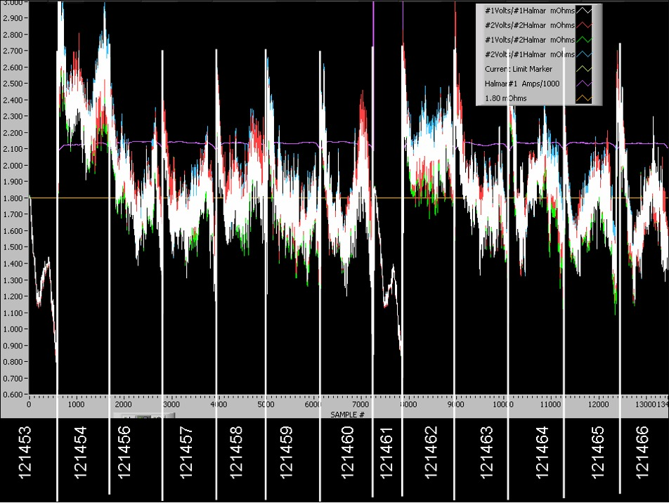
Figure 6 - Winding resistance measurements

The coil resistance was measured manually (outside the cryostat) at 12:30pm prior to any shots. This measurement has none of the ripple associated with the 2kA shots. The resistance was measured to be 1.7 milli-ohms which corresponds to a temperature of 89K. The outlet temperature of the coolant was also measured to be 89K at this time. If we assume that the asymptotic temperature of the winding pack (T_{a}) is 89K and the decay time is 13 minutes (as calculated for the winding pack surface), then the temperature rise during Shot 121461 (ΔT) is estimated to be 28K assuming a simple exponential model. The definitions are the same as before except the soak time is assumed to be very short and therefore ignored.

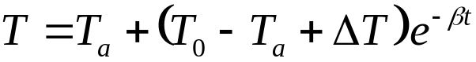

15 minutes after Shot 121461, the winding pack temperature is estimated to be 98K, well above the assumed pre-shot temperature of 89K. In order to cool down in 15 minutes without further thermal ratcheting, the starting temperature would need to be 95K with a coolant temperature of 80K per this simple model. This value is substantially higher than previously assumed. Sub-cooling the coolant below 80K may be necessary to further reduce the starting temperature during continual pulsing.
Run the ANSYS model to [1] predict the response assuming one hour between pulses and a coolant inlet temperature of 83K and [2] determine the minimum pre-shot winding pack surface temperature in order for no ratcheting to occur with a coolant temperature of 80K and a 15 minute rep rate. [Freudenberg]

Strain gage technology

Technical notes from Vishay on strain gage technology can be found at the following URL

http://www.vishay.com/brands/measurements_group/guide/indexes/tn_index.htm

Corrections for Thermal Output -
Simple Procedure
Approximate correction for thermal output can be accomplished most directly and easily using the graph ( Fig. 5 ) supplied in each package of self-temperature-compensated gages. This simple method of correction is based on the fact that the gage factors of A- and K- alloy gages are close to 2.0, which is the standardized gage-factor setting employed in calibrating the gages for thermal output. Adjustment of the thermal output data for a different instrument gage-factor setting is described later.
The first step in the correction procedure is to refer to the graph and read the thermal output corresponding to the test temperature. Then, assuming that the strain indicator was balanced for zero strain at room temperature (the reference temperature with respect to which the thermal output data were measured), subtract the thermal output given on the graph from the strain measurements at the test temperature, carrying all signs . This procedure can be expressed analytically as follows:
Eq.(504.3)
where:
= uncorrected strain measurement, as registered by the strain indicator.
= partially corrected strain indication - that is, corrected for thermal output, but not for gage factor variation with temperature.
= thermal output, in strain units, from the package technical data sheet.
As an example, assume that, with the test part under no load and at room temperature, the strain indicator was balanced for zero strain. At the test temperature of +250° F (+121° C), the indicated strain is +2300 microstrain. Referring to Fig. 5 , assuming that the graph was the one in the gage package, the thermal output at test temperature is -100 microstrain. From Eq. (504.3), the corrected strain is thus 2300 - (-100) = 2400 microstrain. Had the indicated strain been negative, the corrected strain would be: -2300 - (-100) = -2200 microstrain. If the instrument were balanced for zero strain at some temperature other than +75° F (+24° C), the value of for use in Eq. (504.3) is the net change in thermal output in going from the balance temperature to the test temperature. That is, = (T ₂ ) - (T ₁ ), carrying the sign of the thermal output in each case.

