

121305_TRCDimensionalInspection_142_AWB.doc
Date: 13 December 2005

To: Distribution
From: Art Brooks

Subject: TRC Dimensional Inspection

Attachments:
___________________________________________________________________________

Summary

The dimensional inspection of the NCSX Twisted Racetrace Coil has shown that the Winding Process has overall produced a coil with high uniformity of turns and good control of bundle current center for Side A. Side B was not examined in detail. The lack of sufficient useable data on the geometry of the septum has limited our ability to predict the overall bundle current center but I am encouraged by the estimates made based on what data is available.

Purpose

The fabrication of the TRC was done in part to develop coil winding methods and to demonstrate that these methods can produce a coil geometry where the overall current center is controlled to +/- 0.020” relative to datum on the winding form. The Modular Coils of which the TRC is representative are required to have an installed current center tolerance of +/-0.060”, with +/- 0.020” allocated to the winding form and winding, +/- 0.020” to period assembly and +/- 0.020” to machine assembly. Following fabrication and other nondestructive testing, the TRC was sliced at a number of locations to expose the internal structure of the winding pack. Measurements of the individual turns were made to determine an overall current center for the bundle. The focus was on Side A which historically was wound after Side B using slightly modified winding and clamping methods. Based on the information obtained during the winding of Side B it was found that the current center could be controlled to some degree by adjusting the clamps, eliminating the need for shims. This allowed for the inclusion of an additional layer of turns within the same winding envelope.

The purpose of the destructive examination of the TRC was to determine the uniformity of the winding pack (ie distribution of turns). Initial concerns were that the compression of the winding pack with the clamps may lead to more compression of turns/layers near the clamps than away from them producing a shift in the current center.

Additionally, there was concern over the impact of coil curvature and torsion on winding pack uniformity.

Method of Analysis

The sections of the TRC were made a number of locations corresponding to regions of varying coil curvature and torsion. Figure 1 shows the locations relative to the ProE model of the coil. Figure 2 shows the locations relative to the calculated coil curvature and torsion. Table I describes the rationale for each selected location. Following machining of the three of the sections (bold in Table I) work was suspended due to more urgent program demands on the machinists, so only those three are analyzed herein.

Visual examination of the machined sections shows a fairly uniform distribution of turns with very little keystoning. The top two layers near the tubes were an exception to this with a visible shift toward the tubes. The cause of this is believed to be the hydrostatic pressure of the silicon sealant at the clamp septum bolts and the lack of clamp resistance at the tubes. A change in the manufacturing process to limit the flow of silicon with a G10 barrier is expected to improve this situation.

The sections were each scanned at 1200 dpi to provide resolution better than 0.001”. (Scanner calibration with a scale confirmed reasonable accuracy achieved.) The jpeg files produced (figures 3 thru 5) were then imported into ProE (from ProE menu: Insert->Style; then Styling->Trace Sketch). An extrusion was made of each turn by tracing a many sided (20-30) polygon around each turn. The center of gravity was calculated for each turn (Analysis->Model Analysis: Model Mass Properties for each feature). A local coordinate system was established at the intersection of the base and septum interfaces and scaling to the image established. Note this section is assumed normal even though the septum is known to slant in some locations with respect to the base. This has not been quantified here so represents an unknown error in the calculation of the current center. Also, the cladding against the septum and to some extent the base is missing in the scanned images. The cladding either fell off during cutting of the TRC or cuts were made at between cladding segments. This does not however impact the calculation of layer spacings.

The turn center and coordinate system data collected in ProE was imported to the Excel Spreadsheets attached for each section. The overall current centers calculated are summarized in Table II. A plot of the layer spacing of each section is shown in Figure 6. While there is variation in the layer spacing, it is less than predicted. It also has a somewhat hollow distribution, being less in the mid layers than the lower or upper layers, unlike our expectations for the upper layers to be more compacted than the lower layers. The net impact on the current center is small.

Conclusions

The sectioning of the TRC revealed a number of issues, some positive, some not. It has led to improvements in the coil winding process and increased our confidence that we have enough control over the winding of the Modular Coils to meet our dimensional requirements for the current center. At present there are not enough sections to provide improvements to our correlations of current center shift (actually bundle height change) with coil curvature and torsion over what was previously done.

Cc: W Reiersen, P Heitzenroeder, B Nelson, D Williamson, S Raftopoulos, H Nielsen,
J Chrznowski
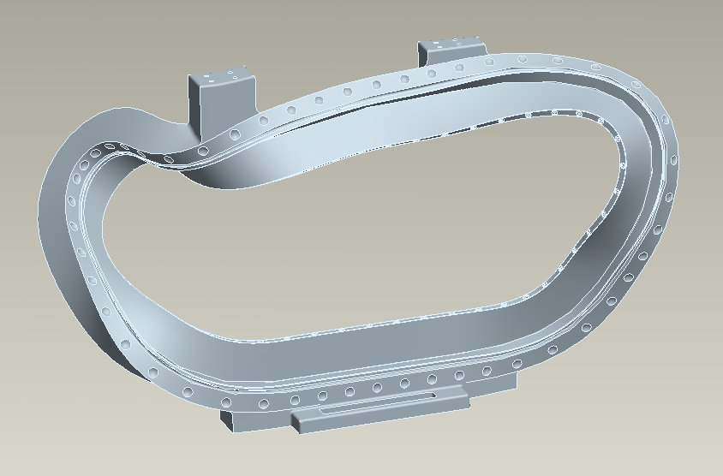
1
2
3
14
13
4
50
30
11
10
9
8
7
6
5
20
40
12
35
25
15
45
16
17
18
19
10.5
29
32
38.5
47.5

Figure 1. Planned (Red) locations of sections

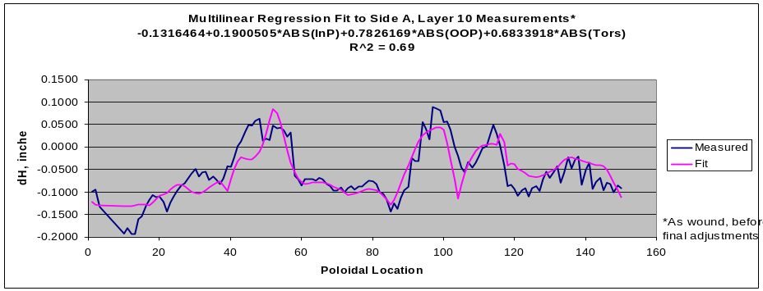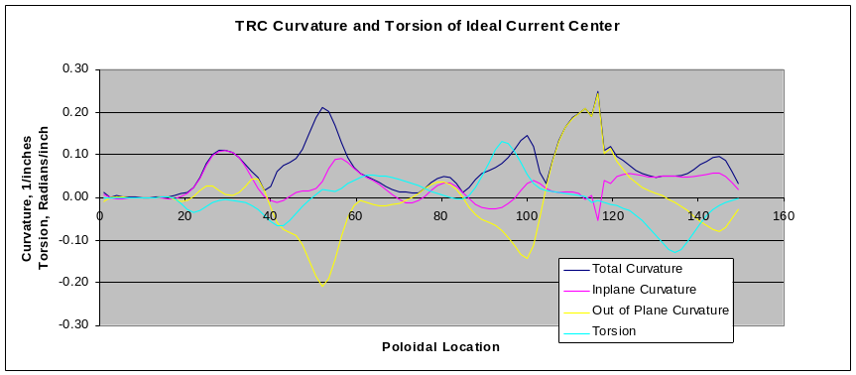
TRC
Proposed
Cut
Locations

Figure 2 Coil Curvature and Torsion at Planned locations of Sections
Table I Proposed Cut Locations

- Clamp#8
  - Fairly Flat (no curvature or torsion) near lead block
- Clamp#10.5 (between clamps 10 and 11)
  - Large In-plane curvature, but low torsion and OOP curvature
- Clamp#18
  - Large Out of Plane curvature, but low torsion and In-plane curvature
- Clamp#29
  - Fairly flat, but between regions of high torsion and curvatures – smallest change in bundle height
- Clamp#32
  - High Torsion and OOP – largest change in bundle height
- Clamp#38.5 (between clamps 38 and 39)
  - Largest Out of Plane curvature, but low torsion and In Plane Curvature – local spike in bundle height change
- Clamp#47.5 (between clamps 47 and 48)
  - Region of combined sizeable inplane, OOP, and Torsion
- Clamp#50
  - Fairly Flat (no curvature or torsion) near other end lead block
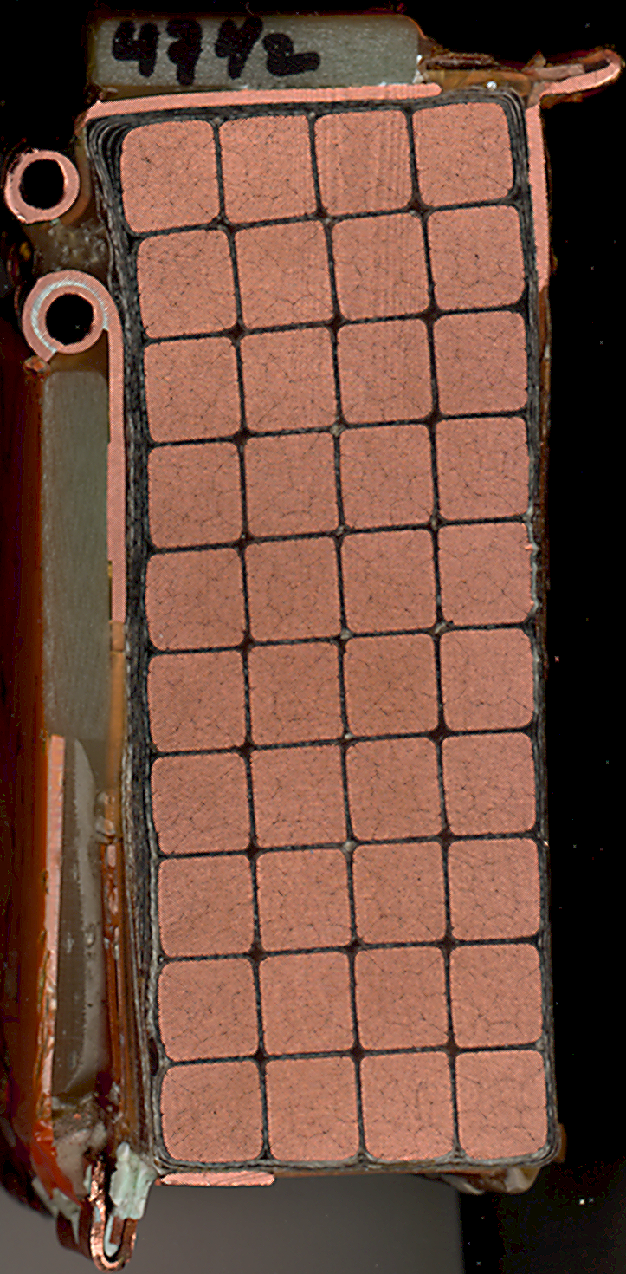

Figure 3 Section 47.5A
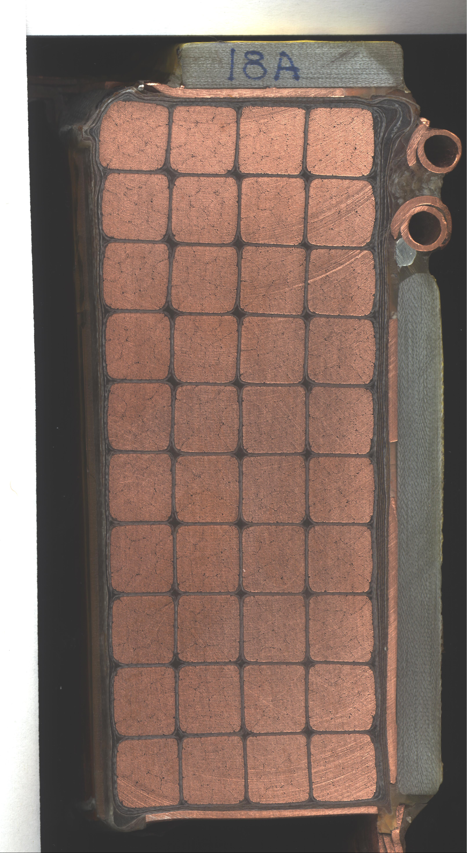

Figure 4 Section 18A
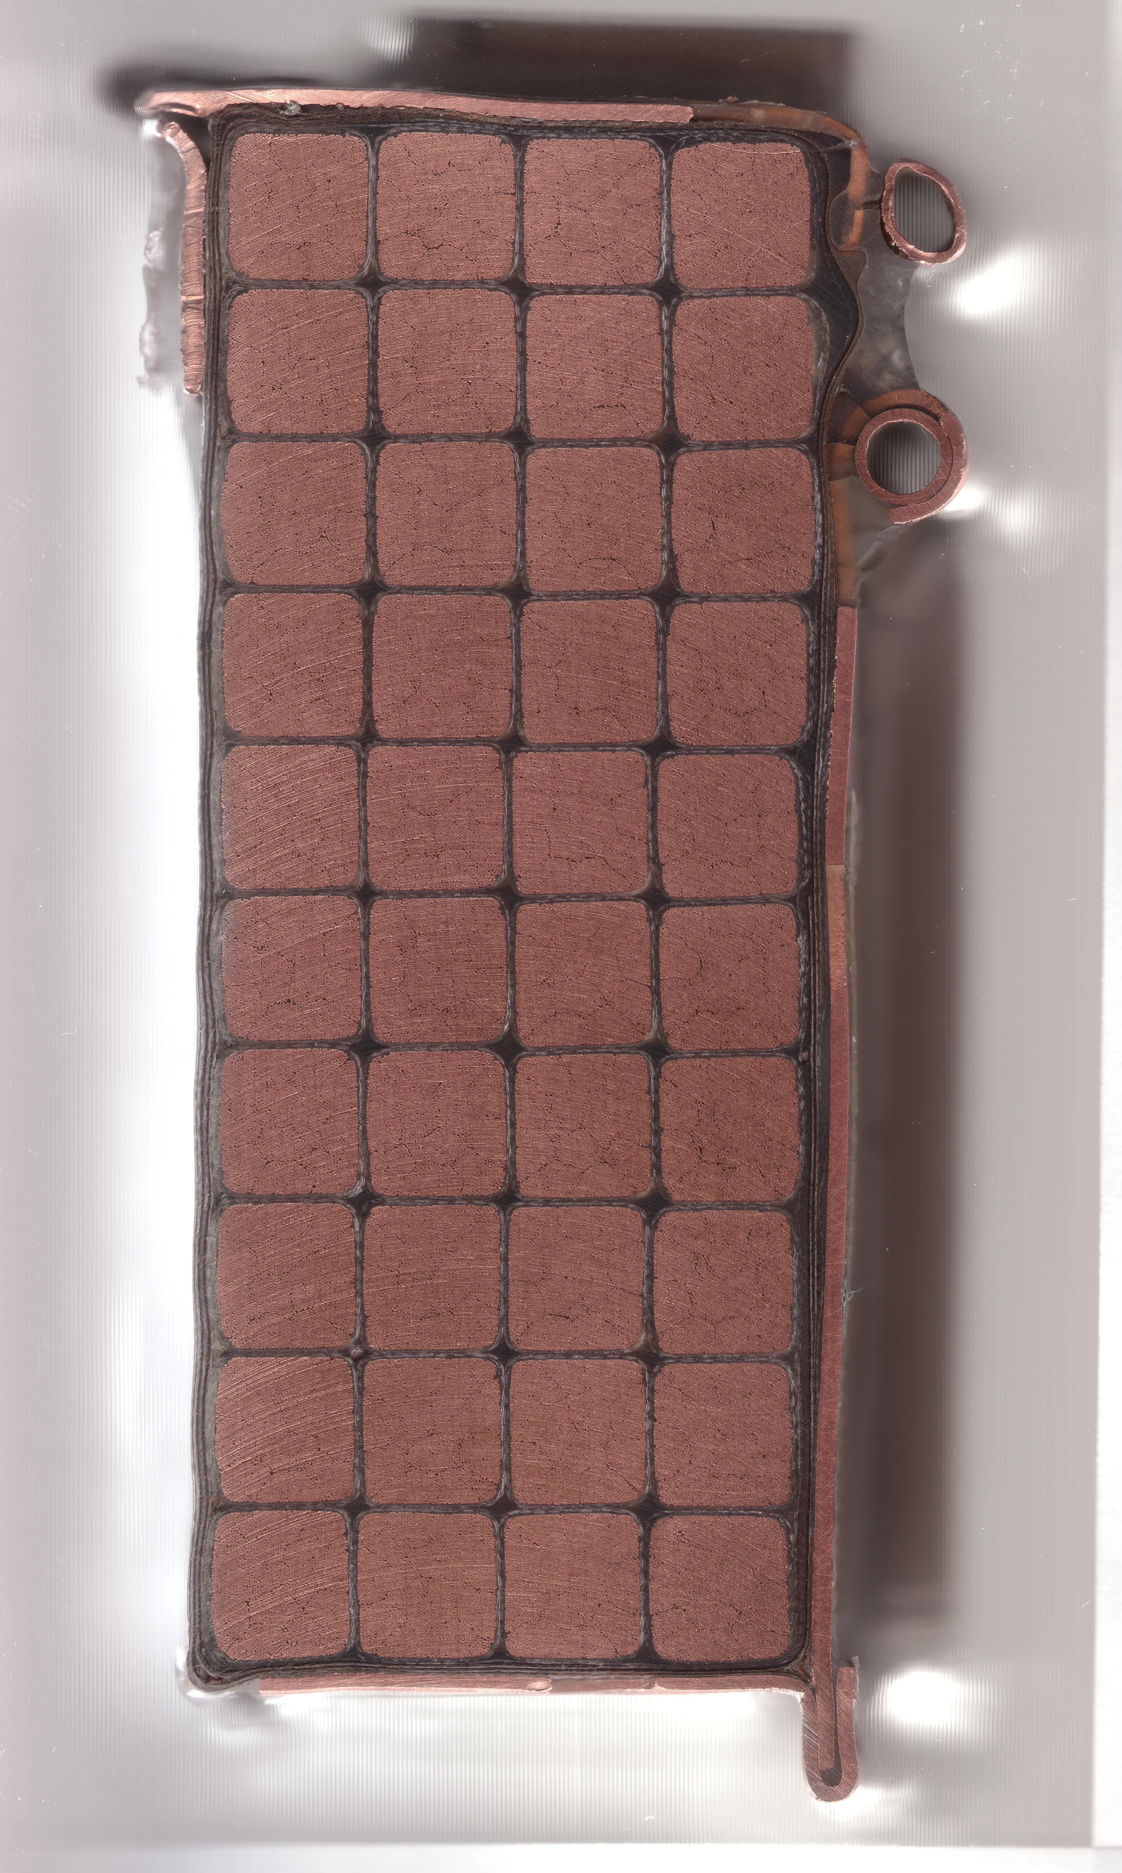

Figure 5 Section 38A
Table II Error in Current Center Location

Winding Error (Not Including Winding Form)
Section | Septum | Base
47.5A | -0.005 | 0.017
38A | 0.052 | 0.013
18A | 0.024 | -0.008
Winding Error (Including Winding Form)
Section | Septum |  | Base
47.5A | ? |  | 0.043
38A | ? |  | 0.008
18A | ? |  | 0.006

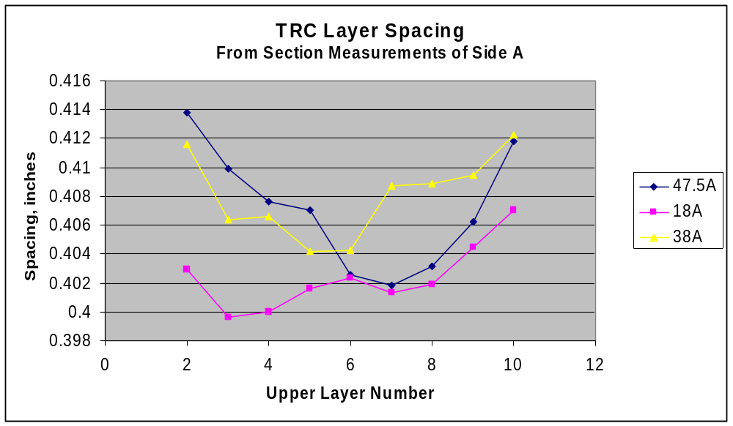
Figure 6 TRC Layer Spacing

